Extended Data
The recruitment for the study was open to all volunteers who were interested in participating. However, most of the participants in the cohort were invited through the Blood and Tissue Bank (BST), a public institution of the Catalan Department of Health. Participants were invited to participate using different strategies (GCAT website or in person).
The validity of the food-frequency questionnaire (FFQ) was assessed in adults aged 55–80 years by comparison with four sets of 3-day dietary records collected over one year.
In the questionnaire filled in 2018, the score of adherence to the Mediterranean diet (rMED) includes 9 components, expressed in energy density (g · 1000 kcal − 1 · d − 1). A score of 0 to 2 was assigned to the first, second, and third tertiles of intake for the 6 beneficial components: fruit & nuts, vegetables (excluding potatoes), legumes, fish, and cereals, olive oil and the scoring was inverted for the 2 detrimental components: meat and dairy products.

Below we report the food frequency questions included in the FFQ. Participants were asked about their eating habits during the previous year.

1) Which meals do you have on working days or weekdays? Select all that apply:

• Breakfast
• Lunch
• Afternoon snack
• Dinner
• Have a snack before going to sleep

2) On working days or weekdays, at what time do you usually have breakfast?

3) On working days or weekdays, at what time do you usually have lunch?

4) On working days or weekdays, how much time do you spend having lunch?

5) On working days or weekdays, at what time do you usually have your afternoon snack?

6) On working days or weekdays, at what time do you usually have dinner?

7) On working days or weekdays, how much time do you spend having dinner?

8) On working days or weekdays, at what time do you usually have a snack before going to sleep?
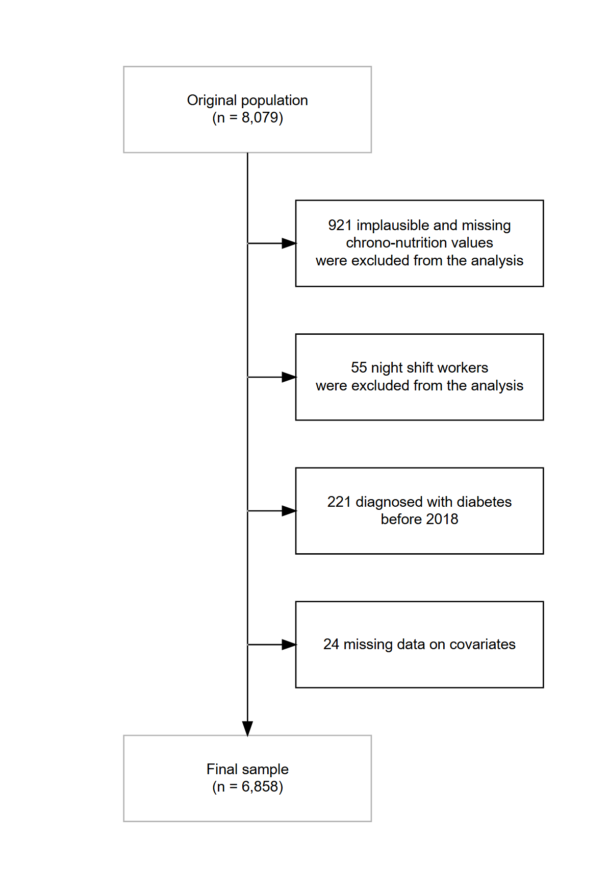

Extended Data Figure 1. Flowchart of subjects included in the study.

Extended Data Table 1. Baseline characteristics of the study population stratified by sex
 | Level | Male | Female | p
n |  | 2841 | 4017
Has type 2 diabetes (%) | No | 2756 (97.0) | 3950 (98.3) | <0.001
 | Yes | 85 (3.0) | 67 (1.7)
Age (median [IQR]) |  | 53.00 [48.00, 59.00] | 52.00 [47.00, 57.00] | <0.001
Education (%) | Primary education | 512 (18.0) | 810 (20.2) | 0.003
 | Secondary education | 930 (32.7) | 1172 (29.2)
 | Higher education | 1399 (49.2) | 2035 (50.7)
CVD risk factor (%) | No | 1733 (61.0) | 2955 (73.6) | <0.001
 | Yes | 1108 (39.0) | 1062 (26.4)
Smoking habit (%) | Smoker | 367 (12.9) | 646 (16.1) | 0.001
 | Former smoker | 1271 (44.7) | 1752 (43.6)
 | Never smoker | 1203 (42.3) | 1619 (40.3)
Physical activity (METs/week) (median [IQR]) |  | 62.00 [38.25, 100.01] | 62.55 [41.00, 94.24] | 0.201
BMI (median [IQR]) |  | 26.89 [24.86, 29.48] | 25.36 [23.06, 28.69] | <0.001
Energy consumption (median [IQR]) |  | 2009.66 [1630.62, 2454.02] | 1902.82 [1552.89, 2305.76] | <0.001
Buckland score (%) | Low adherence | 874 (30.8) | 729 (18.1) | <0.001
 | Medium adherence | 1400 (49.3) | 1876 (46.7)
 | High adherence | 567 (20.0) | 1412 (35.2)
p_gr_g4 (median [IQR]) |  | 9.80 [6.17, 14.77] | 7.08 [4.38, 11.45] | <0.001
Sleeping midpoint (median [IQR]) |  | 3:29 [3:03, 3:56] | 3:30 [3:05, 3:56] | 0.236
N of eating occasions (median [IQR]) |  | 3.00 [3.00, 3.71] | 3.29 [3.00, 4.00] | <0.001
Time of first meal (median [IQR]) |  | 8:34 [7:50, 9:30] | 8:34 [7:47, 9:30] | 0.97
Time of first meal category (%) | After 8:30 | 1460 (51.4) | 2054 (51.1) | 0.853
 | Before 8:30 | 1381 (48.6) | 1963 (48.9)
Time of last meal (median [IQR]) |  | 21:08 [20:52, 21:38] | 21:08 [20:47, 21:34] | 0.007
Nighttime fasting (median [IQR]) |  | 11:22 [10:34, 12:19] | 11:26 [10:34, 12:22] | 0.119
Eating jetlag (median [IQR]) (minutes) |  | 35 [15, 60] | 45 [15, 74] | <0.001
Time wakeup to first meal (median [IQR]) (minutes) |  | 56 [22, 75) | 50 [22, 122] | <0.001
Time last meal to bedtime (median [IQR]) |  | 2:30 [2:00, 3:00] | 2:26 [2:00, 3:00] | 0.216

Extended Data Table 2. Chrono-nutrition variables distribution
Variable | n | Min | P10 | P20 | P25 | P30 | P33.3 | P40 | P50 | P60 | P66.7 | P70 | P75 | P80 | P90 | Max
First meal on weekday | 6858 | 04:30 | 07:00 | 07:00 | 07:20 | 07:30 | 07:40 | 08:00 | 08:00 | 09:00 | 09:00 | 09:00 | 09:30 | 10:00 | 10:26 | 19:00
First meal on weekend | 6858 | 05:15 | 08:00 | 08:30 | 09:00 | 09:00 | 09:00 | 09:00 | 09:00 | 09:30 | 10:00 | 10:00 | 10:00 | 10:00 | 10:30 | 18:00
Last meal weekday | 6858 | 12:00 | 20:00 | 20:30 | 20:45 | 21:00 | 21:00 | 21:00 | 21:00 | 21:00 | 21:30 | 21:30 | 21:30 | 21:30 | 22:00 | 01:00
Last meal weekend | 6858 | 13:00 | 20:30 | 21:00 | 21:00 | 21:00 | 21:00 | 21:00 | 21:00 | 21:30 | 21:30 | 22:00 | 22:00 | 22:00 | 22:00 | 01:30
Nighttime fasting weekday | 6858 | 06:00 | 09:30 | 10:00 | 10:10 | 10:30 | 10:30 | 11:00 | 11:00 | 11:30 | 12:00 | 12:00 | 12:30 | 12:30 | 13:30 | 22:00
Nighttime fasting weekend | 6858 | 04:40 | 10:30 | 11:00 | 11:00 | 11:30 | 11:30 | 11:50 | 12:00 | 12:00 | 12:15 | 12:30 | 12:30 | 13:00 | 13:00 | 21:00
First meal average | 6858 | 04:56 | 07:17 | 07:37 | 07:47 | 07:56 | 08:00 | 08:17 | 08:34 | 09:00 | 09:09 | 09:17 | 09:30 | 09:43 | 10:17 | 17:08
Last meal average | 6858 | 12:34 | 20:17 | 20:38 | 20:49 | 21:00 | 21:00 | 21:00 | 21:08 | 21:17 | 21:22 | 21:30 | 21:38 | 21:43 | 22:00 | 12:43
Nighttime fasting average | 6858 | 06:43 | 09:58 | 10:26 | 10:34 | 10:47 | 10:56 | 11:04 | 11:26 | 11:47 | 12:00 | 12:08 | 12:22 | 12:38 | 13:22 | 20:17
Time wakeup to first meal | 6858 | 00:00 | 00:08 | 00:19 | 00:22 | 00:27 | 00:30 | 00:38 | 00:52 | 01:15 | 01:38 | 01:49 | 02:08 | 02:26 | 03:08 | 09:58
Time last meal to bedtime | 6858 | 00:00 | 01:28 | 01:49 | 02:00 | 02:00 | 02:08 | 02:17 | 02:27 | 02:38 | 02:47 | 02:52 | 03:00 | 03:08 | 03:30 | 11:26
Eating jetlag absolute | 6858 | 00:00 | 00:00 | 00:15 | 00:15 | 00:23 | 00:30 | 00:30 | 00:40 | 00:45 | 01:00 | 01:00 | 01:07 | 01:15 | 01:45 | 06:00
Eating midpoint weekday | 6858 | 09:45 | 13:45 | 14:00 | 14:07 | 14:15 | 14:20 | 14:30 | 14:45 | 15:00 | 15:00 | 15:15 | 15:23 | 15:30 | 16:00 | 20:30
Eating midpoint weekend | 6858 | 10:00 | 14:30 | 14:45 | 15:00 | 15:00 | 15:00 | 15:00 | 15:15 | 15:30 | 15:30 | 15:30 | 15:45 | 16:00 | 16:15 | 20:45
Eating midpoint average | 6858 | 10:17 | 14:00 | 14:17 | 14:23 | 14:30 | 14:34 | 14:42 | 14:53 | 15:04 | 15:13 | 15:18 | 15:26 | 15:33 | 15:57 | 19:34
Sleep duration weekday | 6826 | 03:30 | 06:20 | 06:45 | 07:00 | 07:00 | 07:00 | 07:10 | 07:30 | 07:30 | 07:50 | 08:00 | 08:00 | 08:00 | 08:30 | 11:30
Sleep duration weekend | 6789 | 03:30 | 07:00 | 08:00 | 08:00 | 08:00 | 08:00 | 08:00 | 08:30 | 09:00 | 09:00 | 09:00 | 09:00 | 09:01 | 10:00 | 13:15
Sleep duration average | 6858 | 04:00 | 06:45 | 07:05 | 07:14 | 07:17 | 07:23 | 07:32 | 07:43 | 07:56 | 08:00 | 08:07 | 08:15 | 08:19 | 08:43 | 11:04
Wakeup weekday | 6828 | 04:15 | 06:00 | 06:10 | 06:20 | 06:30 | 06:30 | 06:45 | 07:00 | 07:00 | 07:00 | 07:15 | 07:30 | 07:30 | 08:00 | 11:00
Wakeup weekend | 6810 | 04:35 | 07:00 | 08:00 | 08:00 | 08:00 | 08:00 | 08:10 | 08:30 | 09:00 | 09:00 | 09:00 | 09:00 | 09:00 | 10:00 | 12:00
Wakeup average | 6858 | 04:35 | 06:26 | 06:45 | 06:56 | 07:00 | 07:03 | 07:13 | 07:22 | 07:34 | 07:38 | 07:43 | 07:52 | 08:00 | 08:17 | 11:17
Bedtime weekday | 6857 | 20:00 | 22:30 | 23:00 | 23:00 | 23:00 | 23:00 | 23:00 | 23:30 | 23:45 | 00:00 | 00:00 | 00:00 | 00:00 | 00:30 | 05:00
Bedtime weekend | 6837 | 19:00 | 23:00 | 23:00 | 23:30 | 23:45 | 23:59 | 00:00 | 00:00 | 00:00 | 00:15 | 00:30 | 00:31 | 01:00 | 01:00 | 05:00
Bedtime average | 6858 | 20:34 | 22:38 | 23:00 | 23:08 | 23:17 | 23:17 | 23:23 | 23:38 | 23:52 | 00:00 | 00:00 | 00:07 | 00:17 | 00:38 | 05:00
N of eating occasions  weekday | 6858 | 2 | 3 | 3 | 3 | 3 | 3 | 3 | 3 | 3 | 4 | 4 | 4 | 4 | 4 | 5
N of eating occasions weekend | 6858 | 2 | 3 | 3 | 3 | 3 | 3 | 3 | 3 | 3 | 3 | 4 | 4 | 4 | 4 | 5
N of eating occasions  average | 6858 | 2 | 3 | 3 | 3 | 3 | 3 | 3 | 3 | 3.29 | 3.71 | 3.71 | 3.71 | 4 | 4 | 5

Extended Data Table 3. Associations between chrono-nutrition variables and T2D estimated using logistic regression Models 1, 2, 3.
Exposure | Model 1  OR (95% CI)  Single exposure | Model 2  OR (95% CI)  Single exposure | Model 3  OR (95% CI)  Single exposure | Model 1  OR (95% CI)  Mutually adjusted | Model 2  OR (95% CI)  Mutually adjusted | Model 3  OR (95% CI)  Mutually adjusted
Time of first meal | 0.90 [0.80, 1.02] | 0.84 [0.72, 0.96] | 0.86 [0.74, 0.98] | 0.87 [0.76, 0.99] | 0.85 [0.73, 0.97] | 0.82 [0.71, 0.95] | Meal time model
Time of last meal | 1.37 [1.11, 1.68] | 1.29 [1.05, 1.61] | 1.34 [1.08, 1.68] | 1.43 [1.15, 1.78] | 1.37 [1.10, 1.73] | 1.34 [1.07, 1.69] | Meal time model
N of eating occasions | 1.21 [0.89, 1.65] | 1.20 [0.88, 1.64] | 1.23 [0.90, 1.66] | 0.99 [0.70, 1.37] | 0.99 [0.71, 1.38] | 0.96 [0.68, 1.34] | Meal time model
Nighttime fasting | 0.83 [0.73, 0.93] | 0.81 [0.72, 0.92] | 0.81 [0.71, 0.91] | 0.78 [0.68, 0.90] | 0.79 [0.68, 0.90] | 0.78 [0.68, 0.90] | Nighttime fasting model
Eating midpoint | 1.01 [0.84, 1.20] | 0.95 [0.78, 1.16] | 0.92 [0.75, 1.12] | 1.24 [0.99, 1.56] | 1.17 [0.91, 1.50] | 1.10 [0.86, 1.42] | Nighttime fasting model
N of eating occasions | - | - |  | 0.99 [0.70, 1.37] | 0.99 [0.71, 1.38] | 0.96 [0.68, 1.34] | Nighttime fasting model
Wake up to first meal | 0.87 [0.76, 0.98] | 0.88 [0.76, 1.00] | 0.85 [0.74, 0.97] | 0.88 [0.76, 1.00] | 0.89 [0.77, 1.01] | 0.86 [0.74, 0.98] | Wakeup-to-firstmeal model
N of eating occasions | - | - | - | 1.12 [0.80, 1.54] | 1.13 [0.81, 1.56] | 1.10 [0.79, 1.52] | Wakeup-to-firstmeal model
Last meal to bedtime | 0.89 [0.75, 1.06] | 0.80 [0.65, 0.98] | 0.81 [0.66, 0.99] | 0.91 [0.76, 1.08] | 0.82 [0.66, 1.00] | 0.82 [0.67, 1.01] | Lastmeal-to-bedtime model
N of eating occasions | - | - | - | 1.17 [0.85, 1.60] | 1.14 [0.84, 1.56] | 1.12 [0.82, 1.54] | Lastmeal-to-bedtime model
Eating jetlag | 0.96 [0.76, 1.19] | 0.98 [0.77, 1.21] | 0.99 [0.77, 1.23] | 0.99 [0.77, 1.23] | 1.00 [0.79, 1.25] | 1.01 [0.78, 1.27] | Eating jetlag model
N of eating occasions | - | - | - | 1.21 [0.88, 1.65] | 1.23 [0.90, 1.67] | 1.21 [0.88, 1.65] | Eating jetlag model

Model 1 is adjusted for age, sex, education, smoking habits, physical activity, Mediterranean diet, energy intake and ultra-processed food intake; Model 2 is adjusted for age and sex, education, smoking habits, physical activity, Mediterranean diet, energy intake, ultra-processed food intake and sleeping midpoint; Model 3 is adjusted for age and sex, education, smoking habits, physical activity, Mediterranean diet, energy intake, ultra-processed food intake, sleeping midpoint and BMI. The results for the number of eating occasions in the single-exposure model are reported only once, within the mealtime model.

Extended Data Table 4. Associations between chrono-nutrition variables and T2D estimated using logistic regression and stratified by sex. Models adjusted for age, and sex.
 |  | Men |  | Women
 | Main variables included in model | Single exposure model  OR (95%CI) | Mutually adjusted model  OR (95%CI) | Single exposure model  OR (95%CI) | Mutually adjusted model  OR (95%CI)
Meal time model | Time of first meal | 0.96 [0.82, 1.11] | 0.93 [0.78, 1.09] | 0.90 [0.73, 1.09] | 0.86 [0.69, 1.05]
Meal time model | Time of last meal | 1.32 [1.00, 1.75] | 1.36 [1.01, 1.84] | 1.59 [1.17, 2.16] | 1.66 [1.20, 2.29]
Meal time model | N of eating occasions | 1.12 [0.73, 1.70] | 0.97 [0.61, 1.52] | 1.29 [0.81, 2.03] | 1.01 [0.62, 1.61]
Nighttime fasting model | Nighttime fasting | 0.89 [0.76, 1.03] | 0.83 [0.68, 1.00] | 0.78 [0.64, 0.93] | 0.72 [0.58, 0.89]
Nighttime fasting model | Eating midpoint | 1.05 [0.83, 1.31] | 1.26 [0.93, 1.70] | 1.11 [0.84, 1.45] | 1.42 [1.00, 2.00]
Nighttime fasting model | N of eating occasions | - | 0.97 [0.61, 1.52] | - | 1.01 [0.62, 1.61]
Wake up to first meal model | Wakeup-to-firstmeal | 0.94 [0.79, 1.09] | 0.94 [0.79, 1.10] | 0.83 [0.65, 1.02] | 0.84 [0.66, 1.04]
Wake up to first meal model | N of eating occasions | - | 1.07 [0.67, 1.66] | - | 1.20 [0.75, 1.92]
Last meal to bedtime model | Lastmeal-to-bedtime | 0.87 [0.68, 1.10] | 0.87 [0.68, 1.11] | 0.90 [0.69, 1.15] | 0.93 [0.71, 1.20]
Last meal to bedtime model | N of eating occasions | - | 1.07 [0.69, 1.63] | - | 1.25 [0.78, 1.99]
Eating jetlag model | Eating jetlag | 0.92 [0.65, 1.23] | 0.93 [0.66, 1.26] | 1.02 [0.72, 1.38] | 1.06 [0.74, 1.45]
Eating jetlag model | N of eating occasions | - | 1.10 [0.72, 1.68] | - | 1.31 [0.82, 2.07]
Extended Data Table 5 Associations between chrono-nutrition variables and T2D estimated using logistic regression and stratified by time of the first meal before or after 8:30. Models adjusted for age and sex.
 | Before 8:30 |  | After 8:30
 | Single exposure model  OR (95%CI) | Mutually adjusted model  OR (95%CI) | Single exposure model  OR (95%CI) | Mutually adjusted model  OR (95%CI)
Nighttime fasting | 0.88 [0.68, 1.12] | 0.95 [0.71, 1.28] | 0.68 [0.54, 0.83] | 0.66 [0.53, 0.81]
Eating midpoint | 1.50 [0.95, 2.45] | 1.46 [0.88, 2.50] | 1.00 [0.75, 1.31] | 1.27 [0.88, 1.80]
N of eating occasions | 1.04 [0.64, 1.66] | 0.94 [0.57, 1.53] | 1.36 [0.90, 2.04] | 0.95 [0.60, 1.50]

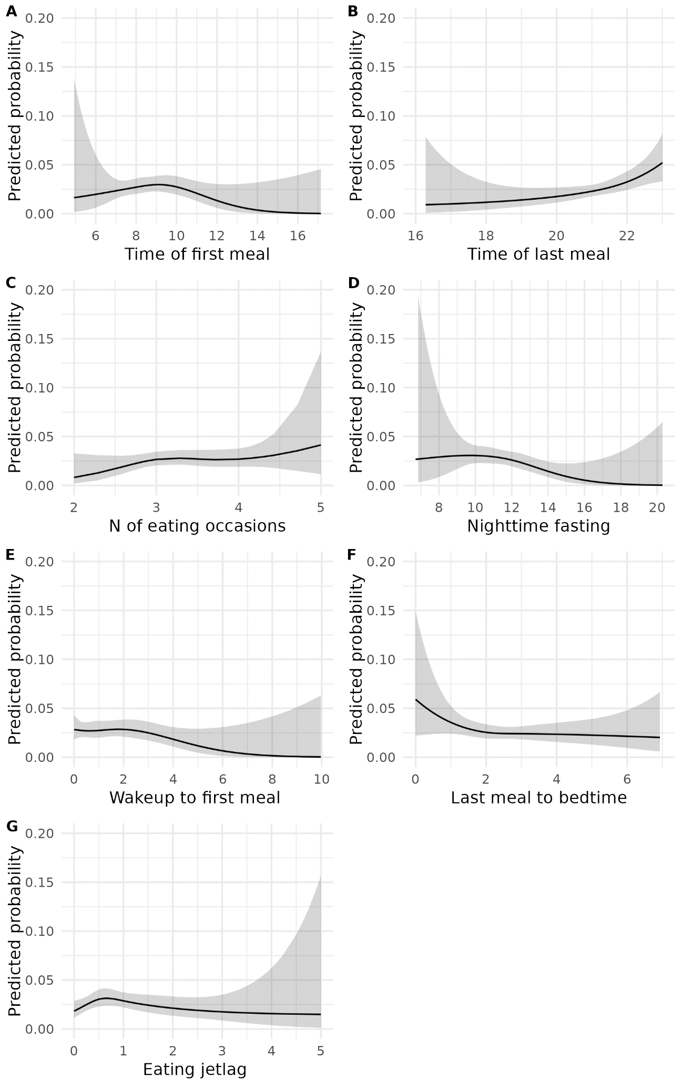
Extended Data Figure 2 Examining the linearity of the association between meal variables and risk T2D. The p-values for the likelihood ratio test is 0.06 for time of first meal (A), 0.69 for time of last meal (B), 0.24 for number of eating occasions (C), 0.24 for nighttime fasting (D), 0.23 for wake up to first meal (E), 0.50 for last meal to bedtime (F), and 0.07 for eating jetlag (G)

