Supplementary materials

Table 1 Qualitative scale applied to describe extent of physical deterioration in smallspotted catsharks Scyliorhinus canicula. All images obtained from the iNaturalist database of UK observations uploaded between 01/01/2008 and 31/10/2025
Low
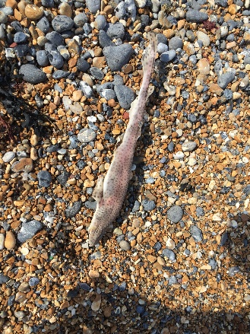 | 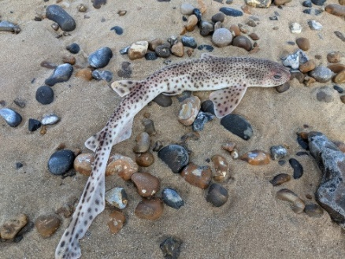 | 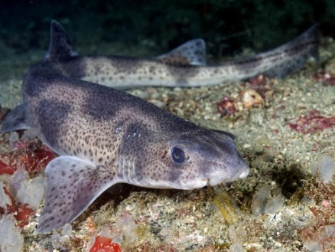
Scan_UK_0798 | Scan_UK_0370 | Scan_UK_0113
Medium
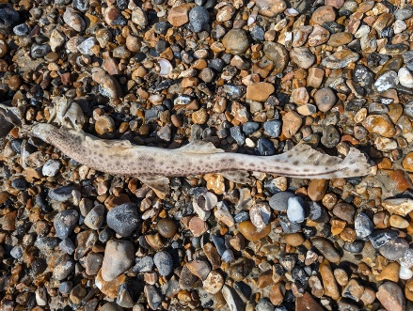 | 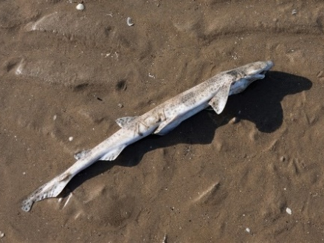 | 
Scan_UK_1351 | Scan_UK_0100 | Scan_UK_0064
High
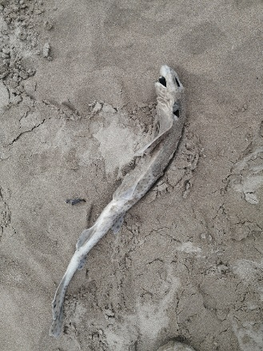 | 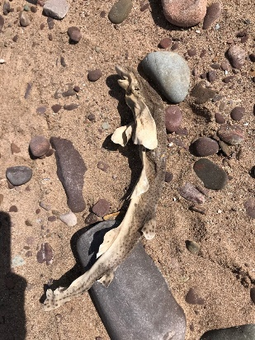 | 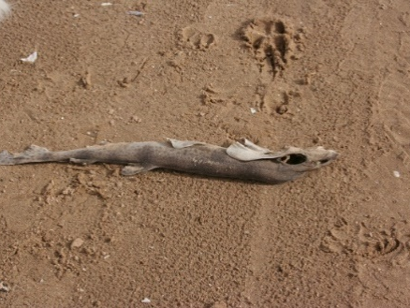
Scan_UK_0450 | Scan_UK_0137 | Scan_UK_0358
Extreme
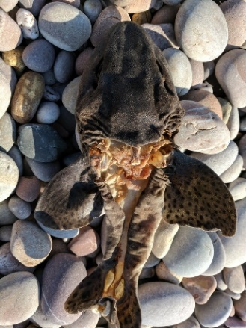 | 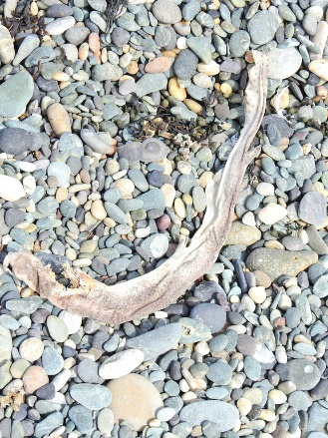 | 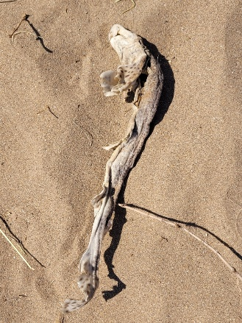
Scan_UK_0012 | Scan_UK_0740 | Scan_UK_1952

Table 2 Smallspotted catsharks Scyliorhinus canicula and nursehounds S. stellaris identified with skin colour aberrations, including hypomelanosis and hypermelanosis. All observations extracted from UK records uploaded to iNaturalist between 01/01/2008 and 31/10/2025
Observation | Description
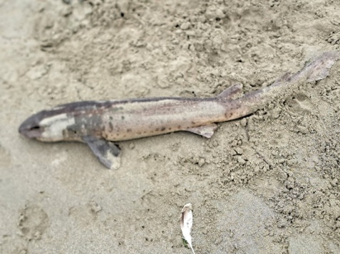  Scan_UK_1036 | - Hypomelanosis  - Clear lack of pigmentation on flank and at the extremity of the pectoral fin.  - Lack of pigmentation behind the eye on sides of head.  - Darker pigmentation dorsally, on the snout and pectoral fin.  - Star rating: 3
Scan_UK_1204 - iNaturalist user contacted re publishing rights | - Hypomelanosis  - Abnormal white markings around the snout, pectoral fins, both dorsal fins, and caudal fin.  - Normal pigmentation dorsally.  - Star rating: 3
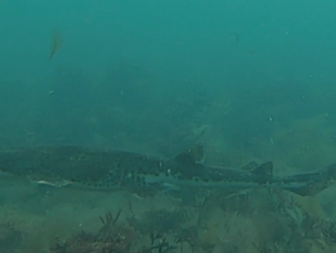  Scan_UK_1093 | - Hypomelanosis  - Abnormal white markings prevalent on lower posterior half to the caudal fin amidst otherwise normally pigmented areas.  - Star rating: 3
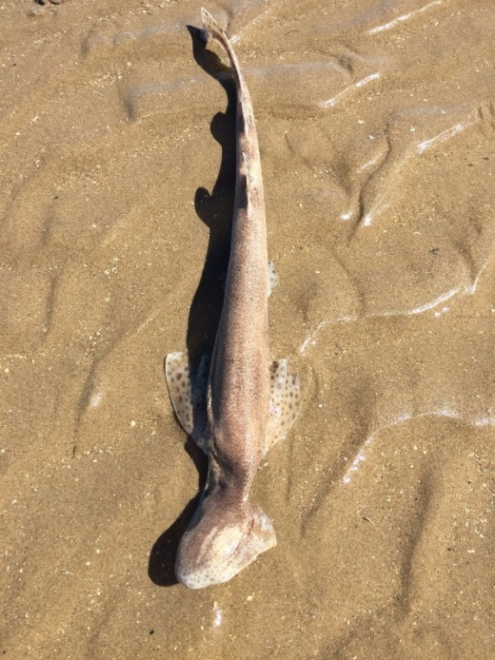  Scan_UK_0150 | - Hypomelanosis  - Abnormal white marking above eye, amidst normal pigmentation.  - Potential light patches behind dorsal fins but unclear due to photo lighting.  - Star rating: 3
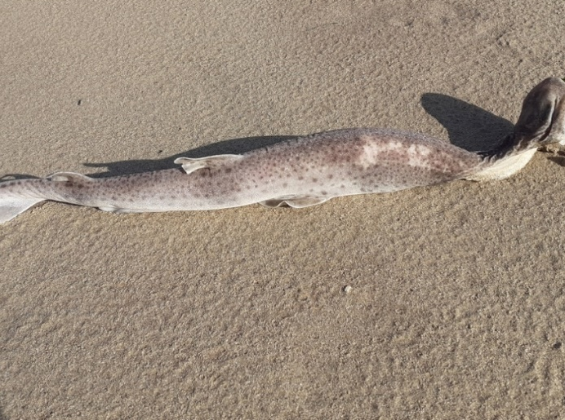  Scan_UK_0479 | - Hypomelanosis  - Unusual light patch on the anterior dorsal area.  - Star rating: 3
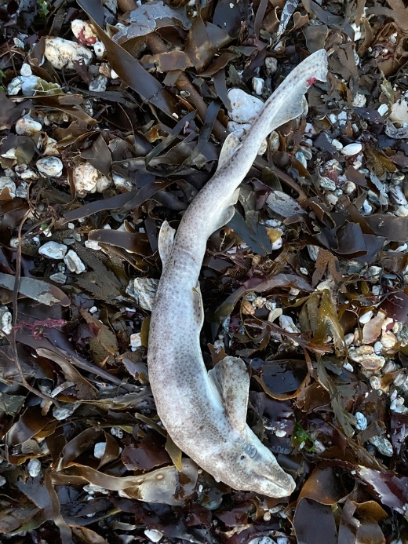  Scan_UK_0505 | - Hypomelanosis  - Reduced pigmentation prevalent on pectoral fin, around the snout and above the pectoral fin with otherwise normal pigmentation.  - Star rating: 3
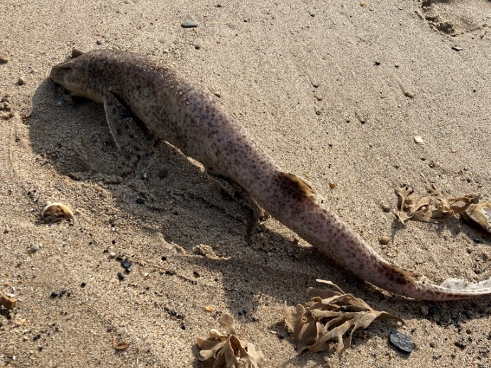  Scan_UK_0595 | - Hypomelanosis  - Normally pigmented dorsal fins and anterior of pectoral fin, with reduced pigmentation and sparser spot pattern on rest of body.  - Star rating: 3
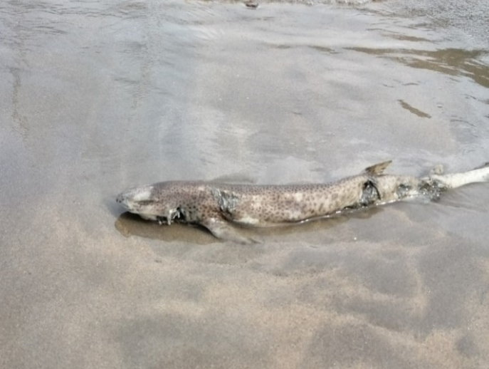  Scan_UK_0737 | - Hypomelanosis  - Reduced pigmentation on head and around snout.  - The pigmentation is patchy on the flank.  - Potentially abnormally coloured caudal fin but could be due to twisting or camera angle.  - Star rating: 3
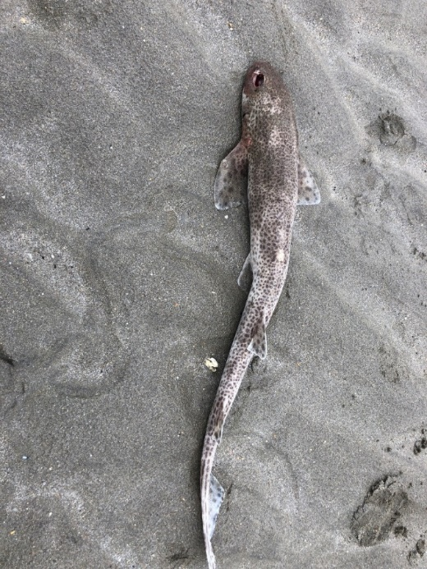  Scan_UK_0741 | - Hypomelanosis  - Patchiness around head and anterior of first dorsal in contrast with normal pigmentation.  - Star rating: 3
  Scan_UK_0913 | - Hypomelanosis  - Hypermelanosis  - Light patch on each dorsal fin.  - Large black spot on caudal fin.  - Star rating: 3
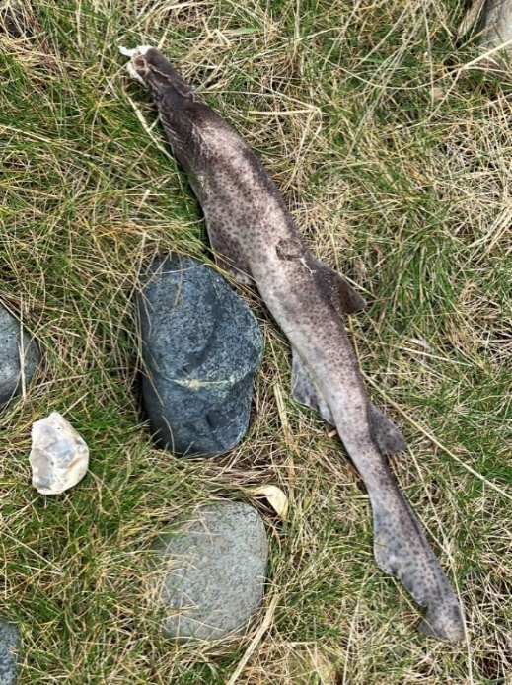  Scan_UK_0836 | - Hypomelanosis  - Unusual light pigmentation dorsally with normal/dark pigmentation on dorsal and pectoral fins.  - Star rating: 3
Scan_UK_0988 – iNaturalist user contacted re publishing rights | - Hypomelanosis  - Reduced pigmentation on the snout.  - Star rating: 3
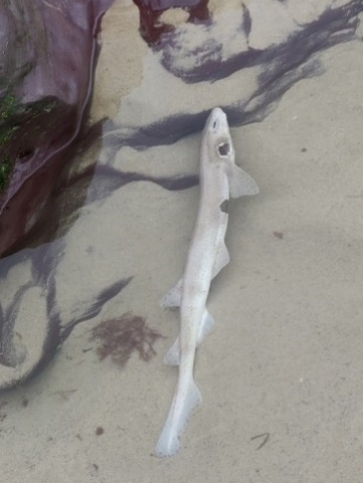  Scan_UK_0744 | - Hypomelanosis  - Hypermelanosis  - Generally pale in colour.  - Minimal spots on caudal fin.  - Large dark patch posterior and anterior of pectoral fin.  - Star rating: 3
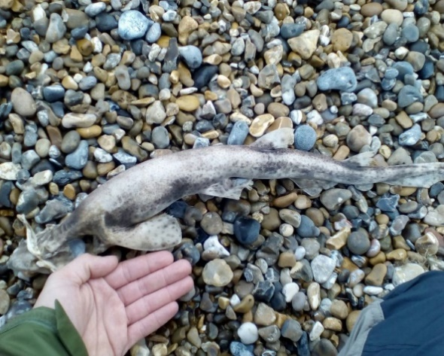  Scan_UK_0005 | - Hypomelanosis  - Reduced pigmentation on dorsal fins, pectoral fin and dorsal area.  - Light patches on caudal fin.  - Some doubt relating to role of deterioration.  - Star rating: 2
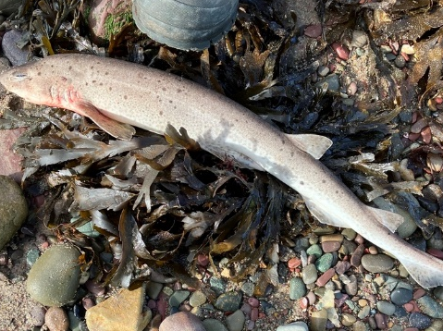  Scan_UK_1168 | - Hypomelanosis  - Pale in colour with irregular spots.  - Star rating: 2
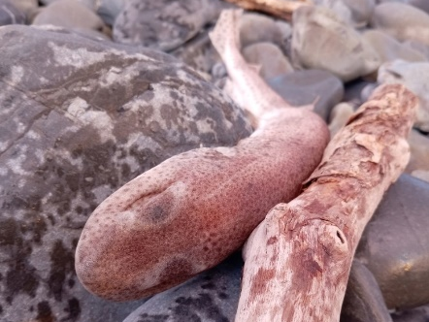  Scan_UK_2102 | - Hypomelanosis  - Unusual white markings above eye with otherwise normal pigmentation.  - Lack of detailed view of rest of body.  - Star rating: 2
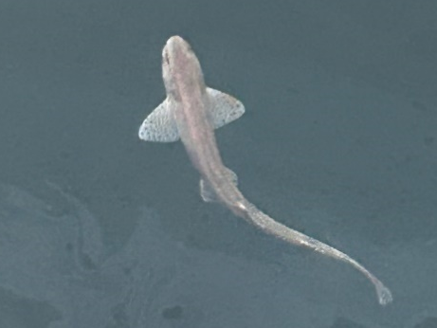  Scan_UK_2110 | - Hypomelanosis  - Potential abnormal pigmentation around snout similar to Scan_UK_1204.  - Uncertainty due to image quality.  - Star rating: 2
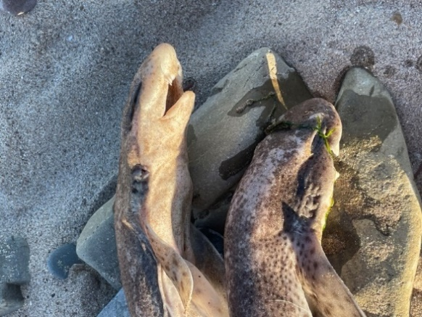  Scan_UK_1592 | - Hypomelanosis  - Unusual light marking on head amidst normal pigmentation.  - Star rating: 2
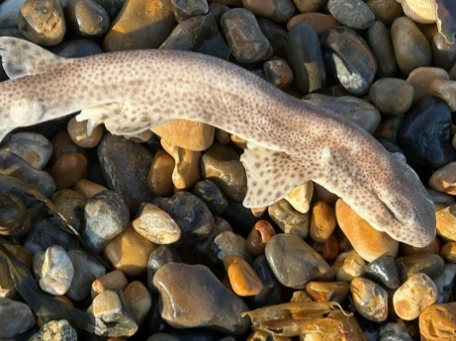  Scan_UK_1664 | - Hypomelanosis  - Light patches above eyes similar to Scan_UK_2102.  - Some reduced pigmentation anterior of pectoral fin.  - Star rating: 2
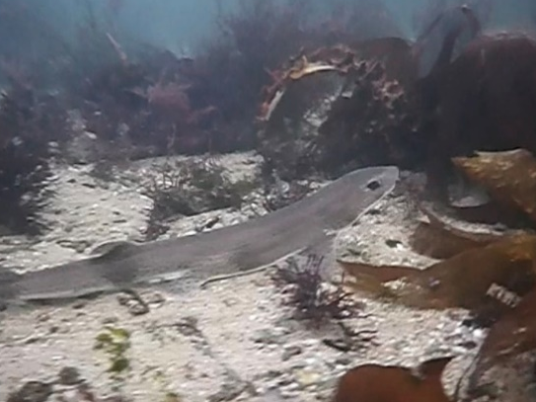  Scan_UK_0510 | - Hypomelanosis  - Dorsal side appears to be uniformly dark with white underside which contrast.  - May be due to a lack of clarity resulting from poor image quality.  - Star rating: 1
Scan_UK_0763 - iNaturalist user contacted re publishing rights | - Hypomelanosis  - Lighter streak running from anterior of pectoral fin to the first dorsal fin on the flank.  - Some of the shark is obscured by sand, causing some uncertainty.  - Star rating: 1
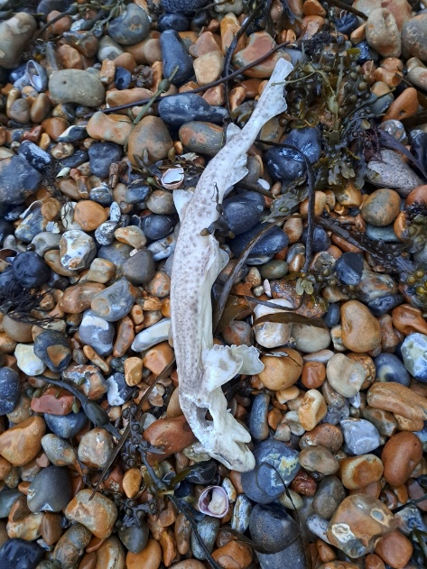  Scan_UK_1183 | - Hypomelanosis  - Reduced pigmentation on the pectoral fin and first dorsal.  - Moderate levels of deterioration incur uncertainty as to causes of light areas.  - Star rating: 1
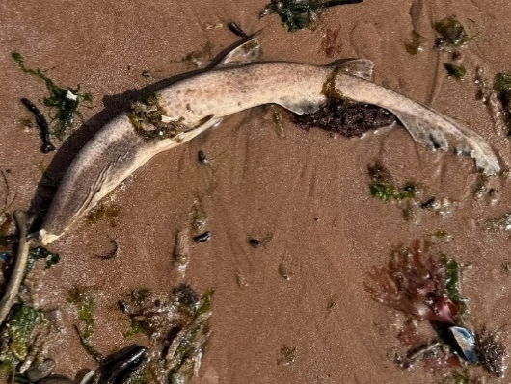  Scan_UK_1967 | - Hypomelanosis  - Light patch dorsally anterior of pelvic fin.  - Moderate levels of deterioration incur uncertainty as to causes of light areas.  - Star rating: 1
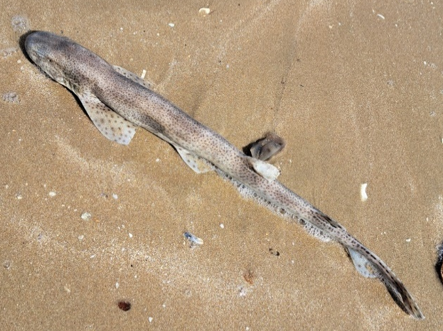  Scan_UK_0980 | - Hypomelanosis  - Reduced pigmentation on dorsal fin, but otherwise normal pigmentation.  - This could be due to light reflecting on the dorsal fin.  - Star rating: 1
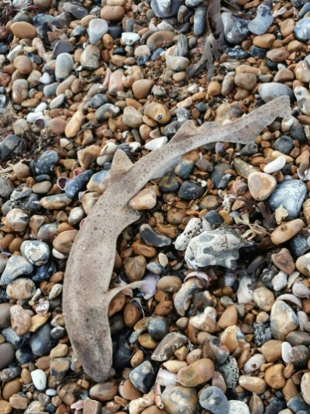  Scan_UK_0783 | - Hypomelansosis  - Sparse spot pattern.  - Star rating: 1
Scan_UK_1899 - iNaturalist user contacted re publishing rights | - Hypomelanosis  - Lighter patch above pectoral fin.  - Star rating: 1
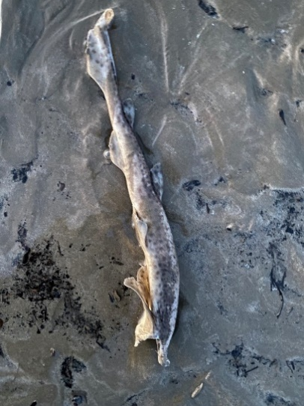  Sstel_UK_118 | - Hypomelanosis  - Abnormal white markings on caudal fin, dorsal fin, anterior dorsal surface and flank amidst normal pigmentation.  - Star rating: 3
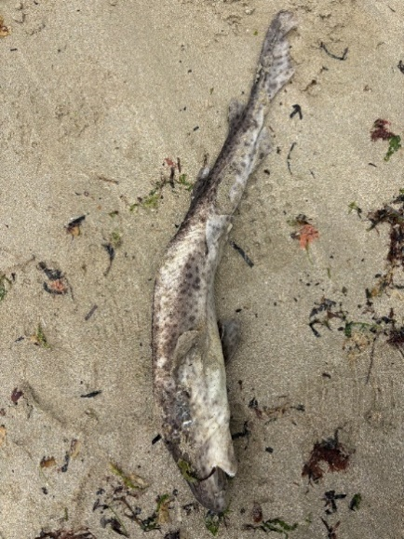  Sstel_UK_0462 | - Hypomelanosis  - Pale patch posterior of pectoral fin on dorsal surface.  - Could be from deterioration.  - Star rating: 1
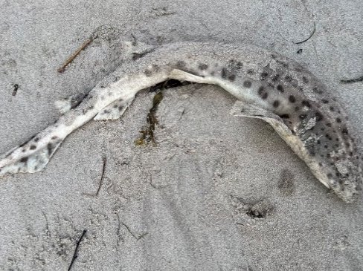  Sstel_UK_152 | - Hypomelanosis  - Reduced pigmentation on dorsal fins.  - Some uncertainty due to sand.  - Star rating: 1
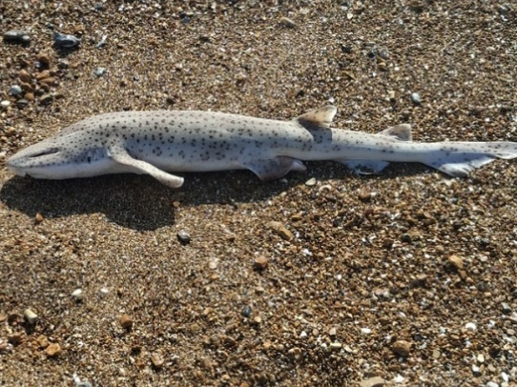  Sstel_UK_379 | - Hypomelanosis  - Generally pale colouring  - Star rating: 1
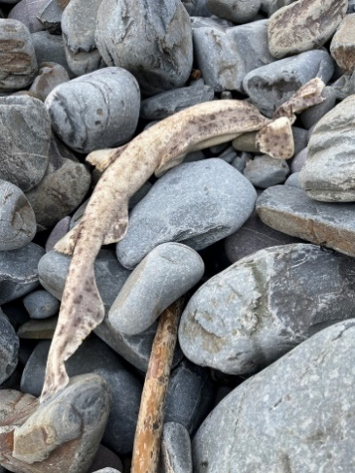  Sstel_UK_380 | - Hypomelanosis  - Reduced pigmentation dorsally and on dorsal fins.  - Star rating: 1
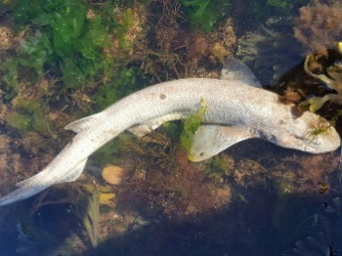  Scan_UK_0030 | - Hypermelanosis  - Larger dark spots on pectoral fins and mid-dorsal area.
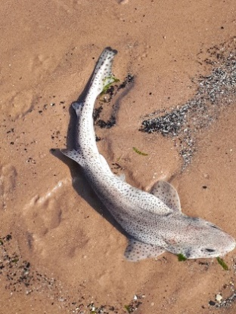  Scan_UK_0056 | - Hypermelanosis  - Dark pigmentation at end of caudal fin and second dorsal.
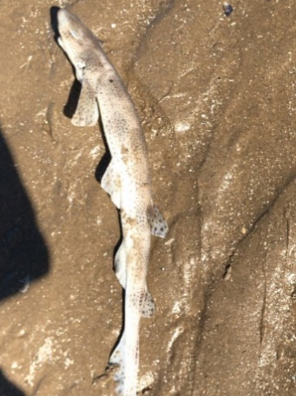  Scan_UK_0144 | - Hypermelanosis  - Larger dark spot above pectoral fin.
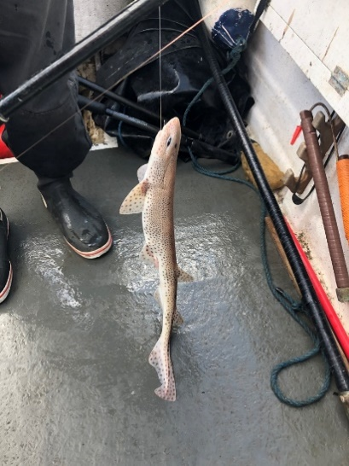  Scan_UK_0176 | - Hypermelanosis  - Larger dark spot above eye.
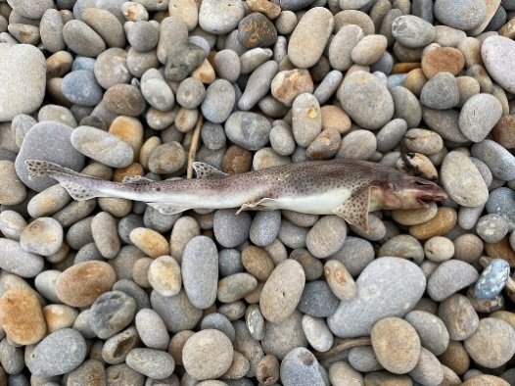  Scan_UK_0497 | - Hypermelanosis  - Larger dark spot just before second dorsal.
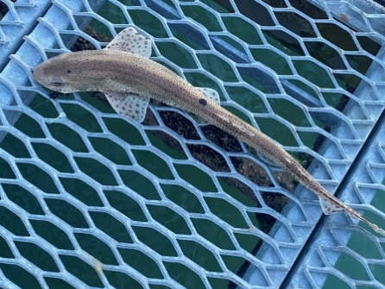  Scan_UK_0748 | - Hypermelanosis  - Dark patch just before first dorsal and larger dark spot above eye.
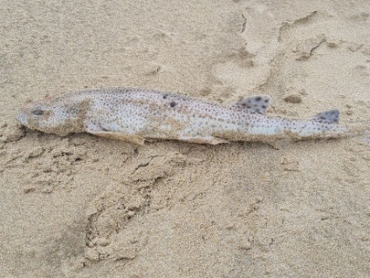  Scan_UK_0752 | - Hypermelanosis  - Larger dark spot dorsally above pelvic fin.
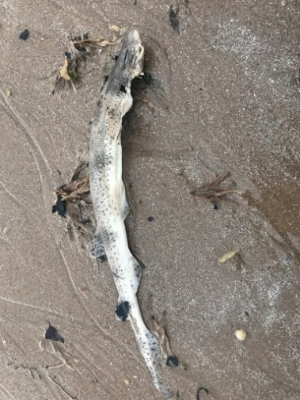  Scan_UK_0764 | - Hypermelanosis  - Dark pigmentation covering head.
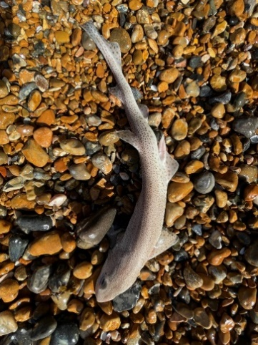  Scan_UK_0769 | - Hypermelanosis  - Darker pigment at edge of pectoral fin.
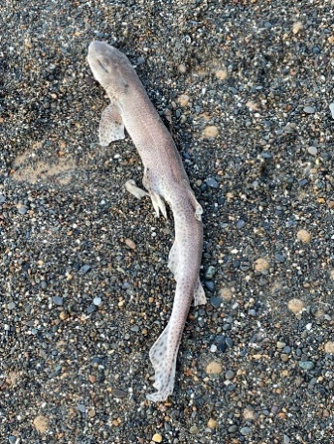  Scan_UK_0776 | - Hypermelanosis  - Larger dark spots on pectoral fin and behind the eye.
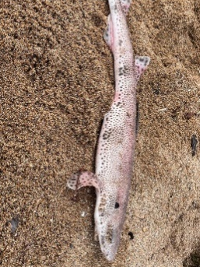  Scan_UK_0861 | - Hypermelanosis  - Larger dark spot between eye and pectoral fin on upper body.
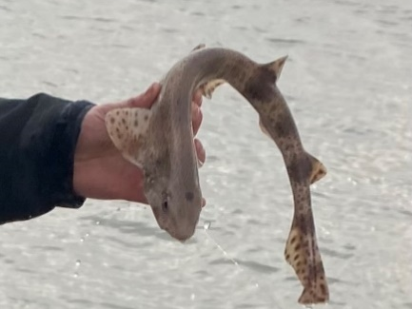  Scan_UK_1200 | - Hypermelanosis  - Darker patch in centre of head.
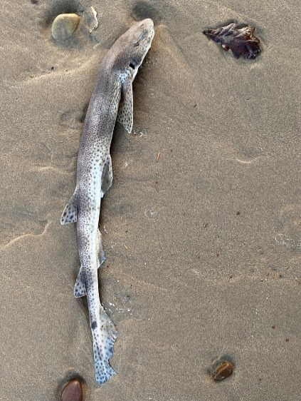  Scan_UK_1211 | - Hypermelanosis  - Dark patch on caudal fin.
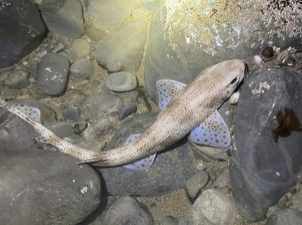  Scan_UK_1681 | - Hypermelanosis  - Dark spot just behind eye and above left-hand pectoral fin.
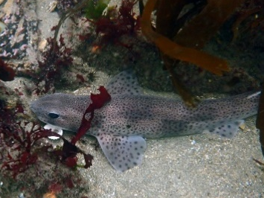  Scan_UK_1715 | - Hypermelanosis  - Dark spot above pectoral fin.
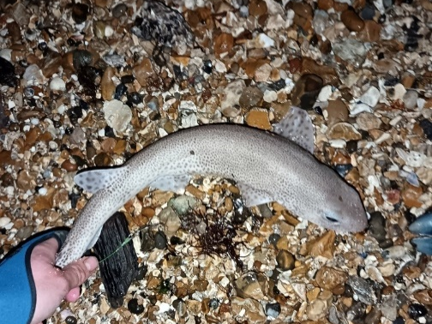  Scan_UK_1717 | - Hypermelanosis  - Dark spot on head and above pelvic fin insertion.
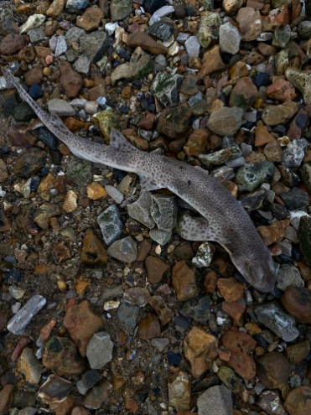  Scan_UK_1797 | - Hypermelanosis  - Larger dark spot at mid-point between pectoral and pelvic fin.
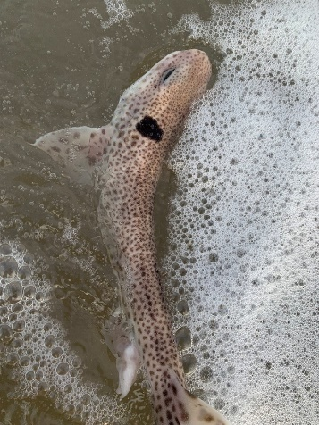  Scan_UK_1889 | - Hypermelanosis  - Large dark patch behind head above pelvic fin.
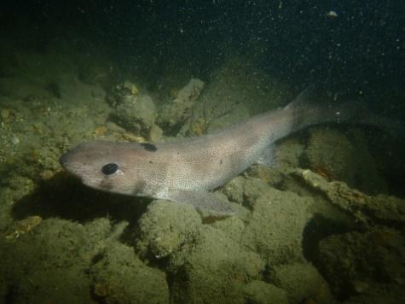  Scan_UK_1891 | - Hypermelanosis  - Large dark patch behind head dorsally.
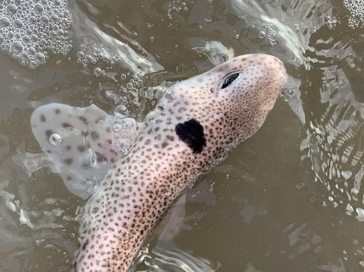  Scan_UK_1911 | - Hypermelanosis  - Large dark patch behind head above pectoral fin and behind eye.
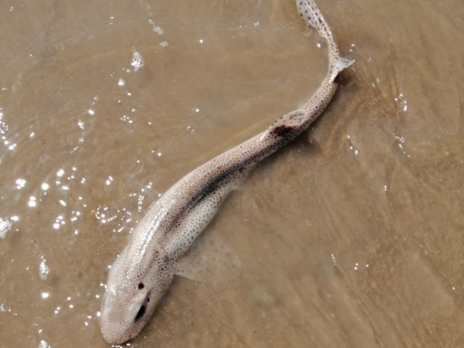  Scan_UK_1927 | - Hypermelanosis  - Large dot above eye and dark streak laterally.
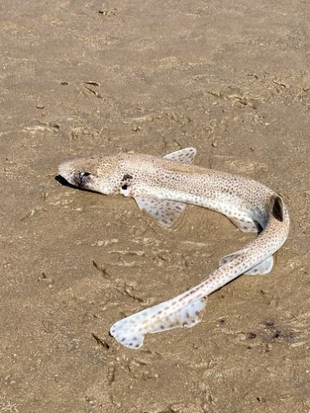  Scan_UK_1938 | - Hypermelanosis  - Dark patch above pectoral fin and below eye.
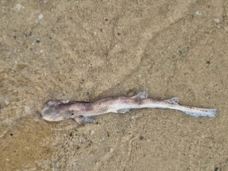  Scan_UK_1958 | - Hypermelanosis  - Dark patch at end of snout and larger dark spot above pectoral fin.
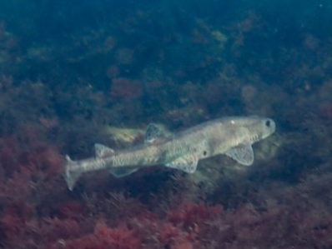  Scan_UK_2003 | - Hypermelanosis  - Dark patch in front of pelvic fin.
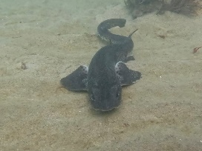  Scan_UK_2009 | - Hypermelanosis  - Generally dark colouring.
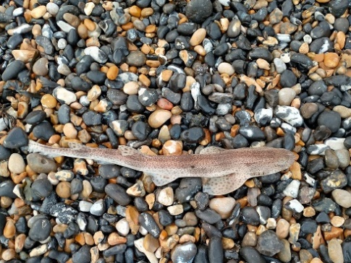  Scan_UK_2019 | - Hypermelanosis  - Dark patch between pelvic and pectoral fin on dorsal area.
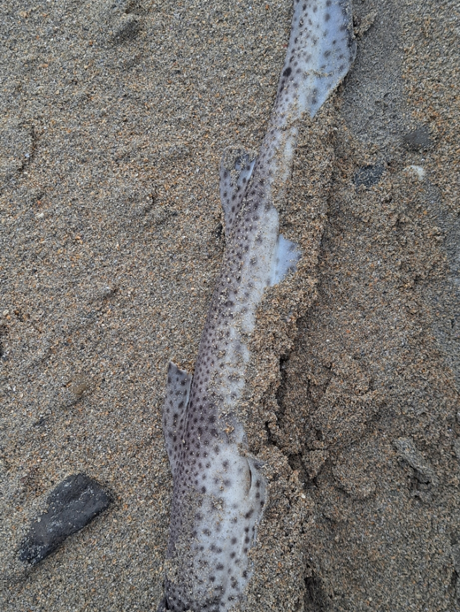  Scan_UK_2060 | - Hypermelanosis  - Larger dark spot on caudal fin.
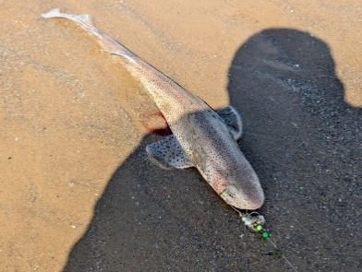  Scan_UK_2062 | - Hypermelanosis  - Two dark spots above pectoral fin.
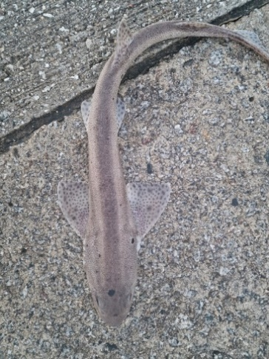  Scan_UK_2063 | - Hypermelanosis  - Multiple dark patches on head.
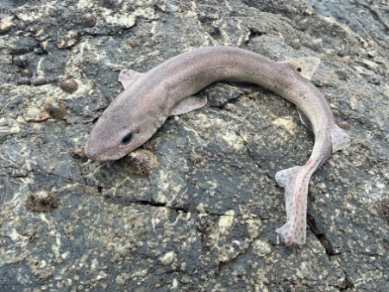  Scan_UK_2108 | - Hypermelanosis  - Dark spot on first dorsal fin.
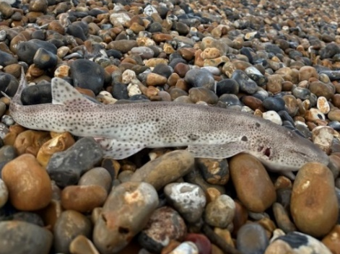  Scan_UK_2115 | - Hypermelanosis  - Multiple larger dark patches above the pectoral fin.
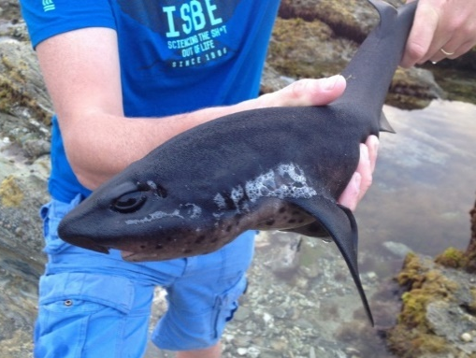  Sstel_UK_373 | - Melanistic nursehound with totally dark phenotype
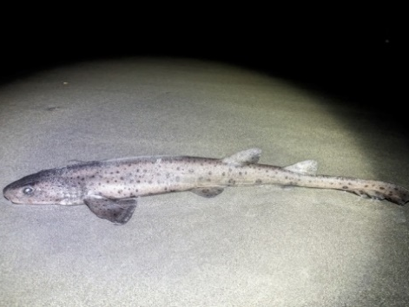  Sstel_UK_241 | - Hypermelanosis  - Darker pigmentation on pectoral fin, head and end of caudal fin.  - Could potentially be an effect of image quality.
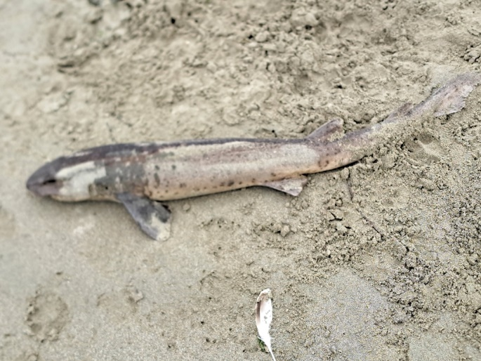
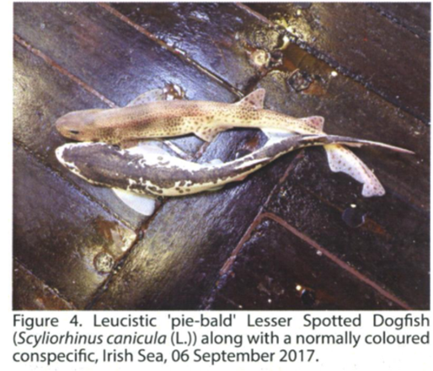

Fig. 1 Comparison between leucistic smallspotted catshark Scyliorhinus canicula observed in Welsh Inshore region (Scan_UK_1036; iNaturalist database) and piebald leucistic specimen found in Irish Sea (2017) as identified by Quigley et al. (2018). Both individuals show similar colouration patterns with reduced pigmentation on sides of head, flanks and caudal fin

