Supplementary information
In-situ electrosynthetic fabrication of highly crystalline, aqua-compatible palladium halide perovskite films for photoelectrocatalysis
Amogh K. Ravi¹, Anku Guha¹,Vaishali Arunachalam¹, Jagjit Kaur², Ponnappa Kechanda², Saurabh Kumar Singh¹, Neeraj Bhatt³, Aparna Shinde⁴, Ranjuna M. K.⁴, Ashish Arora⁴, Ravi Shankar Singh³, Pranav R. Shirhatti¹, Sudip Chackraborty², Tharangattu N. Narayanan¹*, Pabitra K. Nayak¹*
¹Tata Institute of Fundamental Research, 36/P, Gopanpally Village, Hyderabad 500046, India
²Harish-Chandra Research Institute (HRI), Chhatnag Road, Jhunsi, Allahabad 211019, India
³Indian Institute of Science Education and Research Bhopal, Bhopal Bypass Road, Bhauri
Bhopal 462066, Madhya Pradesh, India
⁴Indian Institute of Science Education and Research Pune, Dr. Homi Bhabha Road, Pashan, Pune 411008, India
Email: tnn@tifrh.res.in
Email: pabitra.nayak@tifrh.res.in
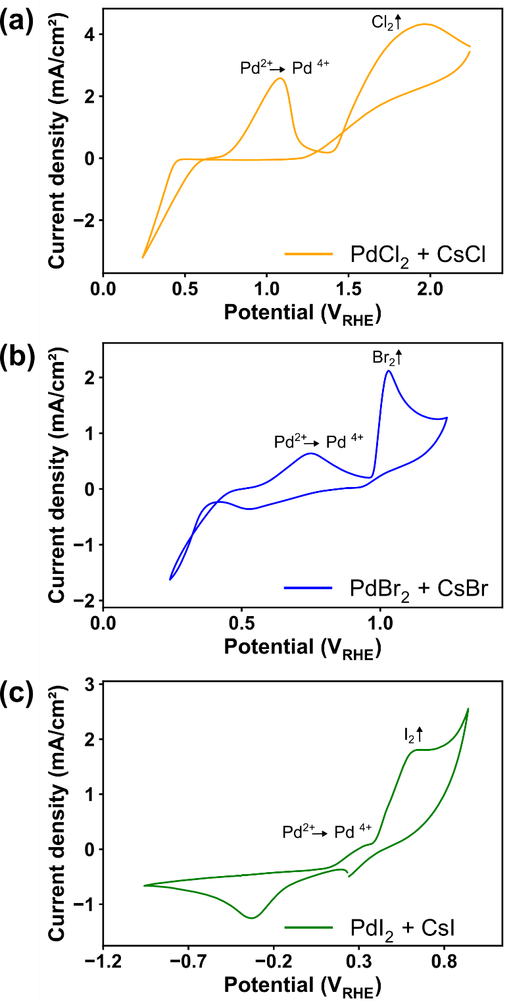

Figure S1: Cyclic voltammograms of PdX₂ and CsX in 0.5 M H₂SO₄ on FTO coated glass plates. Scan rate: 100 mV/s. Reference electrode: Saturated Calomel Electrode, Counter electrode: Graphite rod. Data is presented with respect to RHE.

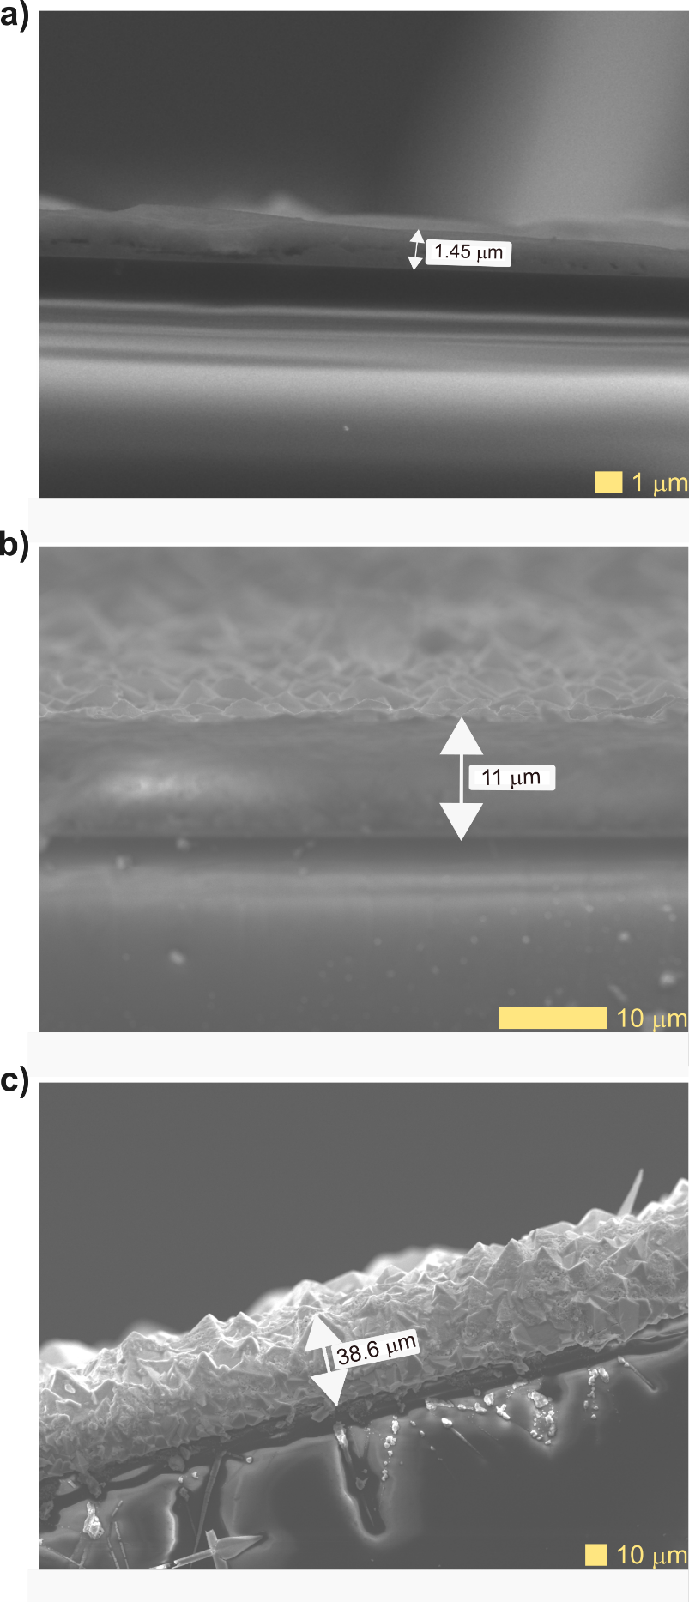

Figure S2: Cross-sectional SEM images of EPIC-Fab made Cs₂PdCl₆ films.

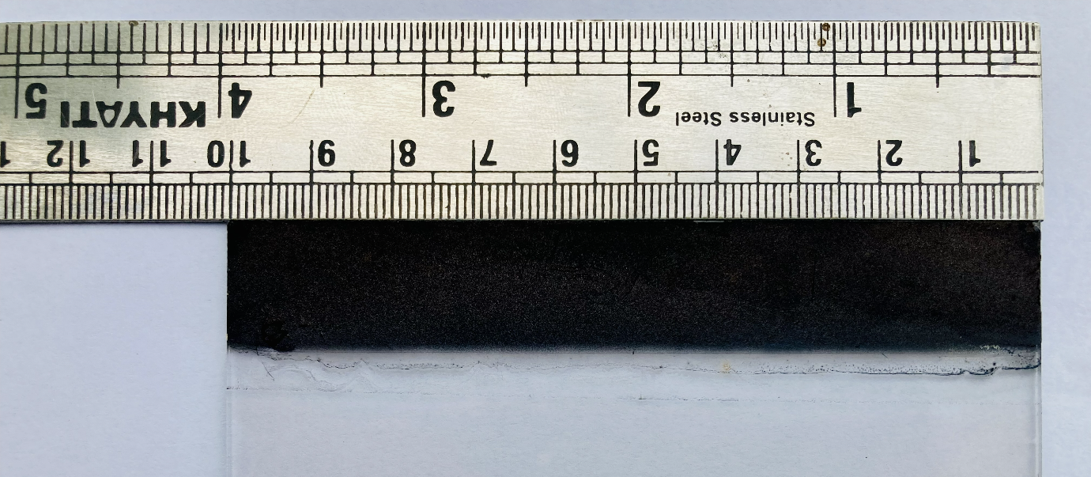
Figure S3: Photograph showing uniform large-area deposition of Cs₂PdCl₆ film on an FTO-coated glass substrate (1.5 cm $×$ 10 cm).

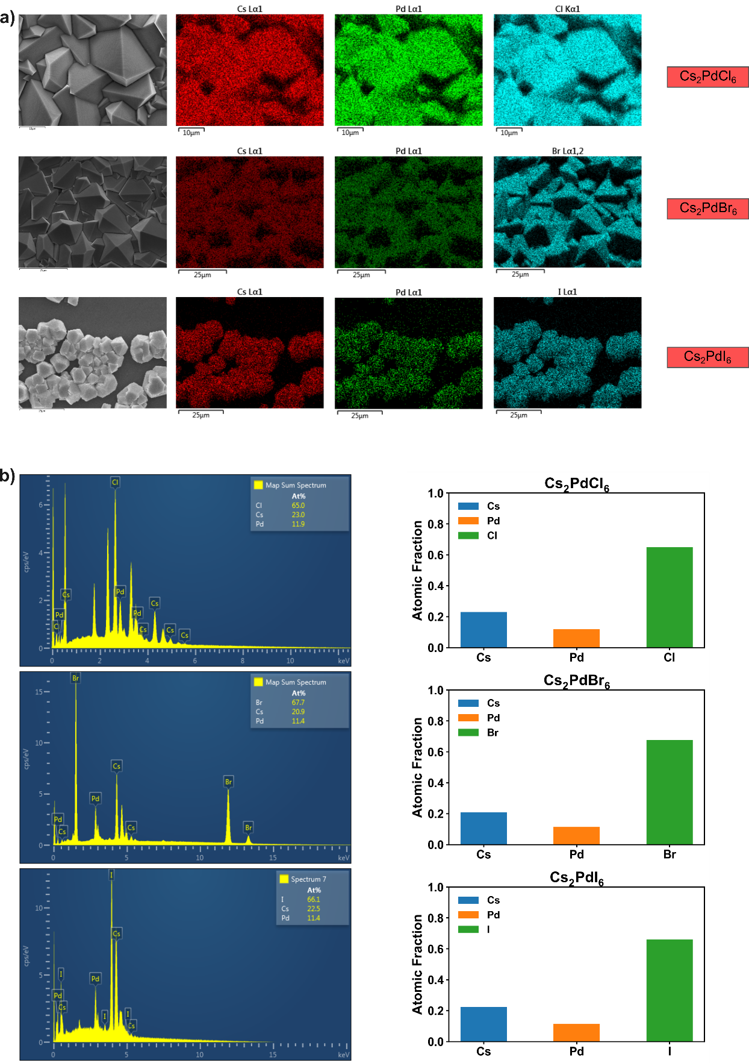

Figure S4: a) EDS maps and b) EDS spectra confirming the stoichiometry of the electrosynthesised Cs₂PdCl₆, Cs₂PdBr₆ and Cs₂PdI₆ . The spectra show the presence and relative proportions of the constituent elements, confirming the successful synthesis of the targeted perovskite compositions.

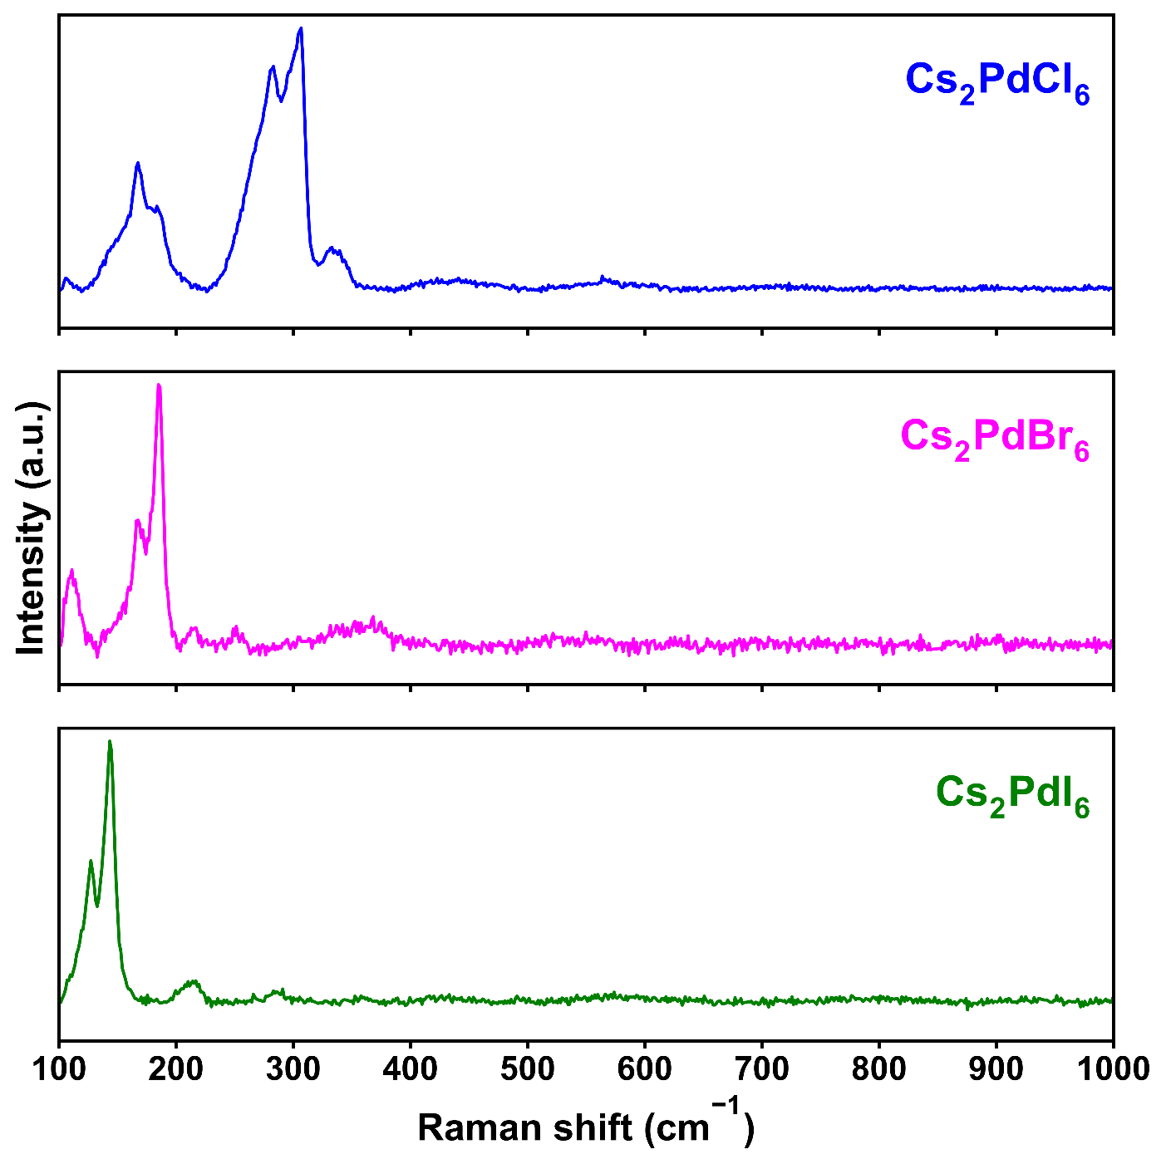
Figure S5: Raman spectra of EPIC-Fab deposited Cs₂PdCl₆, Cs₂PdBr₆, and Cs₂PdI₆ films.

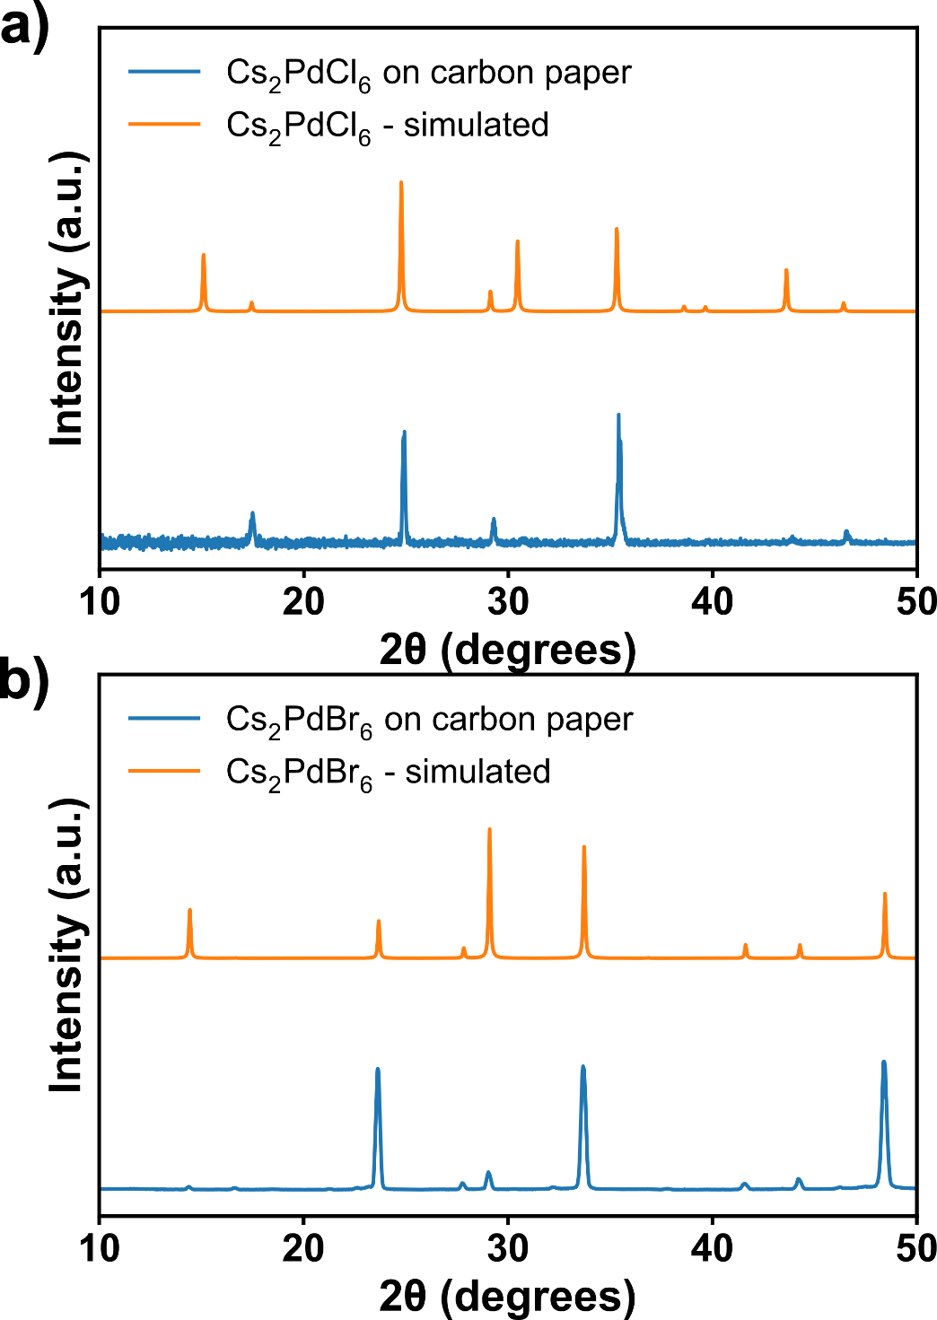
Figure S6: Powder XRD traces of Cs₂PdCl₆ and Cs₂PdBr₆ deposited on carbon paper.

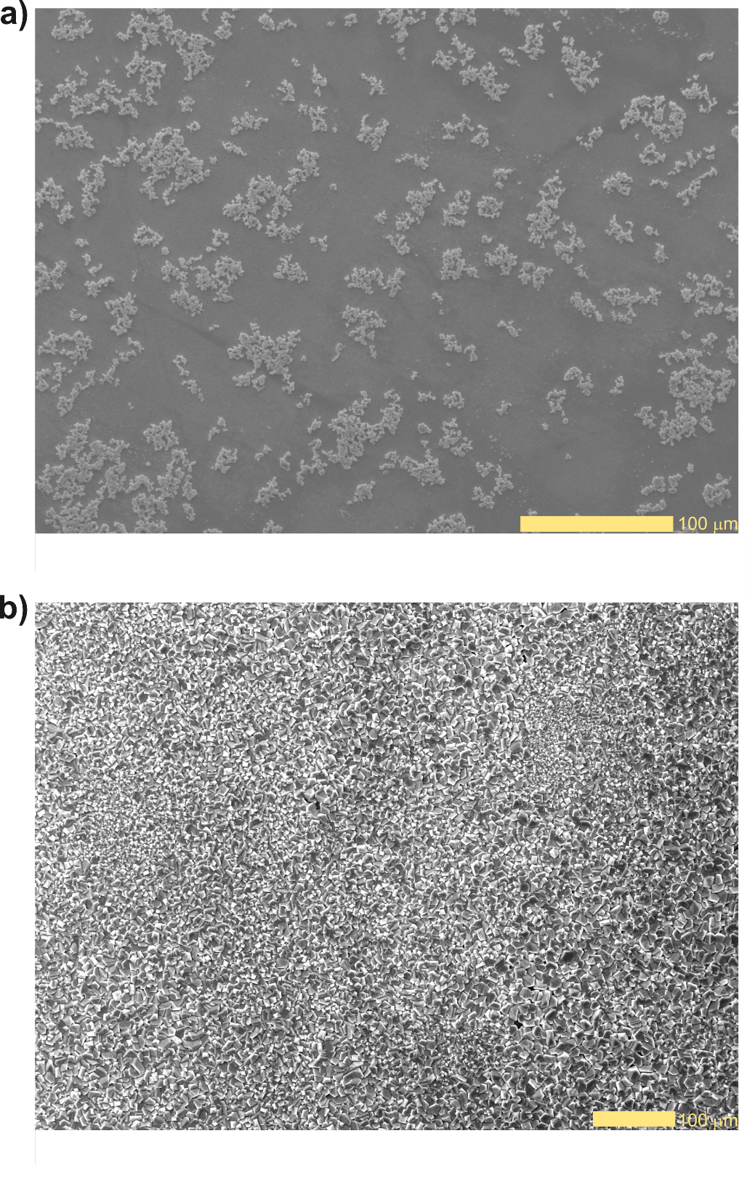
Figure S7: SEM images of Cs₂PdBr₆ films prepared by (a) spin casting a DMF dispersion onto a glass slide and (b) direct electrosynthesis and electrodeposition.

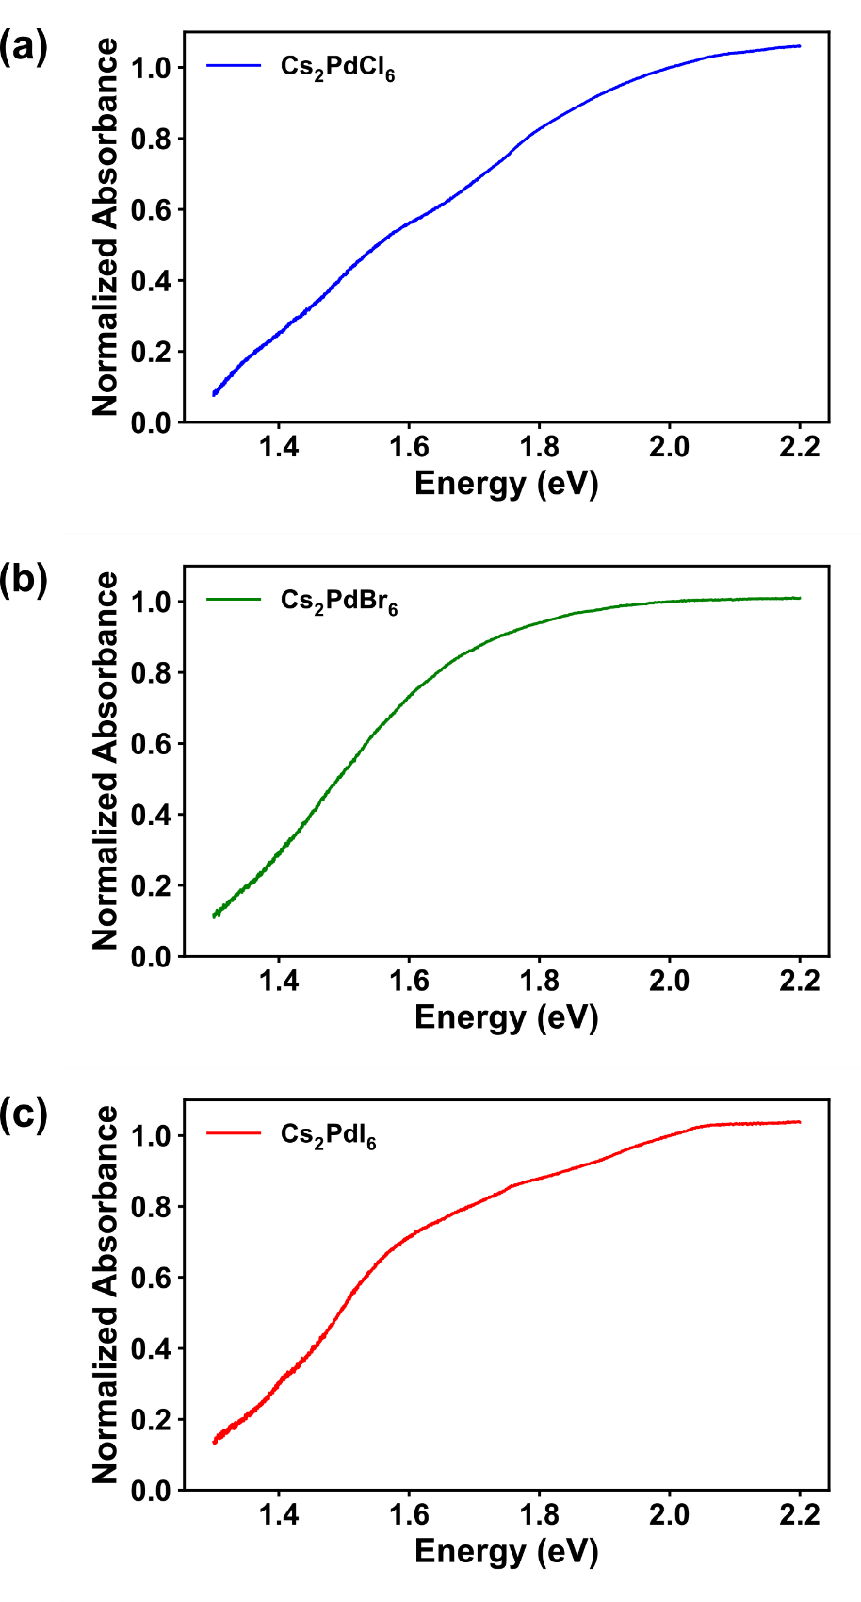

Figure S8: Normalized absorbance spectra of a) Cs₂PdCl₆, b) Cs₂PdBr₆ and c) Cs₂PdI₆.

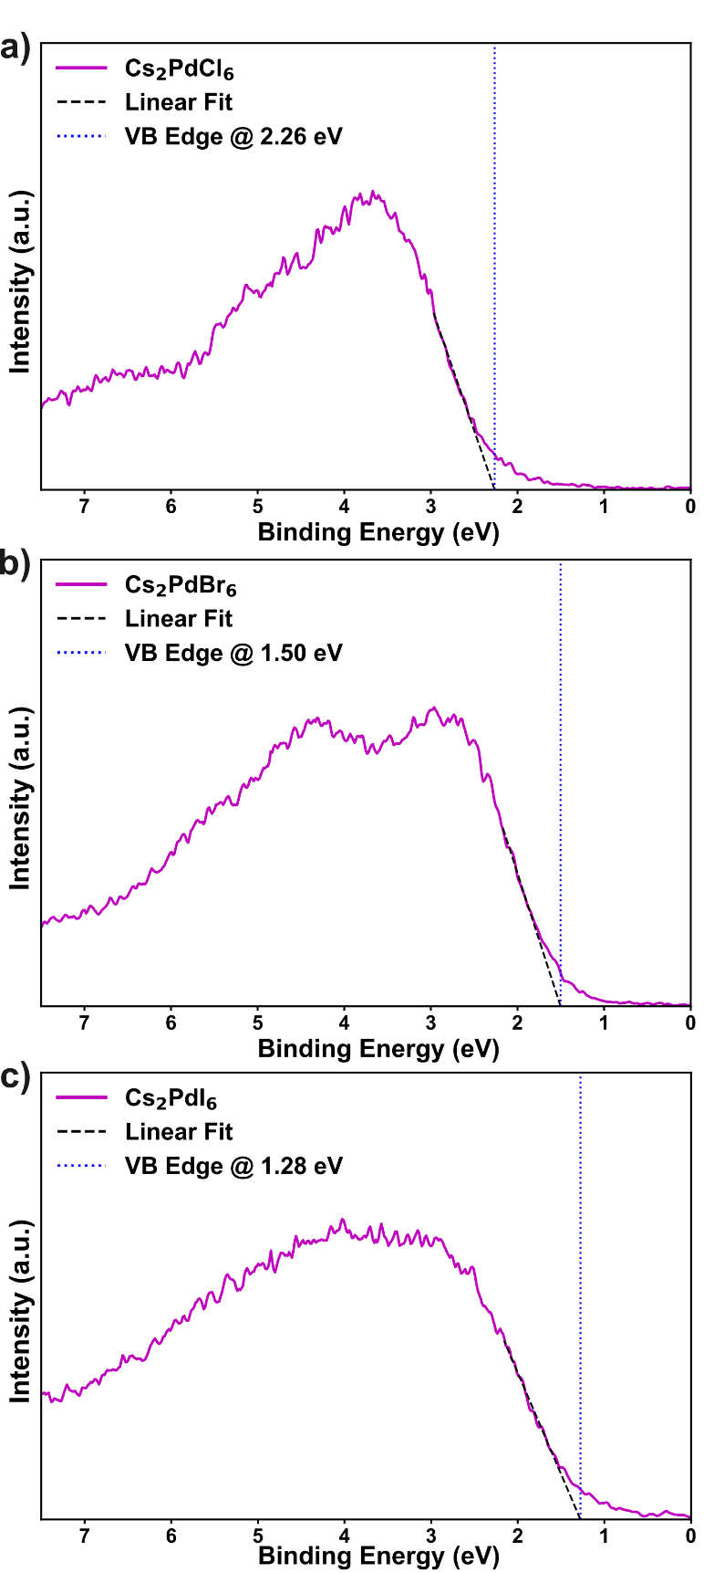

Figure S9: X-ray photoelectron spectroscopy (XPS) valence band spectra of electrosynthesised Cs₂PdX₆ (X = Cl, Br, I) compounds, used to determine the valence band edge positions with respect to the Fermi level.

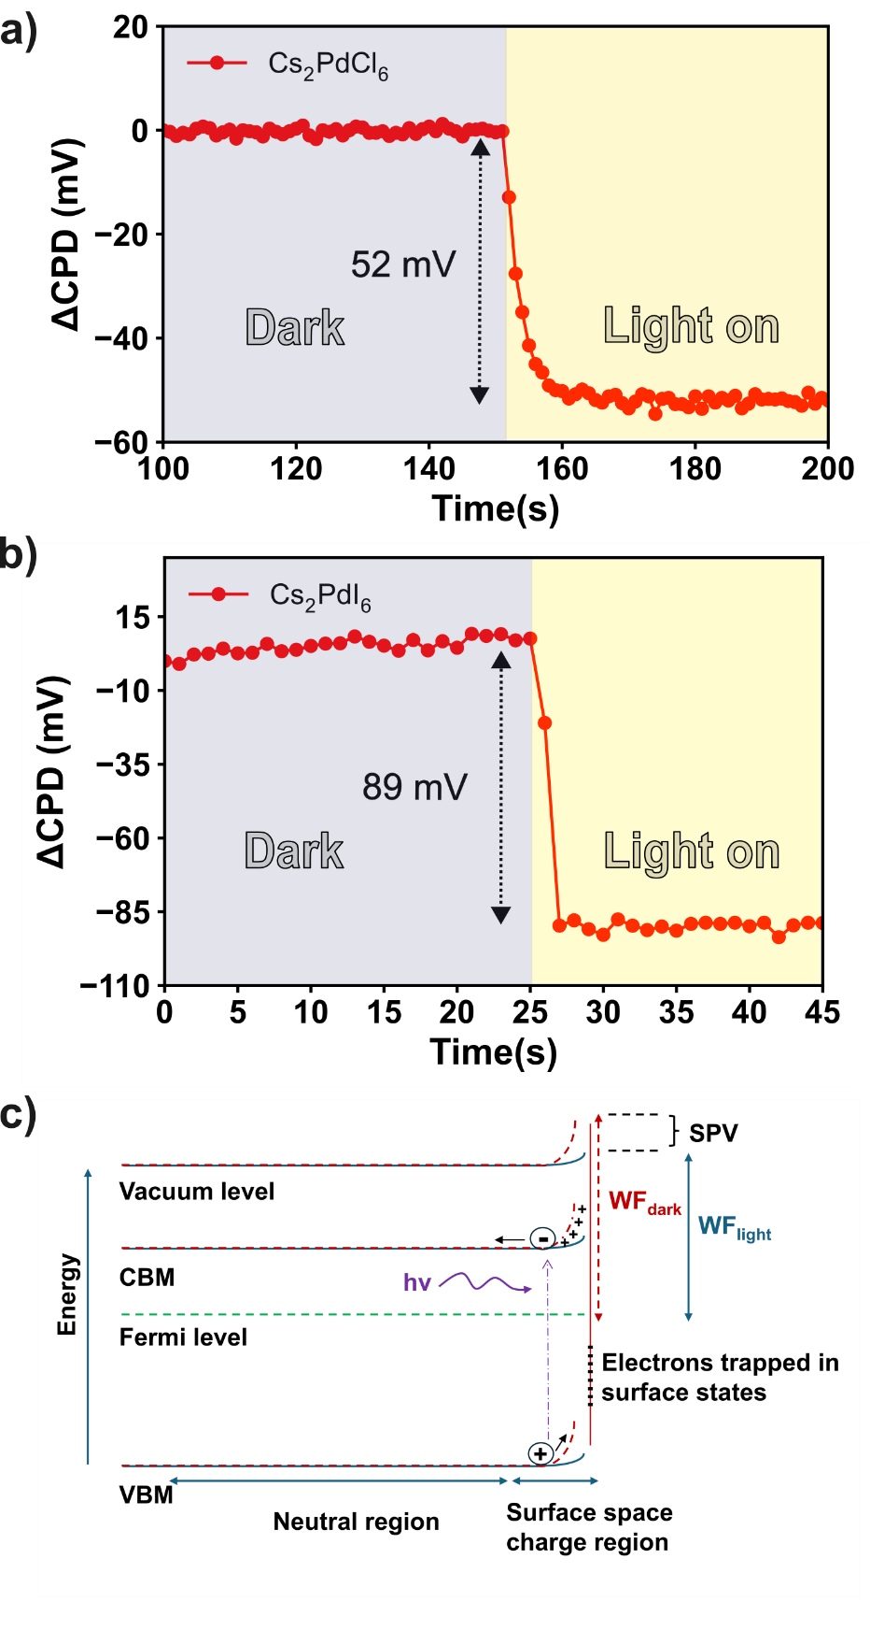

Figure S10: Surface photovoltage (SPV) response of Cs₂PdX₆ perovskite films: a) Cs₂PdCl₆ and b) Cs₂PdI₆. Panel (c) shows a schematic of the SPV mechanism for an n-type semiconductor wherein a decrease of work function upon illumination is observed.

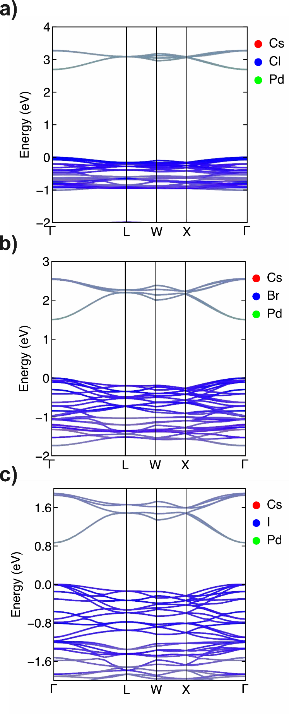

Figure S11: Band structures of Cs₂PdCl₆, Cs₂PdBr₆, and Cs₂PdI₆ calculated using the HSE06 hybrid functional with spin-orbit coupling (SOC).
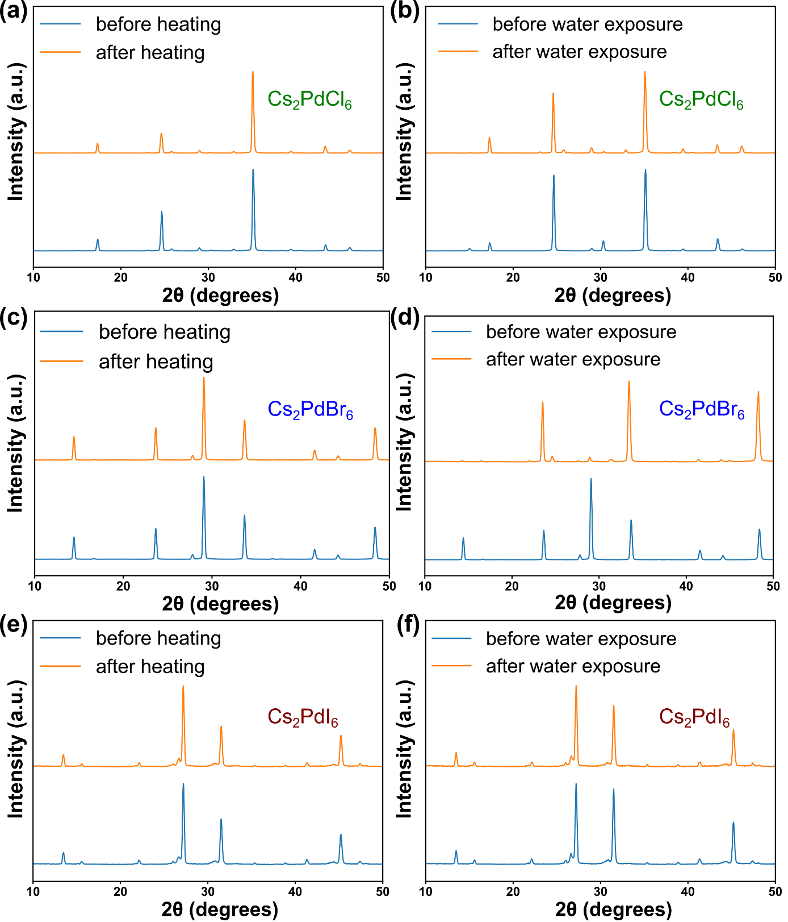

Figure S12: XRD plots of Cs₂PdX₆ films (X = Cl, Br, I) before and after exposure to water (1000 hours) and high temperatures (120ºC for > 300 hours), showing the excellent water and thermal stability of the VODPs.

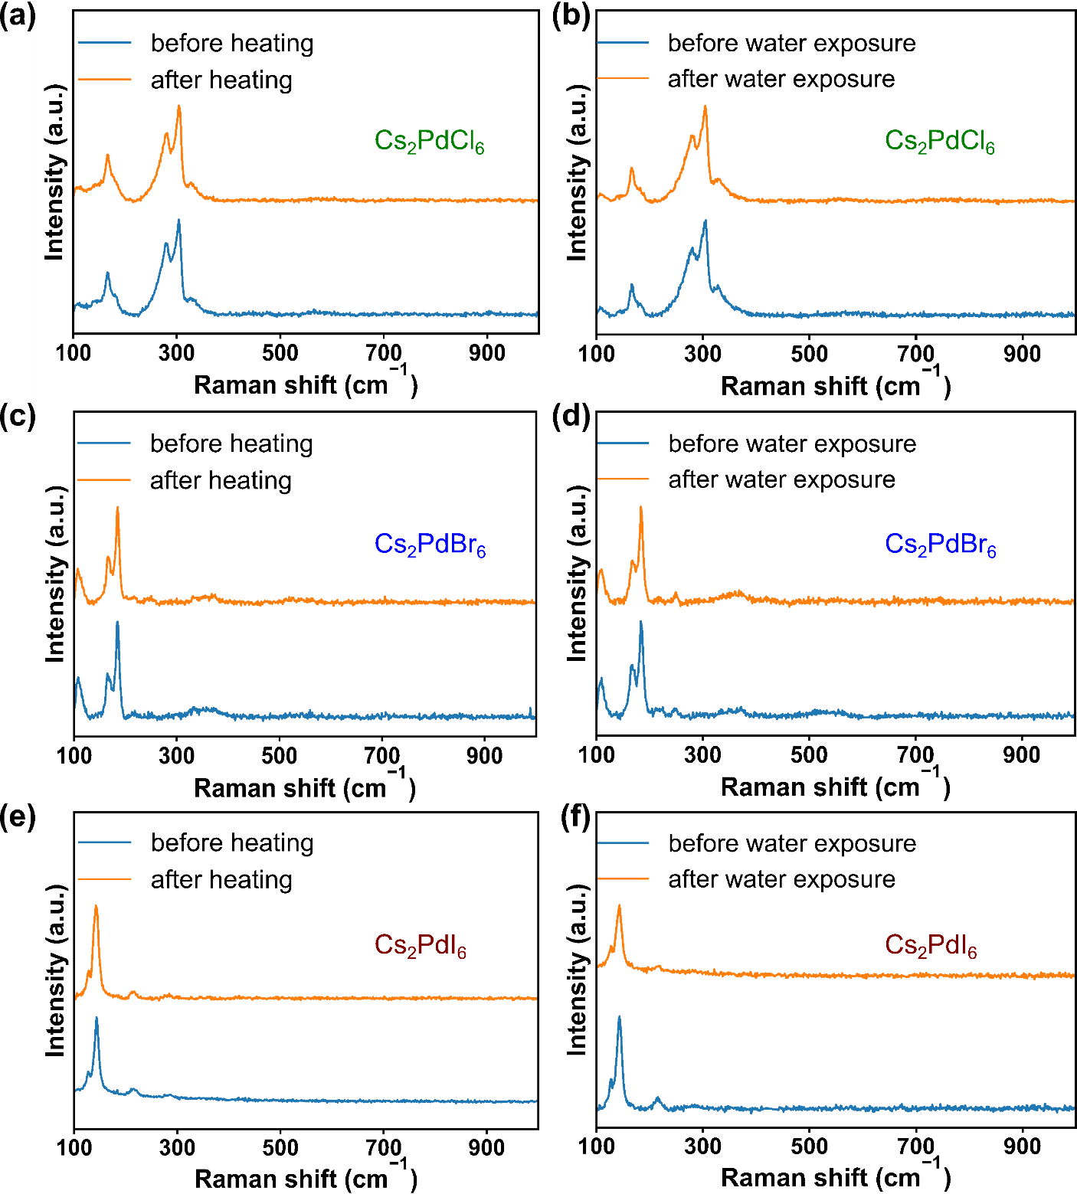
Figure S13: Raman spectra of Cs₂PdX₆ films (X = Cl, Br, I) before and after exposure to water (1000 hours) and high temperatures (120ºC for > 300 hours), showing the excellent water and thermal stability of the VODPs.

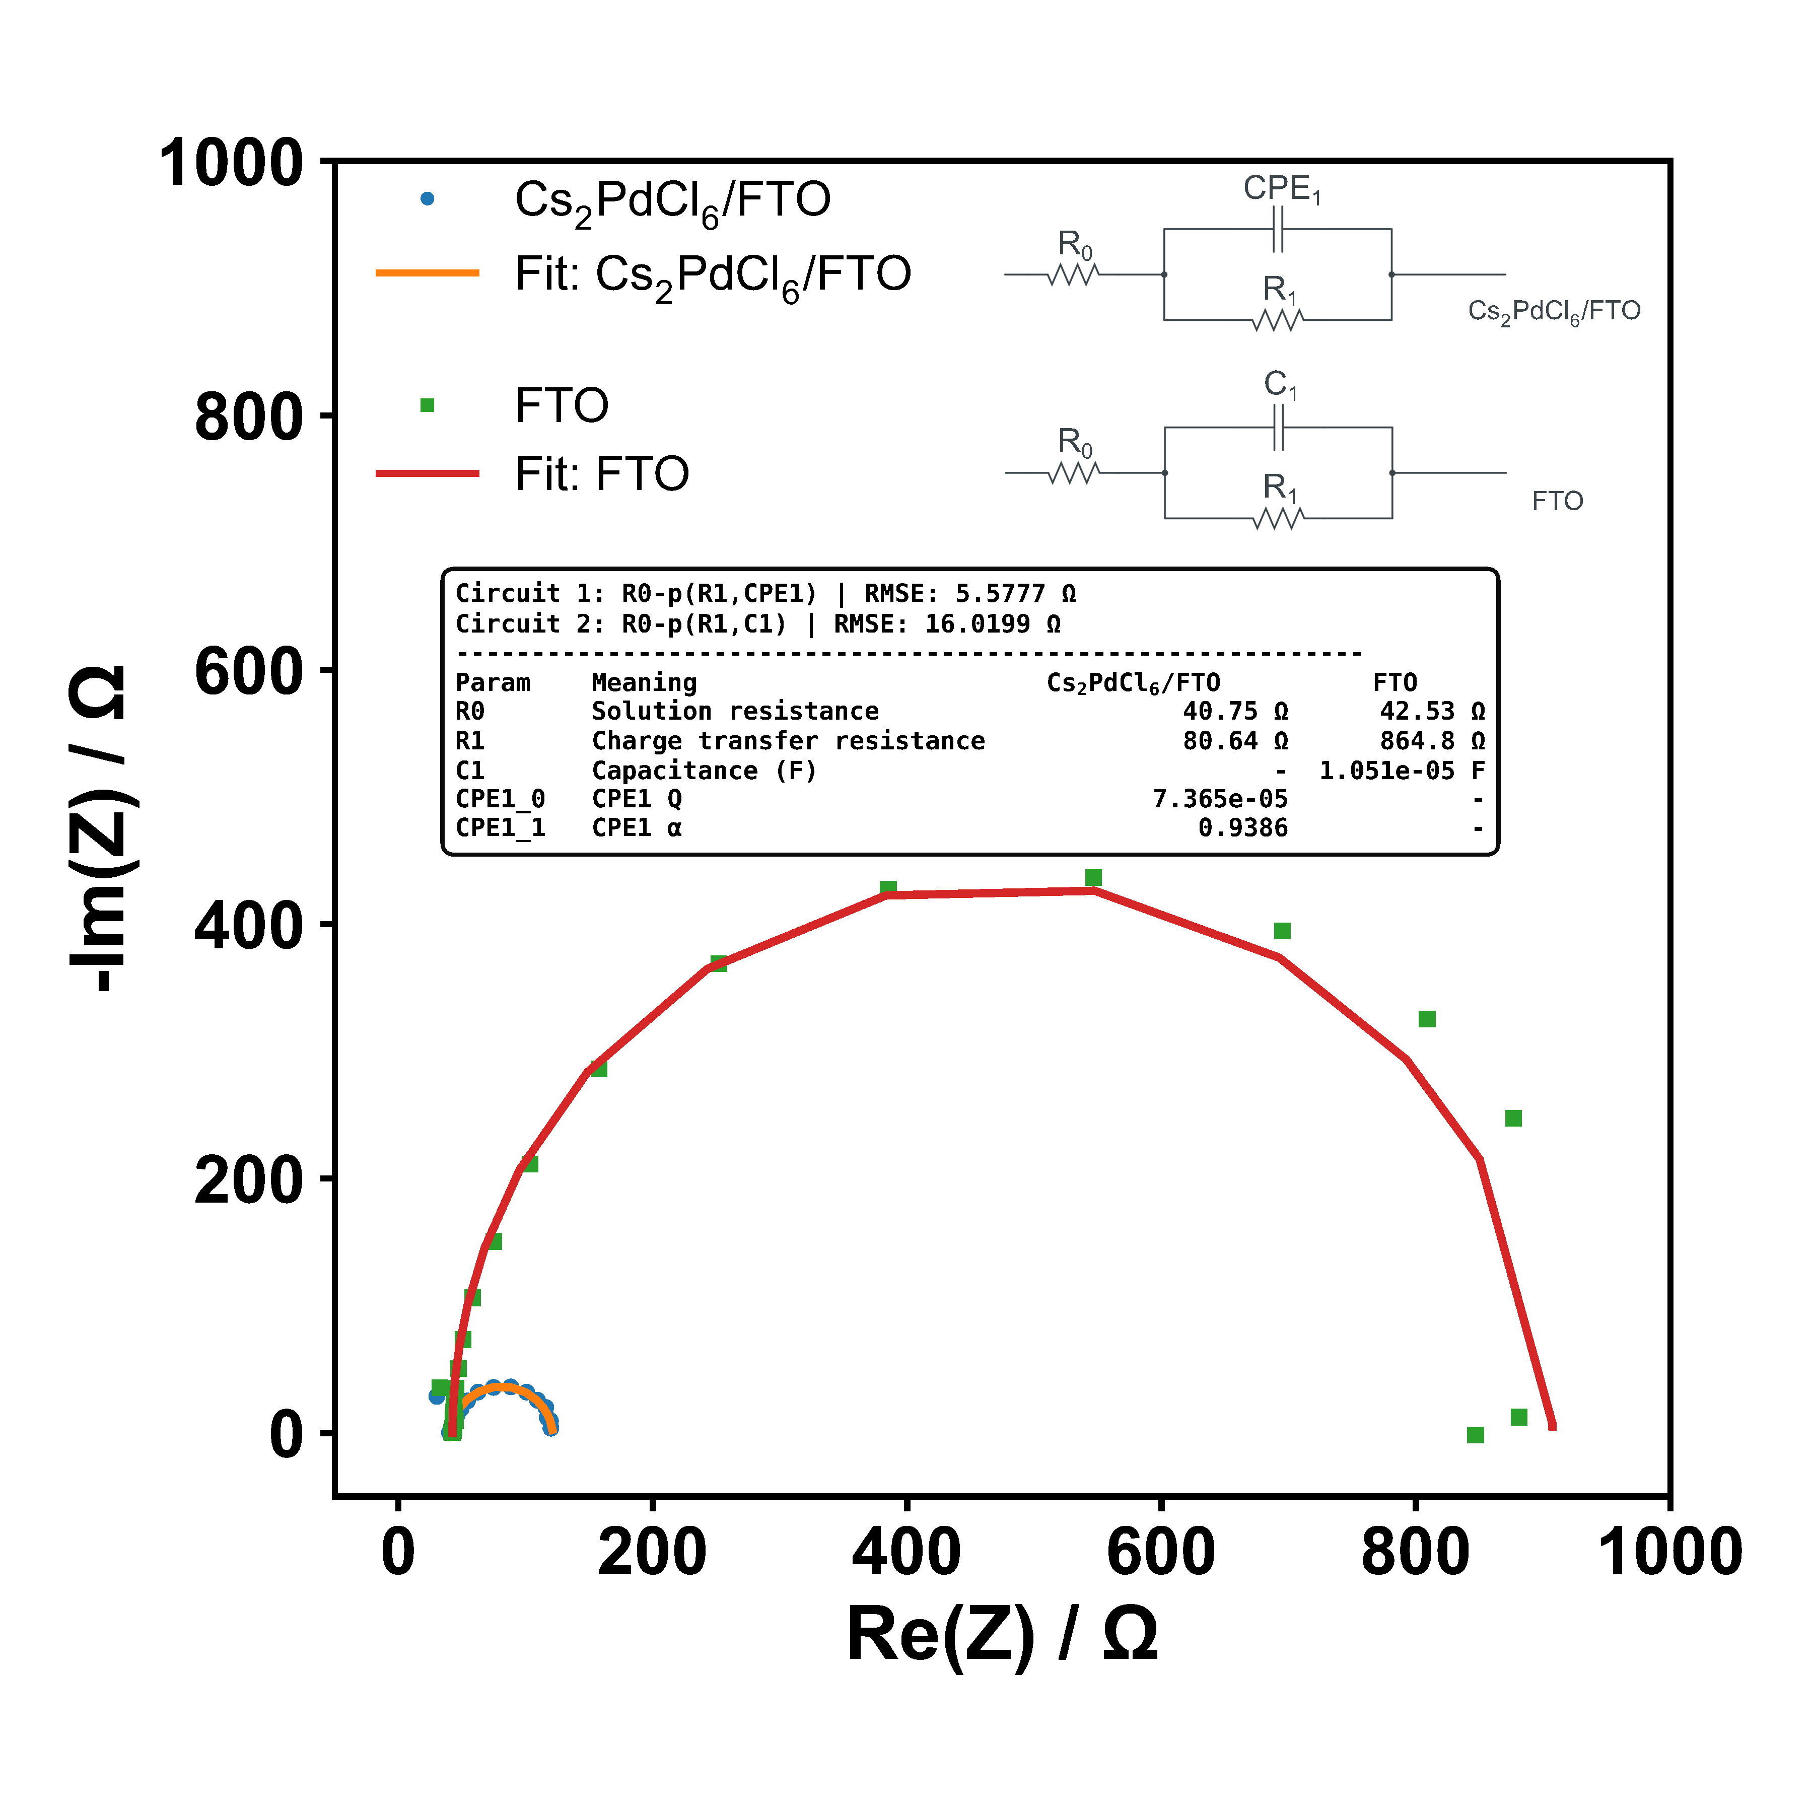
Figure S14: EIS Nyquist plots of FTO and Cs₂PdX₆ (X = Cl) coated FTO. Comparison reveals a significant reduction in charge transfer resistance coating FTO with Cs₂PdX₆ indicating faster charge transfer kinetics. Good electronic conductivities of Cs₂PdX₆ are evidenced by solution resistance values that are comparable to those of bare carbon paper, a well-known good conductor, clearly indicating that the VODP films themselves possess high intrinsic conductivity.

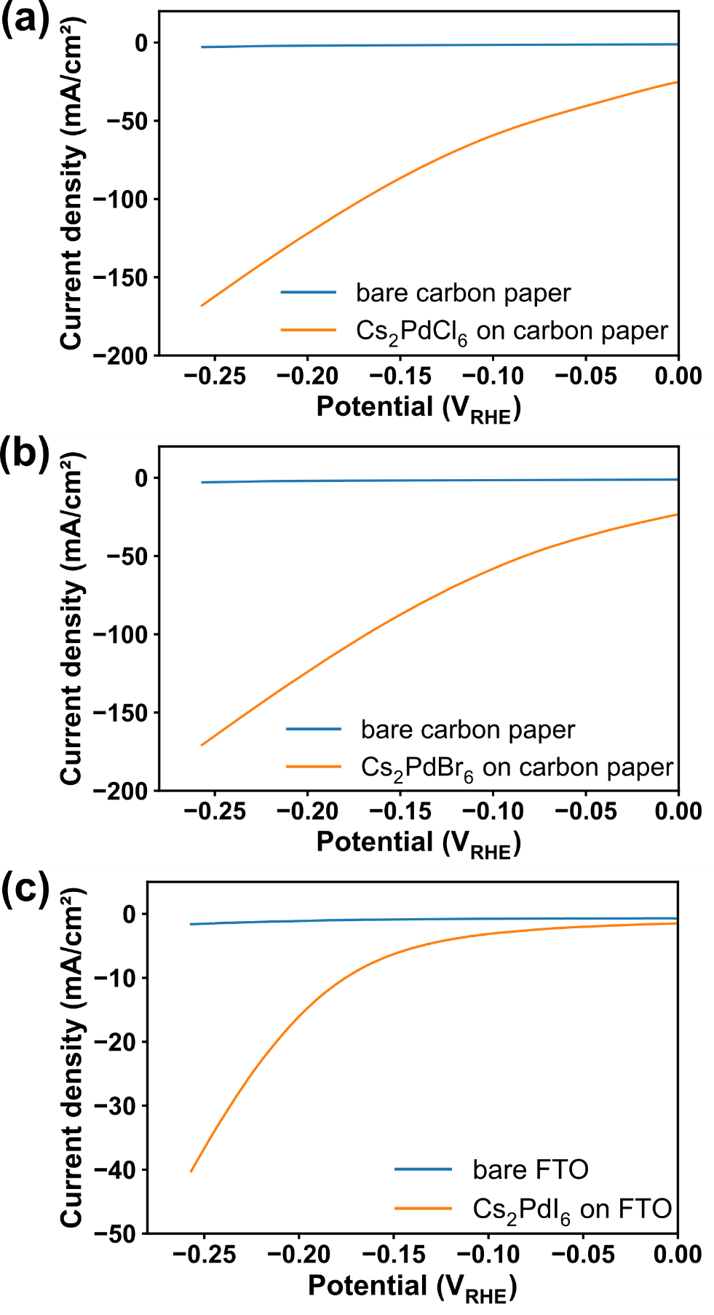
Figure S15: Linear Sweep Voltammetry (LSV) plots of Cs₂PdX₆ films (X = Cl, Br, I) deposited on conductive substrates, showing their electrocatalytic performance for hydrogen evolution.

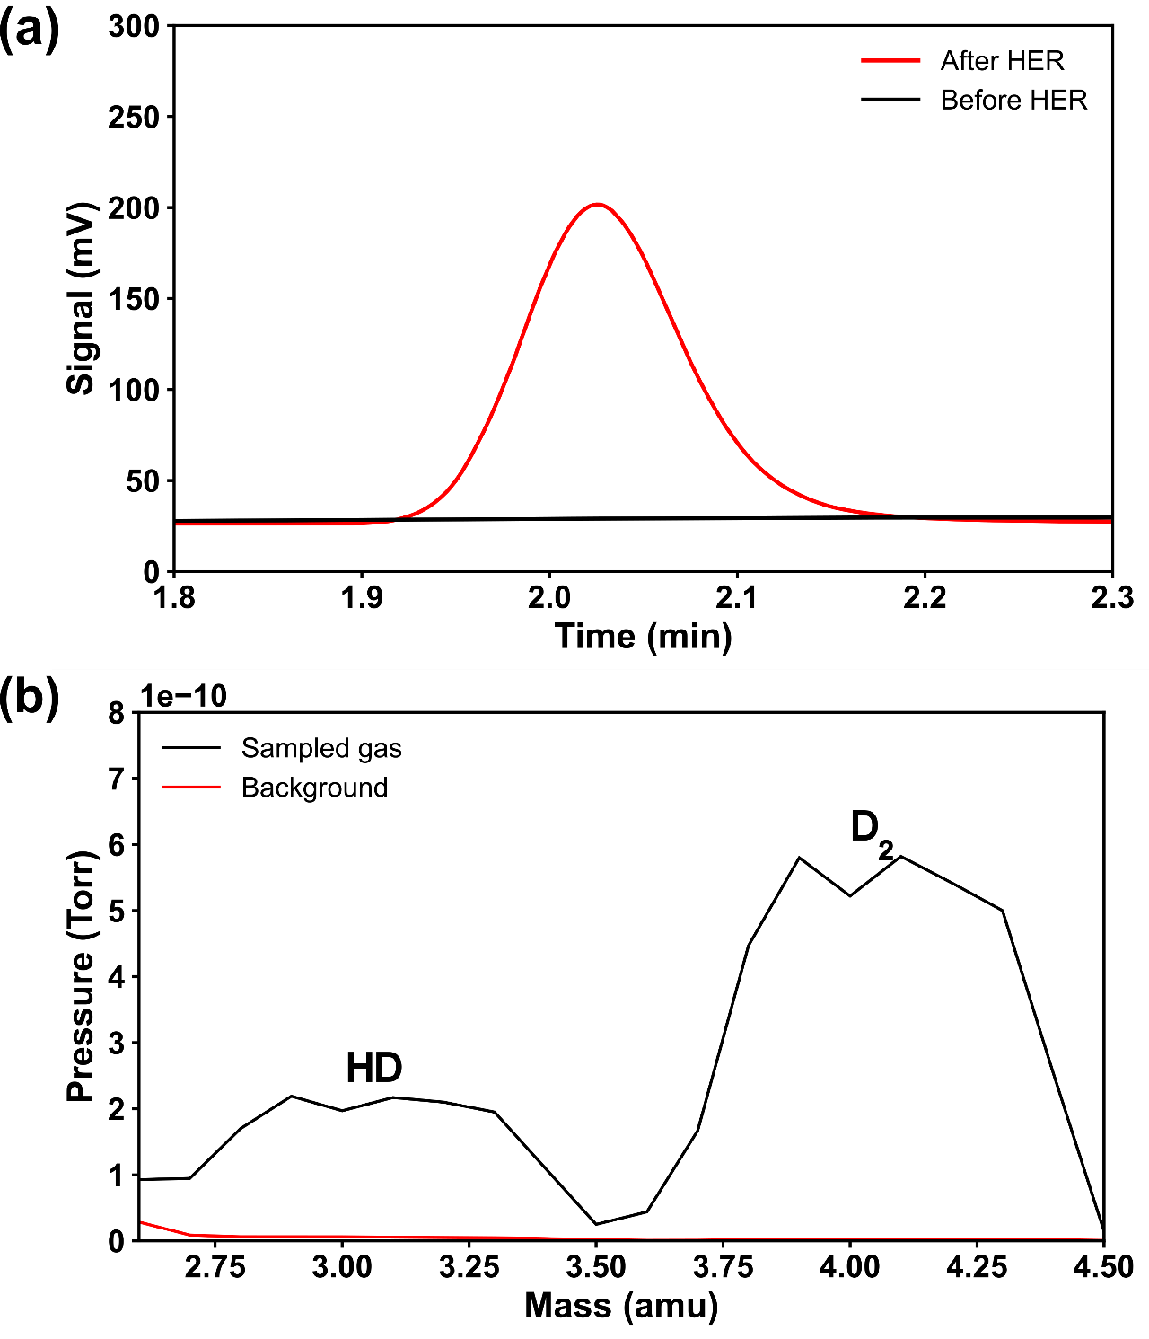

Figure S16: a) Gas chromatogram showing the detection of hydrogen produced during the HER, confirming successful hydrogen generation. b) Mass spectrometric detection of D₂ and HD gases by mass spectrometry following HER using deuterated water (D₂O) containing 0.5 M H₂SO₄.

S.1: Detection of D₂ and HD gases following HER using a quadrupole mass spectrometer:

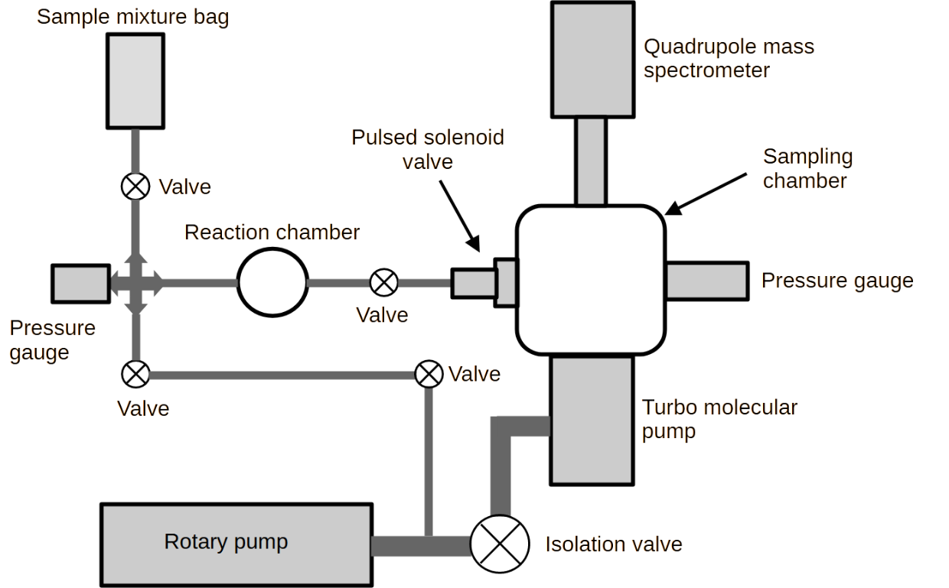

Supplementary Schematic S1: Schematic diagram of the experimental setup for mass spectrometric detection of D₂ and HD gases following HER using a quadrupole mass spectrometer.
S.1. The sample gas was collected from the HER cell into a Tedlar sample bag, which was then let into the sampling chamber in a controlled manner using an electronically controlled pulsed solenoid valve (Parker General Valve series 9). The gas entering the sampling chamber was analyzed using a quadrupole mass spectrometer (QMS - Stanford Research Systems RGA 200). The sampling chamber was pumped using a turbo molecular pump (Pfeiffer, HiPace 80) and backed by a rotary pump (Pfeiffer Duo 11). The sampling chamber base pressure is typically 1x10⁻⁷ mbar (solenoid valve off), and 1x10⁻⁵ mbar with the solenoid valve on.
HER measurements were carried out with the QMS operating in analogue scan mode over 1–65 amu (641 data points, 10 points per amu). A channel electron multiplier (CEM) was used to amplify the signals (-1560 V, gain 1.27 × 10⁴). The QMS was operated at 70 eV electron energy, high ion energy, 90 V focus voltage, and 1.0 mA filament current.
Before carrying out the measurements, the high-vacuum chamber (sampling chamber) was isolated, and the sample line was evacuated. Background HD and D₂ signals were recorded using a pulsed solenoid valve (130 µs, 20 Hz). After introducing the sample mixture, measurements were repeated, yielding clear HD and D₂ peaks in the mass spectra (c.f. Figure S15 b).

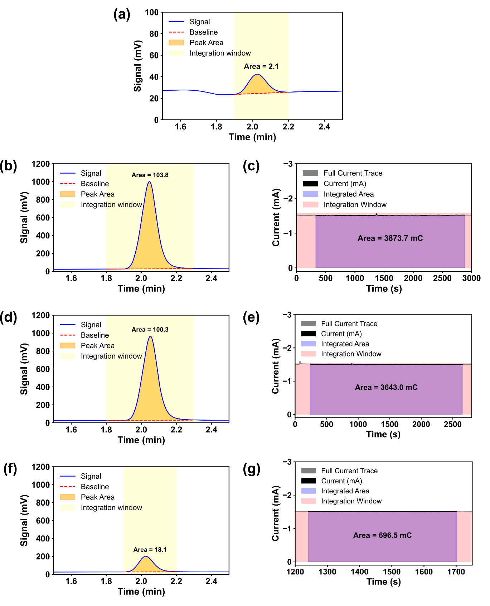
Figure S17: Faradaic efficiency calculation for hydrogen evolution. Panels (b,c), (d,e), and (f,g) represent three separate experimental measurements, each showing the integration of current and corresponding gas chromatogram signals. (b, d, f) shows the gas chromatography plots for hydrogen quantification, while the second panel (c, e, g) shows the charge calculation from the integration of the corresponding current–time plots.

Supplementary Note S2: Faradaic efficiency calculation:
We used a gas mixture containing 492 ppm of hydrogen for standardisation. With a headspace volume of 20 mL and an injection volume of 20 mL, we recorded the production of 19.0 µmol, 18.3 µmol and 3.3 µmol of hydrogen in three separate trials using a Thermo Scientific TRACE 1110 Gas Chromatograph. We used the charge estimated from the corresponding current-time transients to determine the amounts of hydrogen that would have been produced theoretically, which are 20.1 µmol, 18.9 µmol and 3.6 µmol respectively. Faradaic efficiency is then calculated using the following equation:

$$Faradaic efficiency =\frac{Number of moles of hydrogen produced experimentally}{Theoretically achievable number of moles of hydrogen }×100$$

We found the average value for the faradic efficiency as 94.4 %.

Supplementary Note 3: Efficiency calculation of light to hydrogen conversion:
We did the photoelectrochemical measurements in a solution of 0.5 M H₂SO₄ (pH = 0). A SOLIS-525C-High-Power LED, 525nm (green), 2.4 W was used as the light source. Cs₂PdX₆ on carbon paper or FTO on glass was used as the working electrode. This working electrode is biased to -0.5 V vs a Saturated Calomel Electrode (SCE). The working electrode was placed at an appropriate distance from the light source where light power density is 100 mW/cm² (measured by Newport Power Meter (Model 843-R)) at the working electrode.
We measured the current density under the illuminated and dark conditions, and the difference was converted into the output power density and then the efficiency, using the following equation:

$$Efficiency=\frac{\left[\frac{current density}{n×F}\right]×∆G_{ hydrogen}}{light power density}×Faradic efficiency$$
Where,
- current density – the current density measured during the reaction, using chronoamperometry.
- n – number of moles of electrons involved in the formation of one mole of hydrogen gas = 2.
- F- charge corresponding to one mole of electrons = 96485 C.
- ΔG _{hydrogen} – Gibbs free energy associated with the formation of one mole of hydrogen = 237 kJ/mol.
- Faradaic efficiency – the percentage of the supplied electrical charge used for the hydrogen evolution reaction, calculated as the ratio of the number of moles of hydrogen determined using gas chromatography to the number of moles of hydrogen corresponding to the supplied charge = 94.4%

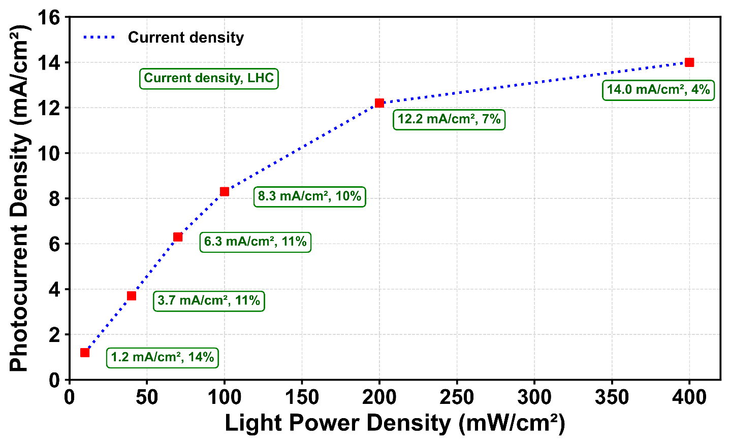
Figure S18: Light-to-hydrogen conversion efficiency (LHC) and the photocurrent density as a function of light power density for Cs₂PdI₆/FTO, during the photoelectrochemical HER.

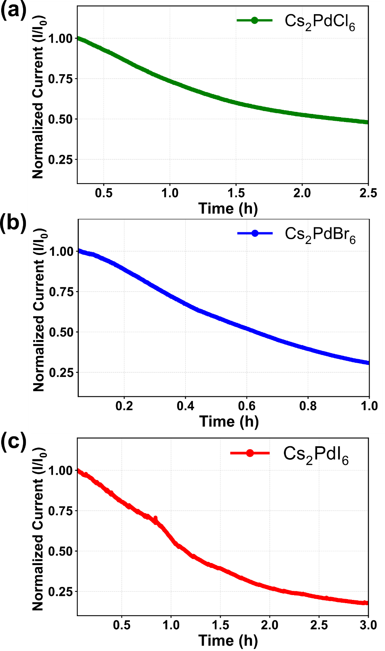

Figure S19: Chronoamperometric plots of current versus operational time during the electrochemical hydrogen evolution HER in the dark.

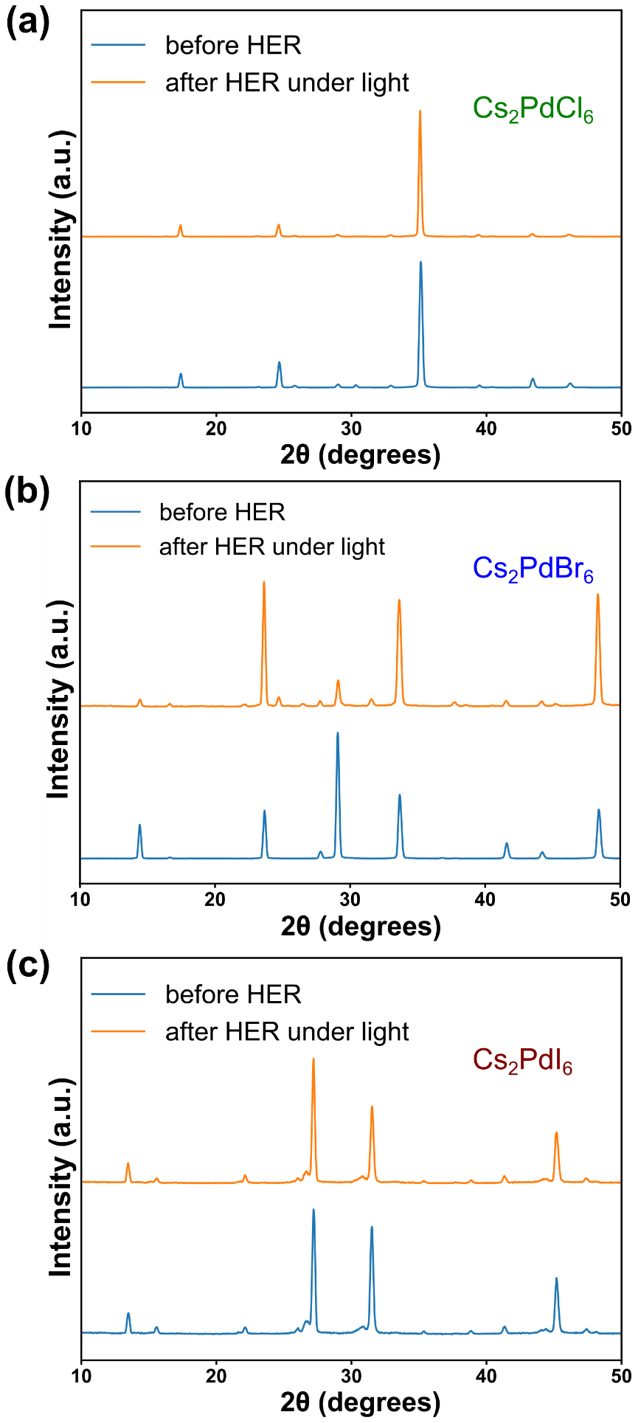

Figure S20: XRD traces of Cs₂PdCl₆, Cs₂PdBr₆, and Cs₂PdI₆ films before and after photoelectrochemical hydrogen generation under illumination.
Supplementary Table S1: Inductively Coupled Plasma Optical Emission Spectroscopy (ICP-OES) measurements of Pd and Cs concentrations in samples after photoelectrochemical HER conducted under light and under dark.
S.No. | Sample description | Concentration of Pd in ppm
1 | Solvent system | Not detected
2 | After HER in dark | 17.44
3 | After HER in light | Not detected

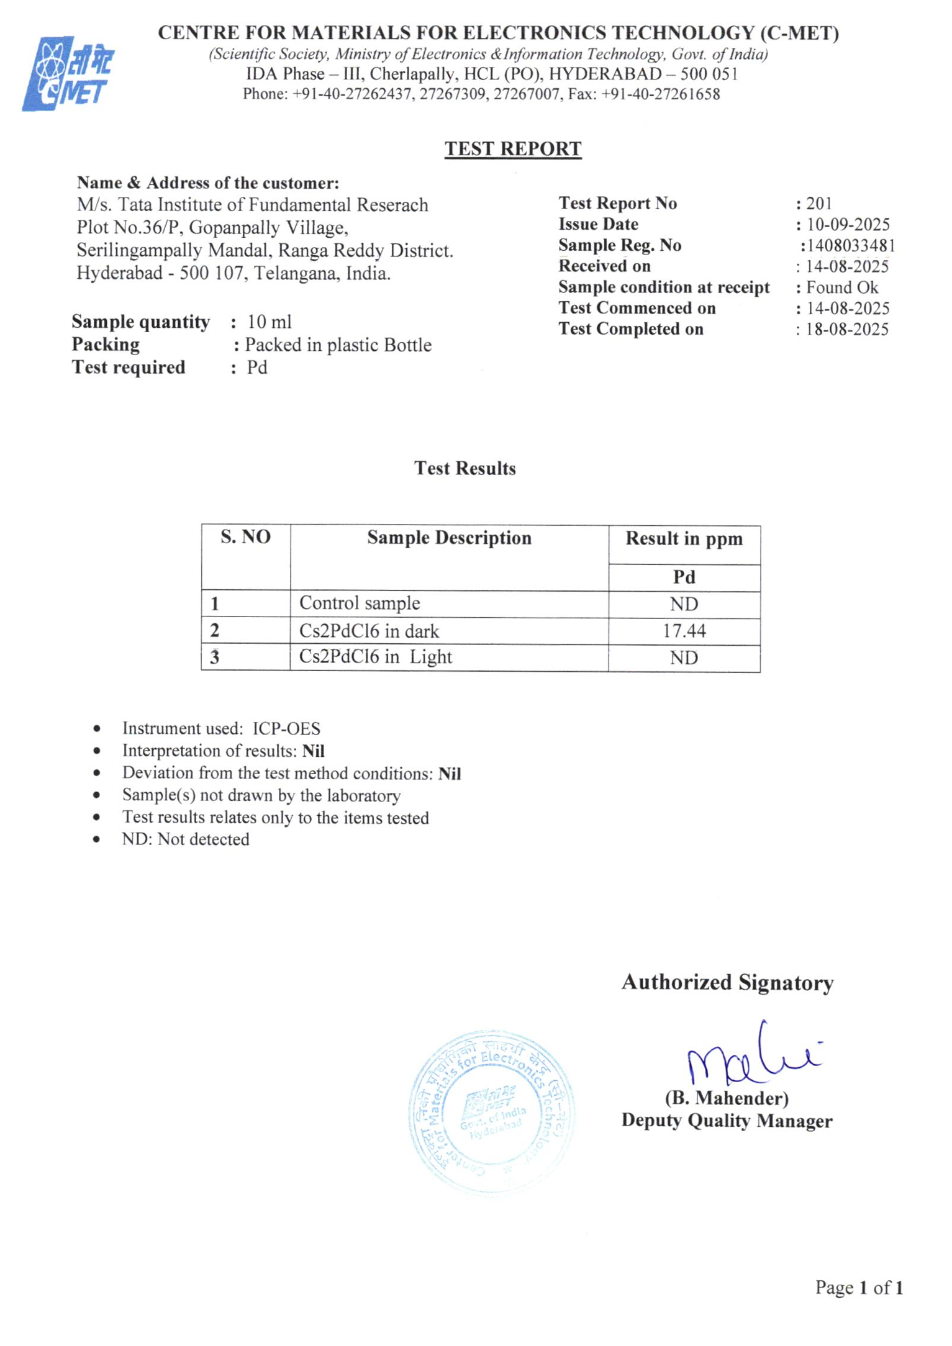

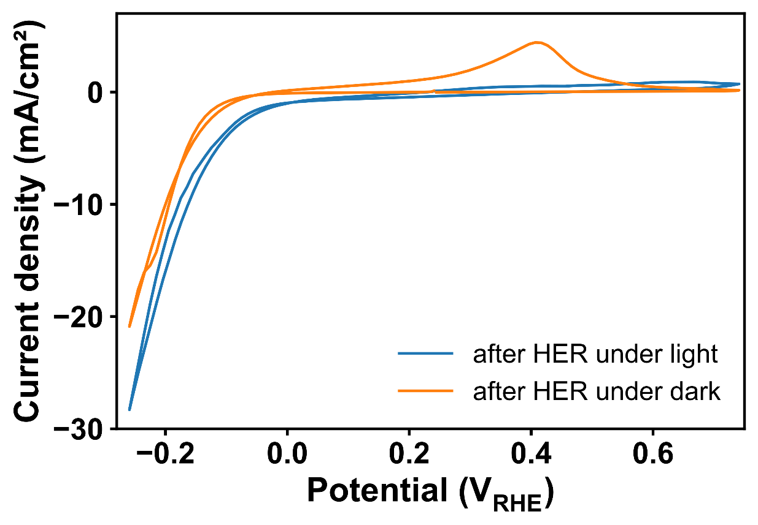
Figure S21: Cyclic voltammogram of Cs₂PdI₆ recorded in 0.5 M H₂SO₄ at 5 mV/s under light and in dark.

