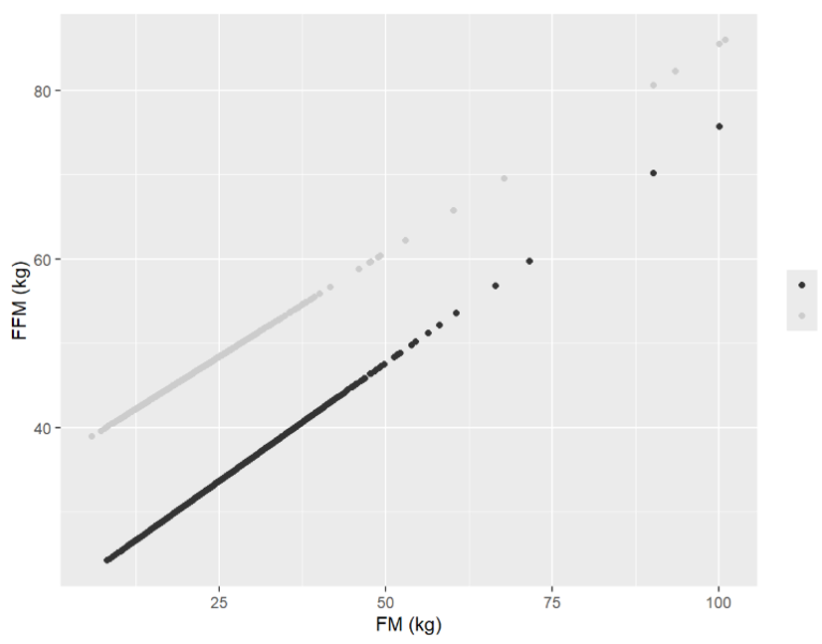
Women
Men
Supplementary Figure 1: Predicted fat-free mass values ​​according to fat mass and sex to define sarcopenia by the new criterion
FFM: fat-free mass; FM: fat mass

