Table S1 Glossary of Technical Terms and Definitions
Weaning success:No reinitiation of circulatory support or respiratory support is required within 48 hours following discontinuation of ECMO therapy.
Hospital Infection:infections acquired during hospitalization, including those that occur during the hospital stay and those acquired in the hospital but manifest after discharge.
Gastrointestinal bleeding(GI bleeding): Gastrointestinal bleeding refers to bleeding occurring anywhere within the digestive tract, spanning from the esophagus to the rectum.
Caloric goal: Enteral nutrition should be initiated as early as clinically feasible following hospital admission, with a caloric goal of achieving 70% of the target requirement within the first week
AKI Occurrence: AKI Occurrence was defined as acute kidney injury occurred within 72hours after ICU admission.
AKI recovery: The patient had pre-existing acute kidney injury (AKI) prior to ICU admission. Renal function returned to normal following treatment.

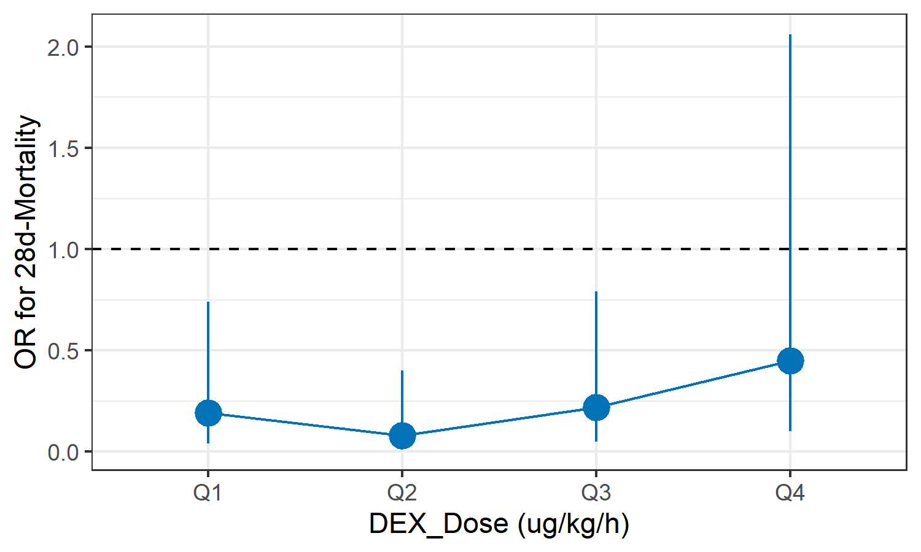
Figure S1 Relationship Between Different Dexmedetomidine Doses (Quartiles) and 28-Day Mortality

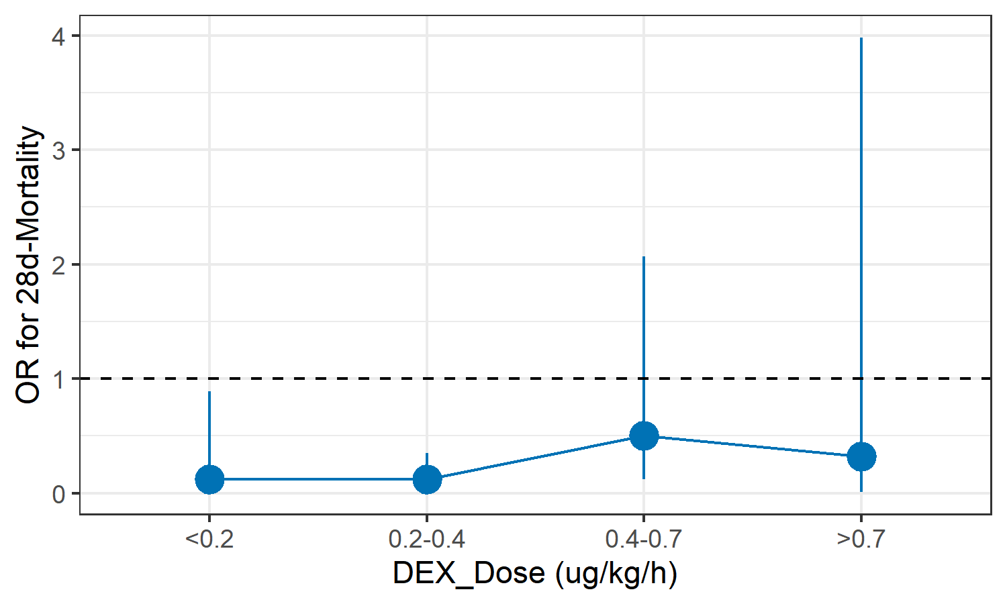
Figure S2 Relationship Between Different Dexmedetomidine Doses and 28-Day Mortality

Table S2 Long-term prognosis in the DEX group versus the non-DEX group in survivors
Outcome | Non-DEX (n=21) | DEX (n=36) | Crude model |  | Adjusted model
Outcome | Non-DEX (n=21) | DEX (n=36) | MD (95% CI) | P-value | MD (95% CI) | P-value
Depression score | 63.00 (51.00, 69.00) | 56.00 (42.50, 64.25) | -4.52 (-12.58, 3.54) | 0.223 | -5.28 (-15.44, 4.87) | 0.316
Anxiety score | 46.00 (43.00, 64.00) | 44.00 (37.00, 54.50) | -5.71 (-13.96, 2.55) | 0.108 | -0.30 (-0.97, 0.37) | 0.316
PSQI | 9.00 (4.00, 13.00) | 4.50 (3.00, 10.50) | -1.82 (-4.70, 1.06) | 0.127 | -6.73 (-16.46, 3.00) | 0.094
TICS | 19.00 (14.00, 25.00) | 24.00 (19.00, 26.00) | 2.96 (-0.50, 6.43) | 0.092 | -0.49 (-1.22, 0.23) | 0.289
QoL | 0.85 (0.59, 0.94) | 0.94 (0.81, 1.00) | 0.14 (-0.03, 0.31) | 0.072 | -0.15 (-3.52, 3.21) | 0.790
Abbreviations: PSQI, Pittsburgh Sleep Quality Index ; TICS, Telephone Interview for Cognitive Status ; EQ-5D-5L EuroQol Five-Dimensional Five-Level Questionnaire.

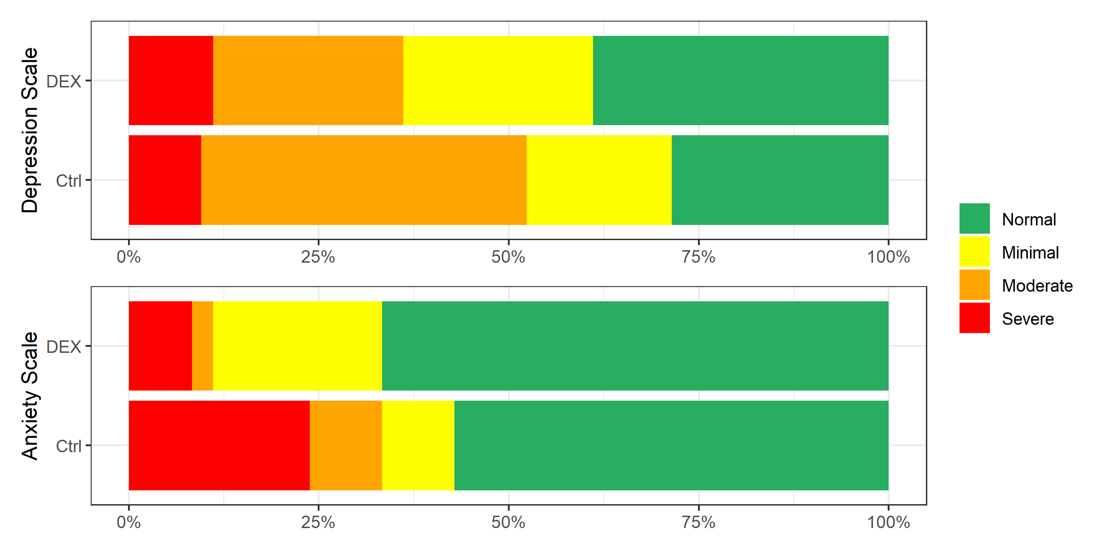
Figure S3 Distribution of Depression Severity Levels as well as Anxiety Severity Levels between DEX and non-DEX groups among survivors

