Supplementary material

Sensitivity and elasticity analysis
To evaluate the effect of parameter values on R₀, we performed a sensitivity and elasticity analysis (Matser et al., 2009). The sensitivity and elasticity of R₀ to a given parameter indicate how a change in that parameter affects R₀, with elasticity offering the advantage of being a relative measure. Elasticity values can be compared when the parameters have different scales. The sensitivities and elasticities are computed numerically using the package popbio in R (Stubben & Milligan, 2007), with the values provided in Table 1. The next generation matrix (NGM) K_{L} of the model without intervention is used to calculate the numerical value of R₀. The NGM is computed following (Diekmann et al., 2010) as $K_{L}\text{=-}T Σ^{\text{-}1}$, with
$$T=\left(\begin{matrix}0 & 0 & 0 & 0 & 0 & 0 & 0 & kp_{C} \\ 0 & 0 & 0 & 0 & 0 & 0 & 0 & 0 \\ 0 & 0 & 0 & 0 & 0 & 0 & 0 & 0 \\ 0 & 0 & 0 & 0 & 0 & 0 & 0 & 0 \\ 0 & 0 & 0 & 0 & 0 & 0 & 0 & 0 \\ 0 & 0 & 0 & 0 & 0 & 0 & 0 & 0 \\ 0 & 0 & 0 & 0 & 0 & 0 & 0 & 0 \\ 0 & 0 & 0 & kp_{VS}\frac{N_{V}}{N_{C}} & kp_{VS}\frac{N_{V}}{N_{C}} & kp_{VS}\frac{N_{V}}{N_{C}} & kp_{VA}\frac{N_{V}}{N_{C}} & 0\end{matrix}\right)$$
And
$$Σ=\left(\begin{matrix}-a & 0 & 0 & 0 & 0 & 0 & 0 & 0 \\ ap_{S} & -γ & 0 & 0 & 0 & 0 & 0 & 0 \\ a{(1-p}_{S}) & 0 & -γ & 0 & 0 & 0 & 0 & 0 \\ 0 & γ & 0 & -b & 0 & 0 & 0 & 0 \\ 0 & 0 & γ & 0 & -τ_{CA} & 0 & 0 & 0 \\ 0 & 0 & 0 & bp_{D} & 0 & -α & 0 & 0 \\ 0 & 0 & 0 & b(1-p_{D}) & 0 & 0 & -τ_{CS} & 0 \\ 0 & 0 & 0 & 0 & 0 & 0 & 0 & -τ_{V}-μ\end{matrix}\right)$$

The elasticity and sensitivity analyses show that the biting rate k, the probability of infection for cattle upon a bite p_{C}, and the vector-to-host ratio (N_{V}/N_{C}) have the largest effect on R₀ (without intervention) (Figure S1). We chose parameter values in a best-case scenario, with a biting rate and vector-to-host ratio in the low range of reported estimates (Sanz-Bernardo et al., 2021; Vergne et al., 2021). Thus, the transmission dynamics are likely underestimated.
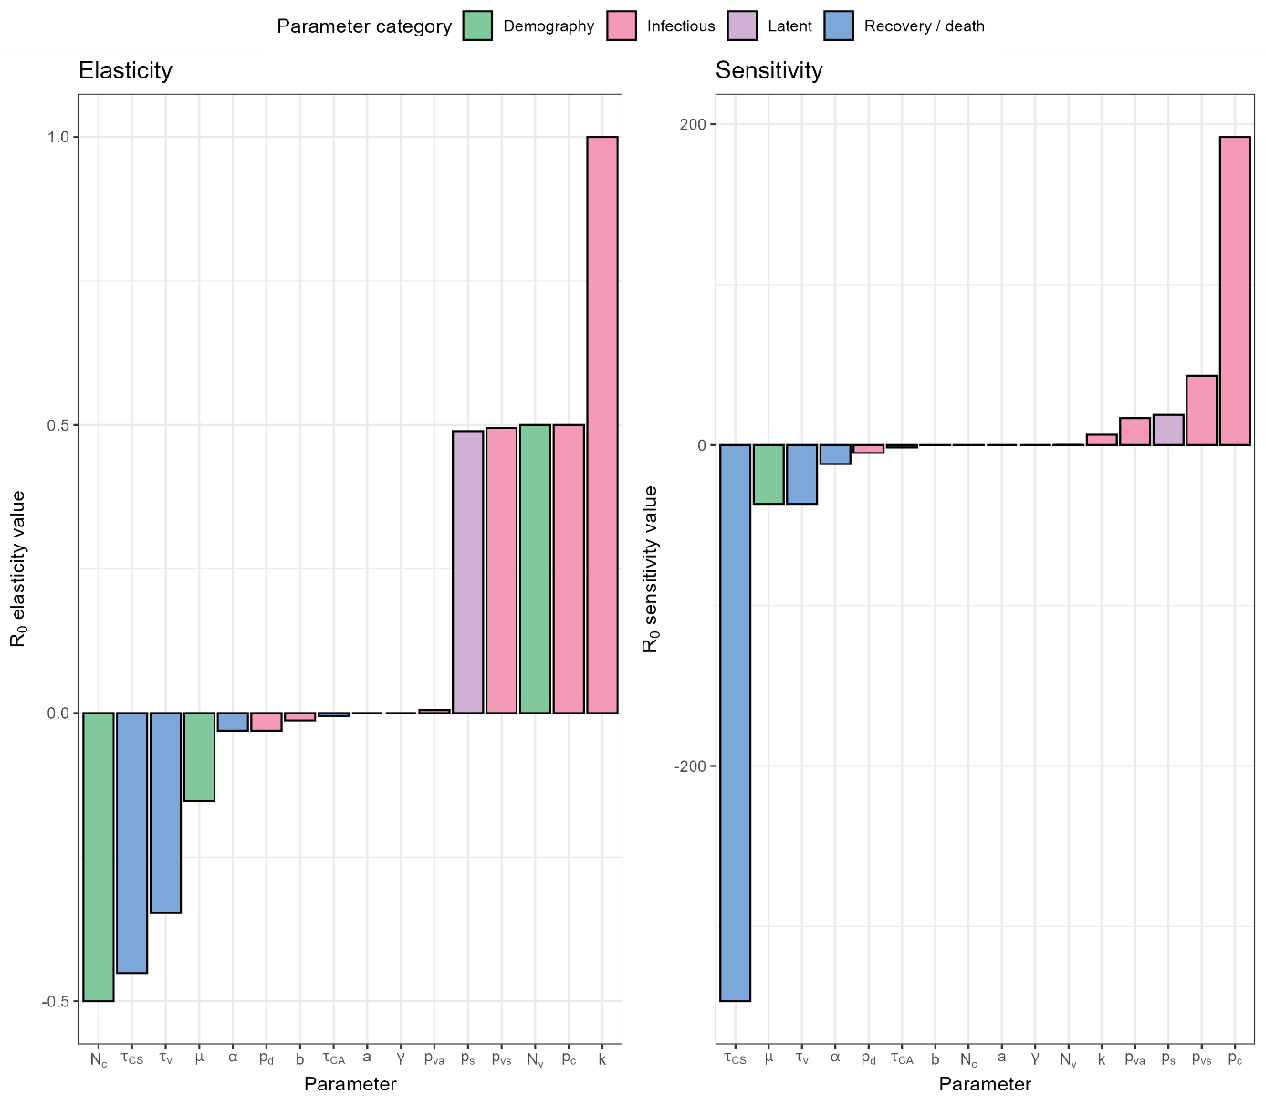
Figure S1: Elasticity and sensitivity analysis of the model without interventions, for all the model parameters reported in Table 1.

Effect of the timing of the start of interventions
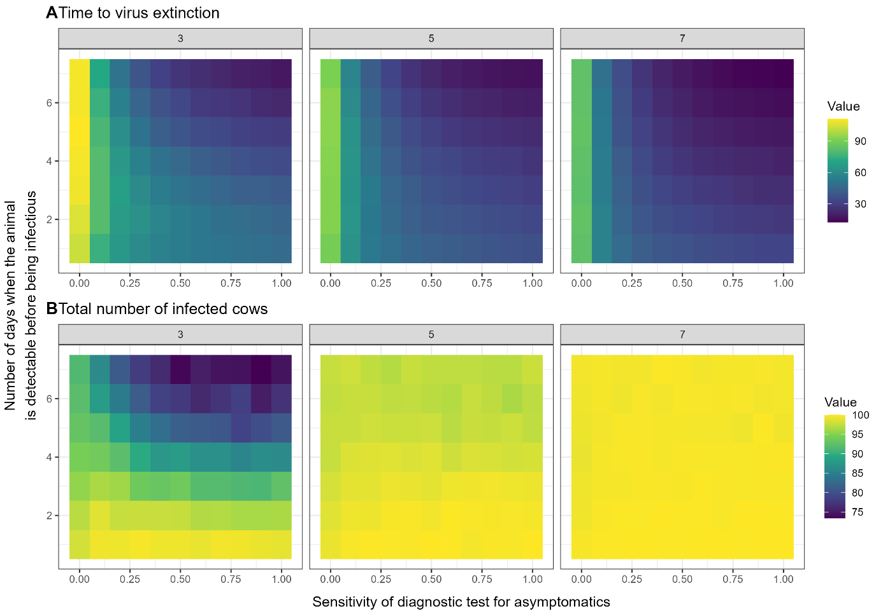
Figure S2: Performance of the selective culling strategy for different timing of start of interventions (3, 5 and 7 days post detection). For each combination of diagnostic test specificity and precocity and start of interventions, the metric is calculated as the average across 1000 stochastic repetitions. These results assume that interventions start respectively 3, 5 and 7 days after the detection of the first clinical cow in the herd, and are implemented as a test-and-cull strategy implemented every two days. A Time to virus extinction, calculated as the time when the last infected animal recovers or dies from the infection. B Total number of infected animals.

