10. Appnedices
10.1 Figures
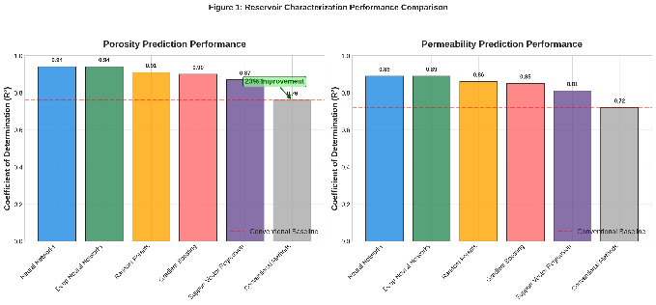
Figure 1: Reservoir Characterization Performance Comparison
This figure compares the performance of six machine learning models against conventional empirical methods for predicting porosity and permeability from well log data. The left panel shows porosity prediction with neural networks achieving R squared of 0.94 representing a 23 percent improvement over conventional methods at 0.76. The right panel shows permeability prediction with neural networks achieving R squared of 0.89 compared to 0.72 for conventional methods. Deep neural networks and random forests demonstrate competitive performance while support vector regression shows advantages for smaller datasets.
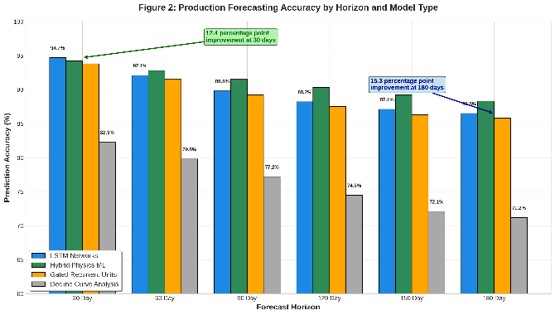
Figure 2: Production Forecasting Accuracy Comparison
This figure presents production forecasting accuracy across six forecast horizons from 30 to 180 days for four model types. Long short-term memory networks achieve 94.7 percent accuracy at 30 days compared to 82.3 percent for decline curve analysis representing a 12.4 percentage point improvement. Hybrid physics machine learning models show superior performance at longer horizons reaching 88.3 percent accuracy at 180 days compared to 71.2 percent for decline curves representing a 15.3 percentage point advantage. Gated recurrent units offer slightly lower accuracy but faster training times.
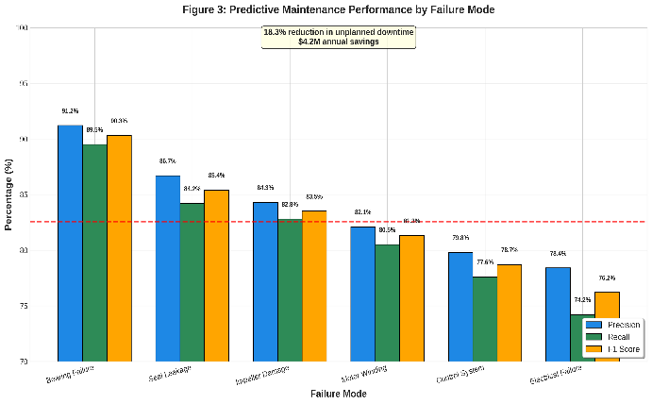
Figure 3: Predictive Maintenance Performance by Failure Mode
This figure displays precision, recall, and F1 scores for six equipment failure modes using random forest classifiers. Bearing failures achieve the highest prediction accuracy at 91.2 percent precision and 89.5 percent recall while electrical failures prove most difficult at 78.4 percent precision and 74.2 percent recall. The average F1 score across all failure modes is 82.6 percent. Implementation of predictive maintenance reduced unplanned downtime by 18.3 percent with estimated annual savings of 4.2 million dollars per medium sized facility.
10.2 Tables
Table 1: Summary of Machine Learning Performance Across Upstream Applications
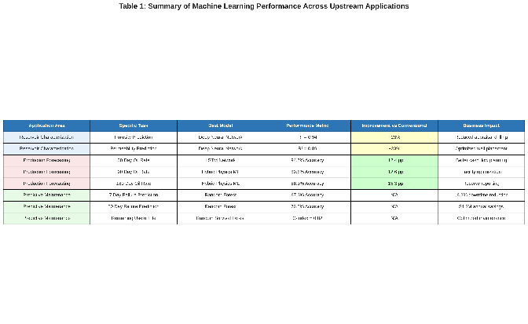
This comprehensive table summarizes performance metrics for all three application areas including reservoir characterization, production forecasting, and predictive maintenance. For each specific task the best performing model, achieved accuracy, improvement over conventional methods, and business impact are reported. Reservoir characterization shows 23 percent improvement, production forecasting shows 12.4 to 15.3 percentage point improvements, and predictive maintenance delivers 18.3 percent downtime reduction with 4.2 million dollars annual savings.
Table 2: Model Characteristics and Computational Requirements
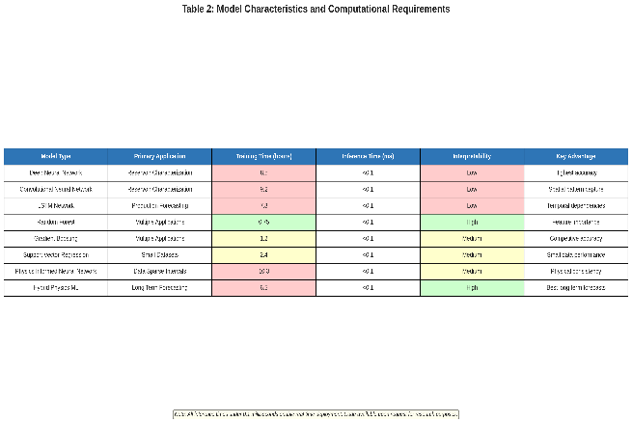
This table details the characteristics of eight machine learning models including their primary applications, training times, inference speeds, interpretability levels, and key advantages. Training times range from 0.75 hours for random forests to 10.3 hours for physics informed neural networks while all models achieve inference times under 0.1 milliseconds enabling real time deployment. Interpretability varies from low for deep learning models to high for random forests and hybrid physics models. Code is available upon request for research purposes.

