- Short discussion on the comparison with the Neptune
Table S1 reports the values for the in-house standard CPI analysed during the course of this project (6 month c.a. for a total of 203 replicates of the solution). The data are compared against the value obtained for analysing the same solution on the MC-ICPMS Neptune using standard sample bracketing (SSB), used for the analysis of lead white in [1–5], and the value obtained analysing the same sample in Klaver et al 2015, that characterised CPI using double spike (DS) technique on three replicates.
The data of the three techniques are within analytical error for the ²⁰⁶Pb/²⁰⁴Pb, ²⁰⁷Pb/²⁰⁴Pb and ²⁰⁸Pb/²⁰⁴Pb. The external error (2SD) of the Neoma MC-ICPMS is lower compared to the one obtained on the Neptune. Note that the total number of replicates and time span for the Neoma is inferior, therefore the 2SD for the Neoma could change in the future as more analyses are conducted. The DS analyses were done only in one session using 3 replicates, therefore there is no possible to compare the external error on the CPI of the DS TIMS analysis vs the Neoma Tl doped analysis. There is a bias between the values obtained via the three methods, between 50 and 150 ppm for the three ratios. This bias is not significant as within error, and consistent with data reported in literature [6]. For the present project, it doesn’t affect the provenance study of lead white. More tests will be done in future to understand the difference between these data, especially characterising better the standards PDLW1 and PDLW2 using DS technique, and evaluate if correcting for it.
 |  | ²⁰⁶Pb/²⁰⁴Pb | 2SD | ²⁰⁷Pb/²⁰⁴Pb | 2SD | ²⁰⁸Pb/²⁰⁴Pb | 2SD | ²⁰⁸Pb/²⁰⁶Pb | 2SD | ²⁰⁷Pb/²⁰⁶Pb | 2SD
Neoma n = 203 | CPI in-house Tl | 17.9006 | 0.0015 | 15.5665 | 0.0020 | 38.0230 | 0.0060 | 2.12409 | 0.00018 | 0.86961 | 0.00005
 | ppm |  | 85.1 |  | 129.8 |  | 159.0 |  | 83.5 |  | 58.0
Neptune n > 500 | CPI in-house SSB | 17.8994 | 0.0031 | 15.5656 | 0.0034 | 38.0186 | 0.0113 | 2.12398 | 0.00033 | 0.86962 | 0.00009
 | ppm |  | 171.2 |  | 220.9 |  | 296.3 |  | 155.7 |  | 102.7
TIMS n = 3 | CPI in-house DS | 17.8996 | 0.0002 | 15.5645 | 0.0003 | 38.0177 | 0.0009 | n.a | n.a | n.a | n.a

Table S1: LIR results on the in-house standard CPI with error reposted as 2D (both absolute and in ppm)
- metal LIR vs LW LIR (end saying PDLW1 std 2 as quality)
Figure S1 compares the analysis of the two lead white standards (PDLW1 and PDLW2) in both their metallic and pigment forms. Each metallic coil was sampled eight times at positions evenly distributed along its length, from both the front and rear sides, to assess isotopic homogeneity of the metal. As shown in Figure S1 (PDLW1-metal and PDLW2-metal), both metals exhibit homogeneous LIR, with 2SD values comparable to those obtained for the solution analyses of the in-house standard CPI reported in Table 2.
The powdered pigments were ground and homogenised prior to analysis, and eight aliquots of each standard were dissolved and analysed by MC-ICP-MS Neoma (n = 40) over a period of six months. Figure 2 shows that the isotopic composition of each lead white pigment is indistinguishable from that of the corresponding metallic precursor, indicating that no measurable isotopic fractionation occurs during lead white synthesis, and that their 2SD values are comparable to those of the CPI in-house standard. The two resulting standards, PDLW1 and PDLW2, also display a clear difference in LIR (1229 ppm for ²⁰⁶Pb/²⁰⁴Pb, 238 ppm for ²⁰⁷Pb/²⁰⁴Pb and 671 ppm for ²⁰⁸Pb/²⁰⁴Pb). This difference is well suited to our purposes: it is smaller than the typical isotopic offset between Italian and Dutch lead whites, yet large enough to provide a stringent test of the efficiency of the LA method for determining LW LIR in the mock-up samples and to evaluate how these data can be applied in provenance studies.
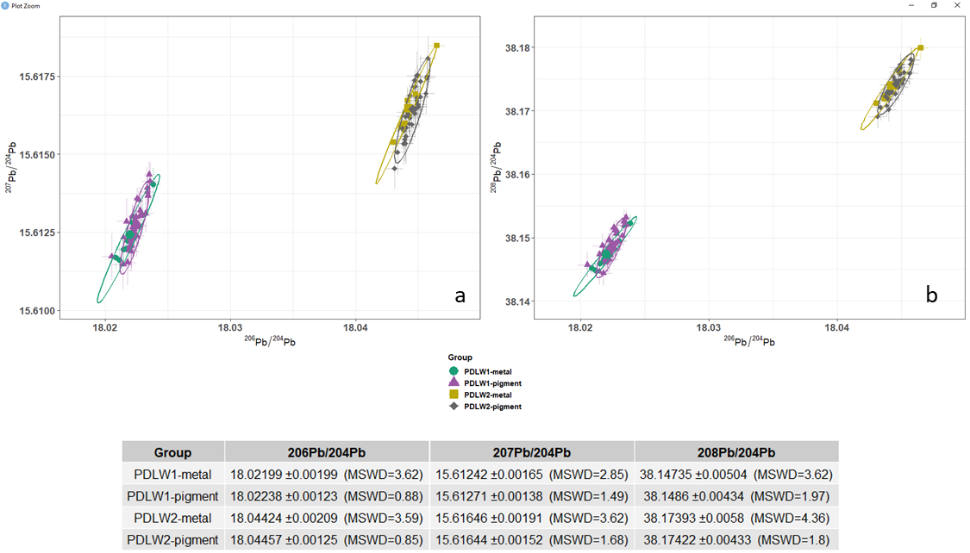
Figure S1: Comparison between the analyses of PDLW1 and PDLW2 in their metal and carbonate forms.

- Decision on the optimal laser ablation settings for lead white:

During the optimisation of the laser ablation analysis of lead white, several laser settings were taken into account. Moreover, two different ablation methods were studied, spot analysis or line/grid analysis.
Grid/line | Area (µm²) | speed µm/sec | spot µm | Energy % | Energy (J) | Hz | Integration time | Ablation time sec | N (dosage) | N*Energy
 | 225 | 4 | 5 | 1 | 0.42 | 10 | 0.1 | 12 | 12.50 | 5.25
 | 225 | 2 | 5 | 1 | 0.42 | 8 | 0.1 | 25 | 20.00 | 8.40
 | 225 | 2 | 5 | 5 | 0.51 | 8 | 0.25 | 21 | 20.00 | 10.20
 | 225 | 1 | 5 | 1 | 0.42 | 7 | 0.5 | 52 | 35.00 | 14.70
 | 225 | 1 | 5 | 1 | 0.51 | 7 | 0.5 | 16 | 35.00 | 26.95
 | 400 | 1 | 5 | 10 | 0.77 | 10 | 0.5 | 70 | 50.00 | 38.50
 | 225 | 1 | 5 | 10 | 0.77 | 10 | 0.5 | 50 | 50.00 | 38.50
 | 400 | 1 | 4 | 20 | 2.14 | 5 | 1 | 85 | 20.00 | 42.80
 | 400 | 0.7 | 4 | 20 | 2.14 | 5 | 1 | 120 | 28.57 | 61.14
 | 400 | 1 | 2 | 40 | 6.25 | 5 | 1 | 78 | 10.00 | 62.50
 | 400 | 0.7 | 2 | 40 | 6.25 | 5 | 1 | 110 | 14.29 | 89.29
Spot
 | 176.7 | 0 | 15 | 5 | 0.51 | 2 | 1 | 113 | 226.00 | 115.26
 | 78.5 | 0 | 10 | 20 | 2.14 | 2 | 1 | 111 | 222.00 | 475.08

Table S2: Setting used to ablate lead white pigments PDLW1 and PDLW2 (Supplementary material S5).
Each type of setting was tested several times in the course of different sessions over different weeks. For the grid/line parameters, the area is calculated taking into account a square (15x15 micrometres for 225 and 20x20 micrometres for 400). Later in the study, the 20x20 approach was abandoned as it was believed to be too invasive and covering an unrealistic too large area, as pure particles of LW of that dimension do not occur commonly in paintings.
For each set of parameters, the Dosage and the product of the dosage for the energy output of the laser were calculated, and used to estimate the best settings.
To identify the best settings, the accuracy (compared to the solution analysis of the pigment reported in this study) and precision (in ppm) for the three lead isotope ratios ²⁰⁶Pb/²⁰⁴Pb, ²⁰⁷Pb/²⁰⁴Pb and ²⁰⁸Pb/²⁰⁴Pb were plotted against the N*Energy (total energy delivered per area), Figure S2. The results were also reported in a biplot graph for the isotope ratios ²⁰⁶Pb/²⁰⁴Pb vs ²⁰⁷Pb/²⁰⁴Pb and ²⁰⁶Pb/²⁰⁴Pb vs ²⁰⁸Pb/²⁰⁴Pb in Figure S3, with 2SD, average and MSDW for each group of settings.
The best results for accuracy and precision were found for Values of N*Energy between 10-20, corresponding to dosages between 20 and 35. The groups at 10.2, 14.7 are the ones giving more consistent and accurate data compared to the solution work of the same pigment PDLW2 (2SD comparable to the solution work presented in D’Imporzano et al 2021). For the laser ablation analyses (n ≈ 20) of the three Pb isotope ratios normalised to ²⁰⁴Pb yielded 2SD values of 150–300 ppm with MSWD between 0.5 and 1.1, while solution analyses (n ≈ 40) produced tighter 2SD of 80–150 ppm and slightly higher MSWD of 0.8–1.8. This indicates that the laser ablation measurements are statistically consistent with their stated uncertainties, with no evidence of significant micro-scale heterogeneity or laser-induced fractionation. Overall, the laser data provide reproducible Pb isotope fingerprints suitable for provenance work, albeit with roughly twofold lower precision than solution measurements, while both methods yield internally coherent results across all three ²⁰⁴Pb-normalized ratios.
Spot analysis on ablation spots of 10 and 15 µm were also tested, using total acquisition times of 60-120 seconds and 1 second integration time on the MC-ICPMS. These spot analyses yielded significantly poorer precision and/or reproducibility than raster or line scans. This degradation is most likely related to localised heating and crater evolution during static ablation, including re-sampling of partially ablated material, changes in focus, and particle melting and recondensation, all of which can destabilise the signal and enhance fractionation. In addition, spot ablation produces deeper craters than line or raster modes, increasing the risk of intersecting adjacent phases if lead white particles are confined to shallow domains, and resulting in greater visible damage to the cross-section—an outcome generally considered undesirable in conservation practice. For these reasons, the method was optimised around line and raster ablation geometries (Figure S4; comparison of spot analyses with the 14.7 protocol).
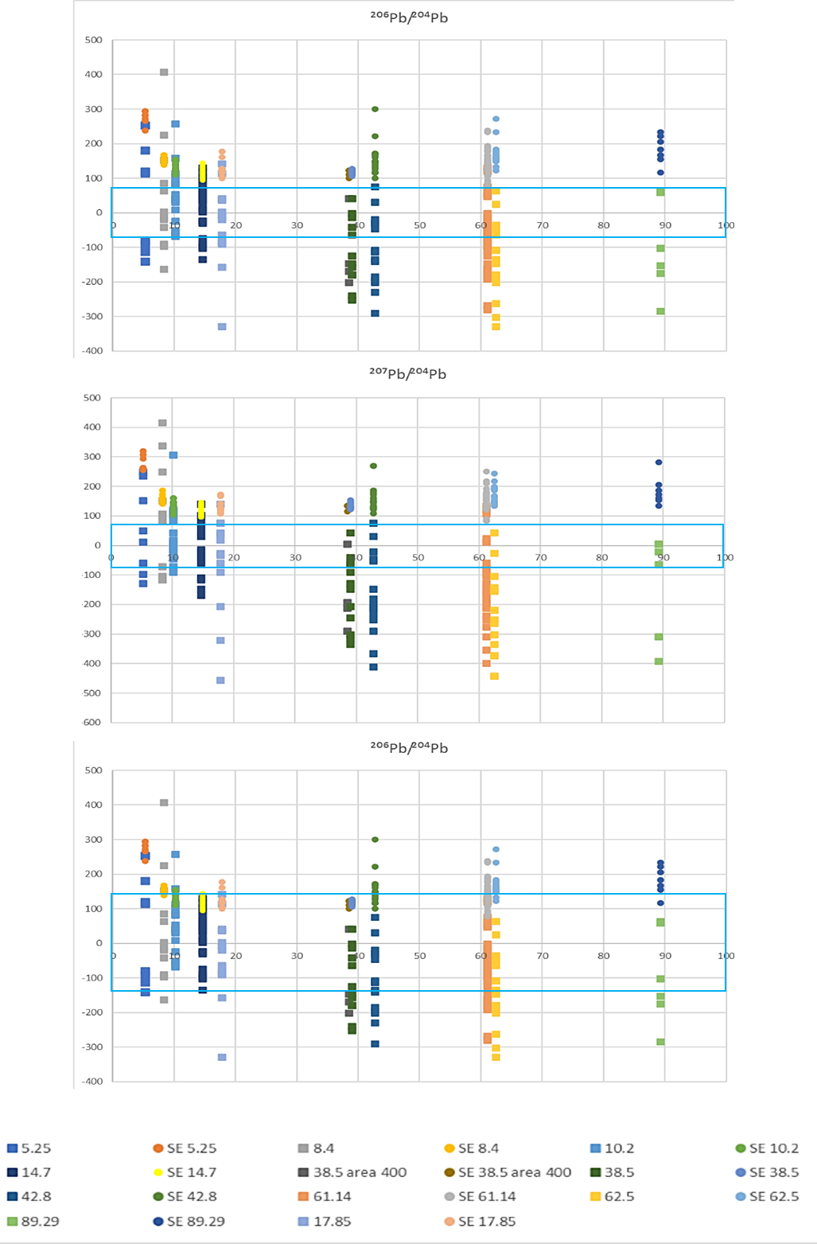
Figure S2: Accuracy and 2SE for each setting tested with the LA method on PDLW2 embedded in epoxy. The 0 on the x-axis is the value obtained by analysing PDLW2 via solution, and the blue rectangle represents the 2SD of the solution analysis on the PDLW2.

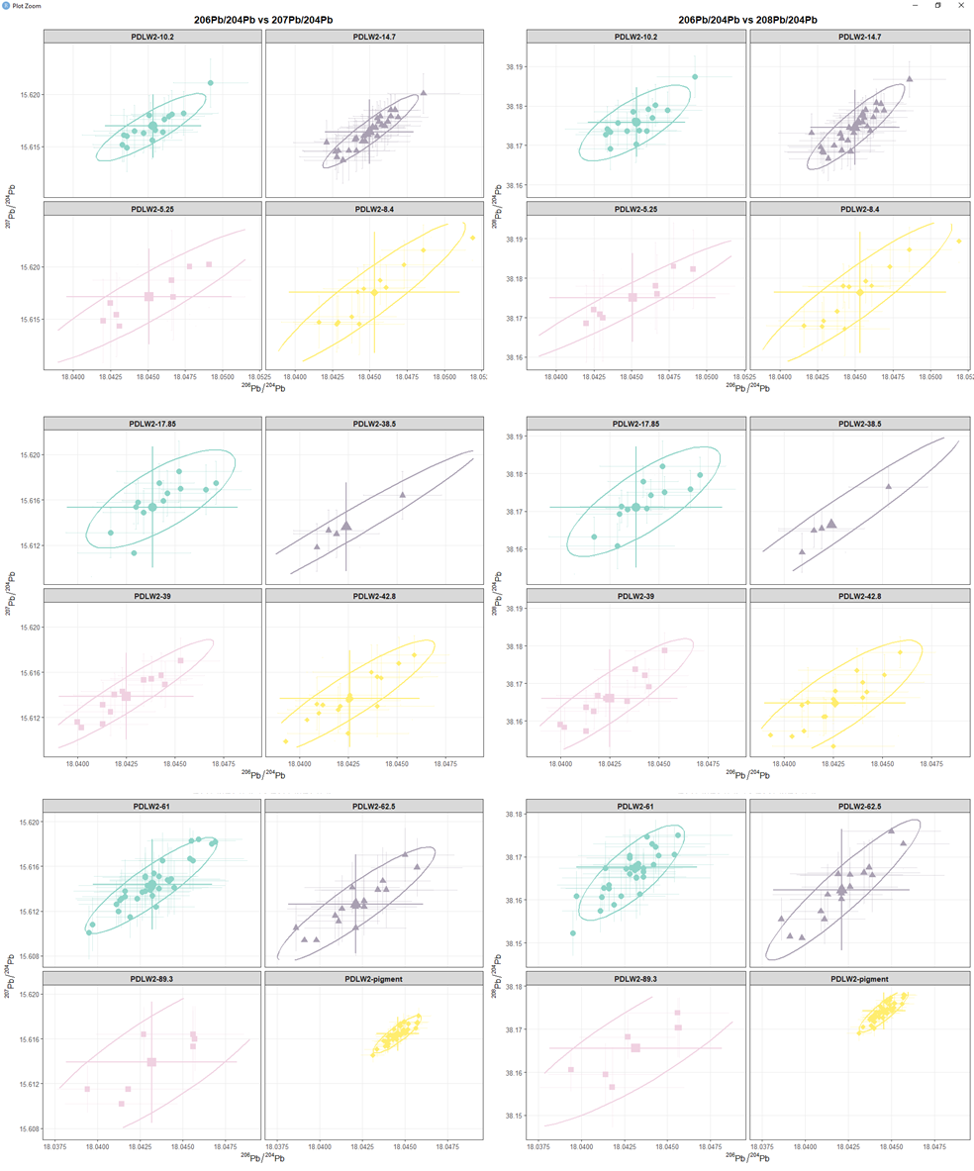
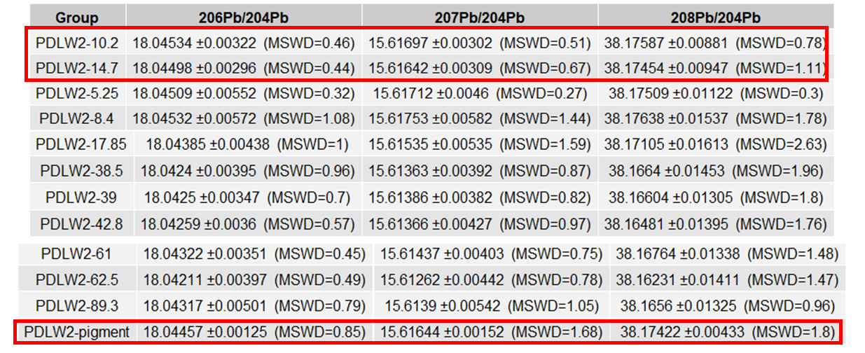
Figure S3: Summary of laser operating conditions and corresponding analytical performance for PDLW2, including mean LIR values, 2SD, and MSWD. PDLW2-pigment represents the analysis of the pigment done in solution and taken as true values of the PDLW2. Ellipses represent the method-specific covariance (95%). Solution measurements show lower 2SD, while all three datasets agree within uncertainty.
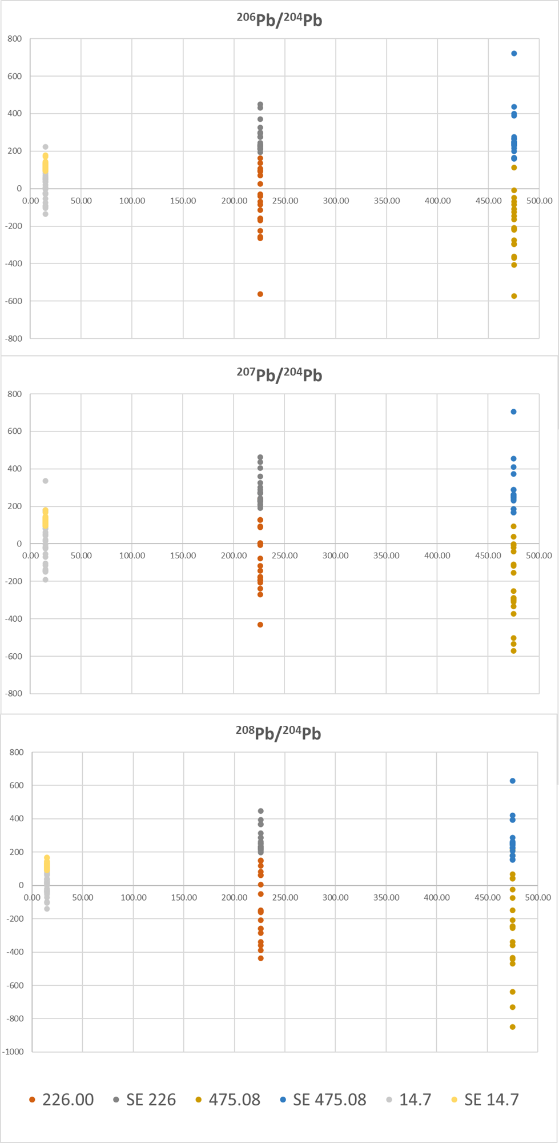
Figure S4: Accuracy and 2SE for spot analysis setting tested with the LA method on PDLW2 embedded in epoxy and compared to the 14.7 LA settings. The 0 on the x axis is the value obtained analysing PDLW2 via solution.
- Material ablated and efficiency:
The various LA parameters were evaluated using an Alpha-Step D-500 surface profilometer (KLA-Tencor stylus profilometer) to estimate the ablation depth produced under different conditions. Initial tests were carried out on LA spots using a 5 µm spot size, stage speeds of 1 and 2 µm/s, and laser energies of 0.42, 0.51, 0.77, and 2.14 J, each at dosages of 35 and 20. The profilometer is equipped with a 2 µm stylus tip, which proved too large relative to the 5 µm crater diameter to allow reliable depth measurements at that spot size. To overcome this limitation, the ablation tests were repeated using a 15 µm spot with the same combinations of speed, energy, and dosage to approximate the ablation depth under the analytical conditions. Although a 15 µm crater is larger than the stylus tip spatial resolution (and experiments were not extended to larger spot sizes to avoid excessive Pb removal and potential long-lasting matrix effects in the laser system and the Neoma MC-ICP-MS), the resulting profiles provided a reasonable estimate of crater depth. In particular, the 2.14 J setting produced a partial flat-bottomed profile at 15 µm spot size, indicating that the stylus tip was able to reach and track the base of the crater. As shown in Figure S4, the ablation depth for the tested conditions lies between approximately 4 and 8 µm, and these values are used to calculate the ablated volume for the efficiency assessment.
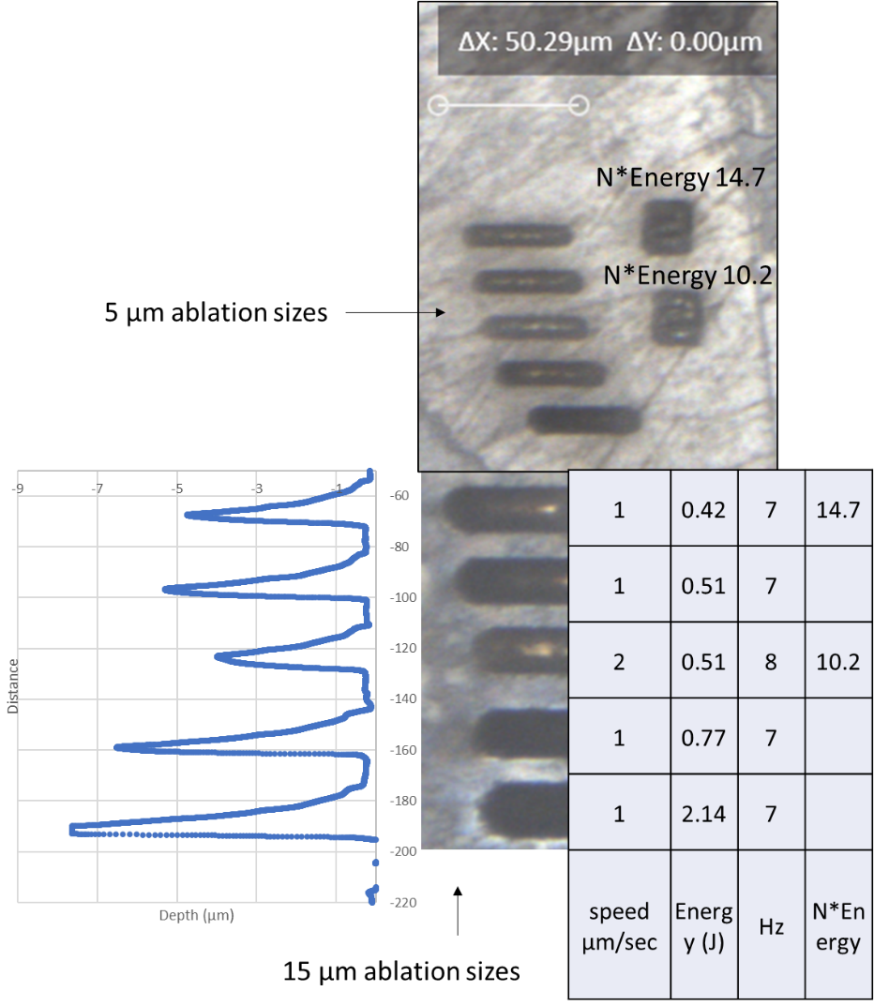
Figure S4: Image of the ablation lines and raster at different LA settings and depth profile of the ablation lines.

Using these values, it was possible to estimate the efficiency for ablating the lead white with N*Energy of 14.7 and 10.2 was around 0.05-0.25%. This range of efficiency is a function of day-to-day tuning conditions and rheology of the carbonate during analysis.
Considering an average ablation depth of 5 µm it is possible to calculate the average amount of pigment ablated (considering a density of lead white of 6.7 g/cm⁻³ and an average length of ablation of 50 µm) around of 8.375 ng, which decreases to 3.35 ng for smaller analyses with 20 µm length ablation areas.
- Laser ablation: raster vs Line
Painting samples stored as cross sections have different layers that vary in thickness and contain irregular particles of pigments. To optimise the sampling procedure for a wider variety of sample specimens, two different approaches were tested: ablating following a raster (grid) or a line. The first approach is more suitable for rounded lead white particles with a diameter of around 10-15 micrometres, while the second can be applied for sampling having a thin layer of lead white homogenously dispersed in oil paint (ideal thickness of the layer around 6-8 micrometres minimum). The line sampling signal (expressed in voltage for each isotope) is more stable than grid sampling. Sampling carbonates results in signal intensity variation of 10-20% depending on the rheology of the sample. Moreover, the raster sampling can have even more variable signal, as the trajectory of the ablation is not linear, but it has 90 degrees turn, that can cause over-ablation of the same area resulting in signal drops (as shown in Figure S4 on the ²⁰⁸Pb voltage signal, which shows two drops in relation to the raster turning). To evaluate whether these transient intensity affects isotope ratios, raster and line scans were directly compared in terms of both signal intensity and LIR. As shown in Figure S4, the raster turning-related signal drops do not measurably affect the calculated isotopic composition. The raster/line comparison supports the use of both geometries, which can be used according to the appearance of the sample.

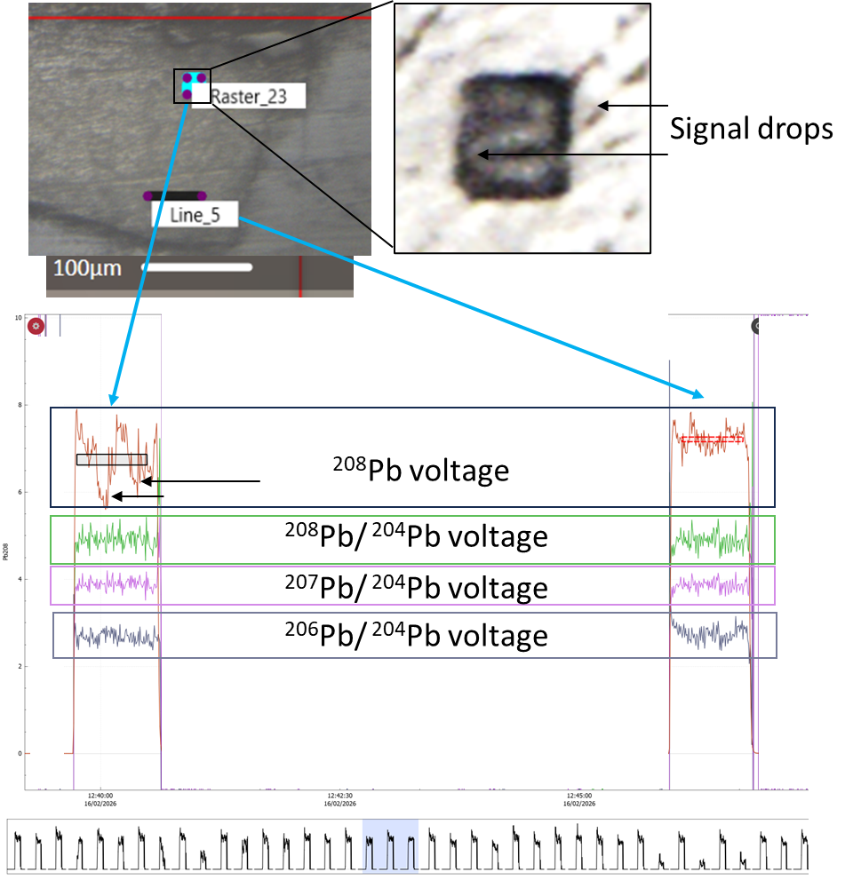
Figure S5: Voltage and LIR signal of the LA showing the differences between raster and line ablation. It is visible that while the Voltage in the raster analysis drops during the turnings, this doesn’t affect the Isotopic composition.

- LA in oil samples

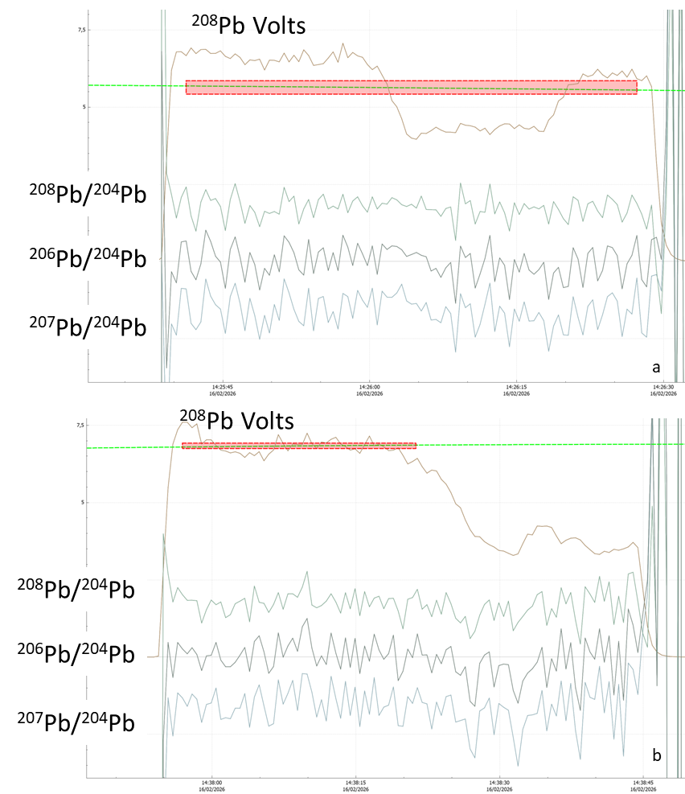
Figure S5: Volt and LIR signal of the analysis of a line in the layer containing PDLW2 in oil in the mock-up sample. The picture shows the difference and alteration of LIR if areas containing high amount of Oil are analysed.
Figure S5 shows two examples of time-resolved signals from the mock-up, processed in Iolite, where the ablation path crosses from a lead white particle into an area with more oil. A clear drop in the ²⁰⁸Pb intensity marks this transition. This change in matrix composition also affects the measured isotope ratios, likely due to increased fractionation in the oil-rich phase.
The impact varies between spots: in Figure S5a, the LIR remains relatively stable across both phases, allowing the entire signal (dotted rectangle) to be used. However, in Figure S5b, the ratios drift significantly in the second, oil-rich part of the signal, resulting in poorer accuracy. In such cases, it is crucial to select only the first part of the signal, corresponding to the pure lead white, for the final calculation to obtain reliable results."
1. D’imporzano P, Reiling HM, Merkel S, van Iperen JM, Garachon I, Keune K, et al. Lead isotope analysis of lead-tin-glaze via on-site portable laser ablation sampling of 17-18th century Delftware (earthenware). J Archaeol Sci. Elsevier; 2026;185:106443.
2. D’imporzano P, Batur K, Keune K, Koornneef JM, Hermens E, Noble P, et al. Lead isotope heterogeneity in lead white: From lead white raw pigment to canvas. Microchemical Journal. Elsevier; 2021;163:105897.
3. D’Imporzano P, Davies GR. Lead Isotope Ratios of Lead White: From Provenance to Authentication. In: Colombini MP, Degano I, Nevin A, editors. Analytical Chemistry for the Study of Paintings and the Detection of Forgeries [Internet]. Cham: Springer International Publishing; 2022. p. 447–71. https://doi.org/10.1007/978-3-030-86865-9_14
4. D’Imporzano P, Keune K, Koornneef JM, Hermens E, Noble P, Vandivere ALS, et al. Time-dependent variation of lead isotopes of lead white in 17th century Dutch paintings. Sci Adv. American Association for the Advancement of Science; 2021;7:eabi5905.
5. D’Imporzano P, Keune K, Koornneef JM, Hermens E, Noble P, van Zuilen K, et al. Micro-invasive method for studying lead isotopes in paintings*. Archaeometry. 2020; https://doi.org/10.1111/arcm.12549
6. Thirlwall MF. Multicollector ICP-MS analysis of Pb isotopes using a 207Pb-204Pb double spike demonstrates up to 400 ppm/amu systematic errors in Tl-normalization. Chem Geol. Elsevier; 2002;184:255–79.

