Microwave synthesis of FeNiSb medium-entropy alloy as high-performance electrode for symmetric supercapacitors
Weiwei Zhao, Xue Wang, Shuai Zhang, Shuangyi He and Jujie Luo
College of Materials Science and Engineering, Taiyuan University of Technology, Taiyuan 030024, PR China
1. Experimental Section
1.1 Preparation of NF
Cut nickel foam (NF) into 1×1 cm² cubes and place them in anhydrous ethanol for ultrasonic cleaning for 40 minutes. Remove the NF and place it in a glass dish, then dry it in an 80°C oven.
1.2. Chemicals
NiCl₂⋅6H₂O (99.5%), FeCl₃ (99.9%), and SbCl₃ (99.9 %) were supplied by Aladdin Reagent (Shanghai) Co., Ltd. Ethylene glycol (EG, 99%) and ethylenediamine (EDA, 99%) were purchased from Beijing MREDA Technology Co., Ltd. KOH (99%) was sourced from Shanghai Macklin Biochemical Co., Ltd. NF was bought from Longshengbao Electronic Materials Co., Ltd.
1.3 Characterization techniques
Elemental composition was determined with a Thermo Fisher ESCALAB Xi+ system via X-ray photoelectron spectroscopy (XPS). The crystal structure of all samples was analyzed using X-ray diffractometer (XRD, Rigaku Ultima IV). A ZEISS Sigma500 scanning electron microscopy (SEM) was used to analyze morphological characteristics and elemental composition of FeNiSb samples under all conditions equipped with an energy-dispersive X-ray spectroscopy (EDS) detector. To further analyze the crystalline phase composition, transmission electron microscopy (TEM) was conducted on a JEM-2100Plus instrument.

2. Characterization section
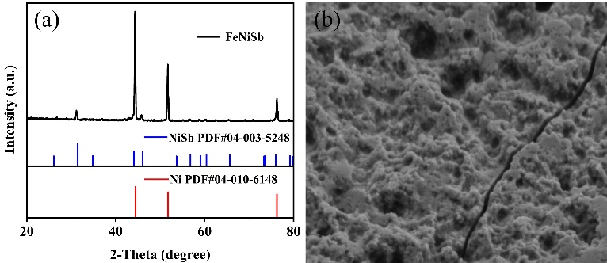
Fig. S1 (a) XRD pattern, (b) SEM of the FeNiSb electrode after long-term cycling.
Table S1 $R_{s}$ and $R_{ct}$ of different samples FeNiSb/NF.
Sample | $R_{s}$ ($Ω$) | $R_{ct}$($Ω$)
T1 | 0.75245 | 0.17571
T2 | 0.54125 | 0.10658
T3 | 0.71923 | 0.33634
S1 | 0.75668 | 0.11395
S2 | 0.67901 | 1.1870

3. Characterization section
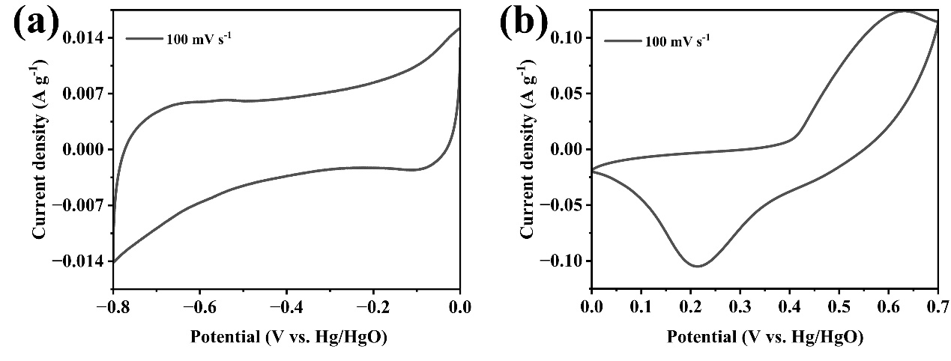
Figure S2: CV of FeNiSb electrode in 6 M KOH to show the most negative (0.0 to -0.8 V) and positive (0.0 to 0.7 V) potential limits at scan rates of 100 mV

Corresponding author. E-mail address: luojujie@126.com.

