SUPPLEMENTARY MATERIAL

TITLE: Psychoactive substances use before suicide: detailed analysis of all cases that occurred in the Brazilian Federal District in a 10-years period

DIAGRAM S1. Cases of suicide with toxicological examination included in the study.
* Psychoactive Substances

Table S1. Parameters adopted for the variables studied. Brazilian Federal District, 2005 – 2014

Variables | Parameters |  | Variables | Parameters
1. Day of month | From 1 |  | 11. Previous suicide attempt? | 0 – no
1. Day of month | To 31 |  | 11. Previous suicide attempt? | 1 – yes
2. Day of the week | 0 – weekday |  | 12. Recent behavior changed? | 0 – no
2. Day of the week | 1 – weekend |  | 12. Recent behavior changed? | 1 – yes
3. Month | From 1 – January |  | 13. Skin color | 0 – white people
3. Month | To 12 – December |  | 13. Skin color | 1 – black/pardo
4. Year | From 2015 |  | 14. Body Mass Index (BMI) | 0 – underweight
4. Year | To 2014 |  | 14. Body Mass Index (BMI) | 1 – normal weight
5. Period | 0 – day |  | 14. Body Mass Index (BMI) | 2 – overweight
 | 1 – night |  | 14. Body Mass Index (BMI) | 3 – obesity
6. Age | 0 - 12-17 years old  1 – 18-29  2 – 30-59 |  | 15. Hanging | 0 – no
 | 3 – ≥60 |  | 15. Hanging | 1 – yes
7. Gender | 0 – Female |  | 16. Firearm use | 0 – no
 | 1 – Male |  | 16. Firearm use | 1 – yes
8. Degree of education | 0 – illiterate |  | 17. Projection | 0 – no
 | 1 – elementary School |  | 17. Projection | 1 – yes
 | 2 – high school |  | 18. Poison use | 0 – no
 | 3 – higher education |  | 18. Poison use | 1 – yes
9. Marital status | 0 – not married |  | 19. Blood Alcohol Content (BAC) | From 0.02
 | 1 – married |  | 19. Blood Alcohol Content (BAC) | To 8.96
10. Suicide in your residence | 0 – no |  | 20. Drug use | 0 – no
 | 1 – yes |  | 20. Drug use | 1 – yes

Table S2. Results of principal component analysis showing factor loadings (correlation coefficients) and variance. Brazilian Federal District, 2005 – 2014.

 | Coefficients of PC1 | Coefficients of PC2 | Coefficients of PC3 | Coefficients of PC4 | Coefficients of PC5
Day of month | 0.10666 | 0.07381 | -0.34262 | 0.07359 | -0.47568
Day of week | -0.28072 | -0.10169 | 0.08138 | 0.29602 | 0.19667
Month | 0.15248 | -0.09462 | -0.06067 | 0.30714 | -0.06015
Year | 0.13308 | 0.24602 | -0.14355 | -0.12216 | 0.47216
Period | -0.04197 | 0.04524 | 0.35882 | 0.32936 | -0.46663
Age | 0.3335 | 0.37386 | -0.20608 | 0.00833 | 0.00477
Gender | -0.38831 | 0.12438 | -0.00765 | 0.14945 | 0.2115
Level of education | 0.36615 | -0.33676 | 0.00048 | 0.03823 | 0.13981
Marital status | 0.20274 | 0.25261 | 0.22332 | 0.37703 | 0.09128
Suicide in own home | 0.05155 | 0.19284 | -0.39194 | 0.37599 | -0.09189
Previous suicide attempt? | 0.09861 | 0.26521 | 0.34433 | -0.18012 | -0.22014
Recent behavior change? | 0.09873 | 0.27809 | 0.23418 | -0.34877 | 0.10028
Skin color | -0.40057 | 0.13132 | 0.29211 | -0.08396 | -0.09474
BMI | 0.28421 | -0.00874 | 0.29122 | 0.25197 | 0.29752
Hanging | -0.39915 | 0.28084 | -0.29099 | 0.12497 | 0.14406
Alcohol use? | 0.05872 | 0.35708 | -0.12034 | -0.26613 | -0.1644
Drug use? | -0.06164 | -0.41435 | -0.18502 | -0.26602 | -0.07675
% of variance | 9.47 | 8.40 | 7.60 | 7.56 | 6.90

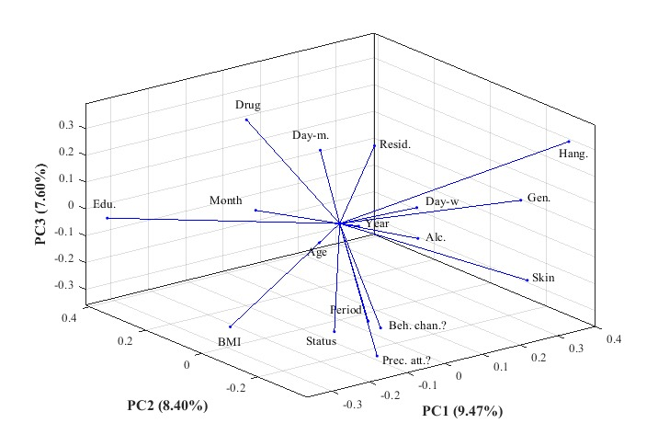

Figure S1. Three-dimensional PCA graph considering the first three principal components. Brazilian Federal District, 2005 – 2014

