SUPLEMENTARY MATERIAL

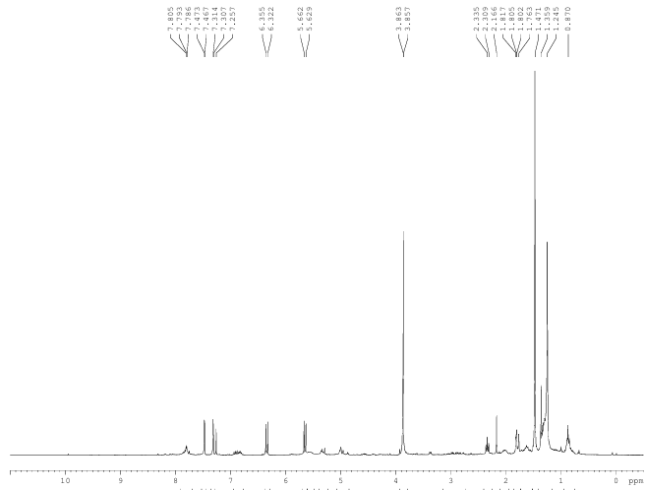
Figure 1S. ¹H NMR spectrum (300 MHz, CDCl₃) of C1 (8-hydroxy-2,2-dimethyl-2H-1-chromene-6-carboxylate).

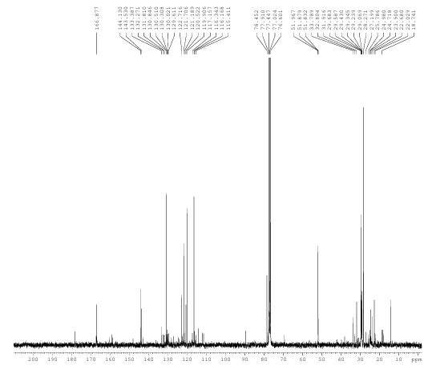
Figure 2S. ¹³C NMR spectrum (75,5MHz, CDCl₃) of C1 (8-hydroxy-2,2-dimethyl-2H-1-chromene-6-carboxylate).
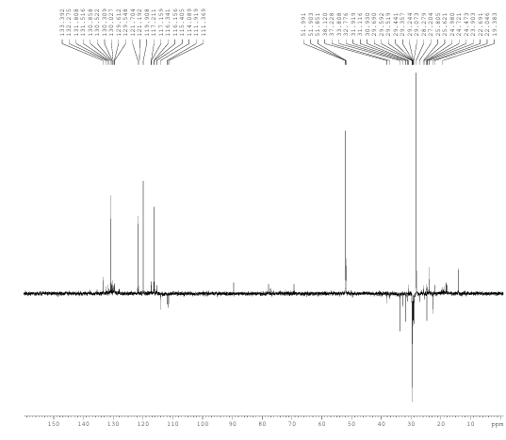
Figure 3S. DEPT spectrum (75,5MHz, CDCl₃) of C1 (8-hydroxy-2,2-dimethyl-2H-1-chromene-6-carboxylate).
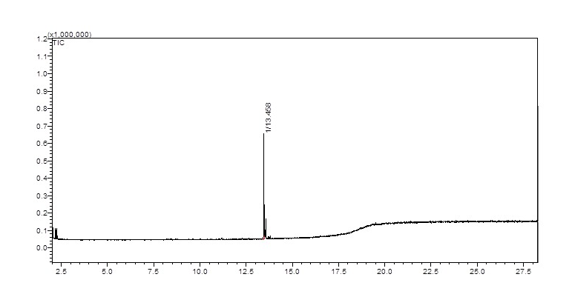
Figura 4S. Gas Chromatogram profile of C1 (8-hydroxy-2,2-dimethyl-2H-1-chromene-6-carboxylate)

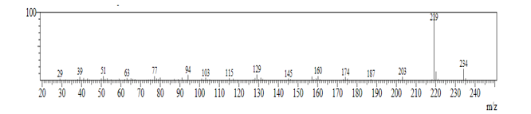
Figura 5S. Mass Espectrum of C1 (8-hydroxy-2,2-dimethyl-2H-1-chromene-6-carboxylate).

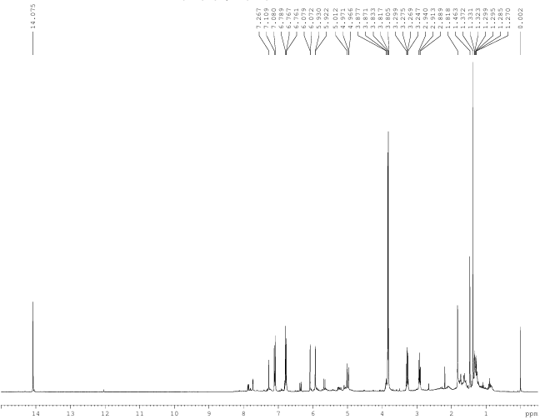
Figure 6S. ¹H NMR spectrum (300 MHz, CDCl₃) of C2 (2', 6'-dihydroxy-4'-methoxy dihydrochalcone).

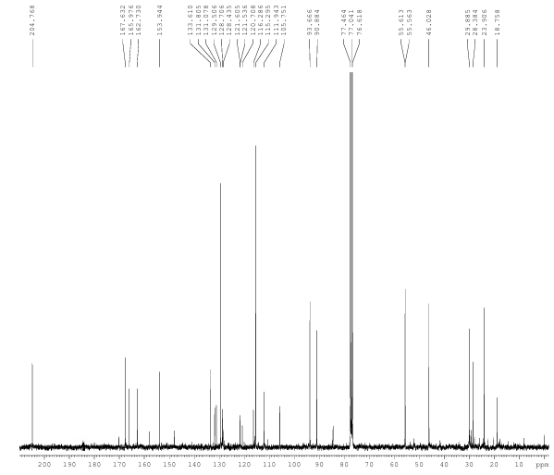
Figure 7S. ¹³C NMR spectrum (75,5MHz, CDCl₃) of C2 (2', 6'-dihydroxy-4'-methoxy dihydrochalcone).

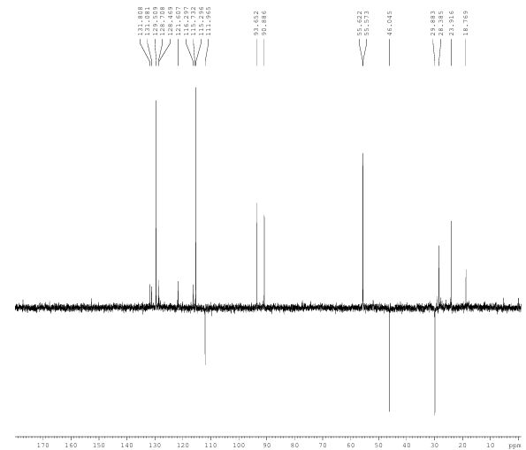
Figure 8S. DEPT spectrum (75,5MHz, CDCl₃) of C2 (2', 6'-dihydroxy-4'-methoxy dihydrochalcone).
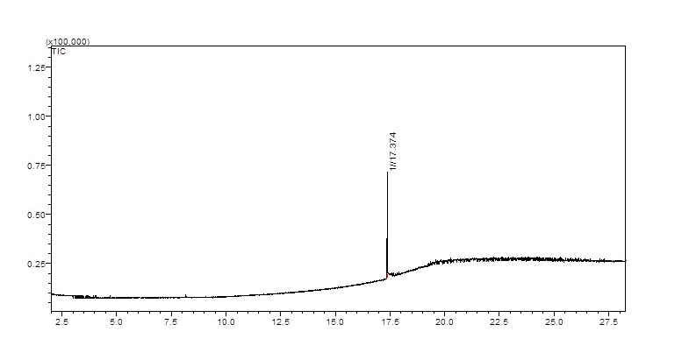
Figura 9S. Gas Chromatogram profile of C2 (2', 6'-dihydroxy-4'-methoxy dihydrochalcone)

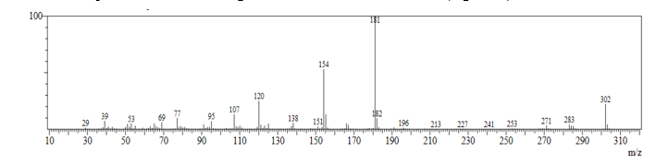
Figura 10S. Mass Espectrum of C2 (2', 6'-dihydroxy-4'-methoxy dihydrochalcone)

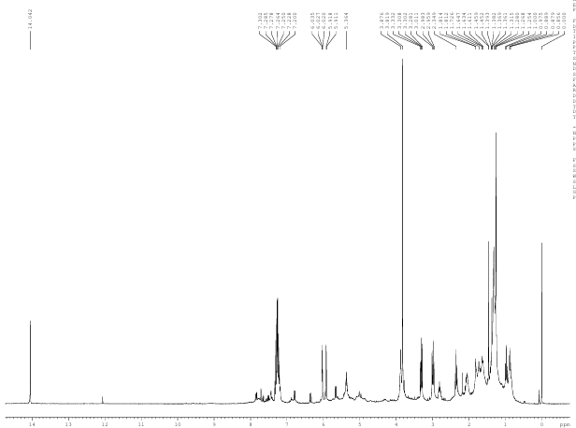
Figure 11S. ¹H NMR spectrum ((300 MHz, CDCl₃) of C3 (2',4-dihydroxy-4',6’-dimethoxy-dihydrochalcone).

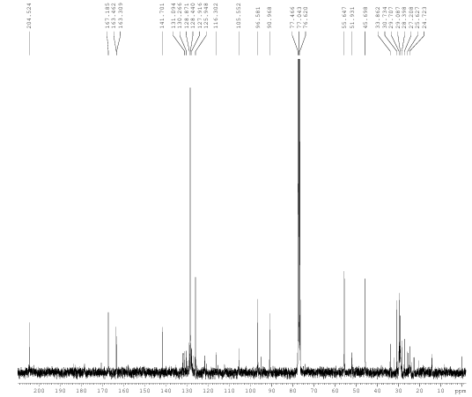
Figure 12S. Espectro ¹³C NMR spectrum of C3 (2',4-dihydroxy-4',6’-dimethoxy-dihydrochalcone).

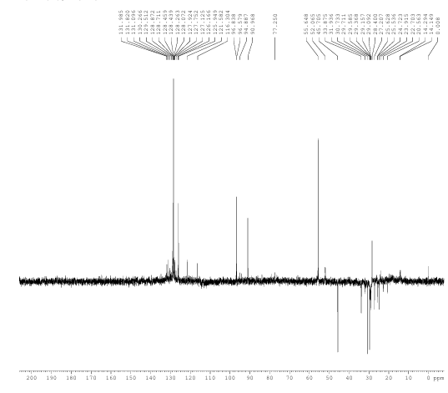
Figure 13S. DEPT spectrum (75,5MHz, CDCl₃) of C3 (2',4-dihydroxy-4',6’-dimethoxy-dihydrochalcone).

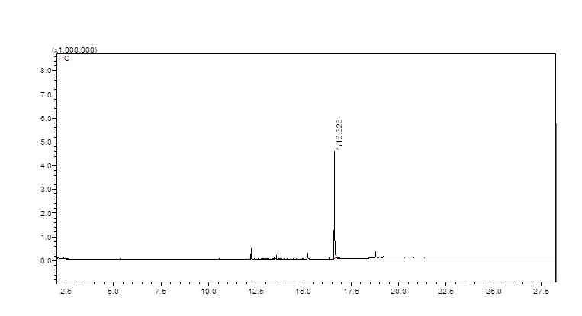
Figura 14S. Gas Chromatogram profile of C3 (2',4-dihydroxy-4',6’-dimethoxy-dihydrochalcone).

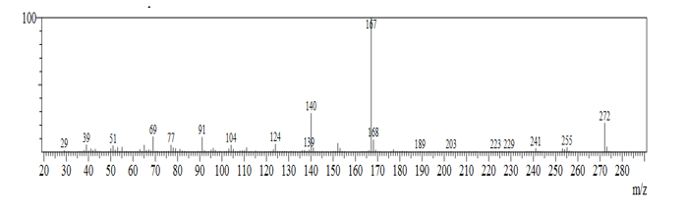
Figura 15S. Mass Espectrum of C3 (2',4-dihydroxy-4',6’-dimethoxy-dihydrochalcone).

