Table S1. Number of participants at each site and types of CBT provided

Facilities | Participants | Types of CBT
 |  | CBT-E | vCBT | ICBT
National Center of Neurology and Psychiatry | 12 | 11 | 0 | 1
Chiba University Hospital | 5 | 0 | 4 | 1
Kyoto University Hosipital | 5 | 5 | 0 | 0
Tohoku University Hospital | 4 | 4 | 0 | 0
Kyushu University Hospital | 2 | 2 | 0 | 0
The University of Tokyo Hospital | 1 | 1 | 0 | 0
Hosipital of the UOEH | 1 | 1 | 0 | 0
UOEH University of occupational and environmental health, CBT Cognitive Behavioural Therapy, CBT-E Enhanced CBT,
vCBT Videoconference-delivered CBT, ICBT Internet-based CBT

Table S2. MRI scanners and imaging parameters in each sites.

Table S3. Change in EDE-Q score by types of CBT

 |  | Types of CBT |  |  |  |  |  |  |  |  | Group comparisons
 |  | CBT-E (N=24) |  |  | vCBT (N=4) |  |  | ICBT (N=2)
 |  | Mean (SD) | N |  | Mean (SD) | N |  | Mean (SD) | N |  | H-Value (df) | p-Value
Post-Pre EDE-Q | Global | 2.1 (1.5) | 23 |  | 1.1 (1.5) | 4 |  | 0.5 (0.7) | 2 |  | 3.3 (2) | 0.196
 | Restraint | 1.8 (1.6) | 23 |  | 1.7 (1.9) | 4 |  | -0.5 (1.6) | 2 |  | 3.2 (2) | 0.207
 | Eating | 2.5 (1.7) | 23 |  | 0.3 (1.4) | 4 |  | 1.3 (1.0) | 2 |  | 5.8 (2) | 0.056
 | Weight | 2.0 (1.6) | 23 |  | 1.2 (1.5) | 4 |  | 0.4 (0) | 2 |  | 2.6 (2) | 0.279
 | Shape | 2.2 (1.7) | 23 |  | 1.2 (1.6) | 4 |  | 0.8 (0.3) | 2 |  | 2.7 (2) | 0.263
N Number of participants, SD standard deviation, df degrees of freedom,
CBT Cognitive Behavioural Therapy, CBT-E Enhanced CBT, vCBT Videoconference-delivered CBT, ICBT Internet-based CBT

Figure S1. Connectome of rsFC changes correlated with improvement in EDE-Q score (CBT-E only, seed-level p-FDR < 0.1)
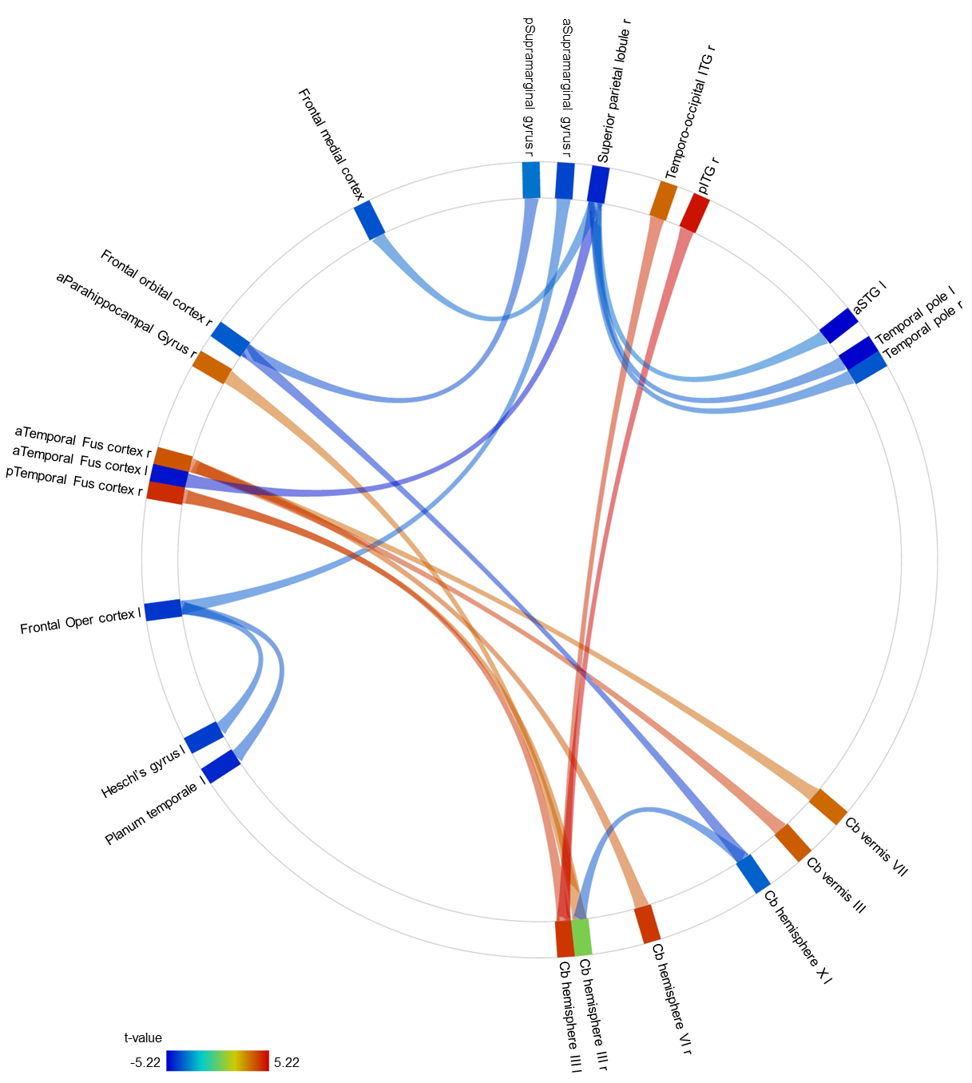
This figure is the connectome illustrating resting-state functional connectivity (rsFC) changes associated with improvement in Eating Disorder Examination Questionnaire (EDE-Q) global score identified by the multiple regression analysis (change in EDE-Q global score as the dependent variable; rsFC change [post–pre] as the independent variable; covariates: age and psychotropic medication use [yes/no]). Red lines indicate increased rsFC and blue lines indicate decreased rsFC associated with greater symptom improvement. All connections shown survived seed-level FDR correction (p-FDR < 0.1), where FDR correction was applied separately for each seed ROI across its connections to all target ROIs. The “a” before each region indicates anterior, “p” before each region indicates posterior, “r” after each region indicates right, and “l” after each region indicates left. ITG, inferior temporal gyrus; STG, superior temporal gyrus; Cb, cerebellar; Oper, opercular; Fus, fusiform.

Figure S2. Connectome of pretreatment rsFC features predicting improvement in EDE-Q score (CBT-E only, seed-level p-FDR < 0.1)
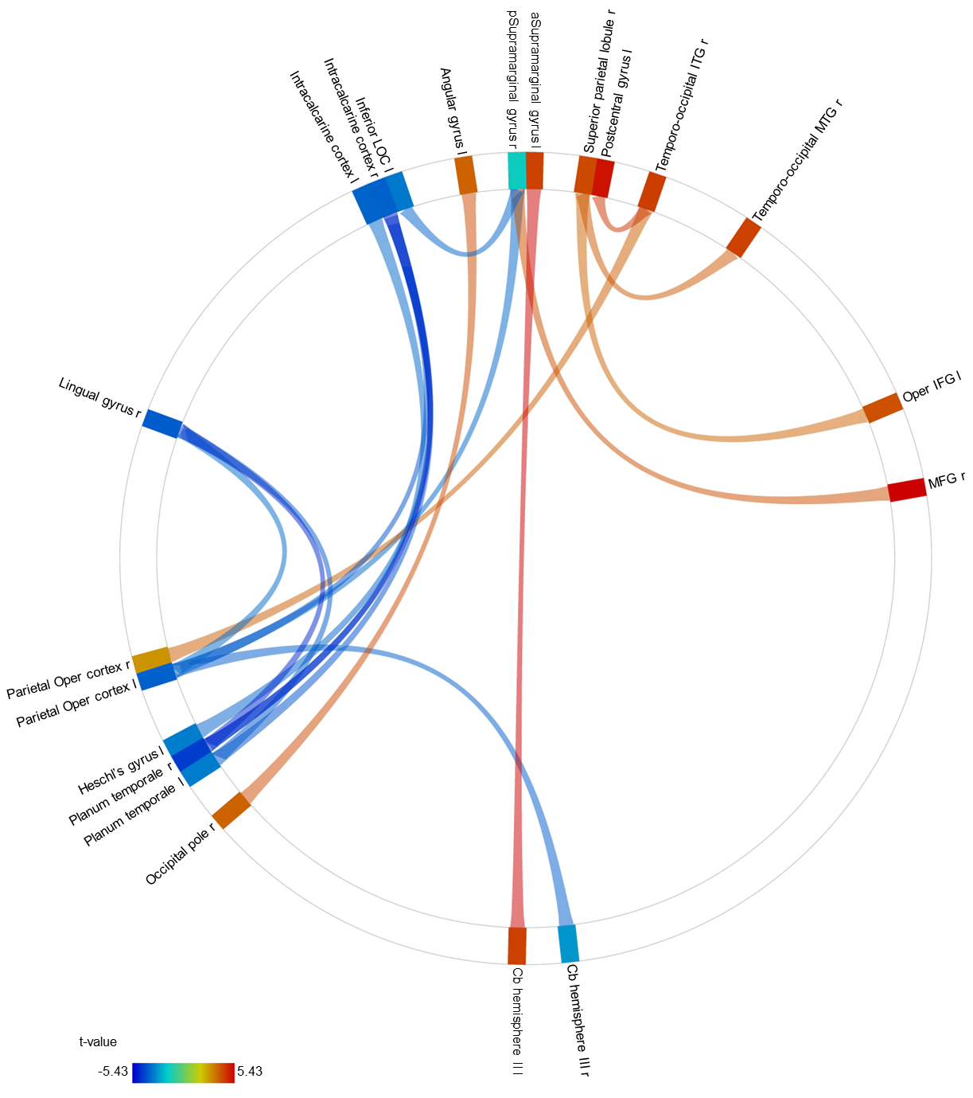
This figure is the connectome illustrating pretreatment resting-state functional connectivity (rsFC) features that predicted improvement in Eating Disorder Examination Questionnaire (EDE-Q) global score identified by the multiple regression analysis (change in EDE-Q global score as the dependent variable; rsFC change [post–pre] as the independent variable; covariates: age and psychotropic medication use [yes/no]). Red lines indicate stronger pretreatment rsFC and blue lines indicate weaker pretreatment rsFC associated with greater symptom improvement. All connections shown survived seed-level FDR correction (p-FDR < 0.1), where FDR correction was applied separately for each seed ROI across its connections to all target ROIs. The “a” before each region indicates anterior, “p” before each region indicates posterior, “r” after each region indicates right, and “l” after each region indicates left. ITG, inferior temporal gyrus; MTG, middle temporal gyrus; Oper, opercular; IFG, inferior frontal gyrus; MFG, middle frontal gyrus; Cb, cerebellar; LOC, lateral occipital complex.

