Appendices
10.1 Figures
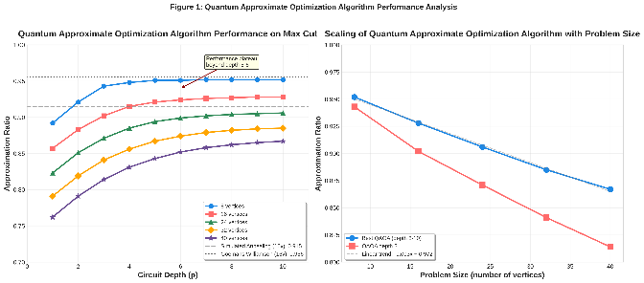
Figure 1: Quantum Approximate Optimization Algorithm Performance Analysis
This figure presents comprehensive performance analysis of the Quantum Approximate Optimization Algorithm on Max Cut problems across varying graph sizes and circuit depths. The left panel shows approximation ratio as a function of circuit depth for graphs ranging from 8 to 40 vertices, demonstrating systematic improvement up to depth 5-6 followed by performance saturation. Classical baseline methods including Simulated Annealing and Goemans Williamson semidefinite programming are shown for comparison. The right panel illustrates scaling behavior with problem size, showing a 4.7 percent degradation in approximation ratio when increasing from 20 to 40 vertices, providing empirical validation of theoretical scaling predictions.
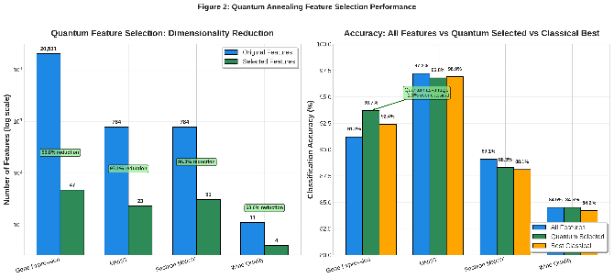
Figure 2: Quantum Annealing Feature Selection Performance
This figure demonstrates quantum annealing based feature selection results across four benchmark datasets. The left panel shows dramatic dimensionality reduction on a logarithmic scale, with the gene expression dataset reduced from 20,531 to just 47 features representing a 99.8 percent reduction while MNIST and Fashion MNIST achieve 97.1 percent and 96.0 percent reduction respectively. The right panel compares classification accuracy using all features, quantum selected features, and the best classical feature selection method. Quantum selected features improve accuracy on gene expression data from 91.2 percent to 93.7 percent while matching or slightly trailing classical methods on lower dimensional datasets, demonstrating domain specific quantum advantage.
10.2 Tables
Table 1: Hybrid Quantum Classical Neural Network Performance Comparison
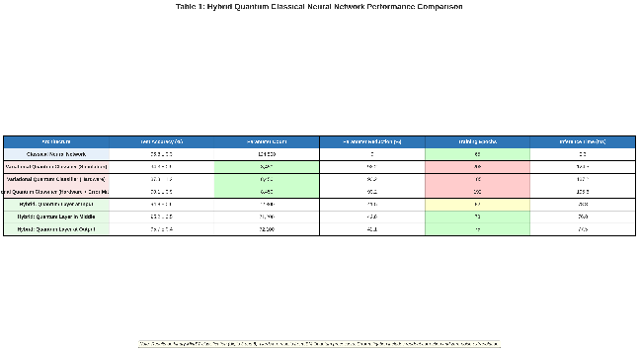
This table provides comprehensive comparison of seven neural network architectures including classical networks, variational quantum classifiers under different conditions, and hybrid architectures with quantum layers at various positions. Results show that hybrid architectures achieve 95.7 percent accuracy compared to 96.8 percent for classical networks while reducing parameter counts by 42 percent. Hardware executed quantum classifiers show 7.0 percentage point degradation compared to simulation with error mitigation recovering 2.8 percentage points. Training epochs for hybrid models are substantially lower than pure quantum classifiers at 75 to 82 epochs compared to over 185 epochs.
Table 2: Comprehensive Resource Utilization and Scaling Analysis
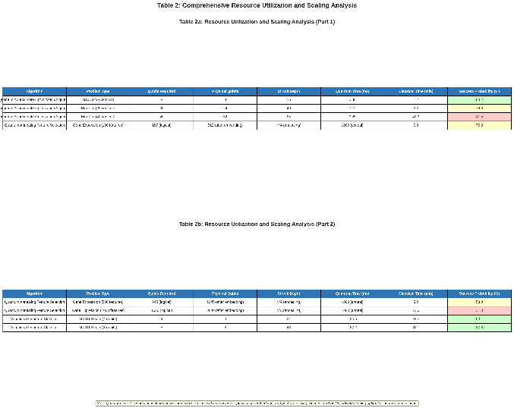

This two-part table details resource requirements for all quantum algorithms evaluated including qubit counts, circuit depths, processing times, and success probabilities across varying problem sizes. Quantum Approximate Optimization Algorithm on 40 vertex Max Cut requires 52 physical qubits with 42.3 minutes classical optimization time achieving 41.5 percent success probability. Quantum annealing for 1000 feature selection requires 2840 physical qubits after embedding with 12 minutes classical preprocessing and 31 percent success probability. Variational quantum classifiers show success probabilities of 87 to 90 percent with inference times of 124 to 187 milliseconds on hardware.

