Supporting Information

Enhancement of electrochromic properties of polyaniline induced by copper ions
Ting Qin¹, Lianwen Deng¹, Pin Zhang²*, Min Tang¹, Chen Li¹, Haipeng Xie¹, Shengxiang Huang¹, Xiaohui Gao¹*
1 School of Physics and Electronics, Central South University, Changsha, 410083, China
2 National Key Laboratory on Electromagnetic Environmental Effects and Electro-optical Engineering, Army Engineering University of PLA, Nanjing 210007, China

* Corresponding author. E-mail: 182211037@csu.edu.cn; xiaohuigao@csu.edu.cn

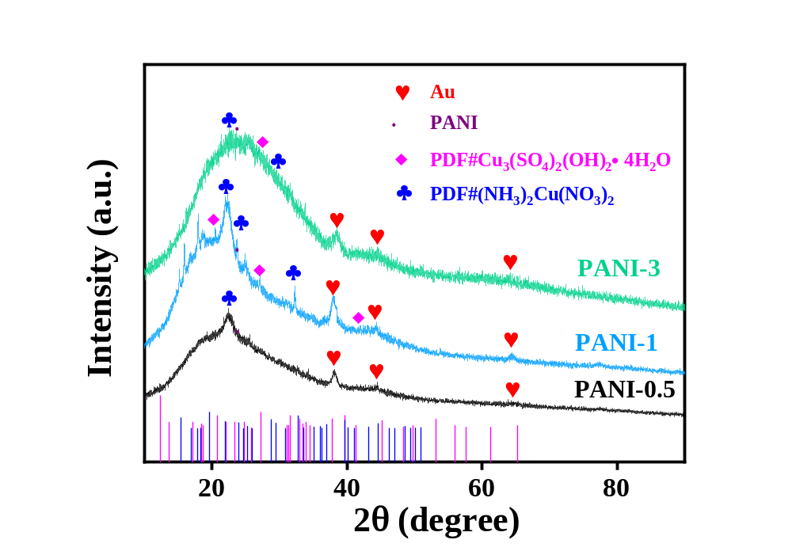
Fig S1. The XRD image of PANI-0.5, PANI-1 and PANI-3 porous films.
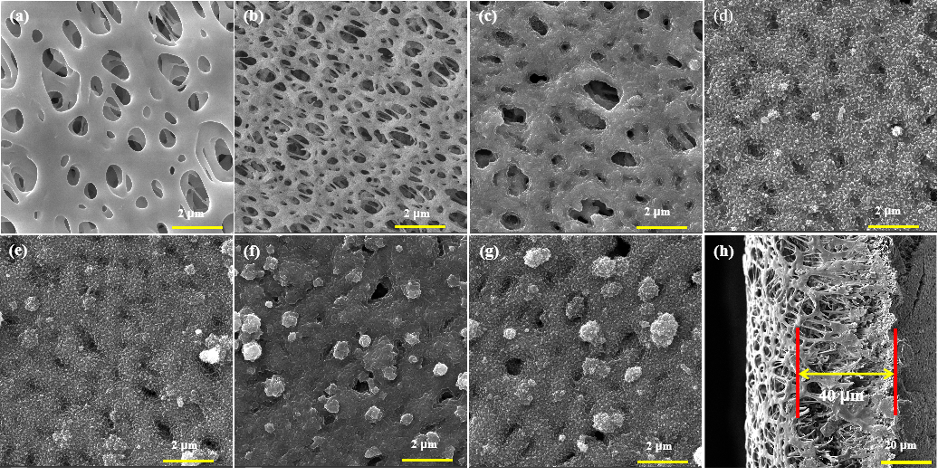
Fig S2. SEM images of (a) PES, (b) Au/PES membrane, (c) PANI-0, (d) PANI-0.5, (e) PANI-1, (f) PANI-2, (g) PANI-3 porous films and (h) cross sections of the PANI-2 porous films.
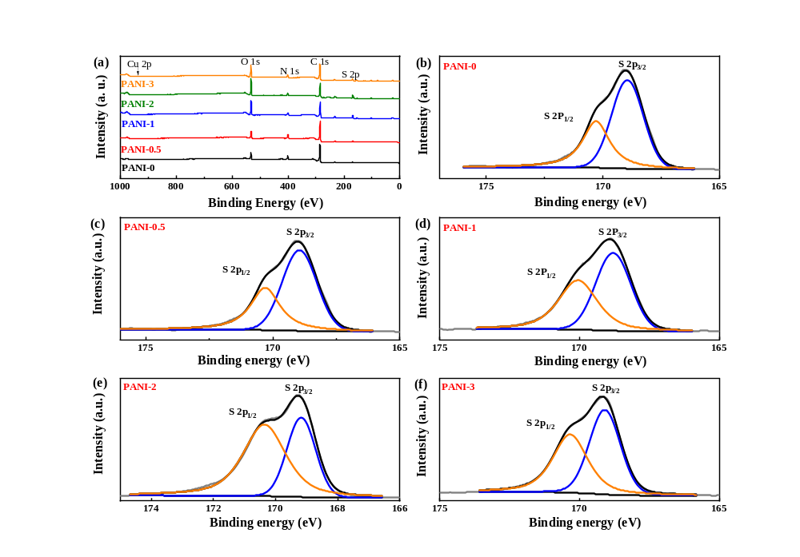
Fig S3. XPS spectra of: (a) survey spectrum, and XPS spectra of S 2p spectrum for (b) PANI-0, (c) PANI-0.5, (d) PANI-1, (e) PANI-2, and (f) PANI-3 porous films.
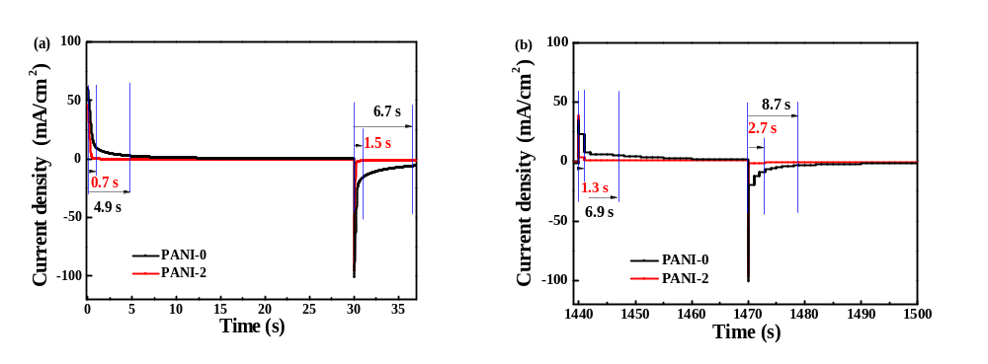
Fig S4. Response time of PANI-0 and PANI-2 porous films at 0.5 V and -0.25 V (a) 1st cycle, and (b) 50th cycles.
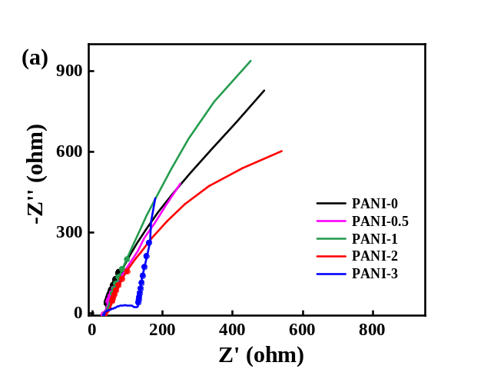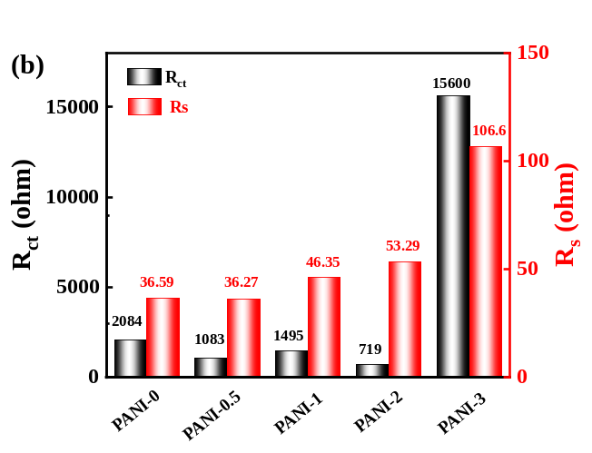
Fig S5. (a) Response time of 1st and 50th cycles of PANI-0 and PANI-2 porous films at 0.5 V and -0.25 V.

