PVA-Concentration-Regulated Conductive Inks for Low-Voltage-Driven Flexible Joule Heating Devices with Tunable Performance and Mechanical Robustness

Rongrong Yuan*, Yizhe Sun, Xiuzhi Du, LuTao, Xinhui Cui, Zhipeng Li and Xinqun Zhang
School of Electrical Engineering, Chuzhou Polytechnic, Chuzhou,
239000, People’s Republic of China
E-mail:yuanrongrong001@126.com

w% | PVA  (5%) | PVA  (10%) | PVA  (15%) | PEDOT:PSS | Cu@Ag（10%） | glycerin | BHT | SDS | CNF | SA
No.1 | 20.81 % |  |  | 20.39 % | 20.12 % | 11.07 % | 6.88 % | 1.17 % | 15.97 % | 2.57 %
No.2 |  | 20.75 % |  | 20.51 % | 20.19 % | 12.71 % | 6.08 % | 1.20 % | 15.94 % | 2.52 %
No.3 |  |  | 20.77 % | 20.67 % | 20.35 % | 11.95 % | 6.62 % | 1.19 % | 15.93 % | 2.50 %
Table SI The specific mass ratios of chemical reagents under different formulations

Table SII Adhesion Test Standard
ISO Grade | ASTM Grade | Test Result
0 | 5B | The edges of the cuts are completely smooth, and there is no peeling at the grid edges.
1 | 4B | There are small pieces of peeling at the intersections of the cuts, and the actual damage in the grid area does not exceed 5%.
2 | 3B | The edges and/or intersections of the cuts are peeled off, and the area is greater than 5% but less than 15%.
3 | 2B | There is partial peeling along the edges of the cuts or entire large pieces are peeled off, and/or some grids are completely peeled off in pieces. The peeled area exceeds 15% but is less than 35%.
4 | 1B | Large pieces are peeled off at the edges of the cuts/or some grids are partially or completely peeled off, and the area is greater than 35% of the grid area but not more than 65%.
5 | 0B | Exceeds the previous grade.

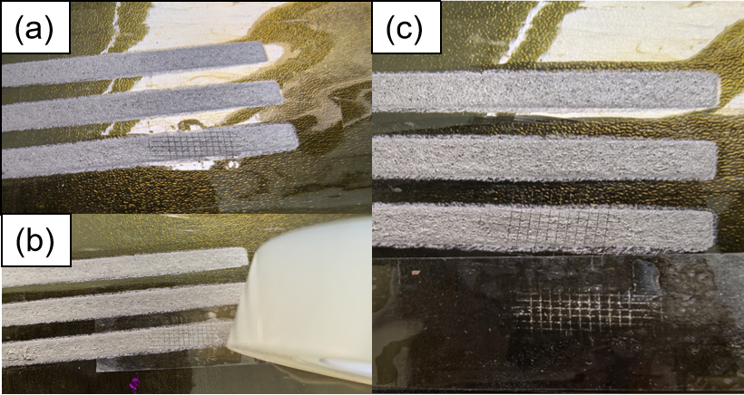
Figure S1 (a) Image of the ink printed on the PI substrate after cutting; (b) Photo of the 3M tape adhering to the ink on PI substrate; (c) Photo of the 3M tape adhering to the ink on the PI substrate.

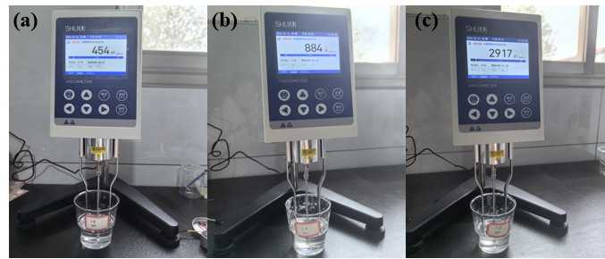
Figure S2. Digital photographs of the rotational viscometer measuring the viscosities of the PVA solutions with different concentrations: (a) 5 wt% PVA (454.09 mPa·s), (b) 10 wt% PVA (884.14 mPa·s), and (c) 15 wt% PVA (2917.01 mPa·s).

