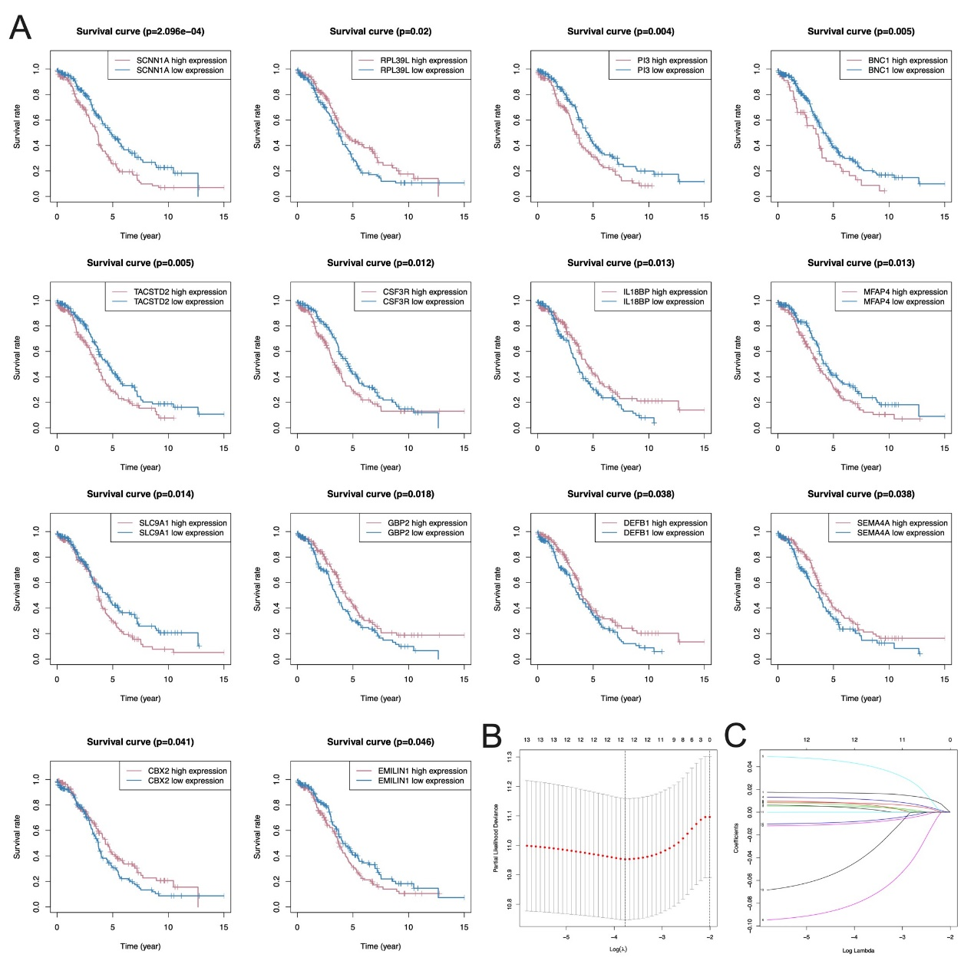
Figure S1. Prognostic value of DNA MDGs in ovarian cancer.
(A) KM analysis of the correlation between the fourteen DNA MDGs selected as candidate genes and OS of EOC patients.
(B) LASSO regression of the target genes.
(C) The twelve DNA MDGs were selected as candidate predictive genes.

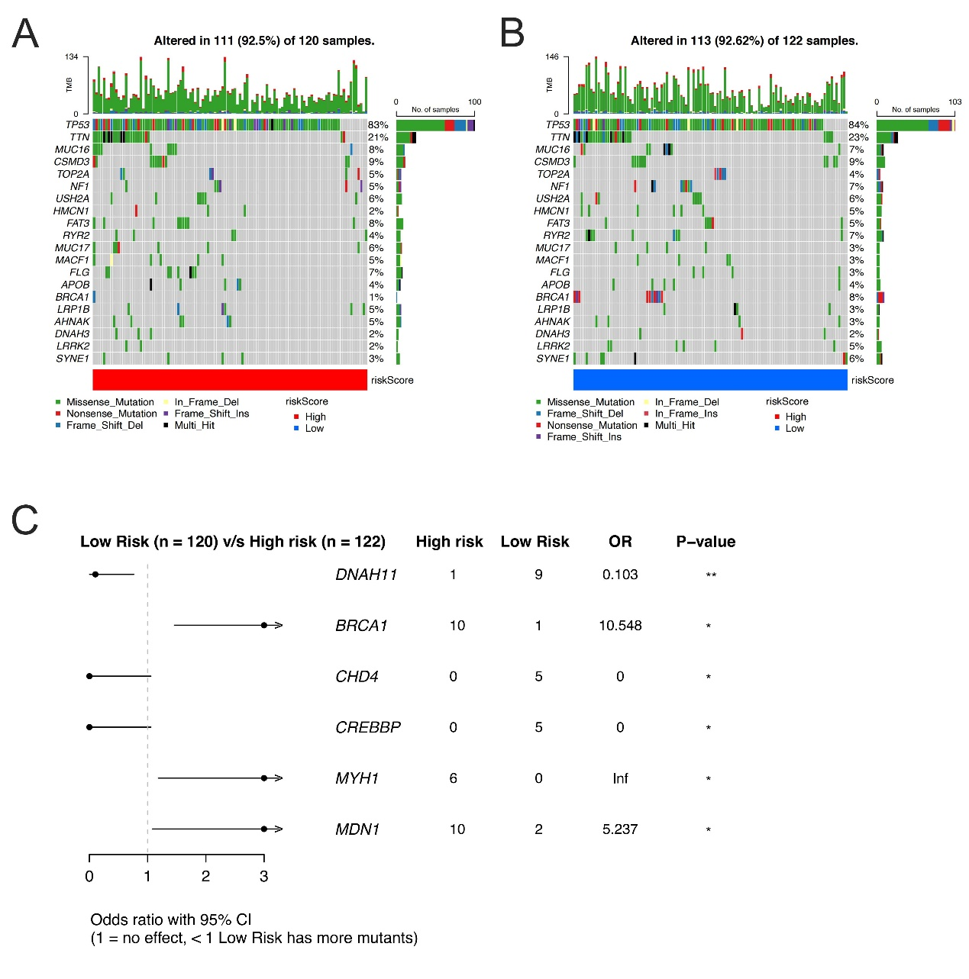
Figure S2. Mutational landscape of the two risk score groups.
(A) High risk group mutation landscape waterfall chart.
(B) Low risk group mutation landscape waterfall chart.
(C) the genes that exhibit significant differences in mutational rate between the two groups were illustrated by Forest plot.

Table S2. Univariate Cox results of the fourteen genes
id | HR | HR.95L | HR.95H | P value
MARVELD1 | 1.039343407 | 1.017433839 | 1.06172478 | 0.000385324
MFAP4 | 1.016532651 | 1.006518173 | 1.026646769 | 0.001169728
EMILIN1 | 1.023392948 | 1.009138608 | 1.037848635 | 0.001232993
PI3 | 1.009541748 | 1.00343774 | 1.015682887 | 0.002147346
SLC9A1 | 1.058983465 | 1.01797057 | 1.101648723 | 0.004458332
IL18BP | 0.923997081 | 0.872142623 | 0.978934619 | 0.007308281
FBLN2 | 1.021925715 | 1.004932856 | 1.039205914 | 0.011240512
STAT5A | 1.05403607 | 1.009107009 | 1.100965535 | 0.017890958
SCNN1A | 1.01656837 | 1.00196456 | 1.031385033 | 0.026027356
GSTP1 | 0.983559097 | 0.969299187 | 0.998028792 | 0.026096794
RPL39L | 0.980643537 | 0.963786767 | 0.997795134 | 0.027141745
MSX1 | 0.98659884 | 0.974233317 | 0.999121314 | 0.03603179
CD3G | 0.801195503 | 0.647927376 | 0.99071942 | 0.040753211
ACTA2 | 1.009574954 | 1.000335427 | 1.018899822 | 0.042208602

Table S3. The primers of the six genes and GAPDH
genes | primers
SLC9A1 | F | 5’AGAAATTTAAGGAAATT3’
SLC9A1 | R | 5’TGAGACCTTAAAGTACTGT3’
MARVELD1 | F | 5’GGGCCTGTAAGGTTTCCATGT3’
MARVELD1 | R | 5’CCCCTACTGCCAGTGAAGAC3’
PI3 | F | 5’TGGCTCCTGCCCCATTATC3’
PI3 | R | 5’CAGTATCTTTCAAGCAGCGGTTAG3’
MFAP4 | F | 5’GGCTCAGTAAGTTTCTTCCGCG3’
MFAP4 | R | 5’CCAAGTCCACTCGCAGCTCATA3’
MSX1 | F | 5’ACCTCTTTGCTCCCTGAGTTCAC3’
MSX1 | R | 5’GACTCTTCCAGCCACTTTTTGG3’
IL18BP | F | 5’GAGGGCCACACAAGTCGC3’
IL18BP | R | 5’GCTGGGCCAGAATGATGTGA3’
GAPDH | F | 5’AAATCAAGTGGGGCGATGCT3’
GAPDH | R | 5’CAAATGAGCCCCAGCCTTCT3’

Table S1. DNA MDGs of EOC after MethylMix R package screen.
gene | normalMean | TumorMean | logFC | pValue | adjustP | cor | corPavlue
VSIG2 | 0.350697516 | 0.600459483 | 0.77583969 | 5.61E-05 | 0.019475695 | -0.767141236 | 2.45E-73
ALPK3 | 0.801920391 | 0.891410344 | 0.15263068 | 1.43E-06 | 0.000497314 | -0.763310339 | 3.37E-72
DQX1 | 0.856784929 | 0.91201831 | 0.090129686 | 9.46E-05 | 0.032819274 | -0.740987451 | 5.73E-66
S100A1 | 0.705379285 | 0.3642429 | -0.953498355 | 4.15E-07 | 0.000144041 | -0.725489639 | 5.22E-62
AMT | 0.307478203 | 0.629958677 | 1.034773053 | 3.99E-08 | 1.38E-05 | -0.67907801 | 1.28E-51
CLDN16 | 0.85857015 | 0.289342822 | -1.56915616 | 3.30E-09 | 1.15E-06 | -0.622680946 | 2.55E-41
ACOX2 | 0.211464222 | 0.528652798 | 1.321906928 | 5.32E-07 | 0.000184682 | -0.616105516 | 2.97E-40
CLDN15 | 0.675147533 | 0.919629648 | 0.445850184 | 3.20E-08 | 1.11E-05 | -0.572792563 | 8.12E-34
PAX8 | 0.718461471 | 0.404953164 | -0.827155731 | 3.21E-07 | 0.000111376 | -0.570833779 | 1.51E-33
SFN | 0.816354383 | 0.477999053 | -0.772187808 | 4.21E-06 | 0.001460938 | -0.567291106 | 4.57E-33
PARP3 | 0.557805873 | 0.366194099 | -0.607154582 | 9.43E-06 | 0.003271073 | -0.558184548 | 7.45E-32
TRIM29 | 0.956907627 | 0.717763155 | -0.414871798 | 7.43E-07 | 0.000257978 | -0.558081681 | 7.69E-32
MFAP4 | 0.137648356 | 0.369594697 | 1.424956673 | 4.30E-05 | 0.014920047 | -0.544229762 | 4.56E-30
EMILIN1 | 0.613176032 | 0.85838 | 0.485315157 | 1.16E-08 | 4.01E-06 | -0.53949207 | 1.76E-29
CDO1 | 0.24135674 | 0.686827999 | 1.508781738 | 2.04E-08 | 7.08E-06 | -0.536741372 | 3.83E-29
LDHD | 0.111875307 | 0.354049138 | 1.662057959 | 5.22E-06 | 0.001812732 | -0.524731577 | 1.04E-27
FCGRT | 0.204535453 | 0.492543294 | 1.267899605 | 4.41E-06 | 0.001530966 | -0.512853017 | 2.42E-26
CFTR | 0.126938958 | 0.586783777 | 2.208694079 | 2.14E-06 | 0.000742306 | -0.509558478 | 5.66E-26
CFB | 0.644637532 | 0.256483651 | -1.329621322 | 1.17E-07 | 4.05E-05 | -0.508696951 | 7.06E-26
TRIM22 | 0.283323843 | 0.500314812 | 0.820384146 | 2.72E-05 | 0.009440389 | -0.504698023 | 1.95E-25
SCNN1A | 0.620066141 | 0.37505209 | -0.725331129 | 3.20E-05 | 0.011088004 | -0.499665826 | 6.88E-25
OLFML1 | 0.665566573 | 0.792329148 | 0.251516898 | 1.00E-06 | 0.000347961 | -0.496787928 | 1.40E-24
PYCR1 | 0.514583656 | 0.349171222 | -0.559470978 | 9.14E-07 | 0.000317013 | -0.489065454 | 9.14E-24
CHST3 | 0.598846058 | 0.913782362 | 0.609665412 | 1.58E-09 | 5.50E-07 | -0.487113613 | 1.46E-23
CSTA | 0.793949719 | 0.552261564 | -0.523695922 | 3.95E-05 | 0.01371306 | -0.481744165 | 5.18E-23
TMEM101 | 0.02769477 | 0.145560841 | 2.393936807 | 9.65E-05 | 0.033488023 | -0.469839788 | 7.98E-22
TNFAIP8 | 0.875208181 | 0.578447022 | -0.597441391 | 8.91E-06 | 0.003090943 | -0.463854192 | 3.03E-21
CRYGD | 0.346411538 | 0.786077253 | 1.182184121 | 2.28E-08 | 7.93E-06 | -0.460383496 | 6.49E-21
GSTM5 | 0.676850989 | 0.910930927 | 0.428503409 | 1.93E-07 | 6.70E-05 | -0.448962944 | 7.50E-20
PCDHB3 | 0.343273417 | 0.627295231 | 0.869786455 | 1.59E-05 | 0.005532227 | -0.448902258 | 7.59E-20
STAT5A | 0.485604209 | 0.280876224 | -0.789846419 | 3.55E-05 | 0.012334377 | -0.444900495 | 1.75E-19
HTATIP2 | 0.436523803 | 0.180171767 | -1.276687368 | 4.33E-08 | 1.50E-05 | -0.444729253 | 1.81E-19
CSF3R | 0.517544162 | 0.789801112 | 0.609807426 | 1.75E-08 | 6.06E-06 | -0.443793588 | 2.20E-19
MARVELD1 | 0.431033471 | 0.544115893 | 0.336114066 | 4.75E-05 | 0.016484132 | -0.441583008 | 3.47E-19
GNE | 0.460616521 | 0.739375013 | 0.682740132 | 1.63E-07 | 5.65E-05 | -0.437748895 | 7.59E-19
CYP4F11 | 0.736228424 | 0.508220813 | -0.534697991 | 0.000120293 | 0.041741576 | -0.434138808 | 1.57E-18
MSX1 | 0.825095173 | 0.932471655 | 0.17649933 | 1.25E-06 | 0.00043443 | -0.42909556 | 4.27E-18
LTF | 0.420493228 | 0.734182126 | 0.804055425 | 1.06E-07 | 3.69E-05 | -0.427179339 | 6.22E-18
MKRN3 | 0.831292472 | 0.641438268 | -0.374045718 | 1.55E-05 | 0.005381453 | -0.426806727 | 6.69E-18
USP44 | 0.756175858 | 0.878555514 | 0.216411659 | 8.53E-07 | 0.000296017 | -0.420127613 | 2.43E-17
KCTD14 | 0.950696849 | 0.819463463 | -0.214305752 | 1.52E-06 | 0.000528649 | -0.419938297 | 2.52E-17
PELO | 0.136827899 | 0.261733005 | 0.935733443 | 2.75E-05 | 0.009542544 | -0.417838726 | 3.76E-17
MLPH | 0.133345266 | 0.080837927 | -0.722062374 | 1.01E-05 | 0.003520285 | -0.415016558 | 6.40E-17
ACTA2 | 0.576101099 | 0.800722893 | 0.474981045 | 1.47E-06 | 0.000509631 | -0.414512138 | 7.04E-17
LEFTY2 | 0.285987033 | 0.692599623 | 1.276071865 | 4.90E-08 | 1.70E-05 | -0.404362801 | 4.57E-16
SREBF1 | 0.648547504 | 0.8054958 | 0.312664815 | 3.81E-05 | 0.013214584 | -0.403899296 | 4.97E-16
DDO | 0.291979537 | 0.579560731 | 0.989092584 | 7.01E-06 | 0.002432706 | -0.396323496 | 1.93E-15
APOL1 | 0.07239947 | 0.149255707 | 1.043735067 | 2.52E-05 | 0.008753876 | -0.396031489 | 2.03E-15
RPL39L | 0.334279192 | 0.112055625 | -1.576838482 | 2.38E-08 | 8.27E-06 | -0.395413558 | 2.26E-15
FGFR1 | 0.566418301 | 0.767258305 | 0.437844478 | 1.07E-05 | 0.003724204 | -0.394866003 | 2.49E-15
CTSS | 0.11102602 | 0.21101787 | 0.926467347 | 3.54E-05 | 0.012268985 | -0.394813308 | 2.51E-15
TM4SF1 | 0.274768086 | 0.130780897 | -1.071062628 | 1.24E-05 | 0.004308582 | -0.39121339 | 4.71E-15
TNF | 0.589436558 | 0.2601824 | -1.179813167 | 1.66E-06 | 0.000575709 | -0.389897463 | 5.91E-15
IL18 | 0.188126496 | 0.099359207 | -0.920977482 | 5.97E-06 | 0.002070847 | -0.388224297 | 7.88E-15
AQP5 | 0.32960309 | 0.181232828 | -0.862885461 | 4.48E-05 | 0.015560725 | -0.386778183 | 1.01E-14
PFKM | 0.635277209 | 0.337788354 | -0.911266674 | 7.77E-06 | 0.002696474 | -0.385827461 | 1.19E-14
PI3 | 0.883937013 | 0.524209134 | -0.753801078 | 2.04E-07 | 7.06E-05 | -0.383019464 | 1.91E-14
AQP1 | 0.790545397 | 0.920795153 | 0.220031929 | 5.29E-07 | 0.000183507 | -0.376896706 | 5.31E-14
HMGCS2 | 0.890956378 | 0.7575944 | -0.233929131 | 2.50E-05 | 0.008659736 | -0.374928117 | 7.34E-14
TPM1 | 0.860194324 | 0.92015372 | 0.097212285 | 1.96E-05 | 0.006817057 | -0.37470251 | 7.61E-14
PLCD1 | 0.592003284 | 0.731113644 | 0.304490496 | 4.93E-05 | 0.017098669 | -0.372723192 | 1.05E-13
MYOCD | 0.856251397 | 0.944715136 | 0.141844936 | 1.30E-06 | 0.000450854 | -0.368007868 | 2.25E-13
IL1R2 | 0.268443634 | 0.488385191 | 0.863400262 | 3.57E-06 | 0.001239244 | -0.367836168 | 2.31E-13
PARVG | 0.719189457 | 0.46722777 | -0.622245847 | 4.08E-05 | 0.01415444 | -0.366909098 | 2.68E-13
MESP1 | 0.871426389 | 0.691190178 | -0.334296085 | 6.04E-07 | 0.000209608 | -0.364909048 | 3.69E-13
SAMD10 | 0.503447087 | 0.232279327 | -1.115979396 | 1.68E-07 | 5.84E-05 | -0.363825755 | 4.38E-13
BNC1 | 0.562383308 | 0.780980307 | 0.473732395 | 1.13E-06 | 0.000393781 | -0.363474354 | 4.63E-13
ZNF154 | 0.135005783 | 0.771296495 | 2.514264346 | 4.91E-09 | 1.71E-06 | -0.363368255 | 4.71E-13
TMPRSS3 | 0.404427 | 0.135899529 | -1.573338862 | 3.24E-08 | 1.12E-05 | -0.362990794 | 4.99E-13
MPZ | 0.757008308 | 0.840768607 | 0.151399668 | 2.76E-05 | 0.009593936 | -0.362337748 | 5.53E-13
LRFN4 | 0.983291153 | 0.910928643 | -0.110280617 | 3.99E-05 | 0.013858149 | -0.361357034 | 6.45E-13
FBLN2 | 0.234828203 | 0.488717949 | 1.057396401 | 1.99E-06 | 0.000690485 | -0.360271959 | 7.64E-13
GBP2 | 0.092154786 | 0.188650736 | 1.033586727 | 8.61E-06 | 0.002987401 | -0.35864604 | 9.84E-13
GOLT1A | 0.45522462 | 0.654707204 | 0.524271269 | 4.04E-05 | 0.014005772 | -0.356467104 | 1.38E-12
GSTP1 | 0.874364294 | 0.424847614 | -1.041289024 | 8.67E-09 | 3.01E-06 | -0.353202907 | 2.27E-12
TMED6 | 0.579109937 | 0.835419593 | 0.528663725 | 9.53E-06 | 0.003308249 | -0.353035166 | 2.33E-12
TNKS | 0.044882859 | 0.108885925 | 1.278580993 | 1.81E-06 | 0.000626787 | -0.351838228 | 2.79E-12
TOP1MT | 0.618393756 | 0.291142163 | -1.086801966 | 8.18E-09 | 2.84E-06 | -0.351525194 | 2.93E-12
GJA5 | 0.263573319 | 0.529511817 | 1.006458545 | 7.49E-08 | 2.60E-05 | -0.348583964 | 4.55E-12
NFATC3 | 0.067632181 | 0.165073577 | 1.287327439 | 5.22E-07 | 0.000181198 | -0.348171868 | 4.84E-12
RNF43 | 0.291749693 | 0.139945342 | -1.05986767 | 2.49E-06 | 0.000862498 | -0.344806596 | 7.98E-12
SEMA4A | 0.388904235 | 0.209268976 | -0.894056499 | 8.00E-05 | 0.027765556 | -0.344646673 | 8.17E-12
GLRX | 0.376914616 | 0.647352639 | 0.780314078 | 3.54E-05 | 0.012268916 | -0.342224821 | 1.17E-11
RNF41 | 0.934151652 | 0.663650974 | -0.493232077 | 6.19E-08 | 2.15E-05 | -0.342092138 | 1.19E-11
RARRES2 | 0.796052229 | 0.532738198 | -0.579436361 | 1.55E-06 | 0.00053841 | -0.340489628 | 1.50E-11
ATP5A1 | 0.148180577 | 0.269587397 | 0.863396691 | 3.95E-05 | 0.013713047 | -0.336734401 | 2.58E-11
S100A14 | 0.485673817 | 0.226362647 | -1.101351803 | 1.13E-06 | 0.00039136 | -0.336477508 | 2.68E-11
IL18BP | 0.620961859 | 0.790328165 | 0.347947164 | 3.61E-05 | 0.01253238 | -0.334786968 | 3.41E-11
KCTD9 | 0.028467167 | 0.041750107 | 0.552480959 | 7.41E-05 | 0.025720267 | -0.334585505 | 3.51E-11
DEFB1 | 0.258985474 | 0.154672599 | -0.74365354 | 1.03E-05 | 0.003580321 | -0.33414711 | 3.74E-11
SLC9A1 | 0.118626383 | 0.204463627 | 0.785419315 | 0.000127681 | 0.044305328 | -0.33324756 | 4.24E-11
SNTB1 | 0.860898295 | 0.326864368 | -1.397150696 | 6.33E-10 | 2.20E-07 | -0.332669741 | 4.61E-11
SPARCL1 | 0.150385143 | 0.606478659 | 2.011794832 | 3.88E-09 | 1.35E-06 | -0.332278004 | 4.87E-11
KCNJ11 | 0.523681473 | 0.335944257 | -0.640467701 | 2.47E-05 | 0.008566576 | -0.331881529 | 5.15E-11
CBX2 | 0.351606636 | 0.181570127 | -0.953435438 | 6.47E-06 | 0.002244813 | -0.331632525 | 5.33E-11
SYK | 0.219853882 | 0.098324441 | -1.160923022 | 1.51E-06 | 0.000522238 | -0.330999524 | 5.83E-11
TMEM87A | 0.07486882 | 0.168651391 | 1.171607308 | 4.60E-07 | 0.000159546 | -0.330898921 | 5.91E-11
C19orf33 | 0.599646307 | 0.267828656 | -1.162801471 | 5.21E-09 | 1.81E-06 | -0.328976668 | 7.73E-11
ARSE | 0.236787413 | 0.584673224 | 1.304038129 | 4.90E-07 | 0.000170041 | -0.328655554 | 8.09E-11
NOXA1 | 0.396410326 | 0.187792216 | -1.077857279 | 1.48E-07 | 5.15E-05 | -0.328118767 | 8.71E-11
SFTPB | 0.706456009 | 0.810430583 | 0.19808889 | 5.91E-05 | 0.020511367 | -0.327943482 | 8.93E-11
MAGEA4 | 0.94004891 | 0.821724277 | -0.194081431 | 8.86E-07 | 0.0003073 | -0.326495339 | 1.09E-10
TOB1 | 0.363753916 | 0.696915671 | 0.938021315 | 6.89E-06 | 0.002391229 | -0.326405779 | 1.10E-10
STMN1 | 0.241735511 | 0.140751223 | -0.780281965 | 5.70E-06 | 0.001977312 | -0.325128296 | 1.32E-10
C9orf64 | 0.259418704 | 0.171881924 | -0.593864667 | 5.88E-05 | 0.020405548 | -0.323609372 | 1.62E-10
ACOT2 | 0.434683421 | 0.232899782 | -0.900255782 | 1.26E-06 | 0.000437241 | -0.323368019 | 1.68E-10
TACSTD2 | 0.099738689 | 0.201036009 | 1.0112288 | 1.57E-05 | 0.005441261 | -0.322844847 | 1.80E-10
CXADR | 0.356742915 | 0.124066653 | -1.523769386 | 1.05E-07 | 3.64E-05 | -0.321212194 | 2.25E-10
CD3G | 0.689966828 | 0.780196693 | 0.17731088 | 4.44E-06 | 0.001539919 | -0.320392943 | 2.51E-10
ARHGDIA | 0.025955064 | 0.093924789 | 1.855489912 | 4.53E-05 | 0.015724989 | -0.318698026 | 3.16E-10
BBOX1 | 0.426929456 | 0.156028047 | -1.452192315 | 1.46E-07 | 5.08E-05 | -0.31630592 | 4.34E-10

