Additional file 1: agronomic traits of the wild-type and the mutant wheat cultivar ‘Long 13-3778’.

Samples | tillering | average hight (cm) | average 1st stem length (cm) | average 2nd stem length (cm) | average 3rd stem length (cm) | average 1st stem width (cm) | average 2nd stem width (cm) | average 3rd stem width (cm) | GI**
LQ1802 | 4 | 69.65 | 5.25 | 10.03 | 16.82 | 2.64 | 3.12 | 3.31 | 0.0771
LQ1803 | 4 | 76.55 | 6.38 | 10.40 | 18.80 | 3.26 | 3.65 | 3.47 | 0.02
LQ1805 | 5 | 80.40 | 3.90 | 9.76 | 16.30 | 3.38 | 3.64 | 3.76 | 0.0114
LQ1806 | 5 | 74.04 | 3.76 | 15.62 | 10.00 | 3.16 | 3.77 | 3.81 | 0.12
LQ1807 | 7 | 80.23 | 6.39 | 10.05 | 19.90 | 3.74 | 4.05 | 3.91 | 0.06
LQ1808 | 6 | 81.73 | 4.60 | 11.18 | 17.07 | 3.38 | 3.97 | 3.93 | 0.0571
LQ1809 | 4 | 74.38 | 4.80 | 9.83 | 16.45 | 3.01 | 3.30 | 3.35 | 0.0229
LQ1810 | 5 | 83.76 | 4.70 | 12.14 | 16.74 | 3.21 | 3.58 | 3.88 | 0.0429
LQ1811 | 9 | 73.28 | 3.77 | 9.96 | 15.59 | 3.26 | 3.54 | 3.46 | 0.04
LQ1813 | 8 | 80.06 | 4.03 | 10.37 | 13.43 | 3.04 | 3.40 | 3.35 | 0.0257
LQ1815 | 6 | 63.65 | 5.33 | 8.85 | 13.17 | 2.97 | 3.30 | 3.53 | 0.0029
Y-2 | 5 | 79.68 | 4.14 | 8.44 | 13.45 | 3.18 | 3.65 | 3.63 | 0.5943
Y-3 | 7 | 89.72 | 3.91 | 8.34 | 13.10 | 3.34 | 3.77 | 3.82 | 0.3771
Y-4 | 5 | 78.90 | 2.96 | 7.90 | 13.22 | 2.94 | 3.43 | 3.42 | 0.5429
Y-5 | 10 | 82.66 | 3.17 | 8.19 | 12.73 | 3.55 | 3.92 | 4.10 | 0.3429
Y-6 | 6 | 67.78 | 3.12 | 6.75 | 10.82 | 2.96 | 3.36 | 3.66 | 0.5314
Y-7 | 4 | 76.10 | 2.45 | 6.45 | 11.05 | 2.97 | 3.49 | 3.77 | 0.3714
Y-8 | 7 | 64.22 | 2.60 | 6.90 | 10.96 | 2.73 | 3.47 | 3.21 | 0.2286

"LQ1802-LQ1815": the selfings of the mutant LQ18; "Y2-Y8": the wild-type ‘Long 13-3778’.

Additional file 2: expression of the ABI5-like gene ‘TraesCS2A02G099400’.
gene_ID | gene_family | FPKM_wildtype | FPKM_LQ1815 | FPKM_LQ1813 | Sig_CvT15 | Sig_CvT13
TraesCS2A02G099400 | ABI-5 like | 0.02±0.01 | 0.74±0.12 | 0.08±0.06 | Up | Up
“Sig_CvT15” and “Sig_CvT13” indicate the significance of the expression of LQ1815 and LQ1813 compared to the wild-type, respectively. “UP” and “DOWN” indicate up-regulation and down regulation (P=0.05).

Additional file 3: directed acyclic graphs of GO enrichment of the intersection genes.
A: biological process.
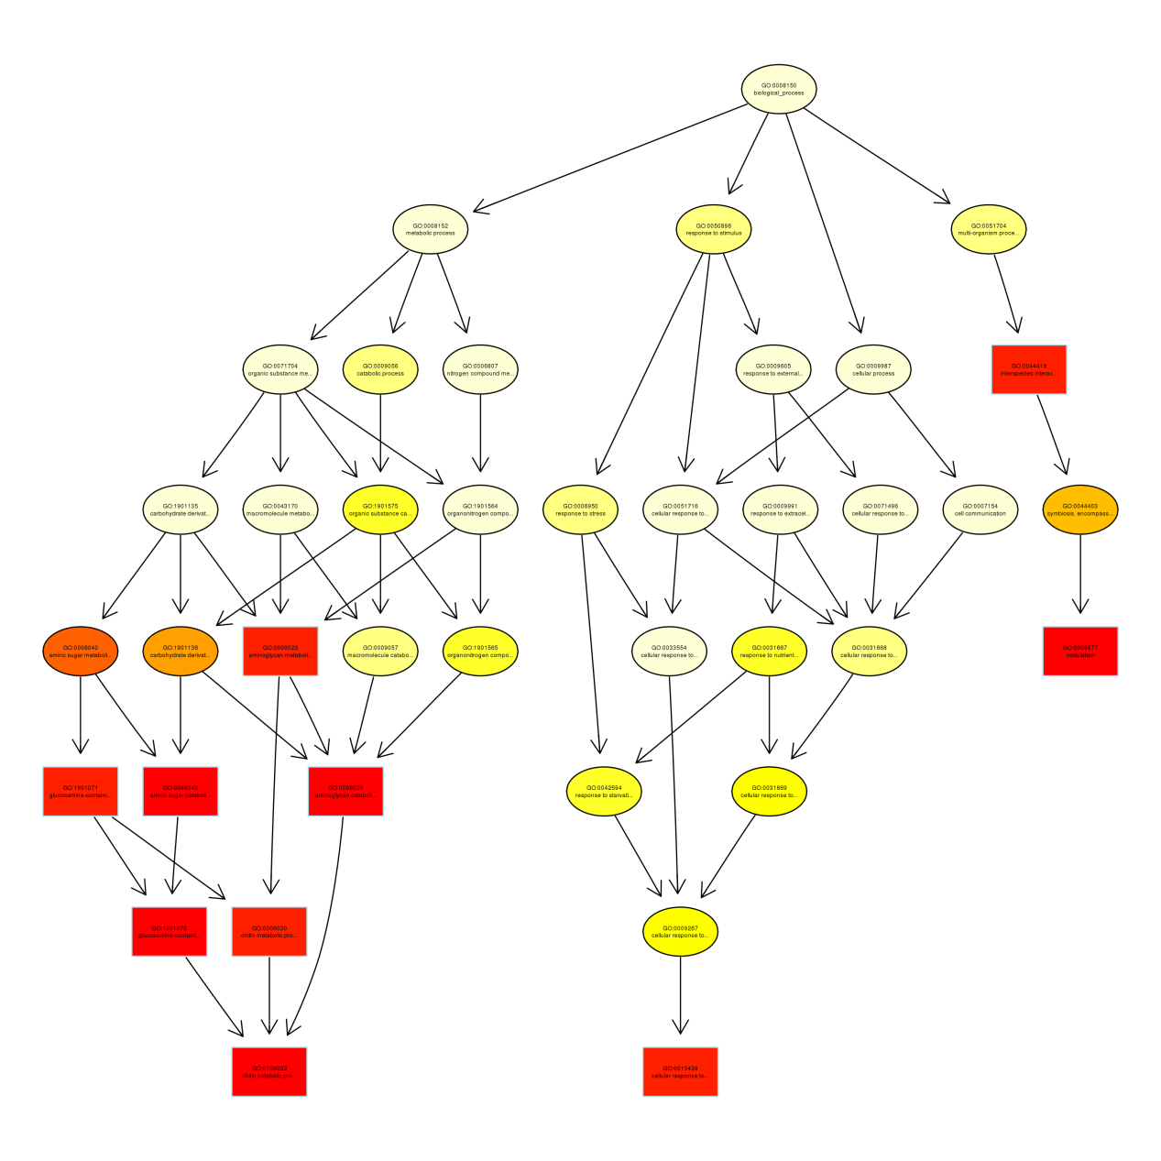
B: cellular component
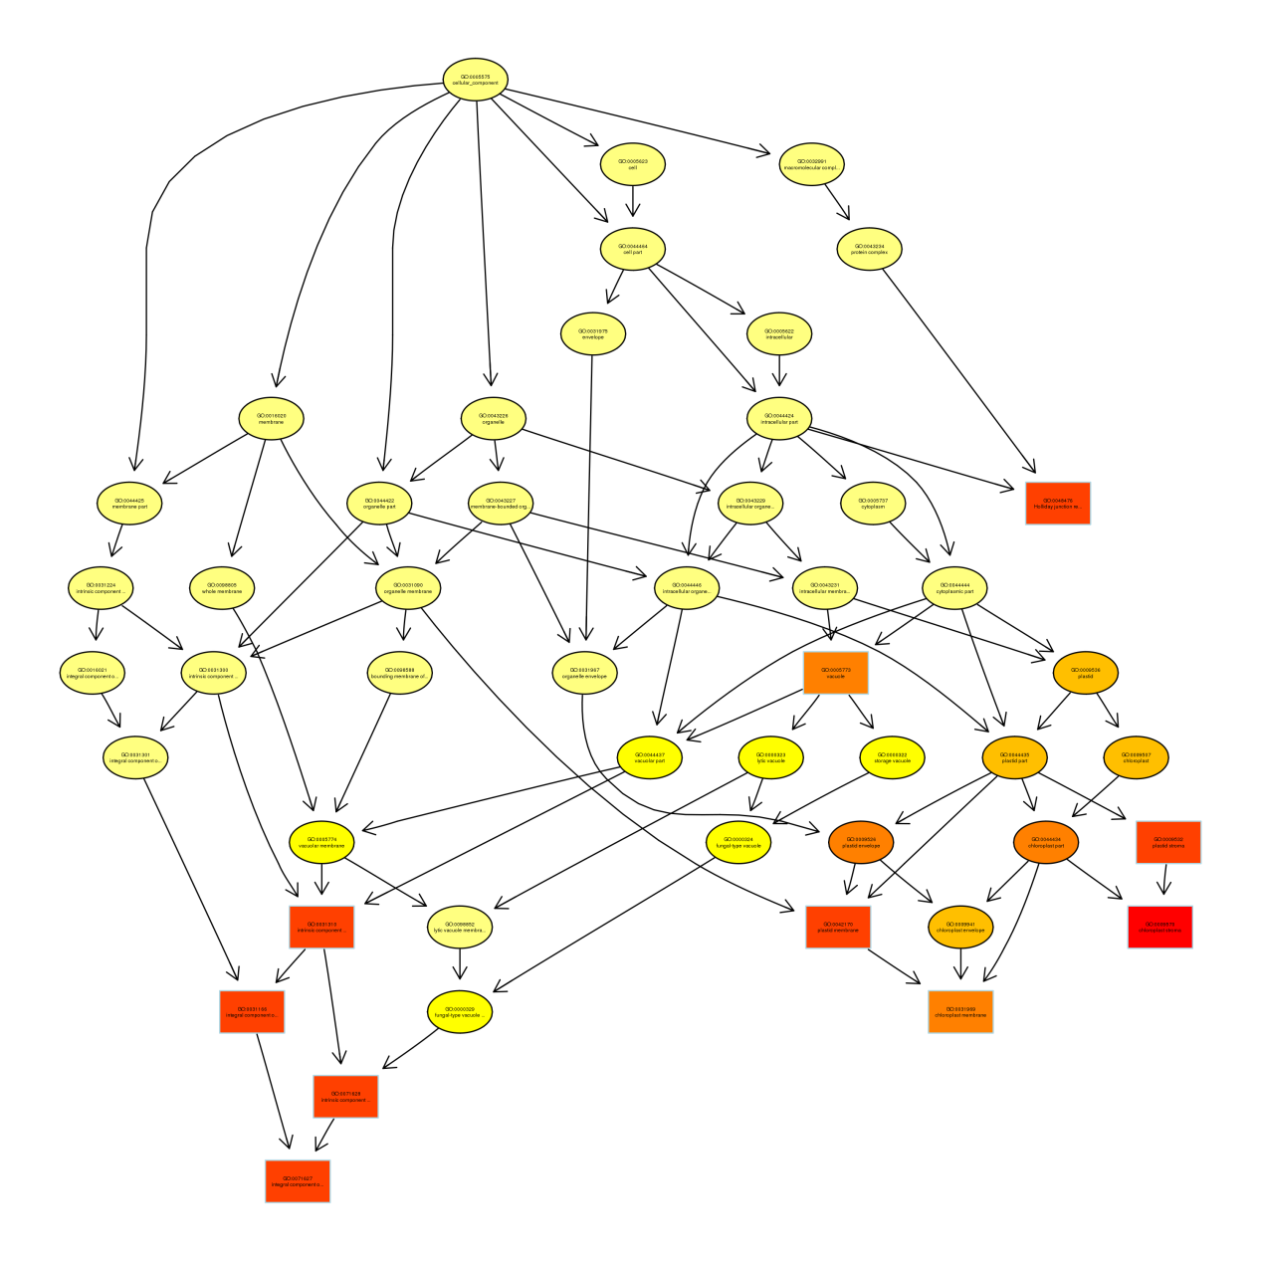
C: molecular function
