Supplementary information
Sustainable Lignin–Acrylonitrile Copolymers via Aqueous Free Radical Polymerization for Carbon Materials Development
Marta C. Lourenço¹, Talita Nascimento¹, Ana C. Marques², Marta Ramos-Andrés^{1,3}

¹Centro de Recursos Naturais e Ambiente (CERENA), Instituto Superior Técnico, Universidade de Lisboa, Avenida Rovisco Pais, 1049-001 Lisbon, Portugal
²CERENA, Department of Chemical Engineering, Instituto Superior Técnico, Universidade de Lisboa, Avenida Rovisco Pais, 1049-001 Lisbon, Portugal
³Bioeconomy Institute of the University of Valladolid (BioEcoUVa), PressTech Group, Department of Chemical Engineering and Environmental Technology, School of Industrial Engineering, University of Valladolid, Paseo Prado de la Magdalena 3-5, 47011 Valladolid, Spain

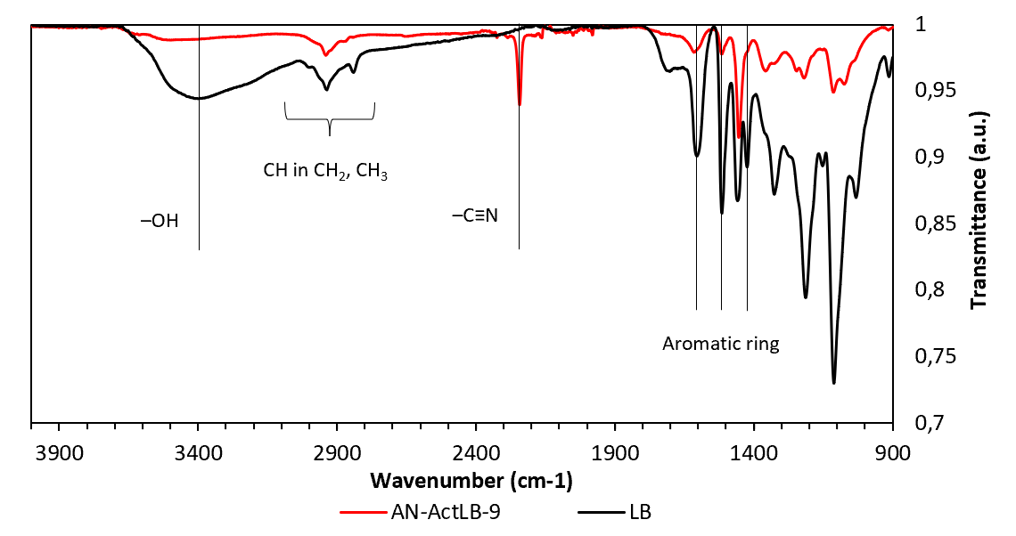
Figure SI.1 – ATR-FTIR spectra of LB and AN-ActLB-9.

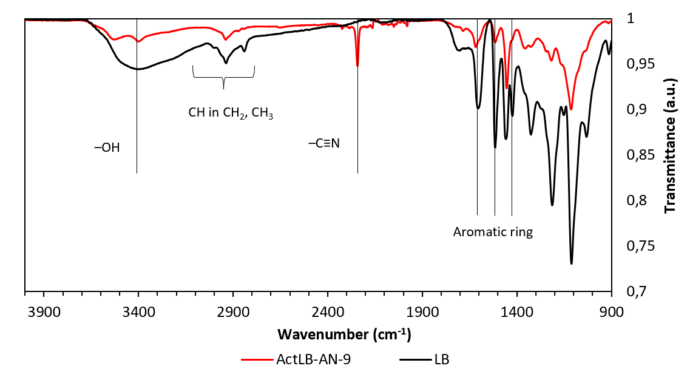
Figure SI.2 – ATR-FTIR spectra of LB and ActLB-AN-9.
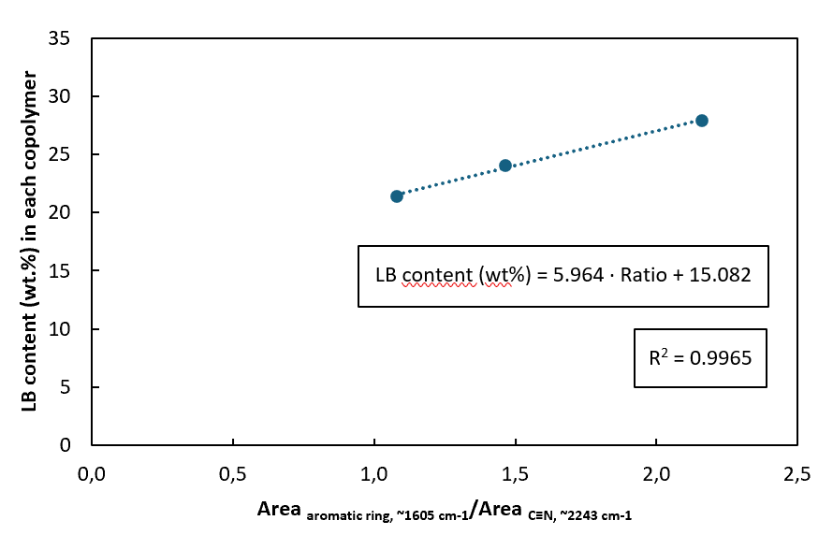
Figure SI.3 – Correlation between lignin incorporation in copolymers and the area ratio of aromatic to nitrile groups in ATR-FTIR spectra.
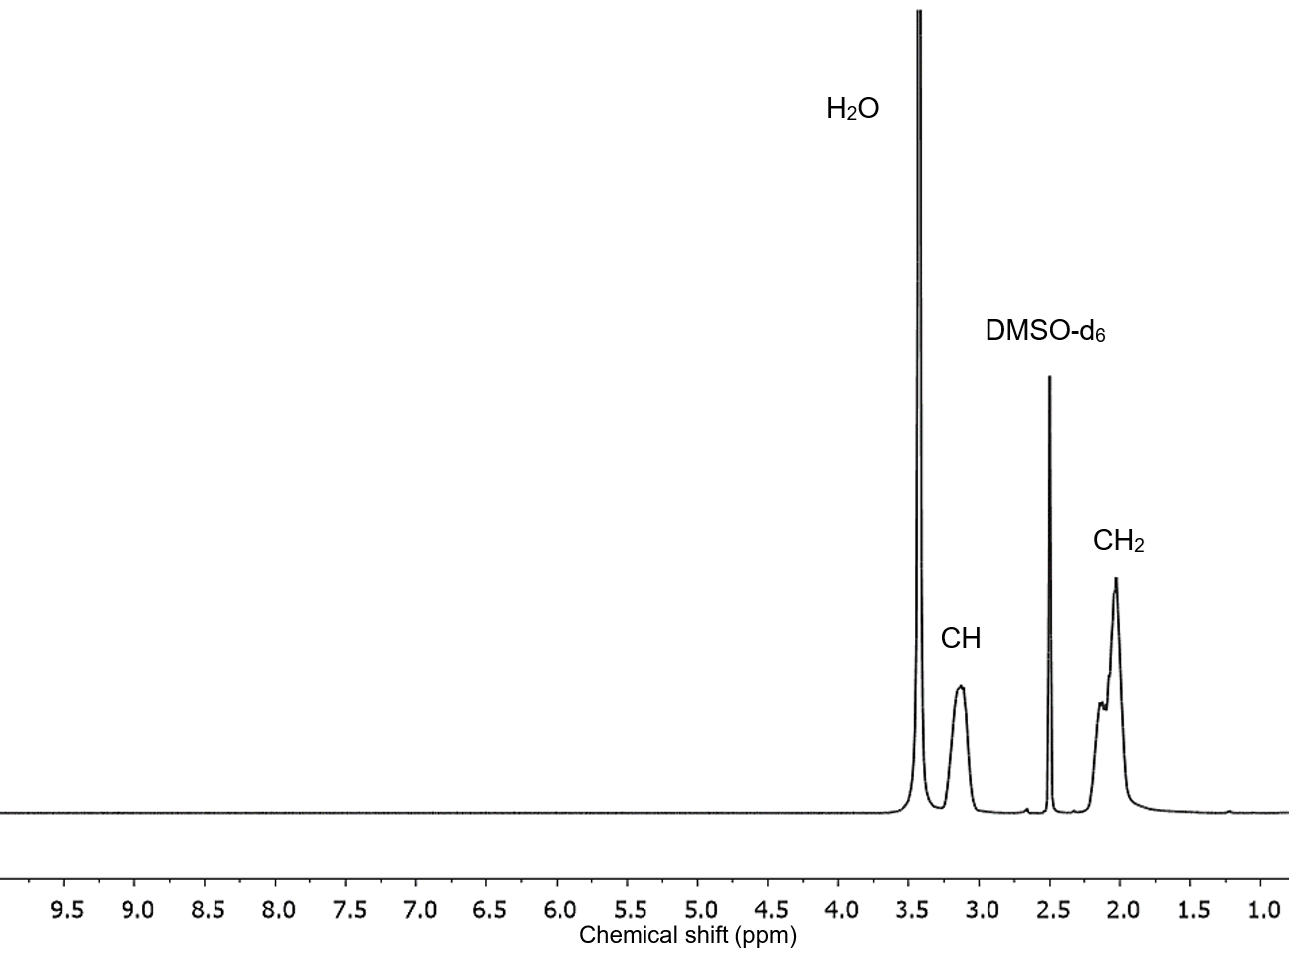
Figure SI.4 – ¹H-NMR spectrum of PAN.
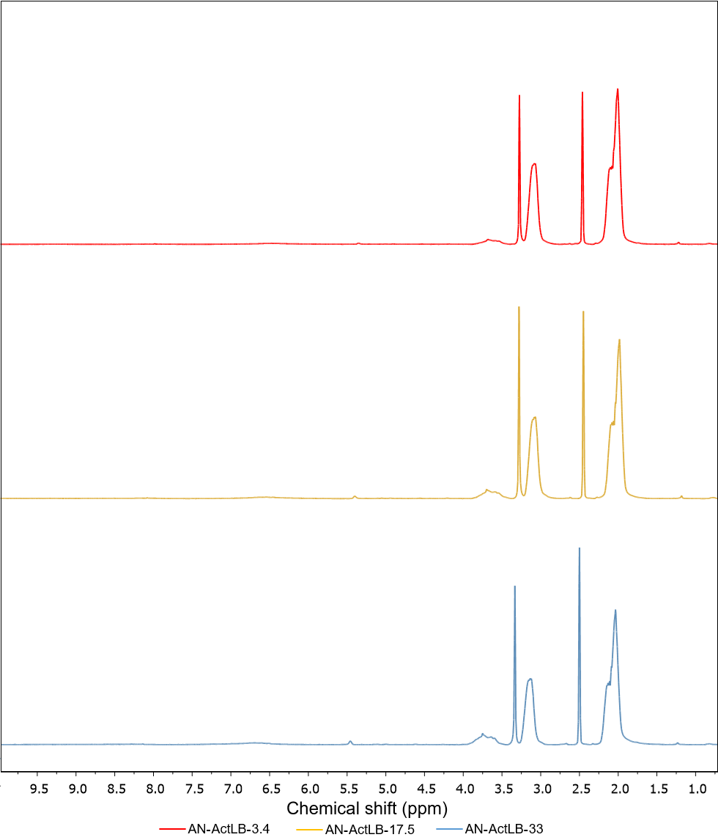
Figure SI.5 – ¹H-NMR spectra of pure LB copolymers.

