Supplementary materials
Supplementary Table 1. Primers for CGG repeat expansion analysis in FMR1 gene
Primer name | Primer sequence
FMR1_forward | 5’-(FAM)TCAGGCGCTCAGCTCCGTTTCGGTTTCA-3’
FMR1_reverse | 5’-AAGCGCCATTGGAGCCCCGCACTTCC-3’
CCG-ChP | 5’-AGCGTCTACTGTCTCGGCACTTGCCCGCCGCCGCCG-3’
Chimeric | 5’-AGCGTCTACTGTCTCGGCACTTGC-3’

Supplementary Table 2. Primers for Sanger sequencing
Genetic variant | Forward primer | Reverse primer
MED13:p.T292_P293del | 5'-TAACCGAAGACATAGCAGGA-3' | 5'-GCAAAGATAACCACCACTGA-3'
MED13:p.S2127* | 5'-AGACCCACTCGTACACAACTG-3' | 5'-GGCTGACTGATTGATTACCTG-3'
MED13:p.D358N | 5'-CTTGCCAAACTCTATCCACC-3' | 5'-TCCTCAGAACCCCACTCTT-3'
Supplementary Table 3. Primers for allele specific expression analysis of p.T292_P293del variant in MED13 gene
Primer type | Primer sequence
MED13 forward primer | 5'-GAAGTTCTTGTTGCTGGTGTCC-3'
MED13 reverse primer | 5'-AGATGAACAGTGAGTGGATCCC-3'
MED13 wild type allele specific probe | 5'-/6-FAM/-AGTCAGACATTCCTACTCCTAGCC-/BHQ-1/-3'
MED13 mutant allele specific probe | 5'-/HEX/-CAGTCAGACATTCCTAGCCCTGT-/BHQ-1/-3'
GAPDH-cDNA forward primer | 5'-AGGTCGGAGTCAACGGATTT-3'
GAPDH-cDNA reverse primer | 5'-GGCAACAATATCCACTTTACCAGA-3'
GAPDH-cDNA probe | 5'-/ROX/-AAGCAGCCCTGGTGACCA-/BHQ2/-3'

Supplementary Figure 1. Sanger sequencing confirms de novo status of MED13 variants in family B (reverse primer) and C (forward primer) and maternal inheritance in family A.
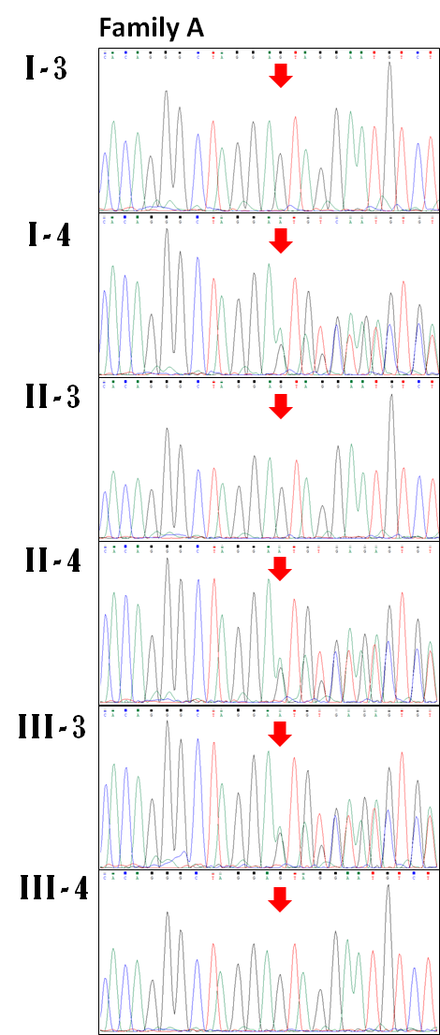

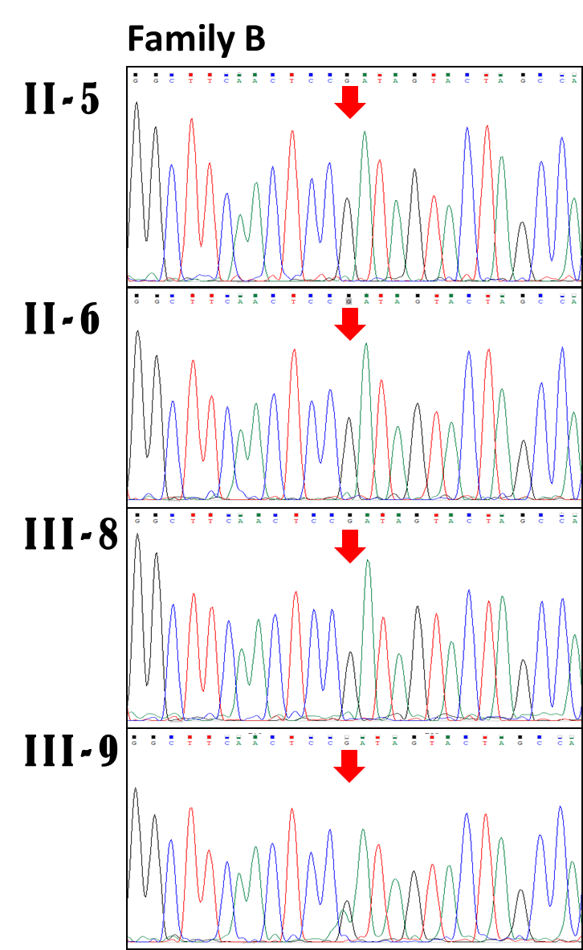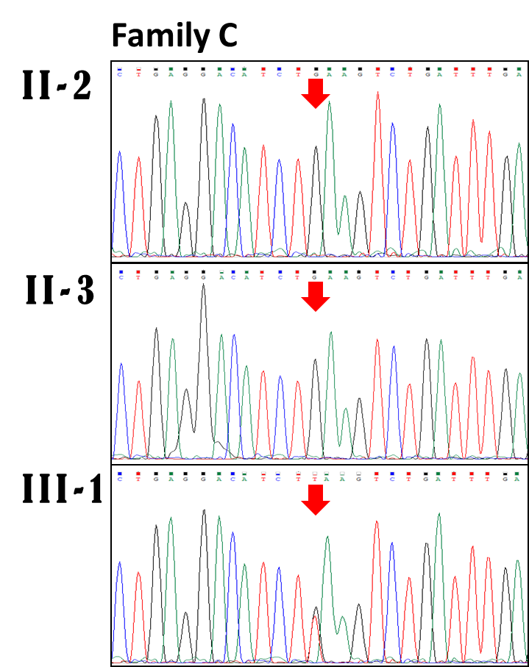

Supplementary Figure 2. Standard curve data for allele specific expression analysis of p.T292_P293del variant in MED13 gene.
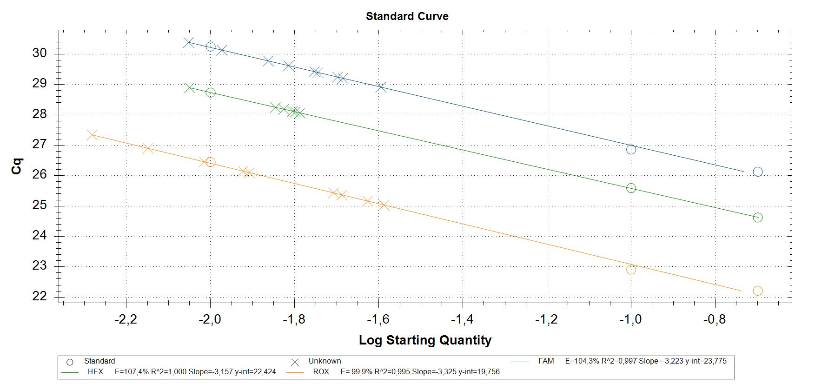

Supplementary Figure 3. aCGH confirms de novo status of extended deletion involving the MED13 gene in family D.
