Living Pore-Expansion in Two-dimensional Porous Frameworks with Single-atom Precision and Tailored Functionality
Yang Zong,ª Run-Tan Gao,ª Ting-Ting Li,ª Hai-Xu Tong,^{b} Shixing Lei,^{c} Jia Tian,^{c} Na Liu,*^{,b} Zhan-Ting Li,^{c} and Zong-Quan Wu*^{,a}
ª State Key Laboratory of Supramolecular Structure and Materials, College of Chemistry, Jilin University, Changchun 130012, Jilin Province, China. E-mail: zqwu@jlu.edu.cn
^{b} The School of Pharmaceutical Sciences, Jilin University, Changchun 130021, Jilin Province, China. E-mail: liuna606@jlu.edu.cn
^{c} State Key Laboratory of Organometallic Chemistry and Shanghai-Hongkong Joint Laboratory in Chemical Synthesis, Shanghai Institute of Organic Chemistry, University of Chinese Academy of Sciences, Chinese Academy of Sciences, Shanghai 200032, China.

Table of Contents
General considerations ··········································································· S3-S4
Synthetic procedures ·············································································· S4-S6
Enzyme immobilization Studies ································································ S6-S8
Table S1 Characterization data for MOF_{m}s and CPF₃₀ ············································· S9
Figure S1 XPS date of MOF₀ ········································································ S10
Figures S2-S10 NMR and FT-IR date of MOF_{m}s ············································ S10-S14
Figures S11-S12. DLS curves of MOF_{m}s ··························································· S15
Figure S13 SAXS profiles of MOF_{m}s ······························································· S16
Figures S14-15 Nitrogen sorption isotherms of MOF_{m}s ···································· S16-S17
Figure S16 XPS date of MOF₁₀ ······································································ S17
Figure S17 AFM image of MOF₁₀ ·································································· S17
Figures S18-21. NMR and FT-IR spectra of MOF_{m}s ········································ S18-S19
Figure S22. DLS curve of CPF₃₀ ···································································· S20
Figure S23 DSC date of CPF₃₀ ······································································· S20
Figures S24-29 Enzymes immobilization ···················································· S20-S22
References ····························································································· S23
General considerations
- Measurements
Nuclear magnetic resonance (NMR) spectra were recorded using a Bruker 400 or 500 MHz spectrometer {H} operated in the Fourier Transform mode. Chemical shifts are reported in delta (d) units and expressed in parts per million (ppm) downfield from tetramethylsilane (TMS) using the residual solvent proton as an internal standard. ¹³C solid state NMR spectra were obtained using a Bruker Avance III model 400 MHz NMR spectrometer at a MAS rate of 5 kHz. Fourier transform infrared (FT-IR) spectra were recorded at ambient temperature on a FT-IR instrument (VERTEX 80V) using KBr pellets. Dynamic light scattering (DLS) was recorded using a Nano-ZS 90 Zetasizer of Malvern instrument. The X-ray photoelectron spectroscopy (XPS) was collected in a KRATOS, Axis UltraDLD, equipped with Al K_{α} ray source (hν = 1486.6 eV) at high vacuum of 9.8 × 10⁻¹⁰ Torr. Powder X-ray diffraction (PXRD) was performed on the Rigaku Smartlab X-ray diffractometer with Cu-K_{α} radiation, 40 kV, 200 mA with a step of 0.01. Structural modeling and Pawley refinements were performed using Materials Studio suite of programs, subsequently, obtained the stacking models of the frameworks and their corresponding lattice cell parameters. The models were firstly constructed based on the coarsely theoretical structure. All the eclipsed and staggered stacking models were geometrically optimized with the Forcite molecular dynamics module. Pawley refinement module was applied to obtain the lattice cell parameters. Transmission electron microscopy (TEM) was performed on a JEM-2100F operating at 200 kV accelerating voltage, and was used for low-magnification and high-resolution transmission electron microscopy (HR-TEM) imaging. Elemental analysis data were collected in Vario micro cube from Agilent. The small angel X-ray scattering (SAXS) data were collected on BL16 at the Shanghai Synchrotron Radiation Facility with a wavelength of 0.1033 nm (energy 12 keV) and a beam size of 0.30 × 0.05 (H × V) mm². The sample concentration is 10.0 mg mL⁻¹, and the exposure time is 30 second. Atomic force microscope (AFM) was performed on a Cypher S microscope (Oxford Instruments, Asylum Research). The Brunauer Emmett-Teller (BET) method was utilized to calculate the specific surface areas on a Micromeritics ASAP 2020 Adsorption Analyzer using volumetric technique. Before measurement, the samples were degassed under vacuum at 80 °C for 12 h. Thermogravimetric analysis (TGA) was performed under a nitrogen atmosphere at a heating rate of 10 °C min⁻¹ from 30 to 800 °C using a Waters Corporation instrument. Differential scanning calorimetric (DSC) measurements were carried on a Mettler-Toledo DSC821e instrument. Samples were first heated from 25 to 250 °C at a heating rate of 10 °C min⁻¹ under nitrogen atmosphere. Utraviolet-visible (UV-vis) absorption spectra were recorded on PerkinElmer UV/vis double beam spectrophotometer in a 1.0 cm quartz cell at 25 °C.
2. Materials
All solvents were obtained from Sinopharm. Co. Ltd., and were purified by standard procedures before use. In the experiments that required dry solvents, such as tetrahydrofuran (THF), toluene, chloroform (CHCl₃), and dichloromethane (CH₂Cl₂) were dried using standard methods and distilled before use. All chemicals were purchased from Aladdin, Sinopharm, and Sigma-Aldrich Chemical Co. Ltd., and were used as received otherwise denoted. Lysozyme and cellulase were purchased from Aladdin Biochemical Technology (Shanghai, China). The monomer 1 was prepared according to reported literatures and the structure was confirmed by ¹H NMR.^{[1-3]}
3. Synthetic procedures
Synthesis of MOF₀. Under an inert atmosphere, 1,3,5-triethynylbenzene (TEB, 0.13 mmol, 0.020 g) and trans-bis(triethyl phosphine) palladium dichloride (0.20 mmol, 0.082 g) were dissolved in triethylamine (Et₃N, 30 mL) and 1,4-diethylene dioxide (30 mL) in the presence of copper(I) chloride (0.013 mmol, 1.3 mg) as catalyst. The mixture was stirred at room temperature for 48 h. After filtration, the afforded powder was washed with acetonitrile, N,N-dimethylacetamide (DMF), and water in turn and dried under a vacuum, to give MOF₀ as a white crystalline powder (73 mg, 83%). FT-IR (KBr, 25 °C, cm^{–1}): 2962 (ν_{C-H}), 2877 (ν_{C-H}), 2109 (ν_{C≡C}), 1569 (ν_{C=C}, aromatic). ¹³C ss-NMR: δ 208.8, 190.8, 129.3, 111.6, 111.6, 18.5, 9.6. Anal. Calcd (%) for C₂₀H₃₂P₂Pd: C, 54.49; H, 7.32. Found (%): C, 54.41; H, 7. 41. The BET surface area (m² g⁻¹) was measured as 134.4 m² g⁻¹ at 77 K with N₂ on a Micromeritics ASAP 2020 Adsorption Analyzer using volumetric technique.
Synthesis of pore-expanded MOF_{m}s. Taking MOF₁₀ as an example. Under N₂ atmosphere, MOF₀ catalyst (8.0 mg, 0.012 mmol) was added to the degassed solution of monomer 1 (52.1 mg, 0.18 mmol) in CHCl₃ (2 mL) ([1]₀/[Pd]₀ = 10, [1]₀ = 0.09 M). After stirred at 55 °C for 12 h, thin layer chromatography analysis indicated monomer 1 was completely consumed. Then, the solvent was removed by evaporation under reduced pressure. The residue was redissolved in a small amount of CH₂Cl₂ then the precipitated into a large amount of methanol. The precipitated solid was isolated via centrifugation and dried under vacuum to afford pore-expanded MOF₁₀ as a yellow solid (36.2 mg, 71% yield). ¹H NMR (400 MHz, CDCl₃, 25 °C): δ 7.46–7.21 (br, 2H, ArH), 5.84–5.63 (br, 2H, ArH), 4.58–3.52 (br, 2H, OCH₂), 1.71–0.70 (br, 19H, CH₂ and CH₃). ¹³C NMR: δ 165.0, 162.6, 150.4 129.7, 127.3, 117.1, 64.9, 31.9, 29.7, 28.6, 26.0, 22.7, 14.1. ³¹P NMR (202 MHz, CDCl₃) δ 16.10. FT-IR (KBr, 25 °C, cm^{–1}): 2940 (ν_{C-H}, aromatic), 2923 (ν_{C-H}, aromatic), 2853 (ν_{C-H}, aromatic), 2160 (ν_{C≡C}), 1716 (ν_{C=O}), 1595 (ν_{C=N}). Anal. Calcd(%) for C₂₀₀H₂₈₂N₁₀O₂₀P₂Pd: C, 72.46; H, 8.58. Found (%): C, 72.51; H, 8.53. The BET surface area (m² g⁻¹) was measured as 115.3 m² g⁻¹ at 77 K with N₂ on a Micromeritics ASAP 2020 Adsorption Analyzer using volumetric technique.
The MOF₂₀, MOF₃₀, and MOF₄₀ were prepared followed the similar procedure described above. The characterization data are showed below.
MOF₂₀ (73% yield). ¹H NMR (400 MHz, CDCl₃, 25 °C): δ 7.53–7.06 (br, 2H, ArH), 5.99–5.43 (br, 2H, ArH), 4.26–3.71 (br, 2H, OCH₂), 1.82–0.70 (br, 19H, CH₂ and CH₃). ³¹P NMR (202 MHz, CDCl₃) δ 15.84. FT-IR (KBr, 25 °C, cm^{–1}): 2968 (ν_{C-H}, aromatic), 2929 (ν_{C-H}, aromatic), 2852 (ν_{C-H}, aromatic), 2197 (ν_{C≡C}), 1721 (ν_{C=O}), 1601 (ν_{C=N}). Anal. Calcd(%) for C₃₈₀H₅₃₂N₂₀O₄₀P₂Pd: C, 73.74; H, 8.67. Found (%): C, 73.82; H, 8.73. The BET surface area (m² g⁻¹) was measured as 89.7 m² g⁻¹ at 77 K with N₂ on a Micromeritics ASAP 2020 Adsorption Analyzer using volumetric technique.
MOF₃₀ (79% yield). ¹H NMR (400 MHz, CDCl₃, 25 °C): δ 7.48–7.13 (br, 2H, ArH), 5.85–5.50 (br, 2H, ArH), 4.43–3.51 (br, 2H, OCH₂), 1.95–0.62 (br, 19H, CH₂ and CH₃). ³¹P NMR (202 MHz, CDCl₃) δ 15.83. FT-IR (KBr, 25 °C, cm^{–1}): 2964 (ν_{C-H}, aromatic), 2930 (ν_{C-H}, aromatic), 2850 (ν_{C-H}, aromatic), 1722 (ν_{C=O}), 1601 (ν_{C=N}). Anal. Calcd(%) for C₅₆₀H₇₈₂N₃₀O₆₀P₂Pd: C, 74.21; H, 8.70. Found (%): C, 74.12; H, 8.71. The BET surface area (m² g⁻¹) was measured as 74.4 m² g⁻¹ at 77 K with N₂ on a Micromeritics ASAP 2020 Adsorption Analyzer using volumetric technique.
MOF₄₀ (69% yield). ¹H NMR (400 MHz, CDCl₃, 25 °C): δ 7.45–7.15 (br, 2H, ArH), 5.86–5.41 (br, 2H, ArH), 4.54–3.39 (br, 2H, OCH₂), 1.98–0.61 (br, 19H, CH₂ and CH₃). ³¹P NMR (202 MHz, CDCl₃) δ 15.76. FT-IR (KBr, 25 °C, cm^{–1}): 2960 (ν_{C-H}, aromatic), 2930 (ν_{C-H}, aromatic), 2854 (ν_{C-H}, aromatic), 1722 (ν_{C=O}), 1597 (ν_{C=N}). Anal. Calcd(%) for C₇₄₀H₁₀₃₂N₄₀O₈₀P₂Pd: C, 74.46; H, 8.72. Found (%): C, 74.51; H, 8.79. The BET surface area (m² g⁻¹) was measured as 31.6 m² g⁻¹ at 77 K with N₂ on a Micromeritics ASAP 2020 Adsorption Analyzer using volumetric technique.
Synthesis of CPF_{m}s. Taking CPF₃₀ as an example, MOF₃₀ (96.8 mg, 0.007 mmol, 1.0 eq.) and Wei-phos (31.4 mg, 0.053 mmol, 5.0 eq. to Pd), and CuI (1.3 mg, 0.007 mmol, 1.0 eq.) were dissolved in THF (10.0 mL) and Et₃N (10.0 mL) in a 100 mL oven-dried flask under N₂ atmosphere. After the reaction solution was stirred at 55 °C overnight, it was cooled to room temperature and the solvent was removed by evaporation under reduced pressure. The crude product was redissolved in a small amount of THF, and then precipitated into a large amount of methanol. The precipitated solid was collected via filtration to obtain CPF₃₀ as a light-yellow solid (69.9 mg, 76% yield). ¹H NMR (400 MHz, CDCl₃, 25 °C): δ 7.40–7.21 (br, 2H, ArH), 5.95–5.55 (br, 2H, ArH), 4.52–3.59 (br, 2H, OCH₂), 1.71–0.74 (br, 19H, CH₂ and CH₃). ¹³C NMR: δ 164.0, 161.6, 149.3 128.6, 126.2, 116.1, 63.9, 30.9, 29.7, 28.6, 27.6, 25.0, 13.1, 21.7. FT-IR (KBr, 25 °C, cm^{–1}): 2951 (ν_{C-H}), 2925 (ν_{C-H}), 2110 (ν_{C≡C}), 1722 (ν_{C=O}), 1605 (ν_{C=N}). Anal. Calcd(%) for C₂₇₄H₃₇₆N₁₅O₃₀: C, 75.48; H, 8.69. Found (%): C, 75.52; H, 8.74. The BET surface area (m² g⁻¹) was measured as 76.3 m² g⁻¹ at 77 K with N₂ on a Micromeritics ASAP 2020 Adsorption Analyzer using volumetric technique.
4. Enzyme immobilization
Taking Lys as an example: MOF₁₀ (10 mg) was added to Lys solution (0.02 mM) in phosphate buffer (PBS, 0.01 M, pH = 7.4). The resulting suspension was slowly stirred at room temperature. To calculate the content of the encapsulated lysozyme, UV-vis spectroscopy was used to measure the decline in absorption at 280 nm at different time intervals until adsorption saturation was achieved (Ab) and following formula was used.^{[4]}
$$Q=\frac{(1-Ab)VCM}{m}$$
In this formula, Q represent the adsorbing mass of Lys (mg) per milligram of MOF_{m}s, and M is the molar mass of lysozyme.
The encapsulation of cellulase (CE) was performed following the same procedure.
5. Enzyme activity
Measurement of Lys activity. Dried M. lysodeikticus cell wall (9.0 mg) was dissolved in 30 mL potassium phosphate buffer (0.1 M, pH 7.0) solution. The cell wall suspension (2.9 mL) was poured into a cuvette and incubated at 25 ℃ for 5 min. Free Lys and Lys@MOF_{m}s of 1 mg protein, were dissolved in 1 ml phosphate buffer (pH 7) and added to the cuvette. Absorbance at 450 nm was then recorded. One unit of activity of lysozyme is defined as the decrease in the absorbance at 450 nm of 0.001 min⁻¹ at pH 7.0 and 25 °C using M. lysodeikticus cells as a substrate.
pH optimization assay of Lys@MOF₁₀: The optimum pH for Lys activity was studied over a pH range of 3 to 10 to determine the activity of free as well as encapsulated enzyme. Citrate buffer (pH 3-6), phosphate buffer (pH 7-8), and bis–tris propane buffer (pH 6.3-10) were used to determine the activity. The stability was determined by preincubating the enzyme for 30 min at 37 ℃ in various buffers. After incubation, the residual enzyme activity (%) was measured using phosphate buffer (0.1 M, pH 7.0).
Kinetics of CE@MOF₂₀. The catalytic activities and Michaelis-Menten constants (K_{m}) of the encapsulated CE@MOF₂₀ were determined on pNPGlc dissolved in 10 mM 4-(2-hydroxyethyl)piperazine-L-ethanesulfonic acid (HEPES) buffer, pH 7.0. The activity of the encapsulated CE@MOF₂₀ was measured. As this reaction follows zero-order kinetics (enzyme saturation), 10 mg of CE@MOF₂₀ were incubated with HEPES buffer (90 µL, 10 mM, pH 7.0) containing different concentrations of pNPGlc (1, 2, 5, 10, 20, 40, 50, 60, and 70 mM) at 70 °C for 5 min under constant shaking at 800 rpm on a Thermomixer. The reaction was stopped by adding 100 µL stop solution (0.4 M glycine, pH 10.8). Then, the reaction product was diluted 20X, and the absorbance was measured at 405 nm. The amount of product generated was calculated by comparing it to a standard curve.
Recycling assay of CE@MOF₂₀. The recycled activity was measured on the chromogenic substrate, pNPGlc. For recycling assays, a 100 μL reaction mixture containing 10 mg of CE@MOF₂₀ and 40 mM of pNPGlc (final concentration) was incubated at 70 °C for 5 min with constant shaking at 800 rpm. To precipitate the CE@MOF₂₀, the reaction content was centrifuged at 10000 rpm for 10 min, and the supernatant was decanted. The pNP in the supernatant was quantified by measuring absorbance at 405 nm by UV-visible spectrophotometry. The CE@MOF₂₀ was reused for another product forming reaction up to five cycles to compare the catalytic efficiency between the first and the later cycles.
Temperature assay of CE@MOF₂₀. The catalytic activity of the CE@MOF₂₀ was determined on pNPGlc at 70 °C after different intervals (0.5, 1, 1.5, 2, 2.5, 3, 3.5, 4 h). 10 mg of CE@MOF₂₀ was incubated with HEPES buffer (90 µL, 10 mM, pH 7) containing pNPGlc (40 Mm, 90 µL) at 70 °C for different time under constant shaking at 800 rpm in a Thermomixer. The reaction was stopped by adding 100 µL stop solution (0.4 M glycine, pH 10.8). Then, the reaction product was diluted 20X, and absorbance was measured at 405nm. The pNP generated was calculated by comparing it with a standard curve.

Table S1. Characterization data for MOF_{m}s and CPF₃₀ ª
Run | Frameworks | S_{BET} ^{b} (m² g⁻¹) | V_{pore} ^{b} (cm³ g⁻¹) | d_{pore} ^{b} (nm)
1 | MOF₀ | 134.4 | 0.212 | 2.0
2 | MOF₁₀ | 115.3 | 0.221 | 4.3
3 | MOF₂₀ | 89.7 | 0.193 | 6.6
4 | MOF₃₀ | 74.4 | 0.155 | 9.6
5 | MOF₄₀ | 31.6 | 0.145 | 15.0
6 | CPF₃₀ | 76.3 | 0.156 | 9.3
ª The frameworks were prepared according to Scheme 1 in main text. ^{b} Surface area (S_{BET}), pore volume (V_{pore}), and pore-diameter (d_{pore}) were calculated from nitrogen adsorption and desorption data using the DFT and BJH method.

Figure S1. XPS survey of MOF₀.
Figure S2. ³¹P NMR (122 MHz) spectra of MOF₁₀ measured in CDCl₃ at 25 °C.

Figure S3. ¹³C NMR(125 MHz) spectrum of MOF₁₀ measured in CDCl₃ at 25 °C.
Figure S4. FTIR spectra of (a) MOF₂₀, (b) MOF₃₀, and (c) MOF₄₀ measured at room temperature using KBr.
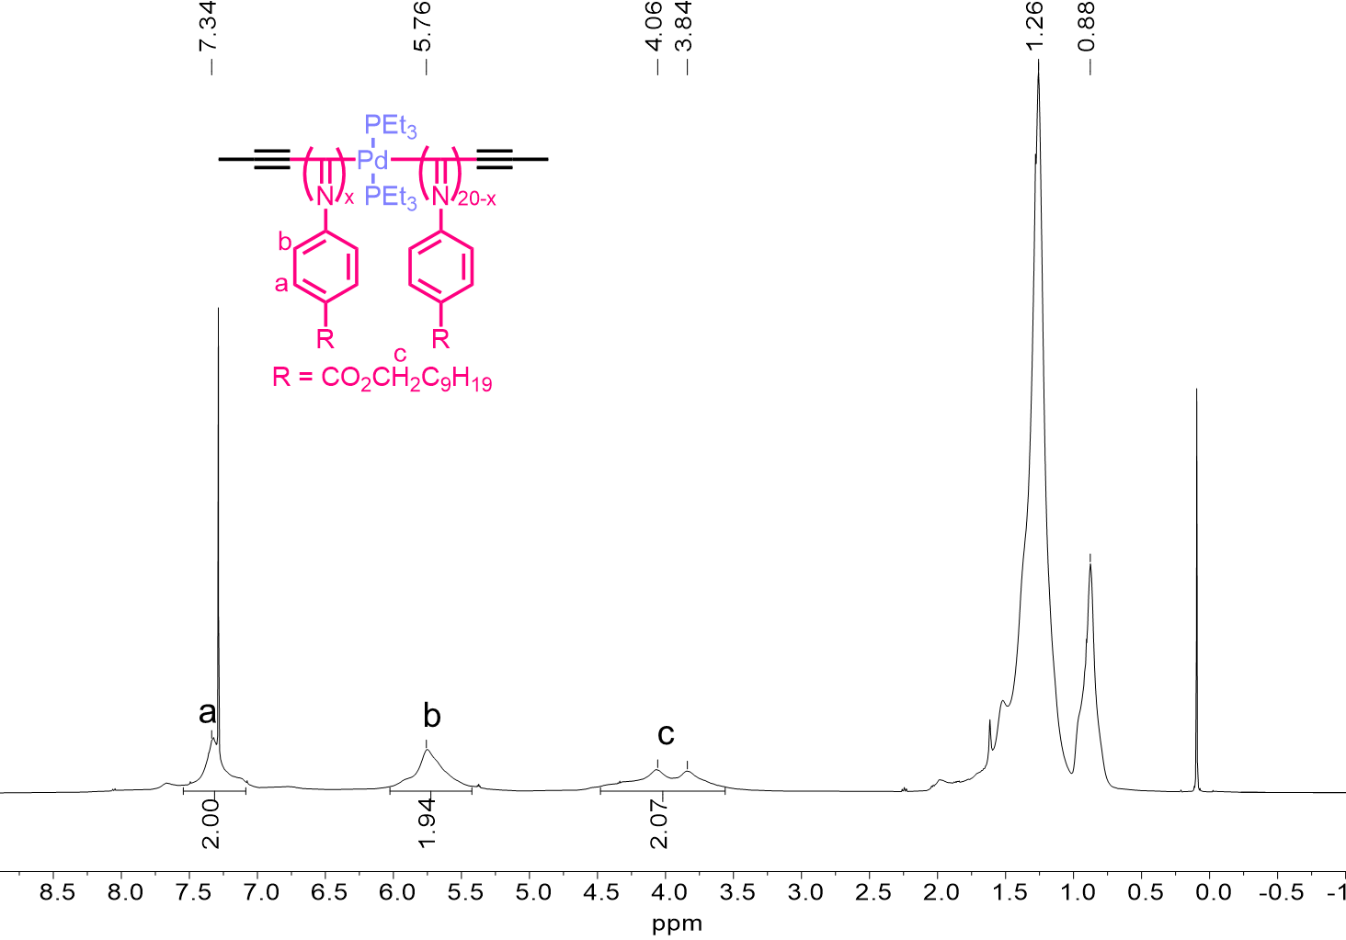
Figure S5. ¹H NMR (500 MHz) spectrum of MOF₂₀ measured in CDCl₃ at room temperature.
Figure S6. ³¹P NMR (122 MHz) spectra of MOF₂₀ measured in CDCl₃ at room temperature.
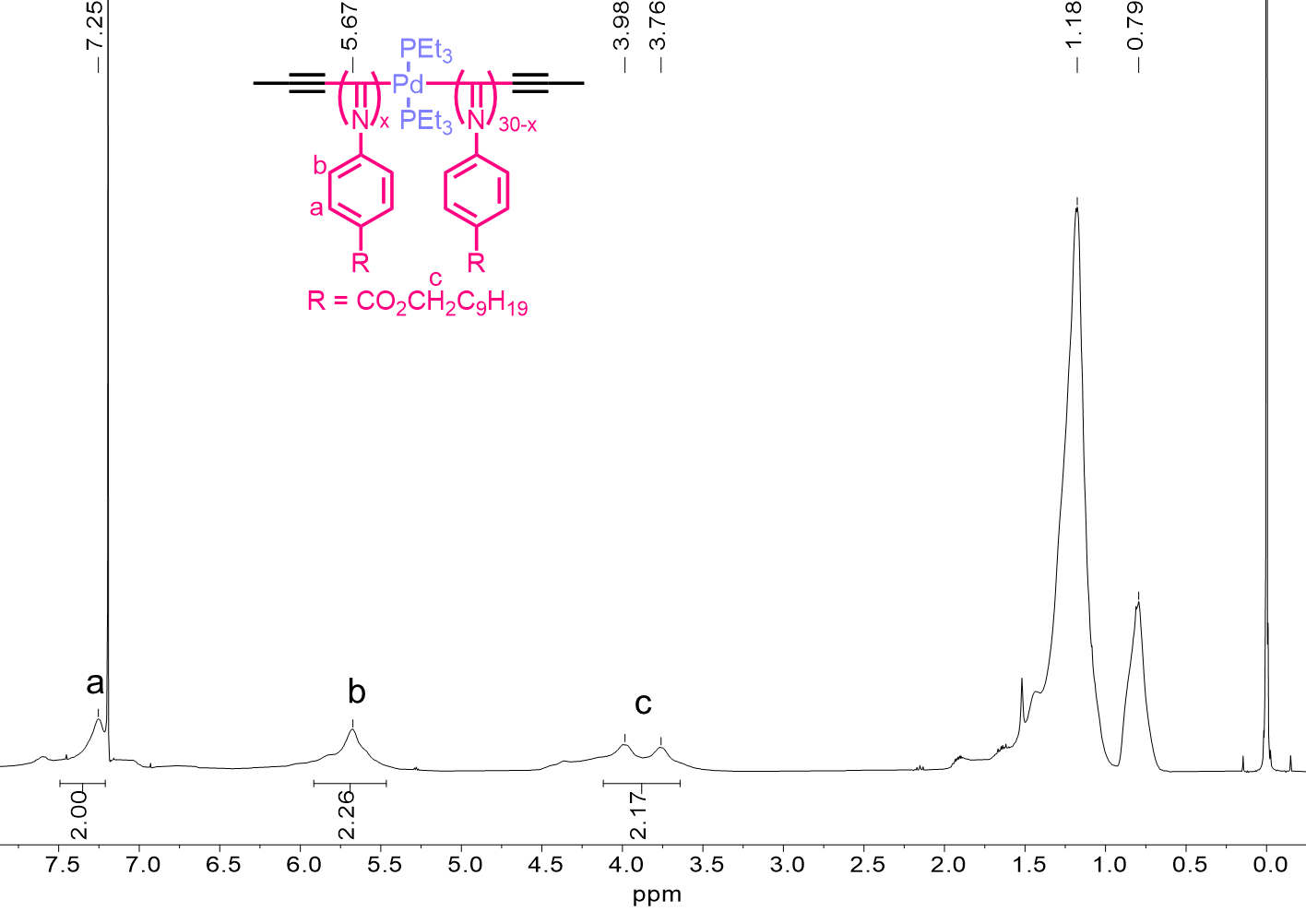
Figure S7. ¹H NMR (500 MHz) spectrum of MOF₃₀ measured in CDCl₃ at room temperature.
Figure S8. ³¹P NMR (122 MHz) spectra of MOF₃₀ measured in CDCl₃ at room temperature.
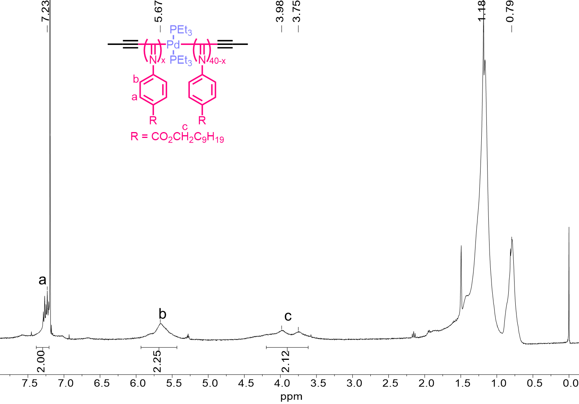
Figure S9. ¹H NMR (500 MHz) spectrum of MOF₄₀ measured in CDCl₃ at room temperature.
Figure S10. ³¹P NMR (122 MHz) spectra of MOF₄₀ measured in CDCl₃ at room temperature.

Figure S11. (a) DLS curves of (a) MOF₁₀, (b) MOF₂₀, (c) MOF₃₀, and (d) MOF₄₀ with different concentrations (CHCl₃, 25 °C).

Figure S12. Hydrodynamic diameters (D_{H}) of MOF_{m}s in CHCl₃ at different concentrations determined by DLS at 25 °C.
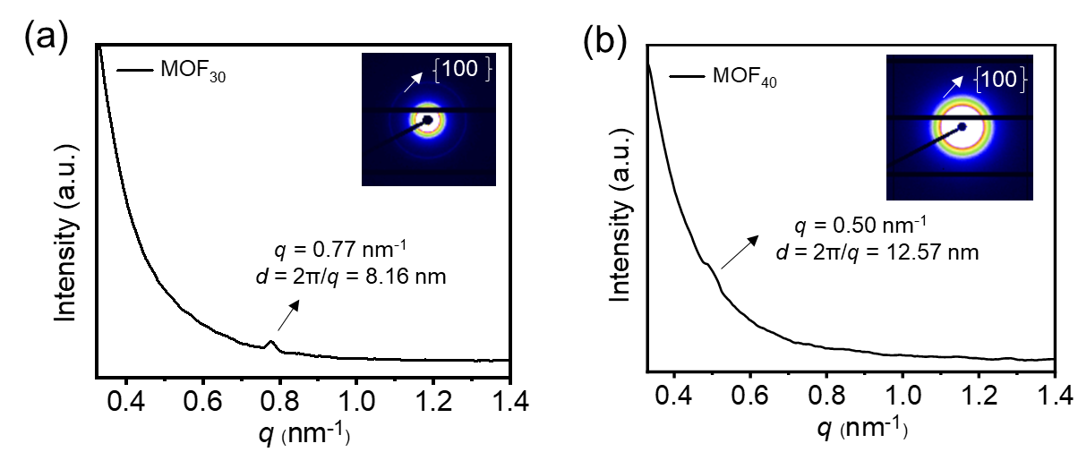
Figure S13. Solution-phase synchrotron SAXS profiles of MOF₃₀ (a) and MOF₄₀ (b) recorded in CHCl₃ (10 mg mL⁻¹).

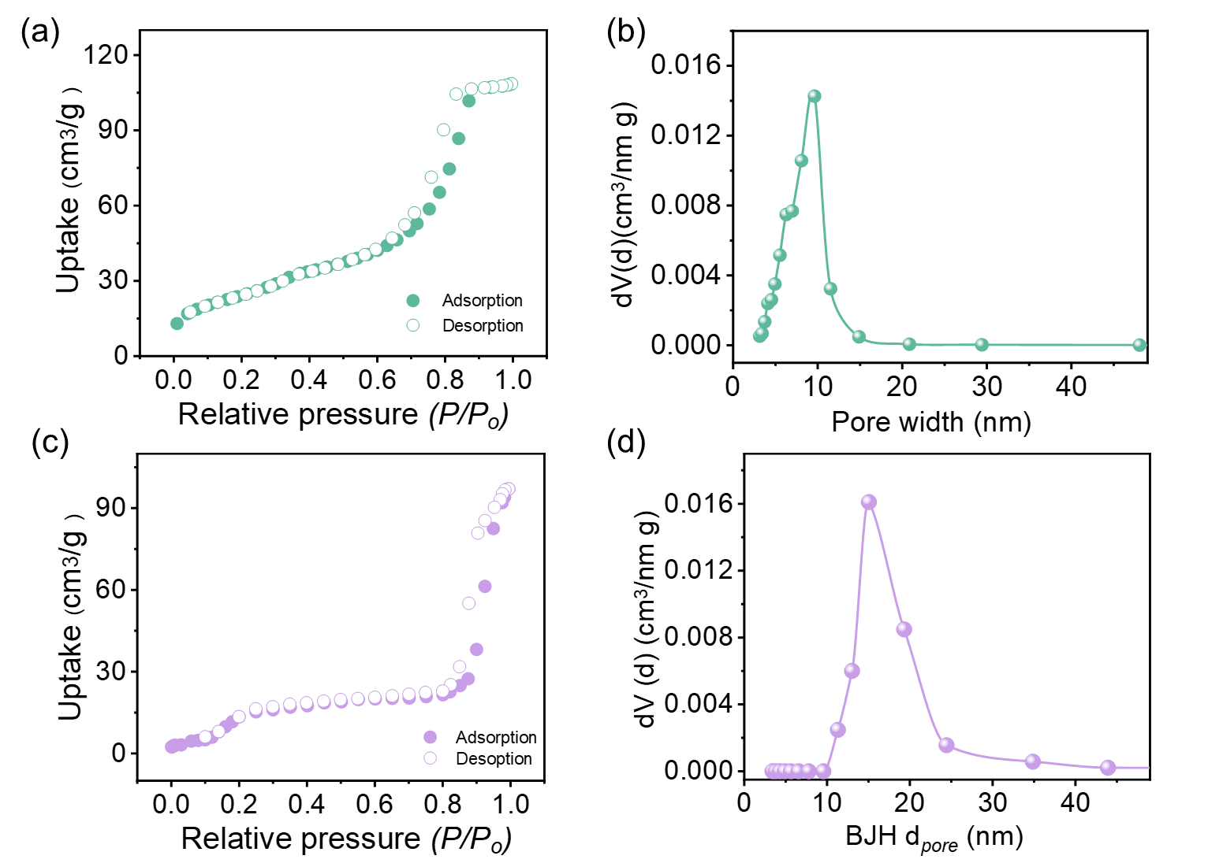
Figure S14. Nitrogen sorption isotherms (a, c) and pore size distribution (b, d) of MOF₃₀ (a, b) and MOF₄₀ (c, d) recorded at 77 K.

Figure S15. Plots of the V_{pore} of MOF_{m}s vs. DP of the polyisocyanide backbone of the synthesized MOF_{m}s.

Figure S16. XPS survey of MOF₁₀.
Figure S17. (a) AFM image of MOF₁₀. (b) The height profile along the length of the line in the image as depicted by the red line in (a).
Figure S18. ¹H NMR (500 MHz) spectrum of CPF₃₀ measured in CDCl₃ at room temperature.
Figure S19. FT-IR spectra of CPF₃₀ measured at room temperature using KBr.
Figure S20. ¹³C NMR(125 MHz) spectrum of CPF₃₀ measured in CDCl₃ at room temperature.
Figure S21. ³¹P NMR (202 MHz) spectra of MOF₃₀ and CPF₃₀ recorded in CDCl₃ at room temperature.
Figure S22. DLS profiles of MOF₃₀ (0.2 mg mL⁻¹) and CPF₃₀ (0.2 mg mL⁻¹) in CHCl₃ at room temperature.
Figure S23. DSC curves of MOF₃₀ and CPF₃₀ measured at a heating rate of 10 °C min⁻¹ under N₂ atmosphere.
Figure S24. Time-dependent UV-vis spectra of Lys encapsulated by MOF₀ (a), MOF₁₀ (b), MOF₂₀ (c), MOF₃₀ (d) and MOF₄₀ (e), respectively in PBS (0.01 M, pH = 7.4) at 25 °C.
Figure S25. Relative activity of free Lys and Lys@MOF_{m}s measured using M. lysodeikticus cells as a substrate.
Figure S26. Relative activity of free Lys and Lys@MOF₁₀ in buffer with different pH values, measured using Micrococcus lysodeikticus cells as the substrate.

Figure S27. Standard curve of pNPGlc assay performed at 25 °C in HEPES buffer with pH 7.0.
Figure S28. The half-life of CE@MOF₂₀ (a) and free cellulase (b) after storage at 70 ℃ in HEPES buffer with pH 7.0.
Figure S29. The relative stability of free CE and CE@MOF₂₀ after storage at 25 ℃ in HEPES buffer with pH 7.0.
References
- Wu, Z.-Q., Nagai, K., Banno, M., Okoshi, K., Onitsuka, K. & Yashima, E. Enantiomer-Selective and Helix-Sense-Selective Block Copolymerization of Isocyanide Enantiomers Initiated by Single-Handed Helical Poly(phenyl isocyanide)s. J. Am. Chem. Soc. 131, 6708–6718 (2009).
- Xue, Y.-X., Zhu, Y.-Y., Gao, L.-M., He, X.-Y., Liu, N., Zhang, W.-Y., Yin, J., Ding, Y., Zhou, H. & Wu, Z.-Q. Air-Stable (Phenylbuta-1,3-diynyl)palladium(II) Complexes: Highly Active Initiators for Living Polymerization of Isocyanides. J. Am. Chem. Soc. 136, 4706–4713 (2014).
- Liu, N., Gao, R.-T. & Wu, Z.-Q. Helix-Induced Asymmetric Self-Assembly of π-Conjugated Block Copolymers: From Controlled Syntheses to Distinct Properties. Acc. Chem. Res. 56, 2954–2967 (2023).
- Deng, H., Grunder, S., Cordova, K. E., Valente, C., Furukawa, H., Hmadeh, M., Gandara, F., Whalley, A. C., Liu, Z., Asahina, S., Kazumori, H., O’Keeffe, M., Terasaki, O., Stoddart, J. F. & Yaghi, O. M. Large-Pore Apertures in a Series of Metal-Organic Frameworks. Science 336, 1018–1023 (2012).

