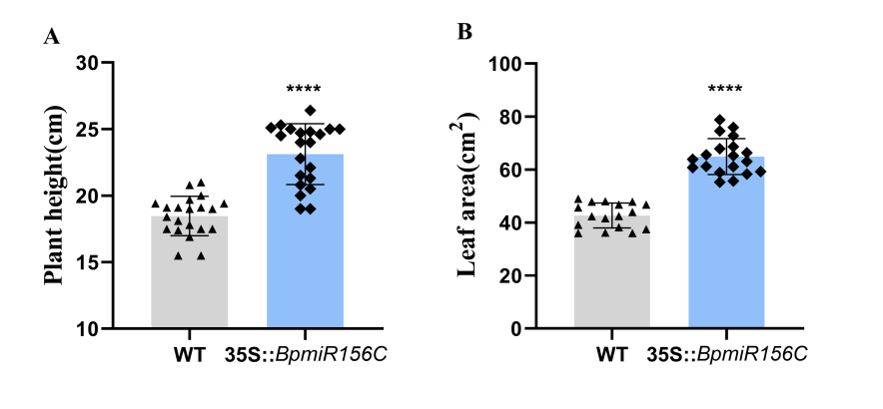
Figure . S1 bp-miR156c regulates the growth of birch.
（A）Plant height, （B）leaf area, Error bars represent the mean ± SD from three independent biological replicates (each replicate consisted of 15 plants). Asterisks indicate significant differences between the WT and transgenic plants as determined by one-way ANOVA with Tukey's multiple comparisons test. (*P < 0.05, **P < 0.01, ***P < 0.001, ****P < 0.0001).

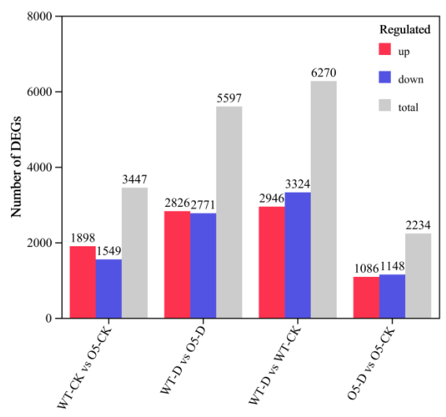
Figure . S2 The total number of DEGs in the BpSPL2 transcriptome

Figure .S3 (A), (B) Expression patterns of BpChr14G12620 and BpChr05G19184 in BpSPL2-OE plants; (C)Screening of the minimum inhibitory concentration of the bait vector AbA in yeast one-hybrid experiments. Error bars represent the mean ±SD from three independent biological replicates. Asterisks indicate significant differences between the WT and transgenic plants as determined by one-way ANOVA with Tukey's multiple comparisons test. (*P < 0.05, **P < 0.01, ***P < 0.001).

Table S1:primers used in this research
1. For construction of GUS staining vector
35S::156c-GUS-F:gagaacacgggggactctagaGCAACCATTCTCTCTCTAGCTTTCT
35S::156c-GUS-R:ataagggactgaccacccgggGACAATTTAGTACAGGCACACATAAACT
35S::BpSPL2-GUS-F:gagaacacgggggactctagaATGGAGTCTTGGAGTTGCAGTTC
35S::BpSPL2-GUS-F:ataagggactgaccacccgggCACACCTTGTTGGTTGCACACT
Note:the vectors were constructed using homologous recombination, with lowercase letters indicating the vector homology arms.
2. For construction of Y1H vector
pGADT-BpSPL2-F: gccatggaggccagtgaattcATGTTCAGCTTTGAGCTAACAACAA
pGADT-BpSPL2-R:cagctcgagctcgatggatccAAAATCTGGTAATTCTGGTATTTCCC
pAbAi-proASA1-F:cttgaattcgagctcggtaccGCCCATGACCACTCCTGTACA
pAbAi-proASA1-R:agcacatgcctcgaggtcgacCTTTTCAAAGCTCATTCAAAGAATCA
pAbAi-proGSTF3-F:cttgaattcgagctcggtaccGATGGGACTTTCCATTTTTCTTTT
pAbAi-proGSTF3-R:agcacatgcctcgaggtcgacGGGTTTAGGGCCCTAATTATGAT
Note:the vectors were constructed using homologous recombination, with lowercase letters indicating the vector homology arms.
3. For construction of dual-luciferase vector
pGreen-BpSPL2-SK-F: caggaattcgatatcaagcttATGGAGTCTTGGAGTTGCAGTTC
pGreen-BpSPL2-SK-R:tcagcgtaccgaattggtaccCACACCTTGTTGGTTGCACACT
pGreen-proASA1-LUC-F: ctatagggcgaattgggtaccTCTGTCTCCCCTCGTATCTTACCA
pGreen-proASA1-LUC-R:cgctctagaactagtggatccCTTTTCAAAGCTCATTCAAAGAATCA
pGreen-proGSTF3-LUC-F:ctatagggcgaattgggtaccGGCGTTTGACGTGTACTAAAAATT
pGreen-proGSTF3-LUC-R:cgctctagaactagtggatccGATTGCGGGTGGTGATAAGTG
Note:the vectors were constructed using homologous recombination, with lowercase letters indicating the vector homology arms.
4. For ChIP-PCR
proASA1-P1-F:TTCAAGACAAGGGAAGGGAAAA
proASA1-P1-R:CGCAAAAATAGAAGTAGGGTATTTTT
proASA1-P2-F:CCCTACTTCTATTTTTGCGTTTTTAA
proASA1-P2-R:GAATTTTCTAAATGAATAAAGTTCAATTATAAA
proASA1-P3-F:ATCCGCTAAGATTTTCTGTTAAATTCT
proASA1-P3-R:TTCAATAATTTCAAGTATGAGTATTTTTGTAA
proASA1-P4-F:GCCCATGACCACTCCTGTACA
proASA1-P4-R:TCAAAGAATCAAAACCGCCG
proGSTF3-P1-F:GGGCGTTTGACGTGTACTAAAAA
proGSTF3-P1-R:ACGGACTTCTGTCGAACCATGG
proGSTF3-P2-F:CGTCGTACTAAACACCAAAAAATACA
proGSTF3-P2-R:TCTGGAAAGTCTTGAATAAAATCCTAA
proGSTF3-P3-F:GATGGGACTTTCCATTTTTCTTTT
proGSTF3-P3-R:GGGTTTAGGGCCCTAATTATGAT
5. For RT-qPCR
Bp18s-F:CATCTCTGATCGGAATGGAAG
Bp18s-R:AGATCCTTTCTGATATCCACG
dl-GST3-F:GCCATCAAAGTCCACGGAAT
dl-GST3-R:TGTCAACAGGAACAAGCTCAA
dl-ASA1-F:TAGTTGGGATGCTCTGCGTG
dl-ASA1-R:TCTCAAAGCGAGGGCAATGT
dl-19184-F:GAAGCTAAGCTGGCTATGGTT
dl-19184-R:TTGTATGGTCGGCAGGTGGTG
dl-12620-F:GGCCATCCCTTGTTGTCCA
dl-12620-R:TCACGCTCTTTCTCTTCGCC
dl-SPL2-F:CGGTGAGGTTGGTAGTGGCTC
dl-SPL2-R:AAATCTTGACTGTTGGCTTCCATAG
dl-156c-F:GTCTGCCTGGGTGTCACGCAA
dl-156c-R:GCTGACAGAAGAGAGTGAGCACA

