Supplementary Material

Microbial Ecology
Local-scale damming impact on the planktonic bacterial and eukaryotic communities in the upper Yangtze River
Hang Li ^{1,2}, Zhe Li ^{1,2}, Qiong Tang ^{1,2,3}, Ran Li ⁴, Lunhui Lu ^{1,2,*}

¹ CAS Key Laboratory of Reservoir Water Environment, Chongqing Institute of Green and Intelligent Technology, Chinese Academy of Sciences, Chongqing 400714, China
² Chongqing School, University of Chinese Academy of Sciences, Chongqing 400714, China
³ Key Laboratory of Hydraulic and Waterway Engineering of the Ministry of Education, Chongqing Jiaotong University, Chongqing 400074, China
⁴ State Key Laboratory of Hydraulics and Mountain River Engineering, Sichuan University, Chengdu 610065, China
* Corresponding author: Lunhui Lu
E-mail address: lulunhui@cigit.ac.cn (L. Lu)

Table S1 Information of the sample sites and names.
Dam | Location of the dam | Normal water level (m) | Upstream of watershed area (km²) | Maximum dam height (m) | Installed capacity (MW)
Xiluodu | N28°15'38.12" E103°39'01.67" | 600 | 4.544×10⁵ | 278 | 12600
Xiangjiaba | N28°38'30.4" E104°23'46.5" | 380 | 4.588×10⁵ | 161 | 6400
Three Gorges Dam | N30°39'27.78" E111°00'11.41" | 175 | 1.0×10⁶ | 181 | 22400

Table S2 Information of the sample sites and names.
Sample name | Sample Information | Sample sites | Sampling depth (m) | Month | Distance from the dam (km)
XLD_u1_5 | the surface water | upstream of the XLD | 0.5 | May | 2
XLD_u2_5 | the second layer | upstream of the XLD | 40 | May | 2
XLD_u3_5 | the third layer | upstream of the XLD | 80 | May | 2
XLD_u4_5 | the fourth layer | upstream of the XLD | 120 | May | 2
XLD_u5_5 | the fifth layer | upstream of the XLD | 160 | May | 2
XLD_d1_5 | the surface water | downstream of the XLD | 0.5 | May | 9
XLD_u1_7 | the surface water | upstream of the XLD | 0.5 | July | 2
XLD_u2_7 | the second layer | upstream of the XLD | 40 | July | 2
XLD_u3_7 | the third layer | upstream of the XLD | 80 | July | 2
XLD_u4_7 | the fourth layer | upstream of the XLD | 120 | July | 2
XLD_u5_7 | the fifth layer | upstream of the XLD | 160 | July | 2
XLD_d1_7 | the surface water | downstream of the XLD | 0.5 | July | 9
XLD_u1_11 | the surface water | upstream of the XLD | 0.5 | November | 2
XLD_u2_11 | the second layer | upstream of the XLD | 45 | November | 2
XLD_u3_11 | the third layer | upstream of the XLD | 90 | November | 2
XLD_u4_11 | the fourth layer | upstream of the XLD | 130 | November | 2
XLD_u5_11 | the fifth layer | upstream of the XLD | 180 | November | 2
XLD_d1_11 | the surface water | downstream of the XLD | 0.5 | November | 9
XJB_u1_5 | the surface water | upstream of the XJB | 0.5 | May | 2
XJB_u2_5 | the second layer | upstream of the XJB | 20 | May | 2
XJB_u3_5 | the third layer | upstream of the XJB | 40 | May | 2
XJB_u4_5 | the fourth layer | upstream of the XJB | 60 | May | 2
XJB_u5_5 | the fifth layer | upstream of the XJB | 80 | May | 2
XJB_d1_5 | the surface water | downstream of the XJB | 0.5 | May | 1.5
XJB_u1_7 | the surface water | upstream of the XJB | 0.5 | July | 2
XJB_u2_7 | the second layer | upstream of the XJB | 20 | July | 2
XJB_u3_7 | the third layer | upstream of the XJB | 40 | July | 2
XJB_u4_7 | the fourth layer | upstream of the XJB | 60 | July | 2
XJB_u5_7 | the fifth layer | upstream of the XJB | 80 | July | 2
XJB_d1_7 | the surface water | downstream of the XJB | 0.5 | July | 1.5
XJB_u1_11 | the surface water | upstream of the XJB | 0.5 | November | 2
XJB_u2_11 | the second layer | upstream of the XJB | 25 | November | 2
XJB_u3_11 | the third layer | upstream of the XJB | 50 | November | 2
XJB_u4_11 | the fourth layer | upstream of the XJB | 70 | November | 2
XJB_u5_11 | the fifth layer | upstream of the XJB | 90 | November | 2
XJB_d1_11 | the surface water | downstream of the XJB | 0.5 | November | 1.5
TGD_u1_5 | the surface water | upstream of the XJB | 0.5 | May | 2
TGD_u2_5 | the second layer | upstream of the XJB | 20 | May | 2
TGD_u3_5 | the third layer | upstream of the XJB | 40 | May | 2
TGD_u4_5 | the fourth layer | upstream of the XJB | 60 | May | 2
TGD_u5_5 | the fifth layer | upstream of the XJB | 80 | May | 2
TGD_d1_5 | the surface water | downstream of the XJB | 0.5 | May | 10
TGD_u1_7 | the surface water | upstream of the XJB | 0.5 | July | 2
TGD_u2_7 | the second layer | upstream of the XJB | 20 | July | 2
TGD_u3_7 | the third layer | upstream of the XJB | 40 | July | 2
TGD_u4_7 | the fourth layer | upstream of the XJB | 60 | July | 2
TGD_u5_7 | the fifth layer | upstream of the XJB | 80 | July | 2
TGD_d1_7 | the surface water | downstream of the XJB | 0.5 | July | 10
TGD_u1_11 | the surface water | upstream of the XJB | 0.5 | November | 2
TGD_u2_11 | the second layer | upstream of the XJB | 25 | November | 2
TGD_u3_11 | the third layer | upstream of the XJB | 50 | November | 2
TGD_u4_11 | the fourth layer | upstream of the XJB | 75 | November | 2
TGD_u5_11 | the fifth layer | upstream of the XJB | 100 | November | 2
TGD_d1_11 | the surface water | downstream of the XJB | 0.5 | November | 10
XLD, Xiluodu dam; XJB, Xiangjiaba dam; TGD, Three Gorges Dam.
Table S3 Environmental variables and physiochemical properties of the samples.
Sampling Time | Sampling Site | T | DO | pH | Chl-a | DOC | NO₃⁻-N | NO₂⁻-N | NH₄⁺-N | TN | DTP | TP | CH₄ | CO₂ | Water level
Sampling Time | Sampling Site | °C | (mg/L) | - | (mg/L) | (mg/L) | (mg/L) | (mg/L) | (mg/L) | (mg/L) | (mg/L) | (mg/L) | ppm | ppm | m
May 2019 | XLD_u1_5 | 20.43 | 9.28 | 8.06 | 2.36 | 1.77 | 0.30 | 0.011 | 0.04 | 1.18 | 0.03 | 0.05 | 2.10 | 707.20 | 559.05
May 2019 | XLD_u2_5 | 19.09 | 8.99 | 8.00 | - | 1.74 | 0.28 | 0.011 | 0.06 | 1.08 | 0.04 | 0.05 | 2.13 | 788.80 | 519.55
May 2019 | XLD_u3_5 | 13.88 | 9.16 | 7.91 | - | 1.42 | 0.30 | 0.011 | 0.05 | 1.33 | 0.03 | 0.05 | 1.93 | 584.20 | 479.55
May 2019 | XLD_u4_5 | 13.53 | 9.23 | 7.90 | - | 1.35 | 0.33 | 0.010 | 0.06 | 1.37 | 0.04 | 0.06 | 2.00 | 593.00 | 439.55
May 2019 | XLD_u5_5 | 13.51 | 9.16 | 7.90 | - | 1.44 | 0.35 | 0.010 | 0.03 | 1.55 | 0.04 | 0.06 | 1.73 | 608.10 | 399.55
May 2019 | XLD_d1_5 | 24.45 | 8.58 | 8.04 | 1.16 | 1.23 | 0.31 | 0.007 | 0.06 | 1.26 | 0.03 | 0.05 | 1.06 | 594.00 | 378.12
May 2019 | XJB_u1_5 | 19.88 | 9.71 | 8.11 | 6.76 | 1.48 | 0.32 | 0.005 | 0.16 | 1.47 | 0.03 | 0.04 | 2.44 | 495.30 | 562.64
May 2019 | XJB_u2_5 | 18.90 | 9.01 | 8.01 | - | 1.32 | 0.36 | 0.002 | 0.17 | 1.63 | 0.03 | 0.04 | 2.18 | 699.80 | 523.14
May 2019 | XJB_u3_5 | 18.70 | 8.87 | 7.99 | - | 1.49 | 0.38 | 0.002 | 0.16 | 1.85 | 0.03 | 0.05 | 2.03 | 653.40 | 483.14
May 2019 | XJB_u4_5 | 18.23 | 8.85 | 7.98 | - | 1.45 | 0.36 | 0.002 | 0.17 | 1.88 | 0.03 | 0.05 | 2.48 | 716.20 | 443.14
May 2019 | XJB_u5_5 | 14.84 | 9.04 | 7.91 | - | 1.27 | 0.31 | 0.002 | 0.06 | 1.28 | 0.03 | 0.04 | 2.43 | 708.43 | 403.14
May 2019 | XJB_d1_5 | 19.22 | 9.19 | 8.08 | 2.12 | 1.37 | 0.37 | 0.002 | 0.08 | 1.64 | 0.03 | 0.05 | 1.52 | 611.64 | 380.38
May 2019 | TGD_u1_5 | 18.97 | 8.20 | 7.74 | 1.08 | 1.50 | 0.51 | 0.006 | 0.03 | 1.35 | 0.07 | 0.09 | 4.78 | 972.30 | 597.03
May 2019 | TGD_u2_5 | 18.50 | 8.03 | 7.70 | - | 1.46 | 0.50 | 0.006 | 0.03 | 1.35 | 0.07 | 0.09 | 5.04 | 994.30 | 552.53
May 2019 | TGD_u3_5 | 18.48 | 7.98 | 7.70 | - | 1.31 | 0.52 | 0.006 | 0.06 | 1.37 | 0.08 | 0.10 | 5.03 | 974.40 | 507.53
May 2019 | TGD_u4_5 | 18.11 | 8.03 | 7.69 | - | 1.47 | 0.52 | 0.006 | 0.03 | 1.52 | 0.08 | 0.09 | 5.62 | 1015.90 | 467.53
May 2019 | TGD_u5_5 | 17.93 | 8.06 | 7.69 | - | 1.56 | 0.56 | 0.006 | 0.14 | 1.64 | 0.08 | 0.10 | 5.17 | 983.70 | 417.53
May 2019 | TGD_d1_5 | 18.55 | 8.24 | 7.69 | 0.62 | 1.64 | 0.33 | 0.003 | 0.11 | 1.76 | 0.04 | 0.05 | 5.32 | 1045.20 | 377.84
July 2019 | XLD_u1_7 | 23.24 | 8.48 | 8.21 | 2.10 | 1.26 | 0.39 | 0.002 | 0.07 | 1.55 | 0.04 | 0.08 | 2.08 | 931.00 | 374.07
July 2019 | XLD_u2_7 | 22.53 | 8.37 | 7.93 | - | 1.14 | 0.38 | 0.002 | 0.08 | 1.49 | 0.04 | 0.09 | 1.76 | 876.30 | 354.57
July 2019 | XLD_u3_7 | 21.86 | 8.24 | 7.92 | - | 1.25 | 0.44 | 0.002 | 0.07 | 1.80 | 0.04 | 0.09 | 1.74 | 705.90 | 334.57
July 2019 | XLD_u4_7 | 14.72 | 8.08 | 7.79 | - | 1.17 | 0.37 | 0.003 | 0.06 | 1.44 | 0.04 | 0.07 | 1.72 | 735.20 | 314.57
July 2019 | XLD_u5_7 | 13.89 | 8.18 | 7.72 | - | 0.97 | 0.40 | 0.002 | 0.02 | 1.49 | 0.04 | 0.07 | 1.60 | 762.60 | 294.57
July 2019 | XLD_d1_7 | 27.04 | 7.94 | 8.05 | 1.10 | 1.40 | 0.42 | 0.002 | 0.07 | 1.78 | 0.05 | 0.10 | 0.59 | 777.20 | 268.97
July 2019 | XJB_u1_7 | 23.68 | 8.82 | 9.01 | 4.38 | 1.10 | 0.39 | 0.003 | 0.13 | 1.69 | 0.05 | 0.06 | 2.78 | 699.00 | 371.99
July 2019 | XJB_u2_7 | 23.03 | 8.37 | 8.37 | - | 1.32 | 0.47 | 0.002 | 0.15 | 1.32 | 0.05 | 0.07 | 2.48 | 813.30 | 352.49
July 2019 | XJB_u3_7 | 22.86 | 8.28 | 8.34 | - | 1.35 | 0.42 | 0.003 | 0.13 | 1.52 | 0.05 | 0.08 | 2.55 | 800.60 | 332.49
July 2019 | XJB_u4_7 | 22.84 | 8.23 | 8.31 | - | 1.34 | 0.44 | 0.002 | 0.11 | 1.14 | 0.04 | 0.07 | 2.50 | 825.80 | 312.49
July 2019 | XJB_u5_7 | 22.80 | 8.21 | 8.30 | - | 1.20 | 0.44 | 0.002 | 0.15 | 1.08 | 0.04 | 0.08 | 2.80 | 846.80 | 292.49
July 2019 | XJB_d1_7 | 25.53 | 8.28 | 8.60 | 1.43 | 1.04 | 0.42 | 0.002 | 0.07 | 1.77 | 0.04 | 0.08 | 2.02 | 748.50 | 271.28
July 2019 | TGD_u1_7 | 24.09 | 7.36 | 7.76 | 1.27 | 1.61 | 0.53 | 0.003 | 0.03 | 1.27 | 0.09 | 0.10 | 1.28 | 1120.60 | 378.20
July 2019 | TGD_u2_7 | 23.89 | 7.21 | 7.74 | - | 1.67 | 0.56 | 0.002 | 0.02 | 1.44 | 0.08 | 0.11 | 1.51 | 1291.30 | 353.70
July 2019 | TGD_u3_7 | 23.87 | 7.13 | 7.74 | - | 1.68 | 0.50 | 0.003 | 0.03 | 1.14 | 0.08 | 0.11 | 1.56 | 1266.00 | 328.70
July 2019 | TGD_u4_7 | 23.87 | 7.12 | 7.73 | - | 1.65 | 0.51 | 0.002 | 0.02 | 1.66 | 0.08 | 0.10 | 1.59 | 1268.50 | 308.70
July 2019 | TGD_u5_7 | 23.88 | 7.12 | 7.72 | - | 1.42 | 0.51 | 0.002 | 0.07 | 1.53 | 0.08 | 0.10 | 1.24 | 1231.80 | 288.70
July 2019 | TGD_d1_7 | 23.99 | 7.41 | 8.06 | 0.64 | 1.75 | 0.50 | 0.002 | 0.07 | 1.57 | 0.08 | 0.11 | 2.73 | 1223.80 | 266.52
November 2019 | XLD_u1_11 | 17.94 | 8.89 | 8.04 | 1.12 | 0.45 | 0.53 | 0.002 | 0.03 | 1.18 | 0.03 | 0.04 | 0.77 | 658.10 | 155.94
November 2019 | XLD_u2_11 | 17.94 | 8.71 | 8.03 | - | 0.51 | 0.47 | 0.002 | 0.01 | 1.85 | 0.03 | 0.04 | 0.87 | 576.90 | 136.44
November 2019 | XLD_u3_11 | 17.82 | 8.74 | 8.02 | - | 0.76 | 0.63 | 0.002 | 0.02 | 1.68 | 0.03 | 0.04 | 0.86 | 532.76 | 116.44
November 2019 | XLD_u4_11 | 17.75 | 8.75 | 8.02 | - | 0.82 | 0.58 | 0.002 | 0.03 | 1.38 | 0.03 | 0.05 | 0.92 | 613.60 | 96.44
November 2019 | XLD_u5_11 | 17.67 | 8.67 | 8.02 | - | 0.50 | 0.56 | 0.002 | 0.04 | 1.27 | 0.03 | 0.04 | 0.82 | 605.28 | 76.44
November 2019 | XLD_d1_11 | 17.03 | 9.07 | 8.02 | 0.83 | 0.64 | 0.60 | 0.002 | 0.01 | 1.55 | 0.03 | 0.04 | 0.84 | 614.08 | 64.15
November 2019 | XJB_u1_11 | 17.88 | 8.89 | 8.06 | 1.43 | 0.51 | 0.47 | 0.002 | 0.11 | 1.68 | 0.03 | 0.04 | 0.50 | 605.68 | 146.32
November 2019 | XJB_u2_11 | 17.87 | 8.71 | 8.05 | - | 0.61 | 0.57 | 0.003 | 0.09 | 1.15 | 0.04 | 0.04 | 0.58 | 619.12 | 126.82
November 2019 | XJB_u3_11 | 17.87 | 8.68 | 8.05 | - | 0.56 | 0.58 | 0.002 | 0.04 | 1.26 | 0.03 | 0.04 | 0.63 | 611.40 | 106.82
November 2019 | XJB_u4_11 | 17.87 | 8.67 | 8.05 | - | 0.48 | 0.73 | 0.002 | 0.03 | 1.20 | 0.03 | 0.04 | 0.60 | 628.10 | 86.82
November 2019 | XJB_u5_11 | 17.88 | 8.88 | 8.05 | - | 0.97 | 0.49 | 0.003 | 0.04 | 1.70 | 0.03 | 0.04 | 0.61 | 624.40 | 66.82
November 2019 | XJB_d1_11 | 16.74 | 9.23 | 8.08 | 1.45 | 0.61 | 0.59 | 0.002 | 0.02 | 1.24 | 0.03 | 0.04 | 0.64 | 613.03 | 65.95
November 2019 | TGD_u1_11 | 19.96 | 8.10 | 7.73 | 0.64 | 1.18 | 0.45 | 0.002 | 0.09 | 1.94 | 0.07 | 0.07 | 3.10 | 968.40 | 173.87
November 2019 | TGD_u2_11 | 19.97 | 7.96 | 7.68 | - | 1.10 | 0.50 | 0.002 | 0.19 | 1.45 | 0.08 | 0.08 | 2.33 | 789.80 | 149.37
November 2019 | TGD_u3_11 | 19.95 | 7.89 | 7.67 | - | 1.17 | 0.52 | 0.002 | 0.12 | 1.44 | 0.07 | 0.07 | 2.44 | 751.60 | 124.37
November 2019 | TGD_u4_11 | 19.95 | 7.88 | 7.67 | - | 1.25 | 0.49 | 0.002 | 0.30 | 1.06 | 0.07 | 0.08 | 2.27 | 785.70 | 99.37
November 2019 | TGD_u5_11 | 19.95 | 7.88 | 7.71 | - | 1.02 | 0.51 | 0.002 | 0.21 | 1.44 | 0.07 | 0.08 | 2.39 | 769.50 | 74.37
November 2019 | TGD_d1_11 | 19.99 | 8.26 | 7.75 | 0.81 | 0.94 | 0.46 | 0.002 | 0.12 | 1.15 | 0.07 | 0.08 | 3.06 | 862.00 | 64.30
Abbreviations: T, temperature; DO, dissolved oxygen; Chl-a, Chlorophyll a; DOC, dissolved organic carbon; NO₃⁻-N, nitrate nitrogen; NO₂⁻-N, nitrite nitrogen; NH₄⁺-N, ammonium nitrogen; DTN, dissolved total nitrogen; TN, total nitrogen; DTP, dissolved total phosphorus; TP, total phosphorus; CH₄, CH₄ concentration; CO₂, CO₂ concentration;

Table S4 RDA/CCA results of dam-related variables and environmental variables on the microbial communities
 | Planktonic bacteria |  |  |  | Planktonic eukaryotes
Variables | RDA1 | RDA2 | r² | p | CCA1 | CCA2 | r² | p
Water temperature (T) | -0.62002 | 0.784584 | 0.119488 | 0.04* | -0.0657 | 0.99784 | 0.320816 | 0.001***
pH | -0.92422 | 0.381852 | 0.184929 | 0.004** | -0.54582 | -0.8379 | 0.11398 | 0.055
Depth | -0.77375 | 0.633489 | 0.008034 | 0.824 | 0.117131 | -0.99312 | 0.017639 | 0.653
Particulate organic matter (POM) | -0.16802 | -0.98578 | 0.064517 | 0.179 | -0.33778 | 0.941224 | 0.113096 | 0.044*
Total particulate matter (TPM) | -0.98368 | -0.17993 | 0.018733 | 0.606 | 0.06849 | 0.997652 | 0.758639 | 0.001***
Dissolved organic carbon (DOC) | -0.26717 | -0.96365 | 0.271945 | 0.001*** | -0.66075 | 0.75061 | 0.712683 | 0.001***
Nitrite (NO₂⁻-N) | 0.056098 | -0.99843 | 0.423817 | 0.001*** | -0.96884 | -0.24768 | 0.092709 | 0.086
Ammonium (NH₄⁺-N) | -0.94359 | -0.33112 | 0.004688 | 0.901 | -0.98145 | 0.191726 | 0.029939 | 0.464
Total nitrogen (TN) | 0.799768 | 0.600309 | 0.465169 | 0.001*** | 0.89307 | 0.449918 | 0.248445 | 0.003**
Total phosphorus (TP) | 0.664298 | 0.747468 | 0.015295 | 0.668 | -0.28044 | 0.95987 | 0.668188 | 0.001***
Methane concentration (CH₄) | 0.790916 | -0.61192 | 0.284899 | 0.001*** | -0.95364 | 0.300958 | 0.264798 | 0.002**
Maximum dam height | -0.99922 | -0.03959 | 0.142352 | 0.02* | -0.03494 | -0.99939 | 0.051852 | 0.258
Water level | -0.23646 | -0.97164 | 0.49773 | 0.001*** | -0.97407 | 0.226251 | 0.679267 | 0.001***
Significance indicator: * indicates p<0.05, ** indicates p <0.01, and *** indicates p<0.001.
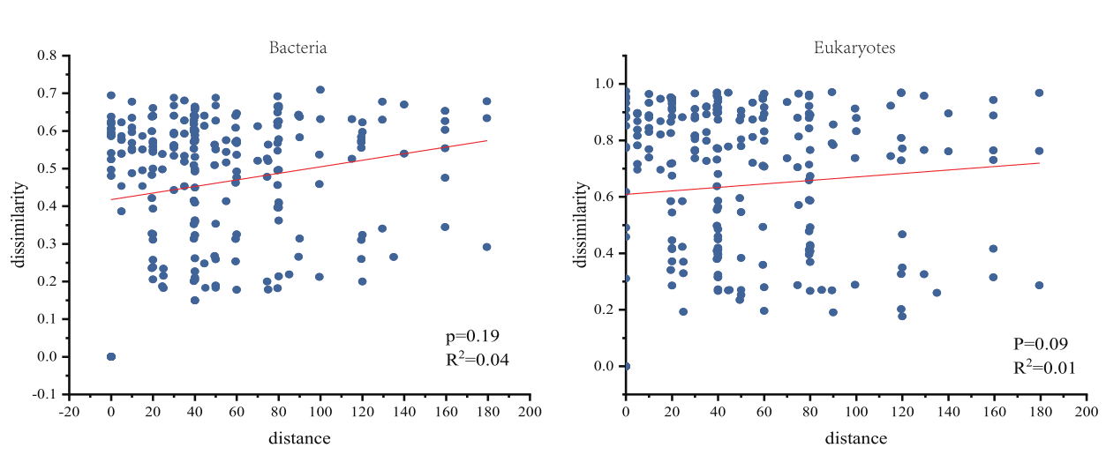
Fig. S1 Distance-decay relationships between the vertical site and a Bray-Curtis dissimilarity matrix of microbial communities.
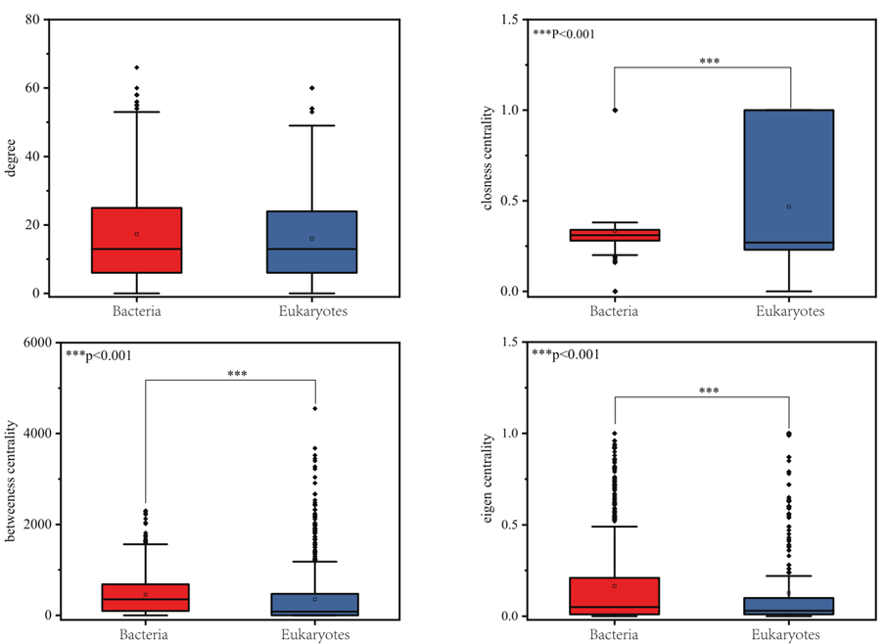
Fig. S2 Node-level topology characteristics of co-occurrence networks.
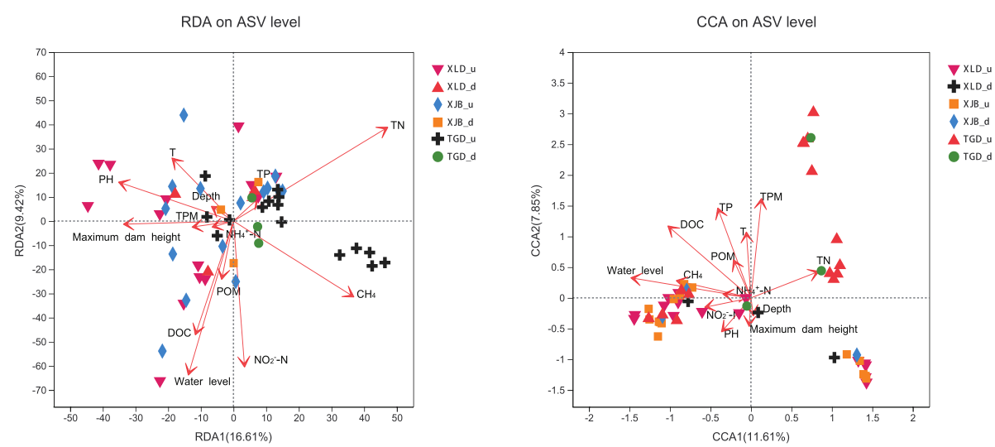
Fig. S3 Redundancy analysis or canonical correspondence analysis of microbial communities’ compositions and variables.
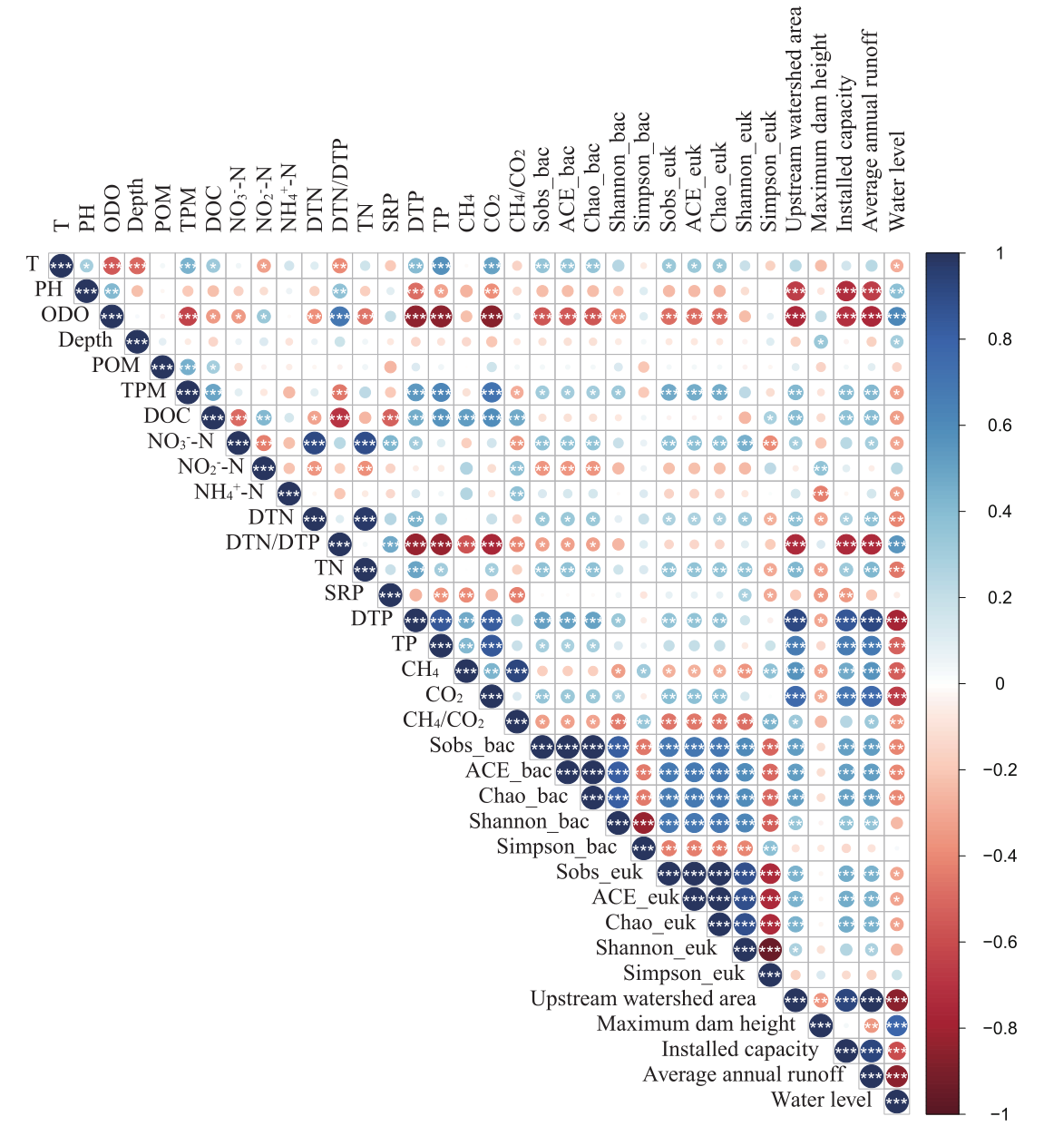
Fig. S4 Pearson correlation analysis between the microbial α-diversity indices, dam-related variables and environmental variables. _bac, the α-diversity index of bacteria; _euk, the α-diversity index of eukaryotes. The color gradient represents Spearman's correlation coefficient.
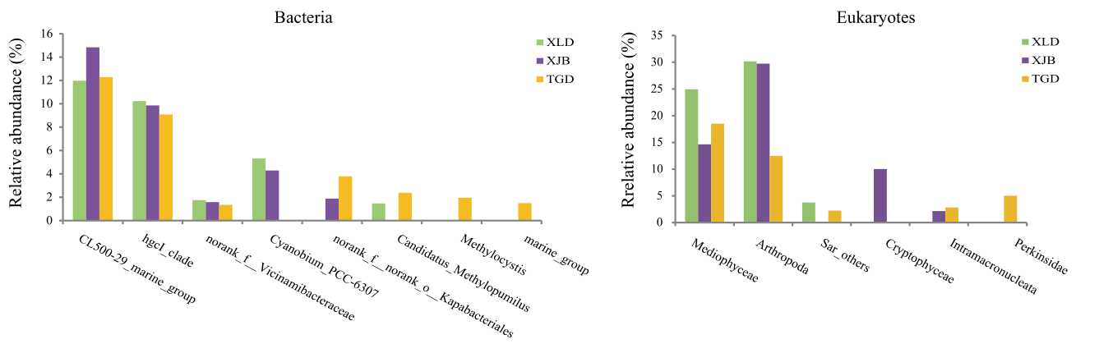
Fig. S5 Relative abundance of the Top 10 ASVs at the different dams were selected for clustering at the genus level. Relative abundance showed the average value. XLD, Xiluodu Dam; XJB, Xiangjiaba Dam; TGD, Three Gorges Dam.

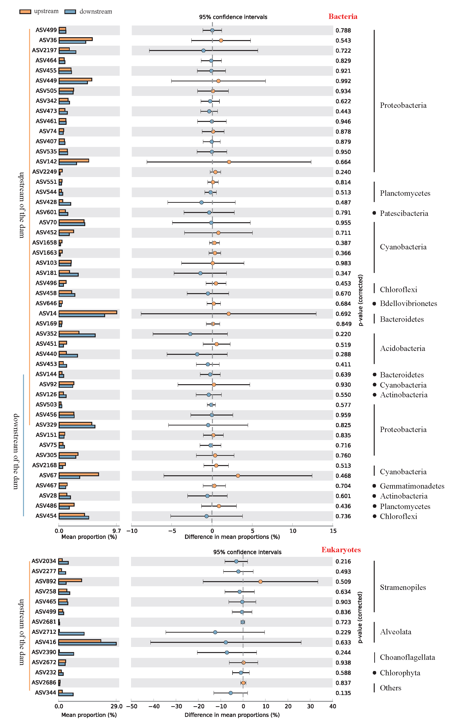
Fig. S6 Extended error bar plots of the differential distribution of the keystone species in the networks of planktonic bacteria and eukaryotes at the ASV level upstream and downstream of the dams.

