PCA Results After Batch Correction
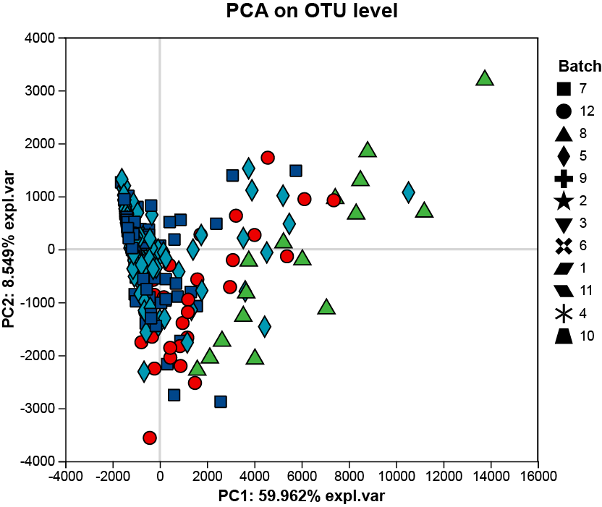
In this study, rumen microbiota were obtained from 340 culled cows across 12 sampling events. To minimize confounding effects caused by different sampling time points, batch correction was performed prior to downstream analysis. We observed that the experimental samples clustered closely, indicating that sampling time had only a minor impact on the microbial profiles.

Fig. S1 PCA results after batch correction. The horizontal and vertical axes represent the two selected principal components, with the percentages indicating the proportion of variance explained by each component. Different colors represent samples from different groups, and different shapes represent different batches. The closer two sample points are, the more similar their microbial community composition

