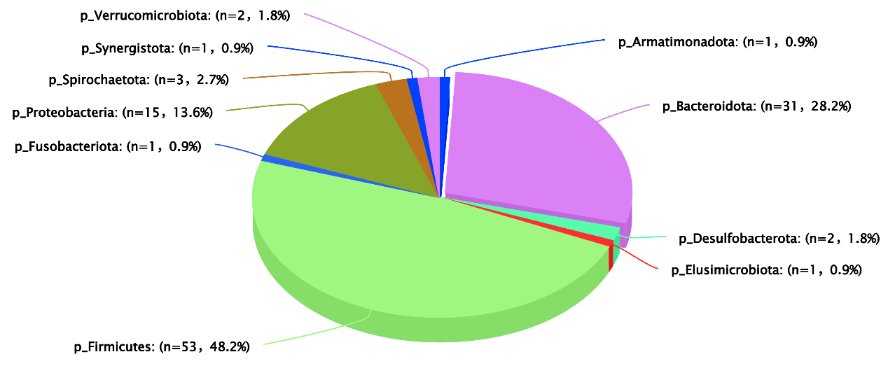
Heritable distribution of rumen microbial genera
Fig. S4 Heritable rumen microbial genera distribution. Microorganisms were classified at the phylum level according to their taxonomic hierarchy.

