Correlation Analysis Between Species Prevalence and Relative Abundance
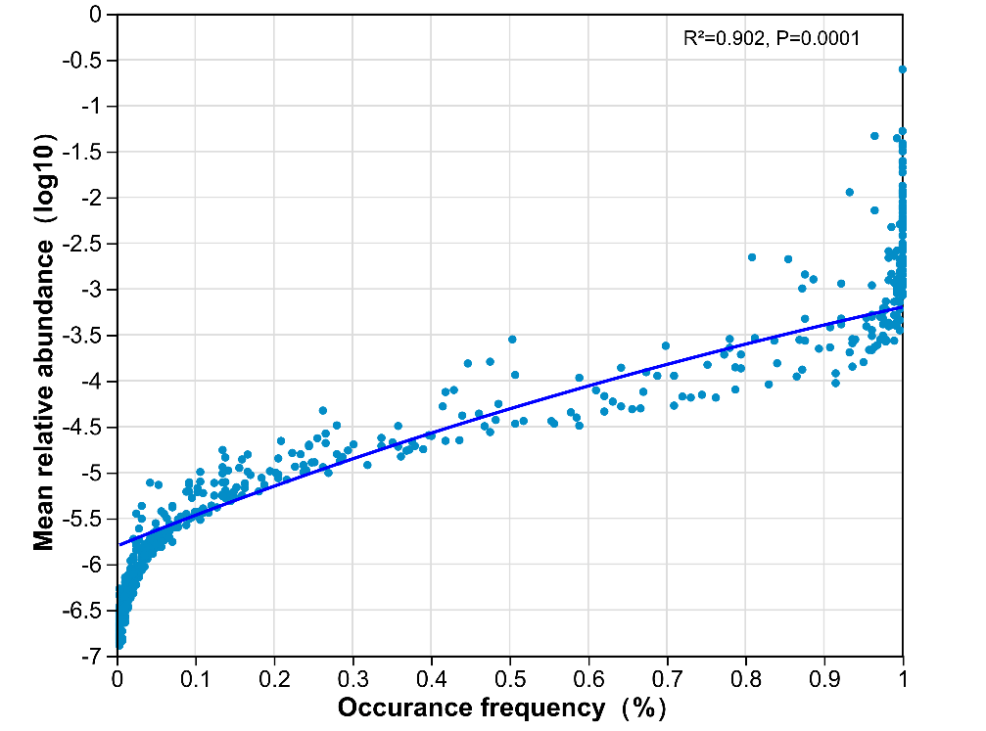

Fig.S3 A strong positive correlation was observed between species prevalence and relative abundance, with R² = 0.902, p < 0.05. Each point in the plot represents one ASV. The x-axis indicates prevalence, and the y-axis shows the log₁₀-transformed mean relative abundance across all samples.

