Differences in Rumen Community Structure Between Dairy Cows with Divergent Productive Lifespans
B
A
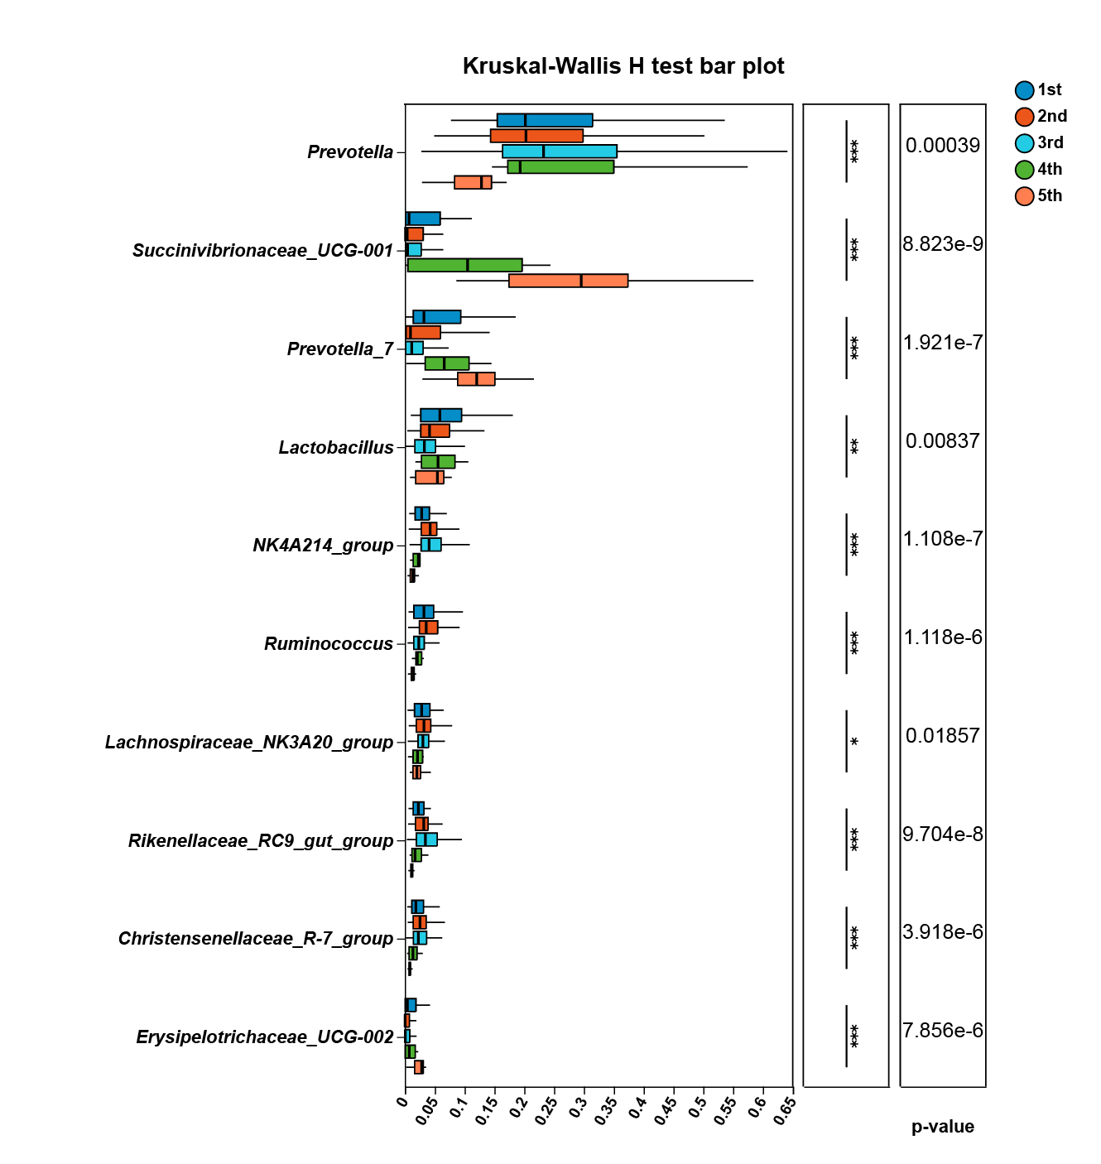
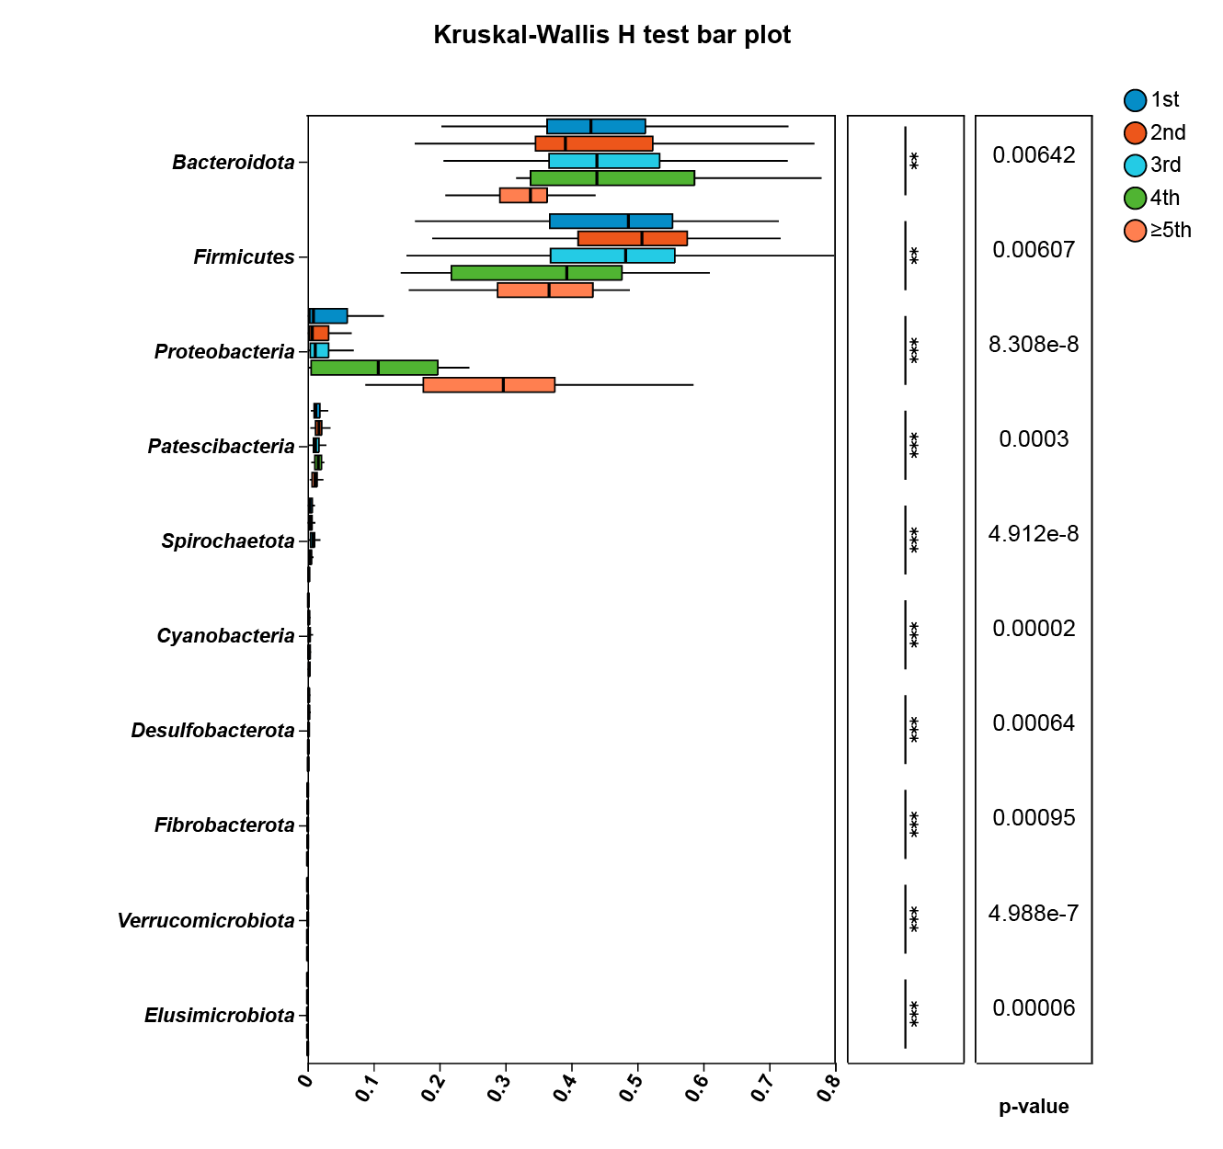

Fig.S2 Rumen microbial composition was compared at the phylum(A) and genus levels(B) across groups with different productive lifespans. Bar plots illustrate the differences in the mean relative abundance of individual taxa between groups, with significance levels marked by P-values and asterisks to clearly indicate the statistical significance of each taxon among multiple groups. The rightmost panel shows the P-value. Significance levels:0.01 < p ≤ 0.05 (*), 0.001 < p ≤ 0.01 (**), p ≤ 0.0001（***）.

