Declarations

Funding
No specific funding was received for this study.
Conflicts of interest
The authors declare no conflicts of interest.
Data availability
Data will be co-owned by the primary investigators and securely stored on the Butterfly Cloud platform and the University of Washington REDCap system. De-identified data will be available upon reasonable ethical request.
Authors’ contributions
CR and MG conceptualized the study. The field work was coordinated by MG. CR, MG, DC, SH, EJ, AS, BW, and AS contributed to data collection. Data analysis and interpretation were conducted by MH, MG, and CR. All authors have read and approved the final document.

Acknowledgements
The authors thank all study participants, the volunteering GPs, midwives, and staff of the participating health centers for their support and collaboration. The investigators also acknowledge Riverstone Health for supplying the Butterfly handheld ultrasound devices used in this study, and the University of Washington for providing REDCap access for data management and structuring via the WWAMI Program.

References
1. World Health Organization. WHO Recommendations on Antenatal Care for a Positive Pregnancy Experience. Geneva: World Health Organization; 2016. Available from: https://www.who.int/publications/i/item/9789241549912
2. Wachira J, Matheka DM, Masheti SA, Githemo GK, Shah S, Haldeman MS, Ramos M, Bergman K. A training program for obstetrics point-of-care ultrasound to 514 rural healthcare providers in Kenya. BMC Med Educ. 2023;23(1). doi:10.1186/s12909-023-04886-x
3. Githemo G, Wanyoro A, Masika J, Onsongo L, Bett S, Githuku S, Gachuiri G, Walker D, Santos N, Ghosh R, Otieno G. Evaluation of large-scale implementation of obstetric point-of-care ultrasound in eight counties in Kenya using RE-AIM framework. BMC Health Serv Res. 2025;25(1):1016. doi:10.1186/s12913-025-13212-8
4. Payesa C, Seyama L, Chimwaza Y, Sindani F, Kanise Y, Bvutula E, Phiri M, Nyangulu P, Gadama L, Kachale F, Gadama G, Mwale M, Yenokyan G, Sripad P, Hyre A, Noguchi LM, Dadabhai S. Feasibility and acceptability of point-of-care ultrasound delivered by midwives during routine antenatal care in Malawi: a prospective implementation science study. BMJ Open. 2025;15(8). doi:10.1136/bmjopen-2025-100515
5. Abawollo HS, Tsegaye ZT, Desta BF, Beshir IA, Mengesha BT, Guteta AA, Heyi AF, Mamo TT, Gebremedhin ZK, Damte HD, Zelealem M, Argaw MD. Contribution of portable obstetric ultrasound service innovation in averting maternal and neonatal morbidities and mortalities at semi-urban health centers of Ethiopia: a retrospective facility-based study. BMC Pregnancy Childbirth. 2022;22(1):368. doi:10.1186/s12884-022-04703-1
6. Woldeyohannes D, Abera M, Gebremedhin S, Tesfaye G. Institutionalization of limited obstetric ultrasound leading to increased antenatal, skilled delivery, and postnatal service utilization in three regions of Ethiopia: a pre-post study. PLoS One. 2023. doi:10.1371/journal.pone.0281626
7. Frija G, Blažić I, Frush DP, Hierath M, Kawooya M, Donoso-Bach L, Brkljačić B. How to improve access to medical imaging in low- and middle-income countries? eClinicalMedicine. 2021;38:101034. doi:10.1016/j.eclinm.2021.101034
8. Fleming KA, Horton S, Wilson ML, Atun R, DeStigter K, Flanigan J, et al. The Lancet Commission on diagnostics: transforming access to diagnostics. Lancet. 2021;398(10315):1997–2050. doi:10.1016/S0140-6736(21)00673-5
9. Della Ripa S, Santos N, Walker D. AI-enabled obstetric point-of-care ultrasound as an emerging technology in low- and middle-income countries: provider and health system perspectives. BMC Pregnancy Childbirth. 2025;25:729. doi:10.1186/s12884-025-07796-6
10. Ranger BJ, Bradburn E, Chen Q, Kim M, Noble JA, Papageorghiou AT. Portable ultrasound devices for obstetric care in resource-constrained environments: mapping the landscape. Gates Open Res. 2024;7:133. doi:10.12688/gatesopenres.15088.2

Supplementary Materials

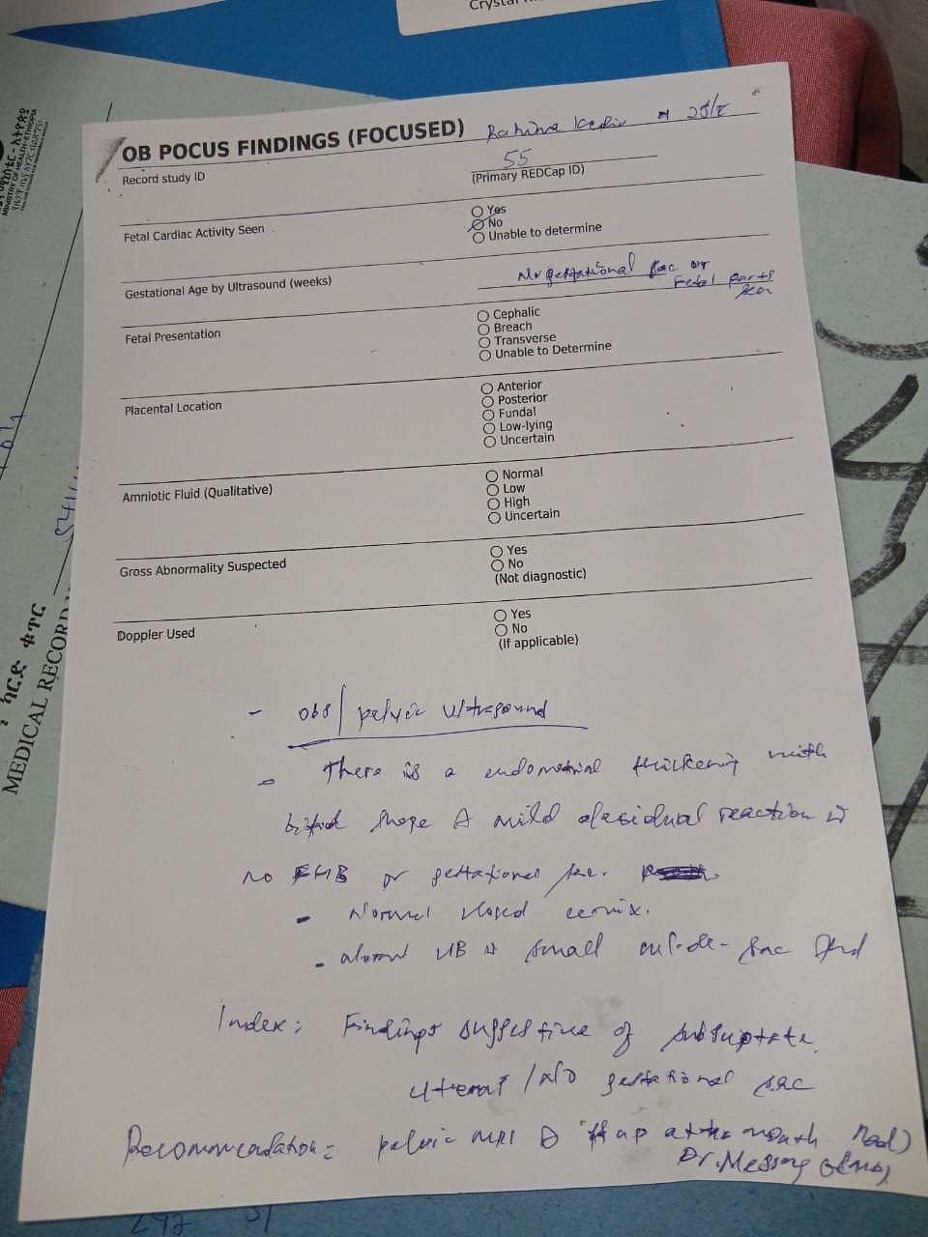
Supplementary Figure S1. Standardized OB POCUS Findings (Focused) acquisition form used at the point of care, and a sample completed form with the doctor’s annotation. These forms were used to capture structured scan findings before REDCap data entry. The forms are presented for methodological transparency and are not intended as main publication figures.

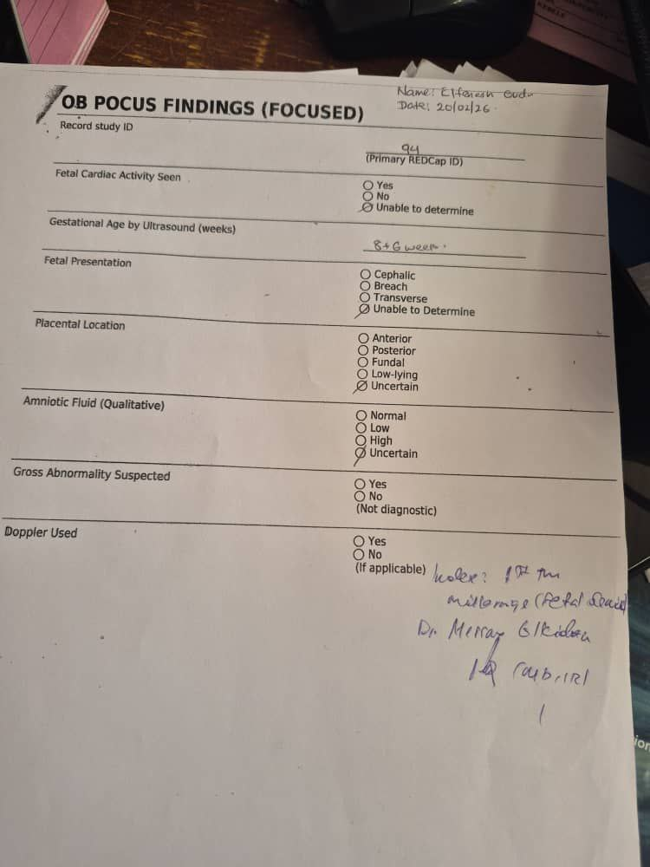

Note: The handwritten clinical annotation shown in the sample form represents a radiologist’s review note documenting an obstetric ultrasound finding of a decidual sac with measurable mean sac diameter (MSD) but no embryonic pole or fetal heartbeat on M-mode, with the internal cervical os closed. The clinical conclusion was an early first-trimester anembryonic pregnancy. Such annotations are part of the specialist quality-assurance pathway described in the Methods section.

