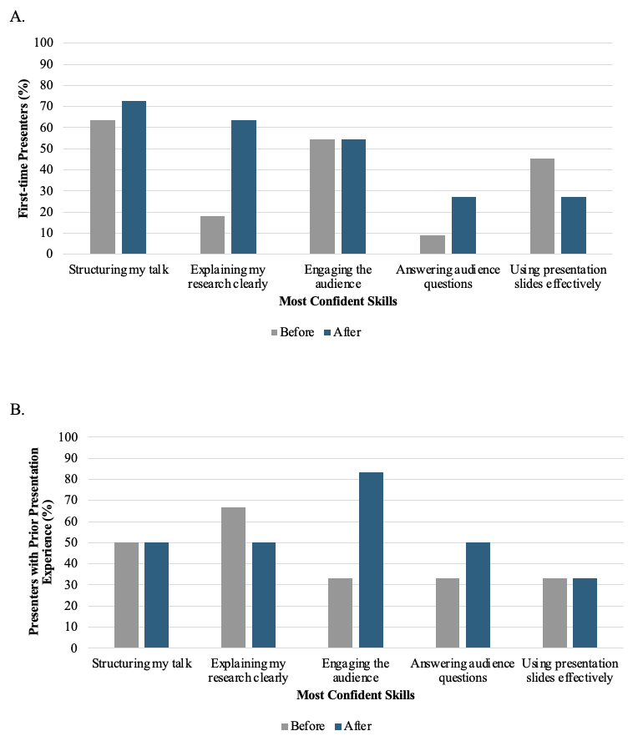 Supplementary Figure 1. Changes in presenter confidence following participation in the Medical Student Research Presentation (MSRP) session. Bars show the percentage of presenters who selected each presentation skill as one of their most confident skills before and after participation. Results are shown separately for first-time presenters (A; n = 11) and presenters with prior presentation experience (B; n = 6). Participants could select up to three skill options.
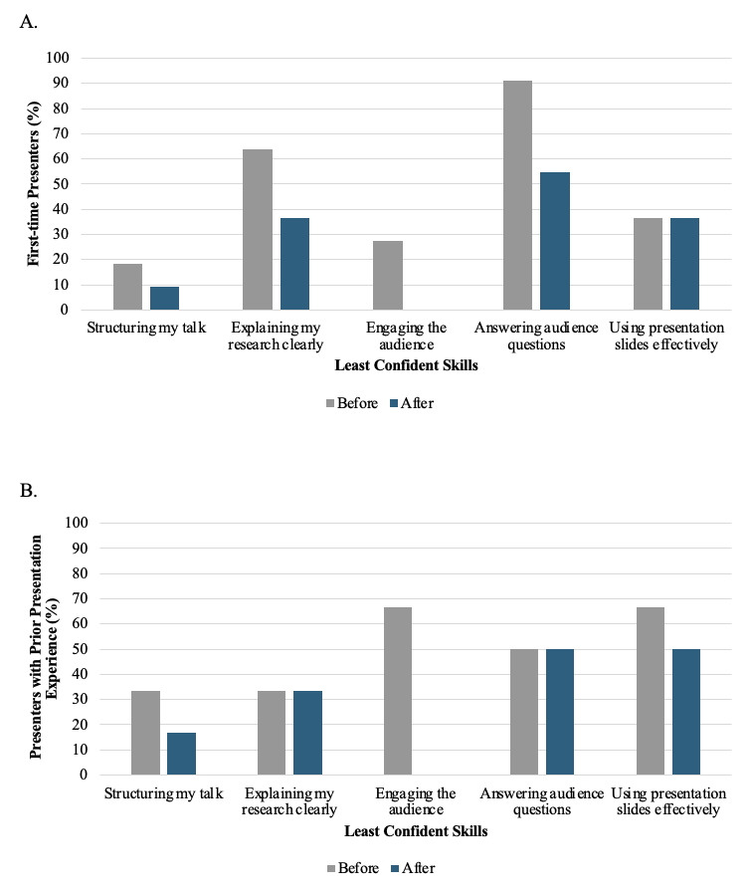
Supplementary Figure 2. Changes in presenter confidence following participation in the Medical Student Research Presentation (MSRP) session. Bars show the percentage of presenters who selected each presentation skill as one of their least confident skills before and after participation. Results are shown separately for first-time presenters (A; n = 11) and presenters with prior presentation experience (B; n = 6). Participants could select up to three skill options.

