Supporting Information
The Human Intervertebral Disc as a Long-Term Repository for Micro/Nanoplastics: Tissue-Specific Accumulation and Risk Estimation
Xuehua Li ¹, Yanhua Wang ^{1,} *, Zixian Feng ¹, Jiawei Zhang ², Baoshan Xing ³, Tan Ding ^{2,} *
¹ School of Geography and Tourism, Shaanxi Normal University, Xi'an, 710119, China
² Department of Orthopedics, Xijing Hospital, The Fourth Military Medical University, Xi’an, Shaanxi, 710032, China
³ Stockbridge School of Agriculture, University of Massachusetts, Amherst, MA, 01003, United States
*Corresponding authors
Tel.: 13991828224
E-mail address: yhwang930@foxmail.com (Dr. Yanhua Wang); dtdyy@fmmu.edu.cn (Dr. Tan Ding)
Supporting information contains:
Number of pages: 9
Texts: S1-S5
Tables: S1-S3
Figures: S1- S4

Text S1 Individual case analysis of blood MPs abundance and associated exposure factors
Approximately 18.6% of agricultural film remains in farmland annually in China ¹. Donor No. 3 had long-term exposure to agricultural plastic films and pesticide packaging, possibly inhaling MPs through dust or ingesting them via agricultural products. It was revealed that microwave heating of food containers for only 3 minutes could release over two billion plastic particles ². Donor No. 21 often used plastic containers for food storage. MPs can migrate into food through heating in such home environments. Additionally, lumbar spine disease may reduce physical activity, indirectly affecting metabolism. Although donor No. 15 had the highest BMI (overweight), MPs abundance in blood was lower than in donors No. 3 and 21, indicating occupational exposure intensity and metabolic differences may play a more critical role.
Text S2 Tissue distribution of non-carcinogenic risk in individuals
Individual risk profiles showed distinct tissue dominance: most patients were "intervertebral disc risk-predominant" (e.g., patients No. 2, 13, and 19), while a minority demonstrated “bone tissue-dominant” profiles (e.g., patients No. 10 and 20). This is particularly important for patients with chronic bone diseases or metabolic disorders. Notably, patients No. 7 and 17 showed the highest HI values in blood, suggesting differences in exposure pathways and transport abilities between individuals. This pattern may indicate recent exposure or transient circulatory presence of MPs. Text S3 Validation of PLS-DA classification
Two independent feature-construction strategies were used for cross-validation. The first PLS-DA (standardized feature set) retained two principal components explaining 72.6% of Y-variance, identifying fiber morphology, white color, larger mean particle size, and PET/PE as key discriminatory features (Total_Importance, Fig. 5d). The second PLS-DA (raw particle data reconstruction) calculated VIP scores; using VIP > 1.0, 20 important variables were identified, with the proportion of 30-60 μm particles (VIP=1.71) and white particles (VIP=1.52) among the top features, corroborating the initial analysis.
One-way ANOVA confirmed significant differences among tissue types (PC1 scores: F=19.86, p<0.001, Fig. S3b) and among phenotype groups (PC1 gradient: F=20.04, p<0.001, Fig. 5c). Post-hoc tests confirmed the disc-enriched and blood-enriched phenotypes as the most significantly different.
Text S4 Correlation and PCA of nanoplastic enrichment
Fig. S4a presents Spearman correlation analysis of PVC, PA66, and PS concentrations across blood, bone tissue, and intervertebral discs. Significant positive correlations were observed between blood and bone tissue for PVC (p ≤ 0.01) and PA66 (p ≤ 0.01). Correlations between bone tissue and intervertebral discs were comparatively weaker, with PVC and PA66 showing marginal significance (p ≤ 0.05). Notably, PA66 in intervertebral discs exhibited a negative correlation with its concentration in other tissues (p ≤ 0.01).
Fig. S4b shows principal component analysis of nanoplastic concentrations and anthropometric parameters (height, age, BMI) from five donors. The first two principal components explained 68.6% of the total variance (PC1: 44.1%, PC2: 24.5%). PC1 was primarily driven by height and BMI, with an inverse association between height and PS concentrations. PC2 was dominated by PVC and PA66, revealing their enrichment patterns. Sample clustering showed distinct tissue-specific distributions: blood samples aligned with the negative PC1 axis, strongly associated with height; bone tissue samples clustered in the positive PC1 region, correlating with BMI and PS concentrations; intervertebral disc samples aggregated in the positive PC2 quadrant, closely overlapping with PVC and PA66 distributions, identifying the disc as the primary accumulation site for these polymers.
Text S5 Health risk assessment
For equation (S1-1), HQ represents the total average daily exposure to MPs through food intake, inhalation, and skin contact. C_{nc} refers to the non-carcinogenic pollutant content in blood, bone tissue, or intervertebral disc (mg·kg⁻¹). EF denotes the frequency of human exposure (d·a⁻¹); ED is the adult exposure duration (a); IRD represents the amount of MPs ingested via various exposure pathways (g·d⁻¹); BW is the average body weight of an adult (kg); AT_{nc} represents the average exposure time for non-carcinogenic effects (d); RFD is the reference dose for non-carcinogenic pollutants, including food intake, inhalation, and skin absorption (mg·kg⁻¹·d⁻¹).
$\text{HQ=}\frac{{\text{C}}_{\text{nc}}\text{×EF×ED×IRD×1}{\text{0}}^{\text{-3}}}{\text{BW×A}{\text{T}}_{\text{nc}}\text{×RFD}}$ （S1-1）
$\text{CR=}\frac{{\text{C}}_{\text{ca}}\text{×SF×ED×IRD}}{\text{BW×A}{\text{T}}_{\text{ca}}}$ （S1-2）
For equation (S1-2), CR represents the carcinogenic risk index for pollutants; C_{ca} is the carcinogenic substance content in blood, bone tissue, or intervertebral disc (mg·kg⁻¹). SF is the carcinogenic slope factor, considering food intake, inhalation, and skin absorption [(mg·kg⁻¹·d⁻¹)⁻¹]; AT_{ca} is the average exposure time for carcinogenic effects (d).
${\text{ρ}}_{\text{B}}\text{=}\text{Particl}{\text{e}}_{}\text{abundance}\text{⋅}\frac{\text{4}}{\text{3}}\text{⋅}\text{π}\text{⋅}{\text{r}}^{\text{3}}$ （S1-3）
The mass fraction used in the health risk assessment formula for MPs is calculated using equation (S1-3) to convert the MPs abundance unit (n·kg⁻¹) to mass fraction (mg·kg⁻¹). The particle abundance is taken as the average value for MPs. The density of plastic is determined by multiplying the average percentage of each MP type by its density, to compute the average density of MPs. The radius (r) of MPs is calculated based on the detected size and the average MP size by percentage.

Table S1 Participant demographics and clinical information
No.sample | Age | Gender | Height/cm | Weight/kg | BMI | Occupation | Principal Diagnosis | Underlying Diseases
Case 1 | 72 | Male | 172 | 87 | 29.4 | Farmer | Lumbar Spinal Stenosis | Hypertension Grade 2
Case 2 | 74 | Female | 155 | 60 | 25.0 | Retired personnel | Lumbar Disc Herniation | -
Case 3 | 52 | Female | 160 | 53 | 20.7 | Farmer | Lumbar Spondylolisthesis | Hypertension Grade 1
Case 4 | 52 | Male | 170 | 65 | 22.5 | Farmer | Lumbar Disc Herniation | -
Case 5 | 58 | Female | 158 | 50 | 20.0 | Unemployed | Lumbar Disc Herniation | -
Case 6 | 58 | Male | 167 | 61 | 21.9 | Farmer | Lumbar Disc Herniation | -
Case 7 | 57 | Male | 165 | 60 | 22.0 | Farmer | Lumbar Disc Herniation | -
Case 8 | 33 | Male | 170 | 64.5 | 22.3 | Farmer | Lumbar Disc Herniation | -
Case 9 | 68 | Male | 165 | 65 | 23.9 | Farmer | Lumbar Disc Herniation | Coronary Heart Disease & Diabetes Mellitus
Case 10 | 57 | Male | 165 | 70 | 25.7 | Farmer | Lumbar Disc Herniation | -
Case 11 | 50 | Male | 173 | 73 | 24.4 | Farmer | Lumbar Disc Herniation | -
Case 12 | 49 | Female | 162 | 60 | 22.9 | Farmer | Lumbar Disc Herniation | -
Case 13 | 41 | Female | 162 | 63 | 24.0 | Farmer | Lumbar Disc Herniation | -
Case 14 | 66 | Female | 161 | 65 | 25.1 | Retired personnel | Lumbar Spondylolisthesis | -
Case 15 | 55 | Female | 155 | 63 | 26.2 | Professional and technical personnel | Lumbar Spondylolisthesis | Hypertension Grade 2
Case 16 | 68 | Male | 180 | 70 | 21.6 | Retired personnel | Lumbar Spinal Stenosis | -
Case 17 | 59 | Female | 150 | 63 | 28.0 | Farmer | Lumbar Spondylolisthesis | -
Case 18 | 70 | Female | 162 | 72 | 27.4 | Other personnel | Lumbar Spinal Stenosis | -
Case 19 | 66 | Female | 154.5 | 72 | 30.2 | Farmer | Lumbar Spondylolisthesis | -
Case 20 | 54 | Male | 165 | 66 | 24.2 | Worker | Lumbar Disc Herniation | Hypertension Grade 2 & Coronary Heart Disease
Case 21 | 40 | Male | 170 | 70 | 24.2 | Homemaker and unemployed | Lumbar Disc Herniation | -

Table S2 Microplastic human health evaluation levels
Evaluation method | Acceptable (not) carcinogenic risk | Unacceptable cancer risk
HQ（HI） | ＜1 | ≥1
CR(CCR) | ＜10⁻⁴ | ≥10⁻⁴

Table S3 Parameters and recommended values for microplastic human health risk evaluation
Parameter Symbol | Name | Recommended Value | Units
C | Pollutant measured mass fraction | Measured value | mg·kg⁻¹
EF | Adult exposure frequency | 250 | d·a⁻¹
ED | Adult exposure duration | 24 | a
IRD | Daily microplastic intake | 0.7 | g·d⁻¹
BW | Adult average body weight | 56.8 | kg
AT_{nc} | Average exposure time for non-carcinogenic effects | 9125 | d
AT_{ca} | Average exposure time for carcinogenic effects | 26280 | d
RFD_{o} | Reference dose for oral intake | 2.00×10⁻² | mg·kg⁻¹·d⁻¹
RFD_{d} | Reference dose for inhalation | 2.00×10⁻² | mg·kg⁻¹·d⁻¹
RFD_{i} | Reference dose for skin absorption | 2.04×10⁻¹ | mg·kg⁻¹·d⁻¹
SF_{o} | Carcinogenic slope factor for oral intake | 8.04×10⁻² | （mg·kg⁻¹·d⁻¹）⁻¹
SF_{d} | Carcinogenic slope factor for inhalation | 8.04×10⁻² | （mg·kg⁻¹·d⁻¹）⁻¹
SF_{i} | Carcinogenic slope factor for skin absorption | 1.06×10⁻¹ | （mg·kg⁻¹·d⁻¹）⁻¹
Fig. S1 Daily plastic intake statistics for 21 patients: I: Frequency of Cosmetic Use; Ⅱ: Frequency of Plastic Utensil Use; Ⅲ: Frequency of Takeaway Food Consumption; IV: Frequency of Bottled Water
Fig. S2 (a) Microplastic color distribution proportions; (b) Microplastic shape distribution proportions
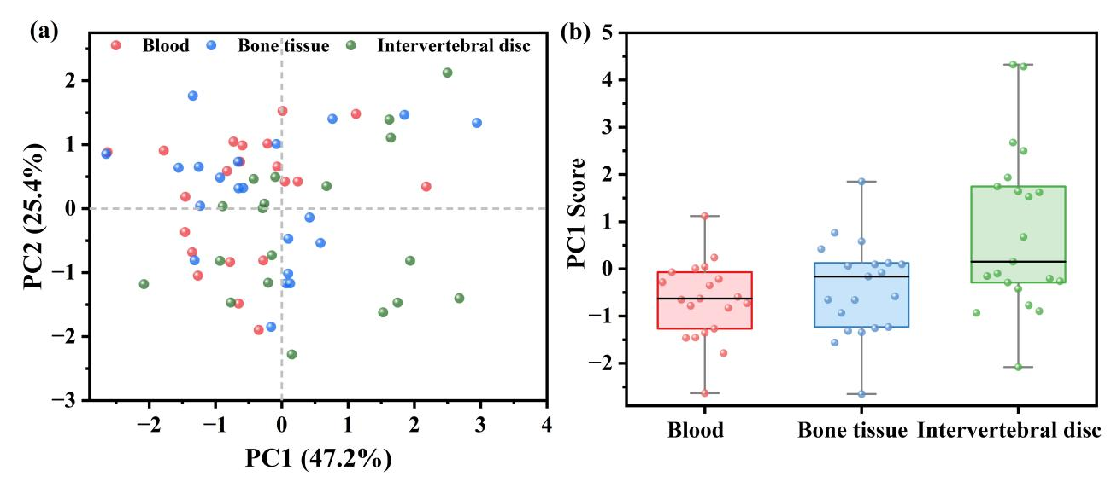
Fig. S3 (a) PLS-DA score plot of blood, bone tissue and intervertebral disc samples; (b) PLS-DA PC1 score box plot of blood, bone tissue and intervertebral disc samples
Fig. S4 (a) Spearman correlation analysis of polymer types and abundance of NPs in three tissues. Significant correlations (p ≤ 0.05 or p ≤ 0.01) are marked with * and ** respectively; (b) Principal component analysis of NPs in three human tissues.

References
1. Zhang, Q.Q., Ma, Z.R., Cai, Y.Y., Li, H.R. & Ying, G.G. Agricultural Plastic Pollution in China: Generation of Plastic Debris and Emission of Phthalic Acid Esters from Agricultural Films. Environ Sci Technol 55, 12459-12470 (2021).
2. Zangmeister, C.D., Radney, J.G., Benkstein, K.D. & Kalanyan, B. Common Single-Use Consumer Plastic Products Release Trillions of Sub-100 nm Nanoparticles per Liter into Water during Normal Use. Environ Sci Technol 56, 5448-5455 (2022).

