Supplementary Materials
Table S1. Overparenting Scale
Thinking about your mother (or mother figure)/father (or father figure), with a focus on the recent 12 months. Please indicate to what degree you agree or disagree with the following statements about her/him:
 | Strongly disagree（1） | Disagree（2） | Neutral（3） | Agree（4） | Strongly agree（5）
- I think my mother/father is too overly involved in my life. | 1 | 2 | 3 | 4 | 5
- I feel like my mother/father sometimes smothers me with her/his attention. | 1 | 2 | 3 | 4 | 5
- I feel my mother/father has interfered in my life when I wish she/he wouldn’t have. | 1 | 2 | 3 | 4 | 5
- I sometimes wish my mother/father would “back off” and stay out of my business. | 1 | 2 | 3 | 4 | 5
- I feel my mother/father is too controlling of me and my life. | 1 | 2 | 3 | 4 | 5
Table S2. Center for Epidemiologic Studies Depression Scale – Short Form (CES-D)
Below is a list of the ways you may have felt or behaved. Please indicate how often you have felt this way during the past week.
 | less than 1 day（0） | 1–2 days （1） | 3–4 days （2） | 5–7 days（3）
- I was bothered by things that usually don't bother me. | 1 | 2 | 3 | 4
- I had trouble keeping my mind on what I was doing. | 1 | 2 | 3 | 4
- I felt depressed. | 1 | 2 | 3 | 4
- I felt that everything I did was an effort. | 1 | 2 | 3 | 4
- I felt hopeful about the future. | 1 | 2 | 3 | 4
- I felt fearful. | 1 | 2 | 3 | 4
- My sleep was restless. | 1 | 2 | 3 | 4
- I was happy. | 1 | 2 | 3 | 4
- I felt lonely. | 1 | 2 | 3 | 4
- I could not get "going." | 1 | 2 | 3 | 4

Table S3. Beck Anxiety Inventory (BAI)
The following is a list of common symptoms of anxiety. Please indicate how much you have been bothered by each symptom during the past month, including today.
 | not at all（0） | mildly but it didn’t bother me much （1） | moderately - it wasn’t pleasant at times （2） | severely - I could barely stand it（3）
- Feeling hot. | 1 | 2 | 3 | 4
- Unable to relax. | 1 | 2 | 3 | 4
- Fear of the worst happening. | 1 | 2 | 3 | 4
- Terrified or afraid. | 1 | 2 | 3 | 4
- Nervous. | 1 | 2 | 3 | 4
- Fear of losing control. | 1 | 2 | 3 | 4
- Scared. | 1 | 2 | 3 | 4
- Indigestion or discomfort in the abdomen. | 1 | 2 | 3 | 4
- Face flushed. | 1 | 2 | 3 | 4
- Sweating (not due to heat). | 1 | 2 | 3 | 4

Table S4. Satisfaction With Life Scale (SWLS)
Below are five statements with which you may agree or disagree. Using the 1–7 scale below, indicate your agreement with each item.
 | Strongly disagree（1） | Disagree（2） | Slightly disagree（3） | Neither agree nor disagree（4） | Slightly agree（5） | Agree（6） | Strongly disagree（7）
- In most ways my life is close to my ideal. | 1 | 2 | 3 | 4 | 5 | 6 | 7
- The conditions of my life are excellent. | 1 | 2 | 3 | 4 | 5 | 6 | 7
- I am satisfied with my life. | 1 | 2 | 3 | 4 | 5 | 6 | 7
- So far I have gotten the important things I want in life. | 1 | 2 | 3 | 4 | 5 | 6 | 7
- If I could live my life over, I would change almost nothing. | 1 | 2 | 3 | 4 | 5 | 6 | 7

Table S5. Parent-Child Relationship Quality
- How satisfied are you with the relationship with your mother (or mother figure)/father (or father figure)? | 1 very unsatisfied | 2 somewhat unsatisfied | 3 somewhat satisfied | 4 very satisfied
- How happy are you with the way things are between you and your mother (or mother figure)/father (or father figure)? | 1 very unhappy | 2 Somewhat unhappy | 3 somewhat happy | 4 very happy
- How close do you feel to your mother (or mother figure)/father (or father figure)? | 1 not at all close | 2 a little bit close | 3 somewhat close | 4 very close

Table S6. Inclusion of Other in the Self (IOS) Scale – Mother Version
Please circle the picture that best describes your relationship with your mother (or mother figure). Each picture represents different degrees of overlap between the self and the other. The greater the overlap, the closer the relationship.
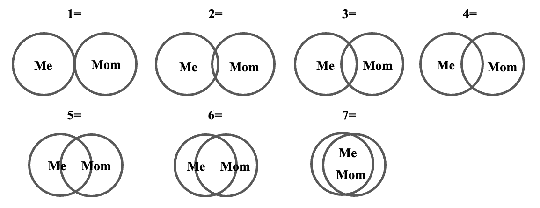
Table S7. Inclusion of Other in the Self (IOS) Scale – Father Version
Please circle the picture that best describes your relationship with your father (or father figure). Each picture represents different degrees of overlap between the self and the other. The greater the overlap, the closer the relationship?

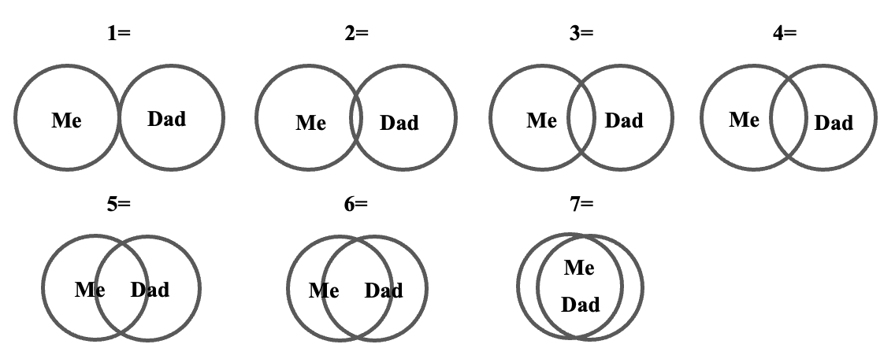

Table S8. Channel locations
ROI | Channel | x | y | z
Right inferior frontal gyrus | 1 | 60.00 | 25.33 | 4.67
Right inferior frontal gyrus | 2 | 54.33 | 40.33 | -10.67
Right inferior frontal gyrus | 7 | 57.00 | 35.33 | 17.33
Right inferior frontal gyrus | 8 | 52.00 | 48.33 | 0.67
Right inferior parietal | 3 | 54.67 | -35.67 | 58.33
Right inferior parietal | 5 | 69.00 | -27.67 | 39.67
Right inferior parietal | 6 | 64.00 | -16.33 | 45.67
Right inferior parietal | 17 | 59.33 | -47.33 | 51.67
Right sensorimotor cortex | 4 | 50.00 | -25.00 | 65.00
Right sensorimotor cortex | 10 | 50.00 | -25.00 | 65.00
Right sensorimotor cortex | 11 | 34.67 | -2.67 | 66.33
Right sensorimotor cortex | 12 | 59.00 | -3.67 | 48.33
Right sensorimotor cortex | 13 | 51.33 | 9.33 | 51.33
Right dorsal lateral  prefrontal cortex | 9 | 43.33 | 55.67 | 19.33
Right dorsal lateral  prefrontal cortex | 18 | 45.67 | 21.33 | 52.33
Left inferior frontal gyrus | 32 | -51.00 | 45.33 | 5.33
Left inferior frontal gyrus | 33 | -55.00 | 30.67 | 21.67
Left inferior frontal gyrus | 38 | -54.00 | 36.67 | -7.33
Left inferior frontal gyrus | 39 | -59.00 | 19.33 | 9.67
Left inferior parietal | 22 | -53.67 | -50.67 | 55.00
Left inferior parietal | 35 | -50.67 | -39.67 | 59.00
Left inferior parietal | 36 | -61.00 | -21.33 | 48.67
Left inferior parietal | 37 | -65.00 | -32.00 | 44.00
Left sensorimotor cortex | 27 | 42.67 | -14.67 | 68.33
Left sensorimotor cortex | 28 | 34.67 | -2.67 | 66.33
Left sensorimotor cortex | 29 | 59.00 | -3.67 | 48.33
Left sensorimotor cortex | 30 | 51.33 | 9.33 | 51.33
Left sensorimotor cortex | 34 | -48.00 | -29.00 | 65.67
Left dorsal lateral  prefrontal cortex | 23 | -44.67 | 15.67 | 54.33
Left dorsal lateral  prefrontal cortex | 31 | -41.67 | 52.67 | 22.67
Frontopolar | 14 | 42.67 | 60.00 | -10.00
Frontopolar | 15 | 32.00 | 67.67 | 4.00
Frontopolar | 16 | 14.00 | 71.67 | -11.00
Frontopolar | 19 | 15.67 | 69.67 | 22.33
Frontopolar | 20 | 0.67 | 69.00 | 2.67
Frontopolar | 21 | 0.67 | 69.00 | 2.67
Frontopolar | 24 | -12.67 | 71.00 | -9.67
Frontopolar | 25 | -32.00 | 65.67 | 6.00
Frontopolar | 26 | -43.33 | 56.33 | -8.33

