Natural Hazards

Supporting Information for

Seasonal and inter-seasonal soil moisture controls on coseismic shallow landsliding near the Cascadia Subduction Zone

Nicolas W. Mathews¹, Ben A. Leshchinsky², Michael J. Olsen³, Adam M. Booth⁴

¹Sitka Sound Science Center, Sitka, AK, USA. ²Oregon State University, Department of Forest Engineering, Resources and Management, Oregon State University, Corvallis, OR, USA. ³Oregon State University, Department of Civil and Construction Engineering, Corvallis, OR, USA. ⁴Portland State University, Department of Geology, Portland, OR, USA.

Corresponding Author: nmathews@sitkascience.org

Contents of this file:

Methodology Details and Parameterization
Figures S1 to S5

Methodology Details

RegionGrow3D Boundary Forces

We computed landslide boundary forces (Figure S1a) as described in Mathews et al. (2024), but modified the equation for prism normal intercolumn force to account for seismic acceleration:

 | $$Q_{prism}=N_{prism}\sin{β_{prism}}-\left[c^{'}A_{prism}+\left(N_{prism}-u_{prism}A_{prism}\right)\tan{ϕ^{'}}\right]\cos{β_{prism}}+k_{h,prism}W_{prism}$$ | (S1)

where $β_{prism}$ is the resultant slip surface angle of the prism, $A_{prism}$ is the area of the prism slip surface, $u_{prism}$ is porewater pressure or suction stress at the prism slip surface, and $k_{h,prism}$ is the horizontal pseudostatic coefficient for each prism. $k_{h,prism}$ is estimated as the mean value of $k_{h}$ for the entire cluster, $k_{h,mean}$, scaled according to the orientation of each prism’s slip surface in relation to the cluster DOS:

 | $$k_{h,prism}=-k_{h,mean}\cos{γ}$$ | (S2)

where $γ$ is the angle between the prism slip surface aspect and the cluster DOS. This scaling ensures that the direction of the pseudostatic coefficient applied to each prism agrees with the cluster DOS, regardless of its orientation. For example, if a prism is at the crest of the cluster ($γ=180°$), then $k_{h,prism}$ acts in the same direction as the prism slip surface aspect, increasing driving force and reducing normal force. Conversely, if a prism is at the toe of the cluster ($γ=0°$), then $k_{h,prism}$ acts in the opposite direction, decreasing resisting forces.

Figures S1 to S5

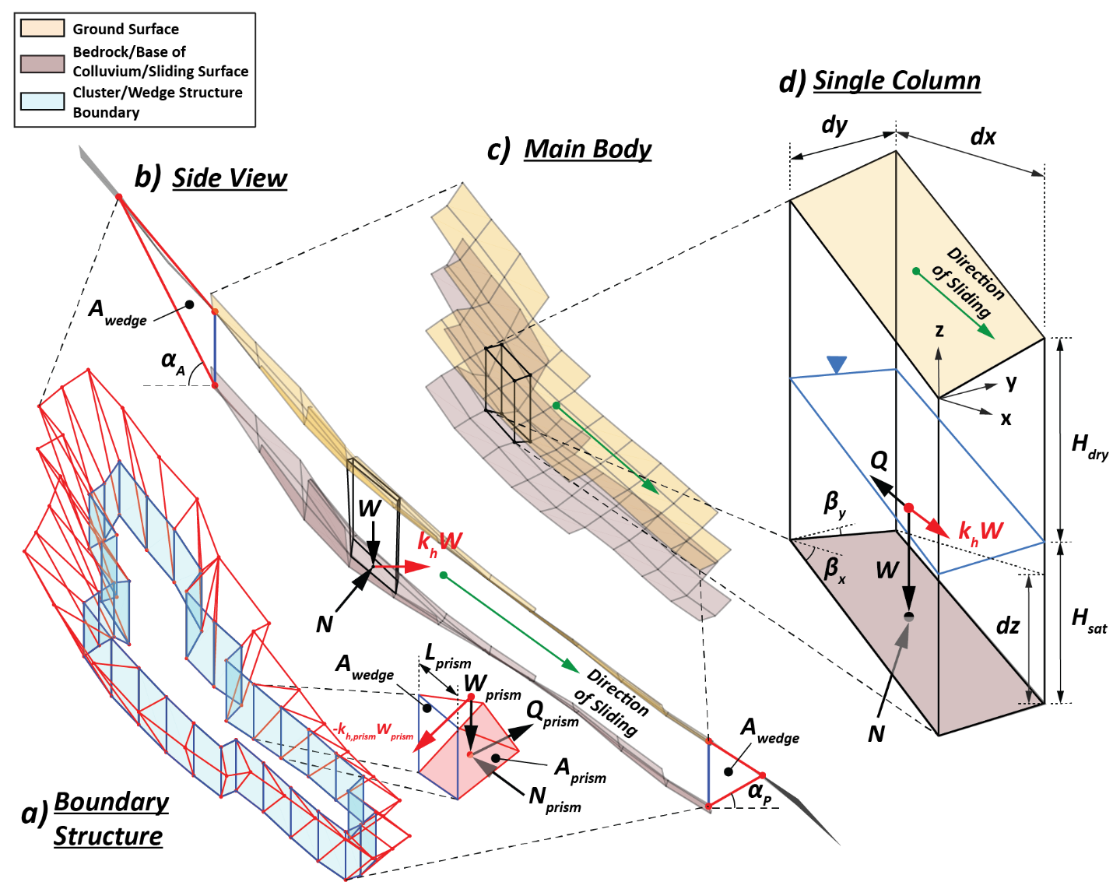
Figure S1: RegionGrow3D schematic modified to account for seismic acceleration (seismic forces in red): a) boundary structure; b) side view of landslide cluster; c) oblique view of landslide cluster; d) schematic for single soil column.

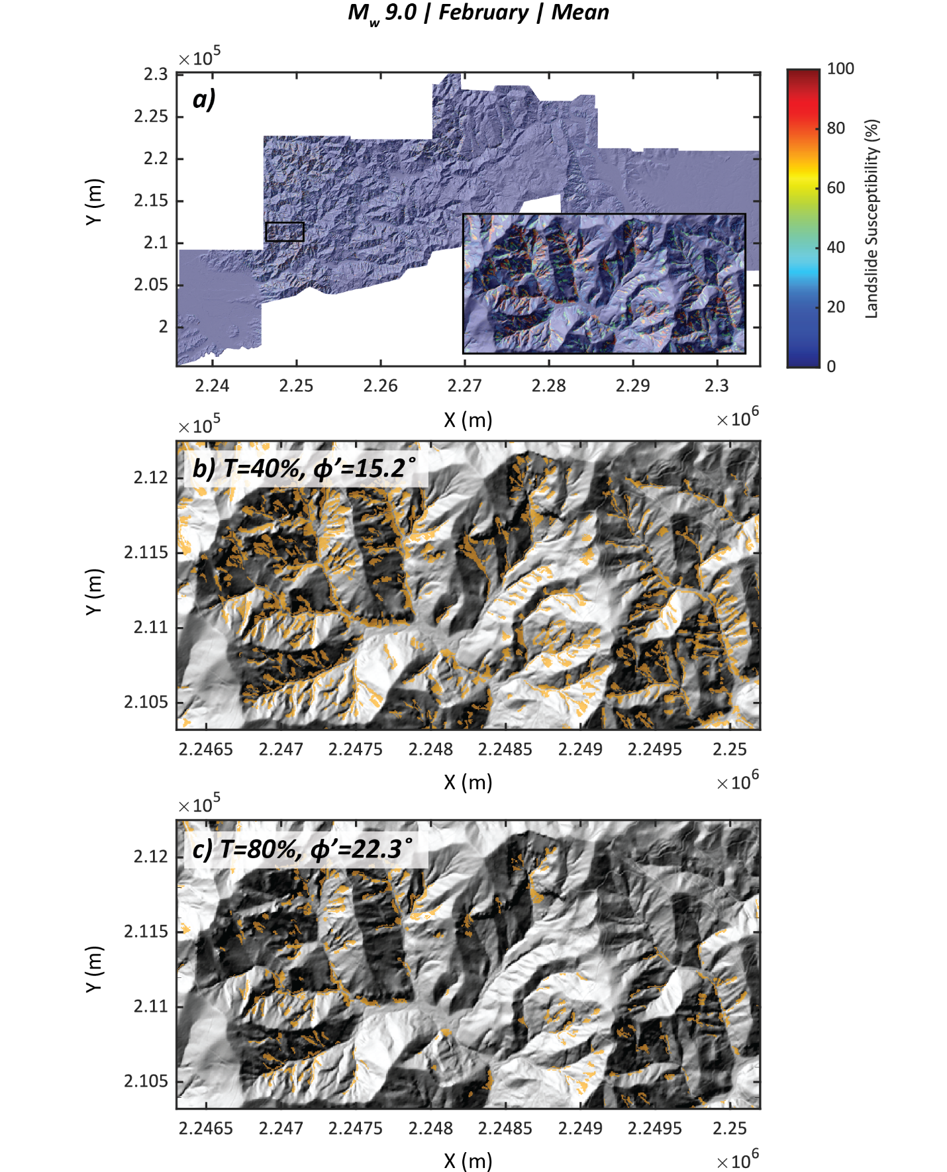
Figure S2: Susceptibility map: a) M_{w} 9.0 in February (mean conditions). Corresponding discrete landslide distributions for subset of study area: b) $T=40\%$ ($ϕ^{'}=15.2°$); c) $T=80\%$ ($ϕ^{'}=22.3°$).

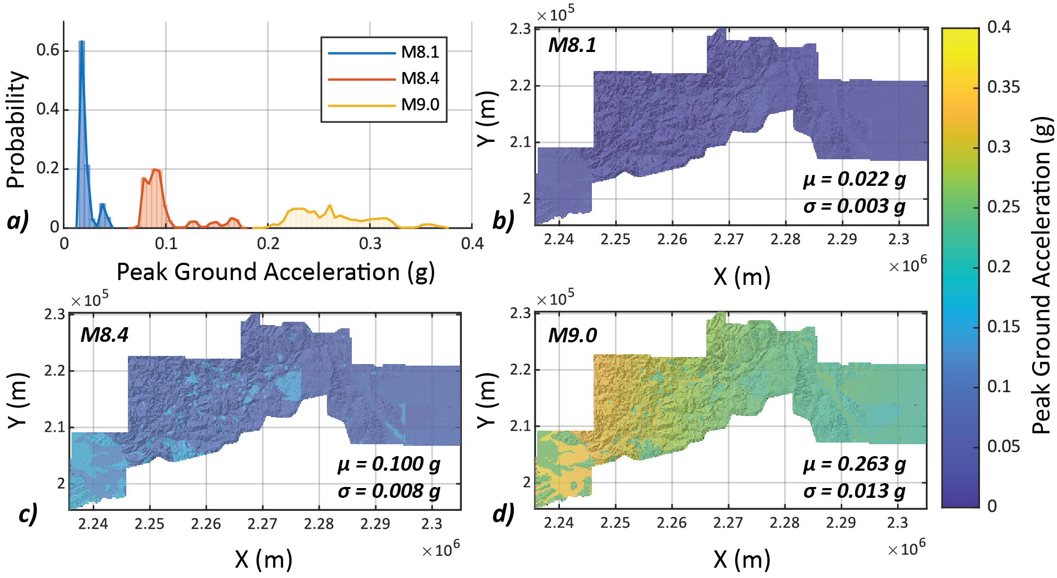
Figure S3: Distributions of peak ground acceleration (PGA) for the study area, with mean, $μ$, and standard deviation, $σ$: a) histograms of PGA distributions. Distributions of PGA for three scenarios with different moment magnitudes: b) M_{w}8.1; c) M_{w}8.4; d) M_{w}9.0.

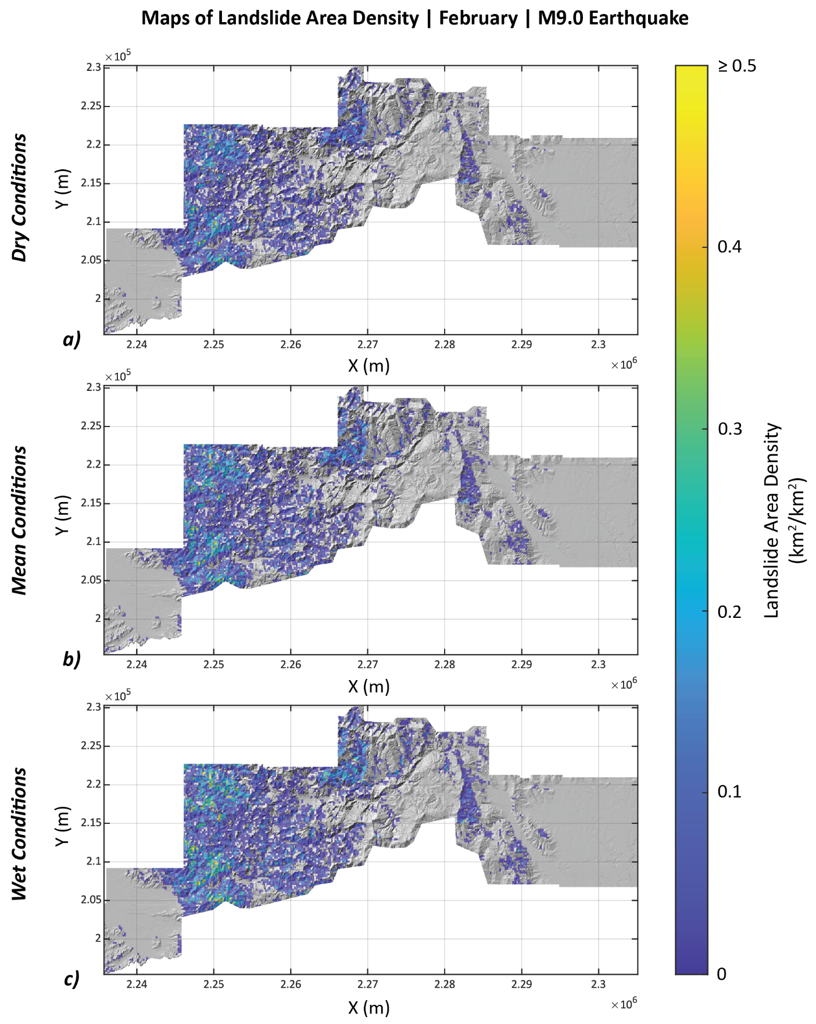
Figure S4: Maps of landslide area density for a M9.0 earthquake in February and a range of inter-seasonal moisture variations: a) dry conditions; b) mean conditions; c) wet conditions.

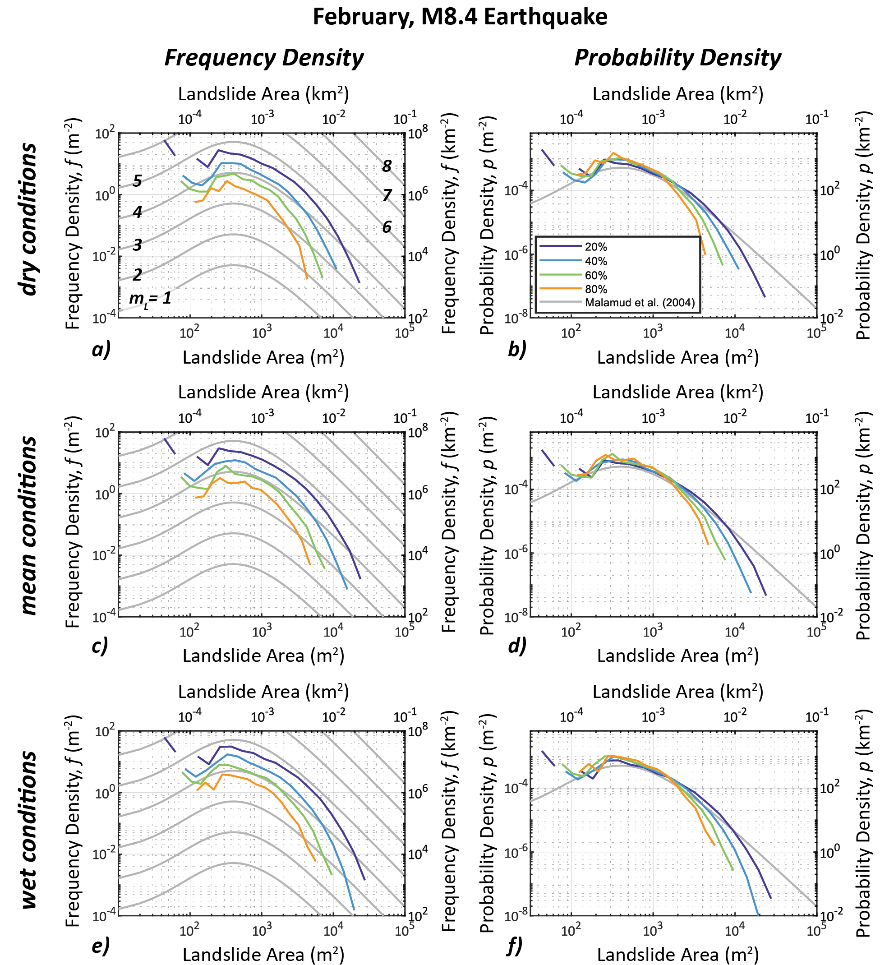
Figure S5: Landslide area scaling relationships for a range of inter-seasonal moisture conditions and susceptibility threshold, $T$ (M_{w} 8.4; February): a) Frequency density (dry); b) Probability density (dry); c) Frequency density (mean); d) Probablity density (mean); e) Frequency density (wet); f) Probablity density (wet).

References

Malamud, B. D., Turcotte, D. L., Guzzetti, F., & Reichenbach, P. (2004). Landslide inventories and their statistical properties. Earth Surface Processes and Landforms, 29(6), 687–711. https://doi.org/10.1002/esp.1064

Mathews, N. W., Leshchinsky, B. A., Mirus, B. B., Olsen, M. J., & Booth, A. M. (2024). RegionGrow3D: A Deterministic Analysis for Characterizing Discrete Three-Dimensional Landslide Source Areas on a Regional Scale. Journal of Geophysical Research: Earth Surface, 129(9), e2024JF007815. https://doi.org/10.1029/2024JF007815

