Supplementary Material
Identifying pyroptosis-related molecular subtypes in asthma through gene expression profiles: implications for airway inflammation
Min Li^{1†}, Jiayao Guo¹, Xianmei Li², Jialin Zheng¹ , Weimin Yang³, Zhuang Luo^{1*}, Wenye Zhu^{4*}
¹Department of Respiratory and Critical Care Medicine, First Affiliated Hospital of Kunming Medical University
²Department of Respiratory and Critical Care Medicine, Dehong Prefecture People's Hospital
³Yunnan Key Laboratory of Pharmacology for Natural Products, Kunming Medical University
⁴Department of Pharmacy, First Affiliated Hospital of Kunming Medical University, Kunming, China
*Correspondence:
Wenye Zhu, M.M. Department of Pharmacy, First Affiliated Hospital of Kunming Medical University, No. 295 Xichang Road,Wuhua District, Kunming, Yunnan, 650032, China, Tel/fax: +86 0871 65324888 2512; e-mail: Lily1124leaf@163.com.
Zhuang Luo, Ph.D Department of Respiratory and Critical Care Medicine, The First Affiliated Hospital of Kunming Medical University, No. 295 Xichang Road, Wuhua District, Kunming, Yunnan, 650032, China, Tel/fax: +86 0871 65324888 2512; e-mail: skyny4511@126.com

Supplementary Tables

Table S1. Gene list of 372 pyroptosis-related genes (PRGs) with a GIFtS above 30
ABL1 | CALM2 | DNMT3B | HSP90AB1 | MUC20 | PTEN | STAT5A | USP48
ACE2 | CALM3 | DPEP1 | HSP90B1 | MYD88 | PTGS2 | STK4 | USP8
ACSM3 | CAMP | DPP8 | HTRA1 | NAIP | PTPN11 | STXBP1 | USP9X
ACTN4 | CAPN1 | DPP9 | HUWE1 | NCR1 | PTX3 | STXBP2 | UTS2
ADIPOQ | CARD8 | DRD2 | ICAM1 | NEDD4 | PVALB | STXBP3 | VCAM1
ADORA1 | CASP1 | DUOX1 | IFI16 | NEK7 | PYCARD | SUGT1 | VDR
ADORA2B | CASP10 | E2F4 | IFI27 | NFE2L2 | RAB5A | SUZ12 | VEGFA
ADORA3 | CASP3 | EED | IFIH1 | NFKB1 | RASGRF1 | SYVN1 | VIM
AGER | CASP4 | EEF2K | IFNB1 | NFKBIA | RBBP4 | TAC1 | VPS28
AHSA1 | CASP5 | EGFR | IGF2BP3 | NFS1 | RBBP7 | TACR1 | VPS4B
AIM2 | CASP6 | ELAVL1 | IKBKE | NINJ1 | RBM26 | TCEA3 | VTN
AKT1 | CASP7 | EPHA2 | IKBKG | NLRC4 | RBMX | TFAM | WFDC12
ALK | CASP8 | ETS1 | IKZF1 | NLRP13 | RELA | TFAP2A | XPNPEP1
ALOX15 | CASP9 | EZH2 | IL13 | NLRP2 | RIPK1 | TFG | YAF2
AMIGO2 | CCL5 | FADD | IL13RA2 | NLRP3 | RIPK3 | TIFA | YTHDF2
ANLN | CD14 | FCGRT | IL17A | NLRP6 | ROCK1 | TLR2 | YWHAE
ANXA1 | CD274 | FGF21 | IL18 | NLRP7 | RPL27A | TLR3 | YWHAZ
ANXA2 | CD55 | FGF5 | IL18BP | NLRP9 | RPL3 | TLR4 | ZBP1
APAF1 | CDC37 | FKBP10 | IL1A | NLRX1 | RPL7A | TLR8 | ZDHHC1
APIP | CDK9 | FLNA | IL1B | NOS1 | RPS19 | TLR9 | ZEB2
APOA1 | CDKN1B | FLOT1 | IL1RN | NR1H2 | RRBP1 | TNF | ZNF329
APOE | CEBPB | FMR1 | IL27 | NR4A1 | RSL1D1 | TNFRSF11B | ZNF532
APOL1 | CHI3L1 | FNDC4 | IL32 | ORMDL3 | S100A12 | TNFSF13B
ATF6 | CHMP2A | FNDC5 | INPP5D | OSM | S100A4 | TOMM20
ATG3 | CHMP2B | FOXP3 | IQGAP1 | P2RX7 | S100A8 | TP53
ATG5 | CHMP4A | FSTL1 | IRAK3 | P4HA1 | S100A9 | TPM3
ATG7 | CHMP4B | GABARAP | IRF1 | PAH | SDHB | TRAF2
ATOH8 | CHMP4C | GABARAPL1 | IRF2 | PAK2 | SEC22B | TRAF3
ATP6AP1 | CHMP6 | GABRG3 | IRF3 | PANX1 | SERPINB1 | TRAF6
AXL | CHMP7 | GALNS | JUN | PARP1 | SERPINC1 | TREM1
BAK1 | CITED2 | GATA1 | KIF23 | PCSK9 | SERPINH1 | TREM2
BAX | CLEC3B | GBP1 | LCN2 | PDCD6IP | SESN2 | TRIM21
BCL2 | CLEC5A | GBP2 | LMNA | PECAM1 | SETD7 | TRIM24
BCL6 | CMA1 | GBP3 | LRPPRC | PEPD | SIRT1 | TRIM25
BECN1 | CNR1 | GBP5 | LY96 | PGF | SIRT3 | TRIM31
BIRC2 | COL2A1 | GGT1 | LYST | PINK1 | SIRT6 | TRPA1
BIRC3 | CPA3 | GJA1 | MALT1 | PKN2 | SLC16A4 | TRPM2
BNIP3 | CRKL | GLMN | MAP2K6 | PLA2R1 | SLC30A7 | TSLP
BNIP3L | CRTAC1 | GNA15 | MAP3K7 | PLAUR | SLC4A2 | TUBB6
BRCA1 | CSNK1A1 | GSK3B | MAPK11 | POLA2 | SMAD2 | TXNIP
BRCC3 | CSTB | GSTO1 | MAPK14 | POP1 | SMC4 | UBE2D2
BRD4 | CTSG | GSTP1 | MDM2 | PPARG | SNIP1 | UBE2D3
BSG | CUL4B | GZMA | MEFV | PPIC | SNRK | UBR2
BST2 | CYBB | GZMB | MELK | PRDM1 | SNRPN | UCP1
BTK | CYCS | HDAC2 | METTL3 | PRF1 | SOCS1 | ULK1
BTN3A1 | DDX3X | HDAC6 | MIB1 | PRG2 | SQSTM1 | USF2
C10orf55 | DGCR8 | HKDC1 | MKI67 | PRIM1 | SRPK1 | USP14
CA1 | DHX8 | HP | MLKL | PRMT5 | SSR1 | USP18
CALM1 | DHX9 | HSF1 | MMP9 | PROM2 | STAT2 | USP25
DNMT3A | DNMT1 | HSP90AA1 | MST1 | PRTN3 | STAT3 | USP47

Table S2. Baseline characteristics of the pyroptosis related clusters in the validation dataset（GSE45111）
Characteristics | Cluster 1 | Cluster 2 | t/z/χ² | P-Value
N | 21 | 26 | - | -
Age, years, median (Q1,Q3) | 63 (57, 68) | 56 (43, 66) | 2.164 | 0.031
Gender, n(%) |  |  | 0.302 | 0.583
Male | 8 (38.0) | 12 (46.1)
Female | 13 (61.9) | 14 (53.8)
Inflammation type（%） |  |  | 8.193 | 0.004
Paucigranulocytic asthma | 1 (4.7) | 17 (65.4)
Non-Paucigranulocytic asthma | 20 (95.2) | 9 (34.6)
Eosinophilic asthma | 11 (52.3) | 6 (23.0)
Neutrophilic asthma | 9 (42.8) | 3 (11.5)
Mixed granulocytic asthma | 0 (0) | 0 (0)

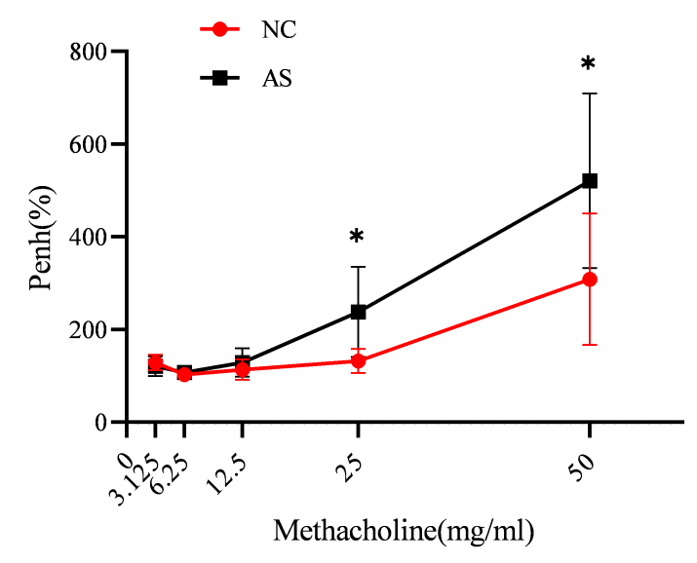
Supplementary Figures

Figure S1. Airway responsiveness of two groups of mice was implied by measuring Penh in response to increasing concentrations of methacholine. *P< 0.05.

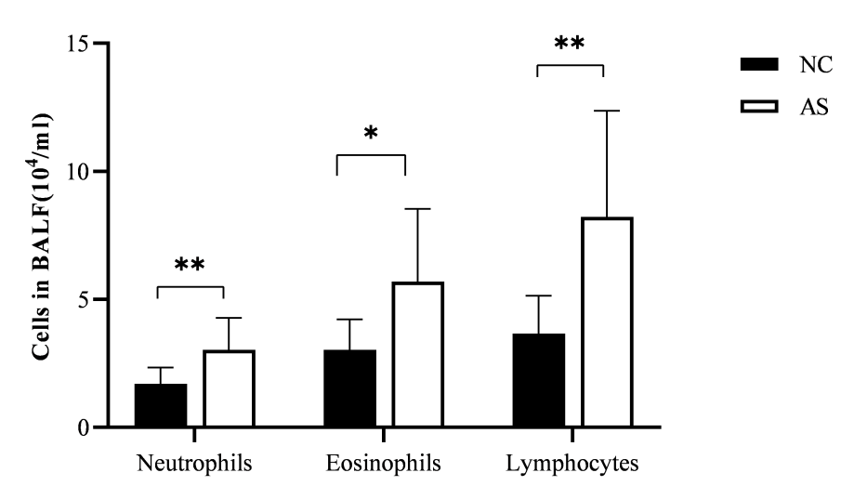
Figure S2. Inflammatory cell analysis in BALF including neutrophils, eosinophils, and Lymphocytes. *P< 0.05,**P< 0.01.

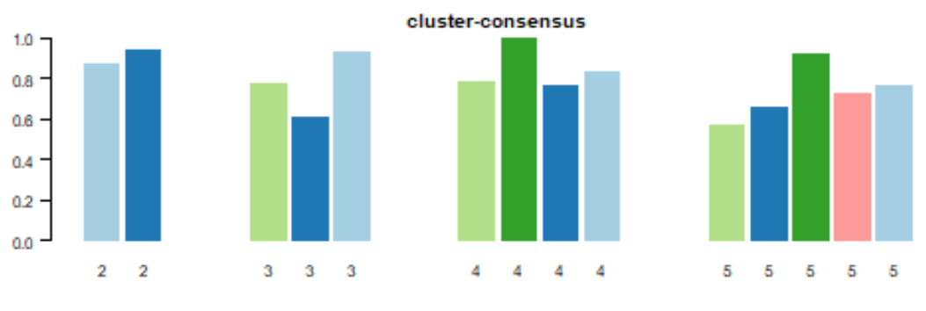
Figure S3. Cluster-consensus score bar-plot of the validation dataset. The bar-plot represents the consensus scores for subgroups with cluster count (k) ranging from 2 to 8.

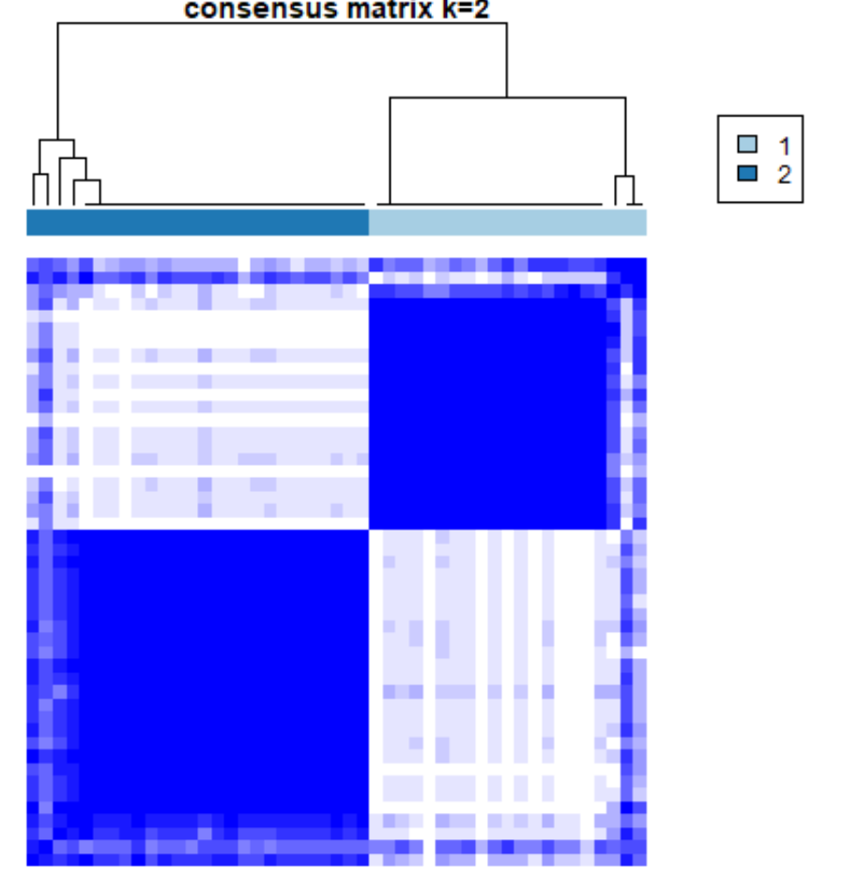
Figure S4. Consensus matrix heatmap of the validation dataset (GSE45111). The color-coded heatmap represents the consensus matrix with consensus k=2, which was determined by the minimal consensus scores for subgroups (>0.8). Color gradients represent consensus values from zero to1. White corresponds to 0 and dark blue to 1.

