Supplementary Material
Multi-structure modulation in Ni-based oxidation enables high water catalysis

Haiyao Li¹, Yiwen Chen¹, Jun Guo^{1,2,3*}, Buming Chen^{1,2,3,4}, Hui Huang^{1,2,3,4*}

1. Faculty of Metallurgical and Energy Engineering, Kunming University of Science and Technology, 650093 Kunming, P. R. China
2. Faculty of Materials Science and Engineering, Kunming University of Science and
Technology 650093 Kunming, P. R. China
3. Kunming Hendera Science and Technology Manufacturing Research Institute Co., Ltd, Kunming 651701, China
4. Kunming Hendera Technology Co. LTD., Kunming 650106, China

* Corresponding authors. 1038gj@kust.edu.cn (J. Guo); huihuanghan@kmust.edu.cn (H. Huang)

This Supplementary Material has 5 figures.
Experiment sections
Material synthesis
NiFeMoO_{x} catalytic materials were synthesized by the co-precipitation method. The stoichiometric amounts of Ni₂SO₄·6H₂O (5mmol), FeSO₄·7H₂O (1.5mmol), and Na₂MoO₄·2H₂O (1.5mmol) were 1.314g, 0.417g, and 0.363g, respectively. The high-purity raw materials Ni₂SO₄·6H₂O (99.99%purity, Aladdin), FeSO₄·7H₂O (99.99%purity, Aladdin), and Na₂MoO₄·2H₂O (99.99%purity, Aladdin) were accurately weighed in a clean beaker, 30 ml of deionized water was added, and 4 ml of NH₄OH (25%purity, Sun brand) was added. The stirrer was stirred at a speed of 75 rpm for 2 h. Then the mixture was washed with anhydrous ethanol and dried. Finally, the precursor powder was fully ground in an agate mortar.
0.1 g of precursor powder was taken out with a scraper and placed on one side of the crucible, and 0.3 g of nitrogen source C₃H₆N₆ (purity 99.99 %, Aladdin) was placed on the other side. The precursor was calcined at 500 °C for 2 hours in a tube furnace with Ar-H₂ (purity 99%), and the heating rate was 5 °C/min.Finally, the catalyst NiFeMoO_{x} powder was prepared.
The other control samples used the same method. The sample NiFeO_{x} was dissolved in 30 ml deionized water with a mixture of Ni₂SO₄·6H2O (5mmol) and FeSO₄·7H₂O (1.5mmol), while the sample NiMoO_{x} was dissolved in 30 ml deionized water with a mixture of Ni₂SO₄·6H₂O (5mmol) and Na₂MoO₄·2H₂O (1.5mmol). The other steps were the same as the sample NiFeMoO_{x}, adding NH₄OH and stirring. After fully reacting, centrifugal drying, grinding, and then placed in a crucible with a nitrogen source in a tube furnace with Ar-H₂ burning for 2 h.

Instrument information :
The phase analysis of the prepared catalytic material NiFeMoO_{x} and the catalysts of different elements was carried out by X-ray diffractometer (Bruker D2 PHASER, Germany). The continuous scanning range is 10-90°, using a copper target (λ = 1.5406 Å).
The morphology and microstructure of the samples were characterized by scanning electron microscopy (SEM) (Hitachi SU8010) and transmission electron microscopy (TEM) (Hitachi 7600, accelerating voltage 15 keV). The elemental composition and valence state of NiFeMoO_{x} materials and catalytic materials with different elements were analyzed by X-ray photoelectron spectroscopy. In the experiment, the monochromatic Al-Kα ray (1486.6 eV) was used as the excitation source, and the C1 s peak (284.8 eV) was used as the binding energy calibration reference.

electrochemical test
The prepared NiFeMoO_{x} catalyst 5 mg and carbon powder 1 mg were weighed in the sample tube, 100 μL of deionized water was added, and 30 μL of Nafion solution was mixed with 370 μL of anhydrous ethanol and sonicated for 30 mins. The dropwise catalyst ink was dropped onto 1X2 nickel foam washed with hydrochloric acid. During each test, the CHI660E electrochemical workstation (Shanghai Chenhua Instrument Company, China) is using a three-electrode system for testing. The prepared catalytic electrode was used as the working electrode, the graphite rod was the counter electrode, and the Hg/HgO electrode was used as the reference electrode. The alkaline electrolyte was 1M KOH. All the potentials obtained by the test are calculated according to the following equations.
E (vs. RHE) = E (Hg / HgO) + 0.059 × pH + 0.197
The electrochemical performance of the catalyst was evaluated by linear sweep voltammetry (LSV) at a scan rate of 0.01Vs⁻¹, and all polarization curves were corrected by 90% IR. The stability test (i-t) was performed at current densities of 10 mA cm⁻² and 100 mA cm⁻² by chronoamperometry. When testing TOF, the electrolyte was replaced with a mixed solution of 38 mL 0.2 mol NaH₂PO₄ and 62 mL 0.2 mol Na₂HPO₄ for testing. The double-layer capacitance (C_{dl}) is obtained by measuring CV at different scan rates (from 10 to 50 mVs⁻¹) in the non-faradaic range (≈ 1.025-1.125 V) and calculated using formula (1).
j = vC_{dl} (1)
where j is the current density and v is the scan rate.
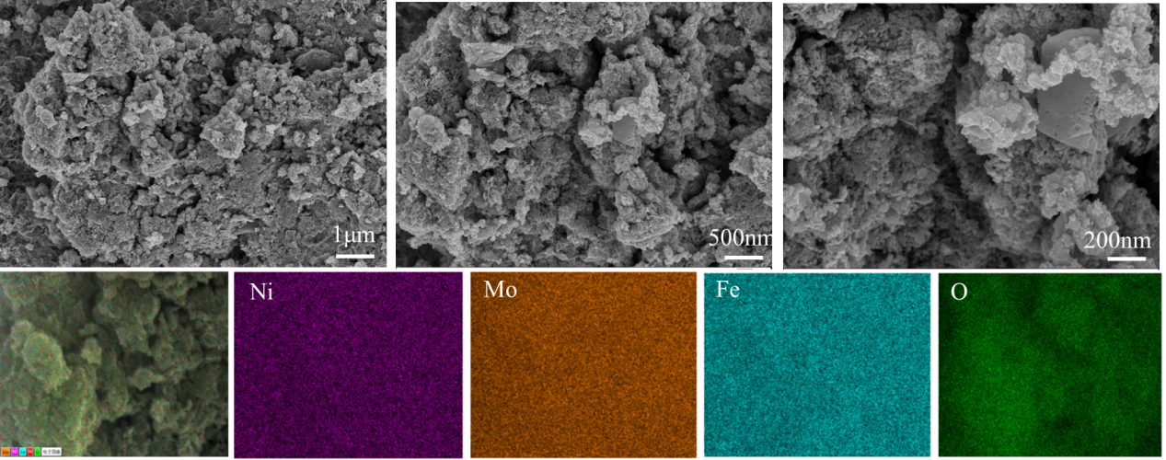
Fig. S1 Scanning electron microscope image of NiFeMoO_{x}

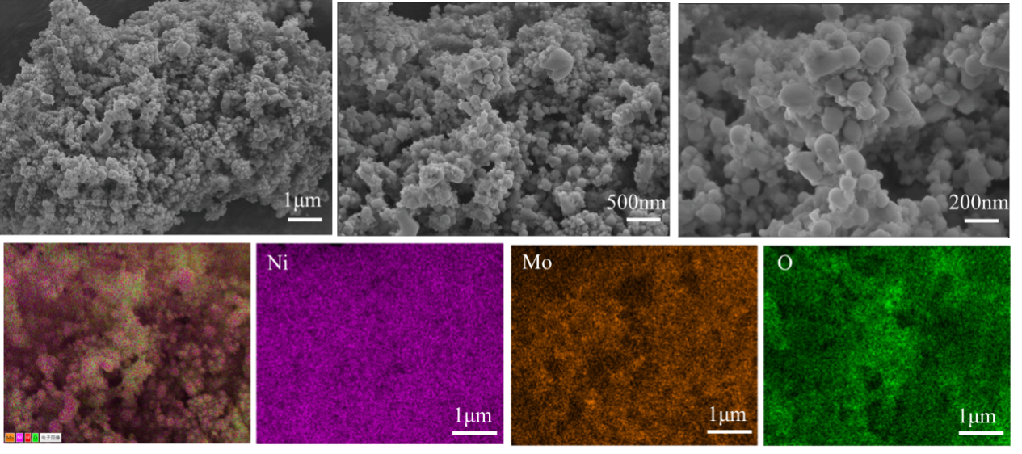
Fig. S2 Scanning electron microscope image of NiMoO_{x}

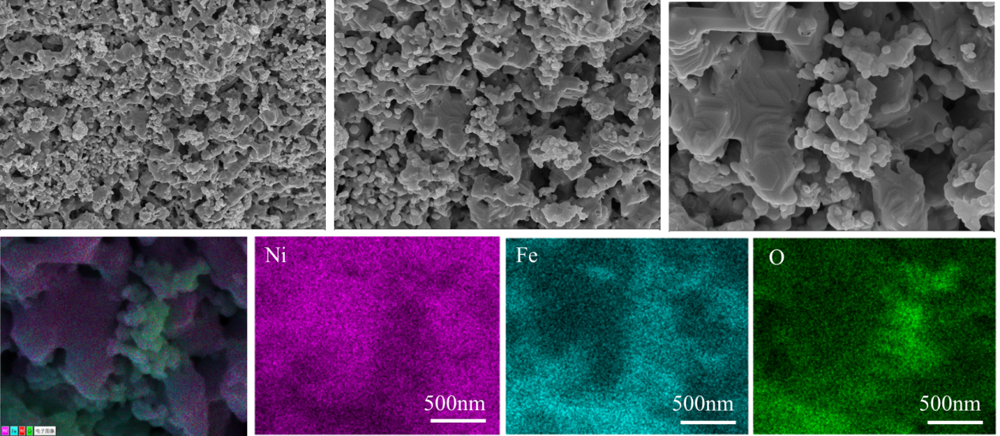
Fig. S3 Scanning electron microscope image of NiFeO_{x}

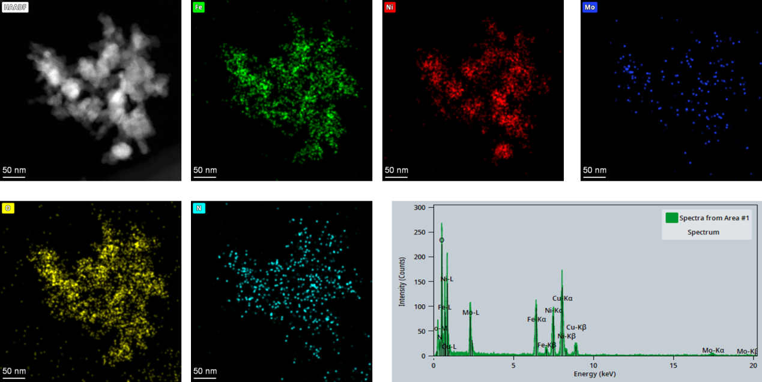
Fig. S4 Energy dispersive X-ray spectroscopy ( EDS ) of NiFeMoO_{x}
Fig. S5 Total X-ray photoelectron spectroscopy ( XPS ) spectra of NiFeMoO_{x}

