Supplementary Tables

Sample ID | Sex | Timepoint | Type
QCTB1524 | M | Dx | B
AYA-0869 | M | Dx | B
AYA-0814 | M | Dx | B
AYA-0846 | M | Dx | T
AYA-0998 | M | Dx | ETP
CHI-0978 | F | Dx | T
CHI-0696 | M | Dx | B
CHI-0891 | F | Dx | B
AYAII-0655 | F | Dx | ETP
ADU-0758 | M | Dx | B

Table 1 ALL patient samples used to validate the graph. (B = B-cell, T = T-cell, ETP = Early T-cell Precursor, Dx = diagnosis, M = male, F = female)

Supplementary Figures

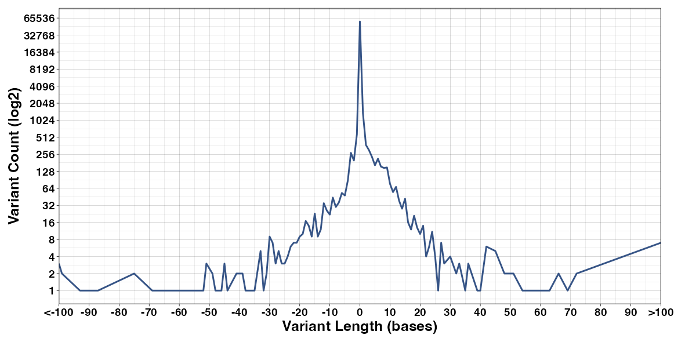
Figure 1 Distribution of variant lengths used as input into the pangenome graph. Insertions are positive, deletions are negative.

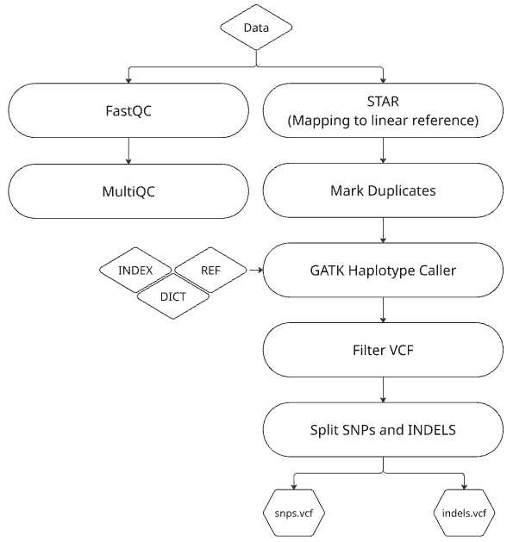
A
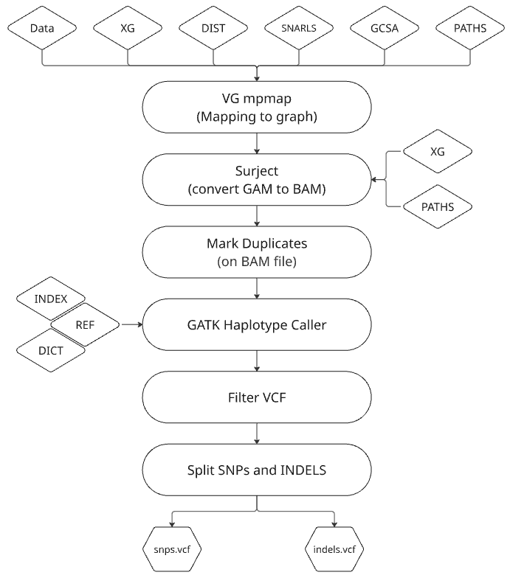
B

Figure 2 Overview of linear and pangenome graph based variant calling workflows. (A) Linear reference workflow. Sequencing reads undergo quality control using FastQC and MultiQC before alignment to the GRCh38 linear reference genome using STAR. Duplicate reads are marked, and variants are called using GATK HaplotypeCaller. Variant calls are filtered according to GATK best practices and subsequently split into SNP and INDEL calls. (B) Pangenome graph workflow. Sequencing reads are aligned to a pangenome graph using vg mpmap, with graph indexing provided. Graph alignments (GAM) are surjected to BAM format using vg surject, followed by duplicate marking. Variant calling is performed using GATK HaplotypeCaller with the appropriate reference files, after which variants are filtered according to GATK best practices and separated into SNV and INDEL calls.

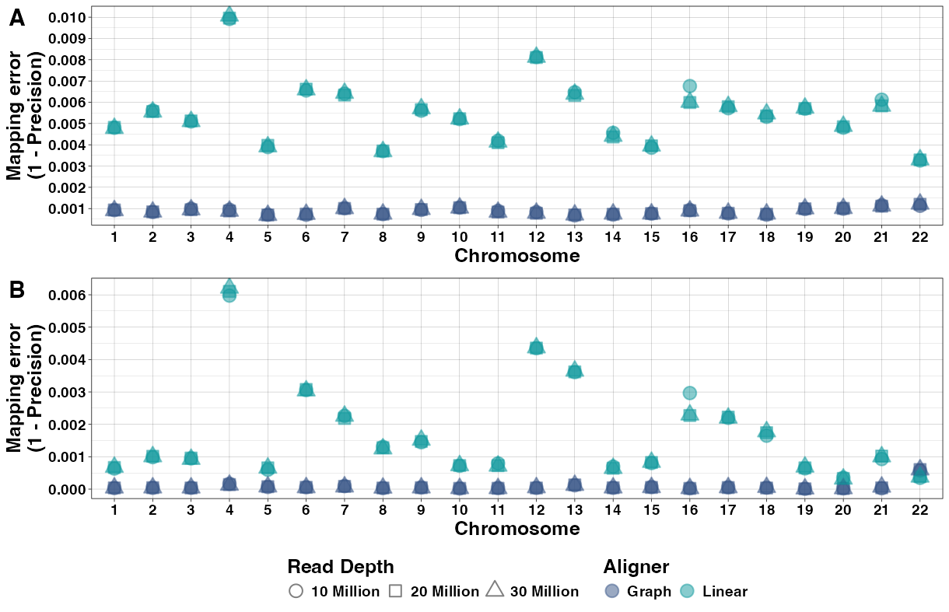
Figure 3. Mapping error rates across chromosomes for simulated reads (dataset 2) under two tolerance settings. Mapping error rates are shown for each chromosome using graph-based and linear alignment at three read depths. (A) Error rates with a 0 bp positional tolerance. (B) Error rates with a 35 bp tolerance. Both panels use the same simulated dataset.

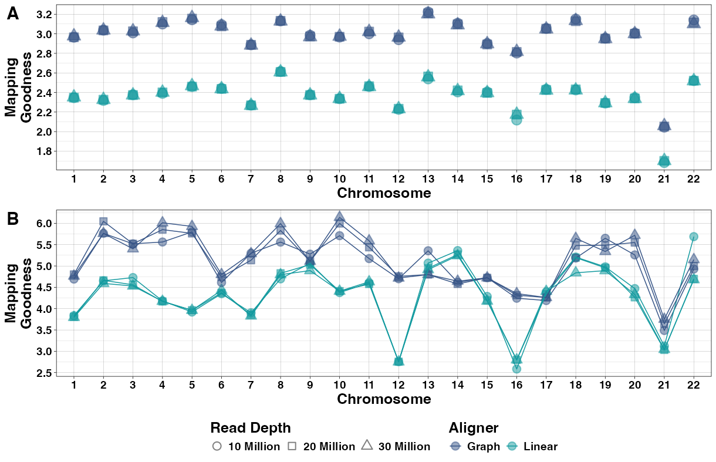

Figure 4 Mapping goodness scores across chromosomes for simulated reads (dataset 2) under two tolerance settings. Mapping goodness scores are shown for each chromosome for graph-based and linear alignment at three read depths. (A) Scores calculated with a 0 bp positional tolerance. (B) Scores calculated with a 35 bp tolerance. Both panels use the same simulated dataset.

A | B
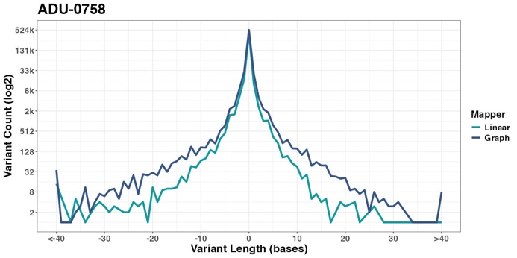 | 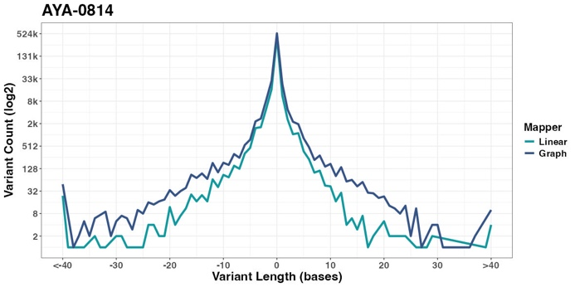
C | D
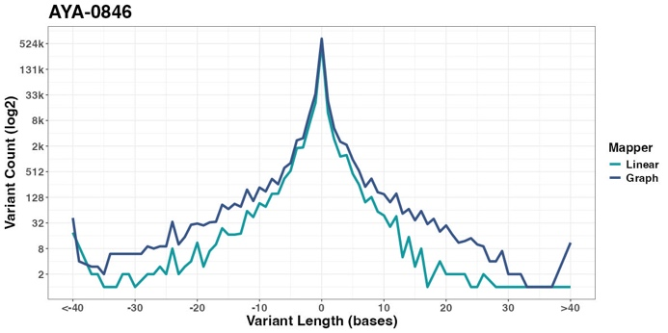 | 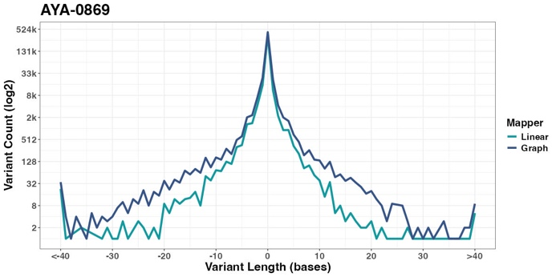
E | F
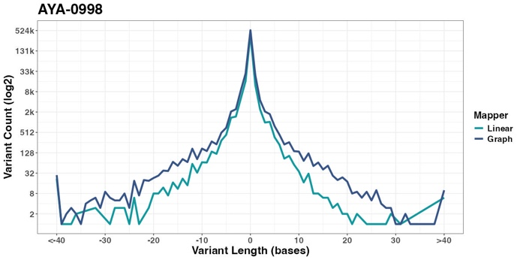 | 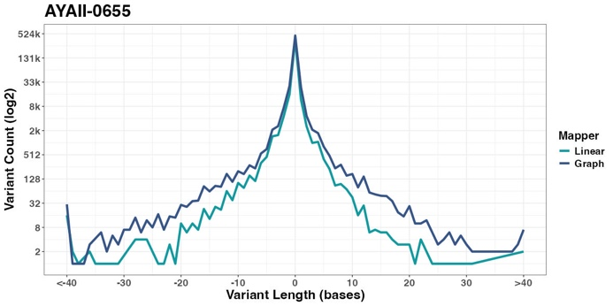
G | H
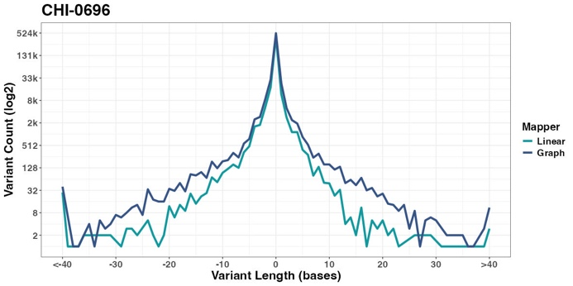 | 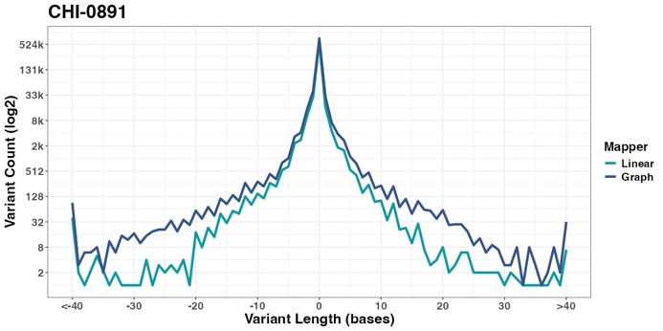
I | J
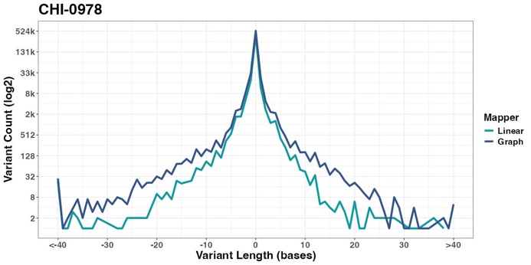 | 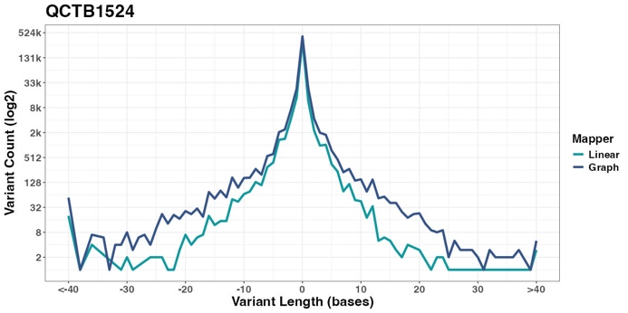

Figure 5 A-J. Distribution of insertion and deletion sizes identified across the 10 real ALL patient samples. Variant counts (log² scale) are plotted by size for both graph-based and linear alignments, showing differences in detection sensitivity across the full INDEL spectrum.

A | B | C | D
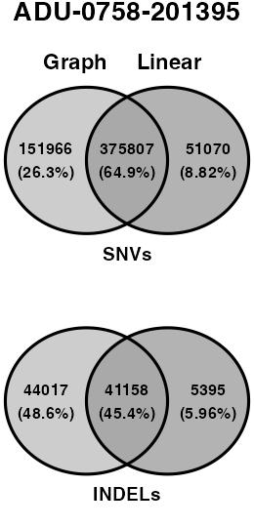 | 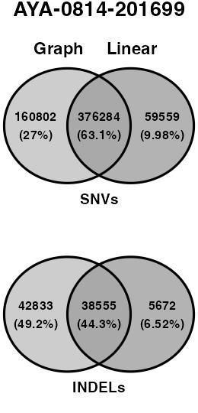 | 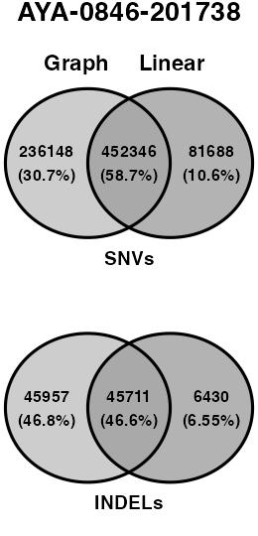 | 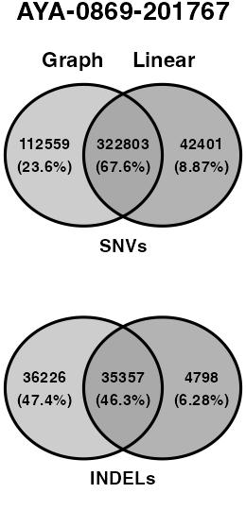
E | F | G | H
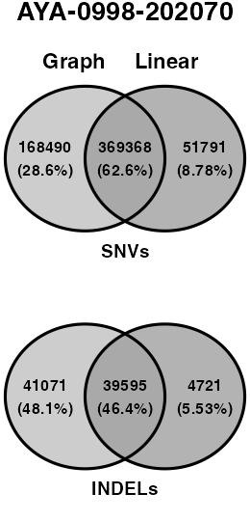 | 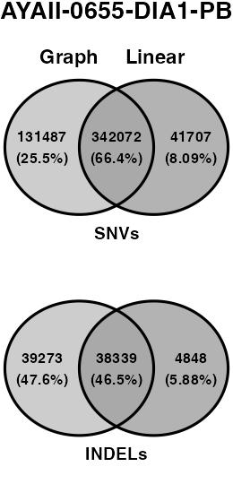 | 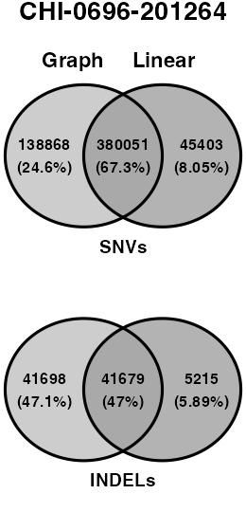 | 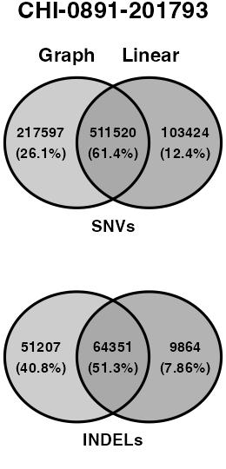
 | I | J
 | 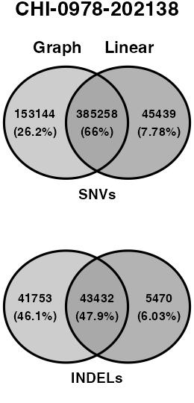 | 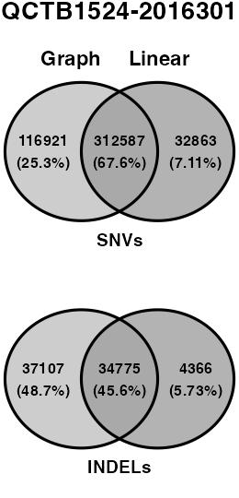

Figure 6 A-J. Venn diagrams showing the overlap in variant calls between the graph-based and linear approaches for INDELs and SNVs, across the 10 real patient samples. Values represent the number and proportion of variants unique to each method and shared between methods.

