Supplementary Information

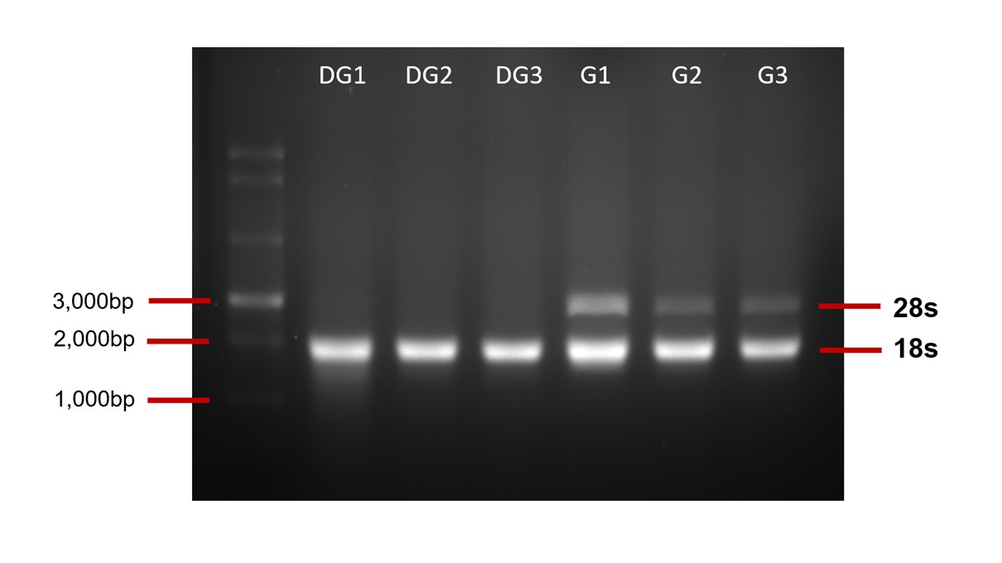
SI Fig. 1. Agarose gel electrophoresis for 3 RNA samples of digestive glands (DG) and 3 RNA samples of gills (G) (ladder: N0362S ssRNA Ladder, New England Biolabs (USA)).

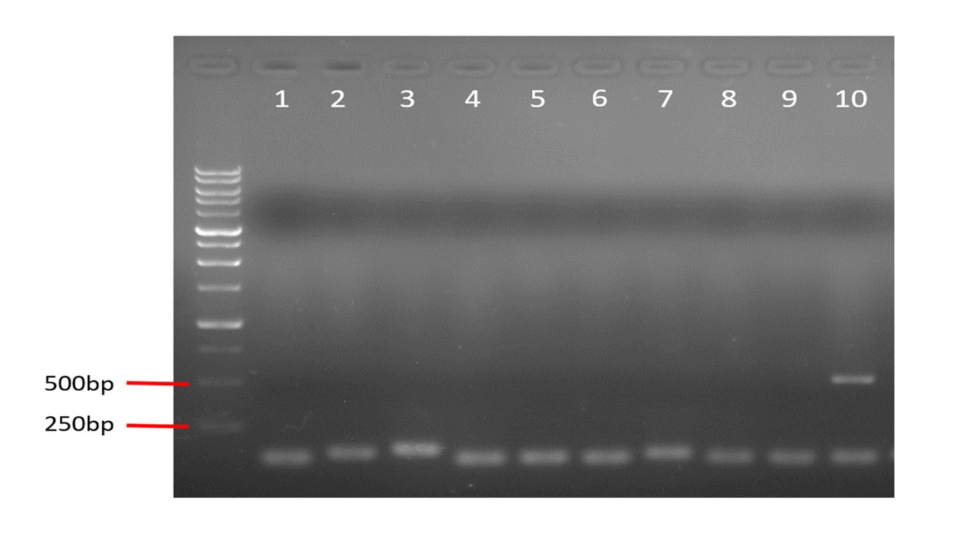
SI Fig. 2. Agarose gel electrophoresis of amplified PCR products from cDNA derived from shipworm digestive glands (DG) using primers from Table 4. The gene fragments were amplified corresponding to the expected fragment length sizes in Table 4 except for gene in lane 10, where unspecific binding of primer was observed.

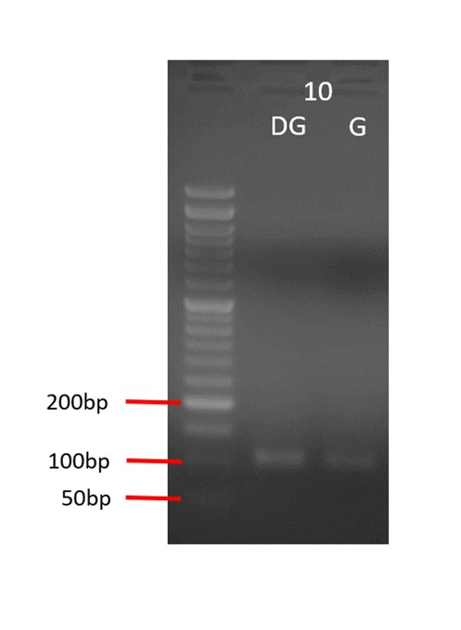
SI Fig. 3. Agarose gel electrophoresis of PCR products from cDNA derived from shipworm digestive glands (DG) and gills (G). The primer in lane 10 from figure was repeated using newly designed primers. Both PCR products showed a single PCR band corresponding to the expected fragment size (Table 5).

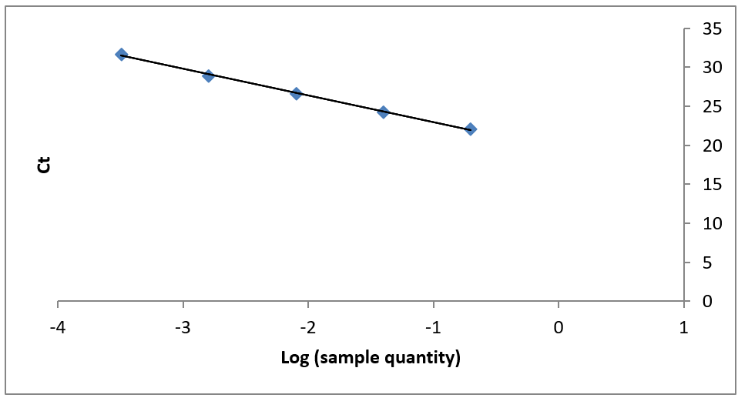
SI Fig. 4. PCR efficiency for target gene number 1 (GH10 DN811) with five 5-fold dilution series starting with 100 ng template copies of cDNA. The Y-axis represents the threshold cycle number. X-axis represents the log starting quantity of the cDNA template. The least squares method of linear regression was used to construct a line best fit for the standard curve. A slope of -3.35 (98.70% efficiency) and r² of 0.999 was obtained.

SI Table 1. Bioanalyzer result for digestive glands and gills sample before sequencing.
Sample name | RNA Integrity Number (RIN) | Concentration (ng/µL)
DG1 | 7.00 | 344
DG2 | 7.60 | 328
DG3 | 7.00 | 278
G1 | 6.90 | 386
G2 | 7.20 | 344
G3 | 7.10 | 322

SI Table 2. Top 10 upregulated genes in Gills differential expression gene analysis (DEG).
Gene ID | Sample A | Sample B | logFC | logCPM | Pvalue | FDR
TRINITY_DN145_c0_g2_i4 | Digestive Glands | Gills | 14.18603605 | 11.5313601 | 1.83E-18 | 2.43E-13
TRINITY_DN145_c0_g2_i7 | Digestive Glands | Gills | 13.63024172 | 10.30701057 | 3.34E-16 | 2.22E-11
TRINITY_DN1145_c0_g1_i1 | Digestive Glands | Gills | 12.14666907 | 10.26165863 | 2.61E-15 | 1.15E-10
TRINITY_DN1619_c0_g1_i19 | Digestive Glands | Gills | 16.42479032 | 9.160283508 | 2.06E-14 | 6.82E-10
TRINITY_DN4791_c0_g1_i3 | Digestive Glands | Gills | 15.82510402 | 8.560822826 | 2.60E-14 | 6.91E-10
TRINITY_DN145_c0_g2_i1 | Digestive Glands | Gills | 14.11196559 | 9.70759564 | 4.50E-14 | 9.95E-10
TRINITY_DN2170_c0_g1_i7 | Digestive Glands | Gills | 15.06657685 | 7.802752223 | 7.29E-14 | 1.38E-09
TRINITY_DN1619_c0_g1_i11 | Digestive Glands | Gills | 12.18531866 | 8.03002011 | 9.78E-14 | 1.62E-09
TRINITY_DN130428_c0_g1_i1 | Digestive Glands | Gills | 12.92955542 | 6.991867198 | 2.98E-13 | 4.39E-09
TRINITY_DN47132_c0_g1_i8 | Digestive Glands | Gills | 12.84119441 | 7.75207053 | 5.38E-13 | 6.74E-09

SI Table 3. Top 10 downregulated genes in Gills differential expression gene analysis (DEG).
Gene ID | Sample A | Sample B | logFC | logCPM | Pvalue | FDR
TRINITY_DN597_c0_g1_i4 | Digestive Glands | Gills | -14.17986026 | 6.917682654 | 3.03E-11 | 7.72E-08
TRINITY_DN557_c0_g1_i7 | Digestive Glands | Gills | -14.08773639 | 6.825818624 | 0.001352292 | 0.015658155
TRINITY_DN707_c0_g1_i9 | Digestive Glands | Gills | -13.85669217 | 6.595266765 | 1.48E-05 | 0.000987108
TRINITY_DN7_c0_g1_i8 | Digestive Glands | Gills | -13.78984891 | 6.528482986 | 3.04E-08 | 1.01E-05
TRINITY_DN194_c0_g1_i3 | Digestive Glands | Gills | -13.77912507 | 6.517818615 | 5.50E-12 | 2.48E-08
TRINITY_DN811_c0_g1_i13 | Digestive Glands | Gills | -13.70059413 | 6.439537869 | 8.70E-06 | 0.000685228
TRINITY_DN7_c0_g1_i14 | Digestive Glands | Gills | -13.56515306 | 6.304388189 | 4.80E-08 | 1.42E-05
TRINITY_DN5830_c1_g1_i1 | Digestive Glands | Gills | -13.45516863 | 6.194771831 | 2.15E-11 | 6.04E-08
TRINITY_DN4093_c0_g1_i10 | Digestive Glands | Gills | -13.31643635 | 6.056623685 | 6.95E-05 | 0.002774018
TRINITY_DN3410_c0_g2_i4 | Digestive Glands | Gills | -13.28746162 | 6.027622975 | 3.79E-11 | 8.88E-08

SI Table 4. Amplification efficiency test for primer of 10 genes of interest was evaluated using efficiency percentage (%) and R² value. All the primers met criteria of R²> 0.98 and efficiency from 90-110%.
 | Primer | Slope | R² | Efficiency (%) | Efficiency
1 | GH10_DN811 | -3.35 | 0.99 | 98.70 | 1.99
2 | GH9_DN402 | -3.30 | 0.99 | 100.67 | 2.01
3 | GH31_DN6736 | -3.45 | 0.99 | 94.65 | 1.95
4 | GH9_DN1179 | -3.332 | 0.99 | 99.73 | 2.00
5 | GH65_DN24600 | -3.31 | 0.99 | 100.18 | 2.00
6 | GH9_DN12158 | -3.19 | 0.99 | 105.54 | 2.06
7 | GH9_DN402 i2 | -3.23 | 0.99 | 103.86 | 2.04
8 | GH31_DN10567 | -3.24 | 0.99 | 103.28 | 2.03
9 | GH31_DN 2805 | -3.56 | 0.99 | 90.78 | 1.91
10 | GH31_DN1562 | -3.12 | 0.99 | 109.86 | 2.09

SI Table 5. PCR efficiency test for 2 housekeeping genes of beta actin and actin-1 was evaluated using efficiency (%) and R² value. All the primers met criteria of R²>0.98 and efficiency from 90-110%.
 | Primer | Slope | R² | Efficiency (%) | Efficiency
1 | Beta actin | -3.11 | 0.99 | 109.45 | 2.09
2 | Actin-1 | -3.47 | 0.99 | 94.05 | 1.94

SI Table 6. LogFC qPCR values calculated using ∆∆CT method and logFC value of differential expression analysis were retrieved from shipworm transcriptome analysis. From a total of 10 genes of interest, only 2 genes are highlighted to indicate these genes have consistent log FC values (please refer to Table 4 for gene function).
 | GOI | log FC qPCR | log FC DE analysis
1 | GH10_DN811 | -12.08893965 | -13.70059413
2 | GH9_DN402 | -7.970808327 | -5.641304845
3 | GH31_DN6736 | -0.898873622 | -6.685292159
4 | GH9_DN1179 | -13.58137793 | -6.944370648
5 | GH65_DN24600 | -0.689958471 | -5.767634374
6 | GH9_DN12158 | -5.153483434 | -6.570771782
7 | GH9_DN402_i2 | -11.20796223 | -5.444756338
8 | GH31_DN10657 | -0.261736291 | -5.125235676
9 | GH3_DN2805 | -2.809073247 | 3.584235065
10 | GH31_DN1562 | -5.678330443 | 6.402015971

