Supplementary materials
Appendix 1 . Map of selected focal redwood trees sampled within the 2020 CZU lightning Complex footprint along the central coast of California.
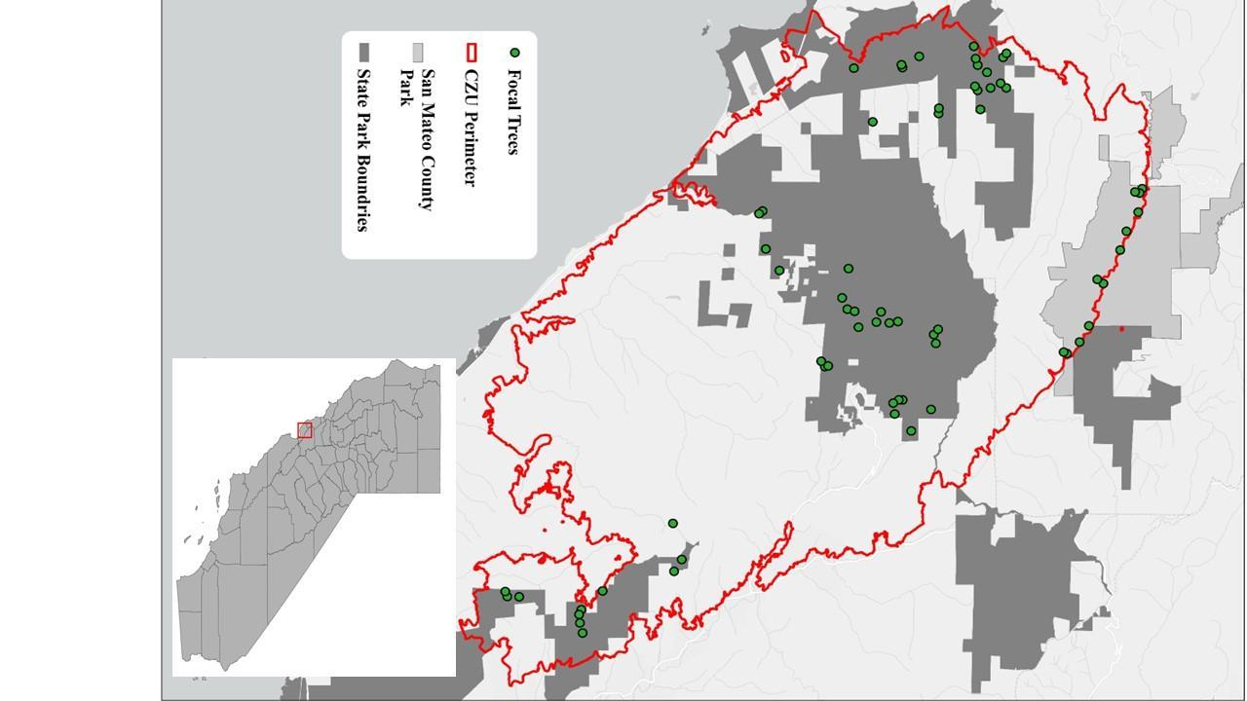

Appendix 2. Results for two-year post-fire redwood basal resprout allometric equations.
Two-year old post-fire redwood basal resprout biomass models used to develop allometric equations were highly explanatory (R² > 0.85; Appendix 6). Total biomass and woody biomass models were the strongest and explained 96% and 95% of the variance, respectively. Performance of these two models were also strong based on normalized root mean squared error (%RMSE), with 35% for total biomass and 55% for woody biomass. Stem biomass and leaf biomass model performance was slightly lower, with 87% and 89% of the variance explained, respectively. However, estimates of NRMSE for stem and leaf biomass were similar or better than total and woody biomass models (20% and 56%, respectively). Compared to the biomass models, the resprout leaf area model was only a function of resprout length and was substantially weaker with an explained variance of 56% and a %RMSE of 110%. Based on univariate model comparisons, stem diameter explained more variance for both total and leaf biomass. Resprout length better explained variance for stem and woody biomass, though strong positive relationships were displayed among all univariate models (Appendix 6).
The developed allometric equations from this study are the first known to quantify biomass and leaf area of post-fire redwood resprouts and are the first to examine resprouts of this size and age range across all disturbance types. Previous allometric equations have been developed for larger redwood post-logging resprout size classes (Kizha and Han 2016; Sillett et al. 2019), this study is the first to quantify biomass and leaf area of young post-fire redwood resprouts. It is uncertain how well our developed post-fire resprout equations for the Santa Cruz Mountains, might apply to other regions in the redwood range. Considering that very few allometric equations exist for post-fire resprouting generally, and for redwoods specifically, expanding the number of allometric equations can enable the determination of important measures, such as productivity (Malhi et al. 2011), carbon sequestration (Heng et al. 2012), and fuel loading (Deltell et al. 2024). Given the potential for increased fire activity in redwood forests due to changing climate (Westerling 2016), allometric equations that can quantify recovery of productivity and biomass will be increasingly needed.
Developed allometric equations proved to be highly informative in predicting post-fire redwood resprout biomass. The utilized allometric equation structure is consistent across equations for other resprouting species that used power functions to describe the relationship and incorporated stem diameter as a primary (e.g. Robertson and Ostertag 2009). However, developed post-fire redwood resprout equations were more explanatory when they included predictors of both stem diameter and length. Univariate biomass equations that were also quite informative (Appendix 7). Though not as robust as the top bivariate equations, univariate equations may be more practical when applying to large sample sizes as only one variable would have to be measured in the field (i.e. resprout stem diameter for calculation of total resprout biomass). While post-fire resprout biomass equations were robust, the resprout leaf area equation preformed relatively poorer. This equation is still useful to estimate post-fire resprout leaf area and represents the only known equation for redwood in the literature, although it does represent a potential area for improvement. Incorporating a larger sample size across a range of stand and light conditions, as well as including a larger leaf subsample size to better represent present morphologies could improve equation performance.

Appendix 3. Allometric equation structure and performance for two-year post-fire redwood resprout biomass categories and leaf area. Where a-d are regression coefficients, Y is the estimated response variable, df is the degrees of freedom, RMSE is the residual mean squared error and %RMSE is the normalized residual mean squared error. All biomass quantities are in grams; leaf area quantity is in cm².

Y | a | b | c | d | df | R² | %RMSE
Total Biomass | 8.95E-07 | 3.46 | 1.73E-01 | 2.31 | 5 | 0.96 | 35.2
Leaf Biomass | 1.20E-42 | 1.77E+01 | 3.82E-01 | 1.87 | 5 | 0.89 | 56.6
Woody Biomass | 2.44E-07 | 3.52 | 3.25E-02 | 2.47 | 5 | 0.96 | 52.3
Stem Biomass | 5.62E-04 | 2.07 | 1.08E-02 | 2.69 | 5 | 0.89 | 24.6
Leaf Area | 4.19E-01 | 1.96 | - | - | 3 | 0.56 | 110.2

Appendix 4. Allometric equation structure for predicting total biomass (g), woody biomass (g), and leaf biomass (g) for redwood resprouts, where a-d are regression coefficients, V1 is a given resprout length, and V2 is a given resprout diameter.

$$Y = {aV1}^{b}+ {cV2}^{d}$$

Appendix 5. Allometric equation structure for predicting total leaf area (cm²) for redwood resprouts, where a and b are regression coefficients and V1 is a given resprout length.

$$Y = {aV1}^{b}$$

Appendix 6. Calculation for total resprout mass, total leaf biomass, and total leaf area for resprout population at each focal tree. Where S is the summation of the response variable (e.g., total resprout biomass, resprout leaf biomass, leaf area) for the entire population of resprouts present at each tree, Σx_{i} is the sum of predicted values for the 10 representative samples for a given length class, ${\underline{M}}_{x}$is the median of the predicted response value for a given length class, and n is the total number of resprouts within a length class for a given tree, if n < 10 for a given class, simply the sum (Σx_{i}) of the available samples were totaled.

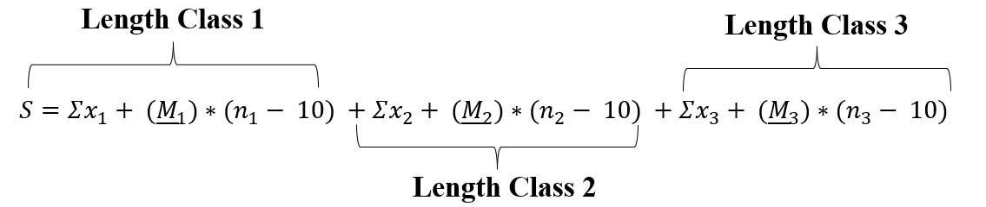

Appendix 7. Power regression model scatterplot matrix including resprout stem diameter (mm) and length (cm) across all measured biomass types for 104 two-year old post-fire redwood basal resprouts. Solid blue lines display the best power regression function for each relationship between predictor on the x-axis and response on the y-axis.

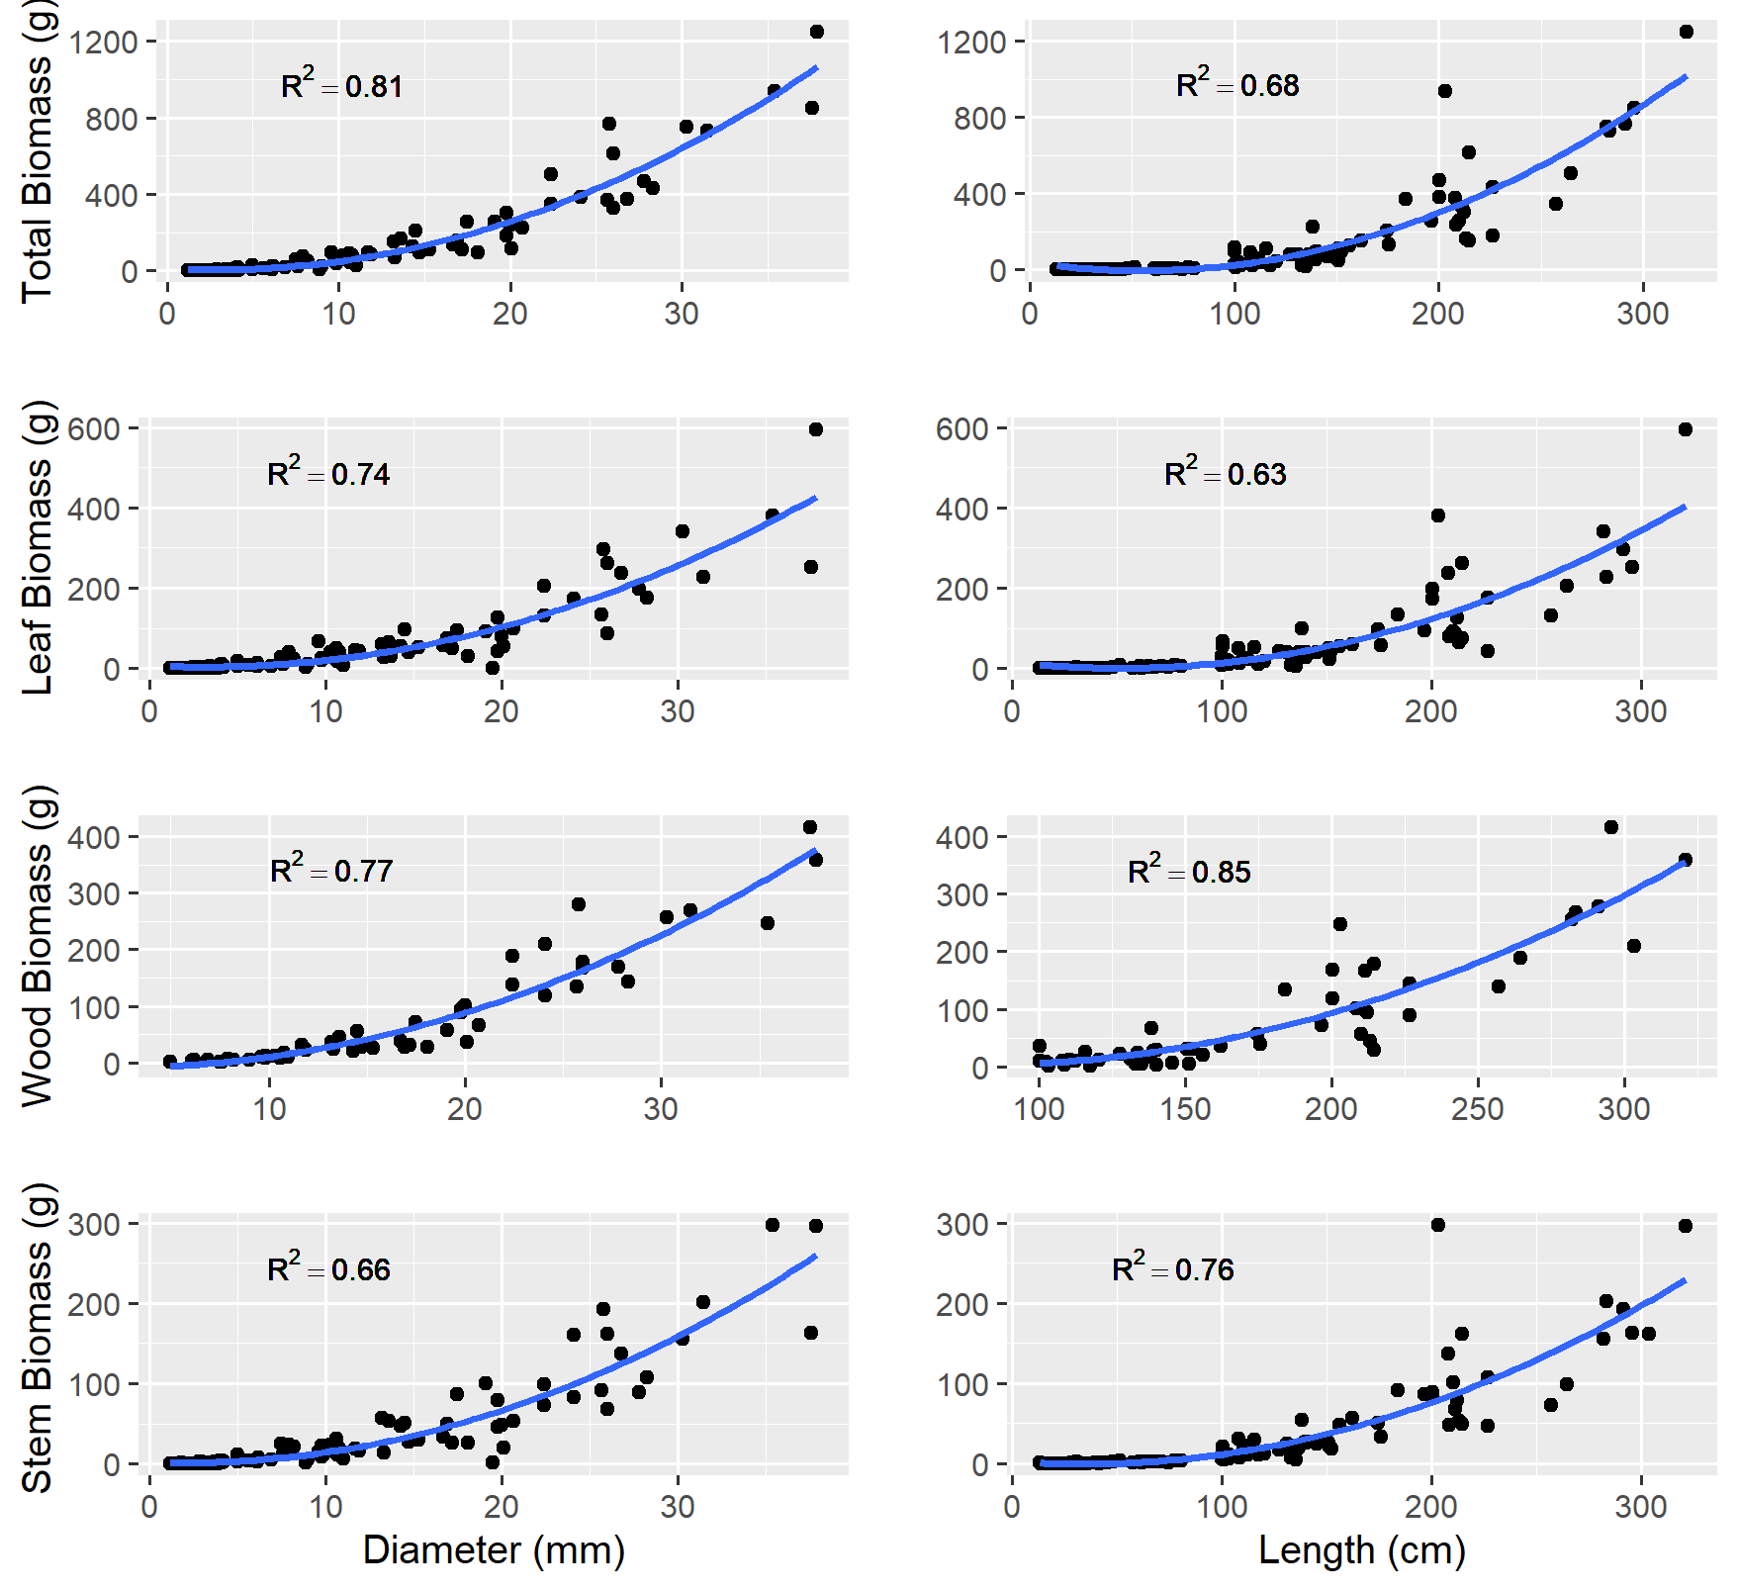

Appendix 8. List of tested predictors in final resprout biomass, leaf mass, and leaf area models. Group indicates which group of variables each variable is from: fire damage, tree-level or stand-level characteristics. Bolded predictors indicate variables that were utilized in the final model selection process.
Group | Variable Name | Units
Tree-Level | Crown Base Height | m
Tree-Level | Bark Thickness | mm
Tree-Level | Total Tree Biomass | kg
Tree-Level | Total Tree Carbon | kg
Tree-Level | Growth Rate Pre-Fire (5yr) | mm yr⁻¹
Tree-Level | Growth Rate Pre-Fire (10yr) | mm yr⁻¹
Tree-Level | Growth Rate Pre-Fire (20yr) | mm yr⁻¹
Tree-Level | Growth Rate Post-Fire (2y) | mm yr⁻¹
Tree-Level | Growth Rate COV (5yr) | %
Tree-Level | Growth Rate COV (10yr) | %
Tree-Level | Growth Rate COV (20yr) | %
Stand-Level | Canopy Openness | %
Climate | Pre-fire Climate Water Deficit (Partial Water Year) | mm
Climate | Pre-fire Climate Water Deficit (2yr) | mm
Climate | Pre-fire Climate Water Deficit (10yr) | mm
Climate | Pre-fire Climate Water Deficit (30yr) | mm
Climate | Post-fire Climate Water Deficit (2y) | mm
Fire Damage | Bole Char Height | m
Fire Damage | Crown Damage Height | m
Fire Damage | Crown Damage Length | m
Fire Damage | Crown Damage Ratio | %
Fire Damage | Bole Char Ratio | %
Fire Damage | Cambium Damage | %

Appendix 9. GLM Model performance and summary for univariate redwood resprout response models using bole char ratio (BCR) as a predictor where Intercept is the y-intercept, N is the number of data points used for each model, Adj. R² is the adjusted r² value for marginal (fixed) effects and mean is the mean response variable value.
Response | BCR Estimate | Intercept | N | Adj. R² | Mean
Resprouting Probability | 0.99 | 0.49 | 718 | 0.27 | 0.84
Resprout Biomass (g) | 9449.5 | 353.7 | 61 | 0.44 | 3323
Resprout Leaf Mass (g) | 3984.2 | 295.8 | 61 | 0.46 | 1547.7
Resprout Leaf Area (m²) | 5514.8 | 417.5 | 61 | 0.42 | 2150.4

Appendix 10. Performance comparison of most informative fire damage variables for redwood resprout presence and abundance (total resprout biomass, resprout leaf biomass, and resprout leaf area). Variables include bole char ratio (BCR), bole char height (m), and crown damage ratio (CDR). Variable evaluation metrics incude LogLoss using natural logs (e.g. binary cross-entropy) or normalized residual mean squared error calculated with standard deviation (NRMSE), Akaike Information Criterian with correction for small sample size (AICc), and Realitive Importance (Friedman 2001).

Resprout Presence
Variable | LogLoss | AICc | Relative Importance
BCR² | 0.33 | 479.6 | 49.8
Bole Char² | 0.35 | 499.6 | 25.8
CDR² | 0.38 | 539.7 | 6.1
Resprout Abundance
Variable | NRMSE | AICc | Relative Importance
Total Biomass
BCR² | 0.69 | 1166.4 | 82.7
Bole Char | 0.76 | 1170.7 | 3.1
CDR² | 0.91 | 1185.3 | 10.3
Leaf Biomass
BCR² | 0.76 | 1055.6 | 79.1
Bole Char | 0.84 | 1062.1 | 6
CDR² | 0.91 | 1077.1 | 11.9
Leaf Area
BCR² | 0.79 | 1105.2 | 86.2
Bole Char | 0.85 | 1112.0 | 2.6
CDR² | 0.92 | 1124.2 | 8.5

Appendix 11. Boosted Regression Trees analysis (10k-fold) performance summary for preliminary variable selection prior to final post-fire redwood resprout presence modeling. Where RI median is the Relative Influence Median following 200 Monte Carlo repetitions, RI IQR is the Relative Influence Inter Quartile Range and RI SD is the relative influence standard deviation. Predictors include ratio of bole char height to total tree height (BCR), partial pre-fire water year (October 2019- July 2020) climate water deficit (mm) (Pre-Fire CWD) and basal area density (m²/ha).
Predictor | RI Median | RI IQR | RI SD
BCR | 63.2 | 3.6 | 2.8
Pre-Fire CWD | 8.4 | 0.8 | 0.6
BA Density | 8.1 | 0.6 | 0.4

Appendix 12. Top three logistic regression models of post-fire resprouting presence based on Generalized Mixed Effects Models (GLMMs). Where CV-LL is the cross-validated LogLoss averaged across 200 Monte-Carlo repetitions, AICc is the AIC is Akaike Information Criterion corrected for small sample size, R² Marginal is indicative of the explanatory power of the fixed effects, while R² Conditional is indicative of the explanatory power of both the random and fixed effects together. Relative LL is the LogLoss difference between the top model and subsequent models relativized to the LogLoss of the null model (LL0 = 0.414). Terms in models include ratio of bole char height to total tree height (BCR) in quadratic form (Quad), partial pre-fire water year (October 2019- July 2020) climate water deficit (Pre-Fire CWD; mm), and tree diameter at breast height (DBH; cm).
Fixed Effects Structure | CV-LL | AICc | R² Marginal | R² Conditional | Relative LL
BCR(Quad) + Pre-Fire CWD | 0.33 | 426.7 | 0.53 | 0.62 | 0
BCR(Quad) + Pre-Fire CWD + DBH | 0.33 | 426.8 | 0.53 | 0.62 | 1.52E-3
BCR(Quad):Pre-Fire CWD + Pre-Fire CWD + DBH | 0.33 | 428.4 | 0.56 | 0.65 | 2.76E-3

Appendix 13. Boosted Regression Trees analysis (10k-fold) performance summary for preliminary variable selection prior to final post-fire redwood resprout abundance modeling. Where RI median is the Relative Influence Median following 200 Monte Carlo repetitions, RI IQR is the Relative Influence Inter Quartile Range and RI SD is the relative influence standard deviation. Predictors include ratio of bole char height to total tree height (BCR), partial pre-fire water year (October 2019- July 2020) climate water deficit (mm) (Pre-Fire CWD), canopy openness (%) (CO), and crown length to total height ratio (CR).
Response | Predictor | RI Median | RI IQR | RI SD
Total Biomass (g) | BCR | 69.9 | 6.9 | 5.5
 | CO | 25.3 | 7.5 | 5.5
 | Pre-Fire CWD | 1.3 | 1.1 | 0.8
Leaf Biomass (g) | BCR | 68.3 | 6.4 | 5.1
 | CO | 28.6 | 6.6 | 5.1
 | Pre-Fire CWD | 1.1 | 0.6 | 0.4
Leaf Area (m²) | BCR | 68.2 | 6.9 | 5.2
 | CO | 25.2 | 6.8 | 5.3
 | Pre-Fire CWD | 1.7 | 1.3 | 1.0
 | CR | 1.6 | 0.7 | 0.5

Appendix 14. Top models for redwood resprout abundance responses two years post-fire. Where CV-NRMSE is the cross-validated normalized root-mean-square error averaged across 200 Monte-Carlo repetitions, CV-NRMSE SD is the standard deviation of the cross-validated normalized root-mean-square error averaged across 200 Monte-Carlo repetitions, AICc is the AIC is Akaike Information Criterion corrected for small sample size, and Adj. R² is the adjusted r-squared. Terms in models include ratio of bole char height to total tree height (BCR) in quadratic form (Quad), partial pre-fire water year (October 2019- July 2020) climate water deficit (mm) (Pre-Fire CWD), canopy openness (%) (CO), and crown length to total height ratio (CR). Bolded models representative of top models for each resprout abundance response.
Response | GLM Structure | CV-NRMSE | CV-NRMSE SD | AICc | Adj. R²
Total Biomass (g) | BCR (Quad) + Pre-Fire CWD | 0.72 | 0.02 | 1161 | 0.5
 | BCR (Quad) | 0.74 | 0.03 | 1166 | 0.44
 | BCR (Quad)+ Pre-Fire CWD + CO (Quad) | 0.79 | 0.06 | 1163 | 0.53
Leaf Biomass (g) | BCR (Quad)+ Pre-Fire CWD | 0.72 | 0.02 | 1056 | 0.48
 | BCR (Quad): Pre-Fire CWD | 0.74 | 0.02 | 1056 | 0.46
 | BCR (Quad) | 0.72 | 0.02 | 1059 | 0.44
Leaf Area (m²) | BCR (Quad)+ Pre-Fire CWD | 0.72 | 0.02 | 1049 | 0.49
 | BCR (Quad)+ Pre-Fire CWD + CR | 0.74 | 0.03 | 1051 | 0.49
 | BCR (Quad) | 0.75 | 0.03 | 1053 | 0.42

Appendix 15. Top selected leaf biomass (g) (left) and leaf area (m²) (right) generalized linear models for redwood resprouts two years following fire. Bole char height to total tree height ratio = Bole Char Ratio, Pre-Fire CWD = partial water year climate water deficit pre-fire (mm). Modeled CWD values were representative of observed Q1, median, and Q3 values rounded to the nearest whole mm. Vertical dotted lines represent Q1, median, and Q3 breaks for BCR distributions.
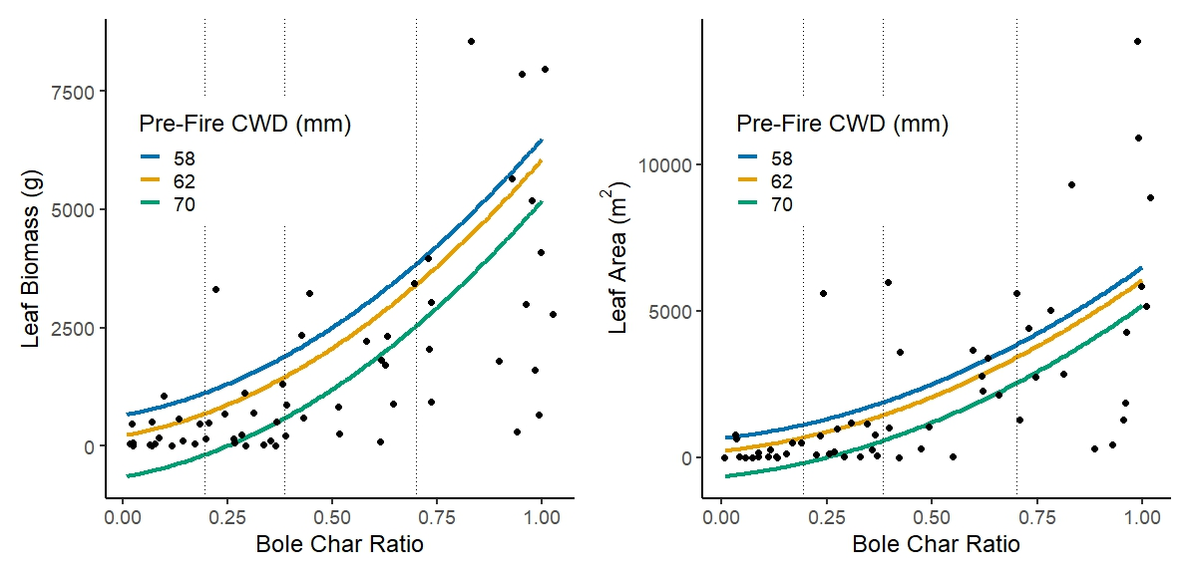
Appendix 16. Model comparison for resprouting responses with inclusion of epicormic sprouting terms, where “Null” is the top model priorly established for a given response prior to the addition of epicormic resprouting terms. Bole char height to total tree height ratio = Bole Char Ratio, Pre-Fire CWD = partial water year climate water deficit pre-fire (mm), Ep. bole = Epicormic sprout coverage of the bole (%).
Response | Fixed Effects | CV-NRMSE/LL | CV-NRMSE SD | AICc | Adj. R² (Marginal)
Resprouting Probability | Null | 0.33 | - | 426.7 | 0.53
 | BCR(Quad) + Pre-Fire CWD * Ep. Bole | 0.29 | - | 420.7 | 0.79
Resprout Biomass (g) | Null | 0.72 | 0.02 | 1160.8 | 0.49
 | BCR(Quad) + Pre-Fire CWD + Ep. Bole | 0.73 | 0.03 | 1161.8 | 0.51
Resprout Leaf Mass (g) | Null | 0.72 | 0.02 | 1056.0 | 0.48
 | BCR(Quad) + Pre-Fire CWD + Ep. Bole | 0.74 | 0.02 | 1057.3 | 0.49
Leaf Area (m²) | Null | 0.72 | 0.02 | 1049.0 | 0.49
 | BCR(Quad) + Pre-Fire CWD + Ep. Bole | 0.74 | 0.02 | 1152.7 | 0.49

