Supplementary Information

Condition-Specific Readmission Risk Stratification in a Predominantly Black Statewide Cohort Using Machine Learning: Development of Subtype-Specific Models for Heart Failure, Acute Myocardial Infarction, Atrial Fibrillation/Flutter, and Hypertensive Heart Disease

Ismail El Moudden, Michael Bittner, Sunita Dodani

Supplementary Table S1. Four-Method Consensus Feature Selection Results
Feature | Boruta | SHAP | RFE | mRMR | Votes | Selected
LACE: ED Visits | Y | Y | Y | Y | 4 | Y
Insurance Type | Y | Y | Y | Y | 4 | Y
Total Diagnoses | Y | Y | Y | Y | 4 | Y
LACE Index (0-19) | Y | Y | Y | Y | 4 | Y
Obesity | Y | Y | Y | Y | 4 | Y
Total CVD Conditions | Y | Y | Y | Y | 4 | Y
Admission Order | Y | Y | Y | Y | 4 | Y
Charlson Comorbidity Index | Y | Y | Y | Y | 4 | Y
Total Procedures | Y | Y | Y | Y | 4 | Y
Length of Stay (days) | Y | Y | Y | Y | 4 | Y
Congestive Heart Failure | Y | Y | Y | Y | 4 | Y
CVD Mortality Risk | Y | Y | Y | Y | 4 | Y
Depression | Y | Y | Y | Y | 4 | Y
Renal Failure | Y | Y | Y | Y | 4 | Y
LACE: Length of Stay | Y | Y | Y | Y | 4 | Y
Other Neurological Disorder | Y | Y | Y | Y | 4 | Y
Peripheral Vascular Disease | Y | Y | Y | Y | 4 | Y
Hypertension, Uncomplicated | Y | Y | Y | Y | 4 | Y
Fluid and Electrolyte Disorder | Y | Y | Y | Y | 4 | Y
Chronic Pulmonary Disease | Y | Y | Y | Y | 4 | Y
Cardiac Arrhythmia | Y | Y | Y | Y | 4 | Y
Valvular Disease | Y | Y | Y | Y | 4 | Y
Pulmonary Circulation Disorder | Y | Y | Y | Y | 4 | Y
Diabetes with Complications | Y | Y | Y | Y | 4 | Y
Admission Year | Y | Y |  | Y | 3 | Y
van Walraven Elixhauser Index | Y | Y | Y |  | 3 | Y
Age (years) | Y | Y | Y |  | 3 | Y
Elixhauser Comorbidity Count | Y | Y | Y |  | 3 | Y
Age-Adjusted Charlson Index | Y | Y | Y |  | 3 | Y
Total Charges ($) | Y | Y |  | Y | 3 | Y
Hospital Ownership | Y | Y |  | Y | 3 | Y
CVD Severity Score | Y | Y | Y |  | 3 | Y
Hospital Size (beds) | Y | Y |  | Y | 3 | Y
Teaching Hospital | Y | Y |  | Y | 3 | Y
Drug Abuse | Y | Y |  | Y | 3 | Y
Female Sex | Y | Y |  | Y | 3 | Y
Diabetes, Uncomplicated | Y | Y |  | Y | 3 | Y
Hypertension, Complicated | Y |  | Y | Y | 3 | Y
Admission Quarter |  | Y |  | Y | 2 | Y
LACE: Acuity | Y |  |  | Y | 2 | Y
Hypothyroidism | Y |  |  | Y | 2 | Y
Deficiency Anemia | Y |  |  | Y | 2 | Y
Alcohol Abuse | Y |  |  | Y | 2 | Y
Age >= 75 years | Y |  |  | Y | 2 | Y
Coagulopathy | Y |  |  | Y | 2 | Y
Features endorsed by at least 2 of 4 methods were retained for model development. Y indicates selection by the corresponding method. A total of 45 of 60 candidate features met the consensus threshold. Abbreviations: SHAP, Shapley additive explanations; RFE, recursive feature elimination with cross-validation; mRMR, minimum redundancy maximum relevance; Y, selected.

Supplementary Table S2. Discrimination and Calibration Performance for All 40 Models
Config | CVD Category | Algorithm | AUC (95% CI) | AUPRC | Sens | Spec | PPV | F1 | Brier | Utility
Bal | AMI | Elastic Net | 0.697 (0.679-0.713) | 0.266 | 0.679 | 0.607 | 0.202 | 0.311 | 0.2028 | Limited
Bal | AMI | XGBoost | 0.695 (0.679-0.71) | 0.264 | 0.706 | 0.577 | 0.196 | 0.307 | 0.1588 | Limited
Bal | AMI | LightGBM | 0.695 (0.679-0.71) | 0.26 | 0.674 | 0.613 | 0.203 | 0.312 | 0.1066 | Limited
Bal | AMI | Super Learner | 0.692 (0.678-0.708) | 0.261 | 0.617 | 0.675 | 0.217 | 0.321 | 0.1112 | Limited
Bal | AMI | Random Forest | 0.682 (0.665-0.699) | 0.249 | 0.62 | 0.653 | 0.207 | 0.31 | 0.1083 | Limited
Unbal | AMI | XGBoost | 0.706 (0.691-0.721) | 0.275 | 0.571 | 0.728 | 0.235 | 0.333 | 0.2125 | Moderate
Unbal | AMI | Super Learner | 0.706 (0.689-0.723) | 0.273 | 0.621 | 0.679 | 0.221 | 0.326 | 0.1042 | Moderate
Unbal | AMI | LightGBM | 0.705 (0.69-0.719) | 0.276 | 0.708 | 0.591 | 0.202 | 0.314 | 0.1891 | Moderate
Unbal | AMI | Elastic Net | 0.689 (0.673-0.704) | 0.257 | 0.592 | 0.691 | 0.219 | 0.319 | 0.105 | Limited
Unbal | AMI | Random Forest | 0.688 (0.673-0.705) | 0.248 | 0.506 | 0.767 | 0.241 | 0.327 | 0.1315 | Limited
Bal | AF/AFL | XGBoost | 0.732 (0.715-0.75) | 0.339 | 0.708 | 0.648 | 0.271 | 0.392 | 0.1204 | Moderate
Bal | AF/AFL | Super Learner | 0.73 (0.712-0.748) | 0.344 | 0.715 | 0.629 | 0.263 | 0.384 | 0.2457 | Moderate
Bal | AF/AFL | Elastic Net | 0.729 (0.712-0.747) | 0.34 | 0.728 | 0.617 | 0.26 | 0.383 | 0.1977 | Moderate
Bal | AF/AFL | LightGBM | 0.725 (0.707-0.743) | 0.33 | 0.672 | 0.666 | 0.271 | 0.387 | 0.1224 | Moderate
Bal | AF/AFL | Random Forest | 0.714 (0.695-0.732) | 0.32 | 0.628 | 0.688 | 0.271 | 0.379 | 0.1228 | Moderate
Unbal | AF/AFL | XGBoost | 0.731 (0.714-0.749) | 0.339 | 0.658 | 0.684 | 0.278 | 0.391 | 0.2115 | Moderate
Unbal | AF/AFL | Super Learner | 0.73 (0.712-0.748) | 0.337 | 0.62 | 0.721 | 0.291 | 0.396 | 0.1195 | Moderate
Unbal | AF/AFL | LightGBM | 0.728 (0.709-0.746) | 0.34 | 0.6 | 0.745 | 0.303 | 0.403 | 0.1543 | Moderate
Unbal | AF/AFL | Elastic Net | 0.725 (0.708-0.742) | 0.336 | 0.598 | 0.736 | 0.295 | 0.395 | 0.1206 | Moderate
Unbal | AF/AFL | Random Forest | 0.719 (0.701-0.736) | 0.321 | 0.628 | 0.704 | 0.282 | 0.389 | 0.1442 | Moderate
Bal | HF | XGBoost | 0.708 (0.701-0.716) | 0.418 | 0.632 | 0.68 | 0.364 | 0.462 | 0.1577 | Moderate
Bal | HF | LightGBM | 0.708 (0.701-0.716) | 0.419 | 0.667 | 0.643 | 0.352 | 0.461 | 0.1574 | Moderate
Bal | HF | Super Learner | 0.704 (0.697-0.711) | 0.414 | 0.657 | 0.646 | 0.35 | 0.456 | 0.1616 | Moderate
Bal | HF | Elastic Net | 0.697 (0.69-0.705) | 0.407 | 0.622 | 0.676 | 0.357 | 0.454 | 0.2051 | Limited
Bal | HF | Random Forest | 0.695 (0.688-0.702) | 0.404 | 0.55 | 0.743 | 0.383 | 0.452 | 0.1599 | Limited
Unbal | HF | XGBoost | 0.707 (0.7-0.714) | 0.418 | 0.678 | 0.63 | 0.347 | 0.459 | 0.2146 | Moderate
Unbal | HF | LightGBM | 0.707 (0.7-0.715) | 0.419 | 0.625 | 0.685 | 0.365 | 0.461 | 0.2138 | Moderate
Unbal | HF | Super Learner | 0.707 (0.7-0.714) | 0.417 | 0.607 | 0.703 | 0.372 | 0.461 | 0.158 | Moderate
Unbal | HF | Elastic Net | 0.696 (0.689-0.704) | 0.408 | 0.598 | 0.701 | 0.367 | 0.455 | 0.1598 | Limited
Unbal | HF | Random Forest | 0.695 (0.687-0.702) | 0.4 | 0.615 | 0.682 | 0.359 | 0.453 | 0.1795 | Limited
Bal | HHD | XGBoost | 0.758 (0.735-0.777) | 0.338 | 0.734 | 0.652 | 0.223 | 0.342 | 0.1156 | High
Bal | HHD | Super Learner | 0.752 (0.729-0.773) | 0.338 | 0.609 | 0.762 | 0.258 | 0.362 | 0.0974 | High
Bal | HHD | LightGBM | 0.75 (0.727-0.772) | 0.336 | 0.58 | 0.78 | 0.264 | 0.362 | 0.0948 | High
Bal | HHD | Elastic Net | 0.746 (0.723-0.769) | 0.324 | 0.711 | 0.661 | 0.222 | 0.338 | 0.171 | Moderate
Bal | HHD | Random Forest | 0.742 (0.719-0.765) | 0.327 | 0.605 | 0.75 | 0.247 | 0.351 | 0.0966 | Moderate
Unbal | HHD | Super Learner | 0.754 (0.732-0.775) | 0.338 | 0.68 | 0.698 | 0.234 | 0.348 | 0.0957 | High
Unbal | HHD | XGBoost | 0.753 (0.732-0.775) | 0.326 | 0.693 | 0.692 | 0.234 | 0.35 | 0.2238 | High
Unbal | HHD | LightGBM | 0.753 (0.73-0.775) | 0.328 | 0.635 | 0.744 | 0.252 | 0.361 | 0.1086 | High
Unbal | HHD | Random Forest | 0.744 (0.721-0.766) | 0.332 | 0.652 | 0.707 | 0.232 | 0.342 | 0.1151 | Moderate
Unbal | HHD | Elastic Net | 0.733 (0.71-0.756) | 0.312 | 0.725 | 0.652 | 0.22 | 0.338 | 0.0955 | Moderate
Forty models comprising 5 base algorithms across 4 CVD categories and 2 dataset configurations, plus 8 Super Learner ensembles. Utility classification: High (AUC >= 0.75), Moderate (0.70-0.74), Limited (< 0.70). Abbreviations: AUC, area under the receiver operating characteristic curve; AUPRC, area under the precision-recall curve; Bal, SMOTE-balanced configuration; CI, confidence interval; CVD, cardiovascular disease; PPV, positive predictive value; Sens, sensitivity; SMOTE, synthetic minority oversampling technique; Spec, specificity; Unbal, unbalanced configuration with class weights.

Supplementary Table S3. DeLong Pairwise Comparisons of Algorithm Discrimination Within the Best-Performing Dataset Configuration per CVD Category
CVD Category | Config | Model 1 | Model 2 | AUC 1 | AUC 2 | Z | P-value | Sig?
HF | Bal | XGBoost | LightGBM | 0.708 | 0.708 | -0.904 | 0.366 | No
HF | Bal | XGBoost | Super Learner | 0.708 | 0.704 | 3.835 | 0.000126 | Yes
HF | Bal | XGBoost | Elastic Net | 0.708 | 0.697 | 7.634 | 2.27e-14 | Yes
HF | Bal | XGBoost | Random Forest | 0.708 | 0.695 | 8.051 | 8.22e-16 | Yes
HF | Bal | LightGBM | Super Learner | 0.708 | 0.704 | 4.698 | 2.63e-06 | Yes
HF | Bal | LightGBM | Elastic Net | 0.708 | 0.697 | 7.354 | 1.92e-13 | Yes
HF | Bal | LightGBM | Random Forest | 0.708 | 0.695 | 8.542 | 1.32e-17 | Yes
HF | Bal | Super Learner | Elastic Net | 0.704 | 0.697 | 4.022 | 5.77e-05 | Yes
HF | Bal | Super Learner | Random Forest | 0.704 | 0.695 | 13.255 | 4.2e-40 | Yes
HF | Bal | Elastic Net | Random Forest | 0.697 | 0.695 | 0.939 | 0.348 | No
AF/AFL | Bal | XGBoost | Super Learner | 0.732 | 0.73 | 0.699 | 0.484 | No
AF/AFL | Bal | XGBoost | Elastic Net | 0.732 | 0.729 | 0.923 | 0.356 | No
AF/AFL | Bal | XGBoost | LightGBM | 0.732 | 0.725 | 3.55 | 0.000385 | Yes
AF/AFL | Bal | XGBoost | Random Forest | 0.732 | 0.714 | 5.038 | 4.72e-07 | Yes
AF/AFL | Bal | Super Learner | Elastic Net | 0.73 | 0.729 | 2.261 | 0.0238 | Yes
AF/AFL | Bal | Super Learner | LightGBM | 0.73 | 0.725 | 1.376 | 0.169 | No
AF/AFL | Bal | Super Learner | Random Forest | 0.73 | 0.714 | 3.411 | 0.000648 | Yes
AF/AFL | Bal | Elastic Net | LightGBM | 0.729 | 0.725 | 0.99 | 0.322 | No
AF/AFL | Bal | Elastic Net | Random Forest | 0.729 | 0.714 | 2.967 | 0.00301 | Yes
AF/AFL | Bal | LightGBM | Random Forest | 0.725 | 0.714 | 3.719 | 0.0002 | Yes
AMI | Unbal | XGBoost | Super Learner | 0.706 | 0.706 | 0.705 | 0.481 | No
AMI | Unbal | XGBoost | LightGBM | 0.706 | 0.705 | 0.842 | 0.4 | No
AMI | Unbal | XGBoost | Elastic Net | 0.706 | 0.689 | 6.097 | 1.08e-09 | Yes
AMI | Unbal | XGBoost | Random Forest | 0.706 | 0.688 | 4.764 | 1.9e-06 | Yes
AMI | Unbal | Super Learner | LightGBM | 0.706 | 0.705 | 0.522 | 0.602 | No
AMI | Unbal | Super Learner | Elastic Net | 0.706 | 0.689 | 5.384 | 7.27e-08 | Yes
AMI | Unbal | Super Learner | Random Forest | 0.706 | 0.688 | 5.892 | 3.82e-09 | Yes
AMI | Unbal | LightGBM | Elastic Net | 0.705 | 0.689 | 5.298 | 1.17e-07 | Yes
AMI | Unbal | LightGBM | Random Forest | 0.705 | 0.688 | 5.049 | 4.44e-07 | Yes
AMI | Unbal | Elastic Net | Random Forest | 0.689 | 0.688 | 0.138 | 0.89 | No
HHD | Bal | XGBoost | Super Learner | 0.758 | 0.752 | 1.36 | 0.174 | No
HHD | Bal | XGBoost | LightGBM | 0.758 | 0.75 | 1.661 | 0.0968 | No
HHD | Bal | XGBoost | Elastic Net | 0.758 | 0.746 | 1.865 | 0.0622 | No
HHD | Bal | XGBoost | Random Forest | 0.758 | 0.742 | 2.513 | 0.012 | Yes
HHD | Bal | Super Learner | LightGBM | 0.752 | 0.75 | 0.489 | 0.625 | No
HHD | Bal | Super Learner | Elastic Net | 0.752 | 0.746 | 0.751 | 0.452 | No
HHD | Bal | Super Learner | Random Forest | 0.752 | 0.742 | 4.279 | 1.88e-05 | Yes
HHD | Bal | LightGBM | Elastic Net | 0.75 | 0.746 | 0.464 | 0.643 | No
HHD | Bal | LightGBM | Random Forest | 0.75 | 0.742 | 1.33 | 0.183 | No
HHD | Bal | Elastic Net | Random Forest | 0.746 | 0.742 | 0.518 | 0.604 | No
DeLong tests for correlated receiver operating characteristic curves comparing all algorithm pairs within each CVD category and dataset configuration. Statistical significance assessed at alpha = 0.05. Abbreviations: AUC, area under the receiver operating characteristic curve; Bal, SMOTE-balanced configuration; CVD, cardiovascular disease; Sig, statistically significant; SMOTE, synthetic minority oversampling technique; Unbal, unbalanced configuration with class weights; Z, DeLong test statistic.

Supplementary Table S4. Generalized Estimating Equation Validation of Within-Patient Correlation
CVD Category | Algorithm | Config | AUC | N Rec | N Clust | % Clust | Alpha | Wald P | Note
HF | XGBoost | Bal | 0.708 | 11295 | 4064 | 39.8 | 0.1198 | 5.88e-15 | Significant
AF/AFL | XGBoost | Bal | 0.732 | 1067 | 461 | 18.8 | 0.1704 | 0.229 | Not significant
AMI | XGBoost | Unbal | 0.706 | 1517 | 708 | 16.8 | 0.0413 | 1.65e-12 | Significant
HHD | XGBoost | Bal | 0.758 | 433 | 173 | 10.1 | 0.1408 | 0.0169 | Significant
GEE models with exchangeable working correlation structure and sandwich (robust) standard errors fitted to multi-admission patient subsets within each test partition. Alpha represents the exchangeable correlation estimate. Wald P indicates significance of model-predicted risk as a readmission predictor after accounting for within-patient correlation. Abbreviations: AUC, area under the receiver operating characteristic curve; Bal, SMOTE-balanced configuration; Clust, clusters (unique patients); CVD, cardiovascular disease; GEE, generalized estimating equations; N Rec, number of records; SMOTE, synthetic minority oversampling technique; Unbal, unbalanced configuration with class weights.

Supplementary Table S5. Clustered Bootstrap Confidence Intervals Compared With Standard Bootstrap

CVD Category | Algorithm | Config | AUC | Std CI | Std Width | Clust CI | Clust Width | Width Ratio
HF | XGBoost | Bal | 0.708 | 0.701–0.716 | 0.015 | 0.7–0.716 | 0.0164 | 1.096
AF/AFL | XGBoost | Bal | 0.732 | 0.715–0.75 | 0.035 | 0.711–0.753 | 0.0415 | 1.185
AMI | XGBoost | Unbal | 0.706 | 0.691–0.721 | 0.03 | 0.692–0.722 | 0.0306 | 1.018
HHD | XGBoost | Bal | 0.758 | 0.735–0.777 | 0.042 | 0.733–0.784 | 0.0509 | 1.212
Patient-resampled clustered bootstrap (1000 iterations) compared with standard record-level bootstrap. Width Ratio represents clustered CI width divided by standard CI width; mean ratio across all models = 1.13 (13% widening), indicating modest but consistent variance underestimation under independence assumptions. Abbreviations: AUC, area under the receiver operating characteristic curve; Bal, SMOTE-balanced configuration; CI, confidence interval; Clust, clustered bootstrap; CVD, cardiovascular disease; SMOTE, synthetic minority oversampling technique; Std, standard (record-level) bootstrap; Unbal, unbalanced configuration with class weights.

Supplementary Table S6. Best-Model Discrimination Stratified by Admission Order

CVD Category | Algorithm | Stratum | N | Event % | AUC (95% CI) | Sens | Spec
HF | XGBoost | First | 20284 | 15.4 | 0.635 (0.624-0.644) | 0.619 | 0.582
HF | XGBoost | Repeat | 8096 | 40.2 | 0.603 (0.59-0.616) | 0.441 | 0.712
AF/AFL | XGBoost | First | 4711 | 11.5 | 0.68 (0.656-0.702) | 0.522 | 0.743
AF/AFL | XGBoost | Repeat | 966 | 35.7 | 0.612 (0.573-0.648) | 0.803 | 0.369
AMI | XGBoost | First | 7833 | 10.7 | 0.673 (0.655-0.692) | 0.596 | 0.655
AMI | XGBoost | Repeat | 1211 | 25.9 | 0.691 (0.662-0.722) | 0.79 | 0.514
HHD | XGBoost | First | 3870 | 9 | 0.699 (0.672-0.727) | 0.683 | 0.638
HHD | XGBoost | Repeat | 413 | 40 | 0.657 (0.606-0.709) | 0.691 | 0.605
Performance of the best-performing algorithm (XGBoost) stratified by first versus repeat admissions within each test partition. Event % denotes the 30-day readmission rate within stratum. Abbreviations: AUC, area under the receiver operating characteristic curve; CI, confidence interval; CVD, cardiovascular disease; N, sample size; Sens, sensitivity; Spec, specificity.

Supplementary Table S7. Aggregated Feature Importance Rankings Across All 40 Base Models
Feature | Mean Importance | Models (of 40)
LACE: ED Visits | 0.8328 | 32
Admission Order | 0.3258 | 29
CVD Mortality Risk | 0.2843 | 27
LACE Index (0-19) | 0.2667 | 32
Total Charges ($) | 0.2555 | 26
Age (years) | 0.2296 | 24
Renal Failure | 0.1751 | 28
Charlson Comorbidity Index | 0.1701 | 30
van Walraven Elixhauser Index | 0.1682 | 29
Insurance Type | 0.1475 | 29
Length of Stay (days) | 0.1440 | 24
Total Diagnoses | 0.1363 | 32
Admission Year | 0.1350 | 31
CVD Severity Score | 0.1294 | 29
Elixhauser Comorbidity Count | 0.1249 | 31
Age-Adjusted Charlson Index | 0.1176 | 29
Obesity | 0.1138 | 30
Teaching Status (Missing) | 0.1099 | 11
Total CVD Conditions | 0.1046 | 28
Hypertension, Complicated | 0.1017 | 25
Congestive Heart Failure | 0.0996 | 28
Total Procedures | 0.0930 | 29
Female Sex | 0.0924 | 27
Hospital Size (beds) | 0.0892 | 26
Admission Quarter | 0.0867 | 25
LACE: Length of Stay | 0.0862 | 27
Teaching Hospital | 0.0748 | 25
Fluid and Electrolyte Disorder | 0.0729 | 26
Chronic Pulmonary Disease | 0.0724 | 24
Hypertension, Uncomplicated | 0.0600 | 28
Diabetes with Complications | 0.0524 | 23
Age >= 75 years | 0.0512 | 23
Cardiac Arrhythmia | 0.0496 | 25
Diabetes, Uncomplicated | 0.0492 | 23
Depression | 0.0432 | 25
Drug Abuse | 0.0423 | 29
Coagulopathy | 0.0421 | 27
Hospital Ownership | 0.0403 | 26
Other Neurological Disorder | 0.0390 | 28
Valvular Disease | 0.0335 | 26
Pulmonary Circulation Disorder | 0.0285 | 22
Alcohol Abuse | 0.0281 | 24
Deficiency Anemia | 0.0261 | 24
Peripheral Vascular Disease | 0.0256 | 25
Hypothyroidism | 0.0220 | 22
LACE: Acuity | 0.0198 | 27
Tax Status (Missing) | 0.0000 | 8
Mean normalized importance (scaled 0 to 1) averaged across all base models in which the feature was retained (minimum 3 models). Features ranked by descending mean importance. Abbreviations: CCI, Charlson comorbidity index; ED, emergency department; ICU, intensive care unit; LOS, length of stay; SDI, social deprivation index; SNF, skilled nursing facility.

Supplementary Table S8. Elastic Net Coefficient Vectors by CVD Category and Configuration
Feature | Coefficient | Odds Ratio
Heart Failure | unbalanced
LACE: ED Visits | 0.4458 | 1.5618
Obesity | -0.1194 | 0.8874
Drug Abuse | 0.0768 | 1.0798
Other Neurological Disorder | 0.0706 | 1.0731
Elixhauser Comorbidity Count | 0.0337 | 1.0343
LACE Index (0-19) | 0.0320 | 1.0325
Congestive Heart Failure | -0.0249 | 0.9754
Admission Order | 0.0221 | 1.0223
Charlson Comorbidity Index | 0.0210 | 1.0212
Admission Year | -0.0197 | 0.9805
Renal Failure | 0.0189 | 1.0191
Total Diagnoses | 0.0146 | 1.0147
Total CVD Conditions | -0.0073 | 0.9927
van Walraven Elixhauser Index | 0.0026 | 1.0026
Total Procedures | -0.0022 | 0.9978
Heart Failure | balanced
LACE: ED Visits | 0.5793 | 1.7848
Obesity | -0.2160 | 0.8057
Drug Abuse | 0.1495 | 1.1613
Other Neurological Disorder | 0.1418 | 1.1524
Congestive Heart Failure | -0.0798 | 0.9233
LACE Index (0-19) | 0.0411 | 1.0419
Total Diagnoses | 0.0405 | 1.0414
Elixhauser Comorbidity Count | 0.0404 | 1.0412
Age >= 75 years | -0.0401 | 0.9607
Total CVD Conditions | -0.0367 | 0.9640
Admission Year | -0.0362 | 0.9645
Hospital Ownership | 0.0332 | 1.0337
Depression | 0.0317 | 1.0322
Charlson Comorbidity Index | 0.0281 | 1.0285
Total Procedures | -0.0267 | 0.9737
Renal Failure | 0.0239 | 1.0242
Valvular Disease | -0.0125 | 0.9876
Admission Order | 0.0120 | 1.0121
Cardiac Arrhythmia | 0.0106 | 1.0107
Hospital Size (beds) | -0.0083 | 0.9918
van Walraven Elixhauser Index | 0.0045 | 1.0045
Peripheral Vascular Disease | -0.0040 | 0.9960
CVD Severity Score | -0.0011 | 0.9989
Admission Quarter | -0.0002 | 0.9998
Insurance Type | 0.0000 | 1.0000
Atrial Fibrillation/Flutter | unbalanced
LACE: ED Visits | 0.5113 | 1.6674
LACE Index (0-19) | 0.0694 | 1.0719
CVD Severity Score | 0.0277 | 1.0281
Age-Adjusted Charlson Index | 0.0212 | 1.0214
Total Diagnoses | 0.0142 | 1.0143
van Walraven Elixhauser Index | 0.0110 | 1.0111
Admission Year | -0.0003 | 0.9997
Atrial Fibrillation/Flutter | balanced
LACE: ED Visits | 0.8939 | 2.4446
CVD Severity Score | 0.2465 | 1.2795
Teaching Status (Missing) | -0.1970 | 0.8212
Drug Abuse | 0.1562 | 1.1690
Obesity | -0.1084 | 0.8973
LACE: Length of Stay | 0.0659 | 1.0682
Insurance Type | 0.0656 | 1.0678
Age-Adjusted Charlson Index | 0.0411 | 1.0420
Admission Year | -0.0406 | 0.9602
LACE Index (0-19) | 0.0398 | 1.0406
Total Diagnoses | 0.0298 | 1.0303
Total CVD Conditions | -0.0286 | 0.9718
Charlson Comorbidity Index | 0.0250 | 1.0253
Diabetes, Uncomplicated | 0.0248 | 1.0251
Teaching Hospital | -0.0220 | 0.9782
Hypertension, Uncomplicated | -0.0165 | 0.9836
van Walraven Elixhauser Index | 0.0163 | 1.0165
Elixhauser Comorbidity Count | 0.0141 | 1.0142
Coagulopathy | 0.0061 | 1.0062
LACE: Acuity | -0.0049 | 0.9951
Hospital Ownership | 0.0031 | 1.0031
Female Sex | 0.0009 | 1.0009
Total Charges ($) | -0.0000 | 1.0000
Acute Myocardial Infarction | unbalanced
LACE: ED Visits | 0.2205 | 1.2466
Admission Order | 0.1279 | 1.1365
CVD Mortality Risk | 0.0972 | 1.1021
CVD Severity Score | 0.0897 | 1.0939
LACE: Length of Stay | 0.0490 | 1.0502
LACE Index (0-19) | 0.0428 | 1.0437
Hypertension, Uncomplicated | -0.0359 | 0.9647
Elixhauser Comorbidity Count | 0.0335 | 1.0341
Female Sex | 0.0314 | 1.0319
Renal Failure | 0.0247 | 1.0250
Charlson Comorbidity Index | 0.0241 | 1.0244
Age-Adjusted Charlson Index | 0.0206 | 1.0208
Total Diagnoses | 0.0125 | 1.0126
Obesity | -0.0111 | 0.9889
Admission Year | -0.0079 | 0.9921
Hypertension, Complicated | 0.0064 | 1.0064
van Walraven Elixhauser Index | 0.0049 | 1.0049
Insurance Type | 0.0029 | 1.0029
Total Procedures | -0.0020 | 0.9980
Congestive Heart Failure | 0.0015 | 1.0015
Acute Myocardial Infarction | balanced
LACE: ED Visits | 0.4406 | 1.5536
Coagulopathy | -0.2578 | 0.7728
CVD Severity Score | 0.2262 | 1.2539
Obesity | -0.2213 | 0.8015
Admission Order | 0.1660 | 1.1805
CVD Mortality Risk | 0.1622 | 1.1761
Hypertension, Uncomplicated | -0.1560 | 0.8556
Alcohol Abuse | 0.1314 | 1.1404
Female Sex | 0.1275 | 1.1360
LACE: Length of Stay | 0.1017 | 1.1071
Deficiency Anemia | 0.0944 | 1.0990
LACE Index (0-19) | 0.0668 | 1.0691
Elixhauser Comorbidity Count | 0.0635 | 1.0656
Hospital Ownership | 0.0607 | 1.0626
Hospital Size (beds) | -0.0492 | 0.9520
Chronic Pulmonary Disease | 0.0407 | 1.0415
Admission Year | -0.0387 | 0.9620
Insurance Type | 0.0383 | 1.0390
LACE: Acuity | -0.0381 | 0.9626
Total Procedures | -0.0303 | 0.9702
Other Neurological Disorder | -0.0272 | 0.9732
Total Diagnoses | 0.0258 | 1.0261
Drug Abuse | 0.0237 | 1.0239
Depression | 0.0178 | 1.0180
Fluid and Electrolyte Disorder | 0.0174 | 1.0176
Charlson Comorbidity Index | 0.0165 | 1.0167
Age-Adjusted Charlson Index | 0.0151 | 1.0152
Peripheral Vascular Disease | 0.0105 | 1.0106
Hypertensive Heart Disease | unbalanced
LACE: ED Visits | 0.5641 | 1.7578
LACE Index (0-19) | 0.0798 | 1.0830
Total Diagnoses | 0.0205 | 1.0207
Elixhauser Comorbidity Count | 0.0103 | 1.0104
Admission Order | 0.0047 | 1.0047
Hypertensive Heart Disease | balanced
LACE: ED Visits | 0.9976 | 2.7116
Teaching Status (Missing) | 0.9589 | 2.6087
Depression | 0.3150 | 1.3702
Obesity | -0.2921 | 0.7467
Coagulopathy | 0.1205 | 1.1281
Other Neurological Disorder | 0.1013 | 1.1066
Valvular Disease | -0.0958 | 0.9086
LACE Index (0-19) | 0.0777 | 1.0808
LACE: Acuity | -0.0749 | 0.9279
Fluid and Electrolyte Disorder | 0.0549 | 1.0565
CVD Mortality Risk | 0.0531 | 1.0545
Total Diagnoses | 0.0499 | 1.0512
Congestive Heart Failure | -0.0440 | 0.9570
Elixhauser Comorbidity Count | 0.0424 | 1.0433
Drug Abuse | 0.0387 | 1.0395
Renal Failure | 0.0317 | 1.0323
Admission Year | -0.0239 | 0.9764
Charlson Comorbidity Index | 0.0192 | 1.0194
Insurance Type | 0.0181 | 1.0183
Hypertension, Uncomplicated | -0.0158 | 0.9843
Total CVD Conditions | -0.0096 | 0.9904
Total Procedures | 0.0024 | 1.0024
Age-Adjusted Charlson Index | 0.0022 | 1.0023
Non-zero elastic net coefficients with regularization parameter lambda selected by the one-standard-error rule. Coefficients enable exact reproduction of predicted probabilities: log-odds(readmission) = intercept + sum(beta_j * x_j). Odds ratios represent exp(coefficient). Abbreviations: Bal, SMOTE-balanced configuration; CVD, cardiovascular disease; OR, odds ratio; SMOTE, synthetic minority oversampling technique; Unbal, unbalanced configuration with class weights. Note: Because 30-day readmission rates exceed 10% in all CVD categories, odds ratios from logistic-scale coefficients should not be interpreted as relative risks. An OR of 1.5 does not indicate 50% higher risk when the outcome is common; consult the calibration analysis (Figure 4) for absolute risk interpretation.

Supplementary Table S9. Sensitivity and Specificity Tradeoffs Between Balanced (SMOTE) and Unbalanced Dataset Configurations.

CVD Category | Event  Rate | AUC | Sens | Spec | PPV | NPV | AUC | Sens | Spec | PPV | NPV | Δ Sens | Δ Spec
AMI | 12.8% | 0.706 | 0.571 | 0.728 | 0.235 | 0.921 | 0.695 | 0.706 | 0.577 | 0.196 | 0.931 | +0.135 | -0.151
AF/AFL | 15.6% | 0.731 | 0.658 | 0.684 | 0.278 | 0.915 | 0.732 | 0.708 | 0.648 | 0.271 | 0.923 | +0.050 | -0.036
HF | 22.5% | 0.707 | 0.678 | 0.630 | 0.347 | 0.871 | 0.708 | 0.632 | 0.680 | 0.364 | 0.864 | -0.046 | +0.050
HHD | 12.0% | 0.753 | 0.693 | 0.692 | 0.234 | 0.943 | 0.758 | 0.734 | 0.652 | 0.223 | 0.948 | +0.041 | -0.040
SMOTE = Synthetic Minority Oversampling Technique (K=5 neighbors), applied to training set only. Balanced configurations apply SMOTE; unbalanced configurations use the natural class distribution. PPV = positive predictive value; NPV = negative predictive value. Best algorithm (XGBoost) shown for each CVD category. Abbreviations: AUC, area under the receiver operating characteristic curve; CVD, cardiovascular disease; HF, heart failure; AMI, acute myocardial infarction; AF/AFL, atrial fibrillation/atrial flutter; HHD, hypertensive heart disease; NPV, negative predictive value; PPV, positive predictive value; SMOTE, Synthetic Minority Over-sampling Technique. Event rates in this table reflect the 30% held-out test partition and may differ slightly from full-cohort rates reported in the main text (e.g., HHD test-set rate 12.0% vs. full-cohort 12.4%).

Supplementary Table S10. Comparison of Key Clinical Features Across ICD-9 (2010–2015 Q3) and ICD-10 (2015 Q4–2020) Coding Eras.
30-Day Readmission Rate by Coding Era and CVD Category
Coding Era | CVD Category |  |  | N |  | Readmission Rate
ICD-10 (2015Q4-2020) | AMI |  |  | 15,259 |  | 12.3%
ICD-10 (2015Q4-2020) | AF/AFL |  |  | 9,176 |  | 14.4%
ICD-10 (2015Q4-2020) | HF |  |  | 51,227 |  | 21.6%
ICD-10 (2015Q4-2020) | HHD |  |  | 8,233 |  | 14.2%
ICD-9 (2010-2015Q3) | AMI |  |  | 14,867 |  | 13.7%
ICD-9 (2010-2015Q3) | AF/AFL |  |  | 9,606 |  | 16.3%
ICD-9 (2010-2015Q3) | HF |  |  | 43,335 |  | 23.6%
ICD-9 (2010-2015Q3) | HHD |  |  | 6,088 |  | 9.9%
Variable |  | Overall  (N=157,791) | ICD-10 Era  (n=83,895) |  | ICD-9 Era  (n=73,896) |  | SMD
LACE Index (0–19), mean (SD) |  | 9.67 (3.02) | 10.01 (2.96) |  | 9.28 (3.04) |  | 0.244
Charlson Comorbidity Index, mean (SD) |  | 3.15 (2.05) | 3.51 (2.11) |  | 2.73 (1.90) |  | 0.389
Age-Adjusted Charlson, mean (SD) |  | 5.04 (2.65) | 5.43 (2.68) |  | 4.60 (2.53) |  | 0.318
van Walraven Elixhauser Index, mean (SD) |  | 11.99 (8.74) | 12.89 (8.63) |  | 10.96 (8.75) |  | 0.223
Elixhauser Comorbidity Count, mean (SD) |  | 4.63 (2.00) | 4.75 (1.84) |  | 4.50 (2.15) |  | 0.124
Total diagnoses, mean (SD) |  | 14.41 (4.14) | 15.39 (3.65) |  | 13.29 (4.38) |  | 0.520
LACE-L (Length of Stay Score), mean (SD) |  | 3.36 (1.53) | 3.40 (1.52) |  | 3.32 (1.53) |  | 0.056
LACE-A (Acuity Score), mean (SD) |  | 2.84 (0.68) | 2.86 (0.63) |  | 2.81 (0.73) |  | 0.074
LACE-C (Comorbidity Score), mean (SD) |  | 3.08 (1.81) | 3.35 (1.75) |  | 2.77 (1.82) |  | 0.328
LACE-E (ED Visits Score), mean (SD) |  | 0.39 (0.89) | 0.40 (0.90) |  | 0.39 (0.88) |  | 0.012
Length of stay, days, mean (SD) |  | 4.99 (6.01) | 5.06 (5.92) |  | 4.90 (6.10) |  | 0.027
Age, years, mean (SD) |  | 62.75 (14.19) | 62.96 (14.04) |  | 62.50 (14.34) |  | 0.032
Total procedures, mean (SD) |  | 1.72 (1.96) | 1.61 (1.80) |  | 1.85 (2.12) |  | 0.120
Congestive Heart Failure, % |  | 68 | 73 |  | 62 |  | 0.235
Renal Failure, % |  | 45 | 50 |  | 40 |  | 0.197
Cardiac Arrhythmias, % |  | 37 | 41 |  | 33 |  | 0.161
Chronic Pulmonary Disease, % |  | 35 | 32 |  | 38 |  | 0.122
Fluid and Electrolyte Disorders, % |  | 32 | 34 |  | 29 |  | 0.112
Diabetes, Uncomplicated, % |  | 25 | 14 |  | 37 |  | 0.547
Diabetes with Complications, % |  | 25 | 38 |  | 10 |  | 0.670
Hypertension, Uncomplicated, % |  | 25 | 17 |  | 34 |  | 0.377
Hypertension, Complicated, % |  | 31 | 26 |  | 36 |  | 0.214
Depression, % |  | 8 | 8 |  | 7 |  | 0.033
Obesity, % |  | 28 | 30 |  | 25 |  | 0.108
Deficiency Anemia, % |  | 6 | 7 |  | 6 |  | 0.039
Coagulopathy, % |  | 5 | 6 |  | 5 |  | 0.062
Hypothyroidism, % |  | 8 | 8 |  | 8 |  | 0.002
Liver Disease, % |  | 4 | 5 |  | 4 |  | 0.043
Peripheral Vascular Disease, % |  | 11 | 13 |  | 9 |  | 0.128
Valvular Disease, % |  | 18 | 17 |  | 19 |  | 0.034
Pulmonary Circulation Disorders, % |  | 19 | 20 |  | 17 |  | 0.070
Admission order, mean (SD) |  | 1.49 (1.59) | 1.50 (1.63) |  | 1.48 (1.54) |  | 0.016
Total CVD conditions, mean (SD) |  | 4.57 (1.94) | 4.48 (1.83) |  | 4.68 (2.05) |  | 0.105
Insurance Type, n (%): Commercial |  | 33,341 (21.1) | 17,358 (20.7) |  | 15,983 (21.6) |  | 0.161
Medicaid |  | 16,868 (10.7) | 9,618 (11.5) |  | 7,250 (9.8)
Medicare |  | 92,250 (58.5) | 50,522 (60.2) |  | 41,728 (56.5)
Self-Pay/Uninsured |  | 15,332 (9.7) | 6,397 (7.6) |  | 8,935 (12.1)
Primary CVD Category, n (%): AMI |  | 30,126 (19.1) | 15,259 (18.2) |  | 14,867 (20.1) |  | 0.096
AF/AFL |  | 18,782 (11.9) | 9,176 (10.9) |  | 9,606 (13.0)
HF |  | 94,562 (59.9) | 51,227 (61.1) |  | 43,335 (58.6)
HHD |  | 14,321 (9.1) | 8,233 (9.8) |  | 6,088 (8.2)
Race/Ethnicity, n (%): Black |  | 152,492 (96.6) | 81,479 (97.1) |  | 71,013 (96.1) |  | 0.056
Hispanic |  | 5,299 (3.4) | 2,416 (2.9) |  | 2,883 (3.9)
LACE Risk Category, n (%): High |  | 84,036 (53.3) | 49,048 (58.5) |  | 34,988 (47.3) |  | 0.231
Low |  | 6,188 (3.9) | 2,500 (3.0) |  | 3,688 (5.0)
Moderate |  | 67,567 (42.8) | 32,347 (38.6) |  | 35,220 (47.7)
Values are mean (SD) for continuous variables and n (%) for categorical variables. SMD = standardized mean difference; SMD > 0.10 indicates meaningful imbalance between coding eras. The ICD-10-CM coding system, implemented October 1, 2015, permits substantially more granular diagnostic coding, which may inflate comorbidity counts. N(ICD-9) = 73,896 (46.8%); N(ICD-10) = 83,895 (53.2%). Abbreviations: CVD, cardiovascular disease; HF, heart failure; AMI, acute myocardial infarction; AF/AFL, atrial fibrillation/atrial flutter; HHD, hypertensive heart disease; ICD, International Classification of Diseases; LACE, Length of stay, Acuity, Comorbidities, Emergency department visits; SD, standard deviation; SMD, standardized mean difference.

Supplementary Table S11. Sensitivity Analysis of LACE Index Construct Overlap on Model Discrimination.
CVD Category | Configuration | Feature  Config | N  Features | AUC (95% CI) | DeLong p  vs Full | DeLong p  vs Composite | DeLong p  vs Components
AMI | Unbalanced | LACE Components Only (Composite Removed) | 46 | 0.707 (0.690-0.724) | 0.664 | 0.6493 | —
AMI | Unbalanced | LACE Composite Index Only (Components Removed) | 44 | 0.707 (0.690-0.723) | 0.9003 | — | 0.6493
AMI | Unbalanced | Full Feature Set (LACE Index + Components) | 47 | 0.707 (0.690-0.723) | — | 0.9003 | 0.664
AF/AFL | Balanced | LACE Components Only (Composite Removed) | 46 | 0.726 (0.708-0.744) | 0.7822 | 0.8308 | —
AF/AFL | Balanced | LACE Composite Index Only (Components Removed) | 44 | 0.727 (0.708-0.744) | 0.5209 | — | 0.8308
AF/AFL | Balanced | Full Feature Set (LACE Index + Components) | 47 | 0.726 (0.707-0.743) | — | 0.5209 | 0.7822
HF | Balanced | LACE Components Only (Composite Removed) | 46 | 0.706 (0.699-0.714) | 0.6441 | 0.2122 | —
HF | Balanced | LACE Composite Index Only (Components Removed) | 44 | 0.706 (0.698-0.713) | 0.2953 | — | 0.2122
HF | Balanced | Full Feature Set (LACE Index + Components) | 47 | 0.706 (0.699-0.713) | — | 0.2953 | 0.6441
HHD | Balanced | LACE Components Only (Composite Removed) | 46 | 0.747 (0.725-0.770) | 0.9268 | 0.0149 | —
HHD | Balanced | LACE Composite Index Only (Components Removed) | 44 | 0.755 (0.731-0.776) | 0.0534 | — | 0.0149
HHD | Balanced | Full Feature Set (LACE Index + Components) | 47 | 0.747 (0.725-0.768) | — | 0.0534 | 0.9268
XGBoost models were trained using the same hyperparameters and patient-grouped train/test splits as the primary analysis. ‘Full’ includes both the LACE Index composite and its constituent components (L, A, C, E); ‘Composite Only’ includes the LACE Index but removes the individual components; ‘Components Only’ includes L, A, C, E but removes the composite LACE Index. DeLong tests compare AUC differences between configurations. Abbreviations: AUC, area under the receiver operating characteristic curve; CI, confidence interval; CVD, cardiovascular disease; HF, heart failure; AMI, acute myocardial infarction; AF/AFL, atrial fibrillation/atrial flutter; HHD, hypertensive heart disease; LACE, Length of stay, Acuity, Comorbidities, Emergency department visits. The full feature set includes 47 features (45 consensus features plus LACE-L and LACE-E scores not in the primary consensus set), compared with 45 features in the primary analysis. This minor difference accounts for small AUC variations relative to Table 2 (e.g., AMI 0.707 vs. 0.706).

Supplementary Figure S1. Four-Method Consensus Feature Selection Heatmap
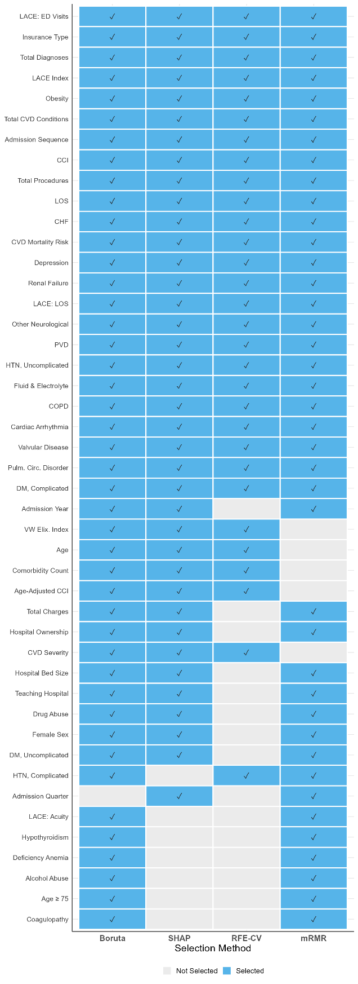
Binary heatmap depicting endorsement of each candidate feature by four independent selection methods: Boruta all-relevant selection, SHAP-based importance from a reference XGBoost model, recursive feature elimination with patient-grouped cross-validation (RFE-CV), and minimum redundancy maximum relevance (mRMR). Features endorsed by at least 2 of 4 methods were retained, yielding 45 consensus-selected features applied uniformly across all CVD categories and dataset configurations. Abbreviations: CVD, cardiovascular disease; mRMR, minimum redundancy maximum relevance; RFE-CV, recursive feature elimination with cross-validation; SHAP, SHapley Additive exPlanations.

Supplementary Figure S2. Super Learner Ensemble Meta-Learner Weights by CVD Category
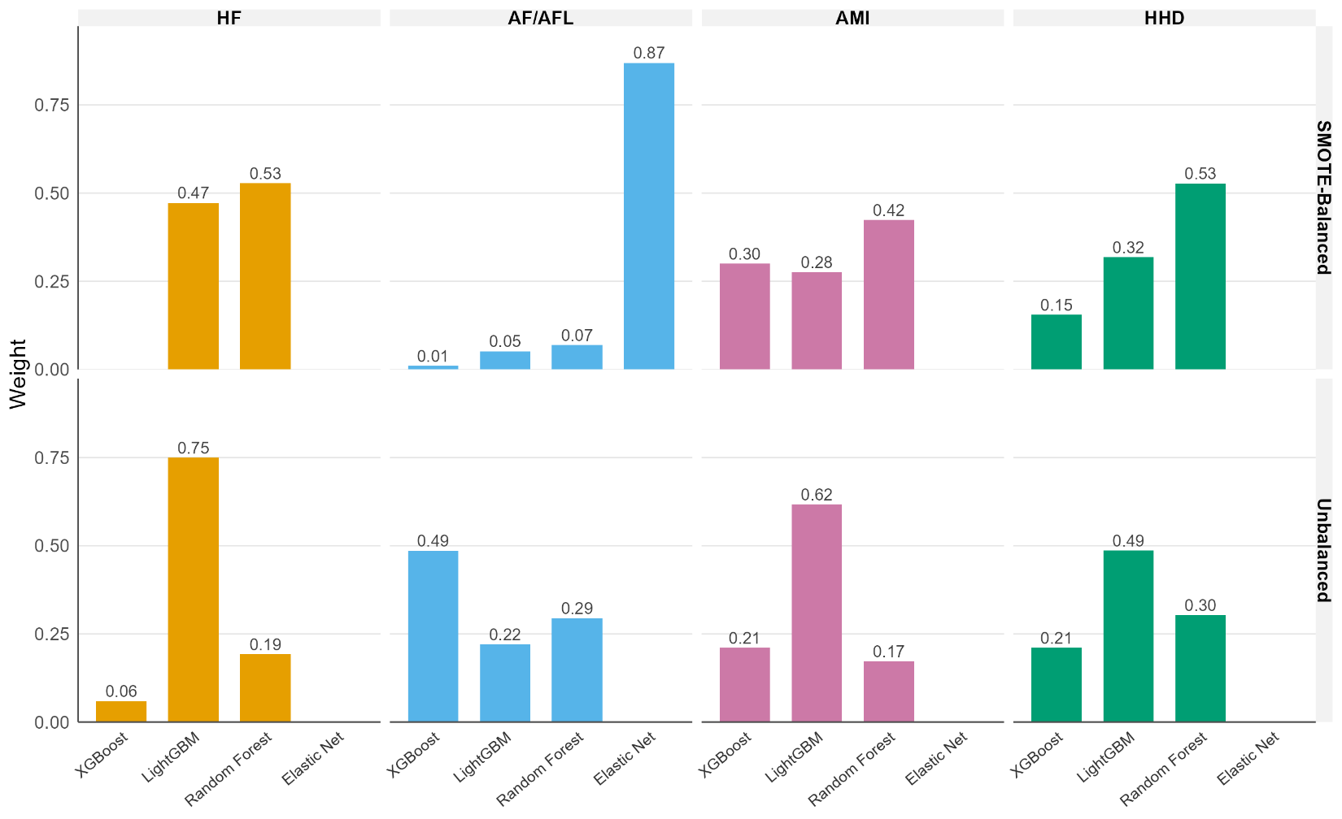
Bar charts showing the optimized convex combination weights assigned to each base learner (XGBoost, LightGBM, Random Forest, Elastic Net) within the Super Learner stacked ensemble, stratified by CVD category and dataset configuration (SMOTE-balanced vs. unbalanced). Weights reflect each algorithm’s relative contribution to the ensemble’s final predictions, with larger weights indicating greater influence on the combined model output. Abbreviations: AF/AFL, atrial fibrillation/flutter; AMI, acute myocardial infarction; CVD, cardiovascular disease; HF, heart failure; HHD, hypertensive heart disease; SMOTE, Synthetic Minority Oversampling Technique.

Supplementary Figure S3. SHAP Dependence Plots for Top Predictors by CVD Category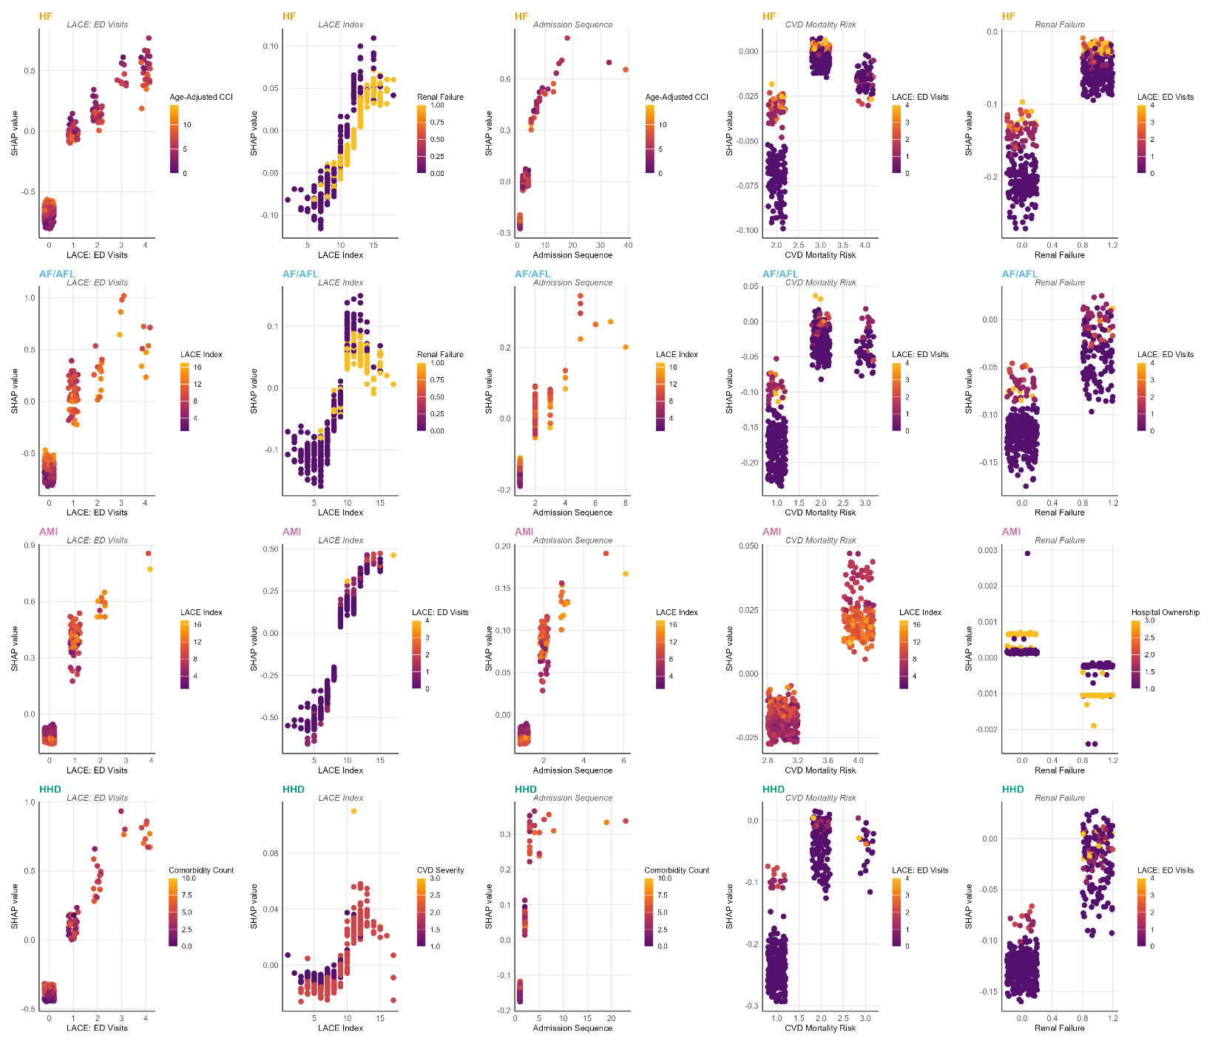
SHAP dependence plots for the top continuous predictors from each CVD category’s best-performing model, illustrating non-linear relationships between feature values (x-axis) and their SHAP contributions to the predicted log-odds of 30-day readmission (y-axis). Color indicates interaction effects with the most correlated feature. These plots reveal threshold effects (e.g., LACE Index), diminishing marginal returns, and differential effects of insurance type across predicted risk levels. SHAP values were computed on a random subsample of 500 test observations per condition (set.seed(42)).
Abbreviations: AF/AFL, atrial fibrillation/flutter; AMI, acute myocardial infarction; CVD, cardiovascular disease; HF, heart failure; HHD, hypertensive heart disease; LACE, Length of stay/Acuity/Comorbidity/Emergency visits; SHAP, SHapley Additive exPlanations.

Supplementary Figure S4. SHAP Waterfall Plots : Individual Prediction Explanations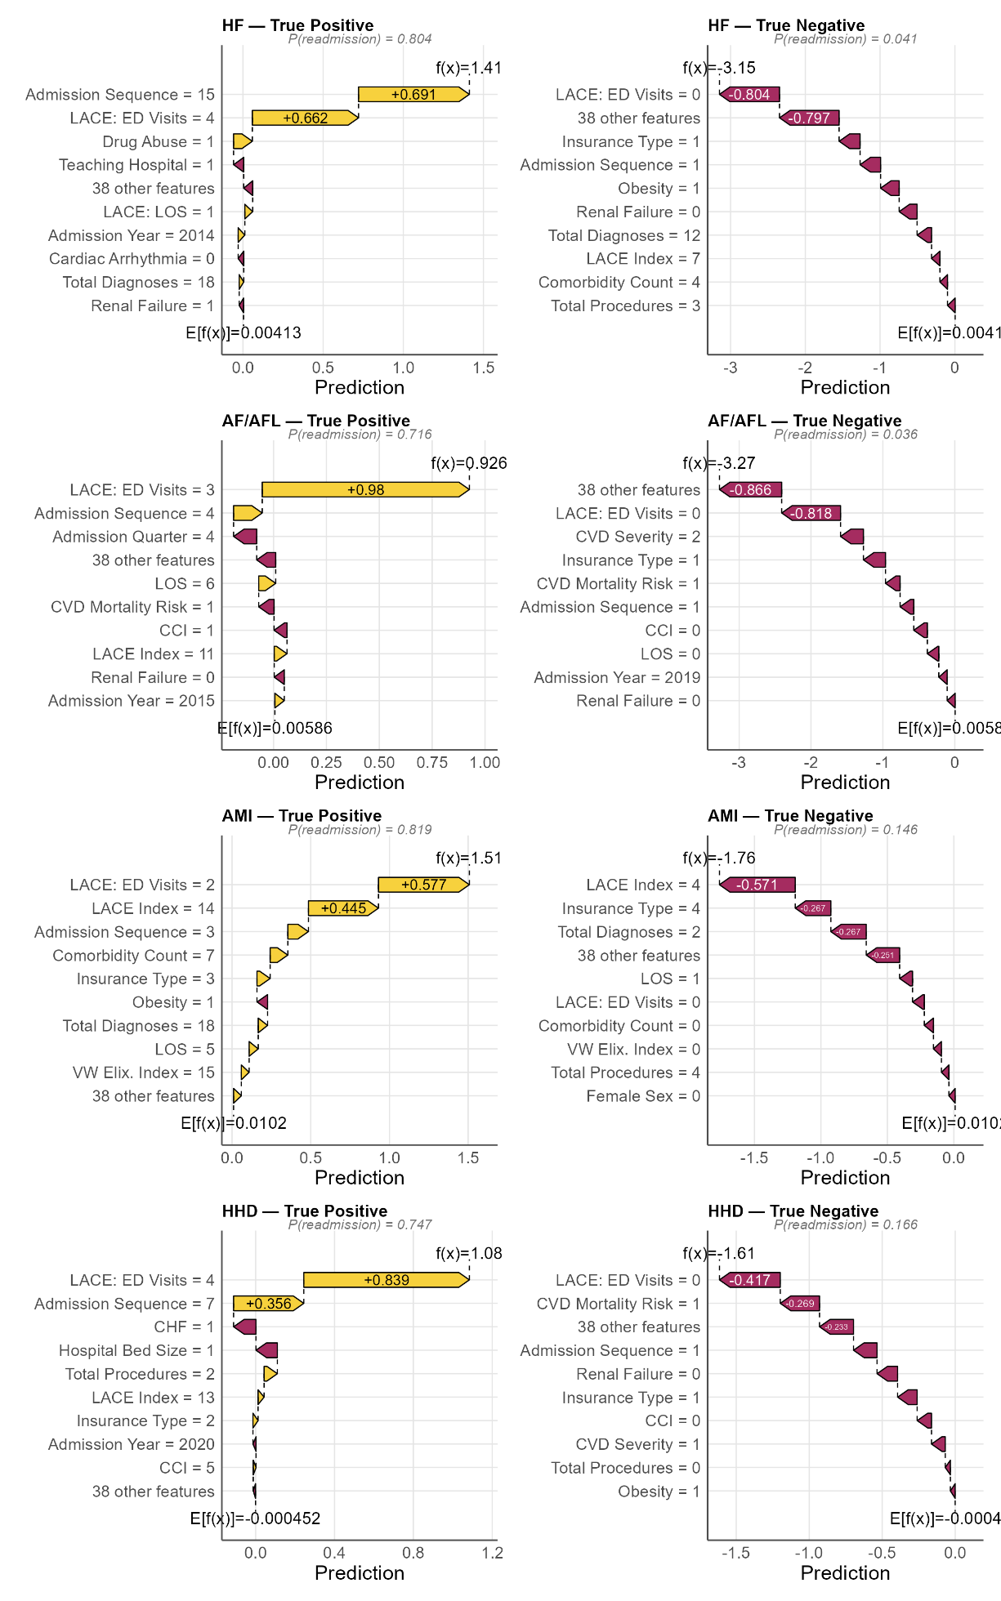
SHAP waterfall plots for representative true positive and true negative cases from each CVD category’s best-performing model. Each panel decomposes a single patient’s predicted probability of 30-day readmission into additive feature contributions, starting from the base rate (E[f(x)]) and showing how each feature pushes the prediction higher (red) or lower (blue). True positive cases are selected as the highest-confidence correct readmission predictions; true negative cases as the lowest-probability correct non-readmission predictions. Feature values for the selected patient are displayed alongside each bar.
Abbreviations: AF/AFL, atrial fibrillation/flutter; AMI, acute myocardial infarction; CVD, cardiovascular disease; E[f(x)], expected model output (base rate); HF, heart failure; HHD, hypertensive heart disease; SHAP, SHapley Additive exPlanations; TN, true negative; TP, true positive.
Note: Because the 30-day readmission rate exceeds 10% in all CVD categories (18.9% overall, 22.5% for Heart Failure, 15.3% for AF/AFL, 13.0% for AMI, 12.4% for HHD), odds ratios from logistic regression do not approximate relative risks at these prevalence levels. ORs presented here should be interpreted as measures of association on the odds scale, not as indicating “X% higher risk” of readmission.

