Appendix Table 1. Plant and invertebrate sites with associated data. This includes the California county, site code, latitude, number of pools sampled, percent development and agriculture, and average temperature and presipitation.
Dataset | CA county | Site | Latitude |  | Number of pools sampled | Percent developed | Percent agriculture | Average temperature (Celsius) | Average precipitation(mm)
Plant
 | Alameda | SPR | 37.72 N | 6 |  | 6.43 | 0 | 15.55 | 38.17
 | Alameda | WAR | 37.48 N | 8 |  | 0 | 3.36 | 15.85 | 38.58
 | Butte | BOO | 39.61 N | 15 |  | 5.87 | 20.88 | 16.38 | 52.42
 | Fresno | KER | 36.73 N | 7 |  | 2.35 | 8.97 | 16.36 | 17.00
 | Fresno | BIG | 37.04 N | 4 |  | 0 | 0 | 16.49 | 50.58
 | Fresno | KEN | 37.09 N | 2 |  | 0 | 0 | 16.49 | 50.58
 | Fresno | TAB | 37.04 N | 3 |  | 1.92 | 6.30 | 16.49 | 50.58
 | Glenn | SAC | 39.44 N | 5 |  | 3.06 | 0.11 | 16.06 | 38.25
 | Kern | SEM | 35.64 N | 1 |  | 0.95 | 9.92 | 17.69 | 15.33
 | Merced | SUN | 37.25 N | 2 |  | 0 | 0 | 16.20 | 22.58
 | Merced | ARE | 37.25 N | 3 |  | 0 | 15.97 | 16.20 | 22.58
 | Merced | GSP | 37.25 N | 3 |  | 2.41 | 1.06 | 16.17 | 21.83
 | Merced | KES | 37.27 N | 5 |  | 0 | 0 | 16.17 | 21.83
 | Merced | CHA | 37.47 N | 15 |  | 0 | 0 | 16.80 | 32.25
 | Merced | FLY | 37.17 N | 16 |  | 2.73 | 12.97 | 16.51 | 28.67
 | Merced | ICO | 37.34 N | 10 |  | 0.06 | 21.41 | 16.80 | 32.25
 | Merced | KEL | 37.35 N | 5 |  | 0 | 6.65 | 16.70 | 37.17
 | Placer | OR | 38.83 N | 18 |  | 22.21 | 0 | 16.61 | 53.42
 | Placer | ORC | 38.84 N | 5 |  | 0.40 | 0.06 | 16.61 | 53.42
 | Plumas | SQU | 39.99 N | 1 |  | 1.38 | 50.99 | 7.21 | 53.33
 | Riverside | SAN | 33.50 N | 3 |  | 2.32 | 34.29 | 17.27 | 29.92
 | Sacramento | HOW | 38.35 N | 24 |  | 0 | 0 | 16.50 | 45.92
 | Sacramento | MAT | 38.53 N | 7 |  | 23.88 | 0.03 | 16.58 | 43.08
 | Sacramento | PHO | 38.65 N | 9 |  | 4.55 | 95.45 | 16.58 | 43.08
 | Sacramento | RAN | 38.33 N | 1 |  | 0 | 0 | 16.24 | 43.17
 | Sacramento | VAL | 38.34 N | 12 |  | 3.57 | 0 | 16.10 | 41.25
 | Sacramento | FRI | 38.60 N | 6 |  | 99.37 | 0.46 | 16.66 | 39.83
 | San Diego | CAR | 32.89 N | 6 |  | 52.26 | 0.29 | 17.72 | 28.42
 | San Diego | DEL | 32.94 N | 5 |  | 30.96 | 0 | 17.72 | 28.42
 | San Diego | MIR | 32.84 N | 4 |  | 0.77 | 2.46 | 17.72 | 28.42
 | San Diego | OTA | 32.55 N | 6 |  | 11.59 | 0 | 17.72 | 22.17
 | San Diego | OTM | 32.59 N | 5 |  | 77.41 | 0.03 | 17.78 | 26.08
 | San Joaquin | LAN | 38.22 N | 15 |  | 4.32 | 0 | 16.24 | 43.17
 | Santa Barbara | ELL | 34.41 N | 2 |  | 24.36 | 2.21 | 15.65 | 38.50
 | Santa Barbara | ISL | 34.41 N | 5 |  | 70.59 | 4.48 | 15.65 | 38.50
 | Shasta | SOL | 41.07 N | 3 |  | 35.71 | 0.03 | 9.85 | 58.25
 | Solano | JEP | 38.28 N | 23 |  | 2.81 | 5.53 | 15.61 | 37.17
 | Solano | WIL | 38.26 N | 4 |  | 52.55 | 0 | 15.71 | 43.00
 | Sonoma | TOD | 38.38 N | 5 |  | 3.90 | 0 | 14.60 | 72.42
 | Tehama | THO | 39.99 N | 22 |  | 7.22 | 82.32 | 16.71 | 47.17
 | Tehama | DAL | 40.33 N | 1 |  | 4.04 | 0 | 16.76 | 63.75
 | Tehama | FOR | 39.94 N | 4 |  | 0 | 0 | 16.76 | 58.17
 | Tehama | HOG | 40.28 N | 1 |  | 1.89 | 0 | 16.76 | 63.75
 | Tehama | INK | 40.34 N | 7 |  | 0 | 0 | 16.66 | 74.75
 | Tehama | LAS | 39.91 N | 5 |  | 4.41 | 0 | 16.76 | 58.17
 | Tehama | ROW | 39.89 N | 5 |  | 0 | 0.56 | 16.46 | 49.00
 | Tehama | TUS | 40.27 N | 1 |  | 0 | 55.06 | 16.76 | 63.75
 | Tehama | VIN | 39.91 N | 6 |  | 0.77 | 9.00 | 16.76 | 58.17
 | Tulare | PIX | 35.98 N | 7 |  | 2.89 | 0.86 | 17.24 | 17.67
 | Tulare | HER | 36.18 N | 6 |  | 1.49 | 60.11 | 17.18 | 22.00
 | Tulare | STO | 36.44 N | 13 |  | 0 | 78.91 | 17.34 | 25.58
 | Yuba | BEA | 39.13 N | 10 |  | 2.38 | 32.20 | 16.97 | 51.25
Invertebrate
 | Alameda | Dublin Ranch | 37.71 N | 25 |  | 12.60 | 0 | 15.55 | 38.17
 | Alameda | Newman Ridge | 38.35 N | 22 |  | 3.86 | 15.30 | 16.10 | 56.33
 | Butte | Meridian Ranch | 39.86 N | 20 |  | 0 | 0 | 16.76 | 58.17
 | Butte | Sycamore Glen | 39.78 N | 5 |  | 0 | 0 | 16.41 | 64.83
 | Contra Costa | Vasco | 37.79 N | 126 |  | 0.17 | 0 | 16.08 | 29.83
 | Madera | Tesoro Viejo | 37.25 N | 7 |  | 0 | 0 | 15.57 | 58.75
 | Merced | Lazy K Ranch | 37.12 N | 53 |  | 3.89 | 95.88 | 16.15 | 23.75
 | Merced | Highway 59 | 37.38 N | 56 |  | 0.34 | 32.88 | 16.80 | 32.25
 | Merced | Burns Haystack | 37.39 N | 17 |  | 0 | 0 | 16.94 | 37.25
 | Placer | Roseville | 38.75 N | 40 |  | 0 | 0 | 9.70 | 108.58
 | Placer | Reason Farms | 38.81 N | 17 |  | 3.56 | 82.74 | 16.57 | 41.58
 | Placer | Doty Ravine | 38.94 N | 21 |  | 1.43 | 19.75 | 16.54 | 44.83
 | Placer | Yankee Slough | 38.96 N | 28 |  | 5.13 | 34.58 | 16.54 | 44.83
 | Riverside | Riverside | 33.75 N | 4 |  | 62.14 | 29.95 | 17.80 | 27.42
 | Sacramento | SMUD Preserve | 38.32 N | 150 |  | 4.16 | 0.57 | 16.24 | 43.17
 | Sacramento | Gill Ranch | 38.47 N | 6 |  | 2.23 | 0 | 16.50 | 45.92
 | Sacramento | Mather | 38.52 N | 16 |  | 3.49 | 0 | 16.58 | 43.08
 | Sacramento | Laguna Stonelake | 38.40 N | 24 |  | 88.38 | 2.98 | 16.17 | 38.75
 | Sacramento | Simmerhorn | 38.26 N | 36 |  | 55.38 | 27.29 | 15.81 | 39.92
 | San Diego | Ramona Spray Fields | 33.05 N | 14 |  | 3.27 | 0 | 17.43 | 32.42
 | San Joaquin | Borden Ranch | 38.30 N | 31 |  | 2.44 | 22.84 | 16.24 | 43.17
 | Shasta | Little Country Church | 40.59 N | 4 |  | 0 | 0 | 6.34 | 80.42
 | Shasta | Clover Creek | 40.54 N | 17 |  | 0 | 0 | 5.81 | 72.67
 | Solano | MWVPP | 38.08 N | 29 |  | 0.03 | 0 | 15.39 | 36.42
 | Solano | WR | 38.31 N | 30 |  | 3.15 | 20.79 | 15.70 | 43.00
 | Solano | Midway Meridian | 38.32 N | 13 |  | 25.25 | 52.68 | 15.70 | 43.00
 | Tehama | VPP | 39.94 N | 6 |  | 0 | 0 | 16.76 | 58.17
 | Tulare | Yokohl Ranch | 36.13 N | 56 |  | 12.66 | 86.37 | 17.27 | 22.08
 | Yuba | Beale | 39.14 N | 15 |  | 0 | 12.79 | 16.97 | 51.25

Appendix Table 2. Pool variables reported in the plant dataset and the aquatic invertebrate dataset.
Data set | Pool variables recorded
Plants | Latitude and longitude, pool surface area, pool volume, maximum pool depth, pool width
Animals | Latitude, depth, surface area (for some pools), water temperature (for most pools), pH (for some pools)

Appendix Table 3. Classification system of the land cover data. This table is adapted from the Multi-resolution Land Characteristics Consortium National Land Cover Database (Dewitz 2019, Homer et al. 2020). Asterisk (*) indicates land cover classifications found within the geographic scope of this study. However, only the Developed and Planted/cultivated classifications were used in the analysis.
Class/Value | Classification Description
Water
 | Open water*- areas of open water, generally with less than 25% cover of vegetation or soil
 | Perennial Ice/Snow- areas characterized by a perennial cover of ice and/or snow, generally greater than 25% of total cover.
Developed
 | Developed, Open Space*- areas with a mixture of some constructed materials, but mostly vegetation in the form of lawn grasses. Impervious surfaces account for less than 20% of total cover. These areas most commonly include large-lot single-family housing units, parks, golf courses, and vegetation planted in developed settings foe recreation, erosion control, or aesthetic purposes.
 | Developed, low intensity*- areas with a mixture of constructed materials and vegetation. Impervious surfaces account for 20%-49% total cover. These areas most commonly include single-family housing units.
 | Developed, medium intensity*- areas with a mixture of constructed materials and vegetation. Impervious surfaces account for 50% to 79% of the total cover. These areas most commonly include single-family housing units.
 | Developed, high intensity*- highly developed areas where people reside or work in high numbers. Examples include apartment complexes, row houses, and commercial/industrial. Impervious surfaces account for 80% to 100% total cover.
Barren
 | Barren Land (Rock/Sand/Clay)*- areas of bedrock, desert pavement, scarps, talus, slides, volcanic material, glacial debris, sand dunes, strip mines, gravel pits, and other accumulations of earthen material. Generally, vegetation accounts for less than 15% of total cover.
Forest
 | Deciduous Forest*- areas dominated by trees generally greater than 5 meters tall, and greater than 20% of total vegetation cover. More than 75% of the tree species shed foliage simultaneously in response to seasonal change.
 | Evergreen Forest*- areas dominated by trees generally greater than 5 meters tall, and greater than 20% of total vegetation cover. More than 75% of the tree species maintain their leaves all year. Canopy is never without green foliage.
 | Mixed Forest*- areas dominated by trees generally greater than 5 meters tall, and greater than 20% of total vegetation cover. Neither deciduous nor evergreen species are greater than 75% of total tree cover.
Shrubland
 | Dwarf Scrub- Alaska only areas dominated by shrubs less than 20 centimeters tall with shrub canopy typically greater than 20% of total vegetation.
 | Shrub/Scrub*- areas dominated by shrubs; less than 5 meters tall with shrub canopy typically greater than 20% of total vegetation. This class includes true shrubs, young trees in an early successional stage or trees stunted from environmental conditions.
Herbaceous
 | Grassland/Herbaceous*- areas dominated by graminoid or herbaceous vegetation, generally greater than 80% of total vegetation. These areas are not subject to intensive management such as tilling, but can be utilized for grazing.
 | Sedge/Herbaceous- Alaska only areas dominated by sedges and forbs, generally greater than 80% of total vegetation.
 | Lichens- Alaska only areas dominated by fruticose or foliose lichens generally greater than 80% of total vegetation.
 | Moss- Alaska only areas dominated by mosses, generally greater than 80% of total vegetation.
Planted/cultivated
 | Pasture/Hay*- areas of grasses, legumes, or grass-legume mixtures planted for livestock grazing or the production of seed of hay crops, typically on a perennial cycle. Pasture/hay vegetation accounts for greater than 20% of total vegetation.
 | Cultivated Crops*- areas used for the production of annual crops, such as corn, soybeans, vegetables, tobacco, and cotton, and also perennial woody crops such as orchards and vineyards. Crop vegetation accounts for greater than 20% of total vegetation. This class also includes all land being actively tilled.
Wetlands
 | Woody Wetlands*- areas where forest or shrubland vegetation accounts for greater than 20% of vegetative cover and the soil or substrate is periodically saturated with or covered with water.
 | Emergent Herbaceous Wetlands*- areas where perennial herbaceous vegetation accounts for greater than 80% of vegetative cover and the soil or substrate is periodically saturated with or covered with water.

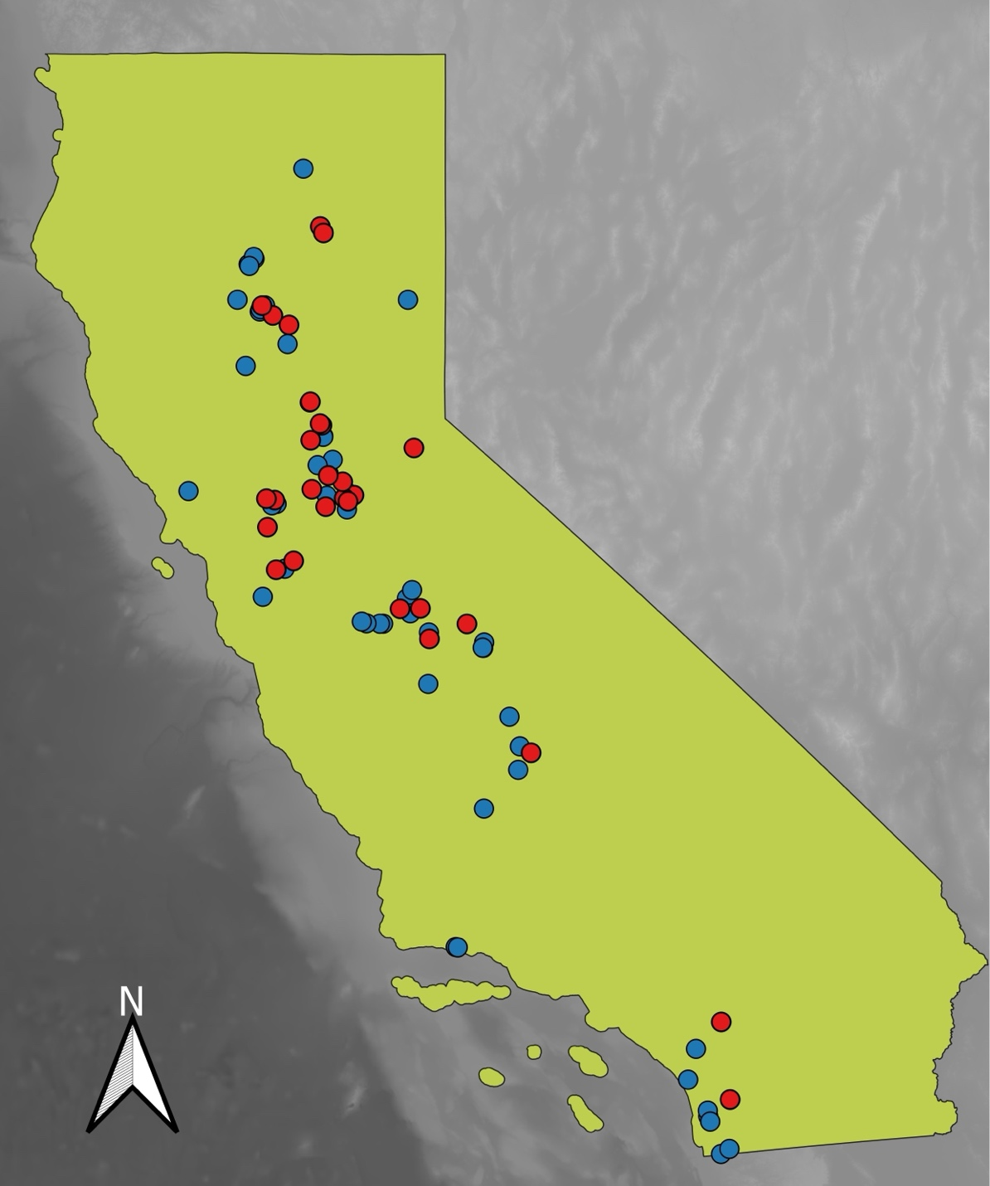
Appendix Figure 1. A map of the state of California showing the location of all vernal pool sites included in the analysis. Blue dots represent plant sites and red dots represent invertebrate sites.

