Supplementary Materials

Uncovering the spatiotemporal patterns of the largest vaccine-derived poliovirus serotype 2 outbreak in the Democratic Republic of the Congo

Kieran Chopra¹*, Tresor Kabeya Mampuela^{2,3}*, Alexander Shaw¹, David Jorgensen¹, Javier Martin⁴, Catherine Pratt⁵, Emmanuel Lokilo Lofiko³, Philippe Lemey⁶, Yogolelo Riziki³, Nicholas C. Grassly¹, Placide Mbala^{2,3,7,8}, Isobel Blake¹, Darlan da Silva Candido¹

Authors marked with an * contributed equally

Affiliations:
¹MRC Centre for Global Infectious Disease Analysis, School of Public Health, Imperial College, London, United Kingdom
²Service de Microbiologie, Departement de Biologie Médicale, Cliniques Universitaires de Kinshasa (CUK), Université de Kinshasa (UNIKIN), Kinshasa, Democratic Republic of the Congo
³Institut National de Recherche Biomédicale, Kinshasa, Democratic Republic of the Congo
⁴Division of Vaccines, National Institute for Biological Standards and Control, Medicines and Healthcare products Regulatory Agency, Potters Bar, UK.
⁵Biosurv International, Salisbury, UK.
⁶Department of Microbiology, Immunology and Transplantation, Rega Institute, KU Leuven, Leuven, Belgium
⁷South African National Bioinformatics Institute, University of the Western Cape, South Africa
⁸Dept of Virology, Graduate School of Medicine, Osaka Metropolitan University, Japan.*Corresponding author. Email: ddasilva@ic.ac.uk

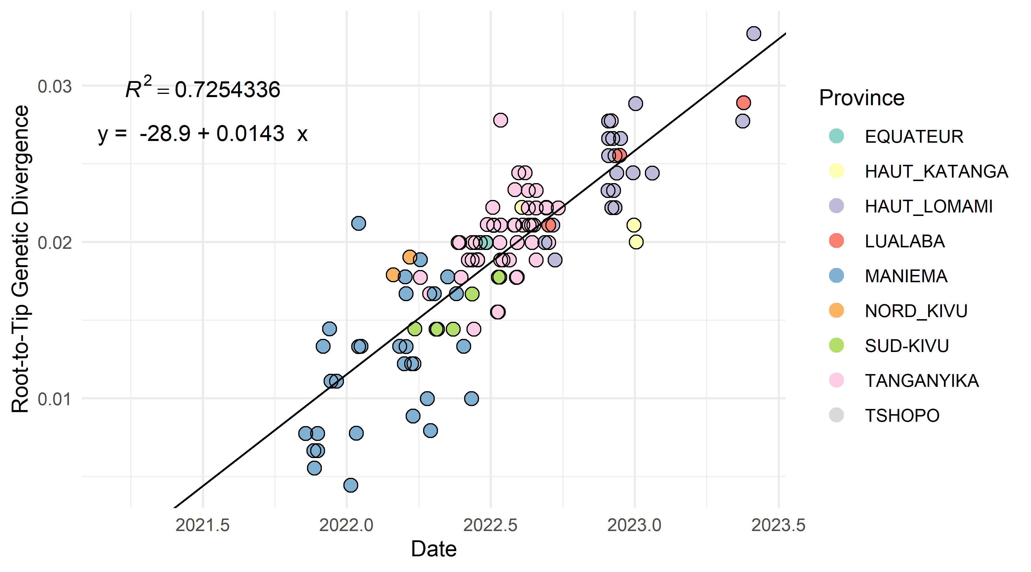
Supplementary Figure 1: Root-to-tip regression analysis of RDC-MAN-3 DDNS sequences (VP1 gene) demonstrating a strong temporal signal

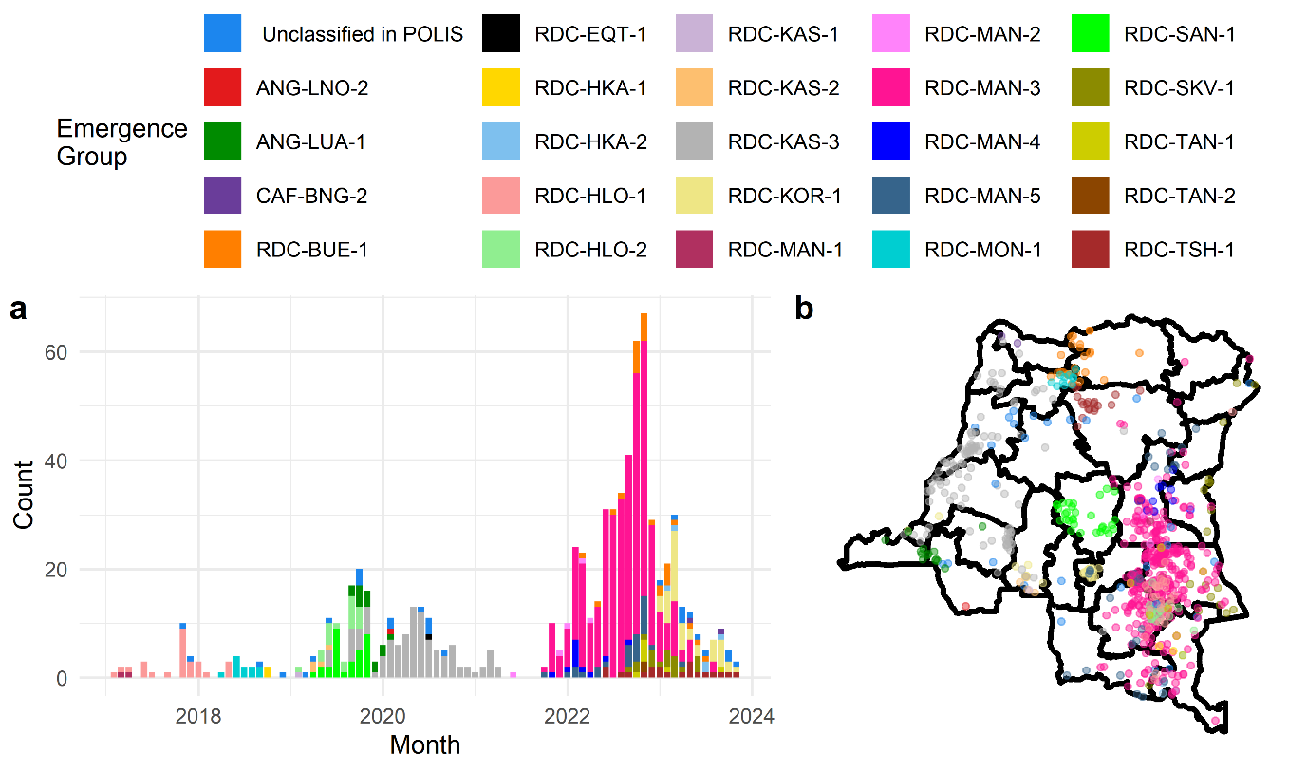
Supplementary Figure 2: cVDPV2 epidemiology in the DRC. (a) Time series of cVDPV2 cases confirmed by gold standard testing in the DRC between 2017 and 2024. (b) A map of the same cVDPV2 cases – locations are accurate to the nearest district.
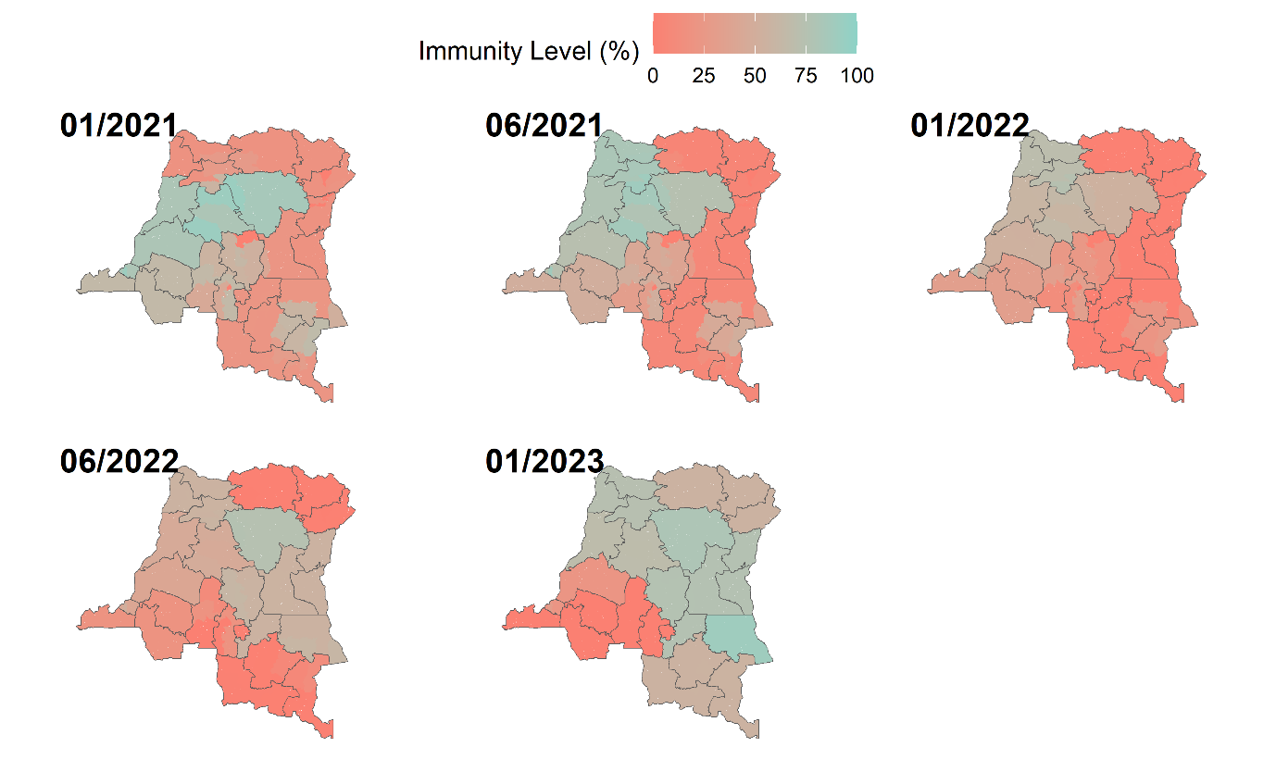
Supplementary Figure 3: Vaccine-induced immunity estimates for serotype 2 polio in the DRC over time.
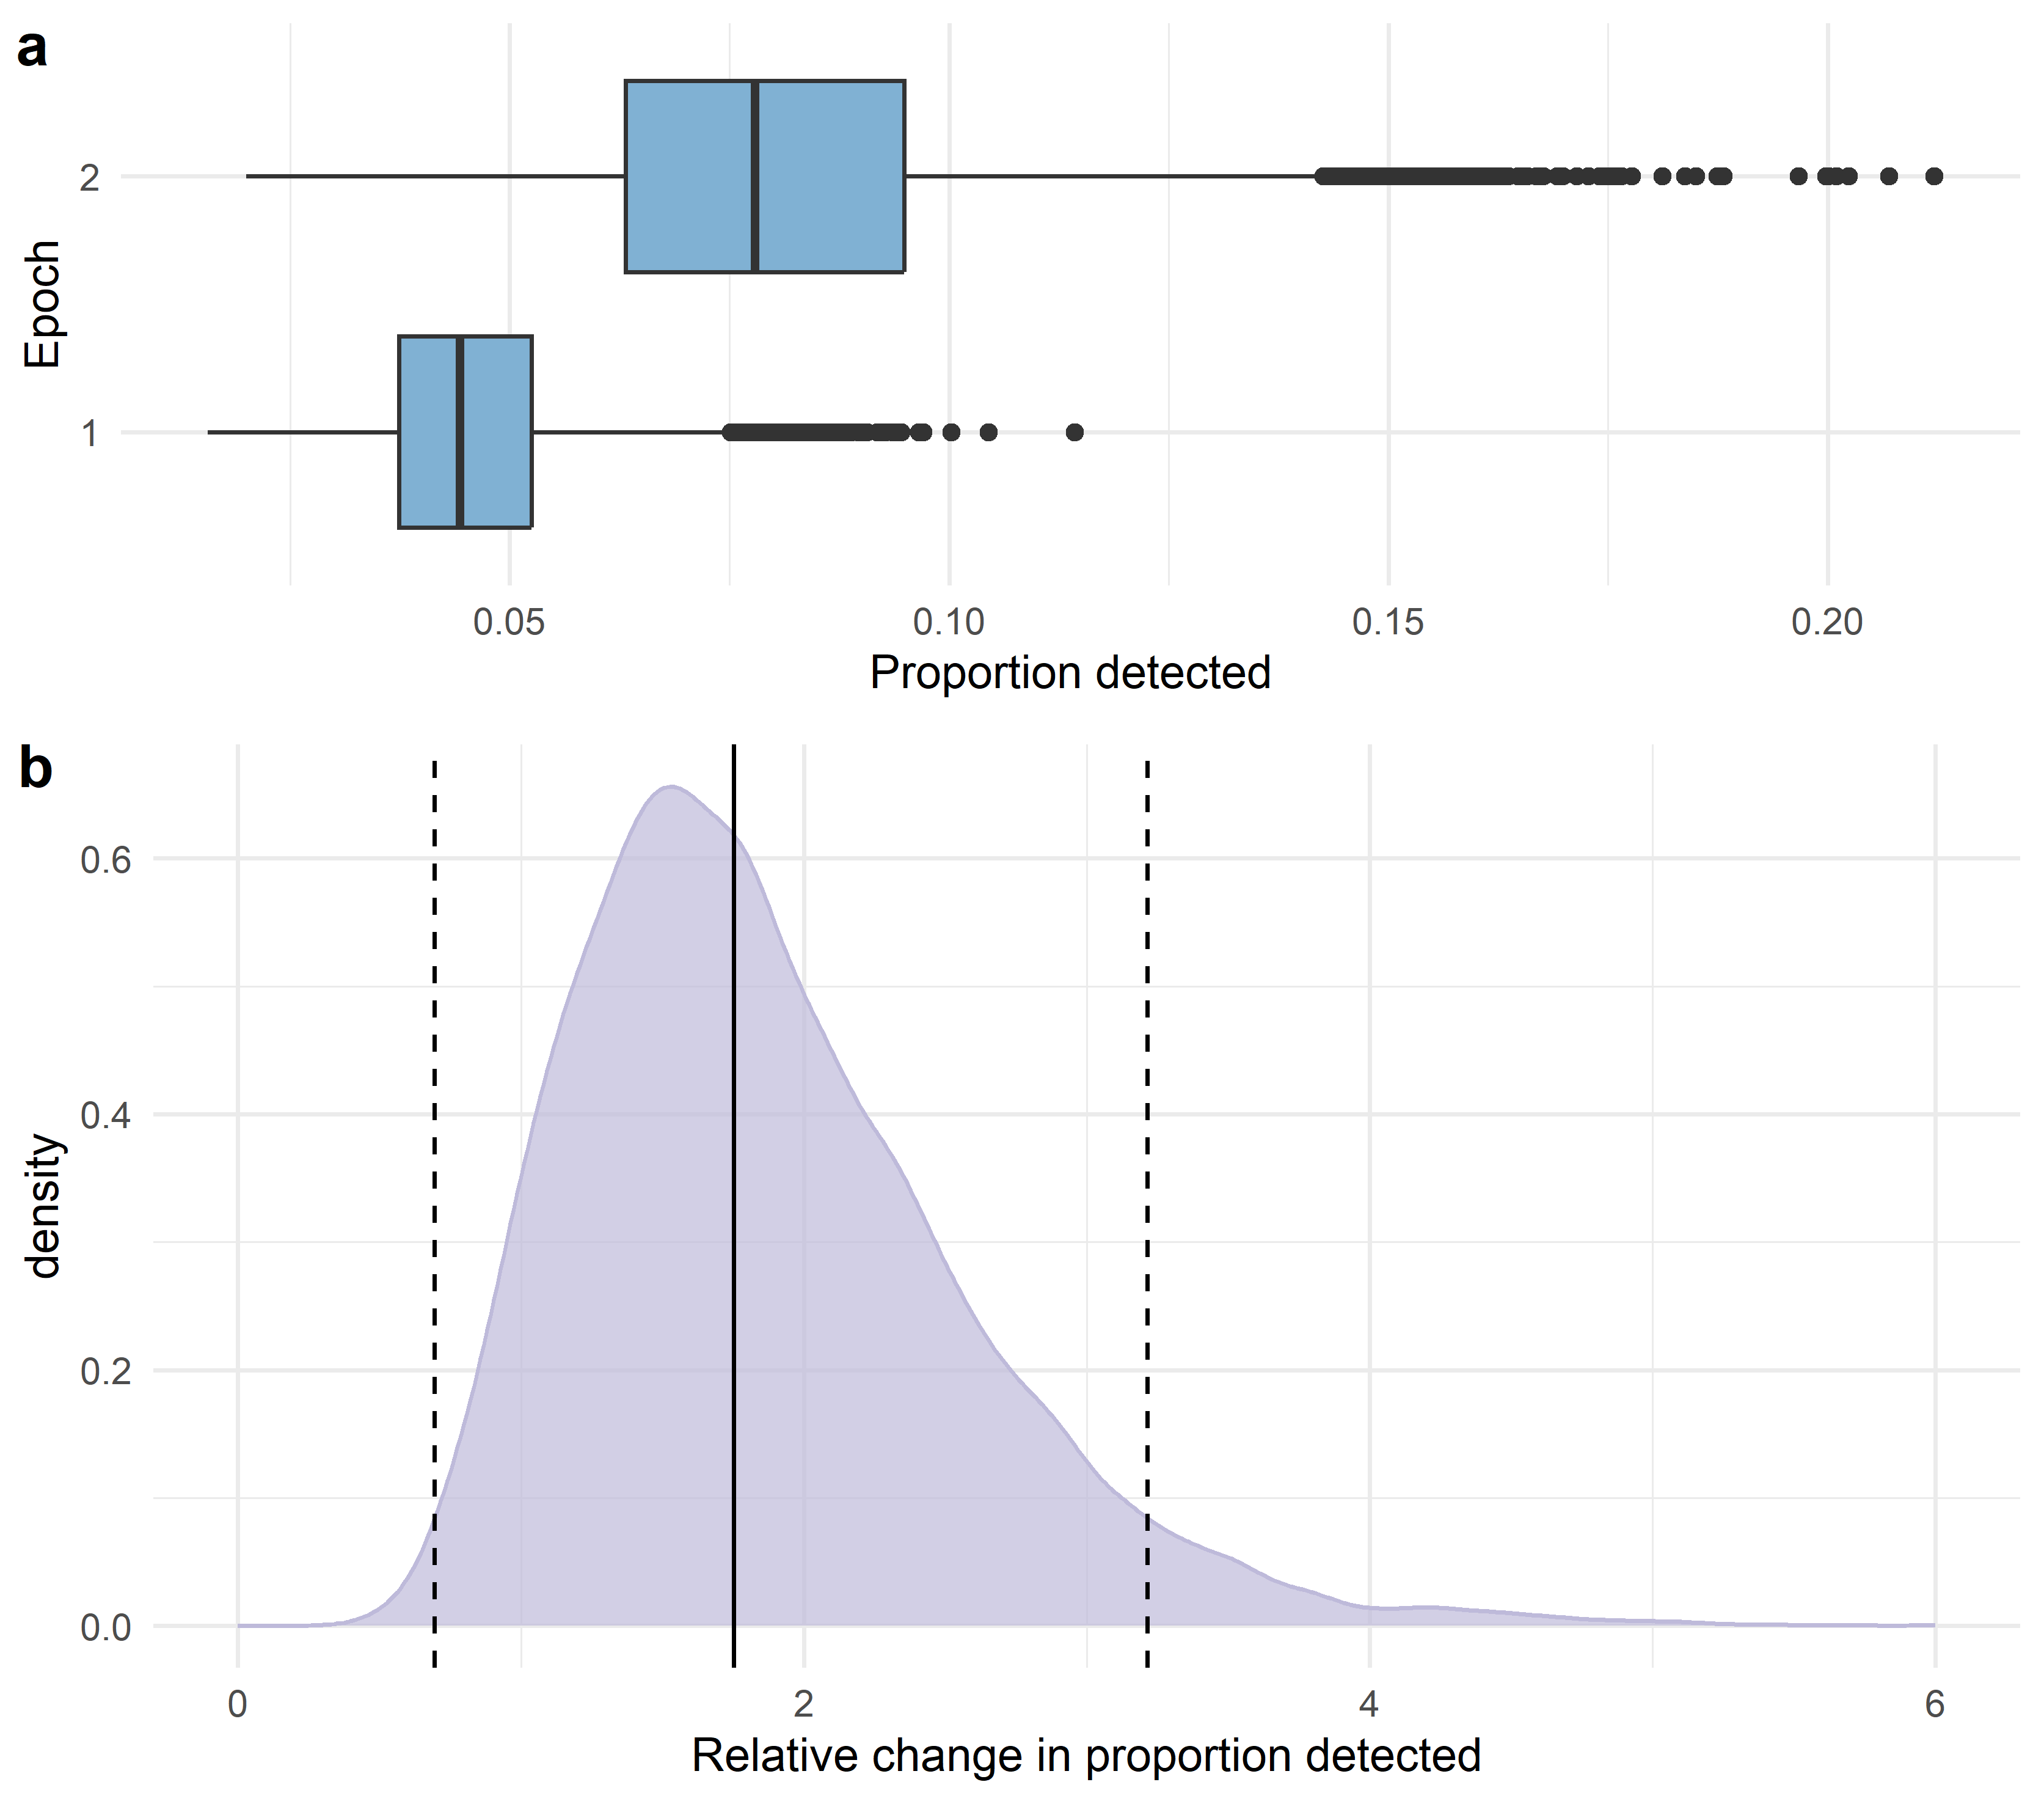
Supplementary Figure 4: (a) Estimated proportion of infections detected by AFP surveillance in sampling epochs 1 ([2021-11-10, 2022-05-01]) and 2 ([2022-05-01, 2023-01-23]). Boxplots show 1st, 2nd, and 3rd quantiles, with whiskers extending to furthest point not more than 1.5 interquartile ranges from the hinge. (b) Posterior density of the relative change in proportion of infections detected from sampling epoch 1 to sampling epoch 2. The median (1.75) is denoted by a solid line, and 95% HPD endpoints (0.693, 3.12) by dashed lines.

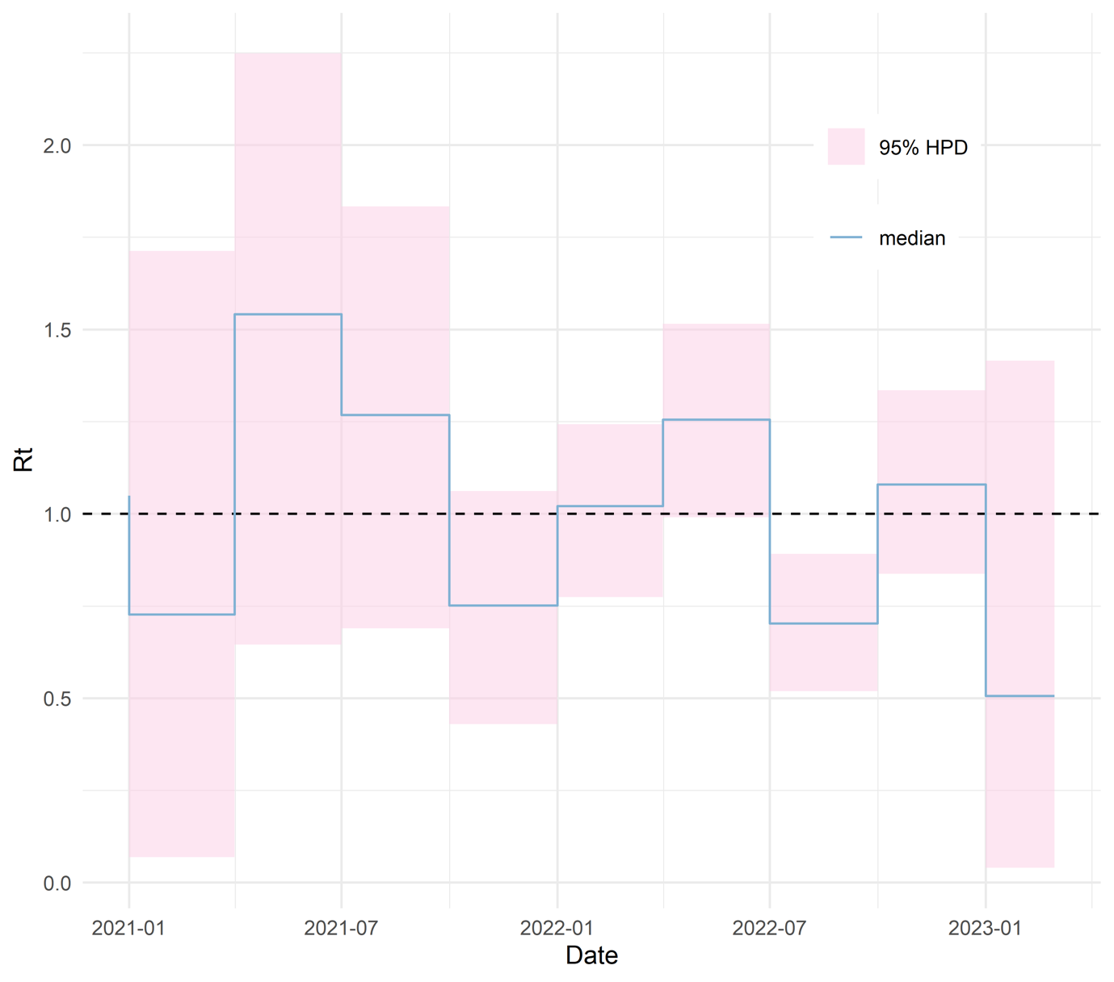
Supplementary Figure 4: Estimate of RDC-MAN-3 effective reproduction number over time from birth-death-sampling analysis
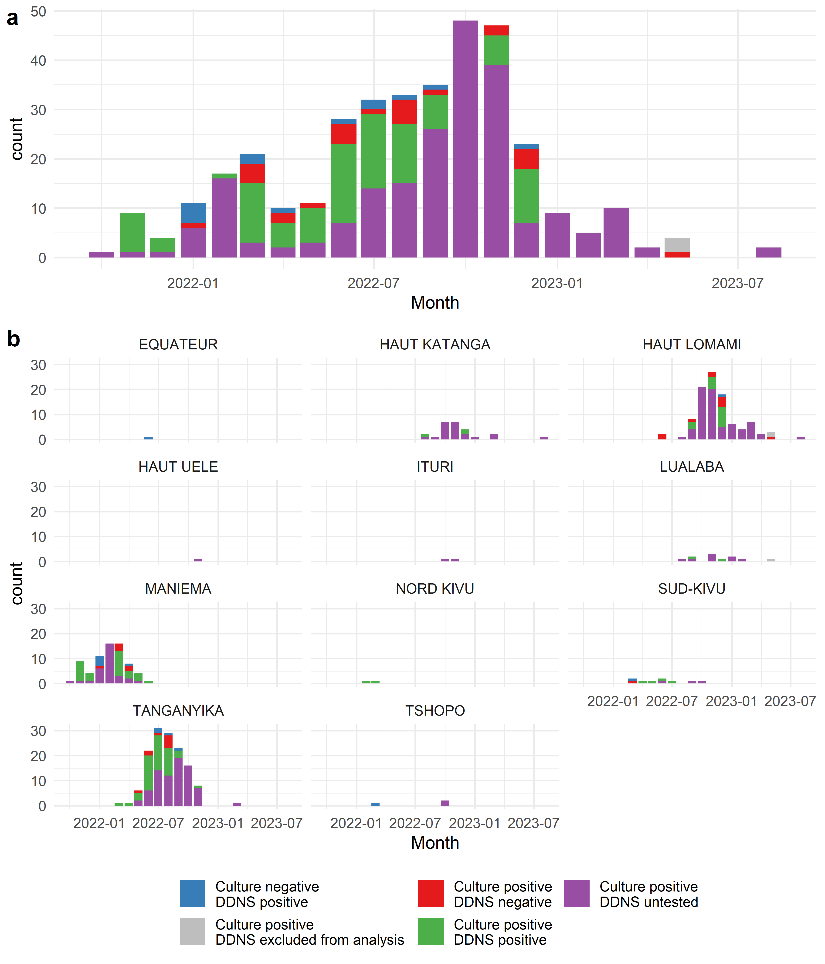
Supplementary Figure 5: Detailed timeseries of DDNS availability (a) aggregated over provinces, and (b) by province

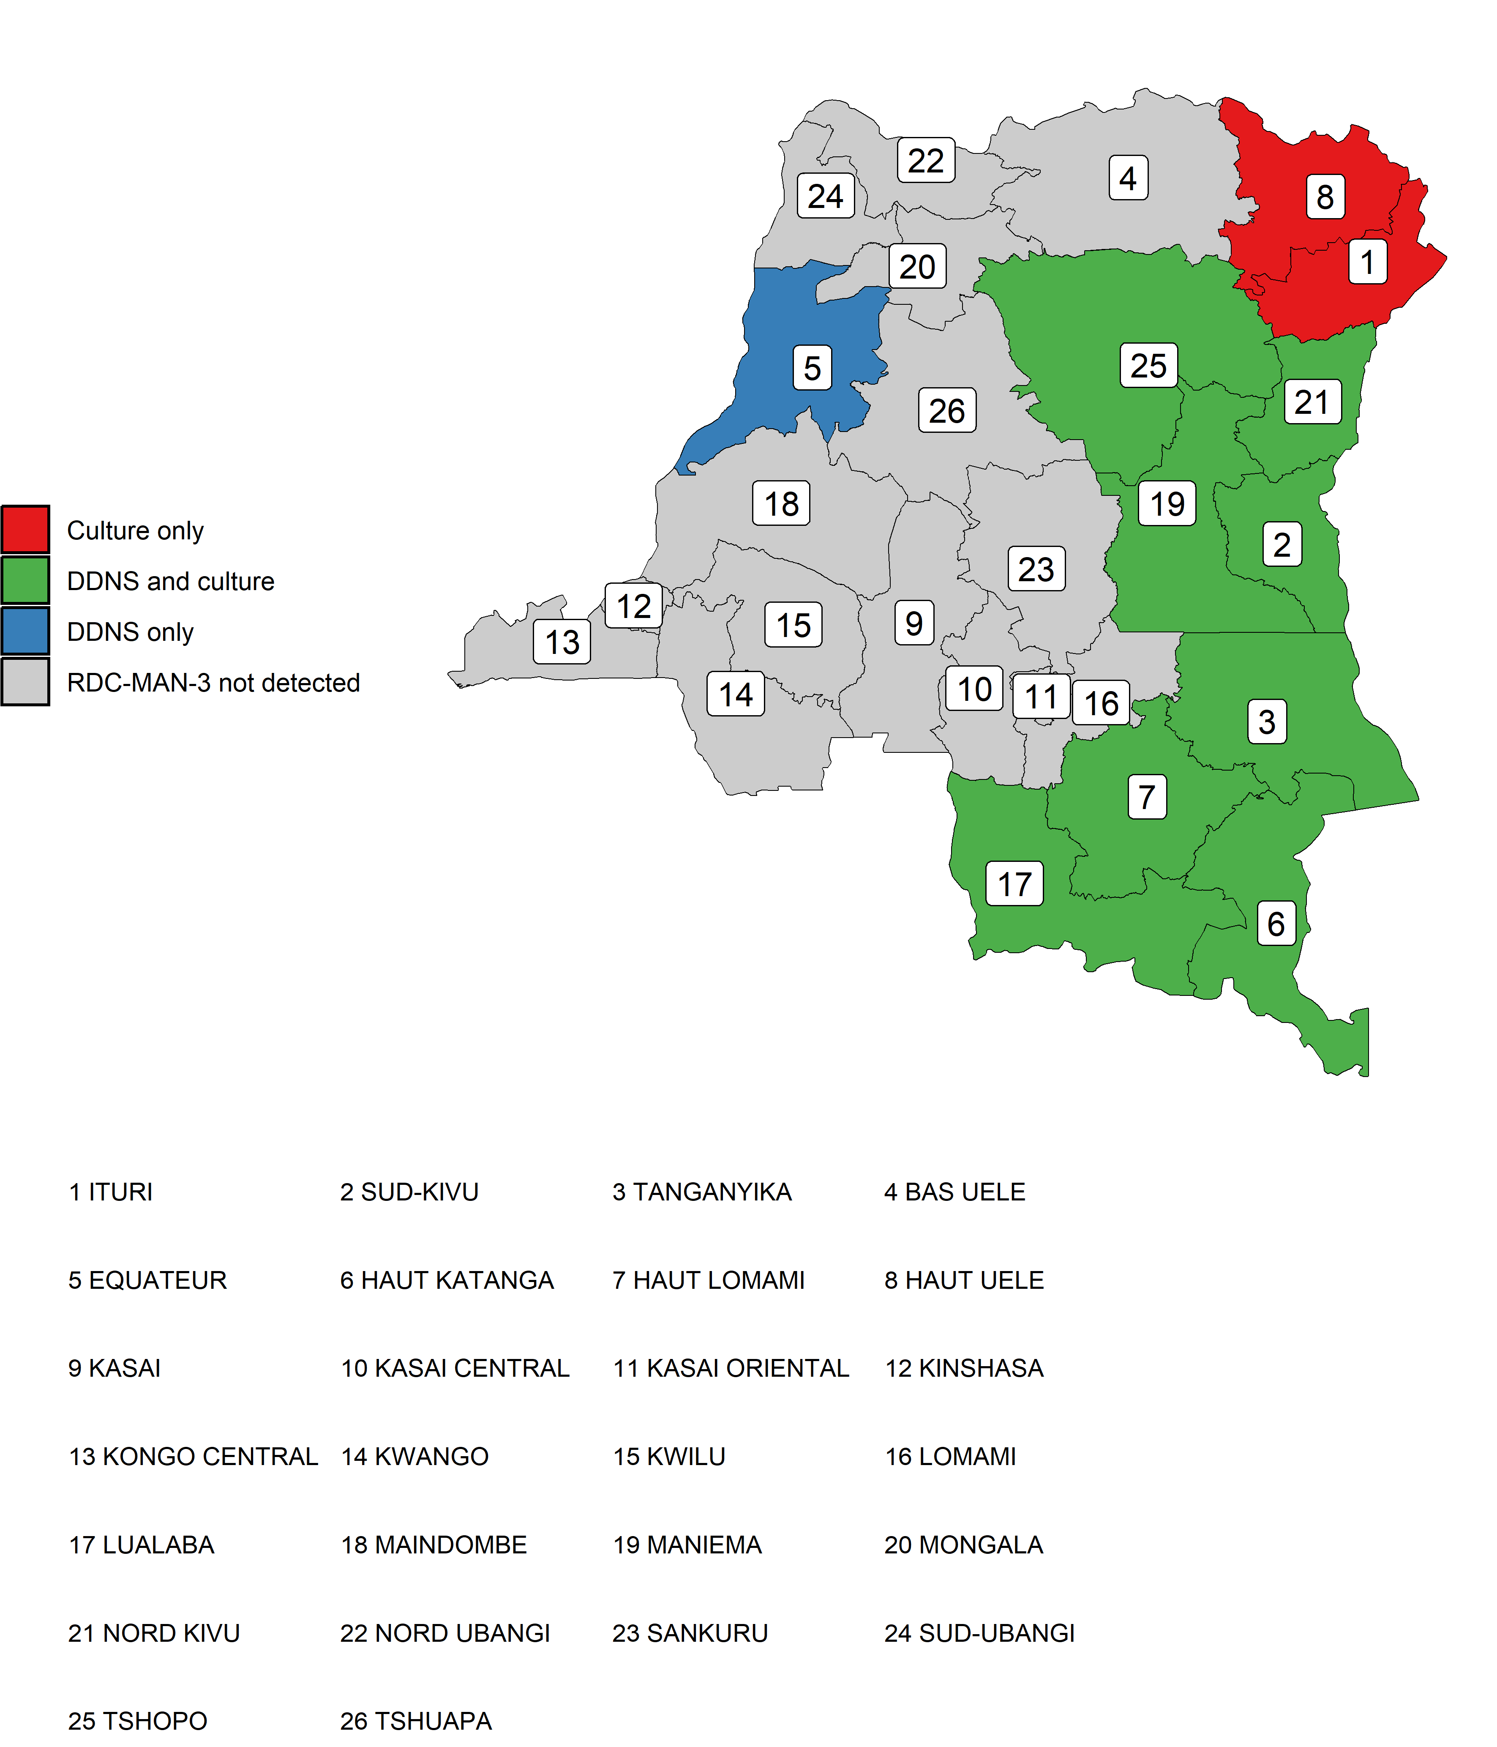
Supplementary Figure 6: Map of provinces of the DRC. Provinces are coloured by sequence availability from culture and DDNS methods.

