Table S1: comparison of mean Log₁₀-transformed CMh bacterial loads by detailed coinfection type

coinf_type - CMh | Count | Mean | Median | Q1 | Q3 | SD
16S-CMh-Mass | 14 | 2.015540 | 1.872029 | 1.541028 | 2.605559 | 0.6837106
Mex-CMh- | 2 | 2.282829 | 2.282829 | 2.081822 | 2.483837 | 0.5685363
16S-Mex-CMh-Mass | 69 | 2.439801 | 2.322219 | 1.876795 | 3.056905 | 0.8543038
16S-Mex-CMh- | 211 | 2.463509 | 2.348305 | 1.886922 | 2.890408 | 0.8887461
16S-CMh- | 62 | 2.529141 | 2.463883 | 1.780112 | 3.175217 | 0.9738487
Mex-CMh-Mass | 1 | 2.858537 | 2.858537 | 2.858537 | 2.858537 | NA
Total | 359 | NA | NA | NA | NA | NA

Table S2: statistical significance of variations of mean Log₁₀-transformed CMh bacterial loads by detailed coinfection type

Group1 | Group2 | Test_Used | p_value
16S-Mex-CMh- | 16S-Mex-CMh-Mass | Wilcoxon | 0.90796551
16S-Mex-CMh- | 16S-CMh- | Wilcoxon | 0.57493182
16S-Mex-CMh- | 16S-CMh-Mass | Wilcoxon | 0.05863844
16S-Mex-CMh-Mass | 16S-CMh- | t-test | 0.57962738
16S-Mex-CMh-Mass | 16S-CMh-Mass | t-test | 0.05528894
16S-CMh- | 16S-CMh-Mass | t-test | 0.41754255

Table S3: comparison of mean Log₁₀-transformed Mass bacterial loads by detailed coinfection type
coinf_type - Mass | Count | Mean | Median | Q1 | Q3 | SD
Mex-CMh-Mass | 2 | 1.616769 | 1.616769 | 0.8583847 | 2.375154 | 2.1450359
16S-Mex-Mass | 10 | 2.271599 | 2.186778 | 1.8806701 | 2.298129 | 0.8457944
16S-Mass | 9 | 2.641187 | 2.423246 | 2.3053514 | 3.117271 | 0.6450083
16S-CMh-Mass | 19 | 2.292487 | 2.578639 | 1.4320448 | 3.265330 | 1.3533163
16S-Mex-CMh-Mass | 71 | 2.529317 | 2.644439 | 1.7400495 | 3.304920 | 1.1940958
Total | 111 | NA | NA | NA | NA | NA

Table S4: statistical significance of variations of mean Log₁₀-transformed Mass bacterial loads by detailed coinfection type
Group1 | Group2 | Test_Used | p_value
16S-Mex-Mass | 16S-Mex-CMh-Mass | Wilcoxon | 0.2419406
16S-Mex-Mass | 16S-CMh-Mass | Wilcoxon | 0.7654916
16S-Mex-Mass | 16S-Mass | Wilcoxon | 0.1023198
16S-Mex-CMh-Mass | 16S-CMh-Mass | t-test | 0.4938788
16S-Mex-CMh-Mass | 16S-Mass | t-test | 0.6697324
16S-CMh-Mass | 16S-Mass | t-test | 0.3643299

Table S5: comparison of mean Log₁₀-transformed Mex bacterial loads by detailed coinfection type
coinf_type - Mex | Count | Mean | Median | Q1 | Q3 | SD
Mex-CMh-Mass | 2 | 2.287016 | 2.287016 | 1.842478 | 2.731553 | 1.2573428
Mex-CMh | 3 | 2.486933 | 2.680336 | 2.318012 | 2.752556 | 0.4657061
16S-Mex | 61 | 2.610693 | 2.552668 | 1.947924 | 2.990783 | 1.0425878
16S-Mex-Mass | 10 | 2.625288 | 2.747411 | 2.583904 | 2.898036 | 0.6815161
16S-Mex-CMh- | 245 | 3.249159 | 2.914343 | 2.250420 | 3.668386 | 2.3168137
16S-Mex-CMh-Mass | 85 | 3.461342 | 3.096910 | 2.311754 | 4.136721 | 1.7033254
Mex | 1 | 3.633468 | 3.633468 | 3.633468 | 3.633468 | NA
Total | 407 | NA | NA | NA | NA | NA

Table S6: statistical significance of variations of mean Log₁₀-transformed Mex bacterial loads by detailed coinfection type
Group1 | Group2 | Test_Used | p_value
16S-Mex-Mass | 16S-Mex-CMh- | Wilcoxon | 0.336997288
16S-Mex-Mass | 16S-Mex-CMh-Mass | Wilcoxon | 0.192357001
16S-Mex-Mass | 16S-Mex- | Wilcoxon | 0.437222168
16S-Mex-Mass | Mex-CMh- | t-test | 0.704817839
16S-Mex-CMh- | 16S-Mex-CMh-Mass | Wilcoxon | 0.272308091
16S-Mex-CMh- | 16S-Mex- | Wilcoxon | 0.005754777
16S-Mex-CMh- | Mex-CMh- | Wilcoxon | 0.368750043
16S-Mex-CMh-Mass | 16S-Mex- | Wilcoxon | 0.002132401
16S-Mex-CMh-Mass | Mex-CMh- | Wilcoxon | 0.231802400
16S-Mex- | Mex-CMh- | Wilcoxon | 0.873818409

Table S7: 16S PCR positivity risk factors
Variable | Category | OR | 95% CI | p-value
Intercept |  | 0.36 | 0.15 - 0.84 | 0.0183
CMh PCR result | CMh PCR neg (ref.) | 1 | — | —
CMh PCR result | CMh PCR pos | 15.49 | 7.35 - 32.68 | p <0.001
Mex PCR result | Mex PCR neg (ref.) | 1 | — | —
Mex PCR result | Mex PCR pos | 11.76 | 5.59 - 24.72 | p <0.001
Mass PCR result | Mass PCR neg (ref.) | 1 | — | —
Mass PCR result | Mass PCR pos | 7.14 | 1.6 - 31.85 | 0.0099
Age (years) | 0-2 years (ref.) | 1 | — | —
Age (years) | 3 years | 2.92 | 0.84 - 10.15 | 0.092
Age (years) | 4-5 years | 3.8 | 1.47 - 9.8 | 0.0058
Age (years) | > 5 years | 2.41 | 1.1 - 5.4 | 0.033
Production system | Beef (ref.) | 1 | — | —
Production system | Dairy | 1.72 | 0.86 - 3.46 | 0.13

OR: odds ratio; CI: confidence interval; ref.: reference category. Odds ratios were obtained from a multivariable logistic regression model: glm(formula = 16S PCR pos ~ production + age + CMh PCR result + Mex PCR result + Mass PCR result, family = binomial(link = "logit"), data = data_haemoplasma)

Table S8: CMh PCR positivity risk factors

Variable | Category | OR | 95% CI | p-value
(Intercept) |  | 7.35e+05 | 1528.45 - 3.53e+08 | 1.81e-05
Mex PCR result | Mex PCR neg (ref.) | 1 | — | —
Mex PCR result | Mex PCR pos | 3.03 | 2.16-4.25 | 1.59e-10
Mass PCR result | Mass PCR neg (ref.) | 1 | — | —
Mass PCR result | Mass PCR pos | 2.02 | 1.24 - 3.3 | 0.005
Age (years) | 0-2 years (ref.) | 1 | — | —
Age (years) | 3 years | 0.6 | 0.39 - 1.19 | 0.17
Age (years) | 4-5 years | 0.48 | 0.29 - 0.81 | 0.0054
Age (years) | > 5 years | 0.19 | 0.16 - 0.32 | 1.21e-10
Production system | Beef (ref.) | 1 | — | —
Production system | Dairy | 1.75 | 0.99 - 3.1 | 0.056
Mean annual daily relative humidity |  | 0.87 | 0.81 - 0.95 | 8.13e-04
Mean annual daily temperature |  | 0.75 | 0.6 - 0.92 | 0.0065
Climate type | Mediterranean (ref.) | 1 | — | —
Climate type | Semi-oceanic | 5.04 | 1.74 - 14.57 | 0.0026
OR: odds ratio; CI: confidence interval; ref.: reference category. Odds ratios were obtained from a multivariable logistic regression model: glm(formula = CMh PCR pos ~ production + age + Mex PCR pos + Mass PCR pos + climate + mean annual daily temperature + annual mean relative humidity, family = binomial(link = "logit"), data = data_CMh)

Table S9: Mex PCR positivity risk factors
Variable | Category | OR | 95% CI | p-value
(Intercept) |  | 2.77 | 0.95 - 8.05 | 0.061
CMh PCR result | CMh PCR neg (ref.) | 1 | — | —
CMh PCR result | CMh PCR pos | 3.16 | 2.27 - 4.41 | 9.35e-12
Age (years) | 0-2 years (ref.) | 1 | — | —
Age (years) | 3 years | 1.58 | 0.93 - 2.65 | 0.088
Age (years) | 4-5 years | 0.66 | 0.43 - 1.02 | 0.062
Age (years) | > 5 years | 0.48 | 0.31 - 0.74 | 0.00092
Mean annual daily wind speed |  | 0.93 | 0.86 - 1 | 0.072
OR: odds ratio; CI: confidence interval; ref.: reference category. Odds ratios were obtained from a multivariable logistic regression model: glm(formula = Mex PCR pos ~ age + CMh PCR pos + annual mean wind speed, family = binomial(link = "logit"), data = data_CMh)

Table S10: Mass qPCR positivity risk factors

Variable | Category | OR | 95% CI | p-value
(Intercept) |  | 0.002 | 0.0001 - 0.05 | 0.00013
CMh PCR result | CMh PCR neg (ref.) | 1 | — | —
CMh PCR result | CMh PCR pos | 1.97 | 1.24 - 3.14 | 0.0043
Mex PCR result | Mex PCR neg (ref.) | 1 | — | —
Mex PCR result | Mex PCR pos | 1.44 | 0.95 - 2.18 | 0.085
Mean annual daily precipitations |  | 1.62 | 1.29 - 2.03 | 3.13e-05
Mean annual daily temperature |  | 1.52 | 1.08 - 2.14 | 0.016
Mean annual daily wind speed |  | 0.75 | 0.61 - 0.93 | 0.0069
OR: odds ratio; CI: confidence interval; ref.: reference category. Odds ratios were obtained from a multivariable logistic regression model:glm(formula = mass_int_num ~ cmh_int + mex_int + tmean_year + precip_year + wind_year, family = binomial(link = "logit"), data = data_Mass)

Table S11: five dairy herds integrally sampled characteristics

Herd | 1 | 2 | 3 | 4 | 5
Type | Dairy | Dairy | Organic dairy | Dairy | Dairy
Breed | HF | HF | HF | HF | Montbéliarde
History | None | Clinical cases | None | None | None
Date of sampling | 03.04.2021 | 11.01.2025 | 04.01.2025 | 19.09.2023 | 19.09.2023
Department | Haute-Garonne | Cantal | Cantal | Ardèche | Ardèche
Number of bovines | 151 | 134 | 82 | 67 | 54
Milking type | AMS | AMS | Milking machine | AMS | Milking machine
Milk yield/cow/305 DIM | 12047 L | 14553 L | 7540 L | 8906 L | 8300 L
Grazing system | No grazing | March to November:  heifers of 10-24 months old | March to November:  dairy cows and heifers > 6 months old | March to December:  dry cows and heifers > 6 months old | March to July:  dairy cows  March to November:  Heifers > 6 months old
T (°C) | 14.41 °C | 10.86 °C | 10.56 °C | 7.81 °C | 12.39 °C
RH (%) | 70.88% | 80.51% | 81.26% | 72.6% | 66.01%
P (mm) | 3.64 mm | 5.24 mm | 6.59 mm | 5.88 mm | 3.26 mm
WS (m/s) | 14.67 m/s | 10.67 m/s | 10.42 m/s | 7.65 m/s | 12.03 m/s
Climate type | Mediterranean | Semi-oceanic | Semi-oceanic | Mediterranean | Mediterranean
16S prevalence | 87.4% | 94% | 97.6% | 79.1% | 79.2%
CMh prevalence | 76.2% | 88.8% | 86.6% | 44.8% | 61.1%
Mex prevalence | 72.2% | 77.6% | 67.1% | 70.1% | 48.1%
Mass prevalence | 16.6% | 23.9% | 39% | 14.9% | 27.8%
Herd 2 and Herd 3 are 8km apart; Herd 4 and Herd 5 are 22 km apart; AMS: Automatic Milking System; DIM: days in milk; coinfection patterns are represented on figure 2. Clinical cases were compatible with hemoplasma infection; T: annual mean daily temperature (°C); RH: annual mean daily relative humidity (%); WS: annual mean daily wind speed (m/s); P: annual mean daily precipitation (mm); dry cow: depending on season, pasture time/year last 2 to 3 months maximum

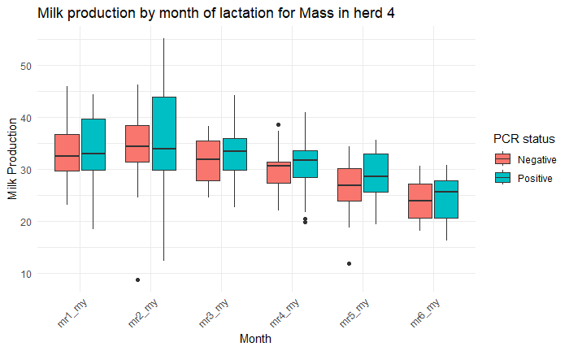
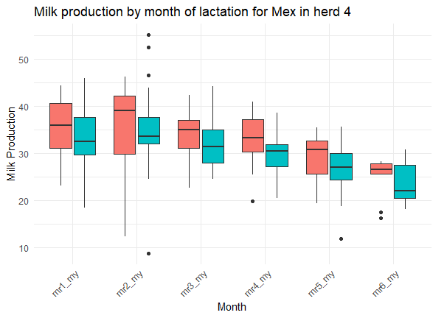
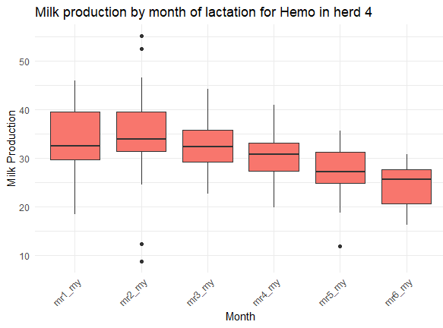
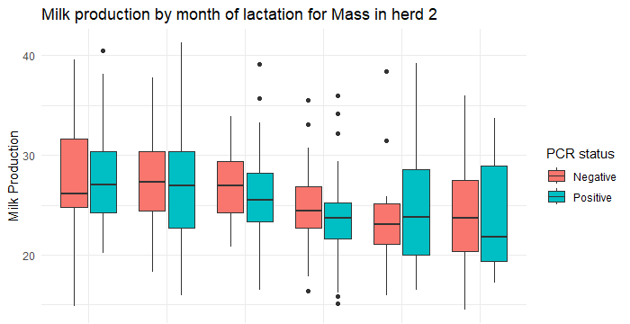
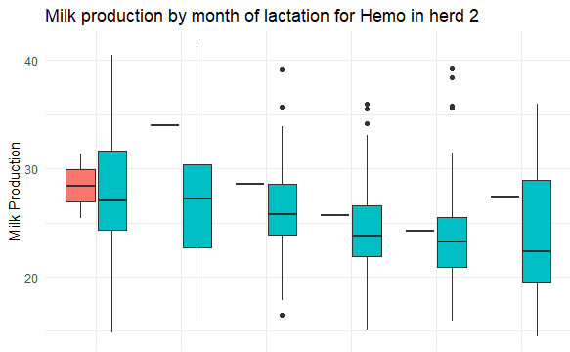
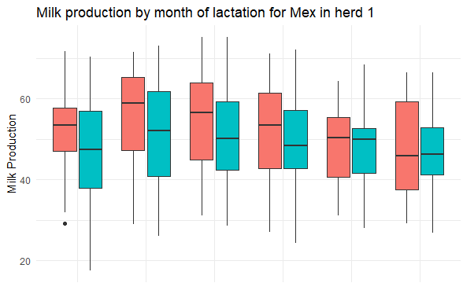
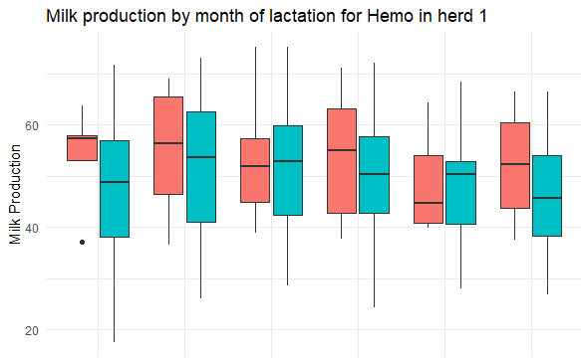
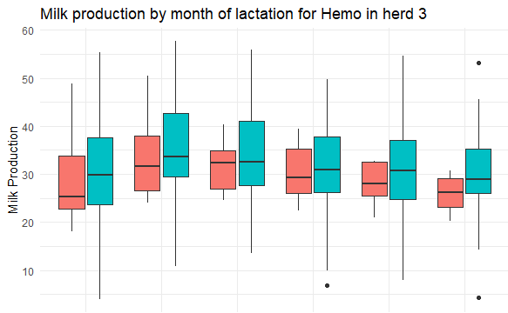
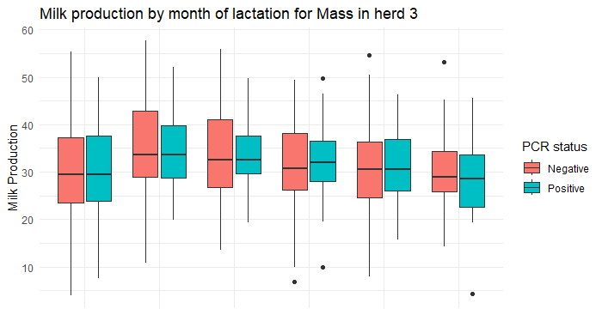
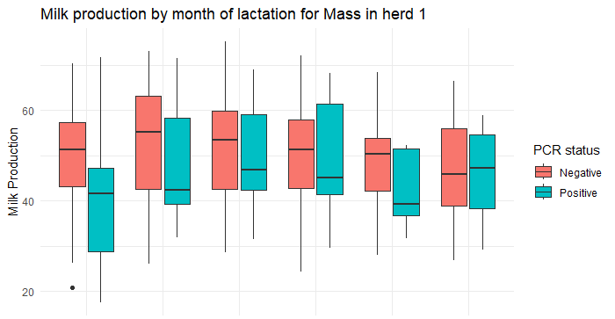
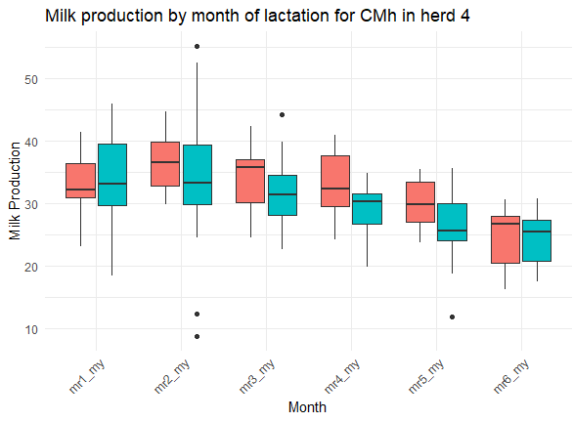
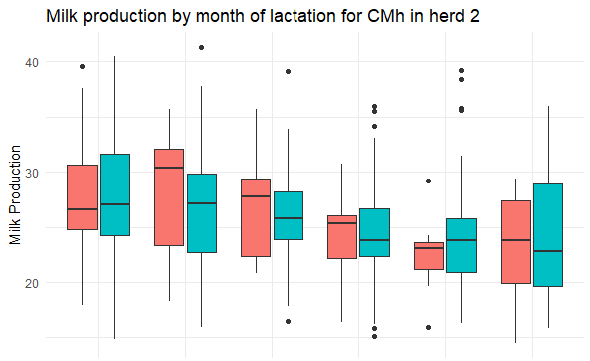
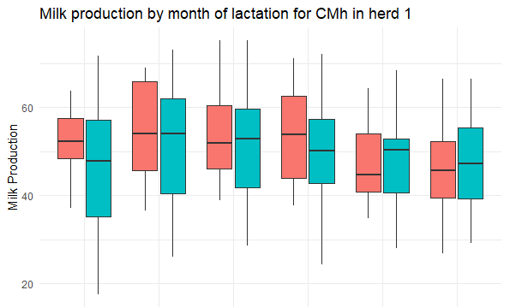
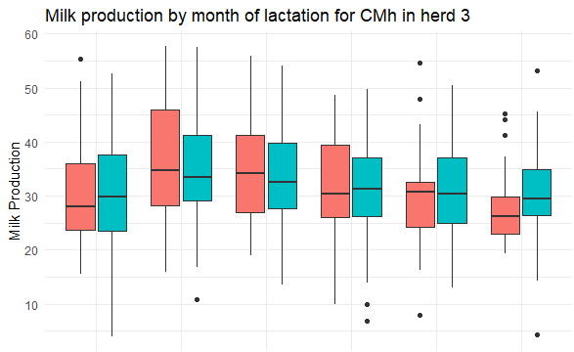
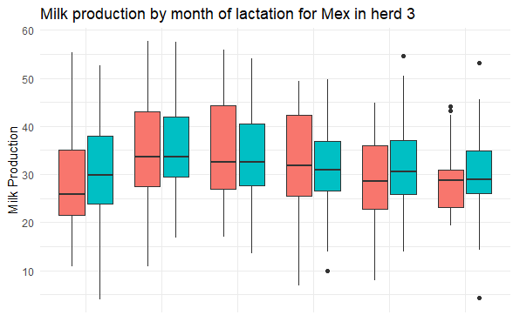
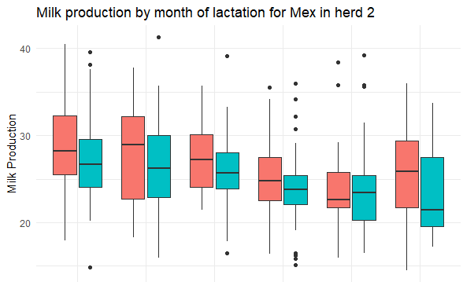
Figure S1: milk yield per cow and per month according according to each PCR status

Herd 4

Herd 3

Herd 2

Herd 1

Herd 5 was not included due to unavailable data during lactation. Milk production is expressed in liter of milk per day. mx: month of lactation number x; my:milk yield. There was no significant difference except for Herd 1 – Hemo – month 6 (t-test, p=0.013).

Table S12: age categories among each herd
Age category | Herd 1 | Herd 2 | Herd 3 | Herd 4 | Herd 5
Of less than 2 years | 46 | 22 | 15 | 18 | 16
Of 2 years | 48 | 31 | 14 | 10 | 7
Of 3 years | 30 | 23 | 8 | 12 | 4
Of 4-5 years | 19 | 35 | 25 | 15 | 14
Of more than 5 years | 8 | 22 | 20 | 12 | 13
Total | 151 | 134 | 82 | 67 | 54

Figure S2: infections by hemoplasma species and strains according to herds and age categories
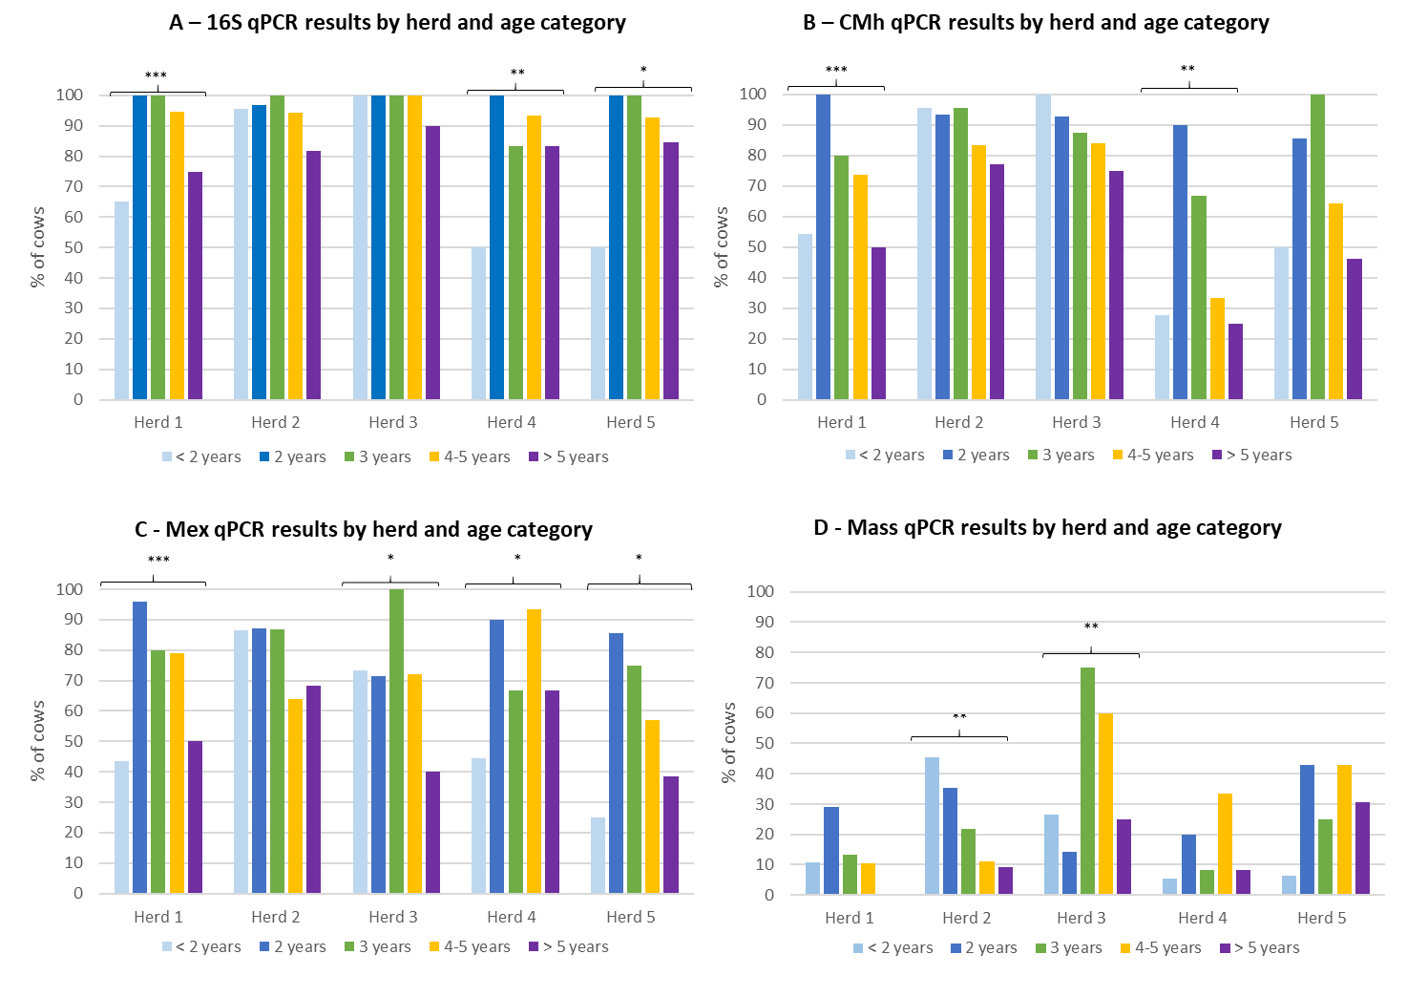
Herd 1: n=151 animals; Herd 2: n=134 animals, Herd 3: n=82 animals; Herd 4: n=67 animals; Herd 5: n=54 animals; statistical significance: *** p<0.001, ** p<0.01, *p<0.05, Fisher exact test; effectives are presented in Table S12

