Supplemental Tables/Figures:

Table of Contents

Tables:
Table E1: Multivariate Model Covariates Variable Definitions and Missingness
Table E2: Strengthening the Reporting of Observational Studies in Epidemiology Checklist (STROBE)

Figures:
Figure E1: Directed Acyclic Graph
Figure E2: Distribution of Cancer Types by CIP Status
Figure E3: NSCLC Only Kaplan Meir Curves
Figure E4: Stratification by P/F ratio of Kaplan Meir Curves

Appendices:
Appendix A: Multidisciplinary Adjudication Criteria

Table E1: Multivariate Model Covariates Variable Definitions and Missingness
Covariate | Study Definition | Missing, n (%)
Included in Multivariate Models
Patient Characteristics
Age, years | At time of hospital admission | 0
Gender | As documented in EHR | 0
Race | Self-reported and documented in EHR. | 0
BMI (weight [lb] and height [m]) | Weight documented closest to time of study ICU admission. If weight from admission data missing, used weight documented closest to time of ICU admission and within 1 year of ICU admission. Height documented closest to time of study ICU admission. If height from admission data missing, used height documented closest to time of ICU admission and within 1 year of ICU admission. | 6 (3)
Elixhauser Comorbidity Index | Weighted Elixhauser Comorbidity Index Predicting In-hospital Mortality ¹. Derived from ICD-10-CM hospital billing codes using the AHRQ HCUP Software. ² | 0
Clinical Factors
Smoking status | Classified as ever or never smoker. | 0
Presence of other immune related adverse event during respiratory failure hospitalization. | Includes all other systems for which immunomodulatory drugs were utilized. | 0
Cancer Type | For multivariable model, classified as lung cancer (including small cell and non-small cell lung cancer) vs. not lung cancer. | 0
Cancer Stage | Cancer stage (I–IV) was abstracted from oncology documentation at or prior to the ARF hospitalization and entered as a categorical variable in multivariable models. | 9 (5)
Cancer Therapeutics
Concurrent chemotherapy | Receipt of systemic cytotoxic chemotherapy administered concurrently with immune checkpoint inhibitor therapy, defined as chemotherapy given during the same treatment period as ICI exposure immediately preceding the ARF event. | 0
Definitive thoracic radiation | Receipt of definitive-intent thoracic radiation therapy prior to the ARF hospitalization, abstracted from oncology treatment records. This variable captured radiation delivered to the chest (e.g., lung, mediastinum). | 0
Tyrosine kinase inhibitor therapy | Exposure to tyrosine kinase inhibitor therapy prior to the ARF event, identified from oncology medication lists and treatment history. | 0
Total ICI duration | Total duration of immune checkpoint inhibitor exposure prior to ARF, defined as the time from first documented ICI administration to onset of acute respiratory failure, measured in days and entered as a continuous variable in sensitivity analyses. | 0
Acute Illness Characteristics
SpO₂/F_{I}O₂ | Defined as the lowest value in the 24 hours after initiation of respiratory support. | 19 (10)

Table E2: Strengthening the Reporting of Observational Studies in Epidemiology Checklist (STROBE)
Study Element | Item No. | Recommendation | Where in Manuscript
Title and Abstract | 1 | - Indicate study in title | Title Page
 |  | - Provide abstract | Abstract
Introduction
Background/rationale | 2 | EXPLAIN SCIENTIFIC RATIONALE | Introduction
Objectives | 3 | States objectives, hypotheses | Intro (last paragraph)
Methods
Study design | 4 | Present key elements of study design early in paper | Methods  (First paragraph)
Setting | 5 | Describe setting, locations, and relevant dates/follow up | Methods
Participants | 6 | - Describe eligibility and follow-up | Methods (Patient Cohort Paragraph 1)
 |  | - For matched studies, give matching criteria | Not applicable
Variables | 7 | Clearly define  outcomes/ exposures/ predictors/confounders.  Give diagnostic criteria if eligible | Methods (Exposures and Outcomes)
Data sources/ measurement | 8 | For each variable of interest, give sources of data and details on methods of assessment. Describe comparability of assessment methods if differed by study group. | Methods (Patient Cohort and Data; Exposures and Outcomes)
Bias | 9 | Describe efforts to address sources of bias | Methods (Exposures and Outcomes; directed acyclic graph in supplement; sensitivity analyses for consistency)
Study size | 10 | Explain how the study size was arrived at | Not predetermined for observational study, but sample construction shown in Flow Diagram (Figure 1)
Quantitative variables | 11 | Explain how quantitative variables were handled in the analysis | Methods
Statistical Methods | 12 | - For each variable of interest, give sources of data and details on methods of assessment. Describe comparability of assessment methods if differed by study group. | Methods
 |  | - Describe any methods used to examine subgroups and interactions | Methods (Statistical Analyses)
 |  | - Explain how missing data were addressed | Methods (Study Design and Patient Cohort)
 |  | - If applicable, explain how loss to follow up was addressed | n/a
 |  | - Describe any sensitivity analyses | Methods (Statistical Analyses)
Results
Participants | 13 | a) Report the numbers of individuals at each stage of the study—eg, numbers potentially eligible, examined for eligibility, confirmed eligible, included in the study, completing follow-up, and analysed b) Give reasons for non-participation at each stage c) Consider use of a flow diagram | Figure 1 Flow Diagram
Descriptive data | 14 | (a) Give characteristics of study participants (eg, demographic, clinical, social) and information on exposures and potential confounders (b) Indicate the number of participants with missing data for each variable of interest (c) Cohort study—summarize follow-up time (eg, average and total amount) | Results, Paragraphs 1-3, Table E1
Outcome data | 15 | Report number of outcome events and summary measure over time | Results, Paragraphs 4-5
Main results | 16 | - Give unadjusted estimates and, if applicable, confounder-adjusted estimates and their precision (eg, 95% confidence interval). Make clear which confounders were adjusted for and why they were included | Results, Paragraphs 4-5, Figure E1
 |  | - Report if continuous variables were broken into categories | None
 |  | - If relevant, consider translating estimates of relative risk into absolute risk for a meaningful time period | None
Other analyses | 17 | Report other analyses done—eg, analyses of subgroups and interactions, and sensitivity analyses | Results, Paragraphs 6-7
Discussion
Key Results | 18 | Summarize key results with reference to study objectives | Discussion (First Paragraph)
Limitations | 19 | Discuss limitations of the study, taking into account sources of potential bias or imprecision. Discuss both direction and magnitude of any potential bias | Discussion (Second to Last Paragraph)
Interpretation | 20 | Give a cautious overall interpretation of results considering objectives, limitations, multiplicity of analyses, results from similar studies, and other relevant evidence | Discussion
Generalizability | 21 | Discuss the generalizability (external validity) of the study results | Discussion (Last Paragraph)
Funding | 22 | Give the source of funding and the role of the funders for the present study and, if applicable, for the original study on which the present article is based | N/A

Figure E1: Directed Acyclic Graph
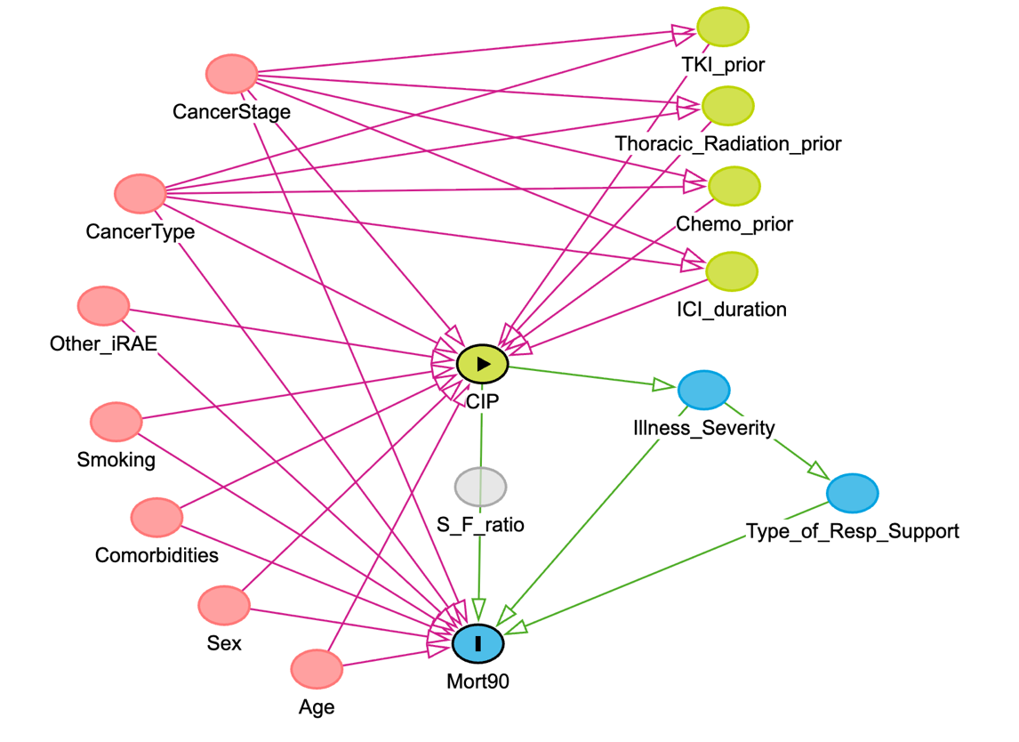
Nodes represent patient characteristics, cancer- and treatment-related factors, illness severity, and outcomes. Pink nodes denote baseline confounders (age, sex, comorbidities, smoking history, cancer type, cancer stage, and other immune-related adverse events). Green nodes represent prior cancer therapies and ICI exposure characteristics (prior chemotherapy, thoracic radiation, tyrosine kinase inhibitor use, and ICI duration). Blue nodes represent downstream markers of acute illness severity and respiratory support during acute respiratory failure. The yellow node represents the exposure of interest (CIP), and the blue outcome node represents 90-day mortality. Arrows indicate assumed directional causal relationships. Illness severity, type of respiratory support, and S/F ratio are conceptualized as mediators rather than confounders and were not adjusted for in the primary causal model.

Figure E2: Distribution of Cancer Types by CIP Status
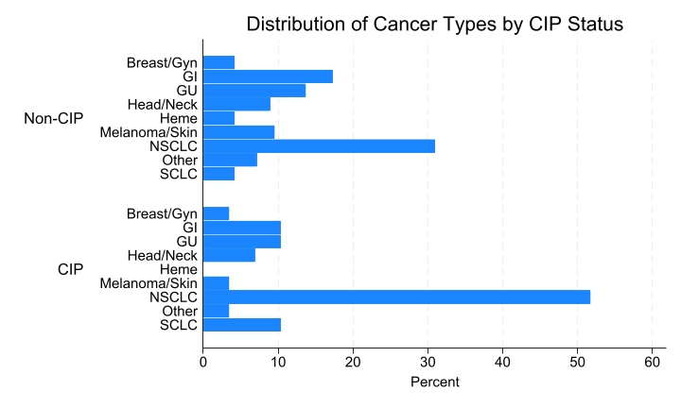
Bar chart showing the percentage distribution of cancer types among patients with CIP and those without CIP. Cancer categories include non–small cell lung cancer (NSCLC), small cell lung cancer (SCLC), melanoma/skin, genitourinary, gastrointestinal, breast/gynecologic, head and neck, hematologic malignancies, and other cancers. Patients with CIP were more likely to have lung cancer, particularly NSCLC, compared with patients without CIP.

Figure E3: 90-day Survival, Restricted to NSCLC Patients (n=67) 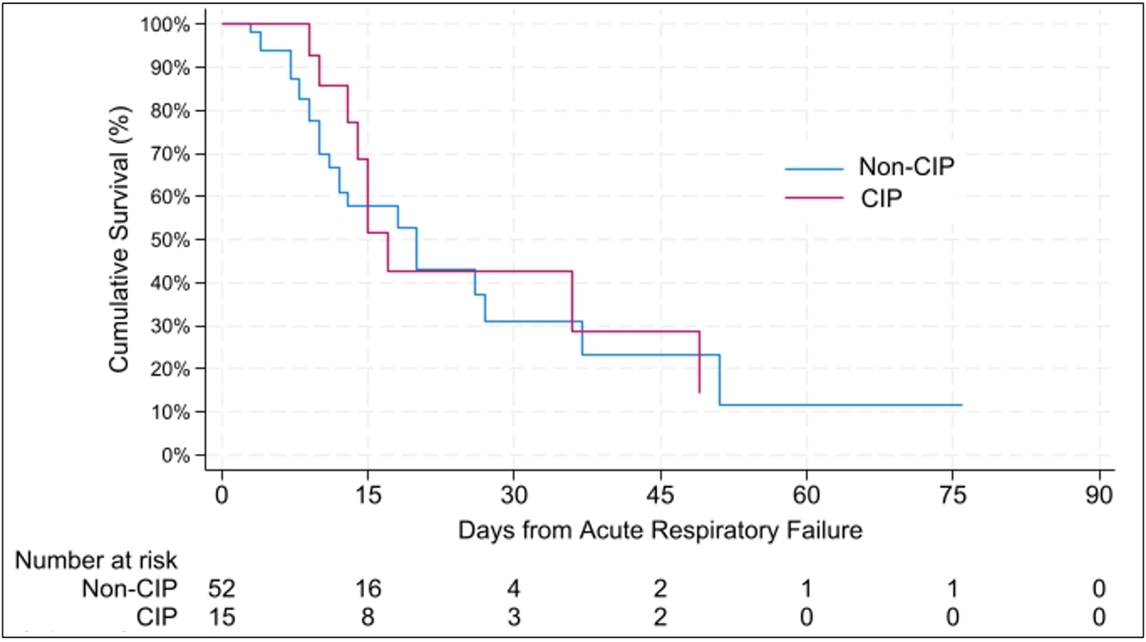
Kaplan–Meier survival curves depicting 90-day survival from the onset of acute respiratory failure among patients with NSCLC, stratified by the presence or absence of CIP. Numbers at risk are shown below the plot. Curves are unadjusted and presented to illustrate survival patterns within a homogeneous cancer subtype. Total sample size was 67 patients.

Figure E4: 90-day Mortality by CIP status, stratified by S/F ratio cut-off 148 (n= 178)
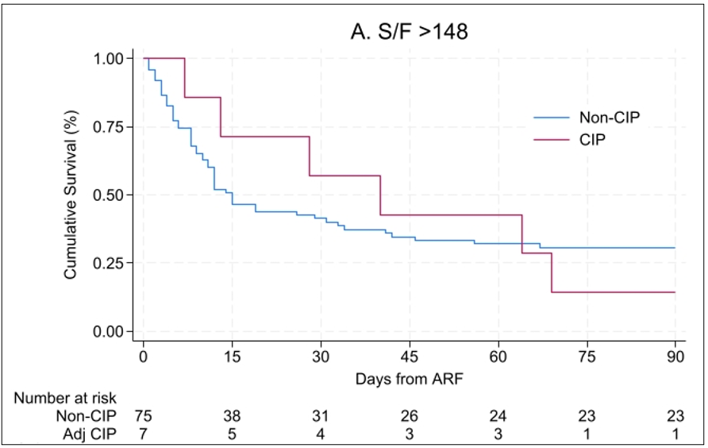
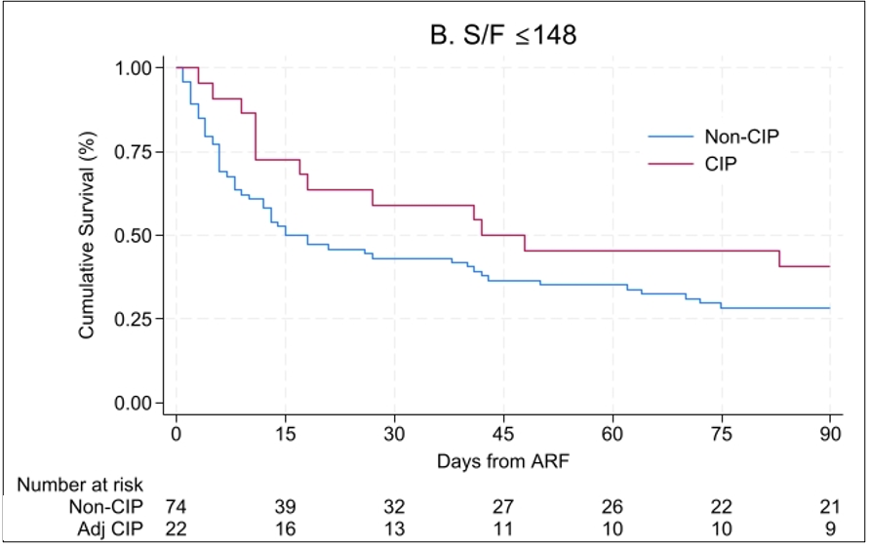
Kaplan-Meier survival curves depicting 90-day survival from the onset of acute respiratory failure among patients with and without CIP, stratified by baseline oxygenation severity using the SpO₂/FiO₂ (S/F) ratio. Panel A includes patients with S/F ratio >148, and Panel B includes patients with S/F ratio ≤148. Numbers at risk are shown below each panel. Curves are unadjusted and intended to illustrate effect modification by baseline oxygenation severity. Total sample size across strata was 178 patients.

Appendix A: Criteria for Multidisciplinary CIP Adjudication

Checkpoint Inhibitor Pneumonitis Multi-Disciplinary Adjudication
 | Criteria
Clinical Features | - Presence of symptoms: dyspnea, cough, desaturation with exertion  - Onset: typically weeks to months after ICI initiation
Radiologic Findings | New infiltrates with specific radiologic patterns:  - Ground-glass opacities  - Patchy consolidations  - Organizing pneumonia pattern  - Interstitial or nodular changes
Microbiologic Workup | Exclude infections:  - Nasal swab (viral pathogens)  - Blood and sputum cultures  - Bronchoscopy with bronchoalveolar lavage (BAL) if available to exclude bacterial, fungal, and viral infections
Tumor-Related Considerations | Differentiate CIP from disease progression:  - Evaluate for new or worsening lesions  - Integrate biopsy and histopathology if available  - Integrate imaging and clinical course
Consideration and Careful Exclusion of Other Etiologies | Maintain comprehensive differential diagnosis:  - Infection (see above)  - Direct tumor related complications (see above)  - Other treatment related complications (radiation, chemo induced lung injury)  - Exacerbation of underlying lung disease (obstructive, interstitial)  - Other immune related adverse events (myocarditis, myasthenia, sarcoid)  - Vascular events (pulmonary embolism)  - Cardiac causes (heart failure, ischemia)
ASCO, NCCN, SITC, ESMO Guidelines³⁻⁵

Supplementary References
1. Moore BJ, White S, Washington R, Coenen N, Elixhauser A. Identifying Increased Risk of Readmission and In-hospital Mortality Using Hospital Administrative Data: The AHRQ Elixhauser Comorbidity Index. Med Care. 2017;55(7):698-705.
2. Elixhauser Comorbidity Software Refined for ICD-10-CM. https://hcup-us.ahrq.gov/toolssoftware/comorbidityicd10/comorbidity_icd10.jsp.
3. Network NCC. Management of Immunotherapy Related Toxicities 2024(Version 2.2024).
4. Haanen J, Obeid M, Spain L, et al. Management of toxicities from immunotherapy: ESMO Clinical Practice Guideline for diagnosis, treatment and follow-up<sup>&#x2606;</sup>. Annals of Oncology. 2022;33(12):1217-1238.
5. Brahmer JR, Abu-Sbeih H, Ascierto PA, et al. Society for Immunotherapy of Cancer (SITC) clinical practice guideline on immune checkpoint inhibitor-related adverse events. Journal for ImmunoTherapy of Cancer. 2021;9(6):e002435.

