SUPPLEMENTARY

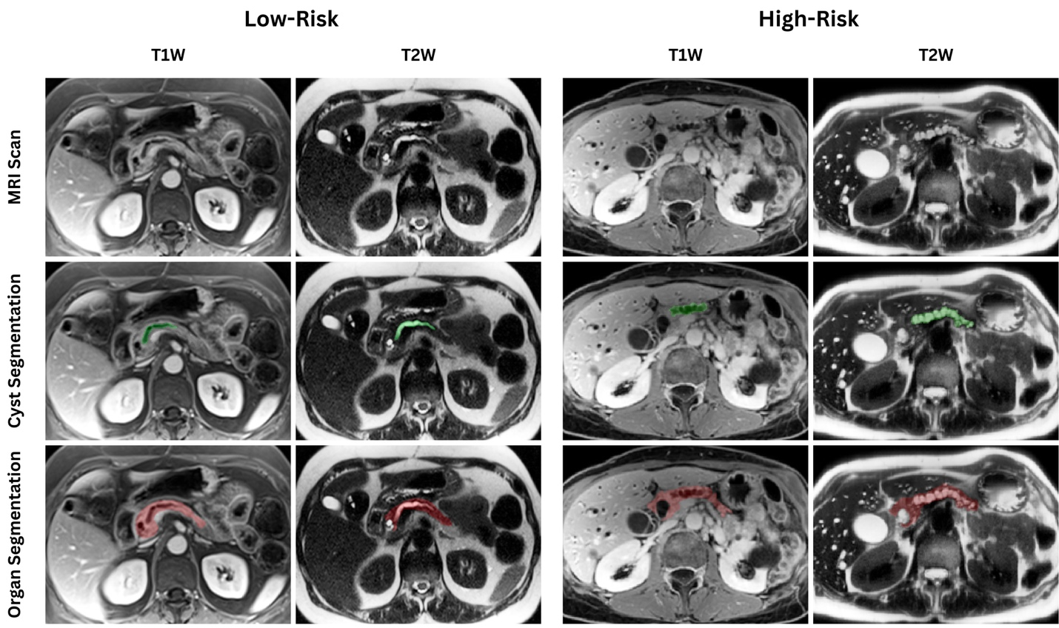
Fig. S1. Representative cases that illustrate manual pancreas segmentation and cyst segmentation from our cohort.

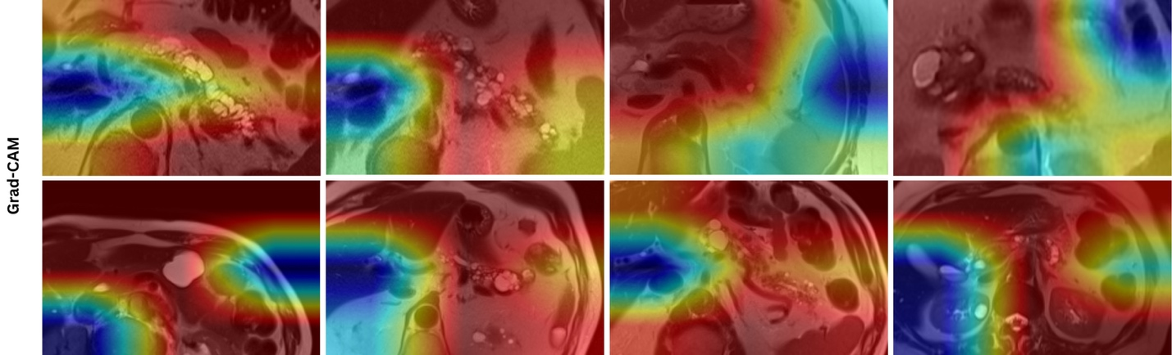
Fig. S2. Representative Grad-CAM heatmap overlays from the deep learning model applied to IPMN cases in our cohort. The color scale reflects the relative contribution of each image region to the model’s classification decision, with warm colors (red–yellow) indicating regions with high activation that strongly influence the prediction, and cool colors (blue) indicating areas with minimal contribution.

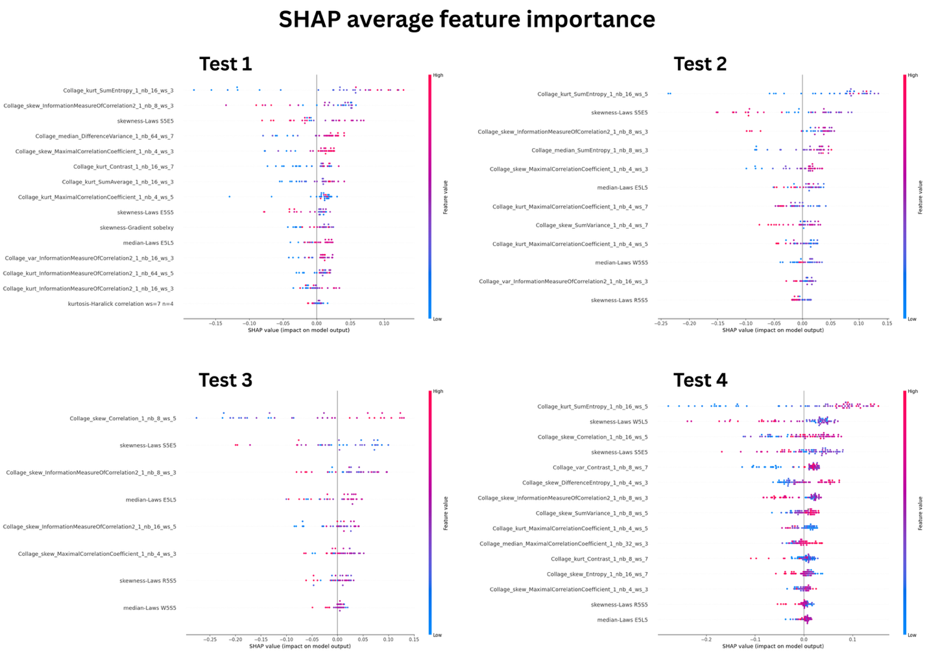
Fig. S3. SHAP summary plots illustrating feature-level contributions across independent test groups. Each point represents the SHAP value of a feature for an individual sample, with features ranked by overall importance. The x-axis indicates the SHAP value, reflecting the contribution of each feature to the model prediction. Positive values indicate contributions toward higher-risk predictions, whereas negative values indicate contributions toward lower-risk predictions. Colors represent the relative feature value (high to low), illustrating how feature magnitude influences the direction and strength of the contribution.
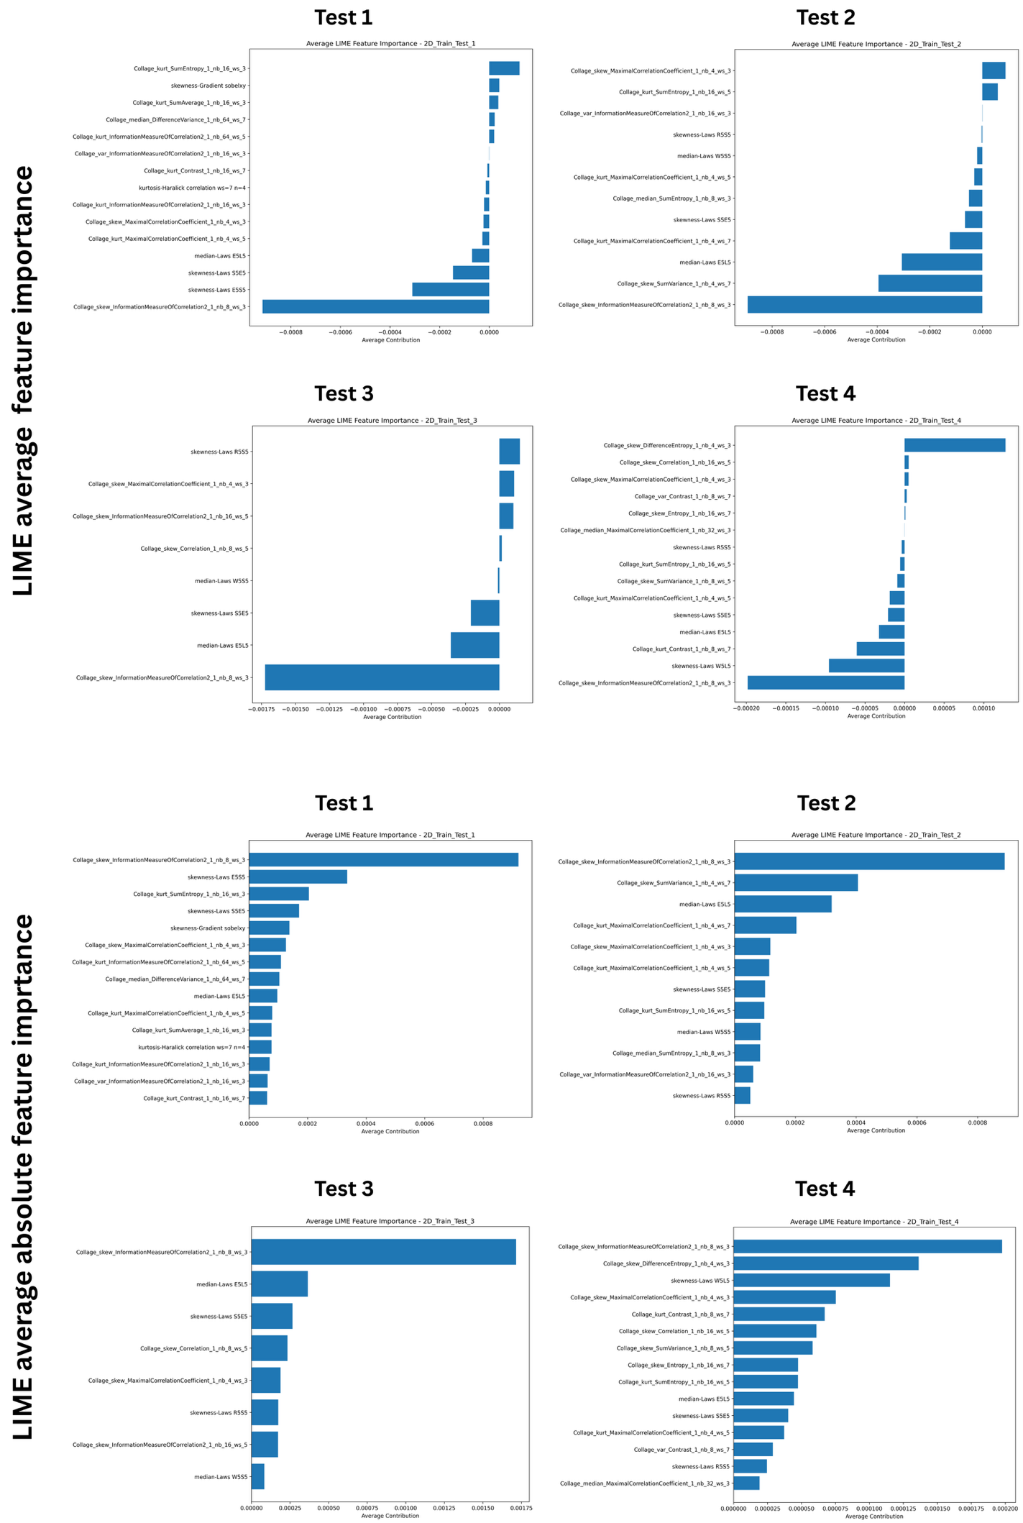
Fig. S4. LIME-based feature importance across independent test groups using signed and absolute aggregation. Top panels show the average signed LIME feature importance, capturing the average directional contribution of each feature to model predictions. Bottom panels show the average absolute LIME importance, reflecting the magnitude of feature influence regardless of direction. Features are ranked by their average contribution across samples within each test group (Test 1–4).

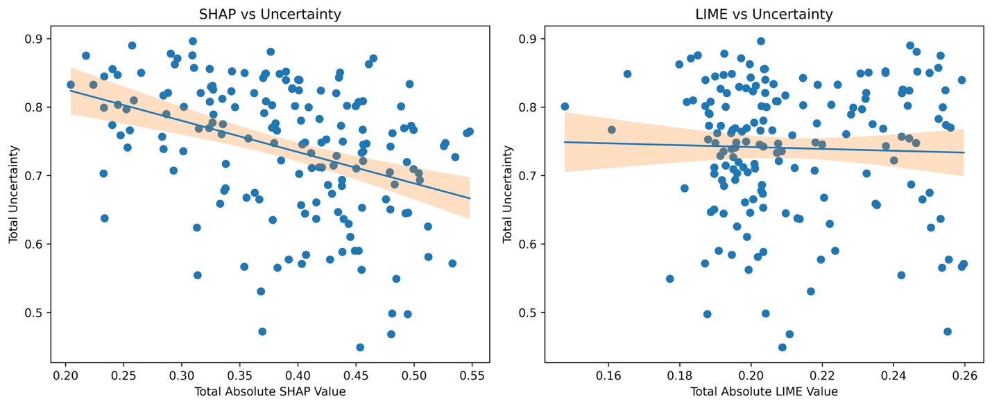Fig. S5. Relationship between explanation magnitude and prediction uncertainty. Scatter plots illustrate the association between total explanation magnitude and prediction uncertainty. (Left) Total absolute SHAP value versus prediction uncertainty. (Right) Total absolute LIME value versus prediction uncertainty. Each point represents an individual case, and shaded regions indicate 95% confidence intervals from linear regression.

