Supplementary Appendix
Supplement to Bell R, O’Brien LM and Eunice Yuen E et al. Population Pharmacokinetic Analysis of Pirtobrutinib, a reversible BTK inhibitor, in Patients with Hematological Malignancies from the Phase 1/2 BRUIN Study

Contents
Supplemental Figures 3
Figure S1. Impact of Various Factors on Pirtobrutinib Clearance 3

Supplemental Figures

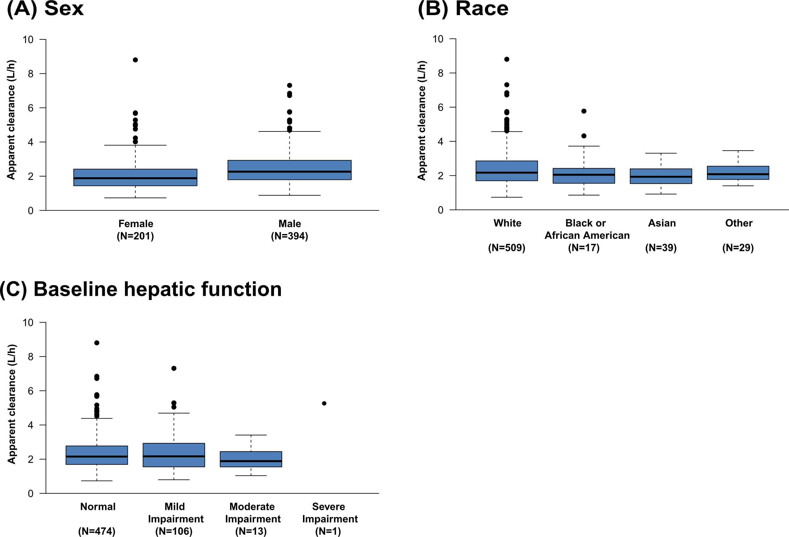

Figure S1. Impact of Various Factors on Pirtobrutinib Clearance. Box plots of apparent clearance (L/h) stratified by (A) sex, (B) race, (C) baseline hepatic function. NOTE: Box plots depict the 25th, 50th, and 75th percentiles. Whiskers represent 1.5 times the interquartile range.
Other races include Native Hawaiian or other Pacific Islander (n=2), American Indian or Alaska Native (n=3), and Mixed race or multiple races (n=24). Hepatic function was categorized as Normal (TBI ≤ ULN and AST ≤ ULN), Mild (TBI ≤ 1.5 • ULN and AST > ULN or ULN < TBI ≤ 1.5 • ULN), Moderate (1.5 • ULN < TBI ≤ 3 • ULN), and Severe (TBI > 3 • ULN). Race and hepatic function classification data missing for 1 patient each.
Abbreviations: AST = aspartate transaminase; eGFR, estimated glomerular filtration rate; PK, pharmacokinetic; QD, once daily; TBI, total bilirubin; ULN, upper limit of normal.

