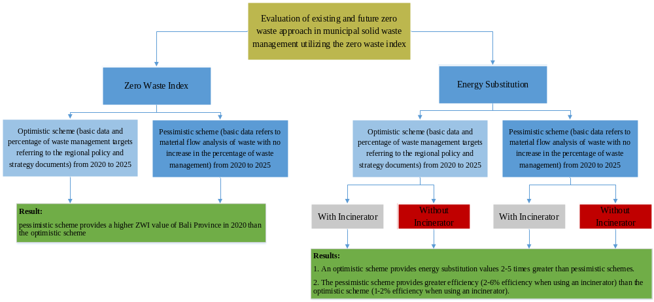
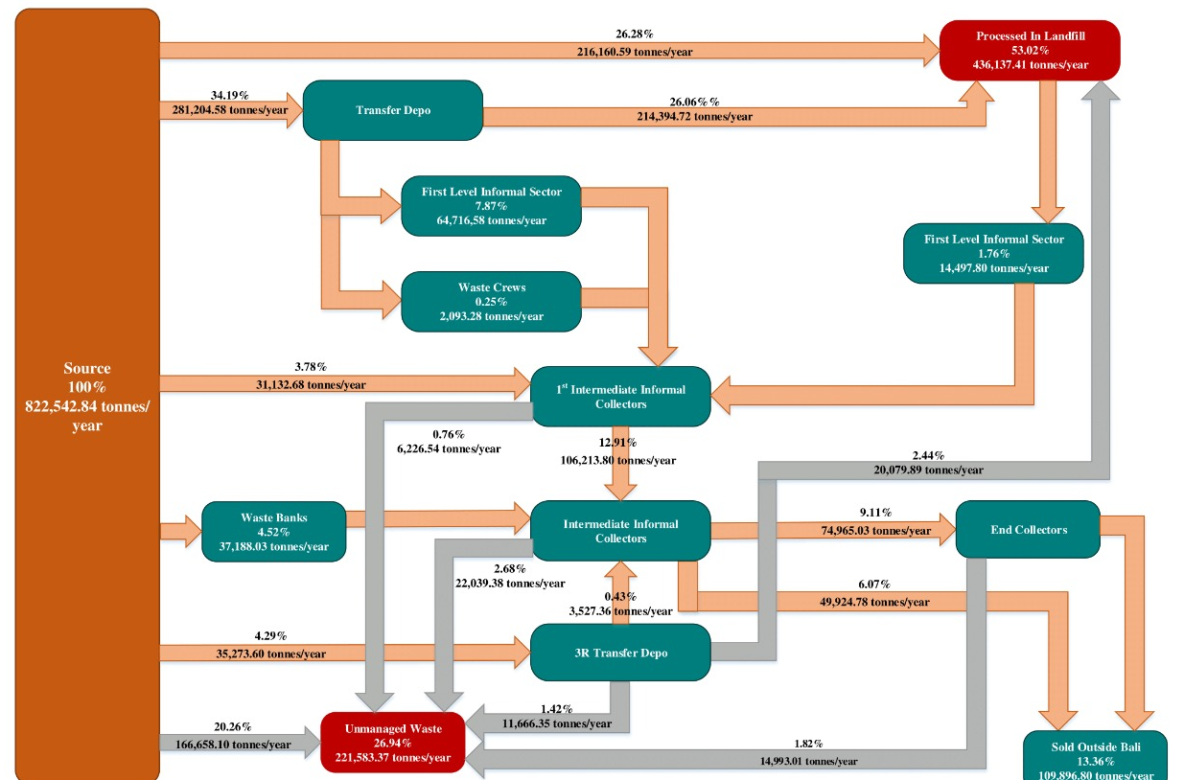
Fig 1. Material flow analysis of Bali Province in 2020

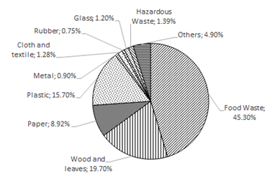
Fig 2. Average waste percentage composition in landfills
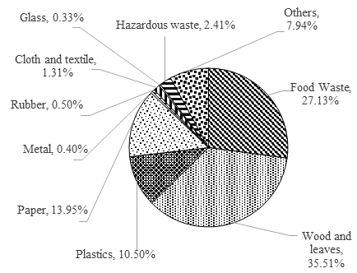
Fig 3. Average waste percentage composition at the source
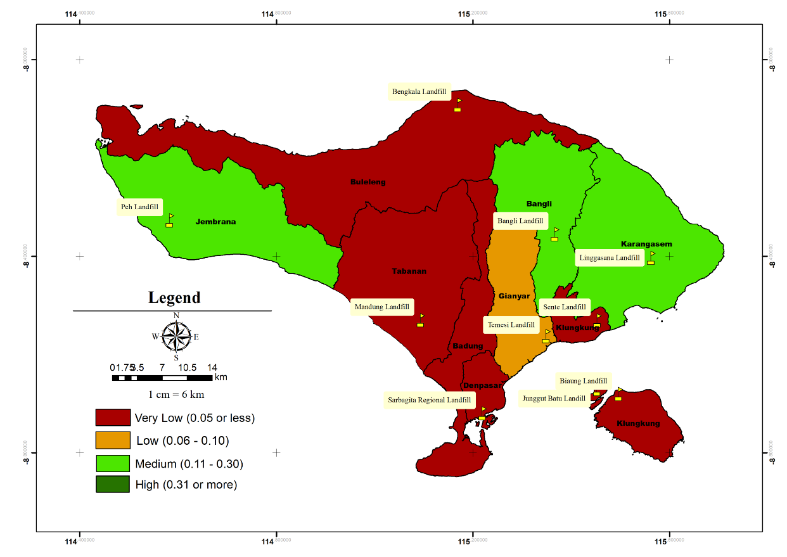

Fig 4. Zero Waste Index of Regencies/Cities in Bali Province by 2020 on Pessimistic Scheme
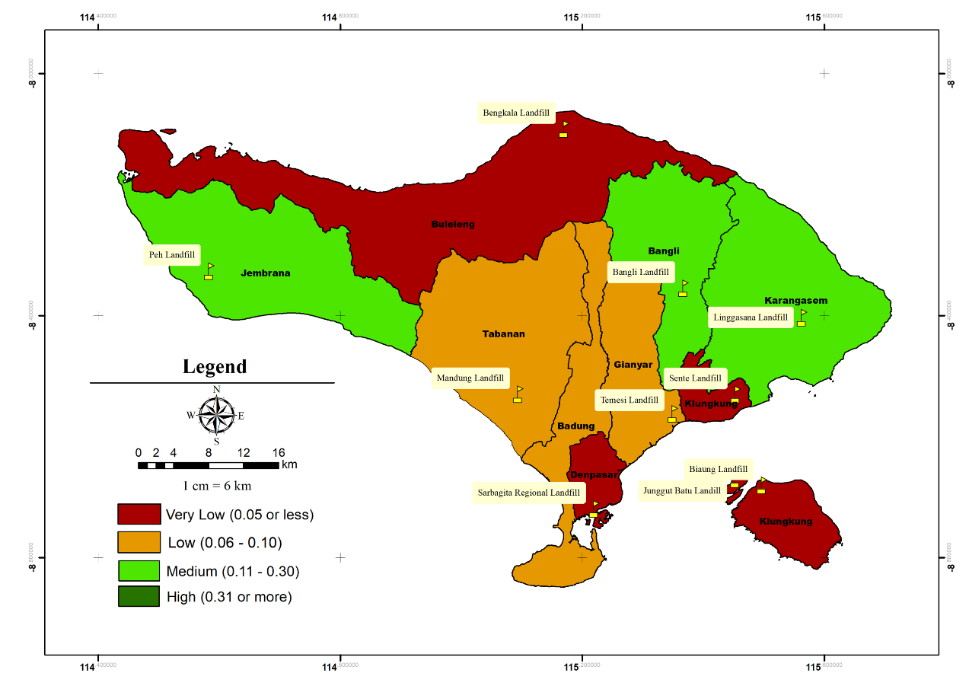
Fig 5. Prediction of Zero Waste Index of Regencies/Cities in Bali Province by 2025 on Pessimistic Scheme

Fig 6. Time series of ZWI from each regency/city of Bali Province
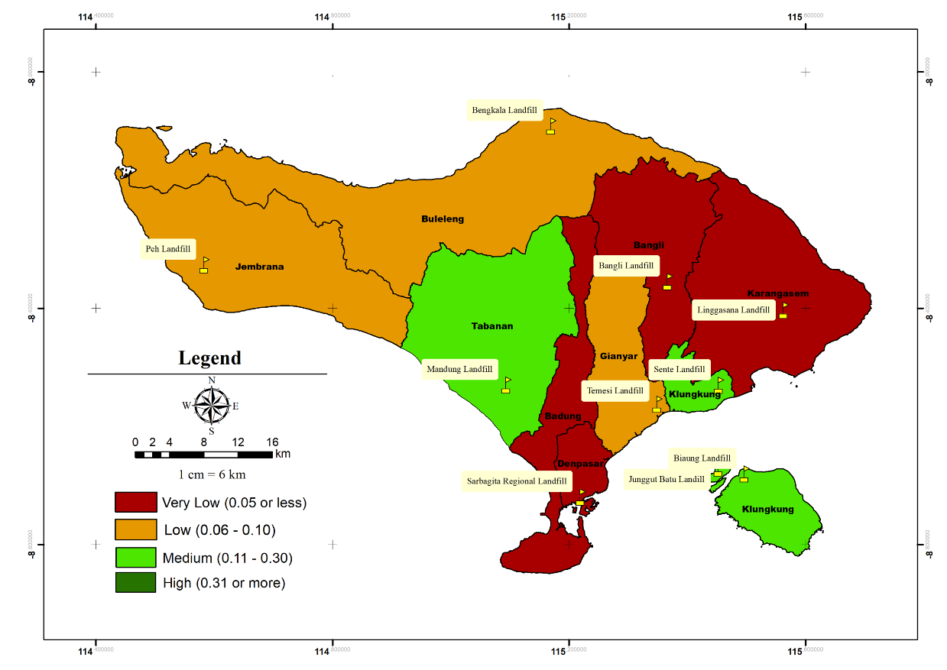
Fig 7. Zero Waste Index of Regencies/Cities in Bali Province by 2020 on Optimistic Scheme
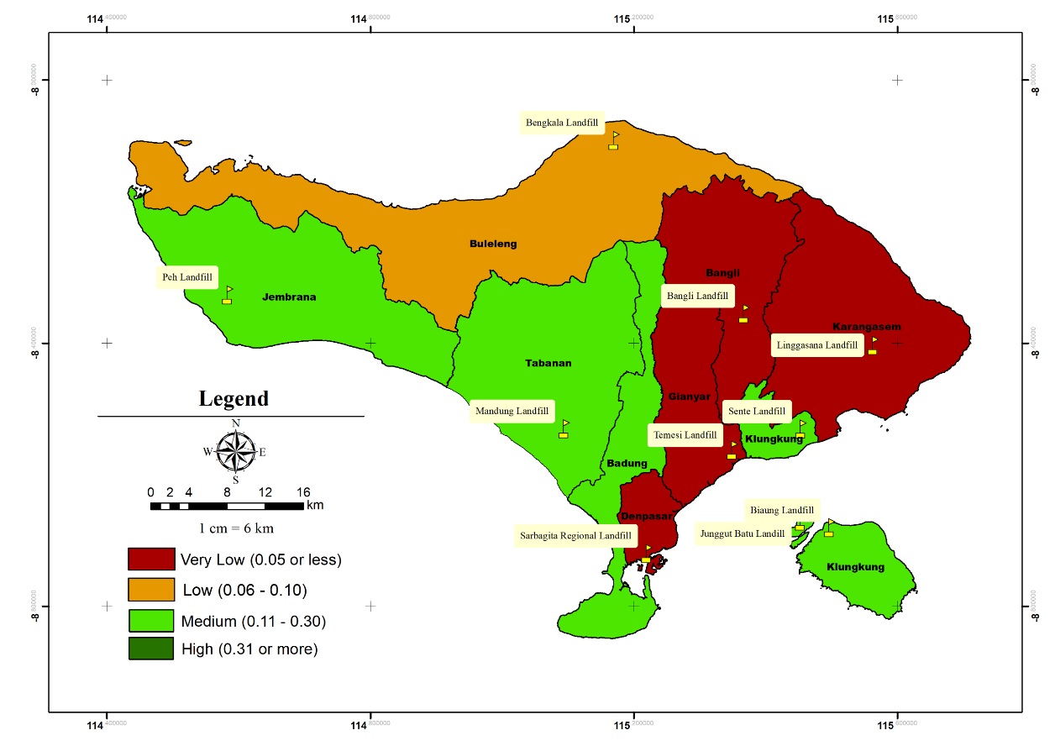
Fig 8. Prediction of Zero Waste Index of Regencies/Cities in Bali Province by 2025 on Optimistic Scheme
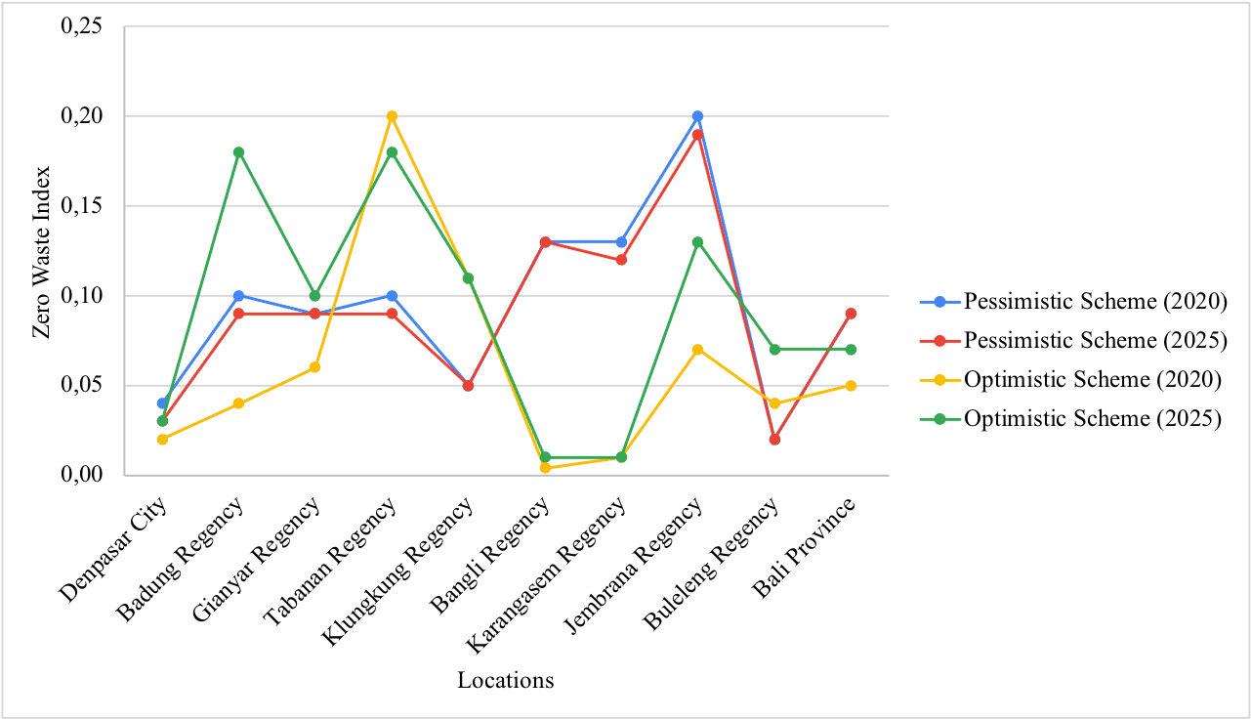
Figure 9. ZWI Comparison between two schemes

