Appendix Table

Appendix 1. SPIRIT checklist 2
Appendix 2. Written consent 6
Appendix 3. Questionnaires 7
Appendix 4. Physical fitness tests 12
Appendix 5. Module-related activities 14
Appendix 6. Set of articles 15
Appendix 7. Visual analogue scales 18
Appendix 8. Stress, sleep, and physical activity diaries 19
Appendix 9. Lists of advice 22
Appendix 10. Pedagogical content examples 23
Appendix 11. Cardiac coherence exercises 29
Appendix 12. Exercises to improve specific aspects of physical fitness 30
Appendix 13. Assessment of student satisfaction with modules 31
Appendix 14. Ethical approval 32
Appendix 15. Funding 34
References 39

Appendix 1. SPIRIT checklist
Section / Topic | Item No. | SPIRIT 2025 item description | Reported on page number - Section
Administrative information
Title and structured summary | 1a | Title stating trial design, population, interventions, identified as protocol | p.1 – Title
Title and structured summary | 1b | Structured summary including WHO Trial Registration Data Set | p.2 – Abstract
Protocol version | 2 | Protocol version and date | p.6 – Methods / Design and settings
Roles and responsibilities | 3a | Names, affiliations, and roles of protocol contributors | p.1 – Author list; p.32 – Declarations / Author contributions
Roles and responsibilities | 3b | Name and contact information for the trial sponsor | p.31 – Declarations / Funding
Roles and responsibilities | 3c | Role of sponsor and funders | p.31 – Declarations / Funding
Roles and responsibilities | 3d | Committees and oversight groups | p.7 – Methods / Ethics statement; p.31 – Declarations / Ethics approval
Open science
Trial registration | 4 | Trial registration (registry, ID, URL, date) | p.2 – Abstract; p.6 – Methods / Design and settings
Protocol and statistical analysis plan | 5 | Access to protocol and statistical analysis plan | p.28 – Methods / Dissemination and open science strategies
Data sharing | 6 | Data sharing (IPD, code, materials) | p.28 – Methods / Dissemination and open science strategies; p.31 – Declarations / Availability of data
Funding and conflicts of interest | 7a | Sources of funding | p.31 – Declarations / Funding
Funding and conflicts of interest | 7b | Conflicts of interest | p.31 – Declarations / Competing interests
Dissemination policy | 8 | Plans to communicate trial results | p.2 – Abstract / Methods; p.28 – Methods / Dissemination strategies
Introduction
Background and rationale | 9a | Scientific background and rationale | p.4 – Background
Background and rationale | 9b | Explanation for choice of comparator | p.4 – Background; p.7 – Methods / Participants; p23 – Methods / Control
Objectives | 10 | Specific objectives related to benefits and harms | p.4 – Background; p7 – Methods / Ethics statement
Methods: Patient and public involvement, trial design
Patient and public involvement | 11 | Patient and public involvement | p.6 – Methods / Design and settings
Trial design | 12 | Trial design (type, allocation ratio, framework) | p.6 – Methods
Methods: Participants, interventions, outcomes
Trial setting | 13 | Trial setting | p.6 – Methods
Eligibility criteria | 14a | Eligibility criteria for participants | p.7 – Methods / Participants
Eligibility criteria | 14b | Eligibility criteria for sites and intervention providers | p.16 – Methods / Expert training
Intervention and comparator | 15a | Intervention and comparator description | p.15 – Methods / Intervention;  p.23 – Methods / Control
Intervention and comparator | 15b | Criteria for modifying/discontinuing intervention | p.7 – Ethics statement
Intervention and comparator | 15c | Strategies to improve adherence | p.17 – Methods / Self-monitoring tools and personalized feedback
Intervention and comparator | 15d | Concomitant care | p.7 – Methods / Participants
Outcomes | 16 | Primary and secondary outcomes (metrics, time points) | p.25 – Methods / Outcomes; Figure 4
Harms | 17 | Harms definition and assessment | p.7 – Methods / Ethics statement
Participant timeline | 18 | Time schedule of enrollment, interventions (including any run-ins and washouts), assessments, and visits for participants. | p.8 – Methods / Data collection; Figures 2 & 3
Sample size | 19 | Sample size calculation | p.24 – Methods / Sample size
Recruitment | 20 | Recruitment strategies | p.7 – Methods / Participants
Methods: Assignment of interventions
Sequence generation | 21a | Sequence generation | p.7 – Methods / Participants
Sequence generation | 21b | Type of randomisation and stratification | p.7 – Methods / Participants
Allocation concealment mechanism | 22 | Allocation concealment mechanism | p.7 – Methods / Participants
Implementation | 23 | Implementation (access to allocation sequence) | p.7 – Methods / Participants
Blinding | 24a | Blinding | p.7 – Methods / Participants
Blinding | 24b | Blinding procedure | p.7 – Methods / Participants
Blinding | 24c | Unblinding | p.7 – Methods / Participants
Methods: Data collection, management, analysis
Data collection methods | 25a | Data collection methods and instruments | p.8 – Methods / Data collection
Data collection methods | 25b | Participant retention and follow-up | p.8 – Methods / Data collection
Data management | 26 | Plans for data entry, coding, security, and storage | p.23 – Methods / Data management
Statistical methods | 27a | Statistical methods | p.24 – Methods / Statistical analysis
Statistical methods | 27b | Analysis population | p.24 – Methods / Statistical analysis
Statistical methods | 27c | Missing data handling | p.24 – Methods / Statistical analysis
Statistical methods | 27d | Additional analyses | p.27 – Methods / Statistical analysis
Methods: Monitoring
Data monitoring committee | 28a | Data monitoring committee | p.24 – Methods / Statistical analysis
Data monitoring committee | 28b | Interim analyses and stopping rules | p.7 – Methods / Ethics statement
Trail monitoring | 29 | Frequency and procedures for monitoring trial conduct | p.7 – Methods / Ethics statement
Ethics
Research ethics approval | 30 | Research ethics approval | p.31 – Declarations / Ethics approval and consent to participate
Protocol amendments | 31 | Protocol amendments | p.31 – Declarations / Ethics approval and consent to participate
Consent or assent | 32a | Informed consent | p.7 – Methods / Ethics statement
Consent or assent | 32b | Additional consent for ancillary studies | p.7 – Methods / Ethics statement
Confidentiality | 33 | How personal information about potential and enrolled participants will be collected, shared, and maintained in order to protect confidentiality before, during, and after the trial | p.7 – Methods / Ethics statement; p.23 – Methods / Data management
Ancillary and post-trial care | 34 | Provisions, if any, for ancillary and post-trial care, and for compensation to those who suffer harm from trial participation | p.31 – Declarations / Ethics approval and consent to participate

 | Enrollment | To | T1 |  |  |  |  |  | T2 | T3
 | Enrollment | Pre  intervention | S1 | S2 | S3 | S4 | S5 | S6 | Post  intervention | Post  intervention
Enrollment | X
Eligility criteria | X
Informed consent | X
Intervention
Sessions |  |  | X | X | X | X | X | X
Assessment
Basal variables
Demographic survey |  | X
Primary outcome
WHOQoL-BREF |  | X |  |  |  |  |  |  | X | X
Secondary and explaratory outcomes
GASE, ESUL, KPDS, ASSIST-lite |  | X |  |  |  |  |  |  | X | X
Accelerometery, BMI |  | X |  |  |  |  |  |  | X
PSS, BCI |  | X | X | X | X |  |  |  | X | X
BFI, SRRS |  | X |  |  |  |  |  |  | X | X
Cardiac activity |  | X | X | X | X | X | X | X | X
Stress VASs |  |  | X | X | X
PSQI, MFI |  | X |  |  | X | X | X |  | X | X
ESS, CSM |  | X |  |  |  |  |  |  | X | X
Sleep VASs |  |  |  |  | X | X | X
ONAPS-PAQ, RAPA |  | X |  |  |  | X | X | X | X | X
Physical fitness |  | X |  |  |  |  |  |  | X
Physical activity VASs |  |  |  |  |  | X | X | X
Module satisfaction VASs |  |  |  |  | X |  | X | X
ASSIST : Alcohol, Smoking and Substance Involvement Screening Test
BCI : Brief Cope Inventory
BFI : Big Five Inventory
BMI : Body Mass Index
CSM : Composite Scale of Morningness
ESS : Epworth Sleepiness Scale
ESUL : Échelle de Solitude de l’Université Laval
GASE : General Academic Self-Efficacy
KPDS : Kessler Psychological Distress Scale
MFI : Multidimensional Fatigue Inventory
ONAPS : Observatoire National de l’Activité Physique et de la Sédentarité
PAQ : Physical Activity Questionnaire
PSQI : Pittsburgh Sleep Quality Index
PSS : Perceived Stress Scale
RAPA : Physical Activity Questionnaire
SRRS : Social Readjustment Rating Scale
VAS : Visual Analog Scale
WHOQOL-BREF : Brief version of the World Health Organization Quality of Life questionnaire

Appendix 2. Written consent


FORMULAIRE DE CONSENTEMENT
POUR PARTICIPATION À UNE RECHERCHE

TITRE DE LA RECHERCHE : Intérêt d’une intervention groupale et multimodale (Preventive Remediation for OptiMal Students PROMESS-Group : remédiation du stress, amélioration du sommeil et promotion de l’activité physique) sur la qualité de vie des étudiants en santé: étude interventionnelle randomisée contrôlée monocentrique.
-------------------------------------------------------------------------------------------------------------------------------------------------------------------
Je soussigné.e ………………………………………………………… (nom et prénom du sujet), accepte de participer à l’étude PROMESS-Group Preventive Remediation for OptiMal Students : remédiation du stress, amélioration du sommeil et promotion de l’activité physique) – Intérêt d’une intervention groupale et multimodale sur la qualité de vie des étudiants en santé : étude interventionnelle randomisée contrôlée monocentrique.
Les objectifs et modalités de l’étude m’ont été clairement expliqués par le Dr Sophie SCHLATTER et/ou par la note d’information. J’ai lu et compris la fiche d’information qui m’a été remise.
À l’exception des responsables de l’étude, qui traiteront les informations dans le plus strict respect du secret médical, mon anonymat sera préservé.
J’accepte que les données nominatives me concernant recueillies à l’occasion de cette étude puissent faire l’objet d’un traitement automatisé par les organisateurs de la recherche. Je pourrai exercer mon droit d’accès et de rectification auprès du Dr Sophie SCHLATTER.
J’ai bien compris que ma participation à l’étude est volontaire.
Je suis libre d’accepter ou de refuser de participer, et je suis libre d’arrêter à tout moment ma participation en cours d’étude. Dans ce dernier cas, je contacte la responsable de l’étude, le Dr Sophie SCHLATTER, tél : +33 7 68 21 05 51, sophie.schlatter@univ-lyon1.fr.
Mon consentement ne décharge pas les organisateurs de cette étude de leurs responsabilités. Je conserve tous mes droits garantis par la loi.
Après en avoir éventuellement discuté et avoir obtenu la réponse à toutes mes questions, j’accepte librement et volontairement de participer à la recherche qui m’est proposée.
Je m’engage à suivre l’ensemble des séances avec assiduité.
Nom et signature de l’investigateur Nom et signature du sujet
SOPHIE SCHLATTER Fait à ………………… le …./.…/…..….

Appendix 3. Questionnaires
Domain  Questionnaire  Item | Questionnaire source | Dimension | Min-max  -  Thresholds | Interpretation | English validation  Internal consistency (Cronbach’s α) |  | French validation  Internal consistency (Cronbach’s α)
Quality of life  WHOQOL-BREF questionnaire  26 items | Development of the World Health Organization WHOQOL-BREF quality of life assessment. The WHOQOL Group. Psychol Med. mai 1998;28(3):551‑8 | Physical health | 0–100 | A higher score indicates better perceived physical health. | Development of the World Health Organization WHOQOL-BREF quality of life assessment. The WHOQOL Group. Psychol Med. mai 1998;28(3):551‑8 | 0.80 | Baumann C, Erpelding ML, Régat S, Collin JF, Briançon S. The WHOQOL-BREF questionnaire: French adult population norms for the physical health, psychological health and social relationship dimensions. Rev Epidemiol Sante Publique. févr 2010;58(1):33‑9 | 0.74
Quality of life  WHOQOL-BREF questionnaire  26 items |  | Psychological health | 0–100 | A higher score indicates better perceived psychological health. |  | 0.76 |  | 0.59
Quality of life  WHOQOL-BREF questionnaire  26 items |  | Social relationships | 0–100 | A higher score indicates better perceived social relationships. |  | 0.66 |  | 0.62
Quality of life  WHOQOL-BREF questionnaire  26 items |  | Environment | 0–100 | A higher score indicates a better perceived quality of the environment. |  | 0.80 | / | /
Academic self-efficacy  General Academic Self-Efficacy Scale  5 items | Nielsen, T., Dammeyer, J., Vang, M. L., & Makransky, G. (2017). Gender fairness in self-efficacy? A Rasch-based validity study of the General Academic Self-Efficacy Scale (GASE). Scandinavian Journal of Educational Research, 62(5), 664–681 | / | 5–20 | A higher score indicates better perceived academic self-efficacy. | van Zyl, L. E., Klibert, J., Shankland, R., See-To, E. W. K., & Rothmann, S. (2022). The General Academic Self-Efficacy Scale: Psychometric properties, longitudinal invariance, and criterion validity. Journal of Psychoeducational Assessment, 40(6), 777-789. | 0.74 –0.78 | / | /
Psychological distress  Kessler Psychological Distress Scale  6 items | Kessler, R. C., Barker, P. R., Colpe, L. J., Epstein, J. F., Gfroerer, J. C., Hiripi, E., Zaslavsky, A. M. (2003). Screening for serious mental illness in the general population. Archives of General Psychiatry, 60(2), 184-189 | / | 0–24  -  ≥ 13: high probability of serious mental illness | A higher score indicates a greater likelihood of having a mental disorder. | Kessler, R. C., Barker, P. R., Colpe, L. J., Epstein, J. F., Gfroerer, J. C., Hiripi, E., Zaslavsky, A. M. (2003). Screening for serious mental illness in the general population. Archives of General Psychiatry, 60(2), 184-189 | 0.89 | Arnaud B, Malet L, Teissedre F, Izaute M, Moustafa F, Geneste J, Schmidt J, Llorca PM, Brousse G. Validity study of Kessler’s psychological distress scales conducted among patients admitted to French emergency department for alcohol consumption-related disorders. Alcohol Clin Exp Res. 2010 Jul;34(7):1235-45. doi: 10.1111/j.1530-0277.2010.01201.x. Epub 2010 May 7. PMID: 20477768. | 0.76
Loneliness  Échelle de Solitude de l’Université Laval  20 items | Russell D, Peplau LA, Ferguson ML. Developing a measure of loneliness. J Pers Assess. 1978 Jun;42(3):290-4. doi: 10.1207/s15327752jpa4203_11. PMID: 660402 | / | 20–80  -  20–34: low  35–49: moderate  50–64: high | A higher score indicates higher perceived loneliness. | Russell, D., Peplau, L.A., et Cutrona, C.E. (1980). The revised UCLA Loneliness Scale. Journal of Personality and Social Psychology, 39(3), 472-480 | 0.94 | de Grâce, G.-R., Joshi, P., & Pelletier, R. (1993). L'Échelle de solitude de l'Université Laval (ÉSUL): validation canadienne-française du UCLA Loneliness Scale [The Laval University loneliness scale: A Canadian-French validation of the University of California at Los Angeles (UCLA) Loneliness Scale]. Canadian Journal of Behavioural Science/Revue canadienne des sciences du comportement, 25(1), 12–27 | 0.88
Substance use  Alcohol, Smoking and Substance Involvement Screening Test – Lite  6 items | Ali R, Meena S, Eastwood B, Richards I, Marsden J. Ultra-rapid screening for substance-use disorders: the Alcohol, Smoking and Substance Involvement Screening Test (ASSIST-Lite). Drug Alcohol Depend. 2013 Sep 1;132(1-2):352-61. doi: 10.1016/j.drugalcdep.2013.03.001. Epub 2013 Apr 3. PMID: 23561823 | Alcohol | 0–4  -  0–1: low  2: moderate  3–4: high | A higher score indicates higher use. | Ali R, Meena S, Eastwood B, Richards I, Marsden J. Ultra-rapid screening for substance-use disorders: The Alcohol, Smoking and Substance Involvement Screening Test (ASSIST-Lite). Drug Alcohol Depend. 2013 Sep 1;132(1-2):352-61.001. Epub 2013 Apr 3. PMID: 23561823 | / | / | /
 |  | Tobacco | 0–3  -  0: low  1–2: moderate  3: high | A higher score indicates higher use. |  | / | / | /
 |  | Cannabis | 0–3  -  0: low  1–2: moderate  3: high | A higher score indicates higher use. |  | / | / | /
 |  | Stimulants | 0–3  -  0: low  1–2: moderate  3: high | A higher score indicates higher use. |  | / | / | /
 |  | Sedatives | 0–3  -  0: low  1–2: moderate  3: high | A higher score indicates higher use. |  | / | / | /
 |  | Opioids | 0–3  -  0: low  1–2: moderate  3: high | A higher score indicates higher use. |  | / | / | /
Life events  The Social Readjustment Rating Scale  43 items (Holmes et al. 1967)  44 items (Wallace et al. 2023) | Holmes, T.H., Rahe, R.H., 1967. The social readjustment rating scale. J. Psychosomatic Res. 11, 213e218 | / | 0–1871  -  <150: low risk  150– 300: medium risk  >300: high risk | A higher score indicates that the individual has been confronted with more and/or worse stressors, which may expose them to a greater risk of deteriorating health. | Wallace D, Cooper NR, Sel A, Russo R. The social readjustment rating scale: Updated and modernised. PLoS One. 2023 Dec 18;18(12):e0295943. doi: 10.1371/journal.pone.0295943. PMID: 38109368; PMCID: PMC10727443. | / | David K. Harmon, Minoru Masuda, Thomas H. Holmes, The social readjustment rating scale: A cross-cultural study of Western Europeans and Americans, Journal of Psychosomatic Research, Volume 14, Issue 4, 1970, Pages 391-400, ISSN 0022-3999 | /
Personality traits  Big Five Inventory  44 items (John & Srivastava 1999)  45 items (Plaisant et al. 2010) | John, O. P., & Srivastava, S. (1999). The Big-Five trait taxonomy: History, measurement, and  theoretical perspectives. In L. A. Pervin & O. P. John (Eds.), Handbook of personality: Theory  and research (Vol. 2, pp. 102–138). New York: Guilford Press | Agreeableness | 1–5 | A higher score indicates a higher expression of the trait. | Husain, W., Haddad, A.J., Husain, M.A. et al. Reliability generalization meta-analysis of the internal consistency of the Big Five Inventory (BFI) by comparing BFI (44 items) and BFI-2 (60 items) versions controlling for age, sex, language factors. BMC Psychol 13, 20 (2025). https://doi.org/10.1186/s40359-024-02271-x | 0.73 | Plaisant O, Courtois R, Réveillère C, Mendelsohn G, John OP. Validation par analyse factorielle du Big Five Inventory français (BFI-Fr). Analyse convergente avec le NEO-PI-R. Annales médico-psychologique, 168, 97-106, 2010 | 0.75
 |  | Openness | 1–5 | A higher score indicates a higher expression of the trait. |  | 0.77 |  | 0.74
 |  | Consciousness | 1–5 | A higher score indicates a higher expression of the trait. |  | 0.80 |  | 0.80
 |  | Extraversion | 1–5 | A higher score indicates a higher expression of the trait. |  | 0.80 |  | 0.82
 |  | Neuroticism | 1–5 | A higher score indicates a higher expression of the trait. |  | 0.80 |  | 0.82
Stress level  Perceived Stress Scale  10 items | Cohen S, Kamarck T, Mermelstein R. A global measure of perceived stress. J Health Soc Behav. 1983 Dec;24(4):385-96. PMID: 6668417 | / | 0–40  -  0–13: low  14–26: moderate  27–40: high | A higher score indicates higher perceived stress. | Review of the Psychometric Evidence of the Perceived Stress Scale  Lee, Eun-Hyun  Asian Nursing Research, Volume 6, Issue 4, 121 - 127 | >.70 | Lesage FX, Berjot S, Deschamps F. Psychometric properties of the French versions of the Perceived Stress Scale. Int J Occup Med Environ Health. juin 2012;25(2):178‑84 | 0.83
Coping strategies  Brief COPE Inventory  28 items | Carver, C. S. (1997). You want to measure coping but your protocol’s too long: Consider the Brief COPE. International Journal of Behavioral Medicine, 4(1), 92–100 | Social support | 1–4 | A higher score indicates a greater use of the coping strategy. | / | / | Baumstarck K, Alessandrini M, Hamidou Z, Auquier P, Leroy T, Boyer L. Assessment of coping: a new French four-factor structure of the brief COPE inventory. Health Qual Life Outcomes. 11 janv 2017;15:8 | 0.82
Coping strategies  Brief COPE Inventory  28 items |  | Problem solving | 1–4 |  | / | / |  | 0.74
Coping strategies  Brief COPE Inventory  28 items |  | Avoidance | 1–4 |  | / | / |  | 0.64
Coping strategies  Brief COPE Inventory  28 items |  | Positive thinking | 1–4 |  | / | / |  | 0.71
Chronotype  Composite Scale of Morningness  13 items | Smith, C. S., Reilly, C., & Midkiff, K. (1989). Evaluation of three circadian rhythm questionnaires with suggestions for an improved measure of morningness. Journal of Applied Psychology, 74(5), 728–738 | / | 13–55  -  <22: evening chronotype  22–44: intermediate chronotype  >44: morning chronotype | / | Smith, C. S., Reilly, C., & Midkiff, K. (1989). Evaluation of three circadian rhythm questionnaires with suggestions for an improved measure of morningness. Journal of Applied Psychology, 74(5), 728–738 | 0.87 | Caci H, Nadalet L, Staccini P, Myquel M, Boyer P. Psychometric properties of the French version of the composite scale of morningness in adults. Eur Psychiatry J Assoc Eur Psychiatr. sept 1999;14(5):284‑90. | 0.85
Sleepiness  Epworth Sleepiness Scale  8 items | Johns MW. A new method for measuring daytime sleepiness: The Epworth Sleepiness Scale. Sleep. 1 nov 1991;14(6):540‑5. | / | 0–24  -  ≥10: excessive daytime sleepiness | A higher score indicates higher daytime sleepiness. | Shahid A, Shen J, Shapiro CM. Measurements of sleepiness and fatigue. J Psychosom Res. 2010 Jul;69(1):81-9. doi: 10.1016/j.jpsychores.2010.04.001. PMID: 20630266 | 0.88 | Kaminska M, Jobin V, Mayer P, Amyot R, Perraton-Brillon M, Bellemare F. The Epworth Sleepiness Scale: Self-administration versus administration by the physician, and validation of a French version. Can Respir J. 2010 Mar-Apr;17(2):e27-34. doi: 10.1155/2010/438676. PMID: 20422065; PMCID: PMC2866221. | 0.88
Sleep quality  Pittsburgh Sleep Quality Index  19 items | Buysse DJ, Reynolds CF 3rd, Monk TH, Berman SR, Kupfer DJ. The Pittsburgh Sleep Quality Index: A new instrument for psychiatric practice and research. Psychiatry Res. 1989 May;28(2):193-213. doi: 10.1016/0165-1781(89)90047-4. PMID: 2748771 | Total score | 0–21  -  ≥5: sleep disturbances | A higher score indicates greater sleep disturbances. | Buysse DJ, Reynolds CF 3rd, Monk TH, Berman SR, Kupfer DJ. The Pittsburgh Sleep Quality Index: A new instrument for psychiatric practice and research. Psychiatry Res. 1989 May;28(2):193-213. doi: 10.1016/0165-1781(89)90047-4. PMID: 2748771 | 0.83 | Blais FC, Gendron L, Mimeault V, Morin CM. Evaluation de l'insomnie: validation de trois questionnaires [Evaluation of insomnia: validity of 3 questionnaires]. Encephale. 1997 Nov-Dec;23(6):447-53. French. PMID: 9488928. | 0.88
Sleep quality  Pittsburgh Sleep Quality Index  19 items |  | Subjective sleep quality | 0–3 | A higher score indicates greater disturbances. |  | / |  | /
Sleep quality  Pittsburgh Sleep Quality Index  19 items |  | Sleep latency | 0–3 | A higher score indicates greater disturbances. |  | / |  | /
Sleep quality  Pittsburgh Sleep Quality Index  19 items |  | Sleep duration | 0–3 | A higher score indicates greater disturbances. |  | / |  | /
Sleep quality  Pittsburgh Sleep Quality Index  19 items |  | Habitual sleep efficiency | 0–3 | A higher score indicates greater disturbances. |  | / |  | /
Sleep quality  Pittsburgh Sleep Quality Index  19 items |  | Sleep disturbances | 0–3 | A higher score indicates greater disturbances. |  | / |  | /
Sleep quality  Pittsburgh Sleep Quality Index  19 items |  | Use of sleeping medication | 0–3 | A higher score indicates greater disturbances. |  | / |  | /
Sleep quality  Pittsburgh Sleep Quality Index  19 items |  | Daytime dysfunction | 0–3 | A higher score indicates greater disturbances. |  | / |  | /
Fatigue  Multidimensional Fatigue Inventory  20 items | Smets E.M.A., Garssen B., Bonke B., Dehaes J.C.J.M., “The Multidimensional Fatigue Inventory (MFI) psychometric properties of an instrument to assess fatigue”, Journal of Psychosomatic Research, 1995;39:315-25 | General fatigue | 9–45 | A higher score indicates a higher level of fatigue | / | / | Gentile S, Delarozière JC, Favre F, Sambuc R, San Marco JL. Validation of the French « multidimensional fatigue inventory » (MFI 20). Eur J Cancer Care (Engl). mars 2003;12(1):58‑64. | 0.92
Fatigue  Multidimensional Fatigue Inventory  20 items |  | Mental fatigue | 6–30 | A higher score indicates a higher level of fatigue | / | / |  | 0.84
Fatigue  Multidimensional Fatigue Inventory  20 items |  | Reduced activity | 3–15 | A higher score indicates a higher level of fatigue | / | / |  | 0.68
Fatigue  Multidimensional Fatigue Inventory  20 items |  | Reduced motivation | 2–10 | A higher score indicates a higher level of fatigue | / | / |  | 0.73
Physical activity and sedentary behaviors  ONAPS Physical Activity Questionnaire  adapted version for students | Charles M, Thivel D, Verney J, Isacco L, Husu P, Vähä-Ypyä H, et al. Reliability and validity of the ONAPS Physical Activity Questionnaire in assessing physical activity and sedentary behavior in French adults. Int J Environ Res Public Health. 25 mai 2021;18(11):5643 | Vigorous activity | / | A higher score indicates a higher level of the corresponding dimension. | / | / | Charles M, Thivel D, Verney J, Isacco L, Husu P, Vähä-Ypyä H, et al. Reliability and validity of the ONAPS Physical Activity Questionnaire in assessing physical activity and sedentary behavior in French adults. Int J Environ Res Public Health. 25 mai 2021;18(11):5643. | /
 |  | Moderate activity | / |  | / | / |  | /
 |  | Light activity | / |  | / | / |  | /
 |  | Sedentary behavior | / |  | / | / |  | /
 |  | Active travel | / |  | / | / |  | /
Physical activity  Rapid Assessment of Physical Activity Questionnaire  adapted version for students | Topolski TD, LoGerfo J, Patrick DL, Williams B, Walwick J, Patrick MB. The rapid assessment of physical activity (RAPA) among older adults. Prev Chronic Dis. 2006 Oct;3(4):A118. Epub 2006 Sep 15. PMID: 16978493; PMCID: PMC1779282 | Vigorous activity | / | A higher score indicates a higher level of the corresponding dimension. | Topolski TD, LoGerfo J, Patrick DL, Williams B, Walwick J, Patrick MB. The rapid assessment of physical activity (RAPA) among older adults. Prev Chronic Dis. 2006 Oct;3(4):A118. Epub 2006 Sep 15. PMID: 16978493; PMCID: PMC1779282. | / | / | /
 |  | Moderate activity | / |  |  | / | / | /
 |  | Light activity | / |  |  | / | / | /
 |  | Strength activity | / |  |  | / | / | /
 |  | Flexibility activity | / |  |  | / | / | /

Appendix 4. Physical fitness tests

The following set of physical tests will be performed under the supervision of a previously trained investigator and a physical activity instructor. Verbal encouragement will be provided to ensure optimal performance (1).

Strength
Voluntary isometric maximal quadriceps force test. Lower limb muscle torque will be assessed using an isometric quadriceps force test. The student will be seated with their hip and knee joints at 90° and their arms crossed over their chest. The right upper leg will be fixed to the chair to minimize extraneous movement, while the ankle will be attached to a dynamometer (DFS II, Chatillon Force Measurement, AMETEK STC, USA) (2,3). First, the student will perform a warm-up with a three-second intended extension at 10%, 30%, and 70% of their theoretical maximal voluntary isometric contraction. Second, two maximal isometric voluntary contractions (MIVC) will be performed, during which the student will be instructed to try to extend their leg as much as possible (2,3). The contractions will be separated by one minute of recovery to prevent muscle fatigue (4). The highest value will be used to determine the student’s maximum isometric strength (in N) (5).

Power
The squat jump test. The student will adopt the starting squat position and hold it for three seconds before performing a vertical jump, with a 90° knee angle and their hands placed at their sides. The jump will be performed without a previous countermovement. Two or three warm-up jumps will be completed to ensure familiarization. After receiving the start signal, the student will perform two jumps, aiming to reach the maximum height, with a one-minute recovery period between each attempt. Jump heights will be recorded (in cm) using the Optojump system (Microgate Srl, Bolzano, Italy, (8)). The highest jump height (cm) will be used to estimate peak power, calculated using the Sayers equation: Peak Power (W) = 60.7 × jump height (cm) + 45.3 × body mass (kg) – 2055. Relative peak power will then be obtained by dividing peak power (W) by body mass (kg).

Flexibility
Shoulder stretch test. The shoulder stretch test is a functional test that will be used to assess overall shoulder mobility, particularly in the glenohumeral joints, as well as the symmetry and muscular balance of the scapulothoracic complex. The participant will place one hand behind their head (external rotation and abduction) and the other behind their back (internal rotation and adduction), with the aim of bringing the fingers closer together or touching. This test is included in the Functional Movement Screen (FMS) battery and can identify limitations in joint range of motion, bilateral imbalances, or functional restrictions that may increase the risk of injury. Measurements will be based on the distance between the hands and may be further categorized on a scale from 5 to 1, as follows: 5 - overlapping their fingers , 4 - fingers touching, 3 - fingers barely touching, 2 - fingers not touching, 1 - and not touching their own shoulder (1). Its inter- and intra-rater reliability are high, with intraclass correlation coefficients generally above 0.90 (11,12). It is a simple, rapid, and relevant tool for clinical screening (13).
Sit-and-reach test. The sit-and-reach test is a standardized test used to assess hamstring flexibility and, to a lesser extent, lumbar mobility (9). The participant will sit with their knees fully extended and their bare feet flat and dorsiflexed against a box or flat surface. The participant will align their fingers with one hand resting on top of the other while they perform a slow, active forward flexion of the trunk. This movement progressively stretches the gastrocnemius, hamstrings, hip external rotators, and erector spinae muscles. The participant will flex in their full range of motion by a controlled concentric contraction of the hip flexors and abdominal muscles, reaching the maximum limit without pain. At the end of the movement, an isometric contraction will be held for approximately two seconds before the distance between the fingers and toes is measured. The measurement was recorded as a positive value when the participant was able to reach beyond the toes (corresponding to the distance between the fingertips and the toes), and as a negative value when the participant was unable to reach the toes.This score reflects overall posterior chain flexibility, with particular emphasis on hamstring extensibility (10).

Endurance
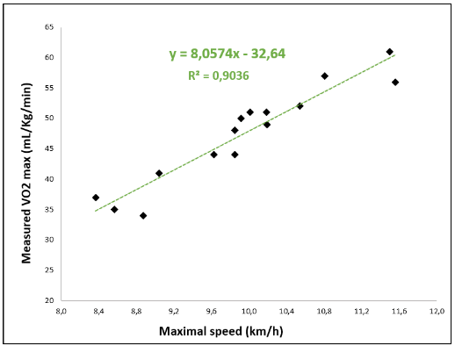
Cardiorespiratory fitness test. The 20-m shuttle run test is a common indirect method for estimating individual cardiorespiratory fitness (14). In this test, participants run back and forth between two lines 20 metres apart, gradually increasing their speed. The highest speed achieved during the test is used to predict the maximal oxygen uptake (VO₂max) (9,14–16). Due to local constraints the modified 10-m version will be used in the current study (16,18). Specifically, the lines will be set 10 metres apart, and the starting speed will be 6.5 km/h. The running pace will increase at regular intervals (+0.5km/h per minute), guided by an audio signal (Pack Sportbeeper Pro, CE, France). The test will stop when the student can no longer maintain the required speed, indicating their Maximal Aerobic Speed (MAS).
Each student’s heart rate will be assessed during and after the shuttle test using a Polar A200 device connected to a Polar H7 chest strap sensor. Their heart rate will be recorded immediately after they stop, as well as one and three minutes after they stop. Heart rate recovery (HRR) will be measured in beats per minute by subtracting the heart rate at one (HRR1) and three minutes (HRR3) of recovery from the heart rate at the time of stopping (HRS). The estimated VO₂max (mL/kg/min) will be calculated using an adjusted equation for this distance (VO_{2max} = 8.0574 * 10m-SRT speed - 32.64).
The relationship between the maximum speed attained in the 10-metre shuttle run test and measured VO₂max.

Appendix 5. Module-related activities
While waiting for individual meetings with the experts, students will be permitted to engage in module-related activities. These activities will be supervised by an experimenter to ensure students’ well-being. Interactions during sessions will be promoted by encouraging students to actively participate in the activities outlined below.
Session 1: The RESPIRELAX+ interface will be explained. The experimenter will then explain to the student how to fill out the stress diary, and for practice, the student will fill in the diary entry for that day. They will be instructed to continue updating it daily until the next session. The experimenter will provide information about the local student health service. Finally, students will be given a certificate of attendance.
Session 2: The students and the experimenter will discuss the stress diary completed during the previous session and review any difficulties they encountered while filling it out.
Session 3: The experimenter will recommend that students install a blue light filter on their phones. The experimenter will then provide the students with the sleep diary. They will fill it out for the previous night. Students will be given sleep masks and earplugs. Finally, students will watch a video titled “To Sleep, Perchance to Dream: Crash Course Psychology #9” (https://www.youtube.com/watch?v=rMHus-0wFSo&ab_channel=CrashCourse).
Session 4: Medical students will receive advice on managing night shifts, while doctoral students will discuss parallels with social jet lag during conferences or vacations. The experimenter and students will review the previous sleep diaries in order to address any difficulties students might have had in completing them. Each student will be asked to undergo a bioimpedance analysis (Biody XpertZM 3; Aminogram SAS, La Ciotat, France). The physical activity diary will then be explained, and students will complete it for the previous day. They will also be invited to download Apple Health or Google Fit to track their daily steps. Finally, students will watch the video “Muscles, Part 1 – Muscle Cells: Crash Course Anatomy & Physiology #21” (https://youtu.be/Ktv-CaOt6UQ?si=z2IO5eJRyI33J8_U).
Session 5: The physical activity diaries completed during the previous session will be reviewed as described above. A new bioimpedance analysis and a handgrip test will be proposed. The handgrip test assess forearm strength using a Jamar® Smart Hand Dynamometer (MD; Performance Health Supply, Cedarburg, WI 53012). The test will be conducted in a standardized manner: students will be seated with their feet flat on the floor, shoulders adducted, elbows flexed at 90°, forearms in a neutral position, and wrists slightly extended. The handle will be adjusted for optimal comfort. Students will be asked to squeeze as hard as possible for three to five seconds without compensating with their trunk or shoulder. Two to three trials will be performed for each hand, and students will take 1-min breaks between attempts. The highest value will be recorded as the maximal isometric strength (in N). Finally, students will watch the video “Muscles, Part 2 – Organismal Level: Crash Course Anatomy & Physiology #22” (https://youtu.be/I80Xx7pA9hQ?si=1VQ8baxjyDJHaMcF). Handgrip test.
Session 6: Students will watch the video “Metabolism & Nutrition, Part 1: Crash Course Anatomy & Physiology #36” (https://youtu.be/fR3NxCR9z2U?si=YBC6XyfPjAYK73E0) and “Metabolism & Nutrition, Part 2: Crash Course Anatomy & Physiology #37” (https://youtu.be/kb146Y1igTQ?si=QD98PUKMV-PlgsnT).

Appendix 6. Set of articles
To become a PROMESS-Group expert, individuals who will conduct the session should have read the following articles regarding the stress, sleep and physical activity module.
Stress | Sleep | Physical activity
Dyrbye et al. (2005)  Medical student distress: causes, consequences, and proposed solutions  Mayo Clin Proc.  https://doi.org/10.4065/80.12.1613 | Baranwal et al. (2023)  Sleep physiology, pathophysiology, and sleep hygiene  Prog Cardiovasc Dis.  https://doi.org/10.1016/j.pcad.2023.02.005 | Gao et al. (2024)  Occupational sitting time, leisure physical activity, and all-cause and cardiovascular disease mortality  JAMA Network Open  https://doi.org/10.1001/jamanetworkopen.2023.50680
LeBlanc. (2009)  The Effects of acute stress on performance: Implications for health professions education  Acad Med.  https://doi.org/10.1097/acm.0b013e3181b37b8f | Ohayon et al. (2017)  National Sleep Foundation’s sleep quality recommendations: first report  Sleep Health.  https://doi.org/10.1016/j.sleh.2016.11.006 | Bull et al. (2020)  World Health Organization 2020 guidelines on physical activity and sedentary behaviour  Br J Sports Med.  https://doi.org/10.1136/bjsports-2020-102955
Shapiro et al. (2000)  Stress management in medical education: a review of the literature  Acad Med.  https://doi.org/10.1097/00001888-200007000-00023 | Windred et al. (2023)  Sleep regularity is a stronger predictor of mortality risk than sleep duration: A prospective cohort study  Sleep  https://doi.org/10.1093/sleep/zsad253 | Tremblay et al. (2017)  Sedentary Behavior Research Network (SBRN) – Terminology Consensus Project process and outcome  International Journal of Behavioral Nutrition and Physical Activity  International Journal of Behavioral Nutrition and Physical Activity  https://doi.org/10.1186/s12966-017-0525-8
Shiralkar et al. (2013)  A Systematic Review of Stress-Management Programs for Medical Students  Acad Psychiatry  https://doi.org/10.1176/appi.ap.12010003 | Azad et al. (2015)  Sleep disturbances among medical students: a global perspective  J Clin Sleep Med.  https://doi.org/10.5664/jcsm.4370 | Peleias et al. (2017)  Leisure time physical activity and quality of life in medical students: results from a multicentre study  BMJ Open Sport Exerc Med.  https://doi.org/10.1136/bmjsem-2016-000213
Fincham et al. (2023)  Effect of breathwork on stress and mental health: A meta-analysis of randomised-controlled trials  Sci Rep.  https://doi.org/10.1038/s41598-022-27247-y | Seoane et al. (2020)  Sleep disruption in medicine students and its relationship with impaired academic performance: A systematic review and meta-analysis  Sleep Med Rev.  https://doi.org/10.1016/j.smrv.2020.101333 | Hoffmann et al. (2025)  Prevalence and correlates of self-reported and accelerometer-determined sedentary behavior and physical activity of German university students: cross-sectional results of the SmartMoving study  BMC Public Health  https://doi.org/10.1186/s12889-025-24378-5
Schlatter et al. (2022)  Effects of relaxing breathing paired with cardiac biofeedback on performance and relaxation during critical simulated situations: a prospective randomized controlled trial  BMC Med Educ.  https://doi.org/10.1186/s12909-022-03420-9 | Perotta et al. (2021)  Sleepiness, sleep deprivation, quality of life, mental symptoms and perception of academic environment in medical students  BMC Med Educ.  https://doi.org/10.1186/s12909-021-02544-8 | Al-Drees et al. (2016)  Physical activity and academic achievement among the medical students: A cross-sectional study  Medical Teacher  http://dx.doi.org/10.3109/0142159X.2016.1142516
Schlatter et al. (2022)  Personality traits affect anticipatory stress vulnerability and coping efficacy in occupational critical care situations  Sci Rep - https://doi.org/10.1038/s41598-022-24905-z | Bani Issa et al. (2023)  Evaluation of the effectiveness of sleep hygiene education and FITBIT devices on quality of sleep and psychological worry: a pilot quasi-experimental study among first-year college students  Front Public Health.  https://doi.org/10.3389/fpubh.2023.1182758 | Leuchter et al. (2022)  Relationship between exercise intensity and stress levels among U.S. medical students  Medical Education Online https://doi.org/10.1080/10872981.2022.2027651
Le Saux et al. (2024)  Association of personality traits with the efficacy of stress management interventions for medical students taking objective structured clinical examinations  Acad Med.  https://doi.org/10.1097/ACM.0000000000005714 | Chandler et al. (2022)  Improving university students’ mental health using multi-component and single-component sleep interventions: A systematic review and meta-analysis  Sleep Med.  https://doi.org/10.1016/j.sleep.2022.09.003 | Plotnikoff et al. (2015)  Effectiveness of interventions targeting physical activity, nutrition and healthy weight for university and college students: A systematic review and meta-analysis  Int J Behav Nutr Phys Act  https://doi.org/10.1186/s12966-015-0203-7
Barret et al. (2024)  Associations of coping and health‐related behaviors with medical students’ well‐being and performance during objective structured clinical examination  Sci Rep.  https://doi.org/10.1038/s41598-024-61800-1 | Shriane et al. (2023)  Healthy sleep practices for shift workers: consensus sleep hygiene guidelines using a Delphi methodology  Sleep.  https://doi.org/10.1093/sleep/zsad182 | Thorndike et al. (2014)  Activity monitor intervention to promote physical activity of physicians-in-training: Randomized controlled trial  PLoS One  https://doi.org/10.1371/journal.pone.0100251
Métais et al. (2025)  Determining the influence of an intervention of stress management on medical students’ levels of psychophysiological stress: the protocol of the PROMESS‐Stress clinical trial  BMC Medical Education  https://doi.org/10.1186/s12909-024-06344-8 | Ruet et al. (2025)  Determining the influence of a sleep improvement intervention on medical students’ sleep and fatigue: protocol of the PROMESS-Sleep clinical trial  BMC Medical Education  https://doi.org/10.1186/s12909-024-06422-x | Schlatter et al. (2025)  Reducing Sedentary Behavior and Promoting Physical Activity in Medical Students: Protocol of the PROMESS-Physical Activity Clinical Trial  https://doi.org/10.21203/rs.3.rs-7441836/v1

Appendix 7. Visual analogue scales
Students will answer several 100-mm visual analogue scales (VASs). Each VAS will prompt the student to move a cursor to indicate their response. The cursor will start at the 0 position for each question.
Stress  -  Session 1 - 2 - 3 | Sleep  -  Session 3 - 4 - 5 | Physical activity  -  Session 4 - 5 - 6
VAS - stressors quantity  “In the past two weeks, how many stressful situations have you encountered?”  Ranging from 0 (maximum/extreme) to 100 (zero). | VAS - sleep quantity  “In the past 2 weeks, how would you characterize your sleep quantity?”  Ranging from 0 (largely insufficient) to 100 (largely sufficient) | VAS - physical fitness  “Over the past two weeks, how would you characterize your level of physical fitness?”  Ranging from 0 (bad shape) to 100 (excellent shape).
VAS - stress quantity  “In the past two weeks, how would you characterize your stress level?”  Ranging from 0 (maximum stress) to 100 (no stress at all). | VAS - sleep quality  “In the past 2 weeks, how would you characterize your sleep quality?”  Ranging from 0 (the worst quality) to 100 (the best quality). | VAS - physical activity  “Over the past two weeks, how would you characterize your level of physical activity?”  Ranging from 0 (completely inactive) to 100 (extremely active).
VAS - stress quality  “Over the past two weeks, how would you characterize your stress?”  Ranging from 0 (very negative feeling) to 100 (very positive feeling). | VAS - fatigue  “Over the past 2 weeks, how would you characterize your physical and mental fatigue level?”  Ranging from 0 (extreme fatigue) to 100 (no fatigue at all). | VAS - sedentary behavior  “Over the past two weeks, how would you characterize your level of sedentary behavior?”  Ranging from 0 (extremely sedentary behavior) to 100 (no sedentary behavior).
VAS - stress coping
“Over the past two weeks, how have you managed stressful situations?”
Ranging from 0 (very bad stress coping) to 100 (excellent stress coping).

Appendix 8. Stress, sleep, and physical activity diaries
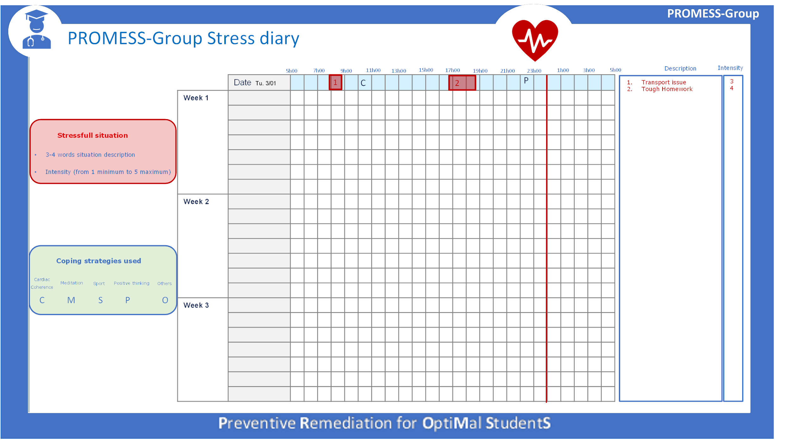
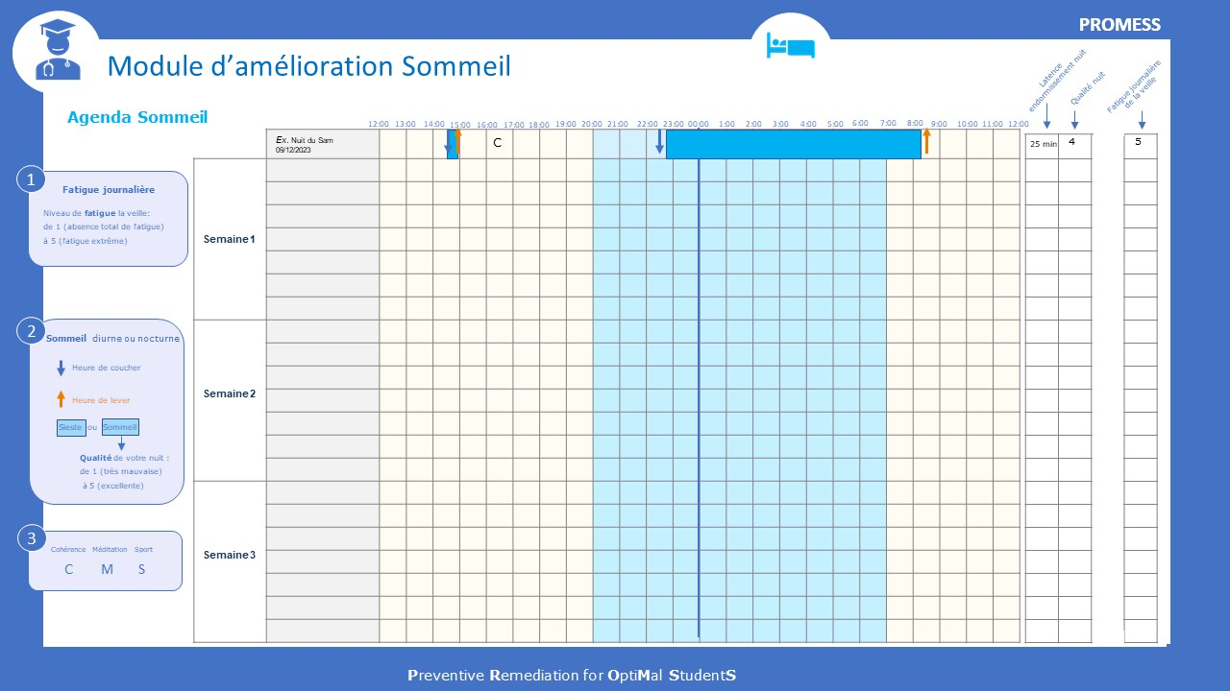
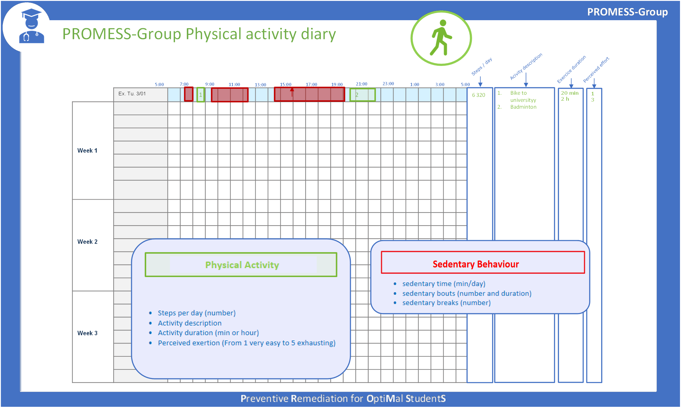

Appendix 9. Lists of advice
During sessions, the PROMESS-Group experts will provide students with specific advice and goals based on the following predefined lists regarding stress, management, sleep and physical activity. These lists are based on well-established knowledge and interventions in their respective fields; additional references are available (19–21). To ensure the list fit the specific needs of students, the list was validated by a sample of students and university staff members working in the health department during a prior workshop (22). The experts will use a 5-point Likert scale to report whether each piece of advice 1) was not mentioned, 2) was mentioned but not directly advised, 3) was mentioned and recommended, 4) was set as a goal, and 5) was mentioned with positive reinforcement performed.
Stress | Sleep | Physical activity
Fill in the stress diary. | Fill in the sleep diary. | Fill in the physical activity diary.
Daily habits  - Take breaks  - Practice positive thinking | Daytime habits  - Anti-blue light filter on screens  - Restricted screen use  - Restricted alcoholic consumption  - No energy drink or coffee intake after 4:00 p.m.  - Regular meal intake  - Eat or have a break outside to maximize sunlight exposure | Daily habits  - Check and/or increase the number of daily steps  - Take the stairs more often  - Increase walking and/or cycling
Relaxation methods
- Practice slowed breathing/cardiac coherence
- Practice meditation/mindfulness
 | Nighttime habits  - Sleep for seven to nine hours nightly  - Regularize bedtime  - Total obscurity (have a sleep mask on)  - Silence (earplugs, devices switched off)  - No phone next to the bed  - No work inside the bed  - Go to sleep when tired  - Read before going to bed  - Having a bedtime routine  - Control the bedroom’s temperature  - Relaxation technique (e.g., meditation and mindfulness, slow-paced breathing, cardiac coherence, guided imagery, muscle relaxation) | Physical activity  - Perform one moderate physical activity session per week  - Perform one intense physical activity session per week  - Gradually increase the duration of your sports activity sessions
Social support
- Reinforce positive social relationships
- Participate in students’ associative activities
- Participate in university health service activities
Physical activity
- Perform physical activity
- Participate in structured physical activities offered by the university
Sedentary behaviors

- Break up sedentary lifestyle free time (screen time, sitting time, etc.)
- Break up a sedentary lifestyle by moving around while sitting (metro, bus, etc.)
Other
- List and reflect on coping behaviors
- Engage in artistic or manual activities
- Spend time in nature
Daytime sleep
- Power nap (10 to 20 minutes)
- Long nap (more than 30 minutes)

Appendix 10. Pedagogical content examples

- Pedagogical content from stress sessions
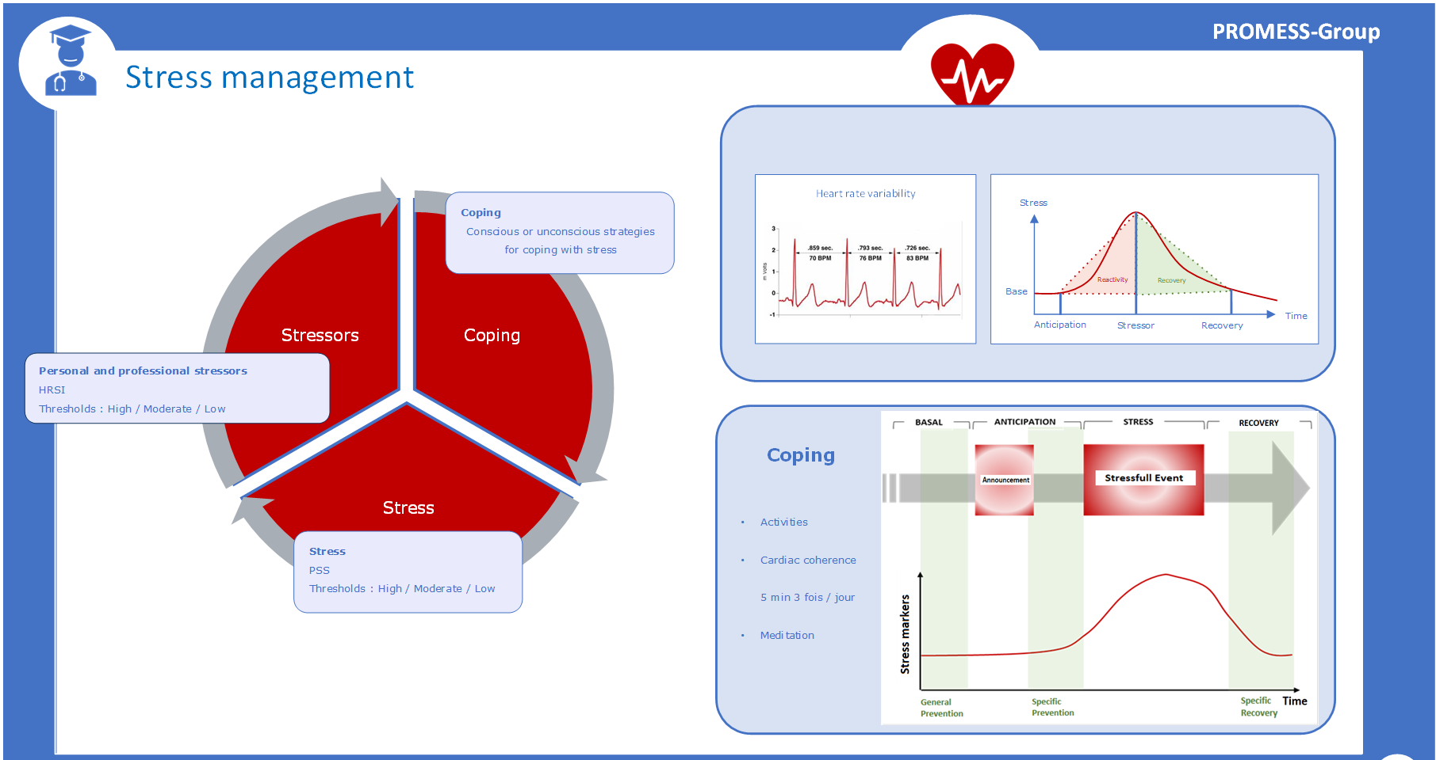

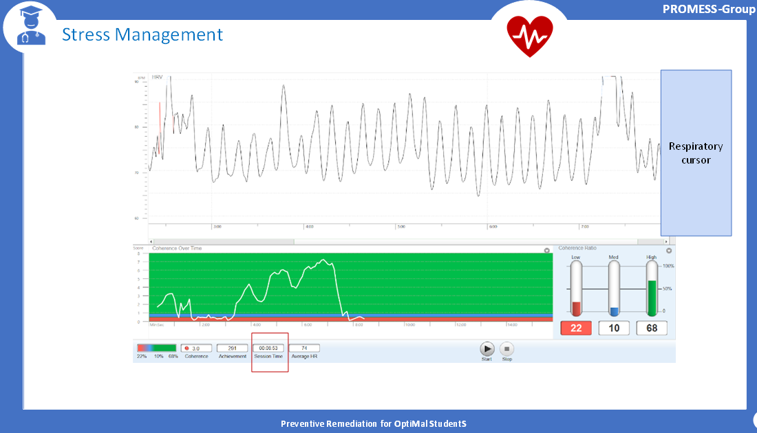
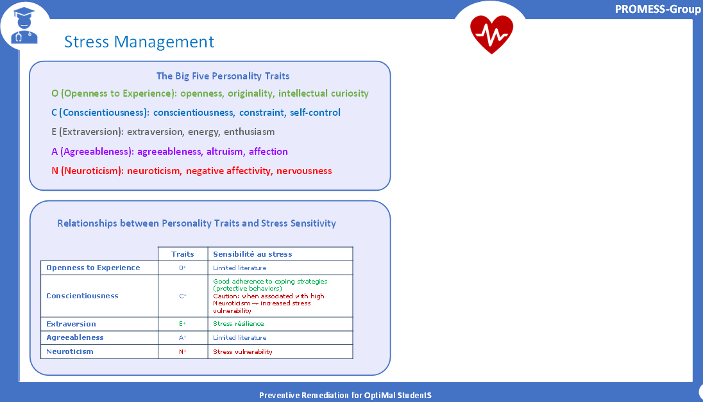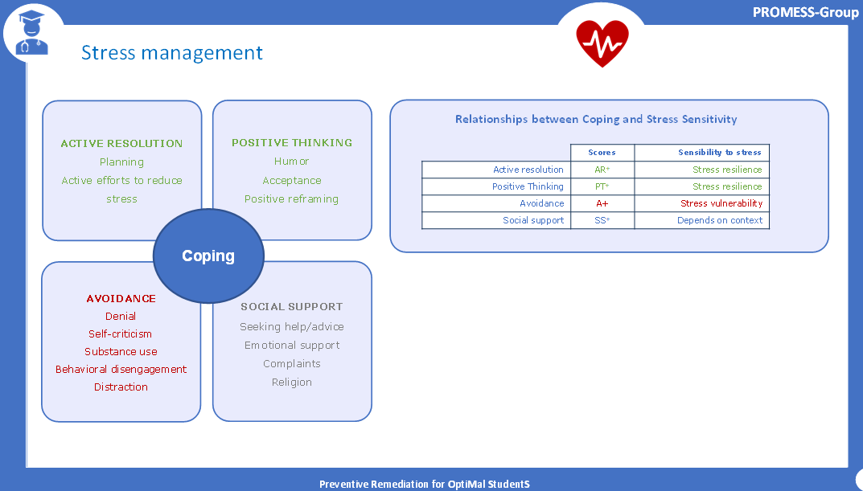

- Pedagogical content from sleep sessions
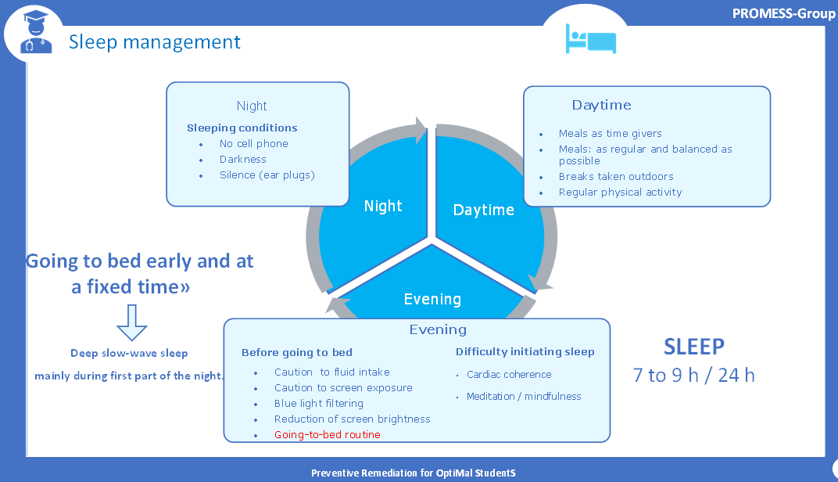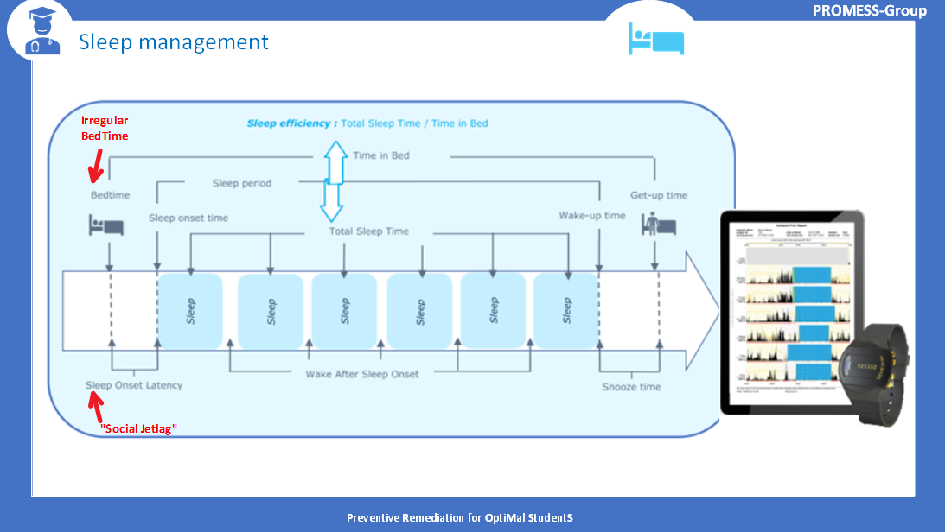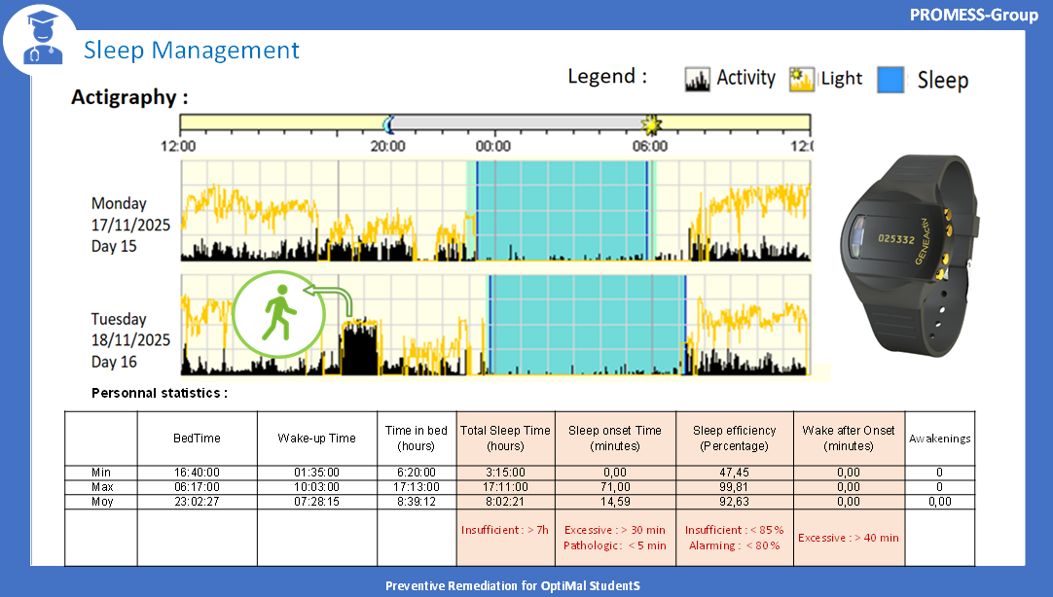

- Pedagogical content from physical activity sessions
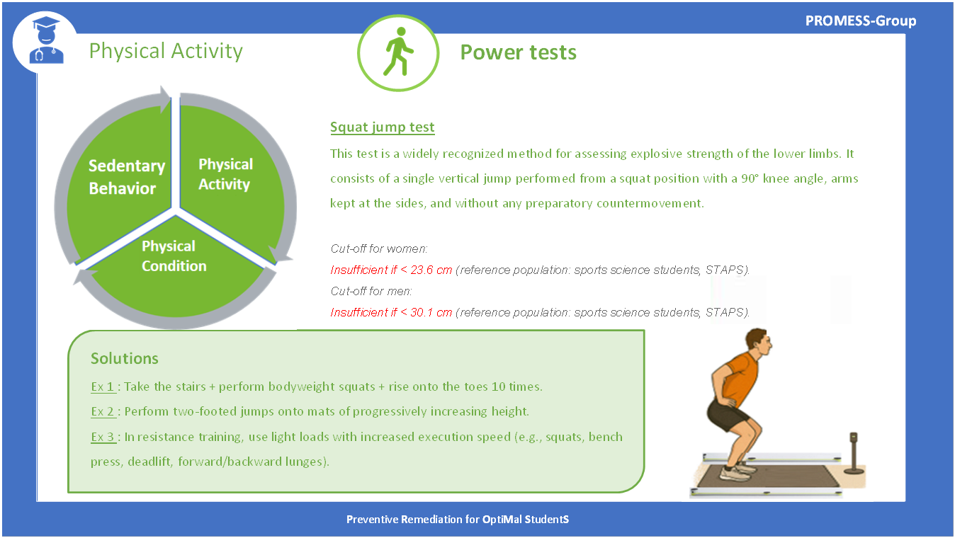
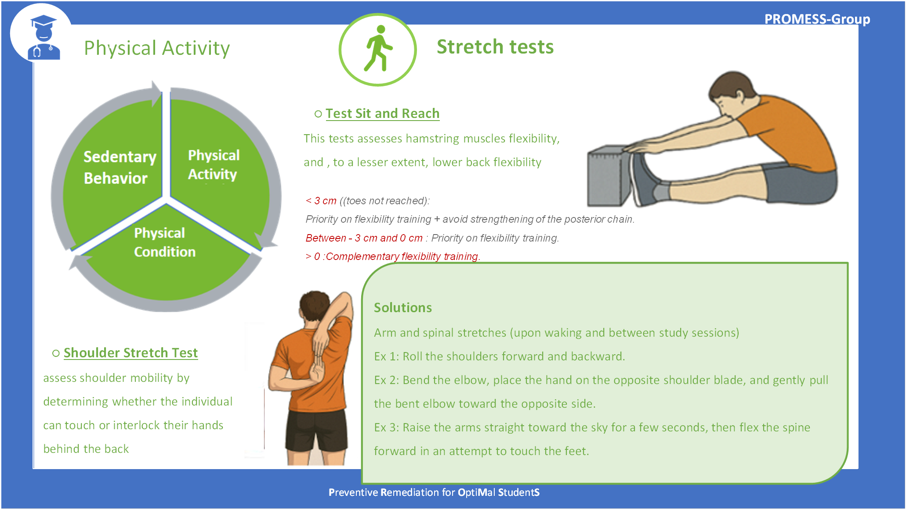

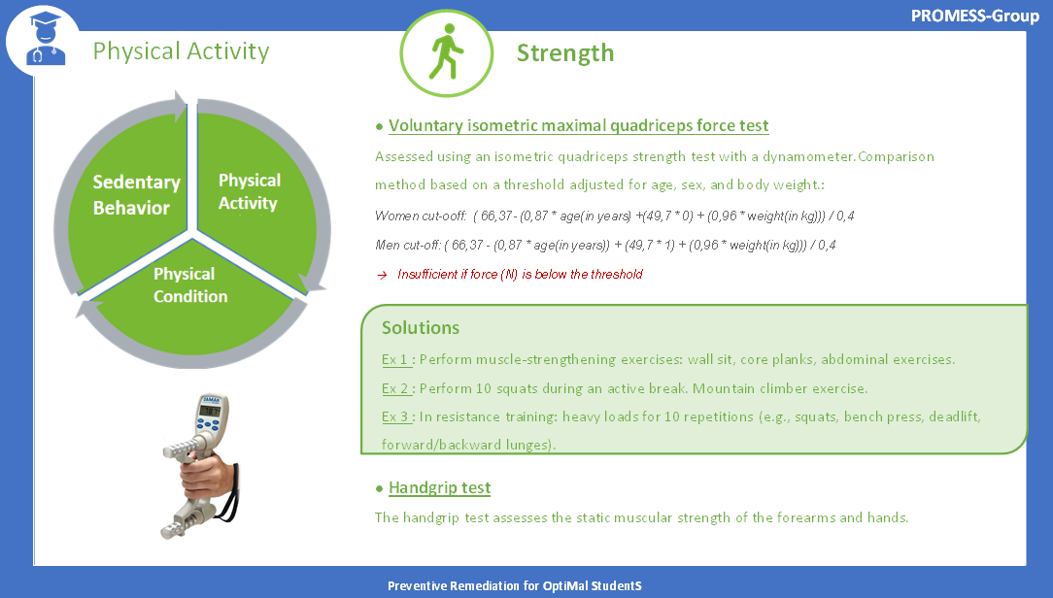
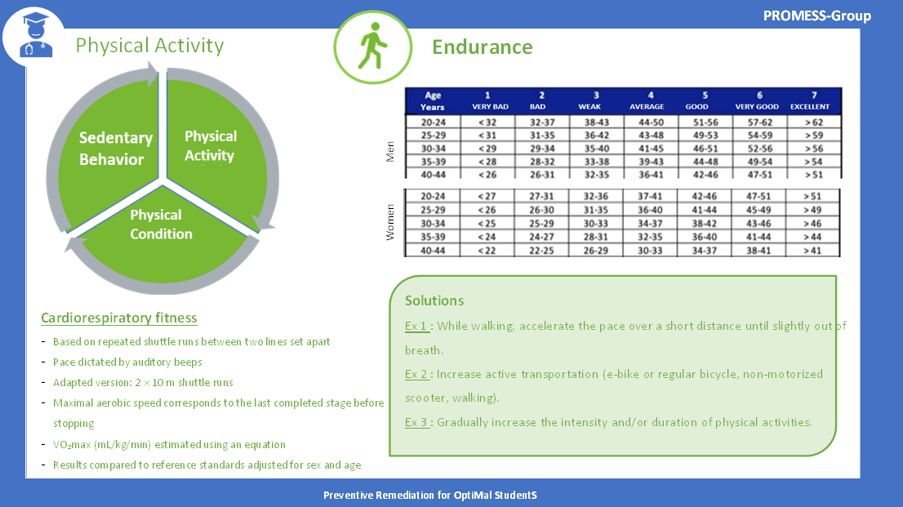

Appendix 11. Cardiac coherence exercises
Session 1
Group session: Students will perform an HRV-biofeedback exercise using emWave® Pro Plus Coherence Training software (v3.14.1, HeartMath Institute, Boulder Creek, CA, USA). During the first three minutes, the expert will explain the visual interface, including the pulse wave, instantaneous heart rate, and cardiac coherence score. Cardiac coherence is defined as a stable, synchronized pattern between heart rate variability (HRV), respiration, and autonomic nervous system activity. The expert will then present the breathing cursor that will guide the participants’ inhalation and exhalation rhythm. From three to six minutes, participants will perform a paced breathing exercise at a rate of six breaths per minute. Between six and eight minutes, the participants will continue the paced breathing exercise while visualizing a breathing image that follows the rhythm—for example, they might imagine a sun or balloon expanding during inhalation and shrinking during exhalation. From eight to nine minutes, participants will close their eyes and remain silent for one minute, without any specific breathing instructions. This will provide data on participants cardiac coherence without further help from the experts. At nine minutes, the recording will be stopped.
Individual meeting: Students will be debriefed based on their cardiac coherence trace, with the expert explaining the different phases of the recording. During the first three minutes, the trace corresponds to the basal level. From three to six minutes, the student performed a three-minute breathing exercise; this phase will allow discussion of reactivity, peak coherence score, and stability. Between six and eight minutes, the student completed two minutes of paced breathing with a respiratory image. From eight to nine minutes, the student remained inactive for one minute, allowing the expert to evaluate how well the coherence score was maintained; this corresponds to the “fade-out speed.”

Session 2
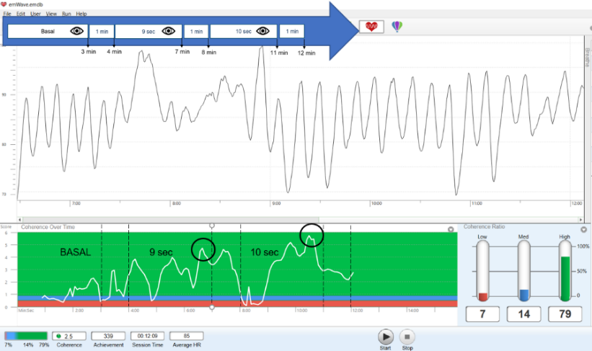
Group session: The students will perform an HRV-biofeedback exercise so that their resonant breathing frequency can be estimated using an adapted version of the Lehrer procedure (23–25). First, the expert will briefly remind participants of the visual interface during 3 minutes, followed by a one-minute period with eyes closed. They will students will engage in three minutes of paced breathing at a frequency of nine cycles per minute, followed by one-minute period with eyes closed. Next, students will perform three minutes of paced breathing at a frequency of ten cycles per minute, followed by a final one-minute period with eyes closed. The expert will identify the most effective breathing frequency to reach a high and sustainable cardiac coherence (this should be close to the student’s breathing resonance). Finally, the students will be advised to practise at their most effective breathing frequency for further self-training (23–25).

Appendix 12. Exercises to improve specific aspects of physical fitness
During the fifth session of the PROMESS-Group programme, students will receive individualized feedback on the results of the physical tests carried out before the intervention (T0) and described above. They will be given specific advice and exercises to improve their flexibility, power, muscle strength, and endurance. These exercises have been designed by experts in physical activity sciences and sports or by professionals with a degree in adapted physical activity; they are intended to be simple and accessible, and most of them can be done without specific equipment.

Flexibility
Objective: improve mobility in the hamstrings, back, and shoulders.
Reference tests: Sit-and-reach test and shoulder stretch test.
Recommended exercises:
- Exercise 1: Roll the shoulders forward and backward.
- Exercise 2: Bend the elbow, place the hand on the opposite shoulder blade, and gently pull the bent elbow toward the opposite side.
- Exercise 3: Raise the arms straight up for five seconds, then flex the spine forward and attempt to touch the feet.

Power
Objective: develop the ability to generate force quickly (working the anterior and posterior chains).
Reference test: Squat jump test.
Recommended exercises:
- Exercise 1: Take the stairs, perform bodyweight squats, and rise onto the toes 10 times.
- Exercise 2: Perform two-footed jumps onto mats of progressively increasing height.
- Exercise 3: In resistance training, use light loads with increased execution speed (e.g. squats, bench press, deadlift, forward/backward lunges).

Strength
Objective: to strengthen the major muscle groups, particularly the quadriceps, abdominals, and shoulder girdles.
Reference test: Maximal isometric quadriceps strength test.
- Exercise 1: Perform muscle-strengthening exercises (wall sit, core planks, abdominal exercises).
- Exercise 2: Perform 10 squats during an active break. Mountain climber exercise.
- Exercise 3: In resistance training, lift heavy loads for 10 repetitions (e.g. squats, bench press, deadlift, forward/backward lunges).

Endurance
Objective: improve cardiorespiratory capacity and recovery after exercise.
Reference test: 10-m shuttle run test.
Recommended exercises:
- Exercise 1: While walking, accelerate the pace over a short distance until slightly out of breath.
- Exercise 2: Increase active transportation (e-bike or regular bicycle, non-motorized scooter, walking).
- Exercise 3: Gradually increase the intensity and/or duration of physical activities.

Appendix 13. Assessment of student satisfaction with modules

Just before the end of each module, student satisfaction with the PROMESS-GROUP modules will be assessed using several 100-mm VASs. Each VAS will prompt the student to move a cursor to indicate their response. The cursor will start at the 0 position for each question. The answer cursor will range from 0 (absolutely not) to 100 (completely). These VASs were previously used during the PROMESS programme (19–21).

For each module, the student’s satisfaction will be measured using a composite score, calculated as the mean of the specific score and the general score, described below.

Specific stress satisfaction score. Mean of the scores obtained for the “stress” VAS (“Do you think the intervention has helped you to lower your stress level?”) and the “coping” VAS (“Do you think the intervention allowed you to better manage the stressful events you have encountered?”).

Specific sleep satisfaction score. Mean of the scores obtained for the “sleep” VAS (“Do you think the intervention has helped you to improve your sleep?”) and the “fatigue” VAS (“Do you think the intervention allowed you to decrease your fatigue?”).

Specific physical activity satisfaction score. Mean of the scores obtained for the “sedentary behavior” VAS (“Do you think the intervention has helped you to decrease your sedentary behavior?”), the “physical activity” VAS (“Do you think the intervention has helped you to increase your physical activity level?”), and the “physical fitness” VAS (“Do you think the intervention has helped you to increase your physical fitness level?”).

General satisfaction score. For the three modules, the general satisfaction score will be the mean of the score obtained for the “relevance” VAS (“Do you think the proposed goals were suitable for your daily life?”) and the “sustainability” VAS (“Do you think you can sustain the performed changes on a daily basis?”)

Appendix 14. Ethical approval

University College of General Medicine
8 avenue Rockefeller
69373 LYON Cedex 08
France
dmg.cumg@univ-lyon1.fr
Lyon, Monday, March 3, 2025
Professor Humbert de Fréminville,
Head of the CER-CUMG
For the attention of
Ms. Marion Nouet
Mr. Alexandre Krikorian
Mr. Benoît Lecocq
Madam, Sirs,
The Research Ethics Committee of the CUMG reviewed your research project entitled: “Interest of a group-based and multimodal intervention (Preventive Remediation or OptiMal StudentS PROMESS-Group: stress remediation, sleep improvement, and promotion of physical activity) on the quality of life of health students: a randomized controlled monocentric interventional study” during the plenary session of Tuesday, February 18, 2025.
Following the discussions, the following decision was reached by a majority of the members present:
Conditional approval subject to minor revisions, to be submitted within 7 days from the date of the committee meeting.
Following receipt of the requested minor revisions, the committee issued a favorable opinion on February 25, 2025: your IRB identification number is 2025-02-18-02.
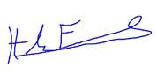
Yours sincerely,
On behalf of the Committee,
Professeur Humbert de FRÉMINVILLE

Original French version below

Collège universitaire de médecine générale  8 avenue Rockefeller  69373 LYON Cedex 08  France  dmg.cumg@univ-lyon1.fr | Lyon, le lundi 3 mars 2025  Professeur Humbert de FRÉMINVILLE,  Responsable du CER-CUMG  à l’attention de  Madame Marion NOUET  Monsieur Alexandre KRIKORIAN  Monsieur Benoît LECOCQ

Madame, Messieurs,

Le Comité d’Éthique de la Recherche du CUMG a examiné votre projet de recherche intitulé « Intérêt d’une intervention groupale et multimodale (Preventive Remediation or OptiMal StudentS PROMESS-Group : remédiation du stress, amélioration du sommeil et promotion de l’activité physique) sur la qualité de vie des étudiants en santé : étude interventionnelle randomisée contrôlée monocentrique » lors de la séance plénière du mardi 18 février 2025.
À l'issue des débats, la décision suivante a été rendue à la majorité des membres siégeant présents :
Avis réservé avec demande de modifications mineures, à envoyer dans un délai de 7 jours à compter de la date de la séance du comité.
Suite à la réception des modifications mineures demandées, le comité a donné un avis favorable le 25 février 2025 : votre numéro d’identification IRB est le 2025-02-18-02.

Veuillez agréer, Madame, Messieurs, l'expression de mes respectueuses salutations.

Pour le Comité,
Professeur Humbert de FRÉMINVILLE
Responsable du CER-CUMG
Collège Universitaire de Médecine Générale
Université Claude Bernard Lyon 1

Appendix 15. Funding

The first proof of funding corresponds to the financial support by the contribution of student and campus life of the Claude Bernard University Lyon 1 (Grant number 22CVEC_SAN). Lines corresponding to this study (PROMESS) are highlighted.
The second proof of funding corresponds to the additional funding provided through a grant awarded to RA (ANR-22-CE14-0073).

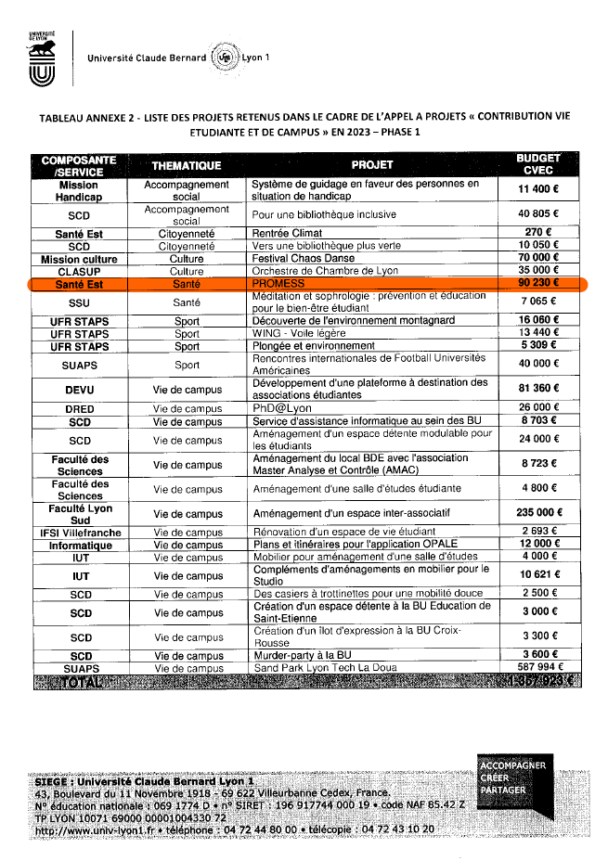

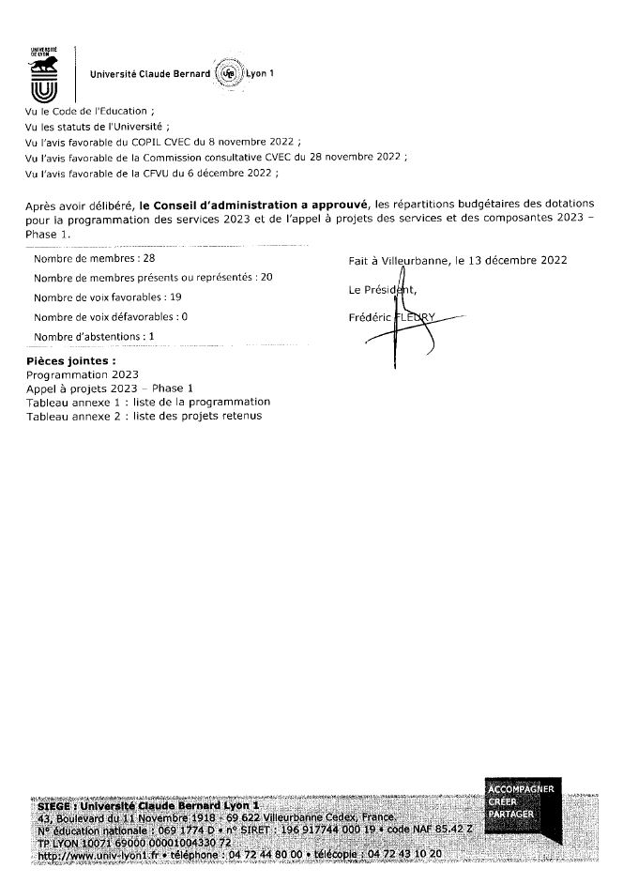

Email object: FUNDING – SHAPE-Med

Date : 2024/11/14
Dear colleagues,
We are pleased to inform you that the Health-Prime project submitted to the 2024 Structuring Call for Projects of SHAPE‑Med@Lyon (ANR‑22‑CE14‑0073) has been evaluated by national and international experts, as well as by the external members of the SHAPE‑Med@Lyon Scientific and Innovation Council (CSI). Following the CSI’s recommendation, the SHAPE‑Med@Lyon Steering Committee has selected the HEALTH‑PRIME project as one of the 11 funded projects.
As a reminder, this project, entitled “The effectiveness of a multimodal, individualized intervention on the health, quality of life, performance, and professional skills of future healthcare professionals”, was written by Sophie Schlatter with the support of C. Hautier and myself. It is based on a multidisciplinary partnership involving: Santé Lyon‑Est, Lyon‑Sud and the RESHAPE laboratory, STAPS and the LIBM laboratory, SSU, Université Lyon 2 and the POPs laboratory, and Université Savoie‑Mont Blanc.
We look forward to this collaboration and thank you for your participation.
We will get back to you as soon as we have more information.
Kind regards.
Anne-Marie Schott, MD, PhD
Faculté de Médecine Lyon-Est - Université Lyon 1
Laboratoire INSERM U1290 RESHAPE - reshapelab.fr
Pôle Santé Publique - Hospices Civils de Lyon


__________________________________________________________________
Original French version below
__________________________________________________________________



References

1. Andreacci JL, LeMura LM, Cohen SL, Urbansky EA, Chelland SA, Von Duvillard SP. The effects of frequency of encouragement on performance during maximal exercise testing. J Sports Sci. 2002;20(4):345‑52.
2. Gouraud E, Connes P, Gauthier-Vasserot A, Faes C, Merazga S, Poutrel S, et al. Impact of a submaximal mono-articular exercise on the skeletal muscle function of patients with sickle cell disease. Eur J Appl Physiol. 2021;121(9):2459‑70.
3. Mura M, Rivoire E, Dehina-Khenniche L, Weiss-Gayet M, Chazaud B, Faes C, et al. Effectiveness of an individualized home-based physical activity program in surgery-free non-endarterectomized asymptomatic stroke patients: a study protocol for the PACAPh interventional randomized trial. Trials. 2022;23(1):145.
4. Petersen NT, Taylor JL, Butler JE, Gandevia SC. Depression of Activity in the Corticospinal Pathway during Human Motor Behavior after Strong Voluntary Contractions. J Neurosci. 2003;23(22):7974‑80.
5. Bachasson D, Villiot-Danger E, Verges S, Hayot M, Perez T, Chambellan A, et al. Mesure ambulatoire de la force maximale volontaire isométrique du quadriceps chez le patient BPCO. Rev Mal Respir. 2014;31(8):765‑70.
6. Hamilton A, Balnave R, Adams R. Grip strength testing reliability. J Hand Ther Off J Am Soc Hand Ther. 1994;7(3):163‑70.
7. Lagerström C, Nordgren B. Methods for measuring maximal isometric grip strength during short and sustained contractions, including intra-rater reliability. Ups J Med Sci. 1996;101(3):273‑85.
8. Glatthorn JF, Gouge S, Nussbaumer S, Stauffacher S, Impellizzeri FM, Maffiuletti NA. Validity and reliability of Optojump photoelectric cells for estimating vertical jump height. J Strength Cond Res. 2011;25(2):556‑60.
9. Mayorga-Vega D, Merino-Marban R, Viciana J. Criterion-Related Validity of Sit-and-Reach Tests for Estimating Hamstring and Lumbar Extensibility: a Meta-Analysis. J Sports Sci Med. 2014;13(1):1‑14.
10. Holt LE, Pelham TW, Burke DG. Modifications to the Standard Sit-and-Reach Flexibility Protocol. J Athl Train. 1999;34(1):43‑7.
11. Minick KI, Kiesel KB, Burton L, Taylor A, Plisky P, Butler RJ. Interrater reliability of the functional movement screen. J Strength Cond Res. 2010;24(2):479‑86.
12. Gribble PA, Brigle J, Pietrosimone BG, Pfile KR, Webster KA. Intrarater reliability of the functional movement screen. J Strength Cond Res. 2013;27(4):978‑81.
13. Cook G, Burton L, Hoogenboom B. Pre-Participation Screening: The Use of Fundamental Movements as an Assessment of Function – Part 1. North Am J Sports Phys Ther. 2006;1(2):62‑72.
14. Léger LA, Lambert J. A maximal multistage 20-m shuttle run test to predict VO2 max. Eur J Appl Physiol. 1982;49(1):1‑12.
15. Magee MK, White JB, Merrigan JJ, Jones MT. Does the Multistage 20-m Shuttle Run Test Accurately Predict VO2max in NCAA Division I Women Collegiate Field Hockey Athletes? Sports. 2021;9(6):75.
16. Cho HL, Park HY, Nam SS. Development of multistage 10-m shuttle run test for VO2max estimation in healthy adults. J Mens Health. 2022;18(1):1-8.
17. Torres G, Gordon NF, Constantinou D. Cardio-Respiratory Fitness and Cardiovascular Disease Risk Factors Among South African Medical Students. Am J Lifestyle Med. 2023;17(6):791‑8.
18. Leger D, Esquirol Y, Gronfier C, Metlaine A. Republication de : Le travail posté et de nuit et ses conséquences sur la santé : état des lieux et recommandations. Médecine Sommeil. 2019;16(3):191‑9.
19. Métais A, Omarjee M, Valero B, Gleich A, Mekki A, Henry A, et al. Determining the influence of an intervention of stress management on medical students’ levels of psychophysiological stress: the protocol of the PROMESS-Stress clinical trial. BMC Med Educ. 2025;25:225.
20. Ruet A, Ndiki Mayi EF, Métais A, Valero B, Henry A, Duclos A, et al. Determining the influence of a sleep improvement intervention on medical students’ sleep and fatigue: protocol of the PROMESS-Sleep clinical trial. BMC Med Educ. 2025;25:267.
21. Schlatter S, Mura M, Morel B, Loisel O, Aouidat M, Gouraud E, et al. Reducing Sedentary Behavior and Promoting Physical Activity in Medical Students: Protocol of the PROMESS-Physical Activity Clinical Trial [Internet]. Research Square; 2025 [cité 7 nov 2025]. Disponible sur: https://www.researchsquare.com/article/rs-7441836/v1
22. Métais A, Besnard L, Valero B, Henry A, Schott AM, Rode G, et al. Addressing medical students’ health challenges: codesign and pilot testing of the Preventive Remediation for Optimal MEdical StudentS (PROMESS) program. BMC Med Educ. 2025;25:812.
23. Shaffer F, Meehan ZM. A Practical Guide to Resonance Frequency Assessment for Heart Rate Variability Biofeedback. Front Neurosci. 2020;14:570400.
24. Lehrer PM, Vaschillo E, Vaschillo B. Resonant Frequency Biofeedback Training to Increase Cardiac Variability: Rationale and Manual for Training. Appl Psychophysiol Biofeedback. 2000;25(3):177‑91.
25. Lehrer P, Vaschillo B, Zucker T, Graves J, Katsamanis M, Aviles M, et al. Protocol for heart rate variability biofeedback training. Biofeedback. 2013;41(3):98‑109.

