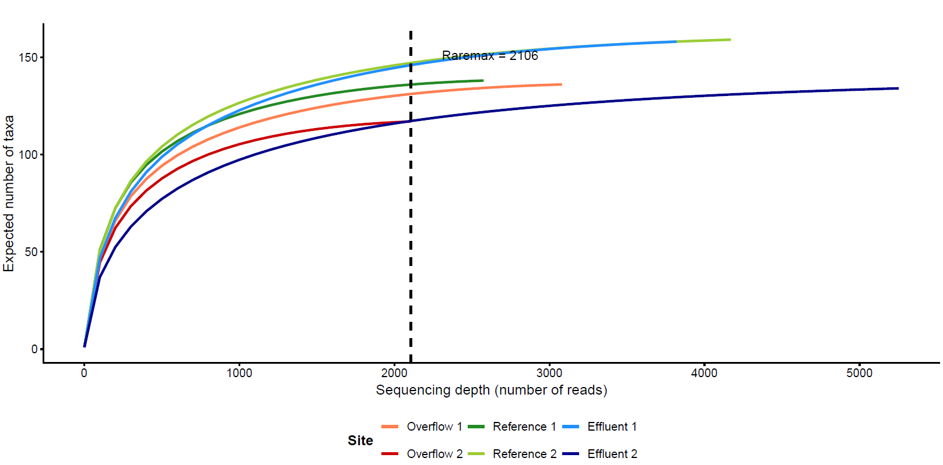
Figure S1. Microbial community coverage and sequencing depth across study sites. Rarefaction curves represent the relationship between the number of detected sequence variants (taxa) and the sequencing depth (reads) for biofilm replicates at the Reference (Site 3), Rain Overflow (Site 2), and Downstream Effluent (Site 4) locations. The vertical dashed line indicates the minimum library size (raremax = 2,100 reads), used as a threshold to verify that all samples reached a diversity plateau. The saturation of all curves suggests that the sequencing depth was sufficient to capture the majority of the microbial taxonomic richness present in the samples, allowing for robust comparisons of community structure across the urban pollution gradient.

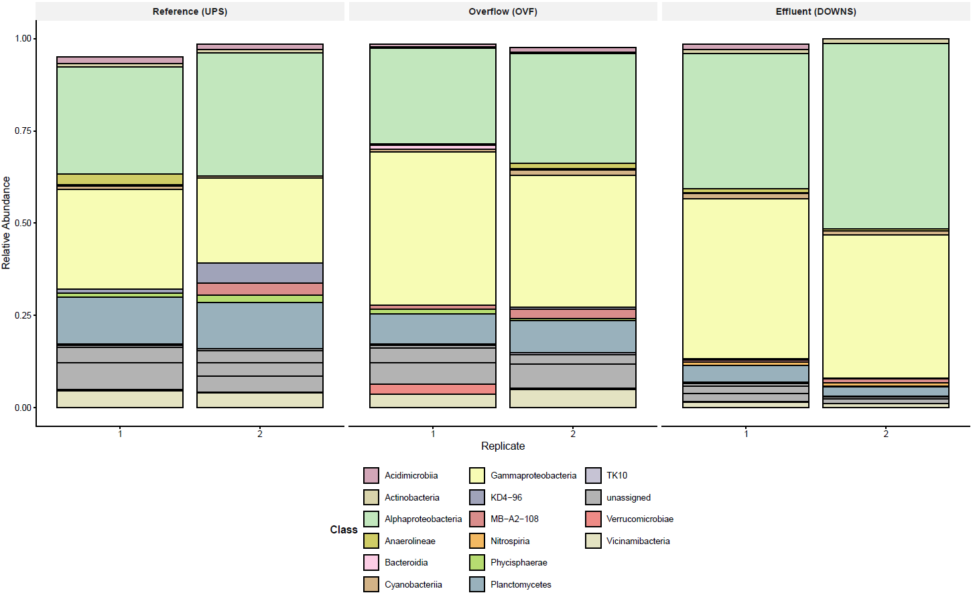
Figure S2. Taxonomic composition of biofilm communities. Relative abundance of the top 20 microbial classes across replicates for each study site. Bars represent individual replicates (1 and 2) for each location. Taxa are colored by class, with unassigned taxa represented in grey. The transition from the upstream reference site to the impacted urban sites (UPS and DOWNS) illustrates the shift from core riverine taxa (e.g., Planctomycetes) toward pollution-associated groups (e.g., Gammaproteobacteria).

