Supplementary data
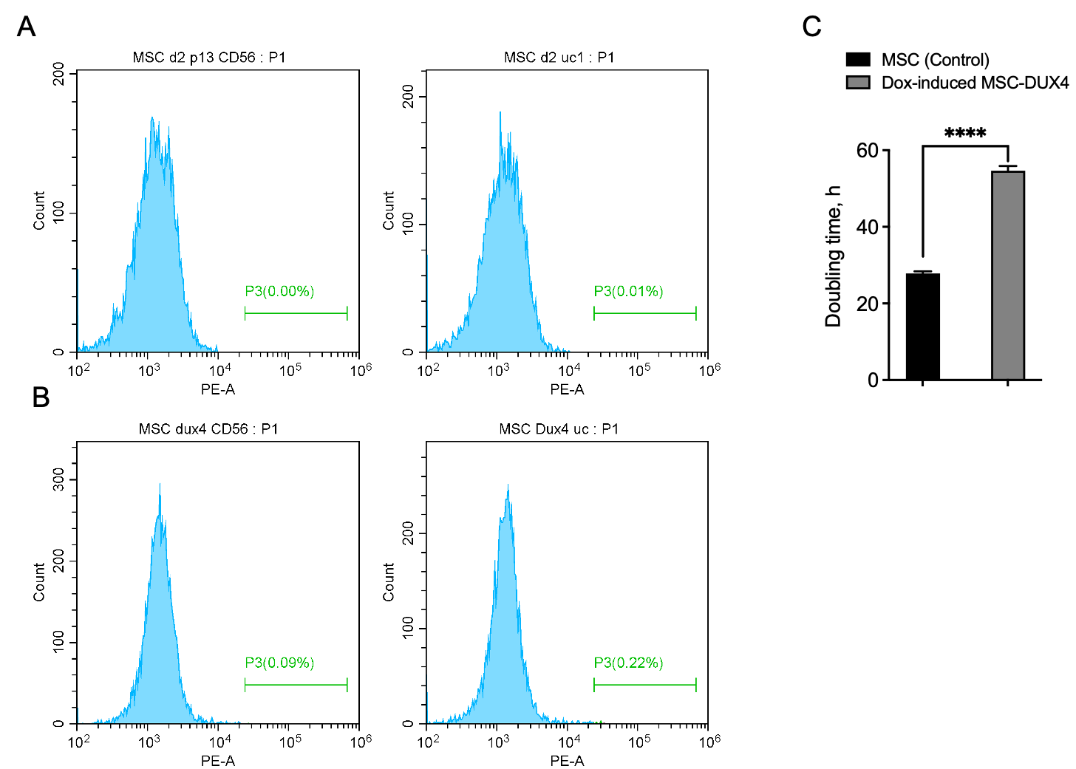

Figure S1. A, Flow cytometry analysis control MSCs: histogram CD56 staining (left) and corresponding unstained control (right); B, Flow cytometry analysis MSC-DUX4 cells: histogram CD56 staining (left) and corresponding unstained control (right); C, Proliferation rate of the control MSCs and Dox-induced MSC-DUX4 (mean ± SD, * p <0.05, **** p <0.0001, n = 3)

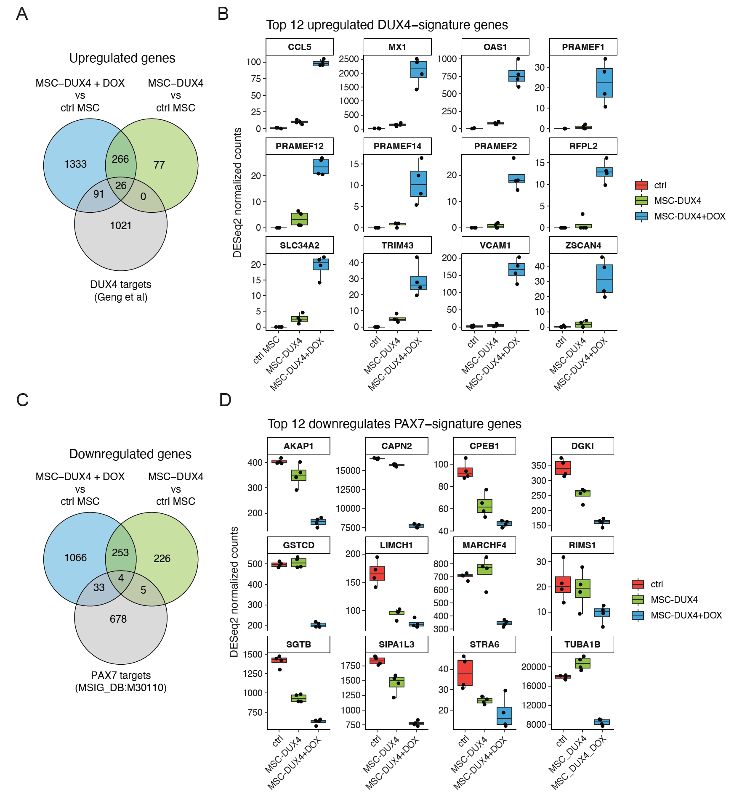
Figure S2. A, Venn diagram showing the intersection between the genes significantly upregulated (log2Fold > 1, padj < 0.05) in the Dox-induced MSC-DUX4 vs control MSC, non-induced MSC-DUX4 vs control MSC, and the DUX4 signature genes published in [41]; B, Expression of top 12 upregulated DUX4 signature genes in the non-induced and Dox-induced MSC-DUX4 and the control MSCs;
C, Venn diagram showing the intersection between the genes significantly downregulated (log2Fold < -1, padj < 0.05) in the Dox-induced MSC-DUX4 vs control MSC, non-induced MSC-DUX4 vs control MSC, and the PAX7 target genes (MSigDB:M30110); D, Expression of top 12 downregulated PAX7 target genes in the Dox-induced MSC-DUX4 and the control MSCs.
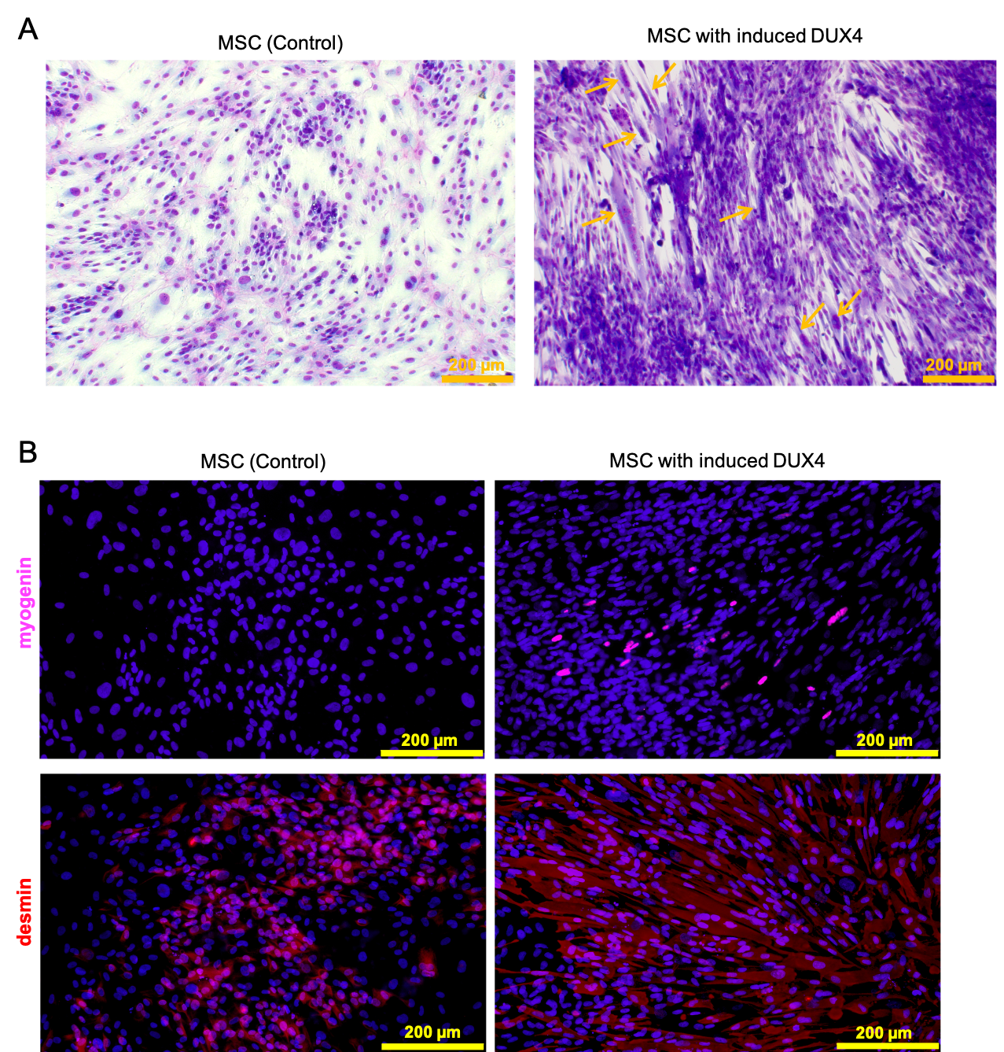
Figure S3. A, Control MSC and Dox-induced MSC-DUX4 were induced to differentiate for 10 days and control and FSHD myoblasts were induced to differentiate for 5 days and then stained as described in Materials and Methods. Myotubes and myotube-like structures are marked with arrows. Jenner-Giemsa staining, B, Representative images of immunohistochemical staining for myogenin (magenta) and desmin (red) of the control MSC and Dox-induced MSC-DUX4 cells after 10 days of myogenic differentiation; Scale bar=200 µm
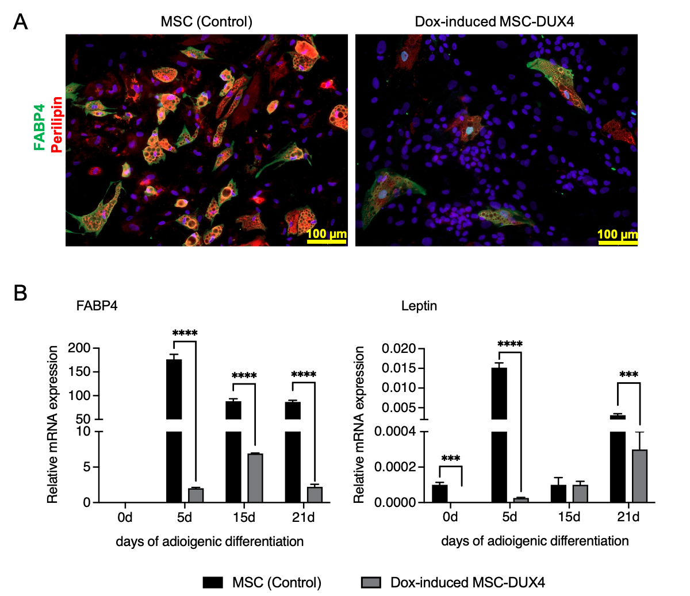
Figure S4. A, Representative image of differentiating MSCs stained for adipogenic markers FABP4 (green) and perilipin (red), the nuclei are counterstained with DAPI (blue), (scale bar: 50 μm) on day 21 adipogenic differentiation ; B, Expression of adipogenic markers FABP4 and Leptin in MSCs on day 5, 15 and 21 of adipogenic differentiation calculated according to the 2−∆∆Ct quantification method vs. GAPDH (results are presented as mean ± SD, * p <0.05, n = 3); Scale bar = 100 µm

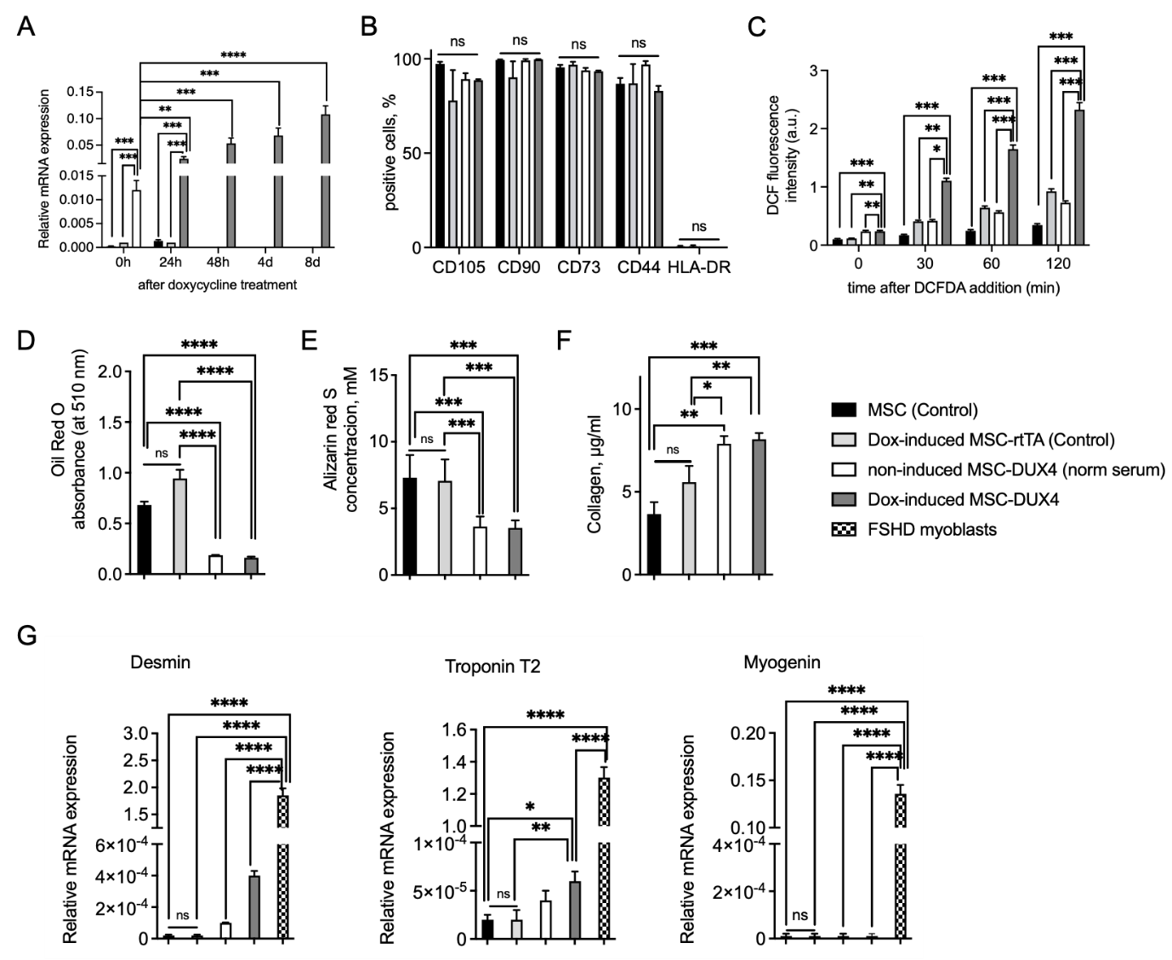
Figure S5. A, Expression level of DUX4 during 8 days after DUX4 induction, calculated according to the 2−∆∆Ct quantification method vs. GAPDH (results are presented as mean ± SD; NS, non-significant; * p<0.05; n = 3); B, Flow cytometry data analysis of MSCs surface markers expression (mean ± SD, NS, non-significant; * p <0.05, n = 3); C, ROS accumulation in the MSCs measured by DCF staining (mean ± SD, NS, non-significant; * p <0.05, n = 11); D, Absorption of Oil Red O dye eluted from stained MSCs (results are presented as mean ± SD; NS, non-significant; * p<0.05; n = 6); E, Concentration of Alizarin Red S dye eluted from stained MSCs; F, Collagen concentration in the lysates of the control MSCs; G, Expression level of myogenic markers in MSC and FSHD myoblasts after 5 days of myogenic differentiation calculated according to the 2−∆∆Ct quantification method vs. GAPDH (results are presented as mean ± SD; NS, non-significant; * p<0.05; n = 3)

Table S1. Primary antibodies
Name | Dilution | Manufacturer | Catalog number
mouse monoclonal anti-MYH (MF20) | 1:500 | Thermo Fisher | 14-6503-82
mouse monoclonal anti-myogenin | 1:100 | Abcam | ab1835
rabbit polyclonal anti-desmin | 1:200 | Abcam | ab15200
mouse monoclonal anti-Troponin T | 1:200 | Sigma | T6277
mouse monoclonal anti-FABP4 | 1:200 | Abcam | ab93945
rabbit monoclonal anti-perilipin | 1:100 | Thermo Fisher | MA5-32597
rabbit polyclonal anti-Collagen III | 1:200 | Abcam | ab7778
rabbit polyclonal collagen IV | 1:250 | Abcam | ab6586
rabbit polyclonal fibronectin | 1:400 | Abcam | ab2413
rabbit polyclonal anti-DUX4 | 1:100 | Abcam | ab220987
mouse monoclonal anti-DUX4 | 1:250 | Invitrogen | MA5-16147

Table S2. Secondary antibodies
Name | Manufacturer | Catalog number
Alexa Fluor 488 donkey anti-mouse IgG (H+L) (2 mg/ml) | Life Technologies | A-21202
Alexa Fluor 488 goat anti-mouse IgG (H+L) (2 mg/ml) | Life Technologies | A-11029
Alexa Fluor 488 goat anti-Rabbit IgG (H+L) (2 mg/ml) | Invitrogen | A-11008
Alexa Fluor 594 chicken anti-mouse IgG (H+L) (2 mg/ml) | Life Technologies | A-21201
Alexa Fluor 594 chicken anti-rabbit IgG (H+L) (2 mg/ml) | Life Technologies | A-21442
Alexa Fluor 594 donkey anti-mouse IgG (H+L) (2 mg/ml) | Life Technologies | A-21203
Alexa Fluor 594 donkey anti-rabbit IgG (H+L) (2 mg/ml) | Life Technologies | A-21207

Table S3. Сonjugated antibodies
Name | Concentration | Manufacturer | Catalog number
PE Mouse anti-Human CD105 | 0,2 mg/ml | BD Pharmingen | 560839
PE-Cy5 Mouse Anti-Human CD90 | 0,2 mg/ml | BD Pharmingen | 555597
FITC Mouse Anti-Human CD73 | 0,2 mg/ml | BD Pharmingen | 561254
BV421 Mouse Anti-Human CD44 | 0,2 mg/ml | BD Opti Build | 743662
FITC anti-HLA-DR | 25 μg/mL | BD Pharmingen | 347400
PE Mouse anti-Human CD56 | 0,2 mg/ml | BD Pharmingen | 556647

Table S4. RT-qPCR primers.
Gene name | Forward primer Sequence (5'→3') | Reverse primer Sequence (5'→3')
FABP4 | CTTCCACGAGAGTTTATGAG | CTTCAGTCCAGGTCAACG
Leptin | CTGTGCGGATTCTTGTGGCT | TTGATGAGGGTTTTGGTGTC
Myogenin | CTACAGATGCCCACAACCT | GCTTGGAAGACAATCTCAGTT
Desmin | CACTAACGATTCCCTGATGAG | CGCAATGTTGTCCTGGTAG
Troponin T2 | GTTACATCCAGAAGACAGAG | CTTCATTCAGGTGGTCAAT
GAPDH | TGCACCACCAACTGCTTAGC | GGCATGGACTGTGGTCATGAG
DUX4 | GCGACGGAGACTCGTTTGGAC | CTGGCGTGACCTCTCATTCTGA

Table S5. Differential expression of genes in Dox-induced MSC-DUX4 vs.control MSCs.
Attached as a separate file

