Annex 1
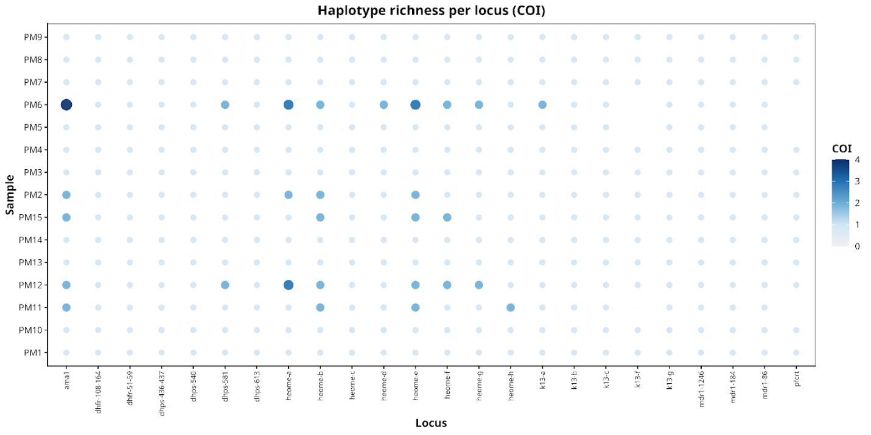
Fig. 5 | Haplotype richness per locus (COI). Dot plot showing COI (0–4) per locus and sample. Loci ordered by genomic position. Ama1 shows highest diversity (PM6 = 4); resistance loci are monoclonal.
Annex 2
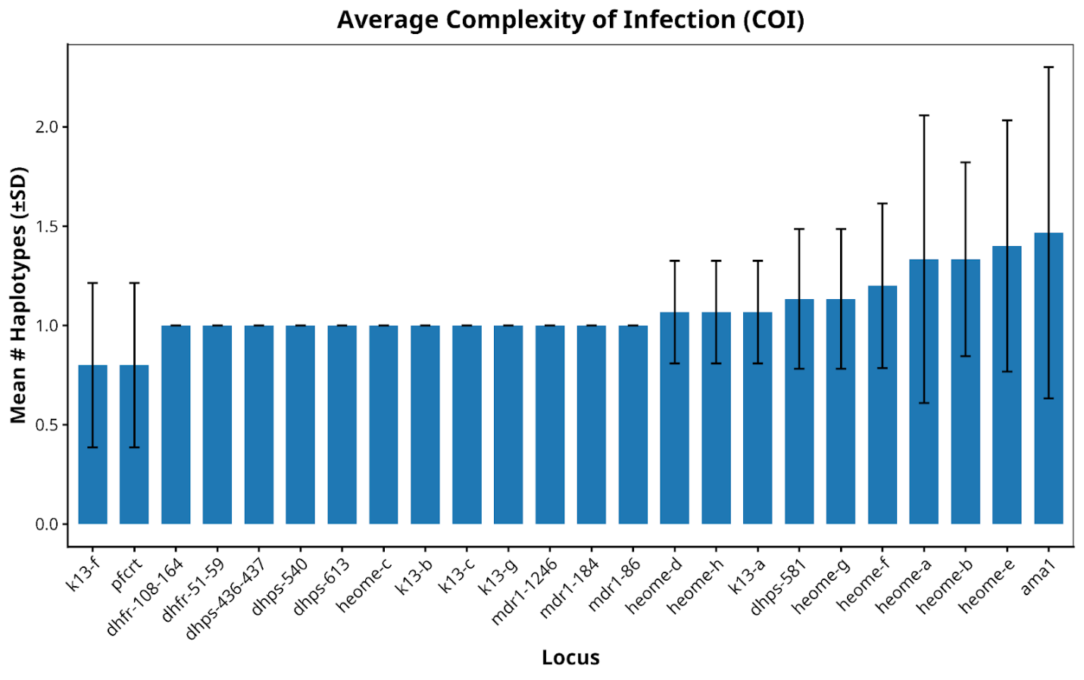
Annex/Figure 6. Average Complexity of Infection (COI). Mean number of haplotypes per locus (±SD). Ama1 and heome loci exceed COI = 1.6; resistance loci ≈ 1.0.

