Supporting Information
Irinotecan Loaded Lipomers: Development, and characterization for proof of concept to combat colon cancer

Prabhanjan S. Giram^{a, b}*, Baijayantimala Garnaik^{a, b}
ªPolymer Science and Engineering Division, CSIR-National Chemical Laboratory, Pune-411008, India.
^{b}Academy of Scientific and Innovative Research (AcSIR), Ghaziabad 201002, India.
__________________________________________________
* To whom correspondence should be addressed.
Dr. Prabhanjan Giram
E. mail: prabhanjanpharma@gmail.com
Tel.: +91-9404677569

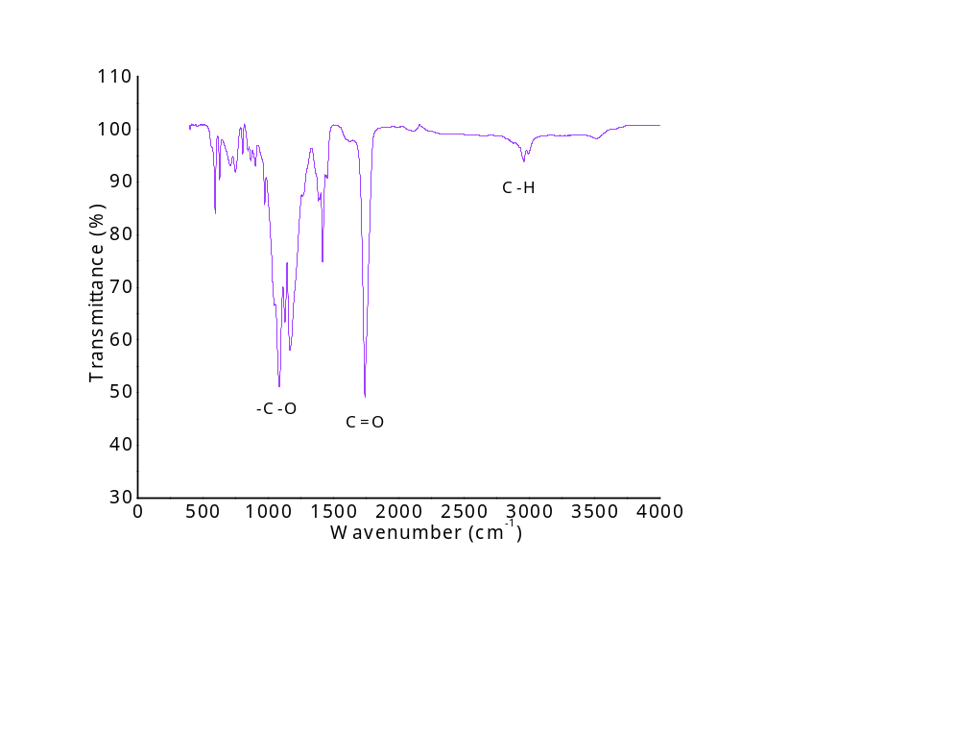

Figure.S1 ATR-FTIR of PLGA

Table.S1 Preliminary Batches of P-DSPE-Ir formulation
Lipomer Code | P1 | P2 | P3 | P4 | P5 | P6 | P7 | P8 | P9 | P10 | P11 | P12
DSPE +Lipid/ Polymer mass | 10 | 15 | 20 | 10 | 15 | 20 | 10 | 15 | 20 | 10 | 15 | 20
Lipid/ DSPE molar | 9:1 |  |  | 8:2 |  |  | 7.5:2.5 |  |  | 7:3
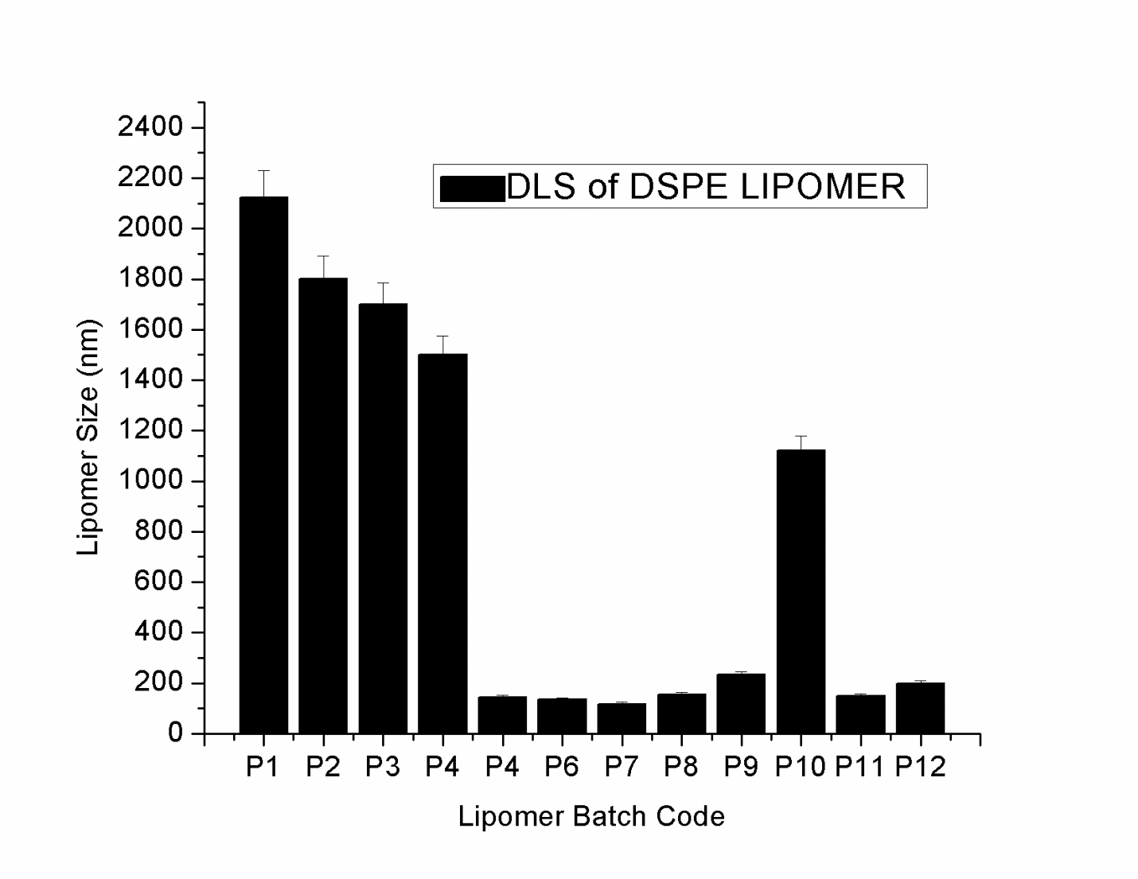
Figure.S2 Dynamic light scattering analysis for particle size measurement for lipomer P-DSPE-Ir batch (P₁-P₁₂)

Table.S2 Preliminary Batches of Lipomer P-DSPE-PEG-Ir formulation
Lipomer Code | P1 | P2 | P3 | P4 | P5 | P6 | P7 | P8 | P9 | P10 | P11 | P12
DSPE +Lipid/ Polymer mass | 10 | 15 | 20 | 10 | 15 | 20 | 10 | 15 | 20 | 10 | 15 | 20
Lipid/ DSPE-PEG-2000 molar | 9:1 |  |  | 8:2 |  |  | 7.5:2.5 |  |  | 7:3
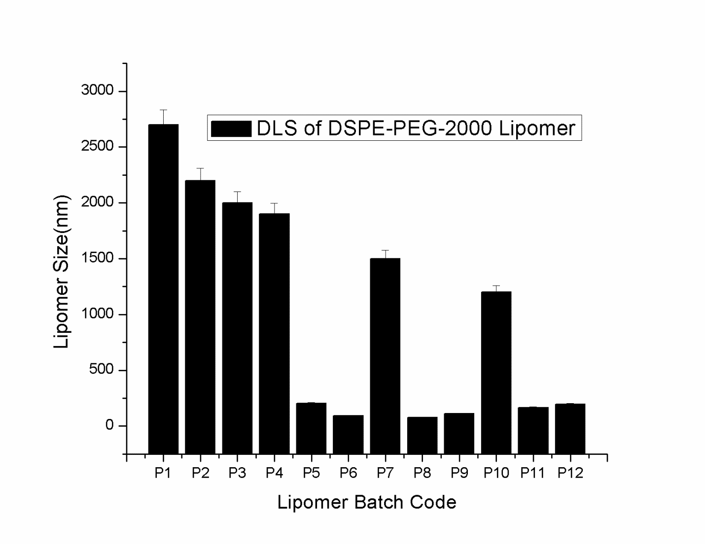
Figure.S3 Dynamic light scattering analysis for particle size measurement for lipomer P-DSPE-PEG-Ir batch (P₁-P₁₂)

Table. S3 Haematological analysis
Test parameter | CTRL | Irinotecan | P-DSPE-Ir | P-DSPE-PEG-Ir
Hematocrit (%) | 37.9±6.0 | 45.3±3.4 | 42.2±1.4 | 47.63±1.9
MCV(fl) | 56.1±3.0 | 55.4±2.4 | 57.1±1.9 | 59.6±3.1
MCH (pg) | 17.03±2.1 | 15.14±0.6 | 15.29±0.4 | 14.77±0.1
MCHC^{d}(g/dl) | 30.55±5.0 | 29.1±0.4 | 26.78±0.3 | 24.84±1.5
Total Lymphocyte (X 10³/µL) | 8.17±1.4 | 8.65±1.0 | 8.23±0.7 | 8.53±1.2
Eosinophil (%) | 1.7±0.6 | 1.3±0.6 | 1±0.1 | 1±0.1
Basophil (%) | 0.7±0.6 | 0.4±0.3 | 1.3±0.6 | 1±0.1

A
P-DSPE-DiR
P-DSPE-PEG-DDiR
5 min min
30 min
1 h
24 h
48 h
72 h
6 d
9 d

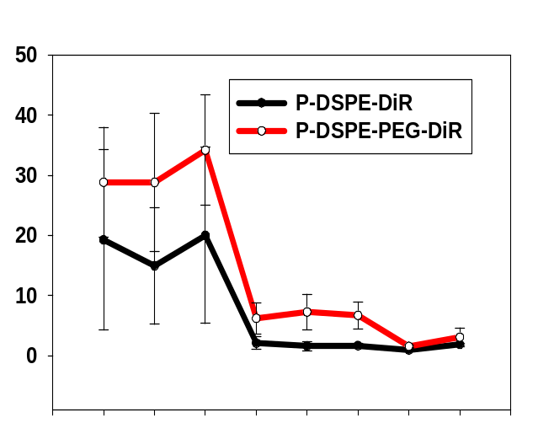
B
5 min
30 min
1 h
24 h
48 h
72 h
6 d
9 d
NIRF intensity(p/sec/cm2 /sr)

Figure.S4 In vivo tumor site retention images (a), Near Infrared frequency signal intensity curve (b)

