Supplementary Information for
Programmable Terahertz Waveform Synthesis via Coherent Interference of Phonon Polaritons
Jixing Gao,^{1,2} Jiajing Hao,^{1,2} Yifei Fang,^{1,2,} * Liwei Song,^{1,2,} * Ye Tian,^{1,2,} * and Ruxin Li,^{1,2,3}
¹State Key Laboratory of Ultra-intense laser Science and Technology, Shanghai Institute of Optics and Fine Mechanics, Chinese Academy of Sciences, 201800 Shanghai, China
²Center of Materials Science and Optoelectronics Engineering, University of Chinese Academy of Sciences, 100049 Beijing, China
³Zhangjiang Laboratory, Shanghai 201210, China
These authors contributed equally: Jixing Gao, Jiajing Hao
*Corresponding author: yifeifang@siom.ac.cn; slw@siom.ac.cn; tianye@siom.ac.cn

Contents:
Supplementary Note 1: Transverse optical oscillator parameters
Supplementary Note 2: Unnormalized intensity of [2 1] and [2 -1] of ΓA direction
Supplementary Note 3: Time-resolved FWM with THz polarization along the ΓM direction
Supplementary Note 4: Dispersion branches with phase-matching condition
Supplementary Note 5: Beat-note model from third-order nonlinear polarization
Supplementary Note 6: Double-THz control of the FWM beat-note waveform

Supplementary Note 1: Transverse optical oscillator parameters
The TO phonon mode frequency $ω_{TO-j}$, oscillator strength $S_{TO-j}$ and damping parameter $γ_{TO-j}$ used in FDTD simulation and phase matching calculations are shown in Table S1.
Table S1 The transverse optical oscillator parameters of crystalline quartz related to the phonon dispersion curves along the directions of ΓA and ΓM.
ΓA
Oscillator j | $$ω_{TO-j}\left({cm}^{-1}\right)$$ | $$S_{TO-j}$$ | $$γ_{TO-j}\left({cm}^{-1}\right)$$
1 | 1220 | 0.011 | 183.0
2 | 1080 | 0.67 | 7.452
3 | 778 | 0.11 | 4.78
4 | 529 | 0.006 | 21.16
5 | 509 | 0.05 | 7.126
6 | 495 | 0.66 | 4.455
7 | 364 | 0.68 | 5.096
$$ε_{∞}=2.383$$
ΓM
Oscillator j | $$ω_{TO-j}\left({cm}^{-1}\right)$$ | $$S_{TO-j}$$ | $$γ_{TO-j}\left({cm}^{-1}\right)$$
1 | 1227 | 0.009 | 134.97
2 | 1163 | 0.01 | 6.978
3 | 1078 | 0.57 | 7.6112
4 | 775 | 0.25 | 7.173
5 | 485 | 1.04 | 4.05
6 | 394 | 0.33 | 2.758
$$ε_{∞}=2.356$$

Supplementary Note 2: Unnormalized intensity of [2 1] and [2 -1] of ΓA direction
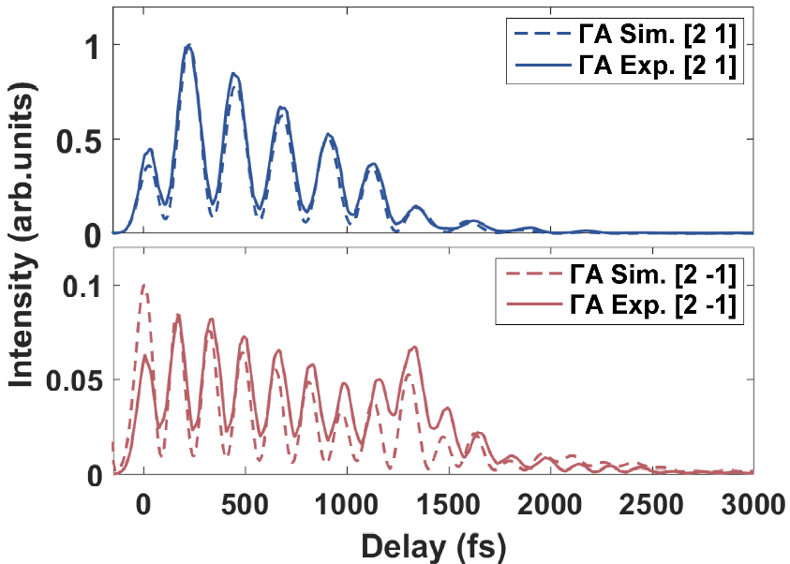
Fig. S1 Time-resolved FWM signals with delay time as a function of pump-probe, with pump polarization along the ΓA direction. FWM signal intensity normalized with respect to [2 1].

Supplementary Note 3: Time-resolved FWM with THz polarization along the ΓM direction
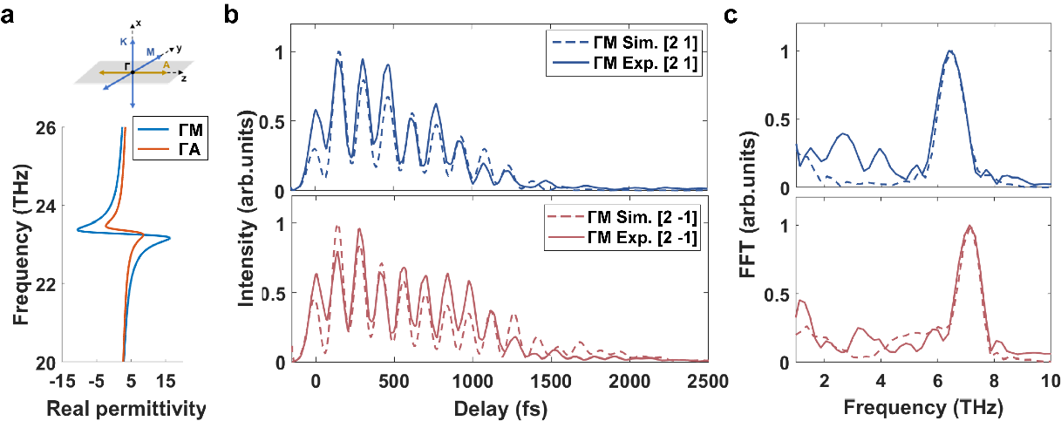
Fig. S2 Polarization-resolved manipulation of the beat frequency in PhPs. (a) Dielectric response function under THz pumping along different crystal axes. (b) Time-resolved FWM signals as a function of pump-probe, with pump polarization along the ΓM direction. (c) Fourier transform of the FWM time-delay trace shown in (b).

Supplementary Note 4: Dispersion branches with phase-matching condition
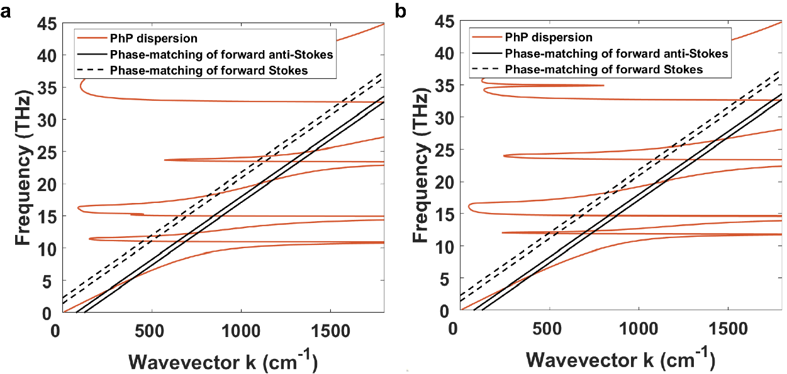
Fig. S3 The PHP dispersion curve and FWM phase matching, with THz polarization along the (a) ΓA and (b) ΓM direction. The black dash and solid lines indicate momentum-energy matching boundaries under forward Stokes and anti-Stokes processes with the wavelength of 1.45 μm to 1.9 μm. Black dashed and solid lines indicate the momentum-energy matching boundaries for forward Stokes and anti-Stokes processes in the wavelength range of 1.45–1.9 μm

Supplementary Note 5: Beat-note model from third-order nonlinear polarization
We consider a four-wave mixing (FWM) process in which two probe photons mix with a THz-driven phonon–polariton (PhPs) component at frequency $Ω$, generating a sideband photon at $ω_{\text{FWM}} =ω_{1}+ω_{2}+sΩ$, with $s=+1$ for the higher FWM photon and $s=-1$ for the lower FWM photon. We write the real physical fields using complex spectral amplitudes:
$$\begin{aligned}E_{\text{IR}}\left(z,t\right)=R\left[\int{\text{d}ωE_{\text{IR}}\left(ω\right)e^{i\left[k\left(ω\right)z-ωt\right]}}\right]\#\left(S1\right)\end{aligned}$$
$$\begin{aligned}E_{\text{PhP}}\left(z,t\right)=R\left[\int{\text{d}ΩE_{\text{PhP}}\left(Ω\right)e^{i\left[k_{\text{PhP}}\left(Ω\right)z-Ωt\right]}}\right]\#\left(S2\right)\end{aligned}$$
A pump–probe delay $τ$ between the THz-driven PhPs and the probe enters as a phase factor on the PhPs spectral component $E_{\text{PhP}}\left(Ω\right)→E_{\text{PhP}}\left(Ω\right)e^{isΩτ}$. Under the undepleted probe approximation, the third-order polarization driving the FWM process at $ω_{\text{FWM}}$ is
$$\begin{aligned}P^{\left(3\right)}\left(z,ω_{\text{FWM}};τ\right)∝ε_{0}χ^{\left(3\right)}\iiint{\text{d}ω_{1}\text{d}ω_{2}\text{d}ΩA\left(s,τ;ω_{1},ω_{2},Ω\right)e^{i\left[k\left(ω_{\text{1}}\right)+k\left(ω_{\text{2}}\right)+sk_{\text{PhP}}\left(Ω\right)\right]z}}\#\left(S3\right)\end{aligned}$$
where the function $A\left(s,τ;ω_{1},ω_{2},Ω\right)$ is defined as follows
$$\begin{aligned}A\left(s,τ;ω_{1},ω_{2},Ω\right)≡E_{\text{IR}}\left(ω_{1}\right)E_{\text{IR}}\left(ω_{2}\right)E_{\text{PhP}}\left(Ω\right)δ\left(ω_{\text{FWM}}-ω_{1}-ω_{2}-sΩ\right)e^{isΩτ}\#\left(S4\right)\end{aligned}$$
So that the emitted FWM field at $ω_{\text{FWM}}$ is obtained by integrating the source polarization along a crystal of thickness $d$, yielding
$$\begin{aligned}E_{\text{FWM}}\left(ω_{\text{FWM}};τ\right)∝ε_{0}χ^{\left(3\right)}\iiint{\text{d}ω_{1}\text{d}ω_{2}\text{d}ΩA\left(s,τ;ω_{1},ω_{2},Ω\right)F\left(s,d;ω_{1},ω_{2},Ω\right)}\#\left(S5\right)\end{aligned}$$
The phase-matching acceptance factor $F\left(s,d;ω_{1},ω_{2},Ω\right)$ is defined as follows
$$\begin{aligned} F\left(s,d;ω_{1},ω_{2},Ω\right)≡\int_{0}^{d}{dze^{iΔk\left(s;ω_{1},ω_{2},Ω\right)z}}=dsinc\left(\frac{Δk\left(s;ω_{1},ω_{2},Ω\right)d}{2}\right)e^{i{Δk\left(s;ω_{1},ω_{2},Ω\right)d}/2}\#\left(S6\right)\end{aligned}$$
where the phase mismatch is
$$\begin{aligned}Δk\left(s;ω_{1},ω_{2},Ω\right)=k\left(ω_{1}\right)+k\left(ω_{2}\right)+sk_{\text{PhP}}\left(Ω\right)-k\left(ω_{\text{FWM}}\right)\#\left(S7\right)\end{aligned}$$
Equations (S3)–(S7) describe the most general case in which the two probe photons can originate from arbitrary spectral components $ω_{1}$ and $ω_{2}$ within the probe spectrum. The energy-conservation delta function $δ\left(ω_{\text{FWM}}-ω_{1}-ω_{2}-sΩ\right)$ constrains the participating frequency triplets, while the phase-matching acceptance factor $F\left(s,d;ω_{1},ω_{2},Ω\right)$ strongly weights contributions near $Δk\left(s;ω_{1},ω_{2},Ω\right)=0$. For the intuitive discussion in the main text, we adopt a quasi-degenerate description appropriate for a probe spectrum centered at $ω_{\text{NIR}}$, i.e., $ω_{1}≈ω_{2}≈ω_{\text{NIR}}$. With $ω_{\text{FWM}}={2ω}_{\text{NIR}}+sΩ$, the phase mismatch reduces to a one-parameter function of $Ω$,
$$\begin{aligned}Δk_{qd}\left(s;Ω\right)=2k\left(ω_{\text{NIR}}\right)+sk_{\text{PhP}}\left(Ω\right)-k\left(2ω_{\text{NIR}}+sΩ\right)\#\left(S8\right)\end{aligned}$$
Within the bandwidth of the driving THz spectrum, the weighting by $F$ can yield two dominant phase-matched PhP contributions at $Ω_{1}$ and $Ω_{2}$. When the detected FWM signal is collected within a finite spectral window around a chosen sideband energy, these two contributions can enter the same detection channel and interfere in the delay-dependent intensity. Accordingly, at a fixed FWM process, the emitted field can be approximated by the coherent sum
$$\begin{aligned}E_{\text{FWM}}\left(τ\right)=C_{1}e^{isΩ_{1}τ}+C_{2}e^{isΩ_{2}τ}\#\left(S9\right)\end{aligned}$$
To include finite coherence of each contribution, we phenomenologically write
$$\begin{aligned}E_{\text{FWM}}\left(τ\right)=C_{1}e^{-τ/{T_{1}}}e^{is\left(Ω_{1}τ+ϕ_{1}\right)}+C_{2}e^{-τ/{T_{2}}}e^{is\left(Ω_{2}τ+ϕ_{2}\right)}\#\left(S10\right)\end{aligned}$$
Taking $s=-1$ for example, the spectrally-resolved detected signal is proportional to the intensity at the selected FWM sideband,
$$\begin{aligned}I_{\text{FWM}}\left(τ\right)∝{\left|C_{1}\right|}^{2}e^{-2τ/{T_{1}}}+{\left|C_{2}\right|}^{2}e^{-2τ/{T_{2}}}+2\left|C_{1}\right|\left|C_{2}\right|e^{-τ/T}\cos\left(Ω_{AS/S}τ+ϕ_{-}\right)\#\left(S11\right)\end{aligned}$$
where $1/T=1/T_{1}+1/T_{2}$ and $ϕ_{-}=ϕ_{1}-ϕ_{2}+argC_{1}-argC_{2}$. Therefore, the delay-dependent modulation is governed by the beat frequency $Ω_{AS/S}≡|Ω_{1}-Ω_{2}|$. Define the slowly varying baseline as:
$$\begin{aligned}I_{0}(τ)≡|C_{1}|^{2}e^{-2τ/T_{1}}+|C_{2}|^{2}e^{-2τ/T_{2}}\#\left(S12\right)\end{aligned}$$
Then Eq. (S11) can be written as
$$\begin{aligned}I_{\text{FWM}}\left(τ\right)=I_{0}(τ)\left[1+η\left(τ\right)\cos\left(Ω_{AS/S}τ+ϕ_{-}\right)\right]\#\left(S13\right)\end{aligned}$$
with modulation depth
$$\begin{aligned}η(τ)=\frac{2|C_{1}||C_{2}|e^{-τ/T}}{|C_{1}|^{2}e^{-2τ/T_{1}}+|C_{2}|^{2}e^{-2τ/T_{2}}}\#\left(S14\right)\end{aligned}$$
If $T_{1}≃T_{2}$ (or within a limited $τ$-window), this reduces to the constant form
$$\begin{aligned}η≈\frac{2|C_{1}||C_{2}|}{|C_{1}|^{2}+|C_{2}|^{2}}\#\left(S15\right)\end{aligned}$$

Supplementary Note 6: Double-THz control of the FWM beat-note waveform
In Supplementary Note 5, the delay-dependent FWM signal was described by the interference of two phase-matched PhP contributions at $Ω_{1}$ and $Ω_{2}$, leading to a beat-note modulation at $Ω_{AS/S}≡|Ω_{1}-Ω_{2}|$. Here we extend that framework to the double-THz-pulse excitation scheme used for active waveform control, and quantify the phase/amplitude resolution expected for an experimental implementation.
Starting from Eq. (S5), the emitted FWM field is determined by the spectral PhP field $E_{\text{PhP}}\left(Ω\right)$. Under double-THz excitation, we write
$$\begin{aligned}E_{\text{PhP}}\left(Ω\right)=E_{\text{PhP}\text{,A}}\left(Ω\right)e^{iϕ_{CEP, A}}+E_{\text{PhP}\text{,}\text{B}}\left(Ω\right)e^{iϕ_{CEP, B}}\#\left(S16\right)\end{aligned}$$
where $E_{\text{PhP}\text{,A}}\left(Ω\right)$ and $E_{\text{PhP}\text{,}\text{B}}\left(Ω\right)$ are narrowband spectra peaked at the two phase-matched PhP frequencies $Ω_{1}$ and $Ω_{2}$, respectively. In the narrowband limit, the CEP is approximated as a frequency-independent phase factor, whereas any fixed phase lag associated with PhP excitation, propagation, and nonlinear conversion is absorbed into constant phases introduced below.
Substituting Eq. (S16) into Eq. (S5), and retaining only the two dominant phase-matched contributions selected by the detection window, the emitted FWM field reduces to the same two-mode form as Eq. (S10), but now with the amplitudes and phases controlled by the two THz pulses:
$$\begin{aligned}E_{\text{FWM}}\left(τ\right)=C_{1}e^{-τ/{T_{1}}}e^{is\left(Ω_{1}τ+ϕ_{1}+ϕ_{CEP, A}\right)}+C_{2}e^{-τ/{T_{2}}}e^{is\left(Ω_{2}τ+ϕ_{2}+ϕ_{CEP, B}\right)}\#\left(S17\right)\end{aligned}$$
here $C_{1}$ and $C_{2}$ are complex pathway coefficients (consistent with the appearance of $argC_{1,2}$ in Supplementary Note 5 and below); their magnitudes $\left|C_{1,2}\right|$ are determined by the excitation efficiencies of the two phase-matched channels and are therefore controlled by the field strengths of THzA and THzB, respectively. The $ϕ_{1}$ and $ϕ_{2}$ represent all fixed phase contributions. The sign $s=±1$ follows the convention in Supplementary Note 5.
Using Eq. (S17), the detected FWM intensity becomes
$$\begin{aligned}I_{\text{FWM}}\left(τ\right)∝{\left|C_{1}\right|}^{2}e^{-2τ/{T_{1}}}+{\left|C_{2}\right|}^{2}e^{-2τ/{T_{2}}}+2\left|C_{1}\right|\left|C_{2}\right|e^{-τ/T}\cos\left(Ω_{AS/S}τ+ϕ_{-}\right)\#\left(S18\right)\end{aligned}$$
where $ϕ_{-}=ϕ_{1}-ϕ_{2}+argC_{1}-argC_{2}+ϕ_{CEP, A}-ϕ_{CEP, B}$. Equation (S18) is the double-THz extension of Eq. (S11): the beat frequency remains fixed by the two phase-matched PhP frequencies, whereas the phase and modulation depth become externally tunable. Accordingly, the slowly varying baseline $I_{0}(τ)$, the modulation depth $η\left(τ\right)$, and the approximately constant form of $η$ for $T_{1}≃T_{2}$ are still given by Eqs. (S12)–(S15). The only difference is that $C_{1}$ and $C_{2}$ are now externally controlled by the two THz pulses. In particular, Eq. (S15) shows that the modulation depth is maximized when $|C_{1}|$ and $|C_{2}|$ are comparable. In our simulation where $ϕ_{CEP, B}$ is fixed and only $ϕ_{CEP, A}$ is scanned, one has
$$\begin{aligned}ϕ_{-}=ϕ_{-}^{\left(0\right)}+ϕ_{CEP, A}\#\left(S19\right)\end{aligned}$$
where the constant term $-ϕ_{CEP, B}$ has been absorbed into $ϕ_{-}^{\left(0\right)}$. Thus, varying $ϕ_{CEP, A}$ shifts the phase of the beat-note waveform without changing $Ω_{AS/S}$. By contrast, at fixed CEPs, changing the field strength of THzB modifies $|C_{2}|$, and therefore changes $η$ through Eq. (S15), while also leaving the beat frequency essentially unchanged. This identifies the CEP as a phase knob and the THz field strength as an amplitude knob.
To quantify the phase resolution, we start from Eq. (S13). After normalization by the slowly varying baseline $I_{0}(τ)$, one obtains
$$\begin{aligned}\frac{I_{\text{FWM}}\left(τ\right)}{I_{0}(τ)}-1=η\left(τ\right)\cos\left(Ω_{AS/S}τ+ϕ_{-}\right)\#\left(S20\right)\end{aligned}$$
within a fitting window where $η\left(τ\right)$ varies slowly, we approximate $η\left(τ\right)=η$ as constant. The phase sensitivity is then
$$\begin{aligned}\frac{∂}{∂ϕ_{-}}\left[\frac{I_{\text{FWM}}\left(τ\right)}{I_{0}(τ)}-1\right]=-η\sin\left(Ω_{AS/S}τ+ϕ_{-}\right)\#\left(S21\right)\end{aligned}$$
as the root-mean-square (RMS) noise of the normalized trace is $σ_{n}$, standard error propagation gives the single-point phase uncertainty
$$\begin{aligned}δϕ_{pt}\left(τ\right)≈\frac{σ_{n}}{η\left|\sin\left(Ω_{AS/S}τ+ϕ_{-}\right)\right|}\#\left(S22\right)\end{aligned}$$
at the quadrature point, where $\left|\sin\left(Ω_{AS/S}τ+ϕ_{-}\right)\right|=1$,
$$\begin{aligned}δϕ_{pt}=\frac{σ_{n}}{η}\#\left(S23\right)\end{aligned}$$
Therefore, the signal resolution is limited by two factors: phase-setting resolution and the phase-readout uncertainty. The former is determined by the step resolution of delay stage. If the CEP of THzA is tuned by shifting the temporal position of the narrowband THzA waveform by $δτ_{A}$, then $δϕ_{set}=2πf_{A}δτ_{A}$, where $f_{A}$ is the carrier frequency of THzA. If the delay is implemented with a retroreflecting translation stage of step size $δx$, then $δτ_{A}={2δx}/c$. The latter corresponds to the laser energy stability limit. From Eq. (S20),
$$\begin{aligned}\frac{∂}{∂η}\left[\frac{I_{\text{FWM}}\left(τ\right)}{I_{0}(τ)}-1\right]=\cos\left(Ω_{AS/S}τ+ϕ_{-}\right)\#\left(S24\right)\end{aligned}$$
so that the optimal single-point uncertainty in $η$ is of order $δη_{pt}\sim σ_{n}$. Accordingly, the minimum resolvable change in the THzB field is determined by the corresponding change it produces in $η$. The experimentally resolvable phase step must therefore exceed both the phase-setting resolution and the phase-readout uncertainty
For a representative experimental implementation, taking $f_{A}=20 THz$ gives a carrier period $T_{A}=1/{f_{A}}≈50 fs$. If the CEP of THzA is tuned by the delay stage with minimum step size $δx=0.1 μm$, the corresponding delay increment is $δτ_{A}={2δx}/c≈0.67 fs$, which gives $δϕ_{set}=2πf_{A}δτ_{A}≈0.088 rad$. The corresponding equivalent timing step of the output beat-note waveform is
$$\begin{aligned}δt_{beat,set}=\frac{δϕ_{set}}{Ω_{AS/S}}\#\left(S25\right)\end{aligned}$$
For $f_{beat}=$4.3, 6.0, and 7.1 THz, this gives
$$\begin{aligned}δt_{beat,set}=3.1 fs, 2.2 fs, 1.85 fs\#\left(S26\right)\end{aligned}$$
respectively.
In this analysis, we utilize the experimentally measured results of the laser system's RMS energy stability obtained within a 1-hour measurement window. Taking $σ_{n}≈5\%$ and $η≈1$, Eq. (S23) gives $δϕ_{pt}\sim 0.05 rad$, which corresponds to
$$\begin{aligned}δt_{beat,pt}=1.9 fs,1.3 fs, 1.1 fs\#\left(S27\right)\end{aligned}$$
for $f_{beat}=$4.3, 6.0, and 7.1 THz, respectively. The experimentally achievable phase (timing) resolution is determined by the larger of the phase-setting granularity and the readout-limited uncertainty:
$$\begin{aligned}δt_{beat,eff}≈max\left(δt_{beat,set},δt_{beat,pt}\right)\#\left(S28\right)\end{aligned}$$
Finally, it should be further clarified that, based on the above analysis, the double-pulse scheme holds the potential to achieve sub-femtosecond (<1 fs) time-resolved control: for example, when the laser energy stability is optimized to $σ_{n}≤2 \%$ and a piezoelectric stage with a step size of 20 nm is used, these correspond to minimum time resolutions of 0.76 fs (for laser stability) and 0.62 fs (for the delay stage), respectively. This distinction provides a physically transparent framework for evaluating and optimizing programmable double-THz control of the PhP-mediated FWM beat-note waveform.

